# Introduction

* The global importance of climate change impacts drives a need to understand patterns of plant community compositional change, as it pertains to understanding ecologically appropriate reference states.
  + Descriptive studies of decadal changes in patch-scale plant community compositional stability are useful to indicate persistence of reference-quality habitat.
* Community stability can be characterized by low variability in species or functional diversity over time.
  + Changes in community-dominant species, native plant species diversity, and species turnover are important because conservation of native species drives redundancy, and creates functional stability in plant communities.
  + Shifts in community-dominant species, loss of native species diversity, and species turnover (such as greater abundance of invasive species) may indicate loss of functional redundancy. In turn, this may indicate reduced resistance to change or resilient capacity to recover from disturbance (Bai, Han, Wu, Chen, & Li, 2004; Tilman, Reich, & Knops, 2006).
    - Thus use of a site which has undergone these changes as an historical reference would be flawed.
    - Furthermore: loss of native species is especially important when the regional pool of potential species is reduced or environmentally constrained (*need references).
* Estuaries are at the terrestrial-marine interface where cumulative environmental and anthropogenic stressors have shifted due to landscape-scale changes, and ecosystems will experience accelerated change under sea level rise. These habitats are of increasing concern for ecosystem service value, and understanding how to maintain or facilitate creation of estuarine habitat is a major objective of climate change resilience strategies.
  + In North America, estuaries are of greater conservation importance in the PNW (limited space due to fjord geography, contrast to expansive alluvial plains of eastern North America).
  + Tidal freshwater marshes (TFMs) are the upper reaches of estuaries where freshwater dominates, but they are particularly important as early transitional habitat along salinity gradient for salmonids).
  + These reaches are of high conservation and restoration interest, therefore understanding changes in species composition over time is useful to conservation objectives in anticipation of sea level rise.
  + Define biodiverse but restricted habitat types within TFM with respect to general herbaceous structure, dominated by sedges/rushes with some salinity tolerance, but with greater forb diversity unique to TFMs that don’t occur in higher salinity or non-tidal wetlands;
    - Emphasize biodiversity and habitat value, and concern for species gained/lost.
* A major challenge of understanding community stability is the lack of long-term monitoring. In absence of long-term monitoring, using historical datasets can provide a ‘snapshot’ of changes across time.
  + One such opportunity exists in Ladner Marsh, which escaped development through designation as protected habitat (Figure 1).
    - Portions of the South Arm Marshes WMA complex are used as reference sites for ongoing restoration projects in the Fraser River Estuary.
    - Understanding how community composition has changed prior to and since the 1991 establishment of the WMA is important for regional land managers in evaluating benchmarks for conservation/restoration targets.
  + Two historical studies conducted in Ladner Marsh (Bradfield & Porter, 1982; Denoth & Myers, 2007) used similar methods to document floristic diversity.
    - Bradfield & Porter identified distinct community sub-types (hereafter, “assemblages”), with niche occupancy driven by edaphic factors such as drainage. Denoth & Myers repeated the sampling to determine whether a non-native species (purple loosestrife) was displacing a species of concern (Henderson’s checkermallow).
    - While these studies independently characterize different community metrics, these datasets provide the opportunity to repeat observations and characterize long-term plant community changes and stability of ‘reference quality’ habitat.
* The main objective of this work is to infer stability of plant community compositional structure in the absence of large-scale or direct disturbance in a tidal freshwater marsh. I used three observational datasets spanning four decades to answer the following questions:

1. Are assemblages are still characterized by the same dominant species?
   1. In the absence of significant environmental disturbance, I expect the same species to dominate each assemblage as identified by Bradfield & Porter (1982).
      1. **ANALYSIS**: cluster analysis (Figure 1) w/ indicator species analysis of each cluster to identify which species are driving the cluster (Table 1, or Supplement).
2. Is diversity stable within and between assemblage types over time?
   1. I expect community-wide diversity to be more stable than diversity within each assemblage type.
      1. **ANALYSIS**: community_stability (“codyn”) to measure mean richness over time, and variance ratio to determine significance of richness variance (report value in text).
3. What is the total community species turnover, and which species gained or lost are driving changes within each assemblage’s diversity?
   1. If assemblages have greater species homogenization within assemblages, I expect this to be driven by significant invasive species abundance.
      1. **ANALYSIS**: (1) total turnover of community (report value in text), (2) rank clock plots of species dominance over time within assemblages and rate of community change (Figure 2)

# Methods

* Site context & plot selection composite figure; show overlay of 2019 transects on line drawing site figure from Bradfield & Porter (1982)? (Figure 1)
* Field methods
  + Historical data collection & site relocation (with statements of uncertainty).
  + Present data collection methods, with estimation of transect accuracy statement.
    - Taxonomy
* Analyses performed

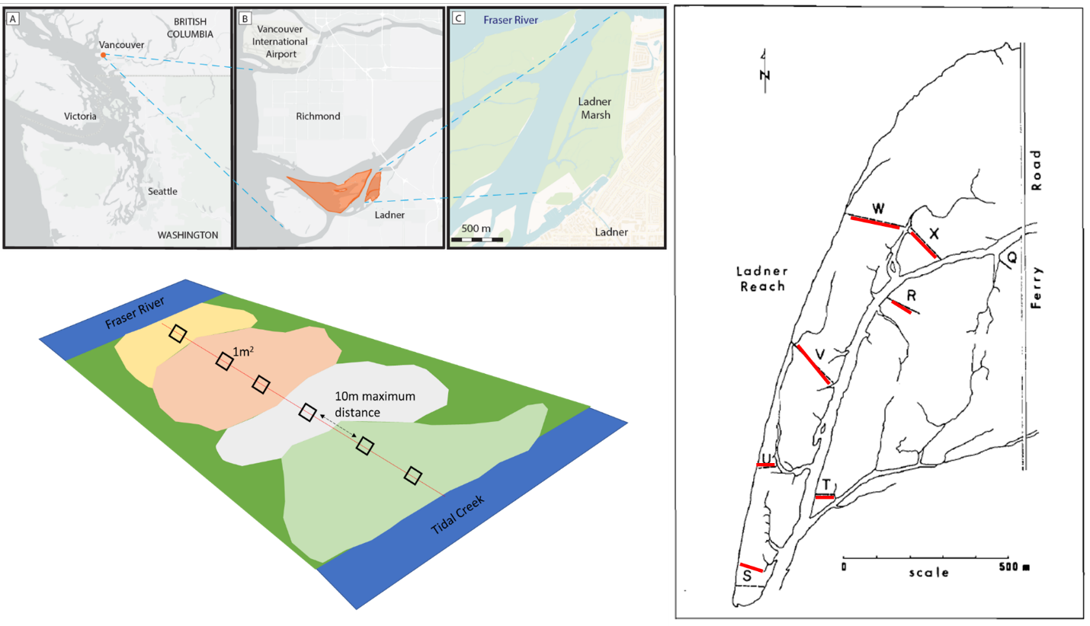

Figure 1. Clockwise from top left: Geographical site context, transect relocation method by overlaying 1982 publication figure onto Google Earth basemap, and field-testing accessibility, and plot sampling design.

# Results

Table 1. Species indicator analysis identifies the same dominant species in each assemblage type (sedge, fescue, bogbean) as significantly driving clustering of assemblages over time.

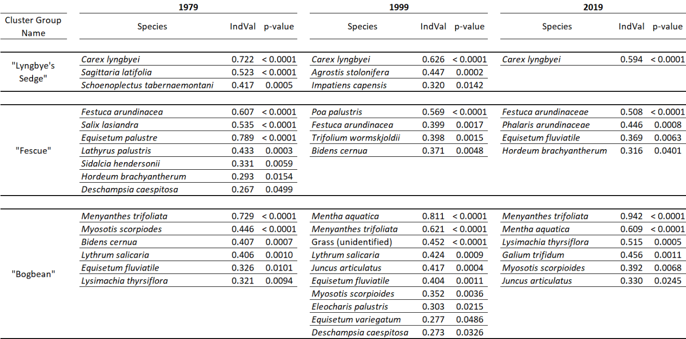

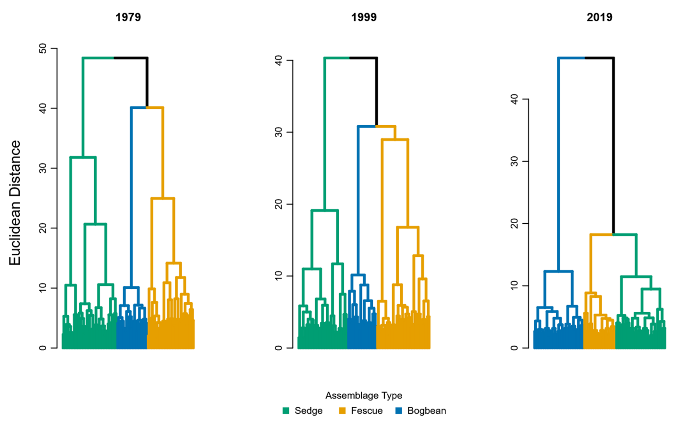

Figure 2. Assemblage diversity becomes more dissimilar over time, as shown by greater Euclidean distance between assemblage types.

Figure 3. Rank abundance clocks for each assemblage type show shift in dominant species over time. In the sedge assemblage, Carex lyngbyei becomes less dominant over time, while dominance of non-native species Agrostis stolonifera remains nearly constant. Fescue assemblage is consistently occupied by Agrostis stolonifera; apparent loss of Poa palustris may be due to misattribution of the species to Agrostis stolonifera in 2019. Phalaris arundinaceae dominates Fescue assemblage after 1999. Bogbean assemblage is consistently dominated by Menyanthes trifoliata, however non-native Mentha aquatica becomes increasingly dominant while dominance of Equisetum fluviatile decreases.

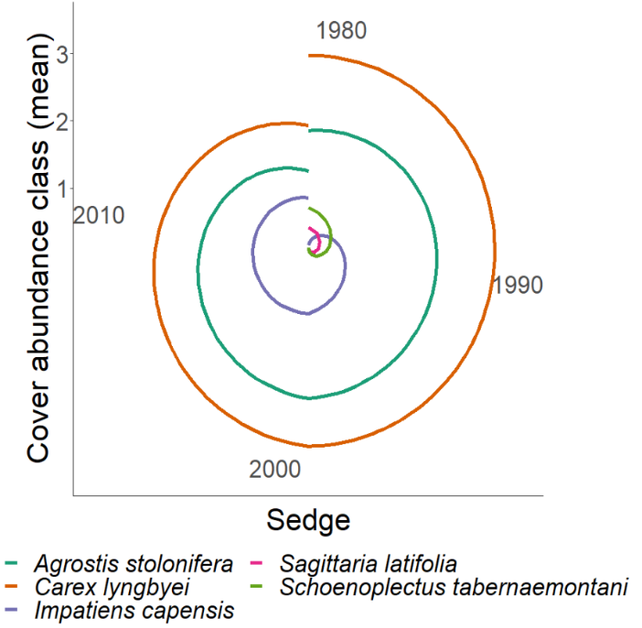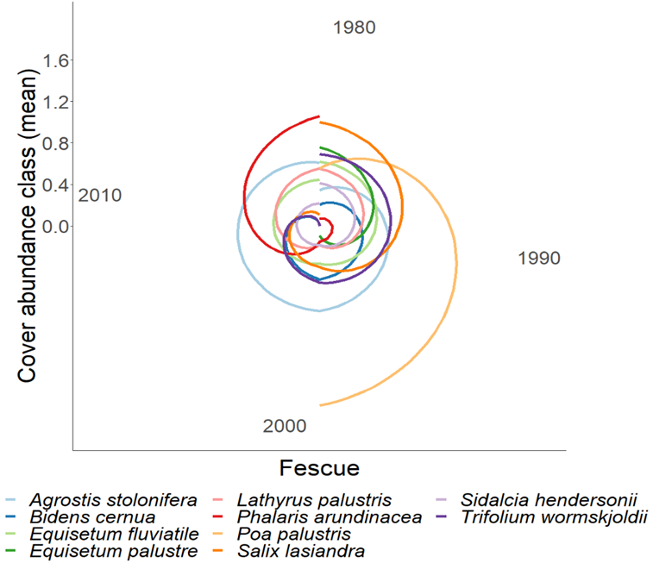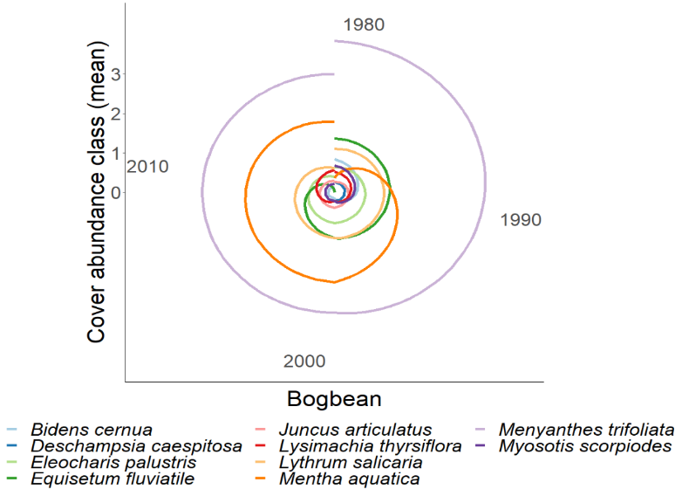

# Discussion

1. Answer the questions
   1. How has stability been affected?
2. What broader pattern of change has been observed, and what does this mean for reference conditions?
   1. Can this suggest species homogenization, especially wrt invasive species?
   2. Discuss key native species lost, with particular attention to blue-listed species such as Henderson’s checkermallow (*Sidalcea hendersonii*, globally nearly exclusive to the lower Fraser River Estuary), and pointed rush (*Juncus oxymeris*, locally abundant but limited range within Fraser River Estuary) (Lomer, 2021).
3. Edaphic factors may be driving species selection by adaptation to saturation or drainage between assemblage patches, more strictly partitioning the diversity of species that can occupy an assemblage. Additionally, recruitment of new diverse individuals into the assemblage may be limited.
   1. Land use conversion due to anthropogenic value led to agricultural, municipal, and industrial/commercial development, which has led to altered abiotic processes: decreased sedimentation rates due to increased impervious cover, or removal of sediment from the system by channel dredging. These actions reduce available sediments which estuaries depend upon to continually build up marsh vegetation platforms.
      1. May suggest future studies measure dendritic channel edge gains/losses through erosion and sedimentation rates may provide mechanistic insight to drivers of microsite edaphic conditions.
4. Discussion of inference limitations, and strengths of comparisons.
   1. Acknowledge transect relocation and sampling method likely alters results, however still provides a ‘snapshot’ of marsh-wide conditions along a major tidal channel.
5. Conservation and restoration of TFMs is a management priority (e.g., Canada’s Sea Level Rise Adaptation programs & major funding given to BC SRIF/CRF for salmonid habitat).
   1. Major objectives of these programs focus on habitat creation, with success targeted on 50-100-year horizons.
   2. Sites with a longer conservation history, such as the South Arm Marshes WMA are often used as ‘reference’ conditions for evaluating restoration success.
   3. Therefore, it is important to understand what plant community stability looks like in TFMs, and whether remnant TFMs used as reference are persisting over these timescales.

# Literature Cited

Bai, Y., Han, X., Wu, J., Chen, Z., & Li, L. (2004). Ecosystem stability and compensatory effects in the Inner Mongolia grassland. *Nature*, *431*, 181–184.

Bradfield, G. E., & Porter, G. L. (1982). Vegetation structure and diversity components of a Fraser estuary tidal marsh. *Canadian Journal of Botany*, *60*, 440–451.

Denoth, M., & Myers, J. H. (2007). Competition between Lythrum salicaria and a rare species: Combining evidence from experiments and long-term monitoring. *Plant Ecology*, *191*, 153–161.

Lomer, F. (2021). Rare Plants of the Fraser Valley. In B. Klinkenberg (Ed.), *E-Flora BC: Electronic Atlas of the Flora of British Columbia [eflora.bc.ca]*. Vancouver, Canada: Lab for Advanced Spatial Analysis, Department of Geography, University of British Columbia. [Accessed January 16, 2022]

Tilman, D., Reich, P. B., & Knops, J. M. H. (2006). Biodiversity and ecosystem stability in a decade-long grassland experiment. *Nature*, *441*, 629–632.