# Introduction

* The global importance of climate change impacts drives a need to understand patterns of plant community compositional change, as it pertains to understanding ecologically appropriate reference states.
  + Descriptive studies of decadal changes in patch-scale plant community compositional stability are useful to indicate persistence of reference-quality habitat.
* Community stability can be characterized by low variability in species or functional diversity over time.
  + Changes in community-dominant species, native plant species diversity, and species turnover are important because conservation of native species drives redundancy, and creates functional stability in plant communities.
  + Shifts in community-dominant species, loss of native species diversity, and species turnover (such as greater abundance of invasive species) may indicate loss of functional redundancy. In turn, this may indicate reduced resistance to change or resilient capacity to recover from disturbance (Bai, Han, Wu, Chen, & Li, 2004; Tilman, Reich, & Knops, 2006).
    - Thus use of a site which has undergone these changes as an historical reference would be flawed.
    - Furthermore: loss of native species is especially important when the regional pool of potential species is reduced or environmentally constrained (*need references).
* Estuaries are at the terrestrial-marine interface where cumulative environmental and anthropogenic stressors have shifted due to landscape-scale changes, and ecosystems will experience accelerated change under sea level rise. These habitats are of increasing concern for ecosystem service value, and understanding how to maintain or facilitate creation of estuarine habitat is a major objective of climate change resilience strategies.
  + In North America, estuaries are of greater conservation importance in the PNW (limited space due to fjord geography, contrast to expansive alluvial plains of eastern North America).
  + Tidal freshwater marshes (TFMs) are the upper reaches of estuaries where freshwater dominates, but they are particularly important as early transitional habitat along salinity gradient for salmonids).
  + These reaches are of high conservation and restoration interest, therefore understanding changes in species composition over time is useful to conservation objectives in anticipation of sea level rise.
  + Define biodiverse but restricted habitat types within TFM with respect to general herbaceous structure, dominated by Sedges/rushes with some salinity tolerance, but with greater forb diversity unique to TFMs that don’t occur in higher salinity or non-tidal wetlands;
    - Emphasize biodiversity and habitat value, and concern for species gained/lost.
* A major challenge of understanding community stability is the lack of long-term monitoring. In absence of long-term monitoring, using historical datasets can provide a ‘snapshot’ of changes across time.
  + One such opportunity exists in Ladner Marsh, which escaped development through designation as protected habitat (Figure 1).
    - Portions of the South Arm Marshes WMA complex are used as reference sites for ongoing restoration projects in the Fraser River Estuary.
    - Understanding how community composition has changed prior to and since the 1991 establishment of the WMA is important for regional land managers in evaluating benchmarks for conservation/restoration targets.
  + Two historical studies conducted in Ladner Marsh (Bradfield & Porter, 1982; Denoth & Myers, 2007) used similar methods to document floristic diversity.
    - Bradfield & Porter identified distinct community sub-types (hereafter, “assemblages”), with niche occupancy driven by edaphic factors such as drainage. Denoth & Myers repeated the sampling to determine whether a non-native species (purple loosestrife) was displacing a species of concern (Henderson’s checkermallow).
    - While these studies independently characterize different community metrics, these datasets provide the opportunity to repeat observations and characterize long-term plant community changes and stability of ‘reference quality’ habitat.
* The main objective of this work is to infer stability of plant community compositional structure in the absence of large-scale or direct disturbance in a tidal freshwater marsh. I used three observational datasets spanning four decades to answer the following questions:

1. Are assemblages are still characterized by the same dominant species?
   1. In the absence of significant environmental disturbance, I expect the same species to dominate each assemblage as identified by Bradfield & Porter (1982).
2. Is diversity stable within and between assemblage types over time?
   1. I expect community-wide diversity to be more stable than diversity within each assemblage type.
3. What is the total turnover within each assemblage, and which species gained or lost are driving changes within each assemblage’s diversity?
   1. I expect greater invasive species abundance (or greater number of species lost) in assemblages that experience greater turnover.

# Methods

* Site context & plot selection composite figure; show overlay of 2019 transects on line drawing site figure from Bradfield & Porter (1982) (Figure 1).
  + Add supplement: number of plots, transect truncating method, and indicate how/why patches were *excluded*.
* Field methods
  + Data collection & site relocation with statements of uncertainty for 1999 and 2019
    - Field identification in 2019 follows (Hitchcock & Cronquist, 1973), and species nomenclature across all years were standardized to most recently accepted binomal name according to the United States Department of Agriculture PLANTS Database (“USDA Plants Database”).
* Analyses:
  + All statistical analyses were performed in R v.4.0.2.
  + To determine dominant community types, cluster analysis was performed for each observation year using Euclidean distance as the measure of plot dissimilarity (“stats,” R Core Team).
    - Clusters were cut into three main groups, and plots contained within the groups were used subjected to species indicator analysis to determine the dominant species driving clusters (“indicspecies,”De Cáceres & Jansen, 2016).
  + Community stability, variance ratio, and turnover within each assemblage type was measured using the “codyn” package (Hallett et al., 2016).
    - Community stability and variance ratio was calculated for each assemblage individually, and across all assemblages.
      * Variance ratio ~1 indicates species vary independently. Values > 1 indicate positive covariance; values < 1 indicate negative covariance.
    - Total species turnover, appearances, and disappearances were calculated for each assemblage at each timepoint since 1979.
  + Species gained or lost were visualized using rank clock plots for each assemblage type.
    - Only species significantly driving assemblage clusters, as identified by species indicator analysis, were included in the rank clock plots.
      * All species cover abundance are summarized in Supplemental Table.

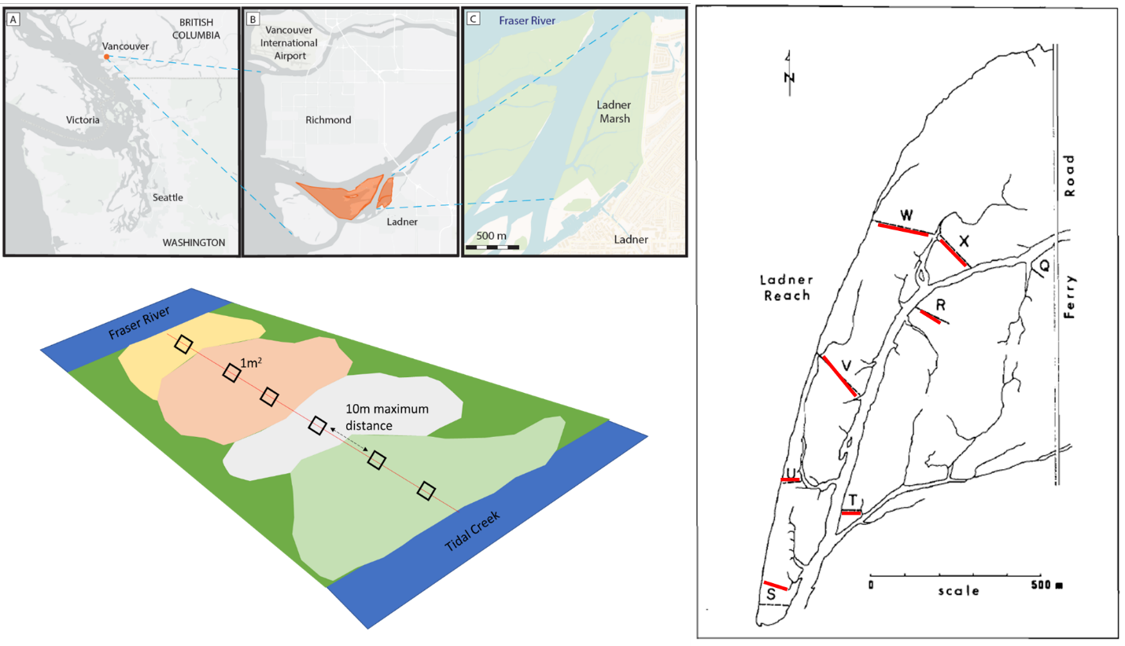

Figure 1. Clockwise from top left: Geographical site context, transect relocation method by overlaying 1982 publication figure onto Google Earth basemap, and field-testing accessibility, and plot sampling design.

# Results

* Three main assemblages within Ladner Marsh can be characterized by the same dominant species.
  + Cluster analysis shows greater dissimilarity between assemblage types over time. That is, plots are increasingly similar to each other within a given assemblage, but share fewer similarities between assemblages (Figure 2).
    - Ecological result: assemblages are becoming homogenized in terms of species similarity, with greater heterogeneity between assemblage types.
  + Indicator species analysis shows that the same species are driving cluster groups across all time points, and thus significantly characterizing each assemblage. However, other species that significantly drive indicators of assemblages change over time (Supplemental).
* Bogbean assemblage shows the greatest stability, while Fescue assemblage is the least stable. The community stability of the total community is less stable than two of its assemblages (Figure 3).
  + This instability is due to the effect of the Fescue assemblage on the overall average.
    - Study limitation: number of plots identified as ‘Fescue:’ 50% fewer plots clustered as Fescue in 2019 compared to 1979.
  + Greater variance ratio indicates lower stability (e.g., Fescue assemblage), and vice versa (e.g., Bogbean assemblage).
    - Ecological result: within a single community (Ladner Marsh), different assemblage types experience different degrees of stability.
* Total species turnover between 1979 and 2019 is ~50% in each assemblage (Table 1).
  + - All assemblage types had more species disappear in 2019 than in 1999.
    - Only the Sedge assemblage had a marked increase in species appearing (~8.5%) over 1999, while the Bogbean community had more species appearing in 1999.
    - Ecological result: greater rates of disappearance from the assemblages drive homogenization observed in cluster analysis.
  + Rank clock plots show changing dominance of select species over time (Figure 4).
    - Notably, Fescue assemblage shows ~50% decrease in cover of characteristic species *Festuca arundinaceae*, while cover of non-native *Phalaris arundinaceae* has more than doubled since 1999.
    - In the Sedge assemblage, cover abundance of *Agrostis stolonifera* appears to have decrease by almost half, however cover of assemblage-defining species *Carex lyngbyei* has decreased by about one-third.
    - Since 1979, native species cover (*Equisetum fluviatile, Eleocharis palustris*) in the Bogbean assemblage declines towards zero, as it is replaced in dominance by non-native species (*Mentha aquatica)*.

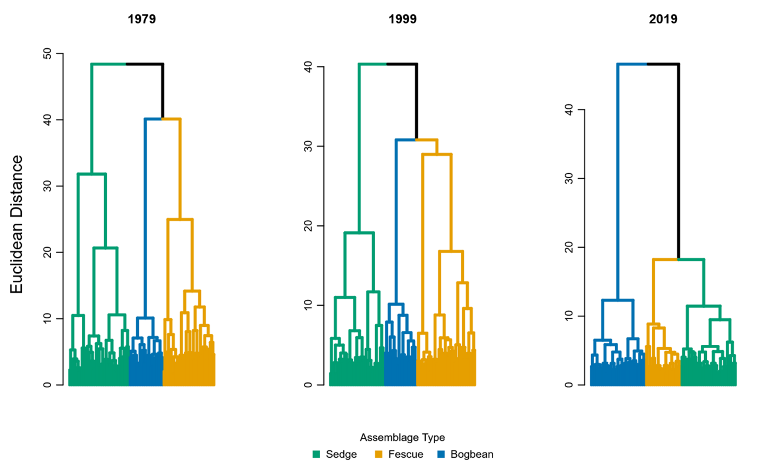

Figure 2. Assemblage diversity becomes more dissimilar over time, as shown by greater Euclidean distance between assemblage types.

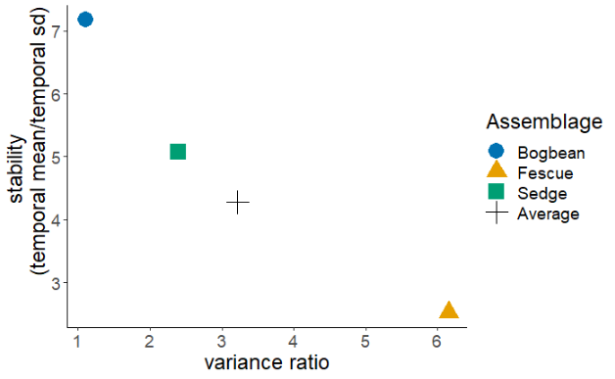

Figure 3. Bogbean assemblage has the greatest stability and lowest variance over time, while Fescue assemblage shows an inverse trend.

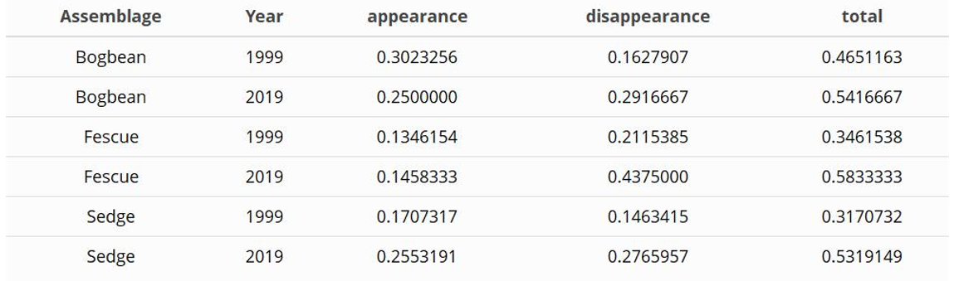Table 1. Greater proportions of species were lost from all three assemblages in 2019, however more species were gained in 2019 than in 1999 in the Sedge assemblage.

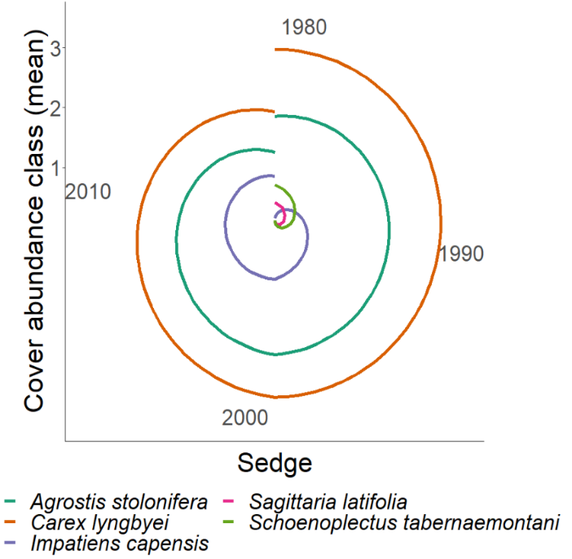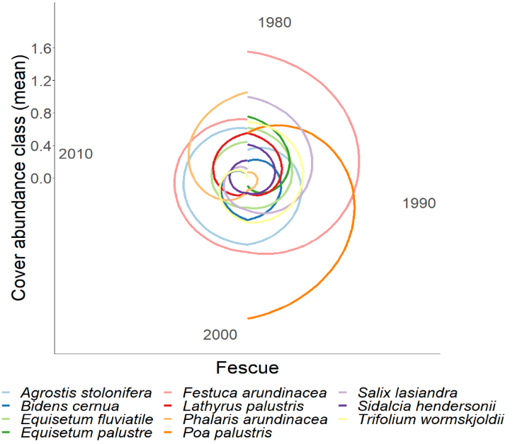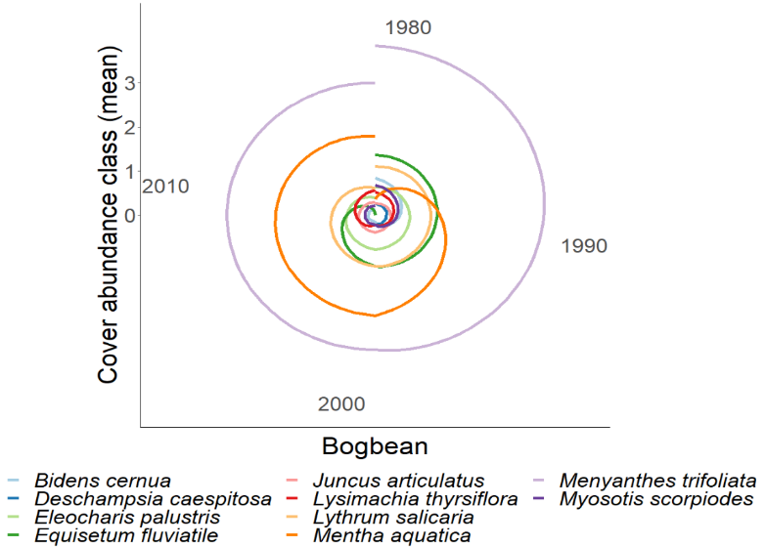

Figure 4. Rank abundance clocks for each assemblage type show shift in dominant species over time. Clockwise from lower left:

Bogbean assemblage is consistently dominated by Menyanthes trifoliata, however non-native Mentha aquatica becomes increasingly dominant while dominance of Equisetum fluviatile decreases.

In the Sedge assemblage, Carex lyngbyei becomes less dominant over time, while dominance of non-native species Agrostis stolonifera remains nearly constant.

Fescue assemblage is consistently occupied by Agrostis stolonifera, while Festuca arundinaceae is gradually replaced by Phalaris arundinaceae in overall dominance; apparent loss of Poa palustris may be due to misattribution of the species to Agrostis stolonifera. Phalaris arundinaceae dominates Fescue assemblage after 1999.

# Discussion

1. Answer the questions

* The three main assemblages have consistently been defined by the same species over the past 40 years, supporting my expectation that assemblage-defining species should not change in the absence of significant environmental disturbance.
* Diversity was stable in the Bogbean and Sedge assemblages, but not in the Fescue assemblage. Contrary to my expectation, the average community-wide stability was not greater than each assemblage individually.
  + Instability of Fescue assemblage points to potential loss of resilience, and ‘weak point’ in overall community resistance to change. Least stable communities may be most prone to invasion
    - Clarify: although Bogbean assemblage has a high abundance of non-native *Mentha aquatica* cover, this may not indicate the potential for new invasive species to become established.
* Total turnover was higher in 2019 than 1999, and only the Sedge assemblage gained more species in 2019 than in 1999.
  + However, greater rates of species lost are concerning for total biodiversity of the habitat.
* Encroachment of invasive species dominance is most evident in the Fescue and Bogbean assemblages.
  + The Fescue assemblage has historically been defined by a non-native species, however abundance of *Festuca arundinaceae* is being overtaken by *Phalaris arundinaceae*, or reed canary grass (RCG).
    - Management concerns for RCG, as this can be a monoculture-forming species, further reducing species diversity within the community.
  + Similarly, the Bogbean assemblage is increasingly dominated by non-native *Mentha aquatica*. While this may have some pollinator value, its vigorous rhizomatous spreading habit and dense canopy may be driving the decline of other native species.
    - Despite this, stability of Bogbean assemblage was the greatest, with
  + Increasing abundance of non-native species, paired with cluster analysis showing greater similarity within plots of each assemblage, supports my expectation that homogenization of species composition is being driven by proliferation of non-native species.

1. What does this mean?

* What broader pattern of change has been observed
  + Turnover, especially greater rates of species disappearance since 1999, indicates loss of biodiversity, which may indicate loss of functional traits. See Tilman, 1999: “Composition is important because this drives differences in plant traits, which affect community traits like stability and invasibility.”
* What does this mean for reference conditions?
  + Maintaining these transitional habitats in estuaries is important for salmon population stability. Therefore, importance of conservation and restoration projects will likely increase as sea levels rise. Understanding historical species composition and assemblage heterogeneity is critical for defining measures of success in restoration projects, and for conserving ecological processes that have yet to be identified.
    - Use of historical datasets to define target conditions may be appropriate over current-day assessments of community composition at ‘reference’ sites.
      * Consideration must be given to species diversity with respect to functional redundancy, as these community attributes relate to resistance to disturbance and resilience.
    - May discuss key native species lost, with particular attention to blue-listed species such as Henderson’s checkermallow (*Sidalcea hendersonii*, globally nearly exclusive to the lower Fraser River Estuary), and pointed rush (*Juncus oxymeris*, locally abundant but limited range within Fraser River Estuary) (Lomer, 2021).

1. Discussion of inference limitations, and strengths of comparisons.
   * Acknowledge transect relocation and sampling method likely alters results, however still provides a ‘snapshot’ of marsh-wide conditions along a major tidal channel.
     1. Plots were subjectively placed based on perceived changes in species composition, or every 10 m when no change was discernable. This means that assemblages characterized by key species, such as the Fescue group, should be proportionately represented in the data. If plots were laid strictly at the same distance along the tape (as was done in 1999), proportional representation of assemblages may be skewed depending on spatial shifts.
   * Cannot over-interpret turnover.
     1. Three timepoints does not show variation in population dynamics over time, thus inferences of species dominance or trends in species gained/lost cannot be explicitly made. However, this snapshot is useful for observing coarse patterns of species shifts, and can be used to refine future questions such as identifying which assemblages may have greater turnover variability.

* Mechanistic processes to explain changes in species composition or site factors were not tested. However, likely driving factors can be inferred to generate new tests of mechanistic changes in in community stability. Specifically: edaphic factors may be driving species selection by adaptation to saturation or drainage between assemblage patches, more strictly partitioning the diversity of species that can occupy an assemblage. Additionally, recruitment of new diverse individuals into the assemblage may be limited due to dispersal or recruitment limitation.
  + Sediment starvation in the marsh may be contributing to landform subsidence and/or loss of sediment accretion. Loss of sediment within the Lower Fraser River reaches is driven by a combination of factors, such as increased impervious cover and channel dredging. Disentangling explicit causes for loss of sediment would be difficult, however long-term monitoring of sediment accretion and changes in elevation using a total GPS station would identify which process is occurring. Effects from either of these processes would lead to more saturated patches within the marsh, which would drive prevalence of Bogbean assemblage.
    - Bogbean was the only assemblage with greater number of plots identified by cluster analysis in 2019, suggesting that marsh-wide prevalence of this assemblage could be increasing.
    - These edaphic shifts may also be driving homogenization and disappearance of species across all assemblages, as fewer species are able to tolerate increasingly saturated conditions.
    - May also suggest importance of dendritic channels: stability of channels may provide mechanistic insight to drivers of microsite edaphic conditions and entry points of invasive species into the community.
  + Recruitment of new species is dependent on many factors. Regional pools of propagules (seeds, clonal fragments) are required to disperse into a site, and suitable conditions must exist to recruit the propagules into the population.
    - If remnant habitats such as Ladner Marsh are becoming more homogenous, species diversity is being lost from the dispersal network.
    - If edaphic processes are limiting the habitat heterogeneity and conditions sufficient for propagule grounding and recruitment into the community, then diverse species composition is not possible, even if propagules are present.

1. Broader impacts & recommendations.

* Conservation and restoration of TFMs is a management priority (e.g., Canada’s Sea Level Rise Adaptation programs & major funding given to BC SRIF/CRF for salmonid habitat).
  + Major objectives of these programs focus on habitat creation, with success targeted on 50-100-year horizons.
  + Sites with a longer conservation history, such as the South Arm Marshes WMA are often used as ‘reference’ conditions for evaluating restoration success.
  + Therefore, it is important to understand what plant community stability looks like in TFMs, and whether remnant TFMs used as reference are persisting over these timescales.

# Literature Cited

Bai, Y., Han, X., Wu, J., Chen, Z., & Li, L. (2004). Ecosystem stability and compensatory effects in the Inner Mongolia grassland. *Nature*, *431*, 181–184.

Bradfield, G. E., & Porter, G. L. (1982). Vegetation structure and diversity components of a Fraser estuary tidal marsh. *Canadian Journal of Botany*, *60*, 440–451.

Denoth, M., & Myers, J. H. (2007). Competition between Lythrum salicaria and a rare species: Combining evidence from experiments and long-term monitoring. *Plant Ecology*, *191*, 153–161.

Lomer, F. (2021). Rare Plants of the Fraser Valley. In B. Klinkenberg (Ed.), *E-Flora BC: Electronic Atlas of the Flora of British Columbia [eflora.bc.ca]*. Vancouver, Canada: Lab for Advanced Spatial Analysis, Department of Geography, University of British Columbia. [Accessed January 16, 2022]

Tilman, D., Reich, P. B., & Knops, J. M. H. (2006). Biodiversity and ecosystem stability in a decade-long grassland experiment. *Nature*, *441*, 629–632.

# Supplemental

Table 2. Species indicator analysis identifies the same dominant species in each assemblage type (Sedge, Fescue, Bogbean) as significantly driving clustering of assemblages over time.

