# Introduction

The importance of climate change effects on ecosystems drives a need to understand patterns of plant community compositional change. Characterization of plant community changes on decadal timescales contributes to observation of meaningful long-term patterns of compositional stability, and is instructive to form inferences about drivers of community stability or change over time. Community stability can be characterized by low variability in species or functional diversity over time. Shifts in community-dominant species, loss of native species diversity, and species turnover (such as greater abundance of invasive species) may indicate loss of functional redundancy. In turn, this may indicate reduced resistance to change or resilient capacity to recover from disturbance (Bai, Han, Wu, Chen, & Li, 2004; Tilman, Reich, & Knops, 2006). Furthermore, the loss of native species may have stronger negative impacts on biodiversity when the regional pool of potential species is reduced or environmentally constrained. Together, these inferences may be of particular importance to sites that are used as ecological benchmarks for restoration targets.

Estuaries are at the terrestrial-marine interface where hydrogeomorphic and plant community changes occur on annual, decadal, and millennial timescales (Pasternack, 2009). Because these ecosystems will experience accelerated change under sea level rise, these habitats are of increasing conservation concern (Brophy et al., 2019); understanding estuarine habitat stability can inform climate change resilience strategies. In North America, estuaries are of particular conservation importance in the Pacific Northwest (PNW) because their pathways of retreat or expansion are spatially restricted by fjord geography (Emmett et al., 2000), whereas estuaries along the Atlantic coast may spread along expansive coastal plains. Tidal freshwater marshes (TFMs) are the upper reaches of estuaries dominated by riverine freshwater, and in the PNW they are particularly important as early transitional habitat along salinity gradient for salmonids (Chalifour et al., 2019; Davis et al., 2021). Estuary conservation efforts are intended to protect coastal municipalities and provide sufficient habitat; stability of plant communities within tidal marshes may contribute to the ability of these habitats to resist change or recover from disturbance (Holling, 1973). Loss of species diversity within these habitats reduces the available biodiversity in the regional species pool, as well as potentially reducing functional habitat value.

A challenge of understanding community stability, including within estuaries, is the lack of long-term data. In absence of long-term monitoring, historical datasets can provide a ‘snapshot’ of changes across time. One such opportunity exists in Ladner Marsh, which is part of the South Arm Marshes (SAM) Wildlife Management Area (WMA) near Delta, BC, Canada (Figure 1). Despite industrialization and municipal expansion within the region, this habitat has escaped development, and to the best of the author’s knowledge has not experienced major natural disturbance in the past 50 years. Understanding how community composition has changed prior to and since the 1991 establishment of the WMA is important for regional land managers in evaluating benchmarks for conservation and restoration targets. Two historical studies conducted in Ladner Marsh (Bradfield & Porter, 1982; Denoth & Myers, 2007) used similar methods to document floristic diversity. Bradfield & Porter (1982) identified distinct community sub-types (hereafter, “assemblages”), likely driven by edaphic factors such as drainage. Denoth & Myers repeated the sampling to determine whether a non-native species (purple loosestrife) was displacing a species of concern, Henderson’s checkermallow. Henderson’s checkermallow (*Sidalcea hendersonii* S. Watson) is locally abundant in this marsh, and thus stability of habitat conditions is vital for species conservation. While these studies independently characterize different community metrics, these datasets provide the opportunity to repeat observations and characterize long-term plant community changes and habitat stability .

The main objective of this work is to infer stability of plant community compositional structure in the absence of large-scale or direct disturbance in a tidal freshwater marsh. I used three observational datasets spanning four decades to answer the following questions:

(1) Are TFM assemblages continuously characterized by the same dominant species? In the absence of significant environmental disturbance, I expect the same species to dominate each assemblage as identified by Bradfield & Porter (1982).

(2) Is species abundance stable within and between assemblage types over time? I expect community-wide diversity to be more stable than diversity within each assemblage type.

(3) What is the total turnover within each assemblage, and which species gained or lost are driving changes within each assemblage? I expect greater invasive species abundance (or greater number of species lost) will be evident in assemblages that experience greater total turnover.

# Methods

## Physical & ecological context

The Fraser River drains the largest catchment in British Columbia, and its estuary currently spans 2814 ha, one-third of which lies within the South Arm Marshes Wildlife Management Area (Schaefer, 2004) (Figure 1). Ladner Marsh occupies approximately 100 ha within the South Arm Marshes, bounded to the east by municipal development and by the Fraser River along its western edge (Figure 1).

Species common to these habitats are generally herbaceous, and the community is largely dominated by sedges and rushes with some salinity tolerance, but a greater diversity of broadleaf flowering species (“forbs”). Forb species such as bogbean (*Menyanthes trifoliata* L.) are tolerant of continuously waterlogged conditions, whereas sedges (*Carex lyngbyei* Hornem.) are better adapted to microsites that are regularly inundated and drained. Grass species such as non-native tall fescue (*Festuca arundinaceae* Schreb.) may prefer the most well-drained sites, although some non-native species such as reed canary grass (*Phalaris arundinaceae* L.) tolerate more saturated soils, and present an invasion threat in tidal wetlands (Sinks, Borde, Diefenderfer, & Karnezis, 2021).

## Vegetation surveys

### 1979-1999

Data were originally collected in 1979 as part of an observational study to characterize dominant assemblage types (Bradfield & Porter, 1982). Eight transects were positioned along a north-to-south gradient, and 1 m2 quadrats (plots) were placed in the center of vegetation patches where species composition noticeably changed, or every 10 m along the transect, whichever distance was shorter (Bradfield, 2019 personal comm.). Cluster analysis and principal components analysis (PCA) distinguished three community associations, each dominated by a distinct species: Lyngbye’s sedge (*Carex lyngbyei* Hornem.), fescue (*Festuca arundinaceae* Schreb.), and bogbean (*Menyanthes trifoliata* L.). Bradfield & Porter (1982) hypothesized that edaphic factors drove assemblages, such as waterlogged soils in the bogbean assemblage, or drainage along channel edges in the fescue assemblage.

A subsequent survey conducted in 1999 recreated the transects and sought to place sampling plots at exact positions sampled in 1979 to test relationships between invasive purple loosestrife (*Lythrum salicaria*, L.) and Henderson’s checkermallow (*Sidalcea hendersonii* S. Watson), which is a Blue Listed species of special concern in British Columbia (Denoth & Myers, 2007). While Denoth & Myers did not seek to test changes in community composition, data were collected according to the same protocols as in 1979, and the data has generously been made available for comparison. This publication will reference dates the data were collected, rather than publication dates of the preceding studies.

### 2019

No permanent markers were left in Ladner Marsh, so precise transects assessed by Bradfield & Porter (1982) or Denoth & Myers (2007) were not identifiable in 2019. Transect locations were approximated using spatial imagery cross-referenced with landscape features evident in Figure 1 in Bradfield & Porter’s 1982 publication (Figure 1). Transect “Q” (n = 7 plots) was omitted in 1999 and 2019 due to conversion to thick riparian forest with an understory of Himalayan blackberry (*Rubus armeniacus*) since 1979; these plots from 1979 are not included in the present analyses. An additional 18 plots were omitted in 2019 due to physical inaccessibility, either due to overgrowth of riparian fringe, widening of tidal channels, or variation in transect placement. Despite these decisions to exclude plots, Kopecký & Macek (2015) have demonstrated that uncertainty of plot location does not produce unreliable evidence of plant community changes on decadal timescales.

Vegetation were sampled in the same manner as the 1979 survey by semi-systematically placing 1 m2 quadrats (plots) in the center of patches where species composition changed, or every 10 m of transect length, whichever distance was shorter (Figure 1). Assemblage types were considered if their boundary intersected the transect tape; assemblages tangential to the survey transect (but not intersecting it) were ignored. Assemblages were defined as being dominated >50% by one or two species. If no species was clearly dominant, the area was characterized as “undefined.” No areas of assemblage types were so small that the 1 m2 quadrat was less than 1 m from the boundary of the next assemblage. Along transects where the same assemblage reached > 20 m, quadrats were sampled every 10 m to reproduce a modal distance of 10 m (Bradfield & Porter, 1982).

Individuals were defined as “in the plot” if >50% of their most basal stem originated within the plot boundary; overhanging stems were not considered. Aerial coverage was considered as percent of the quadrat occluded by foliage; rambling lianas (*Lathyrus palustris* L.) were visually estimated as groundcover (even if climbing vertically). Percent cover of the quadrat was estimated to the nearest 1/64th m2, and later binned into quartile categories (0%, < 25%, 25-50%, 50-75%, and > 75%).

### Taxonomy

Observation of vascular plant species was conducted in all sampling years during early summer (approx. June-July). In all datasets, most plants were identified to species according to Hitchcock & Cronquist (1973), although a few were identified at higher taxonomic levels due to insufficient identifying characteristics (n = 6 to genus, n = 2 to Family; see Supplemental). To account for changes in nomenclature revision over time, all datasets were harmonized to use the most recently accepted species name as reported in the PLANTS Database of the United States Department of Agriculture, Natural Resources Conservation Science [USDA NRCS (Supplemental)]. In the instance of *Agrostis* species, the judgement to assume *Agrostis alba* identified in 1979 and 1999 is the same as *Agrostis stolonifera* in 2019 was made based on the likelihood that the presence of a species would not be replaced by another with similar abundance.

## Analyses

All statistical analyses were performed in R v.4.0.2.

To determine dominant community types, cluster analysis was performed for each observation year using Euclidean distance as the measure of plot dissimilarity (“stats,” R Core Team). Bray-Curtis distance may be preferred to account for species identity and to be less sensitive to species absence (Legendre & Legendre, 2012), however Euclidean distance was chosen to make direct comparisons to results produced by Bradfield & Porter (1982). In initial analyses, both methods were used to confirm distance measure did not have a major effect on plot clustering; results are available in Supplemental.

Clusters were cut into three main groups, and plots contained within the groups were used subjected to species indicator analysis to determine the dominant species driving clusters (“indicspecies,”De Cáceres & Jansen, 2016). Species are randomized within the cluster, and those with the greatest statistical relationship between species occurrence with all plots are selected as indicators for the cluster.

Community stability and turnover within and between assemblage types were measured using the “codyn” package (Hallett et al., 2016). Community stability “aggregates species abundances within replicate and time period, and uses these values to calculate community stability as the temporal mean divided by the temporal standard deviation” (Tilman, 1999). Total species turnover, appearances, and disappearances were calculated for each assemblage between all timepoints since 1979, where total turnover is a ratio of the sum of species gained and lost to the total number of species observed in both timepoints.

Changes in abundance of species gained or lost were visualized using rank clock plots for each assemblage type (“codyn,” Hallett et al., 2016). Only species significantly driving assemblage clusters, as identified by species indicator analysis, were included in the rank clock plots. All species cover abundance are summarized in Supplemental.

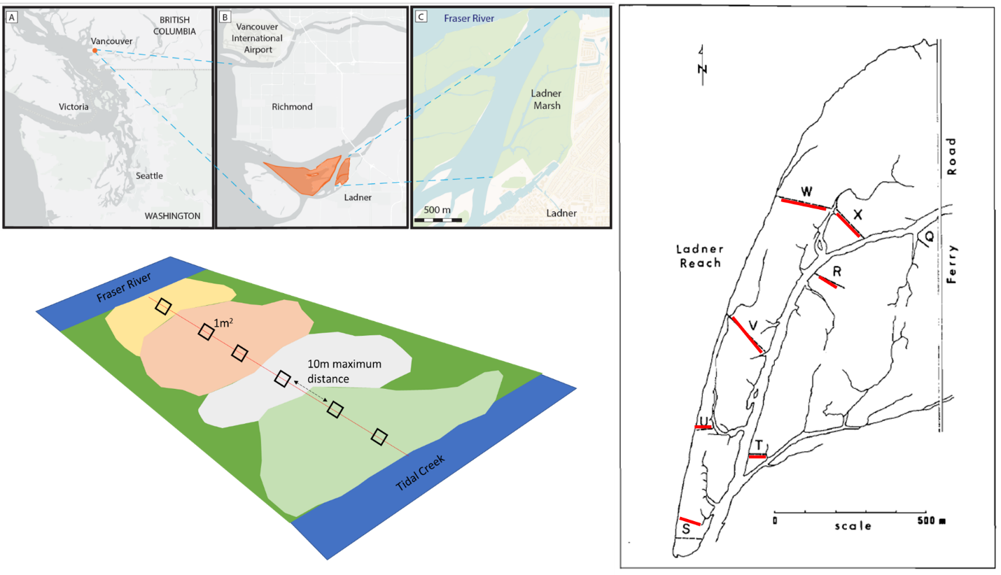

Figure 1. Clockwise from top left: Geographical site context, transect relocation method by overlaying 1982 publication figure onto Google Earth basemap, and plot sampling design.

# Results

Three main assemblages within Ladner Marsh can be characterized by the same dominant species across all sampling periods, however cluster analysis shows increasing dissimilarity between assemblage types over time. That is, plots are increasingly similar to each other within a given assemblage, but share fewer similarities between assemblages (Figure 2). This may indicate that assemblages are becoming homogenized in terms of species similarity, with greater species heterogeneity between assemblage types.

Indicator species analysis shows that the same species are driving cluster groups across all time points, and thus significantly characterizing each assemblage. However, the other species that significantly drive indicators of assemblages change over time (Supplemental).

Bogbean assemblage shows the greatest stability (7.17), while Fescue assemblage is the least stable (2.52). Stability of the sedge assemblage was intermediate (5.08), while the average community stability of all three assemblages was lower than the Bogbean and Fescue assemblages (4.28). This may be due to the effect of the Fescue assemblage on the overall average, despite the occurrence of 50% fewer plots clustered as Fescue in 2019 compared to 1979. It is important to recognize that within a single community (Ladner Marsh), different assemblage types experience different degrees of stability.

Total species turnover between 1979 and 2019 is ~50% in each assemblage (Table 1). Notably, all assemblage types had more species disappear in 2019 than in 1999. Only the Sedge assemblage had a marked increase in species appearance (~8.5%) over 1999, while the Bogbean community had more species appearance in 1999. The greater rates of disappearance from the assemblages drive homogenization observed in cluster analysis.

Rank clock plots show changing dominance of select species over time (Figure 3). Notably, Fescue assemblage shows ~50% decrease in cover of characteristic species *Festuca arundinaceae*, while cover of non-native *Phalaris arundinaceae* has more than doubled since 1999. In the Sedge assemblage, cover abundance of *Agrostis stolonifera* appears to have decrease by almost half, however cover of assemblage-defining species *Carex lyngbyei* has decreased by about one-third. Since 1979, native species cover (*Equisetum fluviatile, Eleocharis palustris*) in the Bogbean assemblage declines towards zero, as it is replaced in dominance by non-native species (*Mentha aquatica)*.

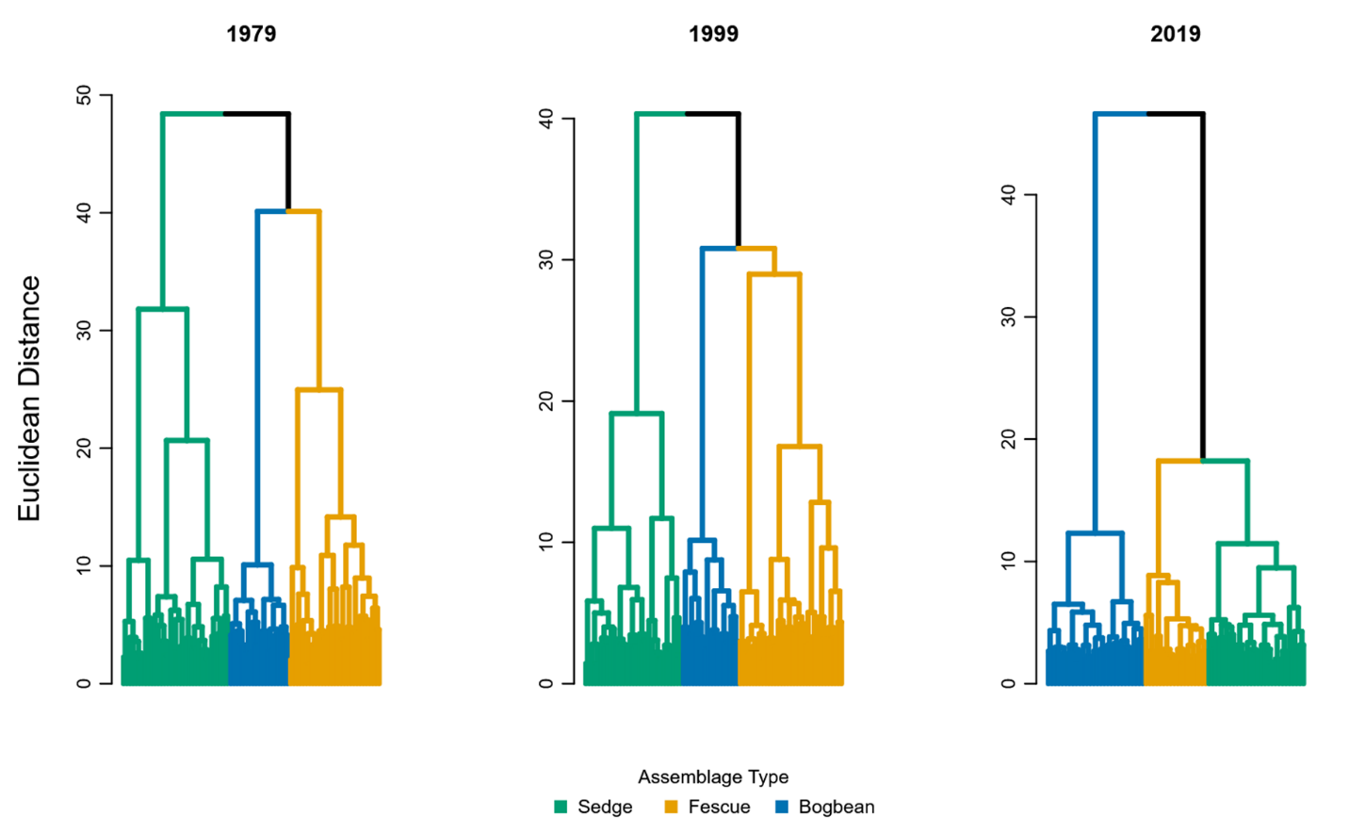

Figure 2. Assemblage diversity becomes more dissimilar over time, as shown by greater Euclidean distance between assemblage types.

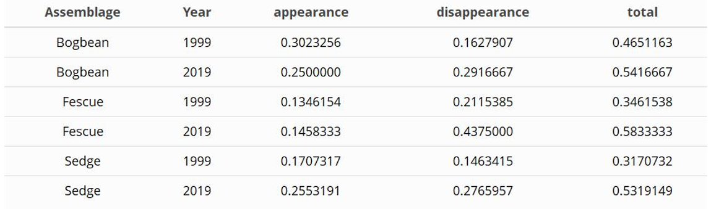Table 1. Greater proportions of species were lost from all three assemblages in 2019, however more species were gained in 2019 than in 1999 in the Sedge assemblage.

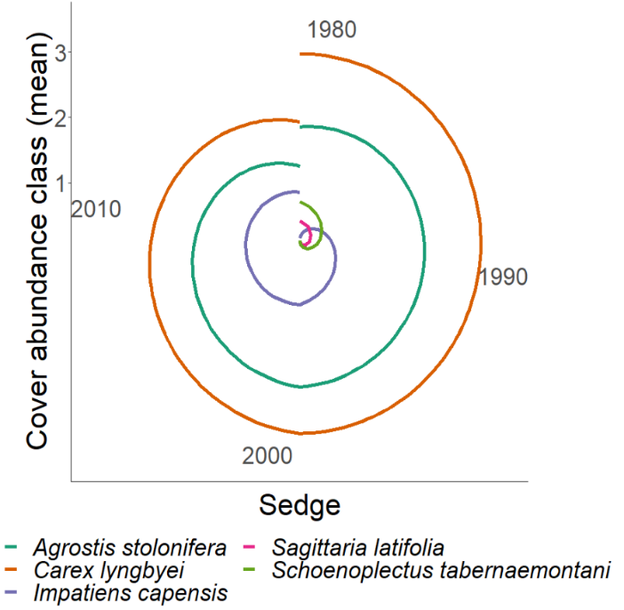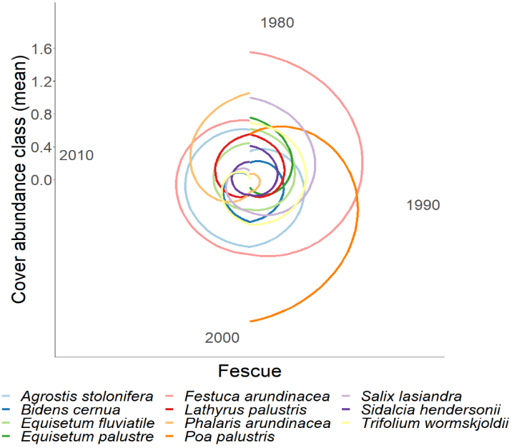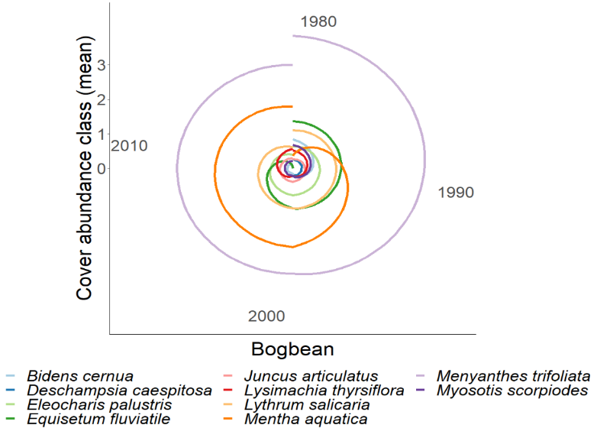

Figure 3. Rank abundance clocks visualize the changing abundance (y-axis values) of a given species from center of the plot (0) along a radius extending from the center. Oldest timepoints are in the 12 o’clock position, and observation timepoints proceed clockwise, ending at the 11:59 position. Clockwise from lower left:

Bogbean assemblage is consistently dominated by Menyanthes trifoliata, however non-native Mentha aquatica becomes increasingly dominant while dominance of Equisetum fluviatile decreases.

In the Sedge assemblage, Carex lyngbyei becomes less dominant over time, while dominance of non-native species Agrostis stolonifera remains nearly constant.

Fescue assemblage is consistently occupied by Agrostis stolonifera, while Festuca arundinaceae is gradually replaced by Phalaris arundinaceae in overall dominance; apparent loss of Poa palustris may be due to misattribution of the species to Agrostis stolonifera. Phalaris arundinaceae dominates Fescue assemblage after 1999.

# Discussion

In this study I wanted to identify whether assemblages may be characterized by the same dominant species over time, whether species abundance was stable within and between assemblage types, and whether turnover may be driven by increasing invasive species abundance. I found the three main assemblages have consistently been defined by the same species over the past 40 years, supporting my expectation that these characteristic species should not change in the absence of significant environmental disturbance.

Species abundance was most stable in the Bogbean and Sedge assemblages, but not in the Fescue assemblage. Contrary to my expectation, the average community-wide stability was not greater than each assemblage individually. Instability of Fescue assemblage points to potential loss of resilience, and may be most prone to invasion. However, increased abundance of non-native species does not indicate instability. Although the Bogbean assemblage has a high abundance of non-native *Mentha aquatica* cover, it also had the highest stability. This may indicate lower potential for new species to become established due to rhizomatous cover of dominant species *Menyanthes trifoliata* and *Mentha aquatica* precluding establishment of new species.

Total turnover was higher in 2019 than 1999, and only the Sedge assemblage gained more species in 2019 than in 1999. However, greater rates of species lost are concerning for total biodiversity of the habitat. This is especially evident by encroachment of invasive species in the Fescue and Bogbean assemblages. The Fescue assemblage has historically been defined by a non-native species, however abundance of *Festuca arundinaceae* is being overtaken by *Phalaris arundinaceae*, or reed canary grass (RCG). This presents a management concern for Ladner Marsh, as RCG can be a monoculture-forming species, further reducing species diversity within the community. Similarly, the Bogbean assemblage is increasingly dominated by non-native *Mentha aquatica*. While this may have some pollinator value, its vigorous rhizomatous spreading habit and dense canopy may be driving the decline of other native species. Higher turnover, especially greater rates of species disappearance since 1999, indicates loss of biodiversity, which may indicate loss of functional traits and greater susceptibility to invasive species (Tilman, 1999). Increasing abundance of non-native species, paired with cluster analysis showing greater similarity within plots of each assemblage, supports my expectation that homogenization of species composition is being driven by proliferation of non-native species.

Maintaining these transitional estuarine habitats is important for salmon population stability. Therefore, importance of conservation and restoration projects will likely increase as sea levels rise. Understanding historical trends in species composition and assemblage heterogeneity is critical for defining measures of success in restoration projects, and for conserving ecological processes that have yet to be identified. In the absence of ideal reference conditions, use of historical datasets to define target conditions may be used in place of or in addition to current-day assessments of community composition to determine ecologically meaningful benchmarks. Using historical conditions can provide greater understanding of species diversity with respect to functional redundancy, as these community attributes relate to resistance to disturbance and resilience.

## Study limitations

These data do interannual Additionally, because permanent transects were not used, transect relocation and sampling method likely alters results. Plots were subjectively placed based on perceived changes in species composition, or every 10 m when no change was discernable. This means that assemblages characterized by key species, such as the Fescue group, should be proportionately represented in the data. If plots were laid strictly at the same distance along the tape (as was done in 1999), proportional representation of assemblages may be skewed depending on spatial shifts.

Another limitation of this study is that mechanistic processes to explain changes in species composition or site factors were not tested. However, likely driving factors can be inferred to generate new tests of mechanistic changes in in community stability. Specifically: edaphic factors may be driving species selection by adaptation to saturation or drainage between assemblage patches, more strictly partitioning the diversity of species that can occupy an assemblage. Additionally, recruitment of new diverse individuals into the assemblage may be limited due to dispersal or recruitment limitation.

## Potential mechanisms

A key abiotic driver of tidal marsh development includes sediment deposition that allows plant communities to compensate for changing inundation rates due to sea level rise (Marijnissen, et al., 2020). Sediment delivered by river transport is trapped by vegetation, creating a feedback loop of rising tidal marsh platforms, increased vegetation growth, and increased sediment trapping capacity (Corenblit et al., 2015; Peteet et al., 2018). Sediment starvation in the marsh may be contributing to landform subsidence and/or loss of sediment accretion. Loss of sediment within the Lower Fraser River reaches is driven by a combination of factors, such as increased impervious cover and channel dredging. Disentangling explicit causes for loss of sediment would be difficult, however long-term monitoring of sediment accretion and changes in elevation using a total GPS station would identify which process is occurring. Effects from either of these processes would lead to more saturated patches within the marsh, which would drive prevalence of Bogbean assemblage. Because Bogbean was the only assemblage with greater number of plots identified by cluster analysis in 2019, this suggests that marsh-wide prevalence of this assemblage could be increasing. Edaphic shifts may also be driving homogenization and disappearance of species across all assemblages, as fewer species are able to tolerate increasingly saturated conditions.

Recruitment of new species is dependent on many factors. Regional pools of propagules (seeds, clonal fragments) are required to disperse into a site, and suitable conditions must exist to recruit the propagules into the population. If remnant habitats such as Ladner Marsh are becoming more homogenous, species diversity is being lost from the dispersal network. If edaphic processes are limiting the habitat heterogeneity and conditions sufficient for propagule grounding and recruitment into the community, then diverse species composition is not possible, even if propagules are present.

* + Broader impacts & recommendations

Management initiatives such as Canada’s Coastal Restoration Fund or British Columbia’s Salmon Restoration and Innovation Fund or Sea Level Rise Adaptation programs target successes on 50-100 year horizons. Understanding what community stability looks like within this timescale is useful to agency managers wanting to maintain or create shoreline communities for immediate habitat conservation or floodwater protection initiatives.

In the absence of ideal reference conditions, smay beBefore selecting sites to use as benchmarks, it is important to understand rates of change within the site, and sitesdecadal Relatively undisturbed sites may be the best extant examples of expected ecological conditions. Wherever these sites exist, land managers should prioritize monitoring to preserve reference to historical conditions, and establish mechanistic explanations for changes over time.

# Acknowledgements

The author would like to thank G. Bradfield, G. Porter, M. Denoth, and J. Myers for sharing existing datasets; Z. Davis for providing R programming advice; P. Roper for field assistance; B. Staines (Ladner Harbour Authority) for providing watercraft use. Support was provided by Natural Sciences and Engineering Research Council of Canada Discovery Grant RGPIN-2018-03838, and research access was granted by The Ministry of Forests, Lands, Natural Resource Operations and Rural Development.

# Literature Cited

Bradfield, G. E., & Porter, G. L. (1982). Vegetation structure and diversity components of a Fraser estuary tidal marsh. *Canadian Journal of Botany*, *60*, 440–451.

Brophy, L. S., Greene, C. M., Hare, V. C., Holycross, B., Lanier, A., Heady, W. N., … Dana, R. (2019). Insights into estuary habitat loss in the western United States using a new method for mapping maximum extent of tidal wetlands. *PLOS ONE*, *14*, e0218558.

Chalifour, L., Scott, D. C., MacDuffee, M., Iacarella, J. C., Martin, T. G., & Baum, J. K. (2019). Habitat use by juvenile salmon, other migratory fish, and resident fish species underscores the importance of estuarine habitat mosaics. *Marine Ecology Progress Series*, *625*, 145–162.

Corenblit, D., Baas, A., Balke, T., Bouma, T., Fromard, F., Garófano‐Gómez, V., … Walcker, R. (2015). Engineer pioneer plants respond to and affect geomorphic constraints similarly along water–terrestrial interfaces world-wide. *Global Ecology and Biogeography*, *24*, 1363–1376.

Davis, M. J., Woo, I., Ellings, C. S., Hodgson, S., Beauchamp, D. A., Nakai, G., & De La Cruz, S. E. W. (2021). A climate-mediated shift in the estuarine habitat mosaic limits prey availability and reduces nursery quality for juvenile salmon. *Estuaries and Coasts*. https://doi.org/10.1007/s12237-021-01003-3

De Cáceres, M., & Jansen, F. (2016). *Indicspecies*. Retrieved from http://r.meteo.uni.wroc.pl/web/packages/indicspecies/indicspecies.pdf

Denoth, M., & Myers, J. H. (2007). Competition between Lythrum salicaria and a rare species: Combining evidence from experiments and long-term monitoring. *Plant Ecology*, *191*, 153–161.

Emmett, R., Llansó, R., Newton, J., Thom, R., Hornberger, M., Morgan, C., … Fishman, P. (2000). Geographic signatures of North American West Coast estuaries. *Estuaries*, *23*, 765–792.

Hallett, L. M., Jones, S. K., MacDonald, A. A. M., Jones, M. B., Flynn, D. F. B., Ripplinger, J., … Collins, S. L. (2016). codyn: An r package of community dynamics metrics. *Methods in Ecology and Evolution*, *7*, 1146–1151.

Hitchcock, C. L., & Cronquist, A. (1973). *Flora of the Pacific Northwest, an illustrated manual*. Seattle and London: University of Washington Press.

Holling, C. S. (1973). Resilience and Stability of Ecological Systems. *Annual Review of Ecology and Systematics*, *4*, 1–23.

Kopecký, M., & Macek, M. (2015). Vegetation resurvey is robust to plot location uncertainty. *Diversity and Distributions*, *21*, 322–330.

Legendre, P., & Legendre, L. (2012). *Numerical Ecology* (3rd ed., Vol. 24). Elsevier.

Marijnissen, R., Kok, M., Kroeze, C., & van Loon-Steensma, J. (2020). The Sensitivity of a Dike-Marsh System to Sea-Level Rise—A Model-Based Exploration. *Journal of Marine Science and Engineering*, *8*, 42.

Pasternack, G. B. (2009). Chapter 3. Hydrogeomorphology and sedimentation in tidal freshwater wetlands. In A. Barendregt, D. F. Whigham, & A. H. Baldwin (Eds.), *Tidal Freshwater Wetlands* (pp. 31–40). Leiden, The Netherlands: Backhuys Publishers.

Peteet, D. M., Nichols, J., Kenna, T., Chang, C., Browne, J., Reza, M., … Stern-Protz, S. (2018). Sediment starvation destroys New York City marshes’ resistance to sea level rise. *Proceedings of the National Academy of Sciences*, *115*, 10281–10286.

Schaefer, V. (2004). Ecological setting of the Fraser River delta and its urban estuary. In B. J. Groulx, D. C. Mosher, J. L. Luternauer, & D. E. Bilderback (Eds.), *Fraser River Delta, British Columbia: Issues of an Urban Estuary* (pp. 147–172). Geological Survey of Canada, Bulletin 547.

Sinks, I. A., Borde, A. B., Diefenderfer, H. L., & Karnezis, J. P. (2021). Assessment of Methods to Control Invasive Reed Canarygrass (Phalaris arundinacea) in Tidal Freshwater Wetlands. *Natural Areas Journal*, *41*, 172–185.

Tilman, D. (1999). The ecological consequences of changes in biodiversity: A search for general principles. *Ecology*, *80*, 1455–1474.

# Supplemental

Table 2. Species indicator analysis identifies the same dominant species in each assemblage type (Sedge, Fescue, Bogbean) as significantly driving clustering of assemblages over time.

