**Plant community compositional persistence over 40 years in a Fraser River Estuary tidal freshwater marsh**

Stefanie L. Lane1, Nancy Shackelford2, Gary Bradfield3, Madlen Denoth3, 4, Tara G. Martin1

1Depertment of Forest and Conservation Science, University of British Columbia, Vancouver, BC, Canada; 2School of Environmental Studies, University of Victoria, Victoria, BC, Canada; 3Department of Botany, University of British Columbia, Vancouver, BC, Canada; 4Gymnasium Neufeld, Bern, Switzerland

Corresponding author: [stefanielane@utexas.edu](mailto:stefanielane@utexas.edu)

# Abstract

TBD per journal (see last heading) – frame premise with respect to issue of global species loss, exemplified here in a protected area subject to indirect disturbances. Value of study is to observe changes in species composition to inform concepts of habitat stability in the absence of direct (pulse) disturbance pressures.

# Introduction

In a time of rapid global change, understanding patterns of ecosystem response over time, through plant community compositional changes can help inform conservation management interventions. Community stability may be characterized as consistency in species or functional diversity through time and space (Donohue et al., 2016; Holling, 1973). Shifts in community-dominant species, loss of native species diversity, and species turnover (such as greater abundance of invasive species) may indicate loss of functional redundancy. In turn, this may indicate reduced resistance to change or resilient capacity to recover from disturbance (Bai, Han, Wu, Chen, & Li, 2004; Tilman, Reich, & Knops, 2006). Furthermore, the loss of native species may have stronger negative impacts on biodiversity persistence when the regional pool of potential species is reduced or environmentally constrained (Hanski, 1982; Lepš, 2004). Characterization of plant community changes on decadal timescales contributes to observation of meaningful long-term patterns of compositional stability, and is instructive for developing hypotheses to test drivers of disturbance, especially in dynamic landscapes heavily impacted by anthropogenic activities, such as estuaries (Ovaskainen, Rybicki, & Abrego, 2019; Underwood, Chapman, & Connell, 2000).

Estuaries are at the terrestrial-marine interface where hydrogeomorphic and ecological changes occur on annual, decadal, and millennial timescales (Pasternack, 2009). Estuarine habitats support high species richness, including species at risk (Kehoe et al 2020) and are important carbon reservoirs (Douglas, et al., 2022). Because these ecosystems will experience accelerated change under sea level rise, these habitats are of increasing conservation concern (Brophy et al., 2019); understanding estuarine habitat stability can inform climate change resilience strategies. In North America, estuaries are of particular conservation importance in the Pacific Northwest (PNW) because their pathways of retreat or expansion are spatially restricted by fjord geography (Emmett et al., 2000), whereas estuaries along the Atlantic coast may spread along expansive coastal plains. Tidal freshwater marshes (TFMs) are the upper reaches of estuaries dominated by riverine freshwater, and in the PNW they are particularly important as early transitional habitat along salinity gradient for salmonids (Chalifour et al., 2019; Davis et al., 2021). Estuary conservation efforts are intended to protect coastal municipalities and provide sufficient habitat; stability of plant communities within tidal marshes may contribute to the ability of these habitats to resist change or recover from disturbance (Holling, 1973). Loss of species diversity within these habitats reduces the available biodiversity in the regional species pool, as well as potentially reducing functional habitat value.

A challenge of understanding community stability, including within estuaries, is the lack of long-term data. In the absence of long-term monitoring, historical datasets can provide a ‘snapshot’ of species compositional variation over time. One such opportunity exists in the Fraser River estuary, British Columbia, Canada in an area called Ladner Marsh ( Figure 1). Despite large-scale industrialization and urbanization within the region, Ladner Marsh has escaped development, and to the best of our knowledge has not experienced major natural disturbance in the past 50 years. Two historical studies conducted in Ladner Marsh (Bradfield & Porter, 1982; Denoth & Myers, 2007) used similar methods to document floristic diversity. Bradfield & Porter (1982) identified distinct community sub-types (hereafter, “assemblages”), likely driven by edaphic factors such as drainage. Denoth & Myers (2007) repeated the sampling to determine whether a non-native species (purple loosestrife) was displacing a species of conservation concern, Henderson’s checkermallow. Henderson’s checkermallow (Sidalcea hendersonii S. Watson) is locally abundant in this marsh, and thus stability of habitat conditions is vital for species conservation. While these studies independently characterize different community metrics, these datasets provide the opportunity to repeat observations and characterize long-term plant community changes and habitat stability.

These two historical studies present a unique opportunity to repeat the sampling a third time and to infer stability of plant community compositional structure in the absence of large-scale or direct disturbance in a tidal freshwater marsh. We used three observational datasets spanning four decades to answer the following questions:

(1) Are tidal freshwater marsh assemblages characterized by the same dominant species over a 40 year period? In the absence of significant environmental disturbance, we expect the same species composition to dominate each assemblage as identified by Bradfield & Porter (1982).

(2) Is the mean species diversity (α-diversity) and variation (β-diversity) within and across assemblages constant between the three sampling periods (1979, 1999, 2019)? If the plant community is stable, we expect little change in α-diversity and β-diversity.

(3) What is the total turnover within each assemblage, and which species gained or lost are driving changes within each assemblage? We expect that increasing abundance of invasive species over time would result in greater number of species lost (and fewer species gained), and thus greater rates of turnover.

# Methods

## Physical & ecological context

The Fraser River drains the largest catchment in British Columbia, and its estuary currently spans 2,814 ha, one-third of which lies within the South Arm Marshes Wildlife Management Area (Schaefer, 2004) (Figure 1). Ladner Marsh occupies approximately 100 ha within the South Arm Marshes, bounded to the east by urban and industrial development and by the Fraser River along its western edge ( Figure 1).

Species common to these habitats are generally herbaceous, and the community is largely dominated by sedges and rushes with some salinity tolerance, but a greater diversity of broadleaf flowering species (“forbs”). Forb species such as bogbean (*Menyanthes trifoliata* L.) are tolerant of continuously waterlogged conditions, whereas sedges (*Carex lyngbyei* Hornem.) are better adapted to microsites that are regularly inundated and drained. Grass species such as non-native tall fescue (*Festuca arundinaceae* Schreb.) may prefer the most well-drained sites, although some non-native species such as reed canary grass (*Phalaris arundinaceae* L.) tolerate more saturated soils, and present an invasion threat in tidal wetlands (Sinks, Borde, Diefenderfer, & Karnezis, 2021).

## Vegetation surveys

### 1979-1999

Data were originally collected in 1979 as part of an observational study to characterize dominant assemblage types (Bradfield & Porter, 1982). Eight transects were positioned along a north-to-south gradient, and 1 m2 quadrats (plots) were placed in the center of vegetation patches where species composition noticeably changed, or every 10 m along the transect, whichever distance was shorter (Bradfield, 2019 personal comm.) (Figure 1D). Cluster analysis and principal components analysis (PCA) distinguished three community associations, each dominated by a distinct species: Lyngbye’s sedge (*Carex lyngbyei* Hornem.), fescue (*Festuca arundinaceae* Schreb.), and bogbean (*Menyanthes trifoliata* L.). Bradfield & Porter (1982) hypothesized that edaphic factors drove assemblages, such as waterlogged soils in the bogbean assemblage, or drainage along channel edges in the fescue assemblage.

A subsequent survey conducted in 1999 recreated the transects and sought to place sampling plots at the exact positions sampled in 1979 to test relationships between invasive purple loosestrife (*Lythrum salicaria*, L.) and Henderson’s checkermallow (*Sidalcea hendersonii* S. Watson), which is a Blue Listed species of special concern in British Columbia (Denoth & Myers, 2007). While Denoth & Myers did not seek to test changes in community composition, data were collected according to the same protocols as in 1979, and the data have been made available for comparison. This publication will reference dates the data were collected, rather than publication dates of the preceding studies.

### 2019

No permanent markers were left in Ladner Marsh, so precise transects assessed by Bradfield & Porter (1982) or Denoth & Myers (2007) were not identifiable in 2019. Transect endpoints were approximated within ~5 m by overlaying Figure 1 in Bradfield & Porter’s 1982 publication (Figure 1D) on a georeferenced basemap, aligning prominent landscape features, and marking GPS locations in Avenza Maps (Avenza Systems Inc., Ontario, Canada, v. 3.2). Transect “Q” (n = 7 plots) was omitted in 1999 and 2019 due to conversion to thick riparian forest with an understory of Himalayan blackberry (*Rubus armeniacus*) since 1979; these plots from 1979 are not included in the present analyses. An additional 18 plots surveyed in 1979 and 1999 were omitted in 2019 due to physical inaccessibility, either due to overgrowth of riparian fringe, widening of tidal channels, or variation in transect placement (Figure 1, Table 4). Despite these decisions to exclude plots, Kopecký & Macek (2015) have demonstrated that uncertainty of plot location does not produce unreliable evidence of plant community changes on decadal timescales.

Vegetation were sampled in the same manner as the 1979 survey by semi-systematically placing 1 m2 quadrats (plots) in the center of patches where species composition changed, or every 10 m of transect length, whichever distance was shorter (

Figure 1E). Assemblage types were considered if their boundary intersected the transect tape; assemblages tangential to the survey transect (but not intersecting it) were ignored. Assemblages were defined as being dominated >50% by one or two species. If no species was clearly dominant, the area was characterized as “undefined.” No areas of assemblage types were so small that the 1 m2 quadrat was less than 1 m from the boundary of the next assemblage. Along transects where the same assemblage extended beyond 20 m, quadrats were sampled every 10 m to reproduce a modal distance of 10 m (Bradfield & Porter, 1982).

Individuals were defined as “in the quadrat” if > 50% of their most basal stem originated within the quadrat boundary; overhanging stems were not considered. Aerial coverage was considered as percent of the quadrat occluded by foliage; rambling lianas (*Lathyrus palustris* L.) were visually estimated as groundcover (even if climbing vertically). Percent cover of the quadrat was estimated to the nearest 1/64th m2, and later binned into quartile categories (0%, < 25%, 25-50%, 50-75%, and > 75%).

### Taxonomy

Observation of vascular plant species was conducted in all sampling years during early summer (approx. June-July). In all datasets, most plants were identified to species according to Hitchcock & Cronquist (1973), although a few were identified at higher taxonomic levels due to insufficient identifying characteristics (n = 6 to genus, n = 2 to Family; see Table 7). To account for changes in nomenclature revision over time, all datasets were harmonized to use the most recently accepted species name as reported in the PLANTS Database of the United States Department of Agriculture, Natural Resources Conservation Science [USDA NRCS]. In the instance of *Agrostis* species, the judgement to assume *Agrostis alba* identified in 1979 and 1999 is the same as *Agrostis stolonifera* in 2019 was made based on the likelihood that the presence of a species would not be replaced by another of the same genus with similar abundance.

## Analyses

To determine dominant community types, cluster analysis was performed for each observation year using Euclidean distance as the measure of plot dissimilarity (“stats,” R Core Team). We also used Bray-Curtis distance which accounts for species identity and is less sensitive to species absence (Legendre & Legendre, 2012), however we present results of Euclidean distance to facilitate direct comparisons to results produced by Bradfield & Porter (1982). Clusters were cut into three groups, and plots contained within the groups were used subjected to species indicator analysis to determine the dominant species driving clusters (“indicspecies,”R package De Cáceres & Jansen, 2016). Indicator Value (IndVal) association indices between species and plots within each cluster were calculated using an abundance-based point biserial correlation coefficient (multipatt func = “r.g”), and significant associations were tested by permutational analysis (Dufrêne & Legendre, 1997).

Changes in mean cover abundance of species most significantly driving cluster groups were visualized as bar charts. Only the top three species most significantly driving assemblage clusters each year, as identified by species indicator analysis, were included for visual simplicity. All species cover abundance are summarized in Table 7 (Supplemental)

Community diversity calculations followed Whittaker (1975), with α-diversity calculated as the mean number of species per quadrat within an observation year and assemblage, and β-diversity calculated as the total number of species within the assemblage divided by α-diversity. These calculations were also performed on all data recorded for the observation year to generate a community-wide measure of diversity. To address inconsistent numbers of plots grouped into assemblages each year, diversity metrics were bootstrapped 10 times using the minimum number of plots observed in an assemblage each year (n = 18).

Community turnover for each assemblage was measured using the “codyn” R package (Hallett et al., 2016). Total species turnover (total magnitude of change), species gained (appearances), and species lost (disappearances) were calculated as a percent change for each assemblage between 1979-1999, and 1999-2019. Total turnover was calculated as a ratio of the absolute value of species gained and lost to the total number of species observed in both timepoints.

During initial analyses, both Euclidean and Bray-Curtis distances were used to confirm distance measure did not have a major effect on plot clustering and subsequent indicator species analysis; cluster analysis figures and indicator species table using Bray-Curtis distance are available in Table 5 and Figure 4. All analyses were performed in R v.4.0.2.

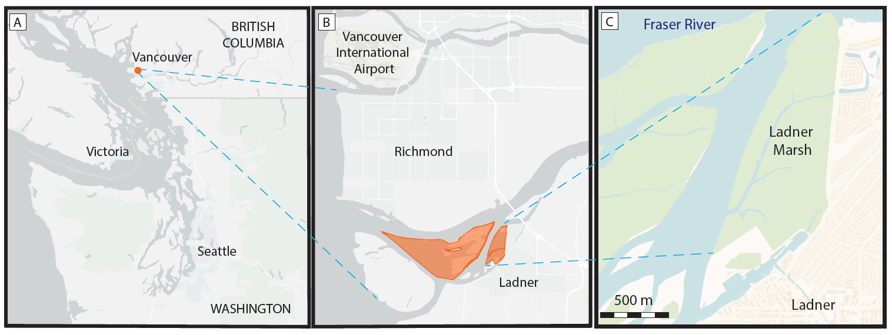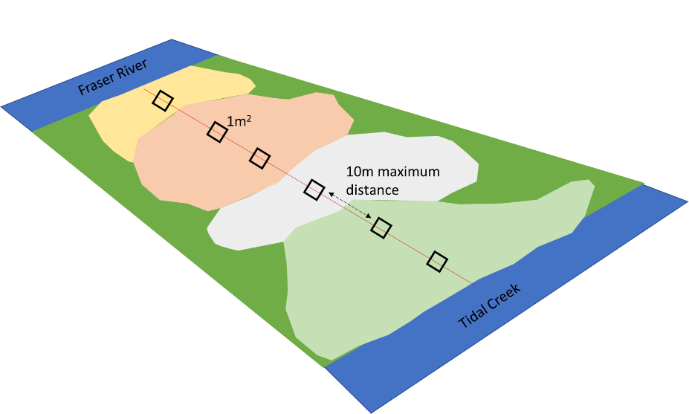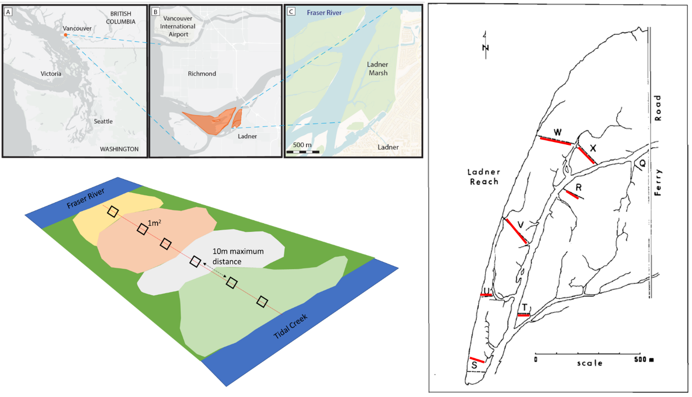

D

E

Figure 1. Location of the study site in Vancouver, British Columbia, Canada (A), approximately 20 km north of the South Arm Marshes Wildlife Management Area (highlighted in orange, B). Ladner Marsh abuts municipal development on the south bank of the Fraser River (C). Base maps (A, B) generated by iMap published by the B. C. Conservation Data Center (Victoria, BC, Canada, <https://maps.gov.bc.ca/ess/hm/imap4m/>) and (C) OpenStreetMap (OpenStreetMap contributors, 2015, <https://www.openstreetmap.org/>), transect locations illustrated in 1982 publication figure (line drawing), which was overlayed on Google Earth basemap to relocate transects in 2019 (red) (D), and semi-systematic plot placement within and between assemblages based on species dominance (E).

# Results

Three main assemblages within Ladner Marsh can be characterized by the same dominant species across all sampling periods, however cluster analysis shows increasing dissimilarity in species cover abundance between assemblage types over time. That is, species cover within plots are increasingly similar to each other within a given assemblage, but share fewer similarities between assemblages (Figure 2). Over time, it appears that species cover is becoming more heterogeneous within and between assemblages. While the indicator species with the highest significance across each assemblage remain constant over time (*i.e.*, *Carex lyngbyei* is consistently the highest indicator of the Sedge assemblage over time) and drive cluster groups, other species that significantly drive indicators of assemblages change over time (Table 1 and S5). For example, in 1979 the indicator species defining the Sedge assemblage cluster were *C. lyngbyei, S. latifolia,* and *S. tabernaemontani*, however in 1999 the same assemblage included indicator species *C. lyngbyei, A. stolonifera,* and *I. capensis*. Thus, although *C. lyngbyei* remained the common indicator species of the assemblage cluster group, the associated indicator species had changed. Additionally, fewer indicator species were found in the Sedge and Fescue assemblages in 2019 than in 1979. For example, the Sedge assemblage was characterized by three species (including *C. lyngbyei*) in 1979 and 1999, but only by *C. lyngbyei* in 2019. The Fescue group was characterized by seven species in 1979, four species in 1999, and three species in 2019. While *Festuca arundinaceae* remained a common indicator species within the assemblage, all other indicator species changed in each observation year.

Across the entire Ladner Marsh plant community, two to three species were lost each year following the 1979 survey (Table 2). Within every assemblage alpha-diversity (mean number of species per plot) decreased every observation year, while beta-diversity (variation in number of species between plots) increased each year for all assemblages (Table 2). For example, the sedge community suffered the least loss of species and alpha-diversity across sampling years, although beta-diversity increased as in other assemblages, indicating increasing variability in which species may be encountered within a given assemblage. The Fescue assemblage had the greatest loss of alpha-diversity (> 50%) between 1979 and 2019. Nearly 50% fewer plots clustered as Fescue in 2019 than in 1979, however bootstrapping 18 random plots from every sampling year showed the same trend, indicating that loss of species is not related to loss of plots (Table S6). The Bogbean assemblage had ~20% decrease in alpha-diversity since 1979 despite an increase of ~47% more plots by 2019. When subjected to bootstrapping of 18 plots per assemblage each year, the assemblage still lost ~10% alpha-diversity, although beta-diversity stayed approximately the same (Table S6). Therefore, despite gaining representation across the entire community, mean number of species in a given 1 m2 are declining.

Total magnitude of species turnover between 1999 and 2019 was ~50% in each assemblage (Table 3), largely driven by greater species disappearance (loss) between 1999 and 2019. For example, rate of species disappearance roughly doubled in each assemblage between 1979-1999 and 1999-2019. Rates of new species appearances in each assemblage were not as great. In fact, new species appearance 1999-2019 compared to 1979-1999 declined by 5% in the bogbean assemblage, increased by 2% in the Fescue assemblage, and increased by 9% in the sedge assemblage. Only the Sedge assemblage had a marked increase in species appearance (gain) from 1999-2019, while the Bogbean community had more species appearance from 1979-1999. While these ratios do not account for species disappearing and reappearing in the same assemblage between 1979 and 2019, the greater rates of disappearance from the assemblages are likely driving the overall loss of species in each sampling timepoint.

Cover abundance of species significantly driving assemblage associations show an overall trend of decreasing cover over time (Figure 3). Notably, Fescue assemblage shows ~50% decrease in cover of characteristic non-native species *Festuca arundinaceae* between 1979 and 2019, while cover of non-native *Phalaris arundinaceae* tripled since 1999. In the Sedge assemblage, cover abundance of *Agrostis stolonifera* appears to have decrease by almost half, however cover of assemblage-defining species *Carex lyngbyei* has decreased by about one-third. Bogbean assemblage maintains greatest coverage of its defining species (*Menyanthes trifoliata*), although cover abundance in 2019 was ~20% less than in 1979. Additionally, non-native *Mentha aquatica* accounts for ~50% of plot cover in the Bogbean assemblage by 2019. In summary, while the dominant species are maintained, their cover abundance within each assemblage is declining. Moreover, some invasive species have increased substantially in cover abundance in the Fescue and Bogbean assemblages since the original survey, indicating these assemblages are becoming increasingly occupied by non-native species.

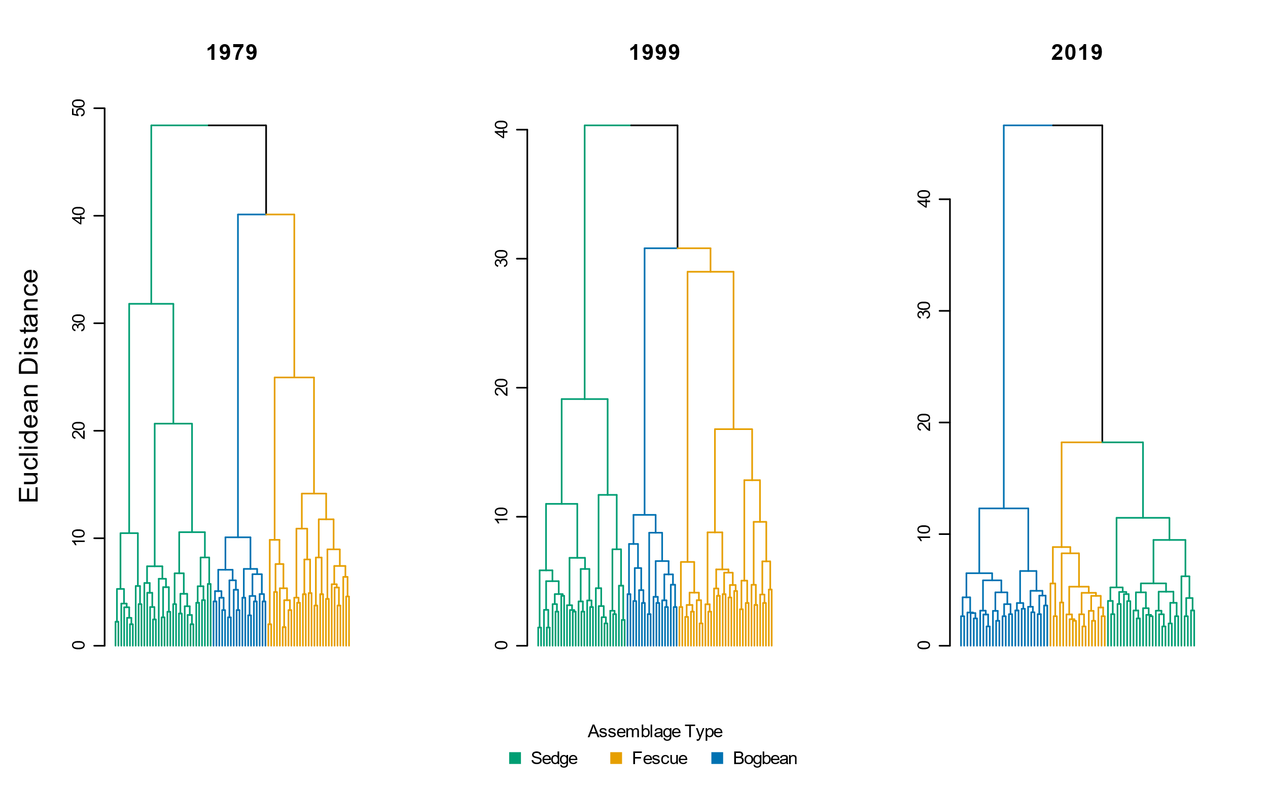

Figure 2. Species cover abundance becomes more dissimilar in each assemblage over time, as shown by greater Euclidean distance between assemblage types. Notably, species cover of the sedge and fescue groups become more similar in 2019.

Table 1. Species indicator analysis of cluster groups using Euclidean distance identifies the same dominant species in each assemblage type (Sedge, Fescue, Bogbean) as significantly driving clustering of assemblages over time. IndVal statistic reports association indices between species and plots within each cluster; p-values < 0.05 indicate the species is significantly defining the clustering association within each assemblage and observation year.

|  |  |  |  |  |  |  |  |  |  |  |  |
| --- | --- | --- | --- | --- | --- | --- | --- | --- | --- | --- | --- |
|  | **1979** | | |  | **1999** | | |  | **2019** | | |
| Cluster Group Name | Species | IndVal | p-value |  | Species | IndVal | p-value |  | Species | IndVal | p-value |
|  |  |  |  |  |  |  |  |  |  |  |  |
| "Sedge" | *Carex lyngbyei* | 0.722 | 0.0001 |  | *Carex lyngbyei* | 0.626 | 0.0001 |  | *Carex lyngbyei* | 0.591 | 0.0001 |
| *Sagittaria latifolia* | 0.523 | 0.0001 |  | *Agrostis stolonifera* | 0.447 | 0.0003 |  |  |  |  |
| *Schoenoplectus tabernaemontani* | 0.417 | 0.0002 |  | *Impatiens capensis* | 0.320 | 0.0147 |  |  |  |  |
|  |  |  |  |  |  |  |  |  |  |  |  |
| "Fescue" | *Festuca arundinaceae* | 0.607 | 0.0001 |  | *Poa palustris* | 0.569 | 0.0001 |  | *Phalaris arundinaceae* | 0.518 | 0.0001 |
| *Salix lasiandra* | 0.535 | 0.0001 |  | *Festuca arundinaceae* | 0.399 | 0.0010 |  | *Festuca arundinaceae* | 0.461 | 0.0005 |
| *Equisetum palustre* | 0.489 | 0.0001 |  | *Trifolium wormskjoldii* | 0.398 | 0.0015 |  | *Equisetum fluviatile* | 0.320 | 0.0122 |
| *Lathyrus palustris* | 0.433 | 0.0002 |  | *Bidens cernua* | 0.371 | 0.0054 |  |  |  |  |
| *Sidalcia hendersonii* | 0.331 | 0.0054 |  |  |  |  |  |  |  |  |
| *Hordeum brachyantherum* | 0.293 | 0.0159 |  |  |  |  |  |  |  |  |
|  |  |  |  |  |  |  |  |  |  |  |  |
| "Bogbean" | *Menyanthes trifoliata* | 0.729 | 0.0001 |  | *Mentha aquatica* | 0.811 | 0.0001 |  | *Menyanthes trifoliata* | 0.942 | 0.0001 |
| *Myosotis scorpiodes* | 0.446 | 0.0005 |  | *Menyanthes trifoliata* | 0.621 | 0.0001 |  | *Mentha aquatica* | 0.618 | 0.0001 |
| *Bidens cernua* | 0.407 | 0.0007 |  | Grass (unidentified) | 0.452 | 0.0007 |  | *Lysimachia thyrsiflora* | 0.537 | 0.0001 |
| *Lythrum salicaria* | 0.406 | 0.0040 |  | *Lythrum salicaria* | 0.424 | 0.0008 |  | *Galium trifidum* | 0.465 | 0.0004 |
| *Equisetum fluviatile* | 0.326 | 0.0112 |  | *Juncus articulatus* | 0.417 | 0.0003 |  | *Myosotis scorpioides* | 0.392 | 0.0062 |
| *Lysimachia thyrsiflora* | 0.321 | 0.0104 |  | *Equisetum fluviatile* | 0.404 | 0.0010 |  | *Juncus articulatus* | 0.334 | 0.0128 |
|  |  |  |  | *Myosotis scorpioides* | 0.352 | 0.0033 |  |  |  |  |
|  |  |  |  | *Eleocharis palustris* | 0.303 | 0.0215 |  |  |  |  |
|  |  |  |  | *Equisetum variegatum* | 0.277 | 0.0485 |  |  |  |  |
|  |  |  |  | *Deschampsia caespitosa* | 0.273 | 0.0292 |  |  |  |  |

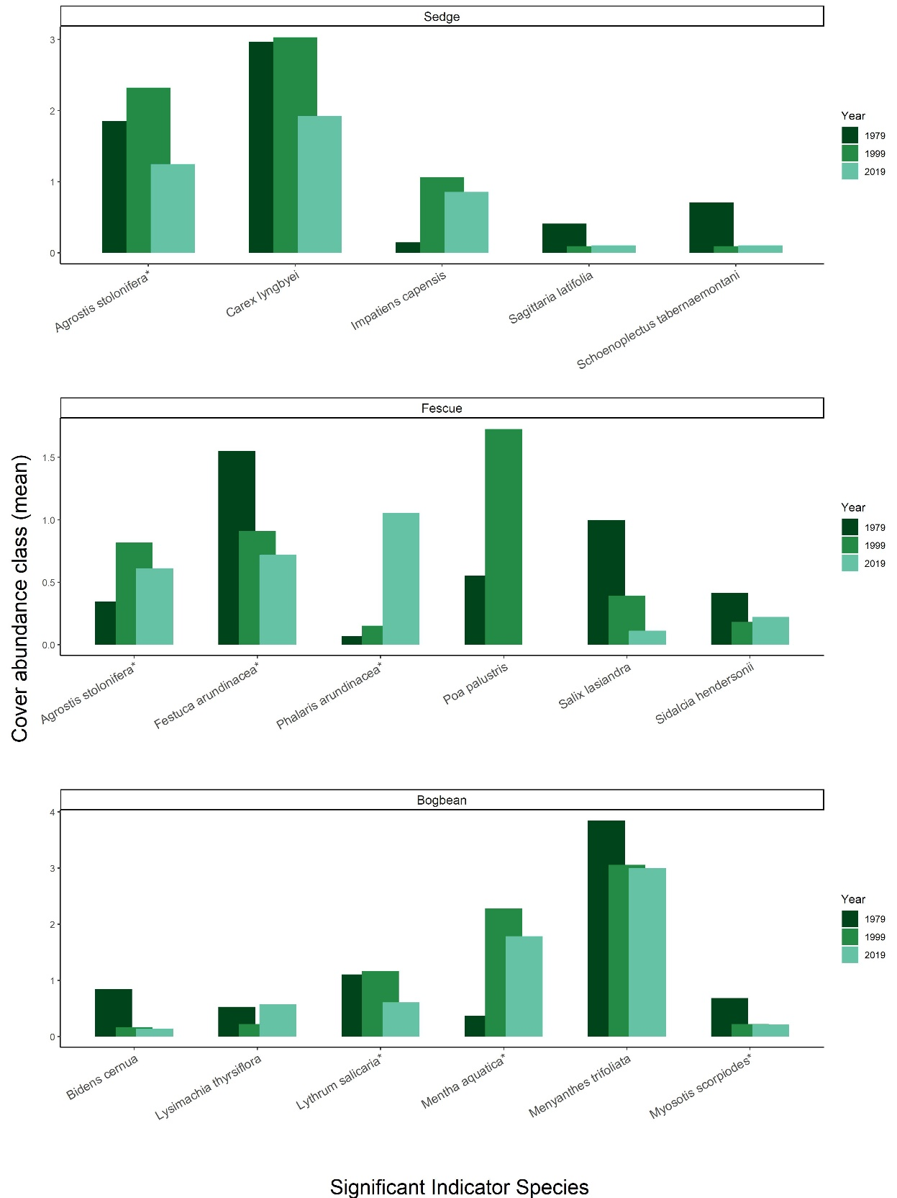

Figure 3. Changes in mean cover abundance of indicator species most significantly driving assemblage associations over time. Species names followed by (\*) are non-native introductions from Eurasia. Notably, each of the assemblage-defining species (C. lyngbyei, F. arundinaceae, and M. trifoliata) decrease in mean abundance in 2010. By 2019, invasive species P. arundinaceae more than triples its abundance in the Fescue assemblage.

Table 2. Between 1979 and 2019, 8 fewer plots and 5 fewer species were observed, resulting in slightly lower α-diversity and greater β-diversity. For each assemblage type, Bogbean is the only assemblage to proportionally gain plots between 1979 and 2019, while the Fescue and Sedge assemblages lost plots. Plot loss did not appear to have an effect on diversity components, as tested by bootstrapping a minimum of 18 plots per assemblage each year (Table S6).

|  |  |  |  |  |  |  |
| --- | --- | --- | --- | --- | --- | --- |
|  | **Plot-level components** | |  | **Diversity components** | | |
| **Assemblage** | **No. quadrats** | **No. species** |  | **α diversity** | **α diversity sd** | **β diversity** |
| **Sedge** |  |  |  |  |  |  |
| 1979 | 34 | 36 |  | 8.74 | 2.45 | 3.89 |
| 1999 | 31 | 35 |  | 8.26 | 1.98 | 4.24 |
| 2019 | 28 | 34 |  | 7.89 | 2.69 | 4.31 |
|  |  |  |  |  |  |  |
| **Fescue** |  |  |  |  |  |  |
| 1979 | 29 | 47 |  | 12.83 | 3.87 | 3.66 |
| 1999 | 33 | 41 |  | 9.69 | 3.96 | 4.23 |
| 2019 | 18 | 27 |  | 5.83 | 2.79 | 4.63 |
|  |  |  |  |  |  |  |
| **Bogbean** |  |  |  |  |  |  |
| 1979 | 19 | 32 |  | 12.84 | 3.61 | 2.49 |
| 1999 | 18 | 36 |  | 11.50 | 2.92 | 3.13 |
| 2019 | 28 | 34 |  | 10.46 | 1.90 | 3.25 |
|  |  |  |  |  |  |  |
| **Total** |  |  |  |  |  |  |
| 1979 | 82 | 48 |  | 9.96 | 3.41 | 4.82 |
| 1999 | 82 | 45 |  | 9.55 | 3.30 | 4.71 |
| 2019 | 74 | 43 |  | 8.36 | 3.03 | 5.14 |

Table 3. Total turnover and rates of species disappearance (loss) was always greater between 1999 and 2019 than between 1979 and 1999. However, fewer species were gained in the Bogbean assemblage 1999-2019 than 1979-1999.

|  |  |  |  |  |
| --- | --- | --- | --- | --- |
| **Assemblage** | **Year** | **Total turnover** | **Species Appearance** | **Species Disappearance** |
| Bogbean | 1979-1999 | 0.47 | 0.30 | 0.16 |
| 1999-2019 | 0.51 | 0.23 | 0.28 |
| Fescue | 1979-1999 | 0.35 | 0.13 | 0.21 |
| 1999-2019 | 0.58 | 0.15 | 0.44 |
| Sedge | 1979-1999 | 0.32 | 0.17 | 0.15 |
| 1999-2019 | 0.50 | 0.24 | 0.26 |

# Discussion

Repeat sampling of vegetation communities over long time frames can inform responses to global change along with appropriate conservation management. This study examined whether plant species assemblages within a protected area in the Fraser River Estuary are characterized by the same dominant species over time, whether measures of species diversity were stable within assemblage types, and whether turnover may be driven by increasing invasive species abundance. We find the three main plant assemblages, Sedge, Fescue and Bogbean have consistently been defined by the same most dominant species over the past 40 years, supporting our expectation that these characteristic species should not change in the absence of significant environmental disturbance. However, we also find that there have been substantive changes in the species composition over time, indicating that despite conservation status and broad resilience of our study region, regional pressures are influencing considerable shifts in the species composition within this habitat. Moreover, cluster analysis shows there was increasing heterogeneity of species compositional abundance between assemblages, but greater similarity of species cover abundance within each assemblage (Figure 2). Overall, these findings indicate decreased cover abundance by fewer species within each assemblage type, creating patchy but sparse assemblages within in the community.

Although the Bogbean assemblage had a high abundance of non-native *Mentha aquatica* cover, it also had the highest α-diversity, and lowest β-diversity over time. Because bogbean (*M. trifoliata*) is tolerant of saturated soils, it may be that this assemblage type is more stable and resistant to diversity loss than assemblages with better-drained soils. The Fescue assemblage had the greatest loss of α-diversity, and greatest increase in β-diversity. The overall loss of species, and greater variation in species compositional abundance between plots in this assemblage may be indicative of greater loss of resilience, and increased susceptibility to invasion. Total turnover for all assemblages was higher in 1999-2019 than 1979-1999, and largely driven by species loss (disappearance), which is concerning for total biodiversity of the habitat and may indicate increased susceptibility to invasive species (Tilman, 1999). This is especially evident by encroachment of invasive species in the Fescue and Bogbean assemblages. The Fescue assemblage has historically been defined by a non-native species (*Festuca arundinaceae*), however abundance of *Festuca arundinaceae* is being overtaken by *Phalaris arundinaceae*, or reed canary grass (RCG). This presents a management concern for Ladner Marsh, as RCG can be a monoculture-forming species (Apfelbaum & Sams, 1987), further reducing species diversity within the community. Similarly, the Bogbean assemblage is increasingly dominated by non-native *Mentha aquatica*, however this assemblage did not lose as much floristic richness as the Fescue assemblage did (Table 7, Supplemental). Increasing abundance of specific non-native species, paired with cluster analysis showing greater similarity within plots of each assemblage, supports our expectation that species loss is being driven by proliferation of non-native species.

The patterns reported here of lost plant species richness over time are reflected in global trends driven by anthropogenic stressors such as urbanization and climate change, and related risk of species homogenization (Brice, Pellerin, & Poulin, 2017; Dornelas et al., 2014). In tidal wetlands, a key climate change-related concern is sea level rise, which will lead to habitat loss through “coastal squeeze” (Torio & Chmura, 2013). Some species will be adaptable to the changing inundation regimes, and tidal marsh habitats can be resilient to climate change if land managers take action before species losses are too great (Short, et al., 2016). Maintaining diverse estuarine habitats under sea level rise important for a variety of wildlife, including migratory and resident shorebirds, and anadromous salmon populations (Chalifour et al., 2019; Finn et al., 2021; Kehoe & Martin, 2021). Understanding historical trends in species composition and assemblage heterogeneity is critical for land managers to define measures of success in restoration projects, and for conserving ecological processes. In the absence of ideal reference conditions, use of historical datasets may be used to determine ecologically meaningful benchmarks. While historical conditions can provide greater understanding of species diversity, land managers must be aware of species composition and abundance shifts, which are only possible to detect through long-term monitoring projects and resampling such as in this study.

## Study limitations

These data do not show variation in population dynamics over time, thus inferences of interannual trends in species gained/lost cannot be explicitly made. However, this snapshot is useful for observing coarse patterns of species shifts, and can be used to refine future questions such as identifying whether high-diversity assemblages, such as the Bogbean assemblage, may be more resistant to invasive species (and thus more stable). Permanent transects were not used, thus transect relocation and plot placement may have resulted in somewhat different observations. However, bootstrapping minimum numbers of plots in each assemblage did not reveal alternative patterns, offering assurance of the general trend of species loss.

Mechanistic processes to explain changes in species composition or site factors were not tested. However, likely driving factors can be inferred to generate new tests of mechanistic changes in in community stability. Specifically: edaphic factors may be driving species selection by adaptation to saturation or drainage between assemblage patches, more strictly partitioning the diversity of species that can occupy an assemblage. Additionally, recruitment of new diverse individuals into the assemblage may be limited due to dispersal or recruitment limitation.

## Potential mechanisms

A key abiotic driver of tidal marsh development includes sediment deposition that allows plant communities to compensate for changing inundation rates due to sea level rise (Marijnissen, et al., 2020). Sediment delivered by river transport is trapped by vegetation, creating a feedback loop of rising tidal marsh platforms, increased vegetation growth, and increased sediment trapping capacity (Corenblit et al., 2015; Peteet et al., 2018). In their 1982 publication, Bradfield and Porter proposed assemblage occurrence was largely driven by edaphic factors, with the Bogbean assemblage occurring in poorly drained areas, Sedge assemblage occurring in regularly flooded and drained areas, and Fescue assemblage along slightly elevated channel edges. *Menyanthes trifoliata* (bogbean) and *Mentha aquatica* are highly adapted to aquatic or poorly drained habitats, and the increased prevalence of plots clustered in the Bogbean assemblage within Ladner Marsh may be indicative of changing edaphic factors such as sediment starvation or marsh subsidence (Mendelssohn & Kuhn, 2003; Nyman, Walters, et al., 2006). Loss of sediment within the Lower Fraser River reaches is driven by a combination of factors, such as increased impervious cover, bank dyking or armoring, and channel dredging (Atkins, et al., 2016). Disentangling explicit sediment dynamics and causes for loss of sediment over time would be difficult, however effects from these processes would lead to more saturated patches within the marsh. Edaphic shifts would likely drive the increased prevalence of Bogbean assemblage, and may also be driving disappearance of species across all assemblages, as fewer species are able to tolerate increasingly saturated conditions.

Besides potential abiotic drivers of species loss, species recruitment may also be impacted. Regional pools of propagules (seeds, clonal fragments) are required to disperse into a site, and suitable conditions must exist to recruit the propagules into the population. If remnant habitats such as Ladner Marsh are locally losing species (or if the habitat is lost altogether through development), species diversity is being lost from the dispersal network , which effectively fragments the dispersal network and potentially leads to regional extinction (Deane, et al., 2017).

## Broader impacts & recommendations

Long-term monitoring is relatively rare, but necessary to inform future management and planning (Willis et al., 2007). Land management planning in anticipation of climate change, particularly sea level rise, should be cognizant of biodiversity loss. This is important at global scales (e.g., global objectives for wetland conservation outlined by the Ramsar Convention), but also at national and local conservation initiatives (e.g., meeting objectives of Canada’s Oceans Protection Plan or British Columbia’s Salmon Restoration & Innovation Fund). Understanding what tidal marsh community stability looks like within decadal timescales is useful to land managers wanting to maintain or restore shoreline communities for immediate habitat conservation or floodwater protection initiatives that will have broader resilience to sea level rise. Initiatives for tidal marsh restoration must identify some ‘reference’ condition (Hallett et al., 2016), which needs to be account for anthropogenic impacts such as biodiversity loss (Diefenderfer et al., 2011). This study is a case-in-point that the biodiversity and compositional abundance of the habitat (and thus ‘reference’ condition) in Ladner Marsh has changed over 40 years despite protected status, and revealed a decreased reference quality in 2019 compared to the original 1979 survey. It is also important to note its condition when surveyed in 1979 was undoubtedly altered from earlier compositional states, and thus not truly a reference to tidal marshes undisturbed by colonial and industrial impacts.

The main need from these results is to determine whether species loss and decreasing habitat heterogeneity is driven by loss of sediment quantity or quality (Nyman et al., 2006), and whether this is affecting the ability of native species to recruit into the community from seed or clonal propagules. If sedimentation quantity or quality is limiting positive feedback between marsh accretion and vegetation recruitment, land managers must address this by implementing sediment application programs to mimic natural sedimentation (VanZomeren, et al., 2018). A paired need is to decouple sedimentation drivers of recruitment from loss of seed or propagule diversity from the dispersal network. If sedimentation is adequate to recruit individuals, recruitment may still be limited by loss of seed or clonal propagules from the dispersal network (Erfanzadeh, et al., 2010; Rand, 2000). If this is the case, land managers must re-introduce populations of native species to existing habitats. These efforts should also be paired with restoration or creation of marsh habitat to increase dispersal connectivity throughout the estuary.

# Acknowledgements

The lead author would like to thank Z. Davis for providing R programming advice; P. Roper for field assistance; B. Staines (Ladner Harbour Authority) for providing watercraft and harbour use. Financial support was provided by Natural Sciences and Engineering Research Council of Canada Discovery Grant RGPIN-2018-03838 to J. Richardson, and research site access was granted by The Ministry of Forests, Lands, Natural Resource Operations and Rural Development.

# Literature Cited

Apfelbaum, S. I., & Sams, C. E. (1987). Ecology and Control of Reed Canary Grass (Phalaris arundinacea L.). *Natural Areas Journal*, *7*, 69–74.

Atkins, R. J., Tidd, M., & Ruffo, G. (2016). Sturgeon Bank, Fraser River Delta, BC, Canada: 150 Years of Human Influences on Salt Marsh Sedimentation. *Journal of Coastal Research*, *SI*, 790–794.

Bradfield, G. E., & Porter, G. L. (1982). Vegetation structure and diversity components of a Fraser estuary tidal marsh. *Canadian Journal of Botany*, *60*, 440–451.

Brice, M.-H., Pellerin, S., & Poulin, M. (2017). Does urbanization lead to taxonomic and functional homogenization in riparian forests? *Diversity and Distributions*, *23*, 828–840.

Brophy, L. S., Greene, C. M., Hare, V. C., Holycross, B., Lanier, A., Heady, W. N., … Dana, R. (2019). Insights into estuary habitat loss in the western United States using a new method for mapping maximum extent of tidal wetlands. *PLOS ONE*, *14*, e0218558.

Chalifour, L., Scott, D. C., MacDuffee, M., Iacarella, J. C., Martin, T. G., & Baum, J. K. (2019). Habitat use by juvenile salmon, other migratory fish, and resident fish species underscores the importance of estuarine habitat mosaics. *Marine Ecology Progress Series*, *625*, 145–162.

Corenblit, D., Baas, A., Balke, T., Bouma, T., Fromard, F., Garófano‐Gómez, V., … Walcker, R. (2015). Engineer pioneer plants respond to and affect geomorphic constraints similarly along water–terrestrial interfaces world-wide. *Global Ecology and Biogeography*, *24*, 1363–1376.

Davis, M. J., Woo, I., Ellings, C. S., Hodgson, S., Beauchamp, D. A., Nakai, G., & De La Cruz, S. E. W. (2021). A climate-mediated shift in the estuarine habitat mosaic limits prey availability and reduces nursery quality for juvenile salmon. *Estuaries and Coasts*. https://doi.org/10.1007/s12237-021-01003-3

De Cáceres, M., & Jansen, F. (2016). *Indicspecies*. Retrieved from http://r.meteo.uni.wroc.pl/web/packages/indicspecies/indicspecies.pdf

Deane, D. C., Fordham, D. A., He, F., & Bradshaw, C. J. A. (2017). Future extinction risk of wetland plants is higher from individual patch loss than total area reduction. *Biological Conservation*, *209*, 27–33.

Denoth, M., & Myers, J. H. (2007). Competition between Lythrum salicaria and a rare species: Combining evidence from experiments and long-term monitoring. *Plant Ecology*, *191*, 153–161.

Diefenderfer, H. L., Thom, R. M., Johnson, G. E., Skalski, J. R., Vogt, K. A., Ebberts, B. D., … Dawley, E. M. (2011). A Levels-of-Evidence Approach for Assessing Cumulative Ecosystem Response to Estuary and River Restoration Programs. *Ecological Restoration*, *29*, 111–132.

Donohue, I., Hillebrand, H., Montoya, J. M., Petchey, O. L., Pimm, S. L., Fowler, M. S., … Yang, Q. (2016). Navigating the complexity of ecological stability. *Ecology Letters*, *19*, 1172–1185.

Dornelas, M., Gotelli, N. J., McGill, B., Shimadzu, H., Moyes, F., Sievers, C., & Magurran, A. E. (2014). Assemblage Time Series Reveal Biodiversity Change but Not Systematic Loss. *Science*, *344*, 296–299.

Douglas, T. J., Schuerholz, G., & Juniper, S. K. (2022). Blue Carbon Storage in a Northern Temperate Estuary Subject to Habitat Loss and Chronic Habitat Disturbance: Cowichan Estuary, British Columbia, Canada. *Frontiers in Marine Science*, *9*. Retrieved from https://www.frontiersin.org/article/10.3389/fmars.2022.857586

Dufrêne, M., & Legendre, P. (1997). Species Assemblages and Indicator Species:the Need for a Flexible Asymmetrical Approach. *Ecological Monographs*, *67*, 345–366.

Emmett, R., Llansó, R., Newton, J., Thom, R., Hornberger, M., Morgan, C., … Fishman, P. (2000). Geographic signatures of North American West Coast estuaries. *Estuaries*, *23*, 765–792.

Erfanzadeh, R., Garbutt, A., Pétition, J., Maelfait, J.-P., & Hoffmann, M. (2010). Factors Affecting the Success of Early Salt-Marsh Colonizers: Seed Availability Rather than Site Suitability and Dispersal Traits. *Plant Ecology*, *206*, 335–347. JSTOR.

Finn, R. J. R., Chalifour, L., Gergel, S. E., Hinch, S. G., Scott, D. C., & Martin, T. G. (2021). Quantifying lost and inaccessible habitat for Pacific salmon in Canada’s Lower Fraser River. *Ecosphere*, *12*, e03646.

Hallett, L. M., Jones, S. K., MacDonald, A. A. M., Jones, M. B., Flynn, D. F. B., Ripplinger, J., … Collins, S. L. (2016). codyn: An r package of community dynamics metrics. *Methods in Ecology and Evolution*, *7*, 1146–1151.

Hanski, I. (1982). Dynamics of Regional Distribution: The Core and Satellite Species Hypothesis. *Oikos*, *38*, 210–221. JSTOR.

Hitchcock, C. L., & Cronquist, A. (1973). *Flora of the Pacific Northwest, an illustrated manual*. Seattle and London: University of Washington Press.

Holling, C. S. (1973). Resilience and Stability of Ecological Systems. *Annual Review of Ecology and Systematics*, *4*, 1–23.

Kehoe, L., & Martin, T. (2021). Fraser River Estuary in Need of Urgent Intensive Care. In K. L. Sobocinski (Ed.), *State of the Salish Sea* (pp. 190–193). Salish Sea Institute, Western Washington University.

Kopecký, M., & Macek, M. (2015). Vegetation resurvey is robust to plot location uncertainty. *Diversity and Distributions*, *21*, 322–330.

Legendre, P., & Legendre, L. (2012). *Numerical Ecology* (3rd ed., Vol. 24). Elsevier.

Lepš, J. (2004). What do the biodiversity experiments tell us about consequences of plant species loss in the real world? *Basic and Applied Ecology*, *5*, 529–534.

Marijnissen, R., Kok, M., Kroeze, C., & van Loon-Steensma, J. (2020). The Sensitivity of a Dike-Marsh System to Sea-Level Rise—A Model-Based Exploration. *Journal of Marine Science and Engineering*, *8*, 42.

Mendelssohn, I. A., & Kuhn, N. L. (2003). Sediment subsidy: Effects on soil–plant responses in a rapidly submerging coastal salt marsh. *Ecological Engineering*, *21*, 115–128.

Nyman, J. A., Walters, R. J., Delaune, R. D., & Patrick, W. H. (2006). Marsh vertical accretion via vegetative growth. *Estuarine, Coastal and Shelf Science*, *69*, 370–380.

Ovaskainen, O., Rybicki, J., & Abrego, N. (2019). What can observational data reveal about metacommunity processes? *Ecography*, *42*, 1877–1886.

Pasternack, G. B. (2009). Chapter 3. Hydrogeomorphology and sedimentation in tidal freshwater wetlands. In A. Barendregt, D. F. Whigham, & A. H. Baldwin (Eds.), *Tidal Freshwater Wetlands* (pp. 31–40). Leiden, The Netherlands: Backhuys Publishers.

Peteet, D. M., Nichols, J., Kenna, T., Chang, C., Browne, J., Reza, M., … Stern-Protz, S. (2018). Sediment starvation destroys New York City marshes’ resistance to sea level rise. *Proceedings of the National Academy of Sciences*, *115*, 10281–10286.

Rand, T. A. (2000). Seed dispersal, habitat suitability and the distribution of halophytes across a salt marsh tidal gradient. *Journal of Ecology*, *88*, 608–621.

Schaefer, V. (2004). Ecological setting of the Fraser River delta and its urban estuary. In B. J. Groulx, D. C. Mosher, J. L. Luternauer, & D. E. Bilderback (Eds.), *Fraser River Delta, British Columbia: Issues of an Urban Estuary* (pp. 147–172). Geological Survey of Canada, Bulletin 547.

Short, F. T., Kosten, S., Morgan, P. A., Malone, S., & Moore, G. E. (2016). Impacts of climate change on submerged and emergent wetland plants. *Aquatic Botany*, *135*, 3–17.

Sinks, I. A., Borde, A. B., Diefenderfer, H. L., & Karnezis, J. P. (2021). Assessment of Methods to Control Invasive Reed Canarygrass (Phalaris arundinacea) in Tidal Freshwater Wetlands. *Natural Areas Journal*, *41*, 172–185.

Torio, D. D., & Chmura, G. L. (2013). Assessing Coastal Squeeze of Tidal Wetlands. *Journal of Coastal Research*, *29*, 1049–1061.

Underwood, A. J., Chapman, M. G., & Connell, S. D. (2000). Observations in ecology: You can’t make progress on processes without understanding the patterns. *Journal of Experimental Marine Biology and Ecology*, *250*, 97–115.

VanZomeren, C. M., Berkowitz, J. F., Piercy, C. D., & White, J. R. (2018). Restoring a degraded marsh using thin layer sediment placement: Short term effects on soil physical and biogeochemical properties. *Ecological Engineering*, *120*, 61–67.

Whittaker, R. H. (1975). *Communities and Ecosystems* (2nd ed.). New York, NY: Macmillan.

Willis, K. J., Araújo, M. B., Bennett, K. D., Figueroa-Rangel, B., Froyd, C. A., & Myers, N. (2007). How can a knowledge of the past help to conserve the future? Biodiversity conservation and the relevance of long-term ecological studies. *Philosophical Transactions of the Royal Society B: Biological Sciences*, *362*, 175–187.

# Supplemental

Table 4. A total of 25 plots sampled in 1979 and 1999 were not sampled in 2019, mostly due to issues of accessibility. Transect names and plot ID of plots omitted follow Fig. 3 in Bradfield & Porter (1982).

|  |  |  |
| --- | --- | --- |
| **Transect** | **1979/1999**  **Plot No.** | **Reason omitted in 2019** |
| Q | 1-7 | Transect in dense riparian thicket overgrown with Himalayan blackberry |
| R | 8 | Plot on lower bench (> 1 m lower than marsh platform), vegetation no longer exists |
| R | 17-19 | Plots in 1979 & 1999 sampled across a channel. Ended transect in 2019 at channel edge. |
| S | 33-36 | Transect length in 2019 was shorter than in 1979/1999. Suspect combination of erosion and offset transect relocation altered sampling distance. |
| T | 45 | Transect length in 2019 was shorter than in 1979/1999. Suspect combination of erosion and offset transect relocation altered sampling distance. |
| U | 51-52 | Transect length in 2019 was shorter than in 1979/1999. Suspect combination of erosion and offset transect relocation altered sampling distance. |
| V | 53 | Plot 53 only plot across a channel. Increased channel width and likely erosion made crossing this channel dangerous; omitted plot in 2019. |
| V | 54, 70-71 | Transect length in 2019 was shorter than in 1979/1999. Suspect combination of erosion and offset transect relocation altered sampling distance. |
| W | 89-92 | Transect length in 2019 was shorter than in 1979/1999. Suspect combination of erosion and offset transect relocation altered sampling distance. |
| X | 93 | Transect length in 2019 was shorter than in 1979/1999. Suspect combination of erosion and offset transect relocation altered sampling distance. |

*Table 5. Species indicator analysis of cluster groups using Bray-Curtis distance identifies the same dominant species in each assemblage type (Sedge, Fescue, Bogbean), however Bray-Curtis distance identifies different associated indicator species than those identified by Euclidean distance (Table 1).*

|  |  |  |  |  |  |  |  |  |  |  |  |
| --- | --- | --- | --- | --- | --- | --- | --- | --- | --- | --- | --- |
|  | **1979** | | |  | **1999** | | |  | **2019** | | |
| **Cluster Group Name** | **Species** | **IndVal stat** | **p-value** |  | **Species** | **IndVal stat** | **p-value** |  | **Species** | **IndVal stat** | **p-value** |
|  |  |  |  |  |  |  |  |  |  |  |  |
| "Sedge" | *Carex lyngbyei* | 0.678 | 0.001 |  | *Carex lyngbyei* | 0.804 | 0.001 |  | *Carex lyngbyei* | 0.714 | 0.001 |
| *Sagittaria latifolia* | 0.559 | 0.001 |  | *Agrostis stolonifera* | 0.434 | 0.003 |  | *Mentha arvensis* | 0.322 | 0.033 |
| *Schoenoplectus tabernaemontani* | 0.391 | 0.001 |  |  |  |  |  |  |  |  |
|  |  |  |  |  |  |  |  |  |  |  |
|  |  |  |  |  |  |  |  |  |  |  |  |
| "Fescue" | *Festuca arundinacea* | 0.753 | 0.001 |  | *Festuca arundinacea* | 0.765 | 0.001 |  | *Phalaris arundinaceae* | 0.584 | 0.001 |
| *Salix lucida* | 0.586 | 0.001 |  | *Phalaris arundinaceae* | 0.334 | 0.019 |  | *Festuca arundinacea* | 0.416 | 0.001 |
| *Lathyrus palustris* | 0.543 | 0.001 |  |  |  |  |  |  |  |  |
| *Equisetum palustre* | 0.475 | 0.002 |  |  |  |  |  |  |  |  |
| *Impatiens capensis* | 0.391 | 0.002 |  |  |  |  |  |  |  |  |
| *Sidalcia hendersonii* | 0.387 | 0.001 |  |  |  |  |  |  |  |  |
| *Platanthera dilatata* | 0.308 | 0.020 |  |  |  |  |  |  |  |  |
|  |  |  |  |  |  |  |  |  |  |  |  |
| "Bogbean" | *Menyanthes trifoliata* | 0.807 | 0.001 |  | *Menyanthes trifoliata* | 0.782 | 0.001 |  | *Mentha aquatica* | 0.752 | 0.001 |
| *Myosotis scorpioides* | 0.577 | 0.001 |  | *Leersia oryzoides* | 0.495 | 0.001 |  | *Menyanthes trifoliata* | 0.709 | 0.001 |
| *Juncus articulatus* | 0.523 | 0.001 |  | *Mentha aquatica* | 0.492 | 0.001 |  | *Lysimachia thyrsiflora* | 0.547 | 0.001 |
| *Lythrum salicaria* | 0.400 | 0.002 |  | *Bidens cernua* | 0.489 | 0.003 |  | *Salix lucida* | 0.465 | 0.001 |
| *Lysimachia thyrsiflora* | 0.400 | 0.002 |  | *Lysimachia thyrsiflora* | 0.478 | 0.001 |  | *Eleocharis palustris* | 0.460 | 0.001 |
| *Trifolium wormskjoldii* | 0.381 | 0.003 |  | *Juncus articulatus* | 0.438 | 0.001 |  | *Juncus articulatus* | 0.373 | 0.004 |
| *Lilaeopsis occidentalis* | 0.360 | 0.004 |  | *Juncus oxymeris* | 0.356 | 0.015 |  | *Galium trifidum* | 0.348 | 0.008 |
| *Mentha aquatica* | 0.313 | 0.010 |  | *Myosotis scorpioides* | 0.356 | 0.019 |  | *Bidens cernua* | 0.323 | 0.012 |
|  |  |  |  | Poaceae (unidentified sp.) | 0.356 | 0.013 |  |  |  |  |
|  |  |  |  | *Deschampsia caespitosa* | 0.354 | 0.014 |  |  |  |  |
|  |  |  |  | *Sagittaria latifolia* | 0.301 | 0.046 |  |  |  |  |

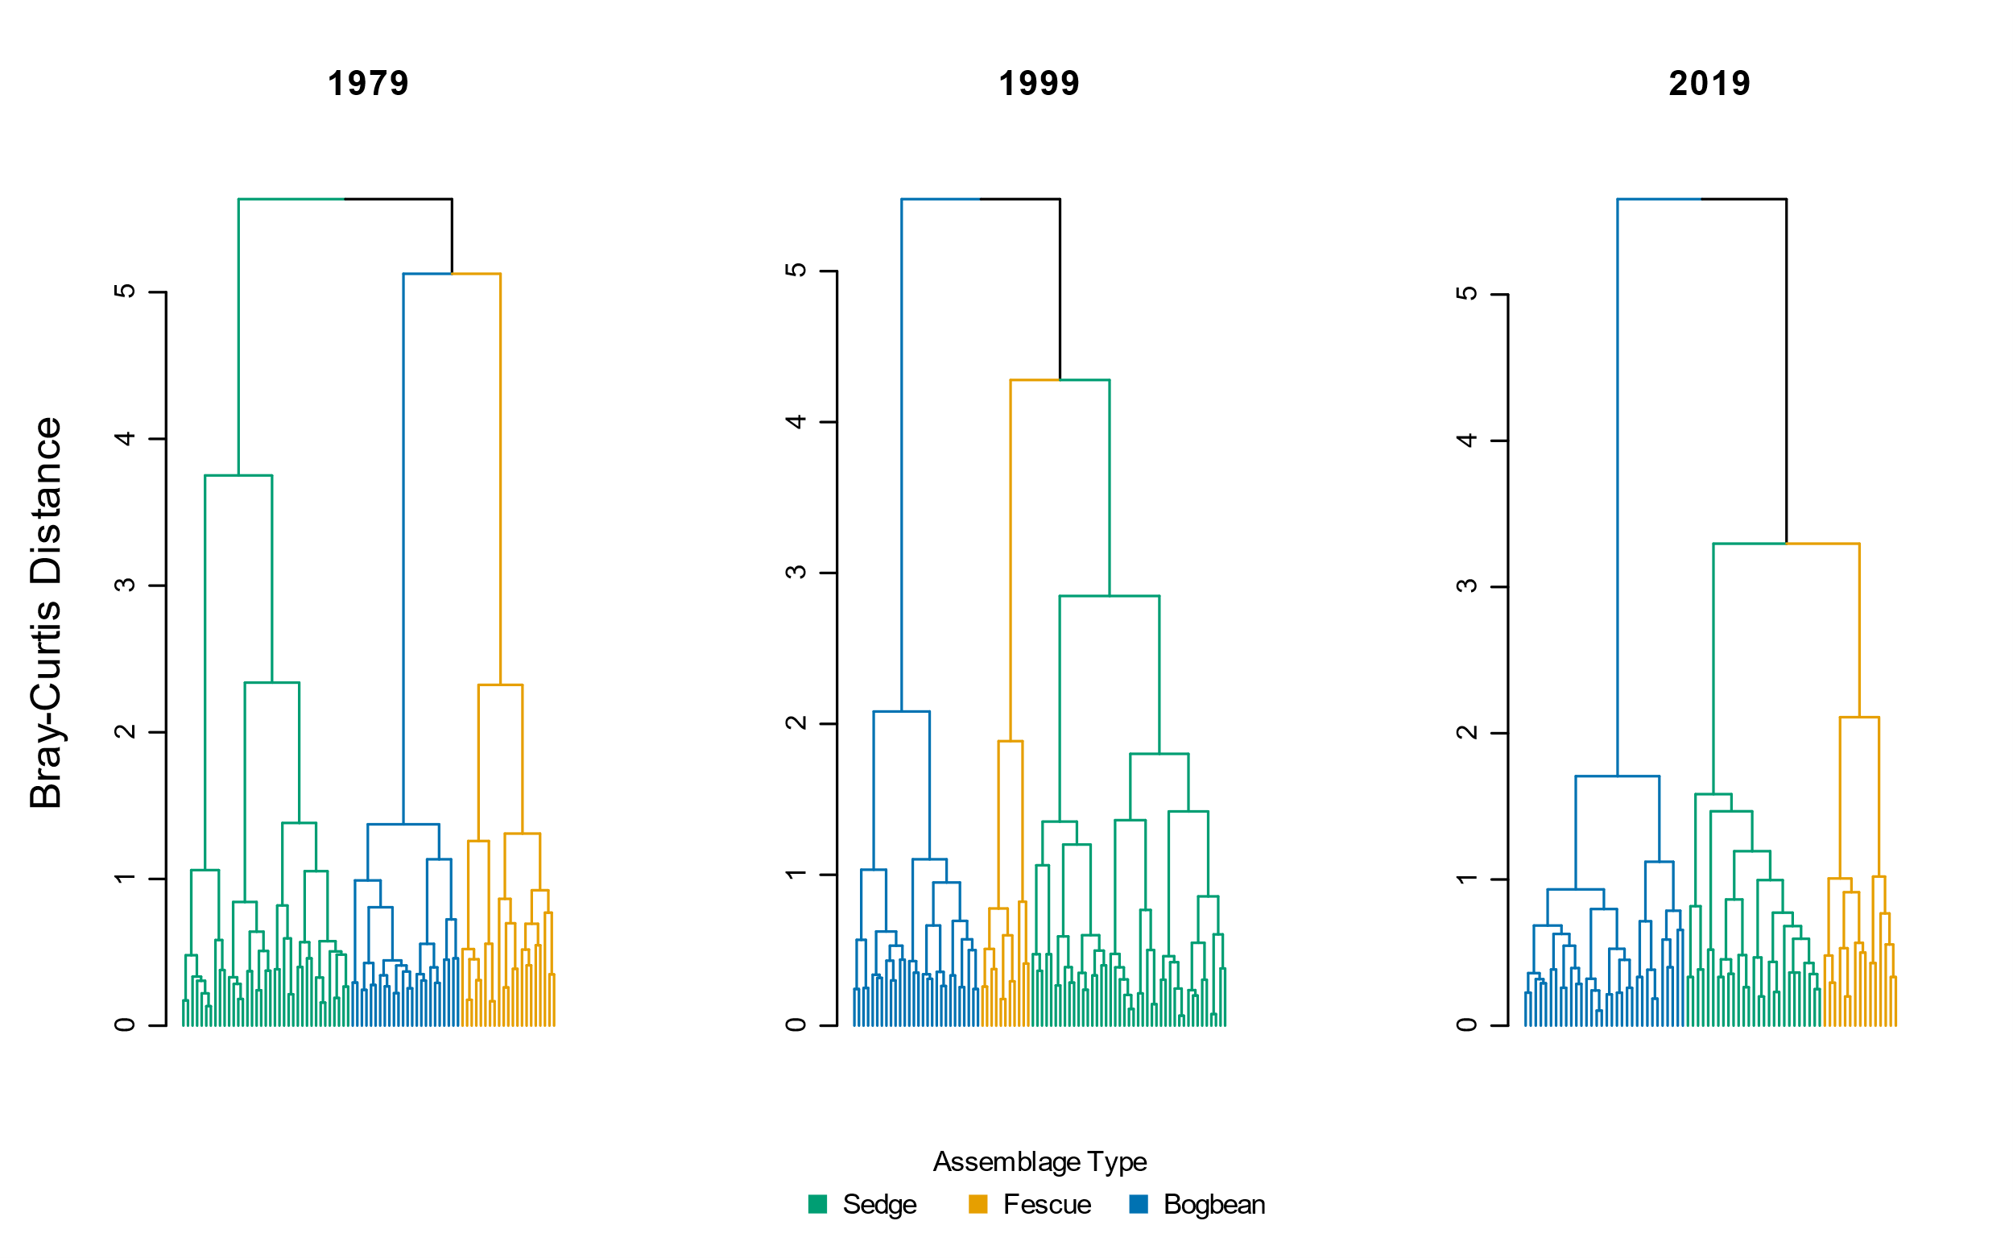

Figure 4. Cluster analysis using Bray-Curtis distance measure shows similar trends of increasing dissimilarity over time as when using Euclidean distance (Figure 2).

|  |  |  |  |  |  |  |
| --- | --- | --- | --- | --- | --- | --- |
|  | **Plot-level components** | |  | **Diversity components** | | |
| **Assemblage** | **No. quadrats** | **No. species** |  | **α diversity** | **α diversity sd** | **β diversity** |
| **Sedge** |  |  |  |  |  |  |
| 1979 | 18 | 32.3 |  | 10.67 | 2.34 | 3.03 |
| 1999 | 18 | 31.6 |  | 8.31 | 1.98 | 3.81 |
| 2019 | 18 | 30.8 |  | 8.18 | 2.51 | 3.77 |
|  |  |  |  |  |  |  |
| **Fescue** |  |  |  |  |  |  |
| 1979 | 18 | 43.3 |  | 12.96 | 3.91 | 3.35 |
| 1999 | 18 | 36.4 |  | 9.72 | 3.92 | 3.76 |
| 2019 | 18 | 27 |  | 5.83 | 2.79 | 4.63 |
|  |  |  |  |  |  |  |
| **Bogbean** |  |  |  |  |  |  |
| 1979 | 18 | 31.7 |  | 12.83 | 3.63 | 2.47 |
| 1999 | 18 | 36 |  | 11.50 | 2.92 | 3.13 |
| 2019 | 18 | 31.4 |  | 10.52 | 1.90 | 2.99 |
|  |  |  |  |  |  |  |
| **Total** |  |  |  |  |  |  |
| 1979 | 54 | 47.6 |  | 12.15 | 3.49 | 3.92 |
| 1999 | 54 | 42.1 |  | 10.02 | 3.35 | 4.22 |
| 2019 | 54 | 41.7 |  | 8.18 | 3.08 | 5.10 |

Table 6. Bootstrapping 18 randomly selected plots 10 times shows consistent overall trend in loss of species and alpha diversity over time, and overall increase in beta diversity between 1979 and 2019 in all assemblages and across the entire Ladner Marsh plant community. Therefore, loss of plots due to sampling re-location or how number of plots clustered into assemblages as reported in Table 2 is not expected to affect loss of species or plot-based diversity metrics.

Table 7. Percent change in mean abundance (cover class) between from 1979 to 2019 for non-native and native species observed in each assemblage. New species appearances from 1979 to 2019 indicated by (+); species only appearing in 1999 indicated by ‘NA’. Native status is listed as ‘unknown’ if plant was not identified to species level.

|  |  |  |  |  |  |  |
| --- | --- | --- | --- | --- | --- | --- |
| **Assemblage** | **Status** | **Species** | **1979** | **1999** | **2019** | **Percent Change (1979-2019)** |
| Bogbean | Non-native | *Mentha arvensis* | 0.47 | 0.00 | 0.07 | -84.9 |
| *Myosotis scorpiodes* | 0.68 | 0.22 | 0.21 | -68.7 |
| *Agrostis stolonifera* | 3.21 | 1.50 | 1.29 | -60.0 |
| *Lythrum salicaria* | 1.11 | 1.17 | 0.61 | -45.1 |
| *Rumex conglomeratus* | 0.05 | 0.00 | 0.04 | -32.1 |
| *Mentha aquatica* | 0.37 | 2.28 | 1.79 | 384.7 |
| *Iris pseudocorus* | 0.00 | 0.33 | 0.21 | + |
| *Lycopus europaeus* | 0.00 | 0.00 | 0.04 | + |
| *Phalaris arundinacea* | 0.00 | 0.06 | 0.04 | + |
| *Festuca arundinacea* | 0.00 | 0.17 | 0.00 | NA |
| Native | *Alisma plantago aquatica* | 0.16 | 0.11 | 0.00 | -100.0 |
| *Alopecurus geniculatus* | 0.05 | 0.00 | 0.00 | -100.0 |
| *Deschampsia caespitosa* | 0.26 | 0.22 | 0.00 | -100.0 |
| *Equisetum fluviatile* | 1.37 | 1.17 | 0.00 | -100.0 |
| *Leersia oryzoides* | 0.26 | 0.33 | 0.00 | -100.0 |
| *Lilaeopsis occidentalis* | 0.21 | 0.00 | 0.00 | -100.0 |
| *Oenanthe sarmentosa* | 0.63 | 0.11 | 0.00 | -100.0 |
| *Poa trivialis* | 0.11 | 0.00 | 0.00 | -100.0 |
| *Sium suave* | 0.63 | 0.17 | 0.00 | -100.0 |
| *Caltha palustris* | 0.95 | 0.22 | 0.07 | -92.5 |
| *Bidens cernua* | 0.84 | 0.17 | 0.14 | -83.0 |
| *Trifolium wormskjoldii* | 0.95 | 0.11 | 0.18 | -81.2 |
| *Schoenoplectus tabernaemontani* | 0.16 | 0.00 | 0.07 | -54.8 |
| *Eleocharis palustris* | 0.63 | 0.78 | 0.39 | -37.8 |
| Symphyotrichum *subspicatum* | 0.47 | 0.33 | 0.32 | -32.1 |
| *Juncus oxymeris* | 0.05 | 0.11 | 0.04 | -32.1 |
| *Platanthera dilatata* | 0.05 | 0.06 | 0.04 | -32.1 |
| *Menyanthes trifoliata* | 3.84 | 3.06 | 3.00 | -21.9 |
| *Lysimachia thyrsiflora* | 0.53 | 0.22 | 0.57 | 8.6 |
| *Juncus articulatus* | 0.26 | 0.39 | 0.29 | 8.6 |
| *Sidalcia hendersonii* | 0.05 | 0.00 | 0.07 | 35.7 |
| *Carex lyngbyei* | 0.47 | 0.33 | 1.00 | 111.1 |
| *Rumex occidentalis* | 0.05 | 0.11 | 0.14 | 171.4 |
| *Potentilla anserina-pacifica* | 0.26 | 1.00 | 1.07 | 307.1 |
| *Equisetum arvense* | 0.00 | 0.00 | 0.64 | + |
| *Galium trifidum* | 0.00 | 0.00 | 0.39 | + |
| *Hypericum scouleri* | 0.00 | 0.00 | 0.04 | + |
| *Impatiens capensis* | 0.00 | 0.44 | 0.32 | + |
| *Juncus acuminatus* | 0.00 | 0.00 | 0.04 | + |
| *Lathyrus palustris* | 0.00 | 0.11 | 0.50 | + |
| *Lysichiton americanum* | 0.00 | 0.00 | 0.07 | + |
| *Salix lasiandra* | 0.00 | 0.61 | 0.50 | + |
| *Salix scouleriana* | 0.00 | 0.00 | 0.04 | + |
| *Typha latifolia* | 0.00 | 0.28 | 0.25 | + |
| *Equisetum palustre* | 0.00 | 0.11 | 0.00 | NA |
| *Equisetum variegatum* | 0.00 | 0.11 | 0.00 | NA |
| *Galium sp.* | 0.00 | 0.06 | 0.00 | NA |
| *Poa palustris* | 0.00 | 0.50 | 0.00 | NA |
| *Poaceae sp.* | 0.00 | 0.28 | 0.00 | NA |
| *Sagittaria latifolia* | 0.00 | 0.17 | 0.00 | NA |
|  |  |  |  |  |  |  |
| **Assemblage** | **Status** | **Species** | **1979** | **1999** | **2019** | **Percent Change (1979-2019)** |
| Fescue | Unknown | *Festuca sp.* | 0.03 | 0.00 | 0.00 | -100.0 |
| Non-native | *Mentha aquatica* | 0.31 | 0.09 | 0.00 | -100.0 |
| *Myosotis scorpiodes* | 0.31 | 0.03 | 0.00 | -100.0 |
| *Mentha arvensis* | 0.17 | 0.24 | 0.06 | -67.8 |
| *Festuca arundinacea* | 1.55 | 0.91 | 0.72 | -53.5 |
| *Lythrum salicaria* | 0.38 | 0.58 | 0.44 | 17.2 |
| *Agrostis stolonifera* | 0.34 | 0.82 | 0.61 | 77.2 |
| *Phalaris arundinacea* | 0.07 | 0.15 | 1.06 | 1430.6 |
| *Cirsium arvense* | 0.00 | 0.03 | 0.06 | + |
| *Iris pseudocorus* | 0.00 | 0.15 | 0.22 | + |
| *Lycopus europaeus* | 0.00 | 0.00 | 0.06 | + |
| Native | *Alisma plantago aquatica* | 0.10 | 0.18 | 0.00 | -100.0 |
| *Alopecurus geniculatus* | 0.03 | 0.00 | 0.00 | -100.0 |
| *Bidens cernua* | 0.21 | 0.52 | 0.00 | -100.0 |
| *Deschampsia caespitosa* | 0.62 | 0.09 | 0.00 | -100.0 |
| *Dulichium arundinaceum* | 0.07 | 0.00 | 0.00 | -100.0 |
| *Eleocharis palustris* | 0.97 | 0.33 | 0.00 | -100.0 |
| *Equisetum palustre* | 0.76 | 0.09 | 0.00 | -100.0 |
| *Galium trifidum* | 0.03 | 0.00 | 0.00 | -100.0 |
| *Hypericum formosum* | 0.10 | 0.00 | 0.00 | -100.0 |
| *Juncus articulatus* | 0.52 | 0.06 | 0.00 | -100.0 |
| *Leersia oryzoides* | 0.14 | 0.24 | 0.00 | -100.0 |
| *Lilaeopsis occidentalis* | 0.17 | 0.00 | 0.00 | -100.0 |
| *Mimulus guttatus* | 0.03 | 0.00 | 0.00 | -100.0 |
| *Oenanthe sarmentosa* | 0.17 | 0.30 | 0.00 | -100.0 |
| *Platanthera dilatata* | 0.21 | 0.03 | 0.00 | -100.0 |
| *Poa palustris* | 0.55 | 1.73 | 0.00 | -100.0 |
| *Poa trivialis* | 0.31 | 0.00 | 0.00 | -100.0 |
| *Polygonum hydropiper* | 0.03 | 0.00 | 0.00 | -100.0 |
| *Sagittaria latifolia* | 0.03 | 0.15 | 0.00 | -100.0 |
| *Salix sp.* | 0.03 | 0.00 | 0.00 | -100.0 |
| *Sium suave* | 0.14 | 0.15 | 0.00 | -100.0 |
| Symphyotrichum *subspicatum* | 0.59 | 0.24 | 0.00 | -100.0 |
| *Trifolium wormskjoldii* | 0.69 | 0.55 | 0.00 | -100.0 |
| *Menyanthes trifoliata* | 1.86 | 1.33 | 0.06 | -97.0 |
| *Caltha palustris* | 0.66 | 0.39 | 0.06 | -91.5 |
| *Salix lasiandra* | 1.00 | 0.39 | 0.11 | -88.9 |
| *Carex lyngbyei* | 0.76 | 1.42 | 0.11 | -85.4 |
| *Potentilla anserina-pacifica* | 0.48 | 0.64 | 0.22 | -54.0 |
| *Sidalcia hendersonii* | 0.41 | 0.18 | 0.22 | -46.3 |
| *Lysimachia thyrsiflora* | 0.10 | 0.33 | 0.06 | -46.3 |
| *Typha latifolia* | 0.69 | 0.36 | 0.44 | -35.6 |
| *Hordeum brachyantherum* | 0.17 | 0.00 | 0.11 | -35.6 |
| *Equisetum fluviatile* | 0.62 | 0.36 | 0.44 | -28.4 |
| *Schoenoplectus tabernaemontani* | 0.07 | 0.15 | 0.06 | -19.4 |
| *Lathyrus palustris* | 0.55 | 0.18 | 0.56 | 0.7 |
| *Rumex occidentalis* | 0.07 | 0.15 | 0.11 | 61.1 |
| *Impatiens capensis* | 0.28 | 0.42 | 0.61 | 121.5 |
| *Equisetum arvense* | 0.00 | 0.00 | 0.39 | + |
| *Juncus effusus* | 0.00 | 0.00 | 0.06 | + |
| *Lysichiton americanum* | 0.00 | 0.00 | 0.11 | + |
| *Myrica gale* | 0.00 | 0.00 | 0.22 | + |
| *Salix scouleriana* | 0.00 | 0.00 | 0.17 | + |
| *Asteracea sp.* | 0.00 | 0.03 | 0.00 | NA |
| *Carex sp.* | 0.00 | 0.06 | 0.00 | NA |
| *Galium sp.* | 0.00 | 0.03 | 0.00 | NA |
| *Juncus oxymeris* | 0.00 | 0.09 | 0.00 | NA |
| *Salix sitchensis* | 0.00 | 0.03 | 0.00 | NA |
|  |  |  |  |  |  |  |
| **Assemblage** | **Status** | **Species** | **1979** | **1999** | **2019** | **Percent Change (1979-2019)** |
| Sedge | Unknown | *Galium sp.* | 0.00 | 0.03 | 0.00 | NA |
| Non-native | *Myosotis scorpiodes* | 0.03 | 0.00 | 0.00 | -100.0 |
| *Mentha arvensis* | 0.29 | 0.16 | 0.04 | -87.9 |
| *Agrostis stolonifera* | 1.85 | 2.32 | 1.25 | -32.5 |
| *Lythrum salicaria* | 0.26 | 0.26 | 0.39 | 48.4 |
| *Festuca arundinacea* | 0.09 | 0.10 | 0.18 | 102.4 |
| *Iris pseudocorus* | 0.00 | 0.13 | 0.25 | + |
| *Lycopus europaeus* | 0.00 | 0.00 | 0.11 | + |
| *Mentha aquatica* | 0.00 | 0.16 | 0.54 | + |
| *Phalaris arundinacea* | 0.00 | 0.00 | 0.07 | + |
| *Cirsium arvense* | 0.00 | 0.03 | 0.00 | NA |
| Native | *Alisma plantago aquatica* | 0.35 | 0.06 | 0.00 | -100.0 |
| *Deschampsia caespitosa* | 0.21 | 0.00 | 0.00 | -100.0 |
| *Leersia oryzoides* | 0.18 | 0.19 | 0.00 | -100.0 |
| *Lilaeopsis occidentalis* | 0.06 | 0.10 | 0.00 | -100.0 |
| *Mimulus guttatus* | 0.09 | 0.00 | 0.00 | -100.0 |
| *Oenanthe sarmentosa* | 0.71 | 0.39 | 0.00 | -100.0 |
| *Platanthera dilatata* | 0.09 | 0.03 | 0.00 | -100.0 |
| *Poa palustris* | 1.00 | 0.23 | 0.00 | -100.0 |
| *Puccinella pauciflora* | 0.03 | 0.00 | 0.00 | -100.0 |
| *Sium suave* | 0.59 | 0.19 | 0.00 | -100.0 |
| *Caltha palustris* | 1.09 | 0.48 | 0.04 | -96.7 |
| *Equisetum fluviatile* | 0.88 | 0.58 | 0.04 | -96.0 |
| *Schoenoplectus tabernaemontani* | 0.71 | 0.10 | 0.11 | -84.8 |
| *Trifolium wormskjoldii* | 0.41 | 0.13 | 0.07 | -82.7 |
| *Sagittaria latifolia* | 0.41 | 0.10 | 0.11 | -74.0 |
| *Bidens cernua* | 0.47 | 0.13 | 0.21 | -54.5 |
| *Eleocharis palustris* | 0.79 | 0.35 | 0.39 | -50.5 |
| *Menyanthes trifoliata* | 0.32 | 0.68 | 0.18 | -44.8 |
| *Carex lyngbyei* | 2.97 | 3.03 | 1.93 | -35.1 |
| *Typha latifolia* | 0.59 | 0.35 | 0.43 | -27.1 |
| Symphyotrichum *subspicatum* | 0.29 | 0.13 | 0.25 | -15.0 |
| *Rumex occidentalis* | 0.12 | 0.16 | 0.11 | -8.9 |
| *Lysimachia thyrsiflora* | 0.09 | 0.00 | 0.11 | 21.4 |
| *Sidalcia hendersonii* | 0.09 | 0.10 | 0.21 | 142.9 |
| *Potentilla anserina-pacifica* | 0.29 | 0.74 | 0.79 | 167.1 |
| *Rumex\_conglomeratus* | 0.03 | 0.00 | 0.11 | 264.3 |
| *Lathyrus palustris* | 0.09 | 0.26 | 0.46 | 426.2 |
| *Impatiens capensis* | 0.15 | 1.06 | 0.86 | 482.9 |
| *Salix lasiandra* | 0.03 | 0.03 | 0.29 | 871.4 |
| *Equisetum arvense* | 0.00 | 0.00 | 0.68 | + |
| *Galium palustre* | 0.00 | 0.00 | 0.04 | + |
| *Galium trifidum* | 0.00 | 0.00 | 0.07 | + |
| *Hypericum scouleri* | 0.00 | 0.00 | 0.07 | + |
| *Juncus articulatus* | 0.00 | 0.00 | 0.04 | + |
| *Juncus oxymeris* | 0.00 | 0.00 | 0.04 | + |
| *Scirpus microcarpus* | 0.00 | 0.00 | 0.07 | + |
| *Equisetum palustre* | 0.00 | 0.19 | 0.00 | NA |
| *Lysichiton americanum* | 0.00 | 0.03 | 0.00 | NA |
| *Salix sitchensis* | 0.00 | 0.06 | 0.00 | NA |

# Potential journals

## [Journal of Vegetation Science](https://onlinelibrary.wiley.com/page/journal/16541103/homepage/forauthors.html)

2020 IF 2.865 (Q1, Ecology/Plant Science)

\*\*Open access fee (J. Veg. Sci. and App. Veg. Sci.) = USD $3800

The Journal of Vegetation Science publishes articles on all aspects of plant community ecology and macroecology of vegetation, with particular emphasis on articles that develop new concepts or methods, test theory, **identify general patterns**, or that are otherwise likely to interest a broad international readership. An article may focus on any aspect of vegetation science, e.g. community structure (including community assembly and plant functional types), **biodiversity (including species richness and composition)**, spatial patterns (including plant geography and landscape ecology), **temporal changes (including demography, community dynamics** and palaeoecology) and processes (including ecophysiology), provided the focus is on increasing our understanding of plant communities. The journal does not publish articles on the ecology of a single species, except for studies framed in the community context, especially of species that play a key role in structuring plant communities (e.g. stand dominants). Articles that apply ecological concepts, theories and methods to the vegetation management, conservation and restoration, and articles on vegetation survey should be directed to our associate journal, [Applied Vegetation Science](https://onlinelibrary.wiley.com/page/journal/1654109x/homepage/forauthors.html).

## [Wetlands](https://www.springer.com/journal/13157/submission-guidelines" \l "Instructions%20for%20Authors_Article%20Types)

2020 SJR IF 2.369 (Q2, Ecology)

\*\* Open access fee = USD $3390, however there may be a discount from SpringerOpen/BMC affiliation

Original research: Articles reporting original research about wetlands, natural or constructed, including, but not limited to mechanisms underlying ecosystem processes, the values of wetlands to society, their management, **quality assessment** and restoration.

## [Marine & Freshwater Research](https://www.publish.csiro.au/mf/forauthors)

2020 SJR IF 2.034 (Q2, Aquatic Science)

Marine and Freshwater Research welcomes the submission of articles presenting original and significant research in the aquatic sciences (see [Scope](http://www.publish.csiro.au/nid/126/aid/429.htm)).

Articles that address broad conceptual questions, are interdisciplinary and of wide interest, and that consider further implications and management applications are especially encouraged, given the journal's broad scope. Specialist articles at the forefront of their field are also welcome as long as their context is clearly stated. **Descriptive articles may be considered if they are placed in an appropriate conceptual setting and have global relevance.** However, articles that are purely taxonomic, parochial, describe preliminary or incremental results, or simply present data without context will not be considered.

## [Plant Ecology](https://www.springer.com/journal/11258)

2020 SJR IF 1.914 (Q2, Ecology)

Plant Ecology publishes original scientific papers that report and interpret the findings of pure and applied research into the ecology of vascular plants in terrestrial and wetland ecosystems. Empirical, experimental, theoretical and review papers reporting on ecophysiology, population, community, ecosystem, landscape, molecular and historical ecology are within the scope of the journal.

* Note – Denoth & Myers (2007) was published in this journal; their dataset is included in this publication.

## [Canadian Journal of Botany](https://cdnsciencepub.com/journal/cjb/about)

2-year IF 1.323, no quartile ranking found

Published since 1929, this monthly journal features comprehensive research articles and notes in all segments of plant sciences, including cell and molecular biology, ecology, mycology and plant-microbe interactions, phycology, physiology and biochemistry, structure and development, genetics, genomics, systematics, and phytogeography….

* Note – Bradfield & Porter (1982) was published in this journal; their dataset is included in this publication.