# Title Page

**Plant community compositional persistence over 40 years in a Fraser River Estuary tidal freshwater marsh**

Stefanie L. Lane1, Nancy Shackelford2, Gary Bradfield3, Madlen Denoth3, 4, Tara G. Martin1

1Depertment of Forest and Conservation Science, University of British Columbia, Vancouver, BC, Canada; 2School of Environmental Studies, University of Victoria, Victoria, BC, Canada; 3Department of Botany, University of British Columbia, Vancouver, BC, Canada; 4Gymnasium Neufeld, Bern, Switzerland

Corresponding author: [stefanielane@utexas.edu](mailto:stefanielane@utexas.edu)

ORCID ID

Stefanie L. Lane (corresponding author): [0000-0002-4851-2772](https://orcid.org/0000-0002-4851-2772)

Nancy Shackelford: [0000-0003-4817-0423](https://orcid.org/0000-0003-4817-0423)

Tara G. Marin: [0000-0001-7165-9812](https://orcid.org/0000-0001-7165-9812)

## Acknowledgements

The lead author would like to thank Z. Davis for providing R programming advice, and P. Roper for field assistance. B. Staines (Ladner Harbour Authority) provided canoe and harbor use. Research site access was granted by The Ministry of Forests, Lands, Natural Resource Operations and Rural Development.

# Abstract

*Wetlands: Please provide an abstract of 150 to 250 words. The abstract should not contain any undefined abbreviations or unspecified references.*

Decreasing species diversity and increasing exotic species abundance may be indicative of decreasing habitat stability. Despite evidence to the contrary, land managers may assume that habitat protection is sufficient for habitat conservation. However, long-term changes in vegetation communities are less frequently documented, yet may serve to inform whether management action is needed. We meet this need by contributing new data to two historical datasets to evaluate decadal changes in plant community biodiversity in a tidal freshwater marsh in the Fraser River Estuary in British Columbia, Canada. We specifically wanted to know whether characteristic plant assemblages were consistent over time, whether α and β diversity were changing within and between assemblages, and whether associated assemblage indicator species were shifting, as these may indicate alternative functional strategies. Across our observation period, we found that α-diversity decreased while β-diversity increased. Further, we found evidence for plant assemblage homogenization through the increased abundance of exotic species. These observations may inform concepts of habitat stability in the absence of pulse disturbance pressures, and corroborate globally observed trends of native species loss and exotic species encroachment. We propose that active management may be necessary in areas of conservation concern in order to prevent further biodiversity loss.

# Keywords

*Wetlands: four to six*

shifting baselines; reference conditions; dispersal networks; species turnover; conservation land management

# Introduction

In a time of rapid global change, temporal shifts in plant community composition can indicate ecosystem stress response and inform conservation management interventions. Shifts in community-dominant species, loss of native species diversity, and abundance of exotic species may indicate loss of stability through loss of species or functional redundancy (Donohue et al., 2016; Holling, 1973). In turn, this may indicate reduced resistance to change or resilient capacity to recover from disturbance (Bai, et al., 2004; Tilman, Reich, & Knops, 2006). Furthermore, the loss of native species may have stronger negative impacts on biodiversity persistence when the regional pool of potential species is reduced or environmentally constrained (Hanski, 1982; Lepš, 2004). Characterization of plant community changes on decadal timescales contributes to observation of meaningful long-term patterns of compositional stability, and is instructive for developing hypotheses to test drivers of disturbance, especially in dynamic landscapes heavily impacted by anthropogenic activities, such as estuaries (Ovaskainen et al., 2019; Underwood et al., 2000).

Estuaries are at the terrestrial-marine interface where hydrogeomorphic and ecological changes occur on annual, decadal, and millennial timescales (Pasternack, 2009). Estuarine habitats support high species richness, including species at risk (Kehoe et al 2020) and are important carbon reservoirs (Douglas, et al., 2022). Because these ecosystems will experience accelerated change under sea level rise, these habitats are of increasing conservation concern (Brophy et al., 2019); understanding estuarine habitat stability can inform climate change resilience strategies. In North America, estuaries are of particular conservation importance in the Pacific Northwest (PNW) because their pathways of retreat or expansion are often spatially restricted by fjord geography (Emmett et al., 2000), whereas estuaries along the Atlantic coast may spread along expansive coastal plains. Tidal freshwater marshes are the upper reaches of estuaries dominated by riverine freshwater, and in the PNW they are particularly important as early transitional habitat along salinity gradient for salmonids (Chalifour et al., 2019; Davis et al., 2021). Estuary conservation efforts are intended to protect coastal municipalities and provide sufficient habitat for wildlife; stability of plant communities within tidal marshes may contribute to the ability of these habitats to resist change or recover from disturbance (Holling, 1973). Loss of species diversity within these habitats reduces the available biodiversity in the regional species pool, as well as potentially reducing functional habitat value.

A challenge of understanding community stability, including within estuaries, is the lack of long-term data. In the absence of long-term monitoring, historical datasets can provide a ‘snapshot’ of species compositional variation over time. One such opportunity exists in the Fraser River estuary, British Columbia, Canada in an area called Ladner Marsh (Figure 1). Despite large-scale industrialization and urbanization within the region, Ladner Marsh has escaped development, and to the best of our knowledge has not experienced major natural disturbance in the past 50 years. Two historical studies conducted in Ladner Marsh (Bradfield & Porter, 1982; Denoth & Myers, 2007) used similar methods to document floristic diversity. While these studies independently characterize different community metrics, these datasets provide the opportunity to repeat observations and characterize long-term plant community changes and habitat stability. We used three observational datasets spanning four decades to answer the following questions:

(1) Are tidal freshwater marsh assemblages characterized by the same dominant species over a 40-year period? In the absence of significant environmental disturbance, we expect the same species composition to dominate each assemblage as identified by Bradfield & Porter (1982).

(2) Is the mean species diversity (α-diversity) and variation (β-diversity) within and across assemblages constant between the three sampling periods (1979, 1999, 2019)? If the plant community is stable, we expect little change in α-diversity and β-diversity.

(3) Are assemblages characterized by similar indicator species? If not, which species gained or lost are driving changes within each assemblage? We expect that increasing abundance of invasive species over time would result in greater net number of species lost (and fewer net species gained).

# Methods

## Physical & ecological context

The Fraser River drains the largest catchment in British Columbia, and its estuary currently spans 2,814 ha, one-third of which lies within the South Arm Marshes Wildlife Management Area (Schaefer, 2004) (Figure 1). Ladner Marsh occupies approximately 100 ha within the South Arm Marshes, bounded to the east by urban and industrial development and by the Fraser River along its western edge (Figure 1).

Species common to these habitats are generally herbaceous, and the community is largely dominated by sedges and rushes with some salinity tolerance, but a greater diversity of broadleaf flowering species (“forbs”). Forb species such as bogbean (*Menyanthes trifoliata* L.) are tolerant of continuously waterlogged conditions, whereas sedges (*Carex lyngbyei* Hornem.) are better adapted to microsites that are regularly inundated and drained. Grass species such as non-native tall fescue (*Festuca arundinaceae* Schreb.) may prefer the most well-drained sites, although some non-native species such as reed canary grass (*Phalaris arundinaceae* L.) tolerate more saturated soils, and present an invasion threat in tidal wetlands (Sinks et al., 2021).

In Ladner Marsh, listed in British Columbia- (*Sidalcea hendersonii* S. Watson)- sufficient

## Vegetation surveys

### 1979-1999

The first data collection was conducted in 1979 (Bradfield & Porter, 1982). Eight transects were positioned along a north-to-south gradient, and 1 m2 quadrats (plots) were placed in the center of vegetation patches where species composition noticeably changed, or every 10 m along the transect, whichever distance was shorter (Bradfield, 2019 personal comm.) (Figure 1D). Cluster analysis and principal components analysis (PCA) distinguished three assemblages, each dominated by a distinct species: Sedge (*Carex lyngbyei*), Fescue (*Festuca arundinaceae*), and Bogbean (*Menyanthes trifoliata* ). Bradfield & Porter (1982) hypothesized that edaphic factors drove assemblages, such as waterlogged soils in the bogbean assemblage, or drainage along channel edges in the fescue assemblage.

A subsequent survey conducted in 1999 recreated the transects and sought to place sampling plots at the exact positions sampled in 1979 to test relationships between invasive purple loosestrife (*Lythrum salicaria*, L.) and Henderson’s checker-mallow (*Sidalcea hendersonii*) (Denoth & Myers, 2007). While Denoth & Myers did not seek to test changes in community composition, data were collected according to the same protocols as in 1979, and the data have been made available for comparison. This publication will reference dates the data were collected, rather than publication dates of the preceding studies.

### 2019

No permanent markers were left in Ladner Marsh, so precise transects assessed by Bradfield & Porter (1982) or Denoth & Myers (2007) were not identifiable in 2019. Transect endpoints were approximated within ~5 m by overlaying Figure 1 in Bradfield & Porter’s 1982 publication (Figure 1D) on a georeferenced basemap, aligning prominent landscape features, and marking GPS locations in Avenza Maps (Avenza Systems Inc., Ontario, Canada, v. 3.2). Transect “Q” (n = 7 plots) was omitted in 1999 and 2019 due to conversion to thick riparian forest with an understory of Himalayan blackberry (*Rubus armeniacus* Focke) since 1979; these plots from 1979 are not included in the present analyses. An additional 18 plots surveyed in 1979 and 1999 were omitted in 2019 due to physical inaccessibility, either due to overgrowth of riparian fringe, widening of tidal channels, or variation in transect placement (Figure 1, Table 2). Despite these decisions to exclude plots, Kopecký & Macek (2015) have demonstrated that uncertainty of plot location does not produce unreliable evidence of plant community changes on decadal timescales.

Vegetation were sampled in the same manner as the 1979 survey by semi-systematically placing 1 m2 quadrats (plots) in the center of patches where species composition changed, or every 10 m of transect length, whichever distance was shorter (Figure 1E). Assemblage types were considered if their boundary intersected the transect tape; assemblages tangential to the survey transect (but not intersecting it) were ignored. Assemblages were defined as being dominated >50% by one or two species. If no species was clearly dominant, the area was characterized as “undefined.” No areas of assemblage types were so small that the 1 m2 quadrat was less than 1 m from the boundary of the next assemblage. Along transects where the same assemblage extended beyond 20 m, quadrats were sampled every 10 m to reproduce a modal distance of 10 m (Bradfield & Porter, 1982).

Individuals were defined as “in the quadrat” if > 50% of their most basal stem originated within the quadrat boundary; overhanging stems were not considered. Aerial coverage was considered as percent of the quadrat occluded by foliage; rambling lianas (*Lathyrus palustris* L.) were visually estimated as groundcover (even if climbing vertically). Percent cover of the quadrat was estimated by modified Braun-Blanquet cover classes [0 = (0%), 1 = (< 25%), 2 = (25-50%), 3 = (50-75%), and 4 = (> 75%)].

### Taxonomy

Observation of vascular plant species was conducted in all sampling years during early summer (approx. June-July). In all datasets, most plants were identified to species according to Hitchcock & Cronquist (1973), although a few were identified at higher taxonomic levels due to insufficient identifying characteristics (n = 6 to genus, n = 2 to Family; see Table 7). To account for changes in nomenclature revision over time, all datasets were harmonized to use the most recently accepted species name as reported in the PLANTS Database of the United States Department of Agriculture, Natural Resources Conservation Science [USDA NRCS]. In the instance of *Agrostis* species, the judgement to assume *Agrostis alba* identified in 1979 and 1999 is the same as *Agrostis stolonifera* in 2019 was made based on the likelihood that the presence of a species would not be replaced by another of the same genus with similar abundance.

## Analyses

To determine dominant community types, cluster analysis was performed for each observation year using Euclidean distance as the measure of plot dissimilarity (“stats,” R Core Team). We also used Bray-Curtis distance which accounts for species identity and is less sensitive to species absence (Legendre & Legendre, 2012), however we present results of Euclidean distance to facilitate direct comparisons to results produced by Bradfield & Porter (1982). Clusters were cut into three groups, and plots contained within the groups were subjected to species indicator analysis to determine the dominant species driving clusters (“indicspecies,”R package De Cáceres & Jansen, 2016). Indicator Value (IndVal) association indices between species and plots within each cluster were calculated using an abundance-based point biserial correlation coefficient (multipatt func = “r.g”), and significant associations were tested by permutational analysis (Dufrêne & Legendre, 1997). All species cover abundance are summarized in Table 7 (Supplemental).

Community diversity calculations followed Whittaker (1975), with α-diversity calculated as the mean number of species per quadrat within an observation year and assemblage, and β-diversity calculated as the total number of species within the assemblage divided by α-diversity. These calculations were also performed on all data recorded for the observation year to generate a community-wide measure of diversity. Community turnover for each assemblage was measured using the “codyn” R package (Hallett et al., 2016). Total species turnover (total magnitude of change), species gained (appearances), and species lost (disappearances) were calculated as a percent change for each assemblage between 1979-1999, and 1999-2019. Total turnover was calculated as a ratio of the absolute value of species gained and lost to the total number of species observed in both timepoints.

During initial analyses, both Euclidean and Bray-Curtis distances were used to confirm distance measure did not have a major effect on plot clustering and subsequent indicator species analysis; cluster analysis figures and indicator species table using Bray-Curtis distance are available in Table 4 and Figure 4. To address inconsistent numbers of plots grouped into assemblages each year, diversity metrics were bootstrapped 10 times using the minimum number of plots observed in an assemblage each year (n = 18) (Table 5). All analyses were performed in R v.4.0.2.

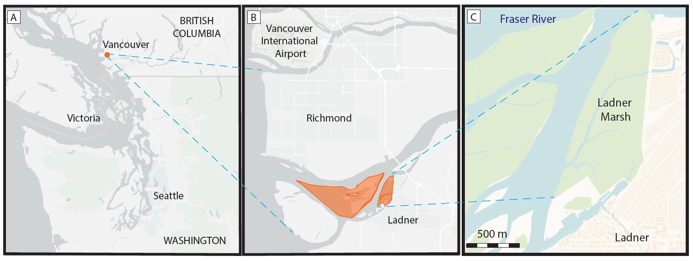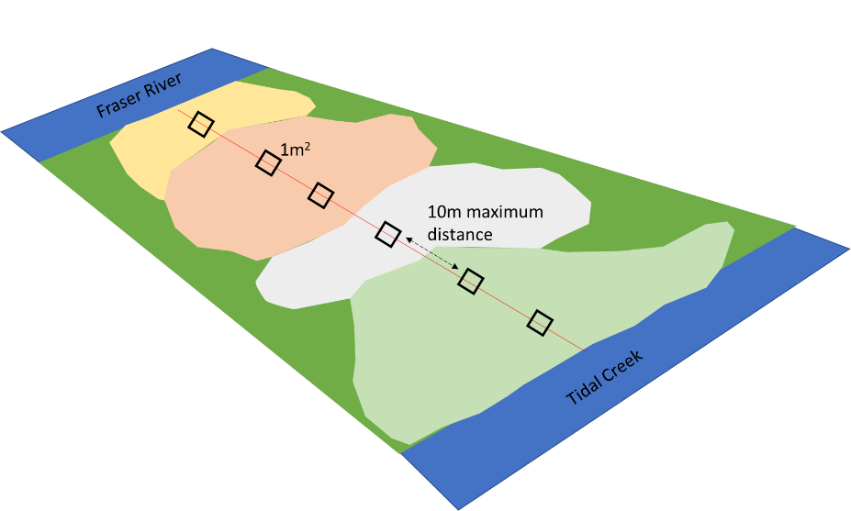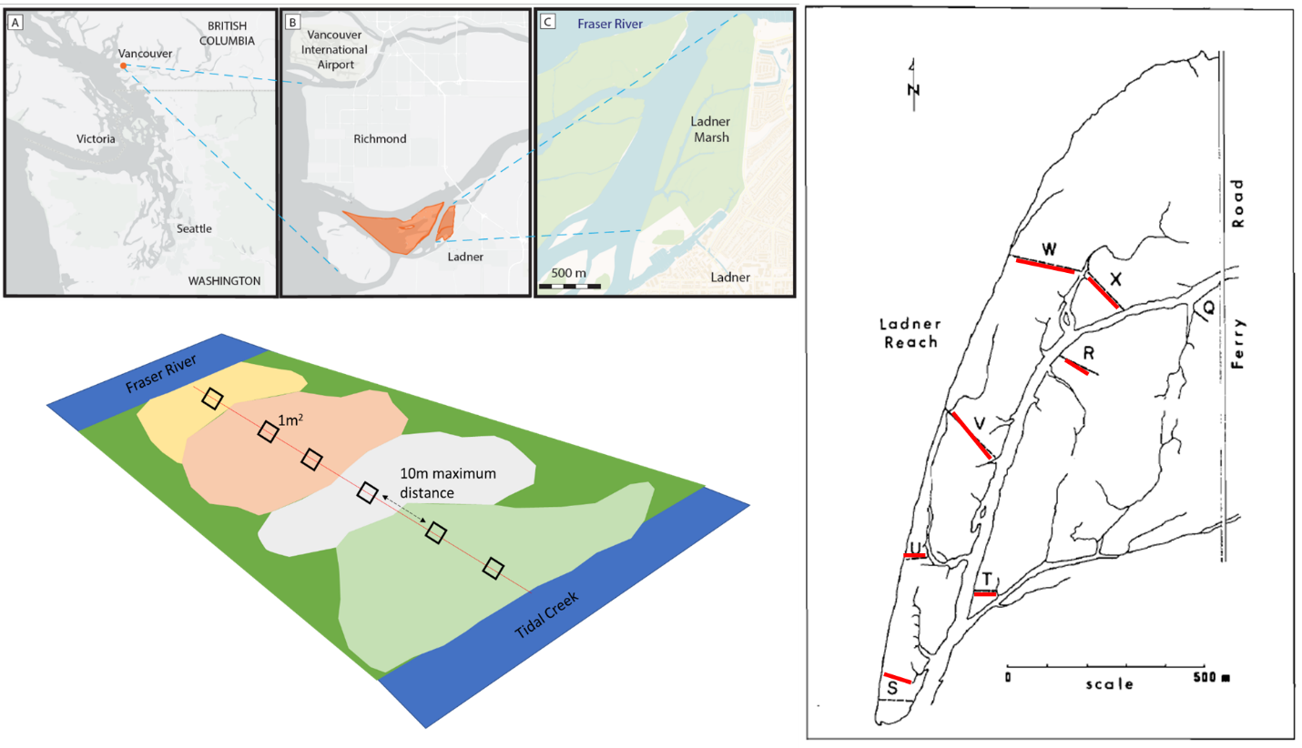

D

E

Figure . Location of the study site in Vancouver, British Columbia, Canada (A), approximately 20 km north of the South Arm Marshes Wildlife Management Area (highlighted in orange, B). Ladner Marsh abuts municipal development on the south bank of the Fraser River (C). Base maps (A, B) generated by iMap published by the B. C. Conservation Data Center (Victoria, BC, Canada, <https://maps.gov.bc.ca/ess/hm/imap4m/>) and (C) OpenStreetMap (OpenStreetMap contributors, 2015, <https://www.openstreetmap.org/>) (Lane, 2022). (D) Transect locations illustrated in 1982 publication figure (line drawing), which was overlayed on Google Earth basemap to relocate transects in 2019 (red)), and (E) semi-systematic plot placement within and between assemblages based on species dominance.

# Results

Three main assemblages within Ladner Marsh can be characterized by the same dominant indicator species across all sampling periods: Sedge (*Carex lyngbyei*), Fescue (*Fescue arundinaceae*), and Bogbean (*Menyanthes trifoliata*). While the three assemblage indicator species remain constant over time and drive cluster groups, other species that significantly drive indicators of assemblages change over time (Table 3). For example, in 1979 the indicator species defining the Sedge assemblage cluster were *C. lyngbyei, Sagittaria latifolia* Wiild.*,* and *Schoenoplectus tabernaemontani* (C.C.Gmel.) Palla, however in 1999 the same assemblage included indicator species *C. lyngbyei, Agrostis stolonifera* L.*,* and *Impatiens capensis* Meerb. By 2019, *C. lyngbyei* was the only indicator for this assemblage. Similarly, *F. arundinaceae* remained a common indicator species within the Fescue assemblage, but the assemblage lost four out of seven total indicator species between 1979-2019, and identities of the remaining indicator species changed.

Across the entire Ladner Marsh plant community, two to three species were lost each year following the 1979 survey. Within every assemblage alpha-diversity (mean number of species per plot) decreased every observation year, while beta-diversity (variation in number of species between plots) increased each year for all assemblages. (Table 1) For example, the Sedge community suffered the least loss of species and alpha-diversity across sampling years, although beta-diversity increased as in other assemblages, indicating increasing variability (and thus increased rarity) in which species may be encountered within a given assemblage. The Fescue assemblage had the greatest loss of alpha-diversity (> 50%) between 1979 and 2019. Nearly 50% fewer plots clustered as Fescue in 2019 than in 1979, however bootstrapping 18 random plots from every sampling year showed the same trend, indicating that loss of species was not related to loss of plots (Table S5). Total magnitude of species turnover between 1999 and 2019 was ~50% in each assemblage, largely driven by greater species disappearance (loss) between 1999 and 2019 (Table 6).

The greatest loss of native species richness occurred in the Fescue assemblage, while gains in exotic richness were found in all assemblages (Table 7). The Fescue assemblage had a net loss of 18 native species between 1979 and 2019. Among the species lost from the assemblage, 12 were lost from all three assemblages (six forbs, six graminoids), or were never found in any other assemblage. Species gained include two woody species, and one each of forb, graminoid, and fern ally (*Equisetum arvense* L.). There was a net zero gain of exotics in the Fescue assemblage, however exotic *Phalaris arundinaceae* (reed canary grass) accounts for the greatest 2019 mean cover in the entire assemblage (25-50% mean cover). In the Bogbean assemblage, new exotic species include *P. arundinaceae* and *Iris pseudacorus* (yellow flag iris). Within the Sedge assemblage, there was a net loss of 3 native species, and net gain of 3 exotic species, including *P. arundinaceae* and *I. pseudacorus*. As of 2019, these species accounted for < 25% mean cover, but may be of significant management concern.

Cover abundance of species significantly defining assemblage associations show an overall trend of decreasing cover over time (Figure 3). Notably, Fescue assemblage shows ~50% decrease in cover of its exotic indicator *F. arundinaceae* between 1979 and 2019, while cover of exotic *P. arundinaceae* tripled since 1999. In the Sedge assemblage both native indicator sedge *C. lyngbyei* and exotic indicator grass *A. stolonifera* had decreased cover abundance from 1979-2019 (Figure 2, Table 3), with each species losing ~25-35% cover abundance between 1979-2019. Meanwhile, exotic species *Lythrum salicaria* and *F. arundinaceae* increased ~50% and 100%, respectively, in abundance (< 25% mean cover) by 2019 (Table 7). Similarly, in the Bogbean assemblage, cover abundance of native keystone species *M. trifoliata* had declined ~21% (50-75% mean cover) by 2019, while cover of exotic *Mentha aquatica* L.had increased ~385% (~25-50% mean cover). In summary, while the dominant species are maintained, their cover abundance within each assemblage is declining. Moreover, some exotic species have increased substantially in cover abundance in the Fescue and Bogbean assemblages since the original survey. Increasing abundance of exotic species within each assemblage is likely driving the greater similarity with assemblages (homogenization) and greater dissimilarity between assemblages, as shown by cluster analysis (Figure 2).

Table 1 Between 1979 and 2019, 8 fewer plots and 5 fewer species were observed, resulting in slightly lower α-diversity and greater β-diversity. For each assemblage type, Bogbean is the only assemblage to proportionally gain plots between 1979 and 2019, while the Fescue and Sedge assemblages lost plots. Plot loss did not appear to have an effect on diversity components, as tested by bootstrapping a minimum of 18 plots per assemblage each year (Table 5)

|  |  |  |  |  |  |  |
| --- | --- | --- | --- | --- | --- | --- |
|  | **Plot-level components** | |  | **Diversity components** | | |
| **Assemblage** | **No. quadrats** | **No. species** |  | **α diversity** | **α diversity sd** | **β diversity** |
| **Sedge** |  |  |  |  |  |  |
| 1979 | 34 | 36 |  | 8.74 | 2.45 | 3.89 |
| 1999 | 31 | 35 |  | 8.26 | 1.98 | 4.24 |
| 2019 | 28 | 34 |  | 7.89 | 2.69 | 4.31 |
|  |  |  |  |  |  |  |
| **Fescue** |  |  |  |  |  |  |
| 1979 | 29 | 47 |  | 12.83 | 3.87 | 3.66 |
| 1999 | 33 | 41 |  | 9.69 | 3.96 | 4.23 |
| 2019 | 18 | 27 |  | 5.83 | 2.79 | 4.63 |
|  |  |  |  |  |  |  |
| **Bogbean** |  |  |  |  |  |  |
| 1979 | 19 | 32 |  | 12.84 | 3.61 | 2.49 |
| 1999 | 18 | 36 |  | 11.50 | 2.92 | 3.13 |
| 2019 | 28 | 34 |  | 10.46 | 1.90 | 3.25 |
|  |  |  |  |  |  |  |
| **Total** |  |  |  |  |  |  |
| 1979 | 82 | 48 |  | 9.96 | 3.41 | 4.82 |
| 1999 | 82 | 45 |  | 9.55 | 3.30 | 4.71 |
| 2019 | 74 | 43 |  | 8.36 | 3.03 | 5.14 |

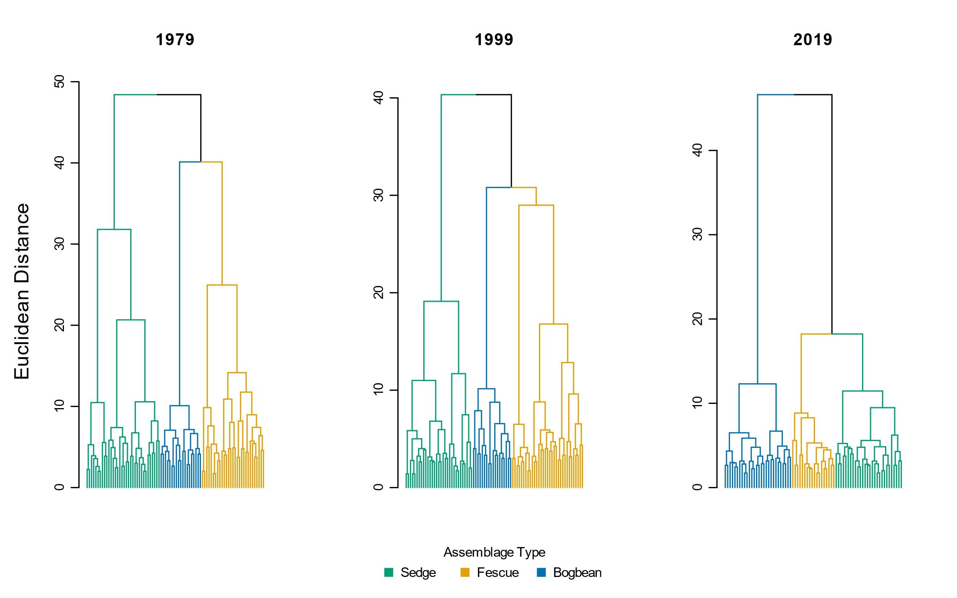

Figure Species cover abundance becomes more dissimilar in each assemblage over time, as shown by greater Euclidean distance between assemblage types. Note clusters of the sedge and fescue assemblages are more similar in 2019



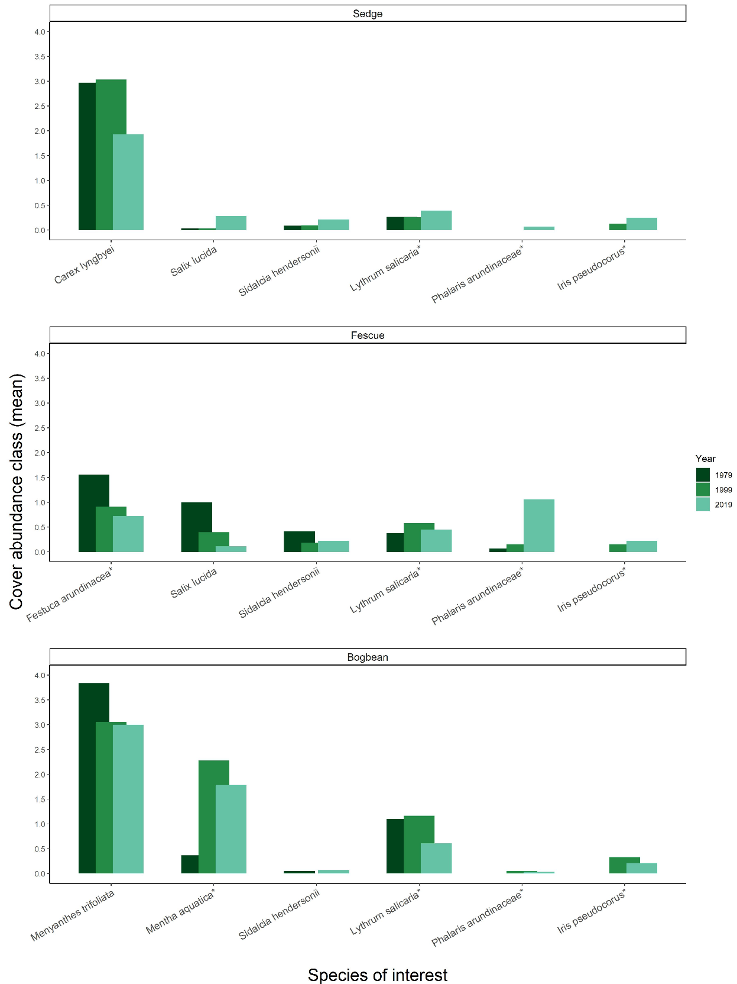

Figure Assemblage-defining species (at left, each panel) decrease in abundance over time, while several exotic species (denoted by (\*)) have increased in cover abundance since 1979



# Discussion

Despite conservation status and general resilience of this ecosystem we found there have been substantive changes in species composition over time, potentially indicating broader-scale processes affected by regional pressures. We found the three species most significantly characterizing the three main plant assemblages, Sedge, Fescue and Bogbean, have remained the same over the past 40 years, supporting our expectation that these characteristic species should not change in the absence of significant environmental disturbance. We observed a decline of native species richness accompanied by an increased richness and abundance of exotic species, which may indicate a loss of community stability. This potential instability may further be evidenced by the homogenization of cover abundance within assemblages, greater dissimilarity between assemblages, and overall loss of secondary indicator species for the Sedge and Fescue assemblages. Our results present another compelling case example of broader global trends of species biodiversity loss, and are of conservation concern for estuary management objectives of wildlife habitat and shoreline stability.

The biodiversity loss of native species richness and abundance could lead to altered biotic interactions and subsequent ecosystem function (Waller et al., 2020). One functional group to note were the woody species, as woody species traits convey different structural habitat qualities than herbaceous species. Willow (*Salix* sp.) was most prevalent in the Fescue assemblage in 1979, but was most abundant in the Sedge assemblage in 2019. This could suggest long-term shifts in edaphic factors and/or the competitive encroachment of exotic reed canary grass (*Phalaris arundinaceae*), making the Fescue assemblage less hospitable to willow recruitment. Alternatively, this could indicate that environmental conditions are becoming more similar between the two assemblages, as evidenced by the clustering of the Fescue and Sedge groups on the same branch in the 2019 dendrogram (Figure 2). Thus, the changing identity of species or functional traits in an assemblage may offer clues to changing abiotic conditions within or between assemblages. By further example, the indicator species analysis for the Sedge assemblage in 1979 included indicators of highly saturated soils (*Sagittaria latifolia, Schoenoplectus tabernaemontani*), but in 1999 the assemblage indicators included species tolerant of drier conditions (*Agrostis stolonifera, Impatiens capensis*) (Table 7). Besides edaphic qualities, this could be indicative of channel morphology changes, such as loss or movement of slumping banks vegetated by aquatic emergent plants. A reduced ecological emphasis on identity of species turnover could be evidenced in the Bogbean assemblage, which maintained four forb indicator species and at least one fern ally of its 6-10 indicator species all observation years. The turnover of secondary indicator species may simply represent high interannual variation in species compositional abundance, despite being a perennial-dominated community. However, greater homogeneity of cover abundance within assemblages, and greater compositional abundance distinction between assemblages may result directly from overall loss of native floristic richness. These trends of high turnover and loss of richness may indicate greater susceptibility to invasion (Kuiters, *et al.*, 2009), and thus a loss of resistance over time to exotic species encroachment. Over time the ratio of native to exotic cover across Ladner Marsh declined (Figure 5), although few species (native or exotic) represent the majority of cover within the assemblage (Table 7). Exotic species of significant management concern (e.g., *P. arundinaceae*, *I. pseudacorus*)) were < 25% mean plot cover in 2019, however these species are notorious for spreading to the point of near-exclusion of other species (especially natives) (Apfelbaum & Sams, 1987; Sinks et al., 2021).

The presence or persistence of species-specific optimal abiotic conditions may largely be driven by soil characteristics and related sedimentation processes. Loss of sediment within estuaries including the Fraser River Estuary is driven by a combination of factors, such as increased impervious cover, bank dyking or armoring, and channel dredging (Atkins et al., 2016). Sedimentary changes such as sediment starvation or subsidence would result in more saturated areas, which would likely drive the increased prevalence of Bogbean assemblage (Mendelssohn & Kuhn, 2003). Alternatively, positive feedbacks between vegetation and sedimentation could support areas of marsh accretion (Nyman et al., 2006), which may also be more likely to receive exotic propagules within the distributed sediment. Propagule pools would depend on local and regional proximity. If similar habitats within tidal estuarine ecosystems are lost to the point where distance between patches exceeds propagule dispersal distance (Shi, et al., 2020), then species colonization within the ecosystem is rare or lost. Alternatively, if exotic species are more prevalent throughout the regional dispersal network, then there is a greater chance of exotic species introduction over native within a local marsh community. Abiotic shifts may be altering the seed recruitment niches to favor exotics and limit native species recruitment (Lane, 2022), while dispersal networks may be delivering disproportionately more seed of exotic species. This reflects a general trend of exotic species’ competitive advantage in disturbed systems, and represents ongoing press disturbance by anthropogenic impacts with cumulative ecosystem effects.

## Synthesis & Recommendations

Species invasion and native species loss may lead to instability in populations through fragmented or lost propagule dispersal networks, resulting in ecosystem instability through altered trophic cascades and implications for endangered species. Disentangling explicit impacts of sedimentary, dispersal, or recruitment processes would be no easy task in a tidal ecosystem, however experimentally testing optimal recruitment niches of species-specific propagules could prove valuable for understanding best practices to maintain at-risk populations or community function.

Despite our knowledge to the contrary, practitioners often erroneously assume no direct anthropogenic disturbance suffices to conserve an ecologically appropriate reference state (e.g., Stoddard, et al., 2006, and citations therein). These findings yet again confirm that contemporary “reference” sites are not sufficient benchmarks for restoration success (Shackelford, et al., 2021). The biodiversity loss described here presents real conservation concerns for this community, and highlights negative biodiversity trends in conservation habitat thought to be relatively pristine. Most importantly: active management informed by experimental testing of hydrogeomorphologic drivers, dispersal networks, and recruitment strategies will be needed to maintain ecologically desired species composition in the face of climate change. If we are to prioritize conservation of functional coastal wetlands that include a significant representation of native species, we must seek new ways to actively manage habitats such as Ladner Marsh. Through control of invasive species and experimental management practices to employ sediment application and/or native species planting, practitioners may enhance ecosystem processes within remnant coastal wetland habitats. This active management process also presents a timely and necessary opportunity in the Pacific Northwest of North America to engage with First Nations to revive traditional management practices in tidal wetlands, such as select mechanical disturbance (Turner, 2014): working with traditional knowledge holders in these ecosystems may yield deeper understanding of plant community function and habitat stability, which would enhance ecosystem resilience and potentially lead to positive effects on regionally important salmonid and shorebird populations while contributing to reconciliation between Indigenous and colonial cultures.

# Statements & Declarations

## Funding

Financial support for 2019 field surveys was provided by Natural Sciences and Engineering Research Council of Canada Discovery Grant RGPIN-2018-03838 to J. Richardson (University of British Columbia).

## Competing interests

The authors have no relevant financial or non-financial interests to disclose.

## Author contributions

Study conception, design, 2019 data collection, and analysis were exclusively undertaken by Stefanie L. Lane. Original (1979) study concept comparing plant assemblages, data collection, and analysis were performed or overseen by Gary Bradfield. Madlen Denoth contributed 1999 dataset. Nancy Shackelford assisted with theoretical framework and manuscript revision. Manuscript was drafted by Stefanie L. Lane; Nancy Shackelford and Tara G. Martin commented on previous versions of the manuscript. All authors read and approved the final manuscript.

## Data availability

Data for all years of observation are available on Dryad (DOI). Code is available on GitHub (REPO), or via Dryad (DOI)

# Literature Cited

Apfelbaum, S. I., & Sams, C. E. (1987). Ecology and Control of Reed Canary Grass (Phalaris arundinacea L.). *Natural Areas Journal*, *7*(2), 69–74.

Atkins, R. J., Tidd, M., & Ruffo, G. (2016). Sturgeon Bank, Fraser River Delta, BC, Canada: 150 Years of Human Influences on Salt Marsh Sedimentation. *Journal of Coastal Research*, *SI*(75), 790–794. https://doi.org/10.2112/SI75-159.1

Bradfield, G. E., & Porter, G. L. (1982). Vegetation structure and diversity components of a Fraser estuary tidal marsh. *Canadian Journal of Botany*, *60*(4), 440–451. https://doi.org/10.1139/b82-060

Brophy, L. S., Greene, C. M., Hare, V. C., Holycross, B., Lanier, A., Heady, W. N., O’Connor, K., Imaki, H., Haddad, T., & Dana, R. (2019). Insights into estuary habitat loss in the western United States using a new method for mapping maximum extent of tidal wetlands. *PLOS ONE*, *14*(8), e0218558. https://doi.org/10.1371/journal.pone.0218558

Chalifour, L., Scott, D. C., MacDuffee, M., Iacarella, J. C., Martin, T. G., & Baum, J. K. (2019). Habitat use by juvenile salmon, other migratory fish, and resident fish species underscores the importance of estuarine habitat mosaics. *Marine Ecology Progress Series*, *625*, 145–162. https://doi.org/10.3354/meps13064

Davis, M. J., Woo, I., Ellings, C. S., Hodgson, S., Beauchamp, D. A., Nakai, G., & De La Cruz, S. E. W. (2021). A climate-mediated shift in the estuarine habitat mosaic limits prey availability and reduces nursery quality for juvenile salmon. *Estuaries and Coasts*. https://doi.org/10.1007/s12237-021-01003-3

De Cáceres, M., & Jansen, F. (2016). *Indicspecies*. http://r.meteo.uni.wroc.pl/web/packages/indicspecies/indicspecies.pdf

Denoth, M., & Myers, J. H. (2007). Competition between Lythrum salicaria and a rare species: Combining evidence from experiments and long-term monitoring. *Plant Ecology*, *191*(2), 153–161. https://doi.org/10.1007/s11258-006-9232-2

Donohue, I., Hillebrand, H., Montoya, J. M., Petchey, O. L., Pimm, S. L., Fowler, M. S., Healy, K., Jackson, A. L., Lurgi, M., McClean, D., O’Connor, N. E., O’Gorman, E. J., & Yang, Q. (2016). Navigating the complexity of ecological stability. *Ecology Letters*, *19*(9), 1172–1185. https://doi.org/10.1111/ele.12648

Douglas, T. J., Schuerholz, G., & Juniper, S. K. (2022). Blue Carbon Storage in a Northern Temperate Estuary Subject to Habitat Loss and Chronic Habitat Disturbance: Cowichan Estuary, British Columbia, Canada. *Frontiers in Marine Science*, *9*. https://www.frontiersin.org/article/10.3389/fmars.2022.857586

Dufrêne, M., & Legendre, P. (1997). Species Assemblages and Indicator Species:the Need for a Flexible Asymmetrical Approach. *Ecological Monographs*, *67*(3), 345–366. https://doi.org/10.1890/0012-9615(1997)067[0345:SAAIST]2.0.CO;2

Emmett, R., Llansó, R., Newton, J., Thom, R., Hornberger, M., Morgan, C., Levings, C., Copping, A., & Fishman, P. (2000). Geographic signatures of North American West Coast estuaries. *Estuaries*, *23*(6), 765–792. http://dx.doi.org/10.2307/1352998

Hallett, L. M., Jones, S. K., MacDonald, A. A. M., Jones, M. B., Flynn, D. F. B., Ripplinger, J., Slaughter, P., Gries, C., & Collins, S. L. (2016). codyn: An r package of community dynamics metrics. *Methods in Ecology and Evolution*, *7*(10), 1146–1151. https://doi.org/10.1111/2041-210X.12569

Hanski, I. (1982). Dynamics of Regional Distribution: The Core and Satellite Species Hypothesis. *Oikos*, *38*(2), 210–221. JSTOR. https://doi.org/10.2307/3544021

Hitchcock, C. L., & Cronquist, A. (1973). *Flora of the Pacific Northwest, an illustrated manual*. University of Washington Press.

Holling, C. S. (1973). Resilience and Stability of Ecological Systems. *Annual Review of Ecology and Systematics*, *4*(1), 1–23. https://doi.org/10.1146/annurev.es.04.110173.000245

Kopecký, M., & Macek, M. (2015). Vegetation resurvey is robust to plot location uncertainty. *Diversity and Distributions*, *21*(3), 322–330. https://doi.org/10.1111/ddi.12299

Lane, S. L. (2022). Using marsh organs to test seed recruitment in tidal freshwater marshes. *Applications in Plant Sciences*, *n/a*, e11474. https://doi.org/10.1002/aps3.11474

Legendre, P., & Legendre, L. (2012). *Numerical Ecology* (3rd ed., Vol. 24). Elsevier.

Lepš, J. (2004). What do the biodiversity experiments tell us about consequences of plant species loss in the real world? *Basic and Applied Ecology*, *5*(6), 529–534. https://doi.org/10.1016/j.baae.2004.06.003

Mendelssohn, I. A., & Kuhn, N. L. (2003). Sediment subsidy: Effects on soil–plant responses in a rapidly submerging coastal salt marsh. *Ecological Engineering*, *21*(2), 115–128. https://doi.org/10.1016/j.ecoleng.2003.09.006

Nyman, J. A., Walters, R. J., Delaune, R. D., & Patrick, W. H. (2006). Marsh vertical accretion via vegetative growth. *Estuarine, Coastal and Shelf Science*, *69*(3), 370–380. https://doi.org/10.1016/j.ecss.2006.05.041

Ovaskainen, O., Rybicki, J., & Abrego, N. (2019). What can observational data reveal about metacommunity processes? *Ecography*, *42*(11), 1877–1886. https://doi.org/10.1111/ecog.04444

Pasternack, G. B. (2009). Chapter 3. Hydrogeomorphology and sedimentation in tidal freshwater wetlands. In A. Barendregt, D. F. Whigham, & A. H. Baldwin (Eds.), *Tidal Freshwater Wetlands* (pp. 31–40). Backhuys Publishers.

Schaefer, V. (2004). Ecological setting of the Fraser River delta and its urban estuary. In B. J. Groulx, D. C. Mosher, J. L. Luternauer, & D. E. Bilderback (Eds.), *Fraser River Delta, British Columbia: Issues of an Urban Estuary* (pp. 147–172). Geological Survey of Canada, Bulletin 547.

Shackelford, N., Dudney, J., Stueber, M. M., Temperton, V. M., & Suding, K. L. (2021). Measuring at all scales: Sourcing data for more flexible restoration references. *Restoration Ecology*, *n/a*(n/a), e13541. https://doi.org/10.1111/rec.13541

Shi, W., Shao, D., Gualtieri, C., Purnama, A., & Cui, B. (2020). Modelling long-distance floating seed dispersal in salt marsh tidal channels. *Ecohydrology*, *13*(1), e2157. https://doi.org/10.1002/eco.2157

Sinks, I. A., Borde, A. B., Diefenderfer, H. L., & Karnezis, J. P. (2021). Assessment of Methods to Control Invasive Reed Canarygrass (Phalaris arundinacea) in Tidal Freshwater Wetlands. *Natural Areas Journal*, *41*(3), 172–185. https://doi.org/10.3375/043.041.0303

Stoddard, J. L., Larsen, D. P., Hawkins, C. P., Johnson, R. K., & Norris, R. H. (2006). Setting Expectations for the Ecological Condition of Streams: The Concept of Reference Condition. *Ecological Applications*, *16*(4), 1267–1276. https://doi.org/10.1890/1051-0761(2006)016[1267:SEFTEC]2.0.CO;2

Turner, N. (2014). *Ancient Pathways, Ancestral Knowledge: Ethnobotany and Ecological Wisdom of Indigenous Peoples of Northwestern North America*. McGill-Queen’s Press - MQUP.

Underwood, A. J., Chapman, M. G., & Connell, S. D. (2000). Observations in ecology: You can’t make progress on processes without understanding the patterns. *Journal of Experimental Marine Biology and Ecology*, *250*(1), 97–115. https://doi.org/10.1016/S0022-0981(00)00181-7

Waller, L. P., Allen, W. J., Barratt, B. I. P., Condron, L. M., França, F. M., Hunt, J. E., Koele, N., Orwin, K. H., Steel, G. S., Tylianakis, J. M., Wakelin, S. A., & Dickie, I. A. (2020). Biotic interactions drive ecosystem responses to exotic plant invaders. *Science*, *368*(6494), 967–972. https://doi.org/10.1126/science.aba2225

Whittaker, R. H. (1975). *Communities and Ecosystems* (2nd ed.). Macmillan.

# Supplemental

Table . A total of 25 plots sampled in 1979 and 1999 were not sampled in 2019, mostly due to issues of accessibility. Transect names and plot ID of plots omitted follow Fig. 3 in Bradfield & Porter (1982).

|  |  |  |
| --- | --- | --- |
| **Transect** | **1979/1999**  **Plot No.** | **Reason omitted in 2019** |
| Q | 1-7 | Transect in dense riparian thicket overgrown with Himalayan blackberry |
| R | 8 | Plot on lower bench (> 1 m lower than marsh platform), vegetation no longer exists |
| R | 17-19 | Plots in 1979 & 1999 sampled across a channel. Ended transect in 2019 at channel edge. |
| S | 33-36 | Transect length in 2019 was shorter than in 1979/1999. Suspect combination of erosion and offset transect relocation altered sampling distance. |
| T | 45 | Transect length in 2019 was shorter than in 1979/1999. Suspect combination of erosion and offset transect relocation altered sampling distance. |
| U | 51-52 | Transect length in 2019 was shorter than in 1979/1999. Suspect combination of erosion and offset transect relocation altered sampling distance. |
| V | 53 | Plot 53 only plot across a channel. Increased channel width and likely erosion made crossing this channel dangerous; omitted plot in 2019. |
| V | 54, 70-71 | Transect length in 2019 was shorter than in 1979/1999. Suspect combination of erosion and offset transect relocation altered sampling distance. |
| W | 89-92 | Transect length in 2019 was shorter than in 1979/1999. Suspect combination of erosion and offset transect relocation altered sampling distance. |
| X | 93 | Transect length in 2019 was shorter than in 1979/1999. Suspect combination of erosion and offset transect relocation altered sampling distance. |

Table 3. Species significantly driving cluster groups (Euclidean distance) include the same dominant species in each assemblage type (Sedge by Carex lyngbyei, Fescue by Festuca arundinaceae, Bogbean by Menyanthes trifoliata). Indicator species significantly defining the assemblage reported for p < 0.05.

|  |  |  |  |  |  |  |  |  |  |  |  |
| --- | --- | --- | --- | --- | --- | --- | --- | --- | --- | --- | --- |
|  | **1979** | | |  | **1999** | | |  | **2019** | | |
| Cluster Group Name | Species | IndVal | p-value |  | Species | IndVal | p-value |  | Species | IndVal | p-value |
|  |  |  |  |  |  |  |  |  |  |  |  |
| "Sedge" | *Carex lyngbyei* | 0.722 | 0.0001 |  | *Carex lyngbyei* | 0.626 | 0.0001 |  | *Carex lyngbyei* | 0.591 | 0.0001 |
| *Sagittaria latifolia* | 0.523 | 0.0001 |  | *Agrostis stolonifera* | 0.447 | 0.0003 |  |  |  |  |
| *Schoenoplectus tabernaemontani* | 0.417 | 0.0002 |  | *Impatiens capensis* | 0.320 | 0.0147 |  |  |  |  |
|  |  |  |  |  |  |  |  |  |  |  |  |
| "Fescue" | *Festuca arundinaceae* | 0.607 | 0.0001 |  | *Poa palustris* | 0.569 | 0.0001 |  | *Phalaris arundinaceae* | 0.518 | 0.0001 |
| *Salix lasiandra* | 0.535 | 0.0001 |  | *Festuca arundinaceae* | 0.399 | 0.0010 |  | *Festuca arundinaceae* | 0.461 | 0.0005 |
| *Equisetum palustre* | 0.489 | 0.0001 |  | *Trifolium wormskjoldii* | 0.398 | 0.0015 |  | *Equisetum fluviatile* | 0.320 | 0.0122 |
| *Lathyrus palustris* | 0.433 | 0.0002 |  | *Bidens cernua* | 0.371 | 0.0054 |  |  |  |  |
| *Sidalcia hendersonii* | 0.331 | 0.0054 |  |  |  |  |  |  |  |  |
| *Hordeum brachyantherum* | 0.293 | 0.0159 |  |  |  |  |  |  |  |  |
|  |  |  |  |  |  |  |  |  |  |  |  |
| "Bogbean" | *Menyanthes trifoliata* | 0.729 | 0.0001 |  | *Mentha aquatica* | 0.811 | 0.0001 |  | *Menyanthes trifoliata* | 0.942 | 0.0001 |
| *Myosotis scorpiodes* | 0.446 | 0.0005 |  | *Menyanthes trifoliata* | 0.621 | 0.0001 |  | *Mentha aquatica* | 0.618 | 0.0001 |
| *Bidens cernua* | 0.407 | 0.0007 |  | Grass (unidentified) | 0.452 | 0.0007 |  | *Lysimachia thyrsiflora* | 0.537 | 0.0001 |
| *Lythrum salicaria* | 0.406 | 0.0040 |  | *Lythrum salicaria* | 0.424 | 0.0008 |  | *Galium trifidum* | 0.465 | 0.0004 |
| *Equisetum fluviatile* | 0.326 | 0.0112 |  | *Juncus articulatus* | 0.417 | 0.0003 |  | *Myosotis scorpioides* | 0.392 | 0.0062 |
| *Lysimachia thyrsiflora* | 0.321 | 0.0104 |  | *Equisetum fluviatile* | 0.404 | 0.0010 |  | *Juncus articulatus* | 0.334 | 0.0128 |
|  |  |  |  | *Myosotis scorpioides* | 0.352 | 0.0033 |  |  |  |  |
|  |  |  |  | *Eleocharis palustris* | 0.303 | 0.0215 |  |  |  |  |
|  |  |  |  | *Equisetum variegatum* | 0.277 | 0.0485 |  |  |  |  |
|  |  |  |  | *Deschampsia caespitosa* | 0.273 | 0.0292 |  |  |  |  |

*Table 4. Species indicator analysis of cluster groups using Bray-Curtis distance identifies the same dominant species in each assemblage type (Sedge, Fescue, Bogbean), however Bray-Curtis distance identifies different associated indicator species than those identified by Euclidean distance (Table 3).*

|  |  |  |  |  |  |  |  |  |  |  |  |
| --- | --- | --- | --- | --- | --- | --- | --- | --- | --- | --- | --- |
|  | **1979** | | |  | **1999** | | |  | **2019** | | |
| **Cluster Group Name** | **Species** | **IndVal stat** | **p-value** |  | **Species** | **IndVal stat** | **p-value** |  | **Species** | **IndVal stat** | **p-value** |
|  |  |  |  |  |  |  |  |  |  |  |  |
| "Sedge" | *Carex lyngbyei* | 0.678 | 0.001 |  | *Carex lyngbyei* | 0.804 | 0.001 |  | *Carex lyngbyei* | 0.714 | 0.001 |
| *Sagittaria latifolia* | 0.559 | 0.001 |  | *Agrostis stolonifera* | 0.434 | 0.003 |  | *Mentha arvensis* | 0.322 | 0.033 |
| *Schoenoplectus tabernaemontani* | 0.391 | 0.001 |  |  |  |  |  |  |  |  |
|  |  |  |  |  |  |  |  |  |  |  |
|  |  |  |  |  |  |  |  |  |  |  |  |
| "Fescue" | *Festuca arundinacea* | 0.753 | 0.001 |  | *Festuca arundinacea* | 0.765 | 0.001 |  | *Phalaris arundinaceae* | 0.584 | 0.001 |
| *Salix lucida* | 0.586 | 0.001 |  | *Phalaris arundinaceae* | 0.334 | 0.019 |  | *Festuca arundinacea* | 0.416 | 0.001 |
| *Lathyrus palustris* | 0.543 | 0.001 |  |  |  |  |  |  |  |  |
| *Equisetum palustre* | 0.475 | 0.002 |  |  |  |  |  |  |  |  |
| *Impatiens capensis* | 0.391 | 0.002 |  |  |  |  |  |  |  |  |
| *Sidalcia hendersonii* | 0.387 | 0.001 |  |  |  |  |  |  |  |  |
| *Platanthera dilatata* | 0.308 | 0.020 |  |  |  |  |  |  |  |  |
|  |  |  |  |  |  |  |  |  |  |  |  |
| "Bogbean" | *Menyanthes trifoliata* | 0.807 | 0.001 |  | *Menyanthes trifoliata* | 0.782 | 0.001 |  | *Mentha aquatica* | 0.752 | 0.001 |
| *Myosotis scorpioides* | 0.577 | 0.001 |  | *Leersia oryzoides* | 0.495 | 0.001 |  | *Menyanthes trifoliata* | 0.709 | 0.001 |
| *Juncus articulatus* | 0.523 | 0.001 |  | *Mentha aquatica* | 0.492 | 0.001 |  | *Lysimachia thyrsiflora* | 0.547 | 0.001 |
| *Lythrum salicaria* | 0.400 | 0.002 |  | *Bidens cernua* | 0.489 | 0.003 |  | *Salix lucida* | 0.465 | 0.001 |
| *Lysimachia thyrsiflora* | 0.400 | 0.002 |  | *Lysimachia thyrsiflora* | 0.478 | 0.001 |  | *Eleocharis palustris* | 0.460 | 0.001 |
| *Trifolium wormskjoldii* | 0.381 | 0.003 |  | *Juncus articulatus* | 0.438 | 0.001 |  | *Juncus articulatus* | 0.373 | 0.004 |
| *Lilaeopsis occidentalis* | 0.360 | 0.004 |  | *Juncus oxymeris* | 0.356 | 0.015 |  | *Galium trifidum* | 0.348 | 0.008 |
| *Mentha aquatica* | 0.313 | 0.010 |  | *Myosotis scorpioides* | 0.356 | 0.019 |  | *Bidens cernua* | 0.323 | 0.012 |
|  |  |  |  | Poaceae (unidentified sp.) | 0.356 | 0.013 |  |  |  |  |
|  |  |  |  | *Deschampsia caespitosa* | 0.354 | 0.014 |  |  |  |  |
|  |  |  |  | *Sagittaria latifolia* | 0.301 | 0.046 |  |  |  |  |

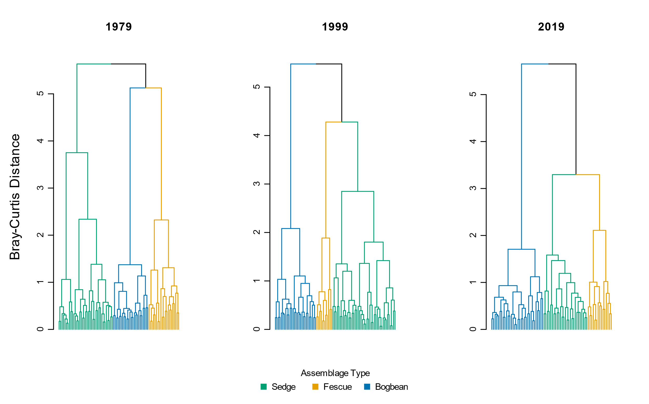

Figure . Cluster analysis using Bray-Curtis distance measure shows similar trends of increasing dissimilarity over time as when using Euclidean distance (Figure 2).

|  |  |  |  |  |  |  |
| --- | --- | --- | --- | --- | --- | --- |
|  | **Plot-level components** | |  | **Diversity components** | | |
| **Assemblage** | **No. quadrats** | **No. species** |  | **α diversity** | **α diversity sd** | **β diversity** |
| **Sedge** |  |  |  |  |  |  |
| 1979 | 18 | 32.3 |  | 10.67 | 2.34 | 3.03 |
| 1999 | 18 | 31.6 |  | 8.31 | 1.98 | 3.81 |
| 2019 | 18 | 30.8 |  | 8.18 | 2.51 | 3.77 |
|  |  |  |  |  |  |  |
| **Fescue** |  |  |  |  |  |  |
| 1979 | 18 | 43.3 |  | 12.96 | 3.91 | 3.35 |
| 1999 | 18 | 36.4 |  | 9.72 | 3.92 | 3.76 |
| 2019 | 18 | 27 |  | 5.83 | 2.79 | 4.63 |
|  |  |  |  |  |  |  |
| **Bogbean** |  |  |  |  |  |  |
| 1979 | 18 | 31.7 |  | 12.83 | 3.63 | 2.47 |
| 1999 | 18 | 36 |  | 11.50 | 2.92 | 3.13 |
| 2019 | 18 | 31.4 |  | 10.52 | 1.90 | 2.99 |
|  |  |  |  |  |  |  |
| **Total** |  |  |  |  |  |  |
| 1979 | 54 | 47.6 |  | 12.15 | 3.49 | 3.92 |
| 1999 | 54 | 42.1 |  | 10.02 | 3.35 | 4.22 |
| 2019 | 54 | 41.7 |  | 8.18 | 3.08 | 5.10 |

Table . Bootstrapping 18 randomly selected plots 10 times shows consistent overall trend in loss of species and alpha diversity over time, and overall increase in beta diversity between 1979 and 2019 in all assemblages and across the entire Ladner Marsh plant community. Therefore, loss of plots due to sampling re-location or how number of plots clustered into assemblages as reported in Table 2 is not expected to affect loss of species or plot-based diversity metrics.

Table 6. Total turnover and rates of species disappearance (loss) was always greater between 1999 and 2019 than between 1979 and 1999. However, fewer species were gained in the Bogbean assemblage 1999-2019 than 1979-1999.

|  |  |  |  |  |
| --- | --- | --- | --- | --- |
| **Assemblage** | **Year** | **Total turnover** | **Species Appearance** | **Species Disappearance** |
| Bogbean | 1979-1999 | 0.47 | 0.30 | 0.16 |
| 1999-2019 | 0.51 | 0.23 | 0.28 |
| Fescue | 1979-1999 | 0.35 | 0.13 | 0.21 |
| 1999-2019 | 0.58 | 0.15 | 0.44 |
| Sedge | 1979-1999 | 0.32 | 0.17 | 0.15 |
| 1999-2019 | 0.50 | 0.24 | 0.26 |

Table . Percent change in mean abundance (cover class) between from 1979 to 2019 for non-native and native species observed in each assemblage. New species appearances from 1979 to 2019 indicated by (+); species only appearing in 1999 indicated by ‘NA’. Native status is listed as ‘unknown’ if plant was not identified to species level.

|  |  |  |  |  |  |  |
| --- | --- | --- | --- | --- | --- | --- |
| **Assemblage** | **Status** | **Species** | **1979** | **1999** | **2019** | **Percent Change (1979-2019)** |
| Bogbean | Non-native | *Mentha arvensis* | 0.47 | 0.00 | 0.07 | -84.9 |
| *Myosotis scorpiodes* | 0.68 | 0.22 | 0.21 | -68.7 |
| *Agrostis stolonifera* | 3.21 | 1.50 | 1.29 | -60.0 |
| *Lythrum salicaria* | 1.11 | 1.17 | 0.61 | -45.1 |
| *Rumex conglomeratus* | 0.05 | 0.00 | 0.04 | -32.1 |
| *Mentha aquatica* | 0.37 | 2.28 | 1.79 | 384.7 |
| *Iris pseudocorus* | 0.00 | 0.33 | 0.21 | + |
| *Lycopus europaeus* | 0.00 | 0.00 | 0.04 | + |
| *Phalaris arundinacea* | 0.00 | 0.06 | 0.04 | + |
| *Festuca arundinacea* | 0.00 | 0.17 | 0.00 | NA |
| Native | *Alisma plantago aquatica* | 0.16 | 0.11 | 0.00 | -100.0 |
| *Alopecurus geniculatus* | 0.05 | 0.00 | 0.00 | -100.0 |
| *Deschampsia caespitosa* | 0.26 | 0.22 | 0.00 | -100.0 |
| *Equisetum fluviatile* | 1.37 | 1.17 | 0.00 | -100.0 |
| *Leersia oryzoides* | 0.26 | 0.33 | 0.00 | -100.0 |
| *Lilaeopsis occidentalis* | 0.21 | 0.00 | 0.00 | -100.0 |
| *Oenanthe sarmentosa* | 0.63 | 0.11 | 0.00 | -100.0 |
| *Poa trivialis* | 0.11 | 0.00 | 0.00 | -100.0 |
| *Sium suave* | 0.63 | 0.17 | 0.00 | -100.0 |
| *Caltha palustris* | 0.95 | 0.22 | 0.07 | -92.5 |
| *Bidens cernua* | 0.84 | 0.17 | 0.14 | -83.0 |
| *Trifolium wormskjoldii* | 0.95 | 0.11 | 0.18 | -81.2 |
| *Schoenoplectus tabernaemontani* | 0.16 | 0.00 | 0.07 | -54.8 |
| *Eleocharis palustris* | 0.63 | 0.78 | 0.39 | -37.8 |
| Symphyotrichum *subspicatum* | 0.47 | 0.33 | 0.32 | -32.1 |
| *Juncus oxymeris* | 0.05 | 0.11 | 0.04 | -32.1 |
| *Platanthera dilatata* | 0.05 | 0.06 | 0.04 | -32.1 |
| *Menyanthes trifoliata* | 3.84 | 3.06 | 3.00 | -21.9 |
| *Lysimachia thyrsiflora* | 0.53 | 0.22 | 0.57 | 8.6 |
| *Juncus articulatus* | 0.26 | 0.39 | 0.29 | 8.6 |
| *Sidalcea hendersonii* | 0.05 | 0.00 | 0.07 | 35.7 |
| *Carex lyngbyei* | 0.47 | 0.33 | 1.00 | 111.1 |
| *Rumex occidentalis* | 0.05 | 0.11 | 0.14 | 171.4 |
| *Potentilla anserina-pacifica* | 0.26 | 1.00 | 1.07 | 307.1 |
| *Equisetum arvense* | 0.00 | 0.00 | 0.64 | + |
| *Galium trifidum* | 0.00 | 0.00 | 0.39 | + |
| *Hypericum scouleri* | 0.00 | 0.00 | 0.04 | + |
| *Impatiens capensis* | 0.00 | 0.44 | 0.32 | + |
| *Juncus acuminatus* | 0.00 | 0.00 | 0.04 | + |
| *Lathyrus palustris* | 0.00 | 0.11 | 0.50 | + |
| *Lysichiton americanum* | 0.00 | 0.00 | 0.07 | + |
| *Salix lasiandra* | 0.00 | 0.61 | 0.50 | + |
| *Salix scouleriana* | 0.00 | 0.00 | 0.04 | + |
| *Typha latifolia* | 0.00 | 0.28 | 0.25 | + |
| *Equisetum palustre* | 0.00 | 0.11 | 0.00 | NA |
| *Equisetum variegatum* | 0.00 | 0.11 | 0.00 | NA |
| *Galium sp.* | 0.00 | 0.06 | 0.00 | NA |
| *Poa palustris* | 0.00 | 0.50 | 0.00 | NA |
| *Poaceae sp.* | 0.00 | 0.28 | 0.00 | NA |
| *Sagittaria latifolia* | 0.00 | 0.17 | 0.00 | NA |
|  |  |  |  |  |  |  |
| **Assemblage** | **Status** | **Species** | **1979** | **1999** | **2019** | **Percent Change (1979-2019)** |
| Fescue | Unknown | *Festuca sp.* | 0.03 | 0.00 | 0.00 | -100.0 |
| Non-native | *Mentha aquatica* | 0.31 | 0.09 | 0.00 | -100.0 |
| *Myosotis scorpiodes* | 0.31 | 0.03 | 0.00 | -100.0 |
| *Mentha arvensis* | 0.17 | 0.24 | 0.06 | -67.8 |
| *Festuca arundinacea* | 1.55 | 0.91 | 0.72 | -53.5 |
| *Lythrum salicaria* | 0.38 | 0.58 | 0.44 | 17.2 |
| *Agrostis stolonifera* | 0.34 | 0.82 | 0.61 | 77.2 |
| *Phalaris arundinacea* | 0.07 | 0.15 | 1.06 | 1430.6 |
| *Cirsium arvense* | 0.00 | 0.03 | 0.06 | + |
| *Iris pseudocorus* | 0.00 | 0.15 | 0.22 | + |
| *Lycopus europaeus* | 0.00 | 0.00 | 0.06 | + |
| Native | *Alisma plantago aquatica* | 0.10 | 0.18 | 0.00 | -100.0 |
| *Alopecurus geniculatus* | 0.03 | 0.00 | 0.00 | -100.0 |
| *Bidens cernua* | 0.21 | 0.52 | 0.00 | -100.0 |
| *Deschampsia caespitosa* | 0.62 | 0.09 | 0.00 | -100.0 |
| *Dulichium arundinaceum* | 0.07 | 0.00 | 0.00 | -100.0 |
| *Eleocharis palustris* | 0.97 | 0.33 | 0.00 | -100.0 |
| *Equisetum palustre* | 0.76 | 0.09 | 0.00 | -100.0 |
| *Galium trifidum* | 0.03 | 0.00 | 0.00 | -100.0 |
| *Hypericum formosum* | 0.10 | 0.00 | 0.00 | -100.0 |
| *Juncus articulatus* | 0.52 | 0.06 | 0.00 | -100.0 |
| *Leersia oryzoides* | 0.14 | 0.24 | 0.00 | -100.0 |
| *Lilaeopsis occidentalis* | 0.17 | 0.00 | 0.00 | -100.0 |
| *Mimulus guttatus* | 0.03 | 0.00 | 0.00 | -100.0 |
| *Oenanthe sarmentosa* | 0.17 | 0.30 | 0.00 | -100.0 |
| *Platanthera dilatata* | 0.21 | 0.03 | 0.00 | -100.0 |
| *Poa palustris* | 0.55 | 1.73 | 0.00 | -100.0 |
| *Poa trivialis* | 0.31 | 0.00 | 0.00 | -100.0 |
| *Polygonum hydropiper* | 0.03 | 0.00 | 0.00 | -100.0 |
| *Sagittaria latifolia* | 0.03 | 0.15 | 0.00 | -100.0 |
| *Salix sp.* | 0.03 | 0.00 | 0.00 | -100.0 |
| *Sium suave* | 0.14 | 0.15 | 0.00 | -100.0 |
| Symphyotrichum *subspicatum* | 0.59 | 0.24 | 0.00 | -100.0 |
| *Trifolium wormskioldii* | 0.69 | 0.55 | 0.00 | -100.0 |
| *Menyanthes trifoliata* | 1.86 | 1.33 | 0.06 | -97.0 |
| *Caltha palustris* | 0.66 | 0.39 | 0.06 | -91.5 |
| *Salix lasiandra* | 1.00 | 0.39 | 0.11 | -88.9 |
| *Carex lyngbyei* | 0.76 | 1.42 | 0.11 | -85.4 |
| *Potentilla anserina-pacifica* | 0.48 | 0.64 | 0.22 | -54.0 |
| *Sidalcea hendersonii* | 0.41 | 0.18 | 0.22 | -46.3 |
| *Lysimachia thyrsiflora* | 0.10 | 0.33 | 0.06 | -46.3 |
| *Typha latifolia* | 0.69 | 0.36 | 0.44 | -35.6 |
| *Hordeum brachyantherum* | 0.17 | 0.00 | 0.11 | -35.6 |
| *Equisetum fluviatile* | 0.62 | 0.36 | 0.44 | -28.4 |
| *Schoenoplectus tabernaemontani* | 0.07 | 0.15 | 0.06 | -19.4 |
| *Lathyrus palustris* | 0.55 | 0.18 | 0.56 | 0.7 |
| *Rumex occidentalis* | 0.07 | 0.15 | 0.11 | 61.1 |
| *Impatiens capensis* | 0.28 | 0.42 | 0.61 | 121.5 |
| *Equisetum arvense* | 0.00 | 0.00 | 0.39 | + |
| *Juncus effusus* | 0.00 | 0.00 | 0.06 | + |
| *Lysichiton americanum* | 0.00 | 0.00 | 0.11 | + |
| *Myrica gale* | 0.00 | 0.00 | 0.22 | + |
| *Salix scouleriana* | 0.00 | 0.00 | 0.17 | + |
| *Asteracea sp.* | 0.00 | 0.03 | 0.00 | NA |
| *Carex sp.* | 0.00 | 0.06 | 0.00 | NA |
| *Galium sp.* | 0.00 | 0.03 | 0.00 | NA |
| *Juncus oxymeris* | 0.00 | 0.09 | 0.00 | NA |
| *Salix sitchensis* | 0.00 | 0.03 | 0.00 | NA |
|  |  |  |  |  |  |  |
| **Assemblage** | **Status** | **Species** | **1979** | **1999** | **2019** | **Percent Change (1979-2019)** |
| Sedge | Unknown | *Galium sp.* | 0.00 | 0.03 | 0.00 | NA |
| Non-native | *Myosotis scorpiodes* | 0.03 | 0.00 | 0.00 | -100.0 |
| *Mentha arvensis* | 0.29 | 0.16 | 0.04 | -87.9 |
| *Agrostis stolonifera* | 1.85 | 2.32 | 1.25 | -32.5 |
| *Lythrum salicaria* | 0.26 | 0.26 | 0.39 | 48.4 |
| *Festuca arundinacea* | 0.09 | 0.10 | 0.18 | 102.4 |
| *Iris pseudocorus* | 0.00 | 0.13 | 0.25 | + |
| *Lycopus europaeus* | 0.00 | 0.00 | 0.11 | + |
| *Mentha aquatica* | 0.00 | 0.16 | 0.54 | + |
| *Phalaris arundinacea* | 0.00 | 0.00 | 0.07 | + |
| *Cirsium arvense* | 0.00 | 0.03 | 0.00 | NA |
| Native | *Alisma plantago aquatica* | 0.35 | 0.06 | 0.00 | -100.0 |
| *Deschampsia caespitosa* | 0.21 | 0.00 | 0.00 | -100.0 |
| *Leersia oryzoides* | 0.18 | 0.19 | 0.00 | -100.0 |
| *Lilaeopsis occidentalis* | 0.06 | 0.10 | 0.00 | -100.0 |
| *Mimulus guttatus* | 0.09 | 0.00 | 0.00 | -100.0 |
| *Oenanthe sarmentosa* | 0.71 | 0.39 | 0.00 | -100.0 |
| *Platanthera dilatata* | 0.09 | 0.03 | 0.00 | -100.0 |
| *Poa palustris* | 1.00 | 0.23 | 0.00 | -100.0 |
| *Puccinella pauciflora* | 0.03 | 0.00 | 0.00 | -100.0 |
| *Sium suave* | 0.59 | 0.19 | 0.00 | -100.0 |
| *Caltha palustris* | 1.09 | 0.48 | 0.04 | -96.7 |
| *Equisetum fluviatile* | 0.88 | 0.58 | 0.04 | -96.0 |
| *Schoenoplectus tabernaemontani* | 0.71 | 0.10 | 0.11 | -84.8 |
| *Trifolium wormskjoldii* | 0.41 | 0.13 | 0.07 | -82.7 |
| *Sagittaria latifolia* | 0.41 | 0.10 | 0.11 | -74.0 |
| *Bidens cernua* | 0.47 | 0.13 | 0.21 | -54.5 |
| *Eleocharis palustris* | 0.79 | 0.35 | 0.39 | -50.5 |
| *Menyanthes trifoliata* | 0.32 | 0.68 | 0.18 | -44.8 |
| *Carex lyngbyei* | 2.97 | 3.03 | 1.93 | -35.1 |
| *Typha latifolia* | 0.59 | 0.35 | 0.43 | -27.1 |
| Symphyotrichum *subspicatum* | 0.29 | 0.13 | 0.25 | -15.0 |
| *Rumex occidentalis* | 0.12 | 0.16 | 0.11 | -8.9 |
| *Lysimachia thyrsiflora* | 0.09 | 0.00 | 0.11 | 21.4 |
| *Sidalcea hendersonii* | 0.09 | 0.10 | 0.21 | 142.9 |
| *Potentilla anserina-pacifica* | 0.29 | 0.74 | 0.79 | 167.1 |
| *Rumex conglomeratus* | 0.03 | 0.00 | 0.11 | 264.3 |
| *Lathyrus palustris* | 0.09 | 0.26 | 0.46 | 426.2 |
| *Impatiens capensis* | 0.15 | 1.06 | 0.86 | 482.9 |
| *Salix lasiandra* | 0.03 | 0.03 | 0.29 | 871.4 |
| *Equisetum arvense* | 0.00 | 0.00 | 0.68 | + |
| *Galium palustre* | 0.00 | 0.00 | 0.04 | + |
| *Galium trifidum* | 0.00 | 0.00 | 0.07 | + |
| *Hypericum scouleri* | 0.00 | 0.00 | 0.07 | + |
| *Juncus articulatus* | 0.00 | 0.00 | 0.04 | + |
| *Juncus oxymeris* | 0.00 | 0.00 | 0.04 | + |
| *Scirpus microcarpus* | 0.00 | 0.00 | 0.07 | + |
| *Equisetum palustre* | 0.00 | 0.19 | 0.00 | NA |
| *Lysichiton americanum* | 0.00 | 0.03 | 0.00 | NA |
| *Salix sitchensis* | 0.00 | 0.06 | 0.00 | NA |

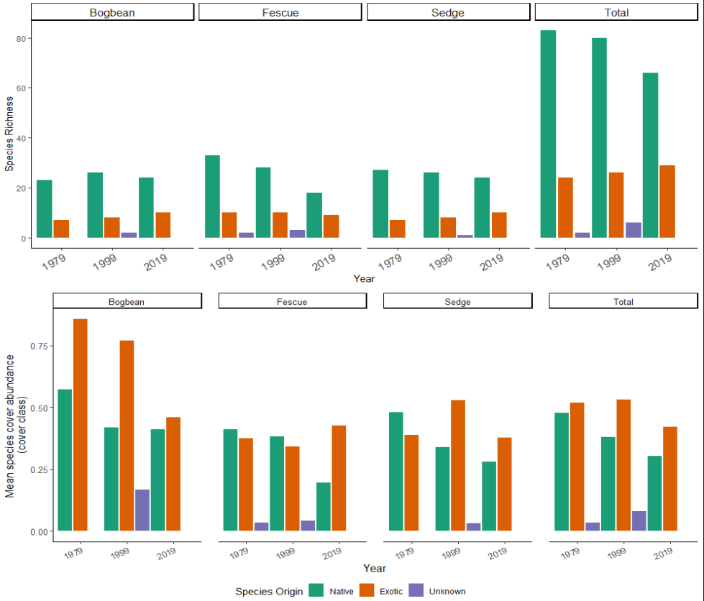

Figure . Top panel: Loss of native species richness over time across all assemblages is largely driven by loss of native species from the Fescue Assemblage. However, native species richness does not change substantially in the other two assemblages. Bottom panel: Native species cover is decreasing on average across all assemblages. Exotic species cover largely remains unchanged, although the ratio of native to exotic cover in Bogbean assemblage becomes more even by 2019. ‘Unknown’ species origin represents species identified only to genus, and assessment of native status cannot be made.

# Potential journals

## [Journal of Vegetation Science](https://onlinelibrary.wiley.com/page/journal/16541103/homepage/forauthors.html)

2020 IF 2.865 (Q1, Ecology/Plant Science)

\*\*Open access fee (J. Veg. Sci. and App. Veg. Sci.) = USD $3800

The Journal of Vegetation Science publishes articles on all aspects of plant community ecology and macroecology of vegetation, with particular emphasis on articles that develop new concepts or methods, test theory, **identify general patterns**, or that are otherwise likely to interest a broad international readership. An article may focus on any aspect of vegetation science, e.g. community structure (including community assembly and plant functional types), **biodiversity (including species richness and composition)**, spatial patterns (including plant geography and landscape ecology), **temporal changes (including demography, community dynamics** and palaeoecology) and processes (including ecophysiology), provided the focus is on increasing our understanding of plant communities. The journal does not publish articles on the ecology of a single species, except for studies framed in the community context, especially of species that play a key role in structuring plant communities (e.g. stand dominants). Articles that apply ecological concepts, theories and methods to the vegetation management, conservation and restoration, and articles on vegetation survey should be directed to our associate journal, [Applied Vegetation Science](https://onlinelibrary.wiley.com/page/journal/1654109x/homepage/forauthors.html).

## [Wetlands](https://www.springer.com/journal/13157/submission-guidelines" \l "Instructions%20for%20Authors_Article%20Types)

2020 SJR IF 2.369 (Q2, Ecology)

\*\* Open access fee = USD $3390, however there may be a discount from SpringerOpen/BMC affiliation

Original research: Articles reporting original research about wetlands, natural or constructed, including, but not limited to mechanisms underlying ecosystem processes, the values of wetlands to society, their management, **quality assessment** and restoration.

## [Marine & Freshwater Research](https://www.publish.csiro.au/mf/forauthors)

2020 SJR IF 2.034 (Q2, Aquatic Science)

Marine and Freshwater Research welcomes the submission of articles presenting original and significant research in the aquatic sciences (see [Scope](http://www.publish.csiro.au/nid/126/aid/429.htm)).

Articles that address broad conceptual questions, are interdisciplinary and of wide interest, and that consider further implications and management applications are especially encouraged, given the journal's broad scope. Specialist articles at the forefront of their field are also welcome as long as their context is clearly stated. **Descriptive articles may be considered if they are placed in an appropriate conceptual setting and have global relevance.** However, articles that are purely taxonomic, parochial, describe preliminary or incremental results, or simply present data without context will not be considered.

## [Plant Ecology](https://www.springer.com/journal/11258)

2020 SJR IF 1.914 (Q2, Ecology)

Plant Ecology publishes original scientific papers that report and interpret the findings of pure and applied research into the ecology of vascular plants in terrestrial and wetland ecosystems. Empirical, experimental, theoretical and review papers reporting on ecophysiology, population, community, ecosystem, landscape, molecular and historical ecology are within the scope of the journal.

* Note – Denoth & Myers (2007) was published in this journal; their dataset is included in this publication.