# Title Page

**Plant community compositional stability over 40 years in a Fraser River Estuary tidal freshwater marsh**

Stefanie L. Lane1, Nancy Shackelford2, Gary E. Bradfield3, Madlen Denoth3, 4, Tara G. Martin1

1Conservation Decisions Lab, Department of Forest and Conservation Science, University of British Columbia, Vancouver, BC, Canada; 2School of Environmental Studies, University of Victoria, Victoria, BC, Canada; 3Department of Botany, University of British Columbia, Vancouver, BC, Canada; 4Gymnasium Neufeld, Bern, Switzerland

Corresponding author: [stefanielane@utexas.edu](mailto:stefanielane@utexas.edu)

ORCID ID

Stefanie L. Lane (corresponding author): [0000-0002-4851-2772](https://orcid.org/0000-0002-4851-2772)

Nancy Shackelford: [0000-0003-4817-0423](https://orcid.org/0000-0003-4817-0423)

Tara G. Marin: [0000-0001-7165-9812](https://orcid.org/0000-0001-7165-9812)

## Abstract

Long-term data sets documenting temporal changes in vegetation communities are uncommon, yet imperative for understanding trends and triggering potential conservation management interventions. For example, decreasing species diversity and increasing non-native species abundance may be indicative of decreasing community stability. We explore long-term plant community change over a 40-year period through the contribution of data collected in 2019 to two historical datasets collected in 1979 and 1999 to evaluate decadal changes in plant community biodiversity in a tidal freshwater marsh in the Fraser River Estuary in British Columbia, Canada. We examine whether characteristic plant assemblages are consistent over time, whether alpha (α) and beta (β) diversity change within and between assemblages, and whether associated indicator species change. We found that plant assemblages were characterized by the same dominant indicator species, over timemost other indicator species changed, and that overall(?)α-diversity decreased while β-diversity increased. Further, we found evidence for plant assemblage homogenization through the increased abundance of non-native species. These observations may inform concepts of habitat stability in the absence of pulse disturbance pressures, and corroborate globally observed trends of native species loss and non-native species encroachment. Our results indicate that within the Fraser River Estuary, active threat management may be necessary in areas of conservation concern in order to prevent further native species biodiversity loss.

## Keywords

shifting baselines; reference conditions; dispersal networks; species turnover; conservation land management

## Acknowledgements

We are grateful to Z. Davis for providing R programming advice, and P. Roper for 2019 field assistance. B. Staines (Ladner Harbour Authority) provided canoe and harbor access for all field navigation. Research site access was granted by The Ministry of Forests, Lands, Natural Resource Operations and Rural Development.

# Introduction

In a time of rapid global change, temporal shifts in plant community composition can indicate ecosystem stress response and inform conservation management interventions. Shifts in community-dominant species may be indicative of interspecific interactions such as facilitation (Bruno, 2000), succession (Butzeck et al., 2016), or cycles of population dynamics on timescales that do not fit within human-oriented timescales for achieving conservation targets (Holling, 1973). Alternatively, changes in community-dominant species paired with loss of native species diversity and increasing abundance of non-native species may indicate loss of stability through loss of functional redundancy (Donohue et al., 2016; Tilman, 1999; Palmer et al., 1997). In turn, this may indicate reduced resistance to change or capacity to recover from disturbance, known as resilience (Tilman et al., 2006; Bai et al., 2004). Furthermore, the local loss of native species may have stronger negative impacts on regional biodiversity persistence when the regional pool of potential species is reduced or environmentally constrained (Lepš, 2004; Hanski, 1982). Characterization of plant community changes on decadal timescales contributes to observation of meaningful long-term patterns of compositional stability, and is instructive for developing hypotheses to test drivers of disturbance, especially in data-deficient, dynamic landscapes heavily impacted by anthropogenic activities such as estuaries (Underwood et al., 2000; Ovaskainen et al., 2019).

Estuaries are at the terrestrial-marine interface where hydrogeomorphic and ecological changes occur on annual, decadal, and millennial timescales (Pasternack, 2009). Estuarine habitats support high species richness, including species at risk (Kehoe et al., 2021) and are important carbon reservoirs (Douglas et al., 2022). Because these ecosystems will experience accelerated change under sea level rise, they are of increasing conservation concern (Brophy et al., 2019); understanding estuarine habitat changes and implications for habitat stability can inform global change resilience strategies. Estuaries in North America are of particular conservation importance in the Pacific Northwest (PNW) because their pathways of retreat or expansion are often spatially restricted by fjord geography (Emmett et al., 2000), whereas estuaries along the Atlantic coast may spread along expansive coastal plains. Tidal freshwater marshes are the upper reaches of estuaries dominated by riverine freshwater, and in the PNW they are particularly important as early transitional habitat along a salinity gradient for anadromous salmonids (Davis et al., 2021; Chalifour et al., 2019). The Fraser River Estuary is the largest estuary in British Columbia and of irreplaceable ecological and commercial value, yet has lost 85% of floodplain and 64% of stream habitat (Finn et al., 2021), emphasizing the need to understand the condition of remaining estuarine habitat. Estuary conservation efforts are intended to protect coastal municipalities and provide sufficient habitat for wildlife. Stability of plant communities within tidal marshes contribute to the ability of these habitats to resist change or recover from disturbance (Holling, 1973).

A barrier to understanding community stability, including within estuaries, is the lack of long-term data. In the absence of long-term monitoring, historical datasets can provide a ‘snapshot’ of species compositional variation over time. One such opportunity exists in the Fraser River estuary, British Columbia, Canada in an area called Ladner Marsh (Fig. 1). Despite large-scale industrialization and urbanization within the region, Ladner Marsh has escaped direct industrial development, and to the best of our knowledge has not experienced major natural or anthropogenic disturbance in the past 50 years. Two historical studies conducted in Ladner Marsh (Bradfield & Porter, 1982; Denoth & Myers, 2007) used similar methods to document floristic diversity. Bradfield & Porter (1982) tested whether species dominating the community statistically characterized distinct sub-community assemblages within the marsh. Their analysis distinguished three assemblages, each dominated by a unique species: Sedge (Carex lyngbyei Hornem.), Fescue (Festuca arundinacea Schreb.), and Bogbean (Menyanthes trifoliata L.). They postulated that edaphic factors drove assemblage distribution: that the Bogbean assemblage occurred on waterlogged soils, the Fescue assemblage on well-drained soils mostly along levees, and the Sedge assemblage along channel edges with greater inundation frequency. Twenty years later, Denoth & Myers (2007) repeated the sampling methods to test relationships between non-native purple loosestrife (Lythrum salicaria L.) and native(?) Henderson’s checker-mallow (Sidalcea hendersonii S. Watson), a threatened species. While these studies independently characterize different community metrics, these datasets provide the opportunity to repeat observations and characterize long-term plant community changes to inform inferences about habitat stability. We used three observational datasets spanning four decades to answer the following questions:

1. Are tidal freshwater marsh assemblages characterized by the same dominant plant species over a 40-year period? In the absence of significant environmental disturbance, we expect the same species composition to dominate each assemblage as identified by Bradfield & Porter (1982).
2. Are assemblages characterized by similar indicator plant species? If not, which species gained or lost are driving changes within each assemblage? We expect that increasing abundance of non-native species over time would result in a greater net loss of native species (and fewer net native species gained).
3. Is the mean species diversity (α-diversity) and variation (β-diversity) within and between assemblages constant between the three sampling periods (1979, 1999, 2019)? If the plant community is stable, we expect little change in α-diversity and β-diversity.

# Methods

The Fraser River is the largest watershed catchment in British Columbia, covering one quarter of the province (Finn et al., 2021). The current extent of the Fraser River Estuary spans 2,814 ha, one-third of which lies within the South Arm Marshes Wildlife Management Area (Schaefer, 2004) (Fig. 1B). Ladner Marsh occupies approximately 100 ha within the South Arm Marshes, bounded to the east by urban and industrial development and to the west by the Fraser River (Fig. 1). Plant species common to these habitats are generally herbaceous, and the community is largely dominated by sedges and rushes with some salinity tolerance, and a diversity of herbaceous flowering species (hereafter, forbs). This publication will reference dates the data were collected, rather than publication dates of the corresponding studies.

Our main goal was to sample the vegetation in a representative way to allow comparison with the datasets collected in 1979 (Bradfield & Porter, 1982) and 1999 (Denoth & Myers, 2007). Because Bradfield & Porter (1982) wanted to assess whether statistical analysis verified visual estimation of species associations, the sampling conducted in 1979 introduces a bias to statistically confirm patterns identified by subjective visual assessment. In 2019 we sought to sample vegetation in as close a manner as the original 1979 survey, which does not eliminate this bias. However, within the context of this sampling design we can make comparisons of changes in floristic diversity and compositional abundance.

No permanent markers were left in Ladner Marsh, so precise transects assessed by Bradfield & Porter (1982) or Denoth & Myers (2007) were not identifiable in 2019. Transect endpoints were approximated within an estimated ~5 m by overlaying Figure 1 in Bradfield & Porter’s 1982 publication (Fig. 1D) on a georeferenced basemap, aligning prominent features such as tidal channel tributary junctions, marking GPS locations in Avenza Maps (Avenza Systems Inc., Ontario, Canada, v. 3.2), and finding these points in the field. Transect “Q” (n = 7 plots) was omitted in 1999 and 2019 due to inaccessibility through riparian forest with a dense understory of non-native Himalayan blackberry (*Rubus armeniacus* Focke); these plots from 1979 were not surveyed in 1999, and are not included in the present analyses. An additional 18 plots surveyed in 1979 and 1999 were also omitted in 2019 because of overgrowth of riparian fringe, widening of tidal channels, or variation in transect placement (Fig. 1, Table S1). Despite these decisions to exclude plots, Kopecký & Macek (2015) have demonstrated that uncertainty of plot location does not produce unreliable evidence of plant community changes on decadal timescales.

Along each transect, we noted patchy species assemblages dominated by one or two species. We defined ‘dominance’ as a species having more than 50% cover within the patchy assemblage (Fig. 1F). If patches extended along more than 10 m of transect length, or no dominant species could be determined, we sampled every 10 m of transect length; we did not consider patches adjacent to the transect. We placed a 1 m2 plot centered over the transect to survey species composition and cover abundance within the center of the species-dominated patch, or every 10 m of transect length, whichever distance was shorter (Fig. 1E). No patches were so small that the 1 m2 plot was less than 1 m from the boundary of the next patch. To record species compositional abundance, we identified all species with > 50% of their foliage-producing basal stems within the plot boundary; overhanging foliage from basal stems outside the plot were not considered. For clonally reproducing species (e.g., *Juncus balticus*), we did not attempt to distinguish stems or ramets from whole plants. Aerial plot cover was estimated by modified Braun-Blanquet cover classes [0 = (0%), 1 = (< 25%), 2 = (25-50%), 3 = (50-75%), and 4 = (> 75%)].

### Taxonomy

For all sampling years, observation of vascular plant species was conducted in early summer when species are identifiable by sexual reproductive traits, but before senescence (approx. June – July). In all datasets, most plants were identified to species according to Hitchcock & Cronquist (1973), although a few were identified at higher taxonomic levels due to insufficient identifying characteristics (n = 6 to genus, n = 2 to Family; see Table S7). To account for changes in nomenclature revision over time, all datasets were harmonized to use the most recently accepted species name as reported in the PLANTS Database of the United States Department of Agriculture, Natural Resources Conservation Science [USDA NRCS]. For example, in the instance of *Agrostis* species, we assumed *Agrostis alba* L. identified in 1979 and 1999 was synonymous with *Agrostis stolonifera* L. in 2019. All species and their synonymous nomenclature from prior data collection years are available in Supplemental Table S7.

## Analyses

All analyses were performed in R v. 4.2.1. We performed cluster analysis on species compositional abundance at the plot scale for each dataset. We used Euclidean distance as the measure of plot dissimilarity (“stats,” R Core Team) to facilitate direct comparisons to results produced by Bradfield & Porter (1982). Following (Legendre & Legendre, 2012), we also performed cluster analysis using Bray-Curtis dissimilarity to compare with Euclidean distance and found no meaningful difference in results from the two distance measures. For each dataset, three main clusters were identified (termed “assemblages”), and species indicator analysis was used to determine which species’ compositional abundance characterized each assemblage (“indicspecies,”R package De Cáceres & Jansen, 2016). Indicator Value (IndVal) association indices between species and clustered assemblages were calculated using an abundance-based point biserial correlation coefficient (multipatt func = “r.g”), and significance of associations was tested by permutational analysis (Dufrêne & Legendre, 1997). All species’ mean cover abundance is summarized in Table S6.

Community diversity calculations followed Whittaker (1975), with α-diversity calculated as the mean number of species per quadrat within an observation year and assemblage, and β-diversity calculated as the total number of species within the assemblage divided by α-diversity. These calculations were also performed on all data recorded for each observation year to generate community-wide measures of diversity. Community turnover for each assemblage was measured using the “codyn” R package (Hallett et al., 2016). Total species turnover (total magnitude of change), species gained (appearances), and species lost (disappearances) were calculated as a percent change for each assemblage between 1979-1999, and 1999-2019. Total turnover was calculated as a ratio of the absolute value of species gained and lost to the total number of species observed in both timepoints.

During analyses, both Euclidean and Bray-Curtis distances were used to assess the effect of distance measure on results; cluster analysis figures and indicator species table using Bray-Curtis distance are available in supplemental Table 4 and Figure 4. To address inconsistent numbers of plots grouped into assemblages each year, diversity metrics were bootstrapped 10 times using the minimum number of plots observed in an assemblage each year (n = 18) (Table S3). All analyses were performed in R v.4.0.2 (cite the R team).

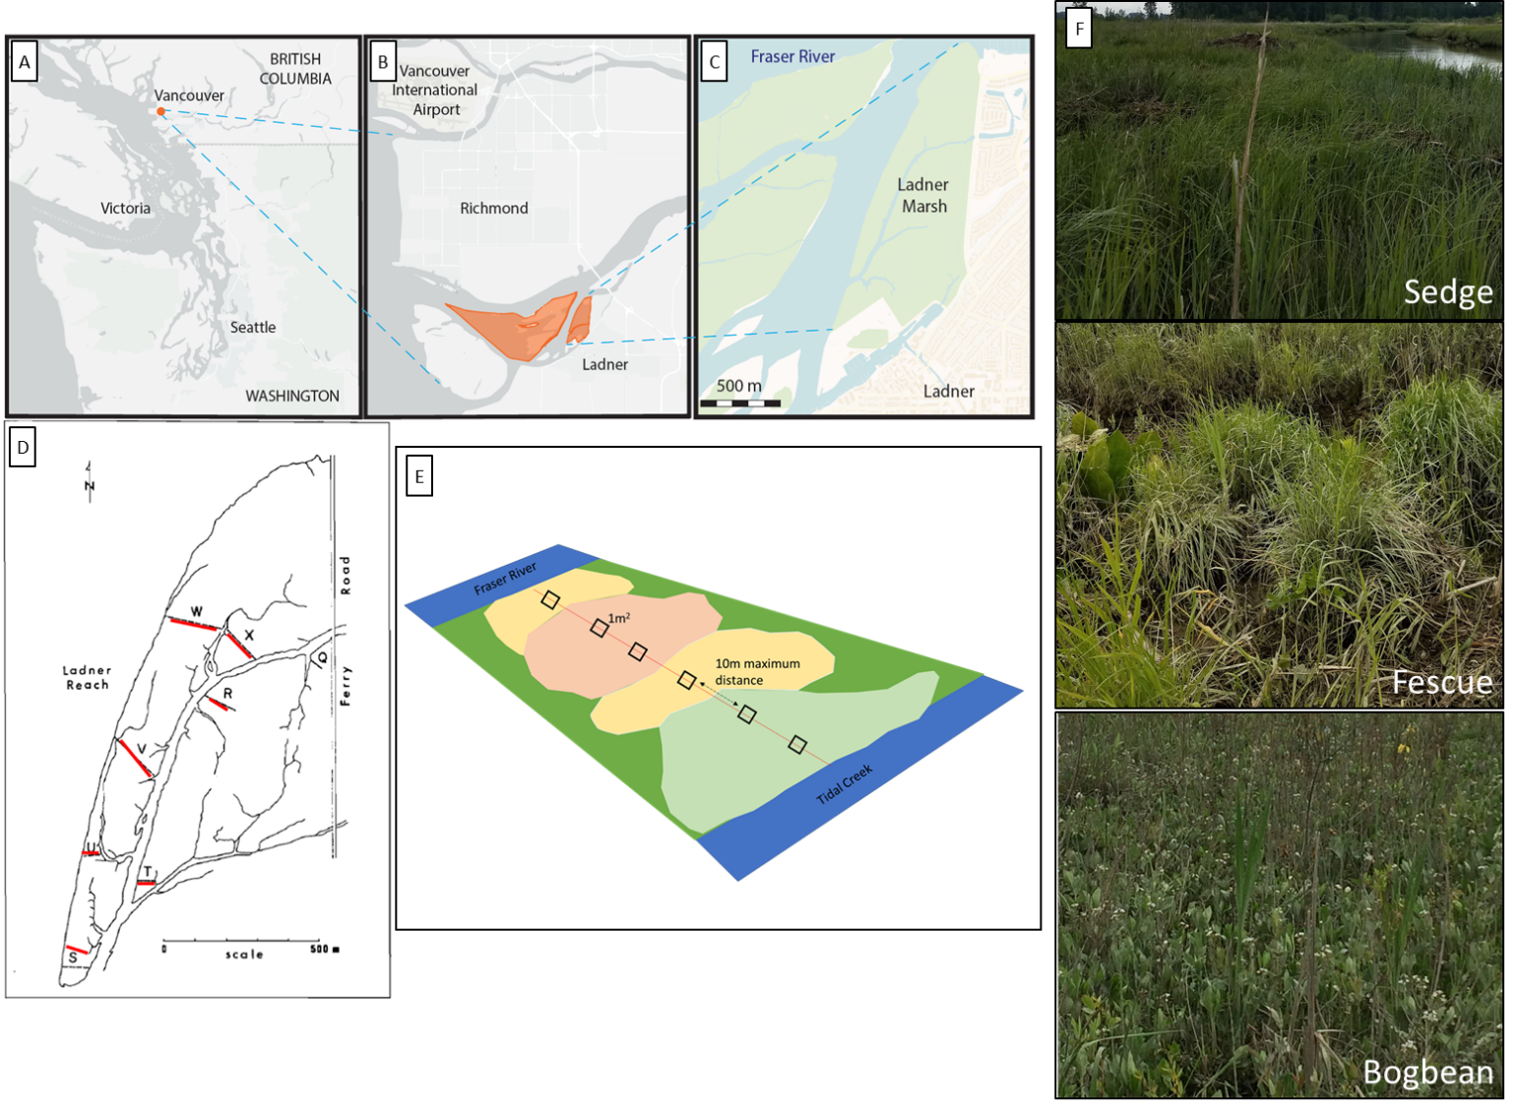

**Fig. 1** Study area location and sampling design. (A) Regional location of the Fraser River Estuary in southwestern British Columbia, Canada, (B) South Arm Marshes Wildlife Management Area (highlighted in orange), (C) Ladner Marsh abuts municipal development on the south bank of the Fraser River. (D) overlay of 2019 transect locations (shown in red) on original transect map from Bradfield and Porter (1982), (E) illustration of semi-systematic plot placement along transect bisecting different vegetation patches, and (F) representative pictures of each assemblage type showing distinctive vegetation characteristics observed in the field. Base maps (A, B) generated by iMap published by the B. C. Conservation Data Center (Victoria, BC, Canada, <https://maps.gov.bc.ca/ess/hm/imap4m>) and (C) OpenStreetMap (OpenStreetMap contributors, 2015, <https://www.openstreetmap.org/>) (Lane, 2022).

# Results

Three main assemblages identified by cluster analysis, characterized by the same dominant indicator species – Sedge (*Carex lyngbyei*), Fescue (*Fescue arundinacea*), and Bogbean (*Menyanthes trifoliata*) – were evident across all sampling periods (Figure 2). Overall dendrogram structures were similar for 1979 and 1999, but two main vegetation changes were evident in the 2019 dendrogram, notably, an increased homogenization of assemblages (i.e., shorter dendrogram branch lengths within cluster groups, and longer branch lengths between cluster groups), and a switch from a stronger Bogbean-Sedge connection 1979 and 1999 to a stronger Fescue-Bogbean connection in 2019 (Fig. 2).

While the three assemblage indicator species remained constant over time, changes were evident in other species with significant indicator values (Table 2). For example, in 1979 the indicator species defining the Sedge assemblage cluster were *C. lyngbyei, Sagittaria latifolia* Wiild.*,* and *Schoenoplectus tabernaemontani* (C.C.Gmel.) Palla, in 1999, however, the same assemblage included indicator species *C. lyngbyei,* and *Impatiens capensis* Meerb. By 2019, *C. lyngbyei* was the only indicator for this assemblage. Similarly, *F. arundinacea* remained a common indicator species within the Fescue assemblage, but the assemblage lost four out of seven total indicator species between 1979-2019. While the identities of the remaining indicator species changed, there was no strong trend of changes in clade, or potential difference for changes in ecological function based on a qualitative review of changing species identity.

Across the entire Ladner Marsh plant community, two to three species were lost from each sampling year following the 1979 survey (Table S6). Within every assemblage α-diversity (mean number of species per plot) decreased every observation year, while β-diversity (ratio of total species in the assemblage to α-diversity) increased each year for all assemblages (Table 1). For example, the Sedge community suffered the least loss of species and α-diversity across sampling years, although β-diversity increased as in other assemblages, indicating increasing variability (and thus increased rarity) in which species may be encountered within a given assemblage. The Fescue assemblage had the greatest loss of α-diversity (> 50%) between 1979 and 2019. Nearly 50% fewer plots clustered as Fescue in 2019 than in 1979, however bootstrapping 18 random plots from every sampling year showed the same trend, indicating that loss of species was not related to loss of plots (Table S3). Total magnitude of species turnover between 1999 and 2019 was ~50% in each assemblage, largely driven by greater species disappearance (loss) between 1999 and 2019 (Table S4).

The greatest loss of native species richness occurred in the Fescue assemblage, while gains in non-native richness were found in all assemblages (Fig. S2). The Fescue assemblage had a net loss of 17 native species between 1979 and 2019 (Table S5). Among the species lost from the Fescue assemblage, 12 were lost from all three assemblages (six forbs, six graminoids), or were never found in any other assemblage. Species gained include two woody species, and one each of forb, graminoid, and fern ally (*Equisetum arvense* L.). There was a net zero gain of non-native species in the Fescue assemblage, however non-native invasive *Phalaris arundinacea* (reed canary grass) accounts for the greatest 2019 mean cover in the entire assemblage (25-50% mean cover, Table S5). In the Bogbean assemblage, new non-native species include *P. arundinacea* and *Iris pseudacorus* (yellow flag iris). Within the Sedge assemblage, there was a net loss of 3 native species, and net gain of 3 non-native species, including *P. arundinacea* and *I. pseudacorus*. As of 2019, these species accounted for < 25% mean cover, but may be of significant management concern (Fig. 3).

Assemblage-defining indicator species showed an overall trend of decreasing cover over time (Fig. 3). Notably, the cover class of non-native indicator *F. arundinaceae* fell from a mean of ~1.5 to ~0.75 from 1979-2019, while the value for the mean cover class value of non-native *P. arundinaceae* tripled since 1999. In the Sedge assemblage native indicator sedge species *C. lyngbyei* decreased cover abundance from 1979-2019 (Fig. 3), stepping down from a mean cover class value of 3 (50-75% cover) to 2 (25-50% cover) between 1979-2019. Meanwhile, non-native species *Lythrum salicaria* and *F. arundinacea* increased in their mean cover abundance, although both species’ cover abundance remained in the same mean cover class (< 25% mean cover) by 2019. Similarly, in the Bogbean assemblage, cover abundance of native species *M. trifoliata* declined from a mean cover class of 4 (> 75%) to 3 (50-75% mean cover) by 2019, while cover of non-native *Mentha aquatica* L. increased from ‘absent’ in 1979 to a mean cover class of ~2 (~25-50% mean cover) by 2019.

**Table 1** Between 1979 and 2019, 8 fewer plots and 5 fewer species were observed, resulting in lower α-diversity and greater β-diversity. For each assemblage type, Bogbean is the only assemblage to proportionally gain plots between 1979 and 2019, while the Fescue and Sedge assemblages lost plots. Plot loss did not appear to have an effect on diversity components, as tested by bootstrapping a minimum of 18 plots per assemblage each year (Table S3)

|  |  |  |  |  |  |  |
| --- | --- | --- | --- | --- | --- | --- |
|  | **Plot-level components** | |  | **Diversity components** | | |
| **Assemblage** | **No. quadrats** | **No. species** |  | **α diversity** | **α diversity sd** | **β diversity** |
| **Sedge** |  |  |  |  |  |  |
| 1979 | 34 | 36 |  | 8.7 | 2.5 | 3.9 |
| 1999 | 31 | 35 |  | 8.3 | 2.0 | 4.2 |
| 2019 | 28 | 34 |  | 7.9 | 2.7 | 4.3 |
|  |  |  |  |  |  |  |
| **Fescue** |  |  |  |  |  |  |
| 1979 | 29 | 45 |  | 10.8 | 3.9 | 4.2 |
| 1999 | 33 | 41 |  | 9.7 | 4.0 | 4.2 |
| 2019 | 18 | 27 |  | 5.8 | 2.8 | 4.6 |
|  |  |  |  |  |  |  |
| **Bogbean** |  |  |  |  |  |  |
| 1979 | 19 | 30 |  | 10.8 | 3.6 | 2.8 |
| 1999 | 18 | 36 |  | 11.5 | 2.9 | 3.1 |
| 2019 | 28 | 34 |  | 10.5 | 1.9 | 3.3 |
|  |  |  |  |  |  |  |
| **Total** |  |  |  |  |  |  |
| 1979 | 82 | 48 |  | 10.0 | 3.4 | 4.8 |
| 1999 | 82 | 45 |  | 9.6 | 3.3 | 4.7 |
| 2019 | 74 | 44 |  | 9.4 | 3.0 | 4.7 |

**Table 2** Species significantly driving cluster groups (Euclidean distance) include the same dominant species in each assemblage type (Sedge by Carex lyngbyei, Fescue by Festuca arundinacea, Bogbean by Menyanthes trifoliata). Indicator species significantly defining the assemblage reported for p < 0.05

|  |  |  |  |  |  |  |  |  |
| --- | --- | --- | --- | --- | --- | --- | --- | --- |
|  | **1979** | |  | **1999** | |  | **2019** | |
| Cluster Group Name | Species | p-value |  | Species | p-value |  | Species | p-value |
|  |  |  |  |  |  |  |  |  |
| "Sedge" | *Carex lyngbyei* | < 0.01 |  | *Carex lyngbyei* | < 0.01 |  | *Carex lyngbyei* | < 0.01 |
| *Sagittaria latifolia* | < 0.01 |  | *Impatiens capensis* | 0.01 |  |  |  |
| *Schoenoplectus tabernaemontani* | < 0.01 |  |  |  |  |  |  |
|  |  |  |  |  |  |  |  |  |
| "Fescue" | *Festuca arundinacea* | < 0.01 |  | *Poa palustris* | < 0.01 |  | *Phalaris arundinacea* | < 0.01 |
| *Salix lasiandra* | < 0.01 |  | *Festuca arundinacea* | < 0.01 |  | *Festuca arundinacea* | < 0.01 |
| *Equisetum palustre* | < 0.01 |  | *Trifolium wormskioldii* | < 0.01 |  | *Equisetum fluviatile* | 0.01 |
| *Lathyrus palustris* | < 0.01 |  | *Bidens cernua* | < 0.01 |  |  |  |
| *Sidalcea hendersonii* | 0.01 |  |  |  |  |  |  |
| *Hordeum brachyantherum* | 0.02 |  |  |  |  |  |  |
| *Deschampsia caespitosa* | 0.05 |  |  |  |  |  |  |
|  |  |  |  |  |  |  |  |  |
| "Bogbean" | *Menyanthes trifoliata* | < 0.01 |  | *Mentha aquatica* | < 0.01 |  | *Menyanthes trifoliata* | < 0.01 |
| *Myosotis scorpioides* | < 0.01 |  | *Menyanthes trifoliata* | < 0.01 |  | *Mentha aquatica* | < 0.01 |
| *Bidens cernua* | < 0.01 |  | Grass (unidentified) | < 0.01 |  | *Lysimachia thyrsiflora* | < 0.01 |
| *Lythrum salicaria* | < 0.01 |  | *Lythrum salicaria* | < 0.01 |  | *Galium trifidum* | < 0.01 |
| *Equisetum fluviatile* | 0.01 |  | *Juncus articulatus* | < 0.01 |  | *Myosotis scorpioides* | 0.01 |
| *Lysimachia thyrsiflora* | 0.01 |  | *Equisetum fluviatile* | < 0.01 |  | *Juncus articulatus* | 0.02 |
|  |  |  | *Myosotis scorpioides* | < 0.01 |  |  |  |
|  |  |  | *Eleocharis palustris* | 0.02 |  |  |  |
|  |  |  | *Equisetum variegatum* | 0.04 |  |  |  |
|  |  |  | *Deschampsia caespitosa* | 0.03 |  |  |  |

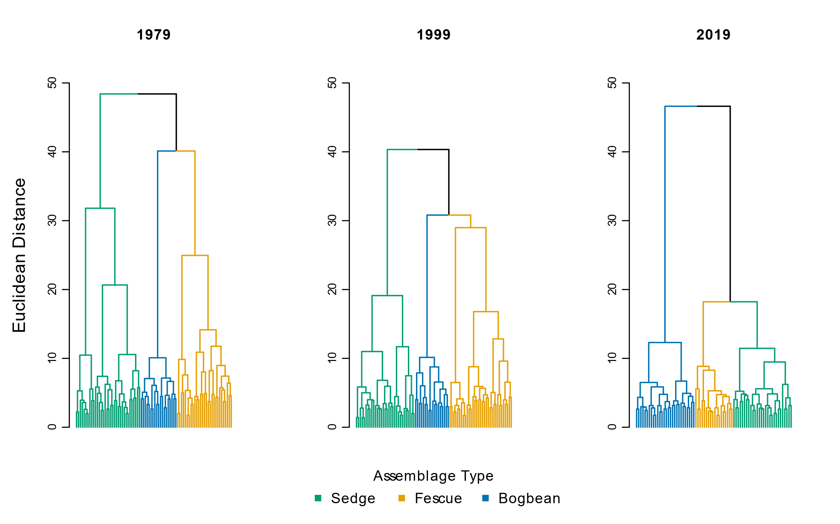

**Fig. 2** Species cover abundance becomes more dissimilar in each assemblage over time, as shown by greater Euclidean distance between assemblage types. Note clusters of the sedge and fescue assemblages are more similar in 2019

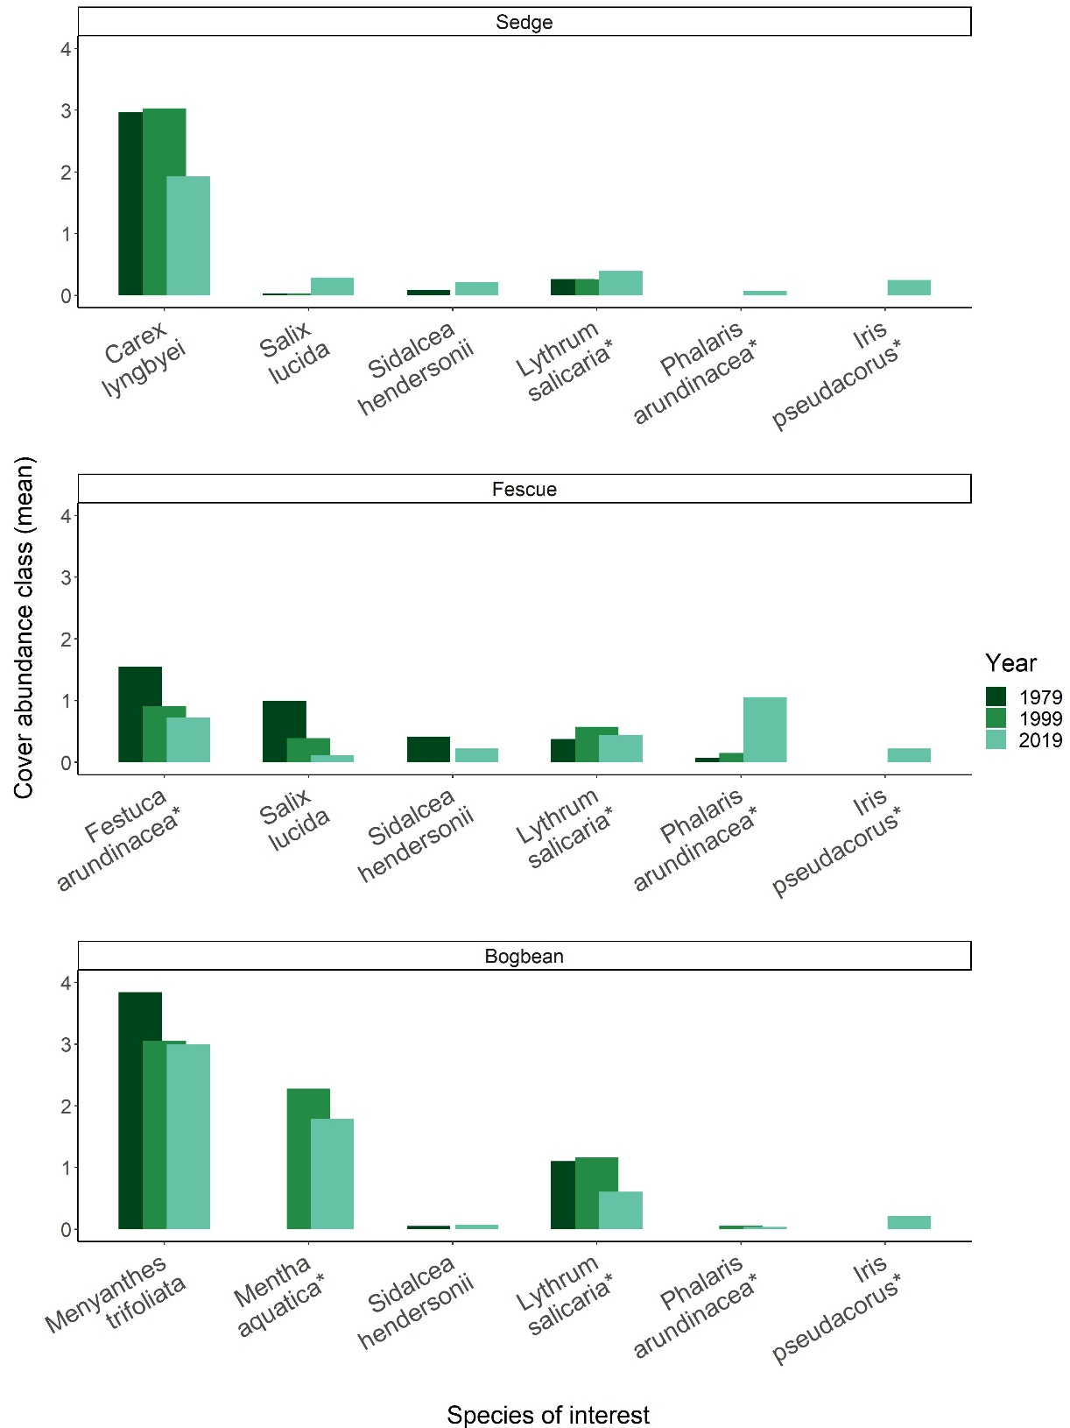

**Fig. 3** Changes in mean cover abundance (cover classes) for select significant indicator species (*Carex lyngbyei, Festuca arundinacea, Menyanthes trifoliata*), the most-abundant woody species (*Salix lucida*), and native/non-native species of local management interest (*Sidalcea hendersonii, Lythrum salicaria, Phalaris arundinacea, Iris pseudacorus*). Non-native species denoted by (*). Significant indicator species within each assemblage have decreased in abundance over time, while several non-native species (denoted by (*)) have increased in cover abundance since 1979. Cover classes are: [1] = < 25%, [2] = 25-50%, [3] = 51-75%, [4] = >75% above-ground vegetated cover.

# Discussion

Despite conservation status and general resilience of the Fraser River tidal marsh ecosystem we found substantive changes in species composition over a 40-year time-frame, potentially indicating broader-scale processes affected by regional pressures. The three species most significantly characterizing the three plant assemblages, Sedge, Fescue and Bogbean, have remained the same over the past 40 years, supporting our expectation that these characteristic species should not change in the absence of significant disturbance. We observed a decline of native species richness accompanied by an increased richness and abundance of non-native species. Of greater concern is our observation of the homogenization of cover abundance within assemblages, and overall loss of indicator species for the Sedge and Fescue assemblages. Increasing abundance of non-native species within each assemblage is likely driving the greater similarity within assemblages (homogenization) and greater dissimilarity between assemblages, as shown by cluster analysis (Figure 2). While addition of non-native species can contribute to greater biodiversity (Sagoff, 2005), the homogenization of plant communities leads to lower diversity overall (Houlahan & Findlay, 2004), which in turn may lead to lower functional redundancy and potential for reduced ecosystem stability (de Bello et al., 2021).

The changing identity of species or functional traits in an assemblage may offer clues to shifting abiotic conditions within or between assemblages (Waller et al., 2020). One functional group to note were the woody species, as their traits convey different structural habitat qualities than herbaceous species. Willow (*Salix* *lucida* Muhl.) was most prevalent in the Fescue assemblage in 1979, but was most abundant in the Sedge assemblage in 2019. This could suggest long-term shifts in edaphic factors and/or the competitive encroachment of non-native reed canary grass (*Phalaris arundinacea*), making the Fescue assemblage less hospitable to willow recruitment. Alternatively, this could indicate that environmental conditions are becoming more similar between the two assemblages, as evidenced by the clustering of the Fescue and Sedge groups on the same branch in the 2019 dendrogram (Fig. 2). The indicator species analysis for the Sedge assemblage in 1979 included plants tolerant of highly saturated soils (*Sagittaria latifolia, Schoenoplectus tabernaemontani*), but in 1999 the assemblage indicators included species less tolerant of aquatic or constantly saturated soils (*Impatiens capensis*) (Table 2).

In contrast, the turnover of indicator species may simply represent variation in species compositional abundance in each sampling year, despite being a perennial-dominated community. For example, the Bogbean assemblage, was indicated largely by unique forbs in 1979 and 2019, and an even mix of unique forbs and graminoids in 1999 (Table 2). It is harder to attribute replacement of forb indicator species to potential woody riparian succession in the Bogbean assemblage as in the Sedge and Fescue assemblages. The indicator graminoid species found only in 1999 in the Bogbean assemblage (excluding an unknown grass identified only to family) are all native wetland species commonly found in high marshes. Rather than indicating altered abiotic conditions, their inclusion as indicator species may represent population dynamics of short-lived perennials such as dispersal and recruitment. Thus, we propose two potential alternative explanations for the observed changes in floristic composition observed in the different assemblages: greater compositional abundance of woody species or species tolerant of drier conditions could be indicative of channel morphology processes limiting bank topography suitable for aquatic emergent plants, or sedimentation feedback processes increasing elevation of the marsh platform relative to tidal inundation. Alternatively, population dynamics may be operating independently of abiotic conditions, or have different outcomes depending on edaphic conditions in each assemblage. Testing how life histories (e.g., species longevity) offer competitive advantage in the context of changing abiotic conditions would be a valuable long-term addition to general interactions of competition and edaphic factors. These interactions would present a valuable experimental test of competitive advantage or how edaphic conditions drive the dominance of native vs. non-native species in tidal wetlands.

Greater homogeneity of cover abundance within assemblages, and greater distinction in compositional abundance between assemblages, may result from overall loss of native floristic richness. Across all assemblages in Ladner Marsh 1979-2019, we found one to two fewer native species, while β-diversity increased. This would indicate that rare (infrequently found) species are becoming more locally rare, which contributes to the loss of heterogeneous cover abundance and increased β-diversity observed at the plot scale. With the exception of woody species gained, the life histories and ecosystem functional traits of the species gained are similar to those lost from Ladner Marsh. More concerning is the net loss of five perennial graminoid and forb species over the study period (Table S6), as this represents a loss of functional redundancy. This species loss from the observed datasets may not represent species loss from the entire Ladner Marsh Wildlife Management Area, however the net species loss from the dataset, along with the addition of three non-native species to the datasets, poses concern for potential of species loss from the habitat over time.

Plant biodiversity loss may reduce the dense root networks to trap sediment in the marsh platform and seasonal pollinator value of forbs, although these contributions by the species lost in Ladner Marsh have not been quantified. Regardless of whether the loss is due to turnover or shifting abiotic conditions, trends of lost native plant species richness may indicate greater susceptibility to invasion (Kuiters, *et al.*, 2009), and thus a loss of resistance to non-native species encroachment over time. This can be evidenced by the decreasing ratio of native to non-native cover across Ladner Marsh 1979-2019 (Fig. S2), although few species (native or non-native) represent the majority of cover within the assemblage (Table S5). Non-native species of significant management concern (e.g., *P. arundinacea*, *I. pseudacorus*)) were < 25% mean plot cover in 2019, however these species are notorious for spreading to the point of near-exclusion of other species (especially natives) (Apfelbaum & Sams, 1987; Sinks et al., 2021).

## Mechanisms, Synthesis & Recommendations

Non-native species encroachment and native species loss may lead to instability in native populations through fragmented or lost propagule dispersal networks, potentially leading to ecosystem instability through altered trophic cascades, especially when top-down trophic interactions are also lost from the ecosystem (Duffy, 2003). Disentangling explicit effects of abiotic processes of sedimentation, propagule dispersal, or propagule recruitment from other biotic interactions would be no easy task in a tidal ecosystem; however, experimentally testing optimal recruitment niches of species-specific propagules (e.g., Lane, 2022) could prove valuable for understanding best practices to maintain at-risk populations or test community function. Optimal abiotic conditions for the recruitment and spatial occupancy of native or non-native species may largely be driven by soil characteristics and related sedimentation processes. Sedimentary changes such as sediment starvation or subsidence would result in more saturated areas, which would likely drive the increased prevalence of saturated conditions favored by the Bogbean assemblage (Mendelssohn & Kuhn, 2003). Alternatively, positive feedbacks between vegetation and sedimentation could support areas of marsh accretion (Nyman et al., 2006), which may also be more likely to receive non-native propagules within the distributed sediment. Propagule pools would depend on local and regional proximity. If similar habitats within tidal estuarine ecosystems are lost to the point where distance between patches exceeds propagule dispersal distance (Shi, et al., 2020), then species colonization within the ecosystem is rare or lost. Alternatively, if non-native species are more prevalent throughout the regional dispersal network, then there is a greater chance of non-native species introduction within a local marsh community. Thus, abiotic shifts may be altering the seed recruitment niches which may restrict recruitment of native species diversity, while dispersal networks may be delivering disproportionately more seed of non-native species.

A common (mis)assumption is that “undisturbed” areas such as Ladner Marsh represent ecologically appropriate reference states (e.g., Stoddard, et al., 2006, and citations therein). Our findings illustrate how, in a heavily impacted region (Finn et al., 2021), compositional states have likely shifted from recent (< 100 years) historical references, yet may still contribute value as an example of potential ecological benchmarks for restoration success (Shackelford, et al., 2021). We suggest that the plant community changes described here should alert land managers not only to what species diversity might be targeted in conservation practice, but also to how reference sites may have changed during the span of 20-40 years. Active management informed by experimental testing of hydrogeomorphologic drivers, dispersal networks, and recruitment strategies will be needed to maintain ecologically desired species composition in the face of climate change. If we are to prioritize conservation of functional coastal wetlands that include a significant representation of native species, we must seek new ways to actively manage habitats such as the Ladner Marsh. Through control of non-native species and experimental management practices to employ sediment application and/or native species planting, practitioners may enhance ecosystem processes within remnant coastal wetland habitats. This active management process also presents a timely and necessary opportunity in the Pacific Northwest of North America to engage with First Nations to revive traditional management practices in tidal wetlands, such as select mechanical disturbance (Turner, 2014): working with traditional knowledge holders in these ecosystems may yield deeper understanding of plant community function and habitat stability, which would enhance ecosystem resilience and potentially lead to positive effects on regionally important salmonid and shorebird populations while contributing to reconciliation between Indigenous and colonial cultures.

# Statements & Declarations

## Funding

Financial support for 2019 field surveys was provided by Natural Sciences and Engineering Research Council of Canada Discovery Grant RGPIN-2018-03838 to J. Richardson (University of British Columbia). Support for analysis and manuscript writing was supported by Liber Ero Chair in Conservation to Tara G. Martin, and a Mitacs Accelerate Fellowship to Stefanie L. Lane.

## Competing interests

The authors have no relevant financial or non-financial interests to disclose.

## Author contributions

Study conception, design, 2019 data collection, and analysis were exclusively undertaken by Stefanie L. Lane. Original (1979) study concept comparing plant assemblages, data collection, and analysis were performed or overseen by Gary Bradfield. Madlen Denoth contributed data collected in 1999. Nancy Shackelford assisted with theoretical framework and manuscript revision. Manuscript was drafted by Stefanie L. Lane; Nancy Shackelford and Tara G. Martin commented on previous versions of the manuscript. All authors read and approved the final manuscript.

## Data availability

Data for all years of observation are available on Dryad (DOI). Code is available on GitHub (REPO), or via Dryad (DOI)

# Literature Cited

Apfelbaum, S. I., & Sams, C. E. (1987). Ecology and Control of Reed Canary Grass (Phalaris arundinacea L.). *Natural Areas Journal*, *7*(2), 69–74.

Bai, Y., Han, X., Wu, J., Chen, Z., & Li, L. (2004). Ecosystem stability and compensatory effects in the Inner Mongolia grassland. *Nature*, *431*(7005), 181–184. https://doi.org/10.1038/nature02850

Bradfield, G. E., & Porter, G. L. (1982). Vegetation structure and diversity components of a Fraser estuary tidal marsh. *Canadian Journal of Botany*, *60*(4), 440–451. https://doi.org/10.1139/b82-060

Brophy, L. S., Greene, C. M., Hare, V. C., Holycross, B., Lanier, A., Heady, W. N., O’Connor, K., Imaki, H., Haddad, T., & Dana, R. (2019). Insights into estuary habitat loss in the western United States using a new method for mapping maximum extent of tidal wetlands. *PLOS ONE*, *14*(8), e0218558. https://doi.org/10.1371/journal.pone.0218558

Bruno, J. F. (2000). Facilitation of Cobble Beach Plant Communities Through Habitat Modification by Spartina Alterniflora. *Ecology*, *81*(5), 1179–1192. https://doi.org/10.1890/0012-9658(2000)081[1179:FOCBPC]2.0.CO;2

Butzeck, C., Schröder, U., Oldeland, J., Nolte, S., & Jensen, K. (2016). Vegetation succession of low estuarine marshes is affected by distance to navigation channel and changes in water level. *Journal of Coastal Conservation*, *20*(3), 221–236. https://doi.org/10.1007/s11852-016-0432-1

Chalifour, L., Scott, D. C., MacDuffee, M., Iacarella, J. C., Martin, T. G., & Baum, J. K. (2019). Habitat use by juvenile salmon, other migratory fish, and resident fish species underscores the importance of estuarine habitat mosaics. *Marine Ecology Progress Series*, *625*, 145–162. https://doi.org/10.3354/meps13064

Davis, M. J., Woo, I., Ellings, C. S., Hodgson, S., Beauchamp, D. A., Nakai, G., & De La Cruz, S. E. W. (2021). A climate-mediated shift in the estuarine habitat mosaic limits prey availability and reduces nursery quality for juvenile salmon. *Estuaries and Coasts*. https://doi.org/10.1007/s12237-021-01003-3

de Bello, F., Lavorel, S., Hallett, L. M., Valencia, E., Garnier, E., Roscher, C., Conti, L., Galland, T., Goberna, M., Májeková, M., Montesinos-Navarro, A., Pausas, J. G., Verdú, M., E-Vojtkó, A., Götzenberger, L., & Lepš, J. (2021). Functional trait effects on ecosystem stability: Assembling the jigsaw puzzle. *Trends in Ecology & Evolution*, *36*(9), 822–836. https://doi.org/10.1016/j.tree.2021.05.001

De Cáceres, M., & Jansen, F. (2016). *Indicspecies*. http://r.meteo.uni.wroc.pl/web/packages/indicspecies/indicspecies.pdf

Denoth, M., & Myers, J. H. (2007). Competition between Lythrum salicaria and a rare species: Combining evidence from experiments and long-term monitoring. *Plant Ecology*, *191*(2), 153–161. https://doi.org/10.1007/s11258-006-9232-2

Donohue, I., Hillebrand, H., Montoya, J. M., Petchey, O. L., Pimm, S. L., Fowler, M. S., Healy, K., Jackson, A. L., Lurgi, M., McClean, D., O’Connor, N. E., O’Gorman, E. J., & Yang, Q. (2016). Navigating the complexity of ecological stability. *Ecology Letters*, *19*(9), 1172–1185. https://doi.org/10.1111/ele.12648

Douglas, T. J., Schuerholz, G., & Juniper, S. K. (2022). Blue Carbon Storage in a Northern Temperate Estuary Subject to Habitat Loss and Chronic Habitat Disturbance: Cowichan Estuary, British Columbia, Canada. *Frontiers in Marine Science*, *9*. https://www.frontiersin.org/article/10.3389/fmars.2022.857586

Duffy, J. E. (2003). Biodiversity loss, trophic skew and ecosystem functioning. *Ecology Letters*, *6*(8), 680–687. https://doi.org/10.1046/j.1461-0248.2003.00494.x

Dufrêne, M., & Legendre, P. (1997). Species Assemblages and Indicator Species: the Need for a Flexible Asymmetrical Approach. *Ecological Monographs*, *67*(3), 345–366. https://doi.org/10.1890/0012-9615(1997)067[0345:SAAIST]2.0.CO;2

Emmett, R., Llansó, R., Newton, J., Thom, R., Hornberger, M., Morgan, C., Levings, C., Copping, A., & Fishman, P. (2000). Geographic signatures of North American West Coast estuaries. *Estuaries*, *23*(6), 765–792. http://dx.doi.org/10.2307/1352998

Finn, R. J. R., Chalifour, L., Gergel, S. E., Hinch, S. G., Scott, D. C., & Martin, T. G. (2021). Quantifying lost and inaccessible habitat for Pacific salmon in Canada’s Lower Fraser River. *Ecosphere*, *12*(7), e03646. https://doi.org/10.1002/ecs2.3646

Hallett, L. M., Jones, S. K., MacDonald, A. A. M., Jones, M. B., Flynn, D. F. B., Ripplinger, J., Slaughter, P., Gries, C., & Collins, S. L. (2016). codyn: An r package of community dynamics metrics. *Methods in Ecology and Evolution*, *7*(10), 1146–1151. https://doi.org/10.1111/2041-210X.12569

Hanski, I. (1982). Dynamics of Regional Distribution: The Core and Satellite Species Hypothesis. *Oikos*, *38*(2), 210–221. JSTOR. https://doi.org/10.2307/3544021

Hitchcock, C. L., & Cronquist, A. (1973). *Flora of the Pacific Northwest, an illustrated manual*. University of Washington Press.

Holling, C. S. (1973). Resilience and Stability of Ecological Systems. *Annual Review of Ecology and Systematics*, *4*(1), 1–23. https://doi.org/10.1146/annurev.es.04.110173.000245

Houlahan, J. E., & Findlay, C. S. (2004). Effect of Invasive Plant Species on Temperate Wetland Plant Diversity. *Conservation Biology*, *18*(4), 1132–1138. https://doi.org/10.1111/j.1523-1739.2004.00391.x

Kehoe, L. J., Lund, J., Chalifour, L., Asadian, Y., Balke, E., Boyd, S., Carlson, D., Casey, J. M., Connors, B., Cryer, N., Drever, M. C., Hinch, S., Levings, C., MacDuffee, M., McGregor, H., Richardson, J., Scott, D. C., Stewart, D., Vennesland, R. G., … Martin, T. G. (2021). Conservation in heavily urbanized biodiverse regions requires urgent management action and attention to governance. *Conservation Science and Practice*, *3*(2), e310. https://doi.org/10.1111/csp2.310

Kopecký, M., & Macek, M. (2015). Vegetation resurvey is robust to plot location uncertainty. *Diversity and Distributions*, *21*(3), 322–330. https://doi.org/10.1111/ddi.12299

Lane, S. L. (2022). Using marsh organs to test seed recruitment in tidal freshwater marshes. *Applications in Plant Sciences*, *n/a*, e11474. https://doi.org/10.1002/aps3.11474

Legendre, P., & Legendre, L. (2012). *Numerical Ecology* (3rd ed., Vol. 24). Elsevier.

Lepš, J. (2004). What do the biodiversity experiments tell us about consequences of plant species loss in the real world? *Basic and Applied Ecology*, *5*(6), 529–534. https://doi.org/10.1016/j.baae.2004.06.003

Mendelssohn, I. A., & Kuhn, N. L. (2003). Sediment subsidy: Effects on soil–plant responses in a rapidly submerging coastal salt marsh. *Ecological Engineering*, *21*(2), 115–128. https://doi.org/10.1016/j.ecoleng.2003.09.006

Nyman, J. A., Walters, R. J., Delaune, R. D., & Patrick, W. H. (2006). Marsh vertical accretion via vegetative growth. *Estuarine, Coastal and Shelf Science*, *69*(3), 370–380. https://doi.org/10.1016/j.ecss.2006.05.041

Ovaskainen, O., Rybicki, J., & Abrego, N. (2019). What can observational data reveal about metacommunity processes? *Ecography*, *42*(11), 1877–1886. https://doi.org/10.1111/ecog.04444

Palmer, M. A., Ambrose, R. F., & Poff, N. L. (1997). Ecological Theory and Community Restoration Ecology. *Restoration Ecology*, *5*(4), 291–300. https://doi.org/10.1046/j.1526-100X.1997.00543.x@10.1111/(ISSN)1526-100X.2525thAnniversaryVI

Pasternack, G. B. (2009). Chapter 3. Hydrogeomorphology and sedimentation in tidal freshwater wetlands. In A. Barendregt, D. F. Whigham, & A. H. Baldwin (Eds.), *Tidal Freshwater Wetlands* (pp. 31–40). Backhuys Publishers.

Sagoff, M. (2005). Do Non-Native Species Threaten The Natural Environment? *Journal of Agricultural and Environmental Ethics*, *18*(3), 215–236. https://doi.org/10.1007/s10806-005-1500-y

Schaefer, V. (2004). Ecological setting of the Fraser River delta and its urban estuary. In B. J. Groulx, D. C. Mosher, J. L. Luternauer, & D. E. Bilderback (Eds.), *Fraser River Delta, British Columbia: Issues of an Urban Estuary* (pp. 147–172). Geological Survey of Canada, Bulletin 547.

Shackelford, N., Dudney, J., Stueber, M. M., Temperton, V. M., & Suding, K. L. (2021). Measuring at all scales: Sourcing data for more flexible restoration references. *Restoration Ecology*, *n/a*(n/a), e13541. https://doi.org/10.1111/rec.13541

Shi, W., Shao, D., Gualtieri, C., Purnama, A., & Cui, B. (2020). Modelling long-distance floating seed dispersal in salt marsh tidal channels. *Ecohydrology*, *13*(1), e2157. https://doi.org/10.1002/eco.2157

Sinks, I. A., Borde, A. B., Diefenderfer, H. L., & Karnezis, J. P. (2021). Assessment of Methods to Control Invasive Reed Canarygrass (Phalaris arundinacea) in Tidal Freshwater Wetlands. *Natural Areas Journal*, *41*(3), 172–185. https://doi.org/10.3375/043.041.0303

Stoddard, J. L., Larsen, D. P., Hawkins, C. P., Johnson, R. K., & Norris, R. H. (2006). Setting Expectations for the Ecological Condition of Streams: The Concept of Reference Condition. *Ecological Applications*, *16*(4), 1267–1276. https://doi.org/10.1890/1051-0761(2006)016[1267:SEFTEC]2.0.CO;2

Tilman, D. (1999). The ecological consequences of changes in biodiversity: A search for general principles. *Ecology*, *80*(5), 1455–1474.

Tilman, D., Reich, P. B., & Knops, J. M. H. (2006). Biodiversity and ecosystem stability in a decade-long grassland experiment. *Nature*, *441*(7093), 629–632. https://doi.org/10.1038/nature04742

Turner, N. (2014). *Ancient Pathways, Ancestral Knowledge: Ethnobotany and Ecological Wisdom of Indigenous Peoples of Northwestern North America*. McGill-Queen’s Press - MQUP.

Underwood, A. J., Chapman, M. G., & Connell, S. D. (2000). Observations in ecology: You can’t make progress on processes without understanding the patterns. *Journal of Experimental Marine Biology and Ecology*, *250*(1), 97–115. https://doi.org/10.1016/S0022-0981(00)00181-7

Waller, L. P., Allen, W. J., Barratt, B. I. P., Condron, L. M., França, F. M., Hunt, J. E., Koele, N., Orwin, K. H., Steel, G. S., Tylianakis, J. M., Wakelin, S. A., & Dickie, I. A. (2020). Biotic interactions drive ecosystem responses to exotic plant invaders. *Science*, *368*(6494), 967–972. https://doi.org/10.1126/science.aba2225

Whittaker, R. H. (1975). *Communities and Ecosystems* (2nd ed.). Macmillan.

# Supplemental

**Table S1** A total of 25 plots sampled in 1979 and 1999 were not sampled in 2019, mostly due to issues of accessibility. Transect names and plot ID of plots omitted follow Fig. 3 in Bradfield & Porter (1982)

|  |  |  |
| --- | --- | --- |
| **Transect** | **1979/1999**  **Plot No.** | **Reason omitted in 2019** |
| Q | 1-7 | Transect in dense riparian thicket overgrown with Himalayan blackberry |
| R | 8 | Plot on lower bench (> 1 m lower than marsh platform), vegetation no longer exists |
| R | 17-19 | Plots in 1979 & 1999 sampled across a channel. Ended transect in 2019 at channel edge. |
| S | 33-36 | Transect length in 2019 was shorter than in 1979/1999. Suspect combination of erosion and offset transect relocation altered sampling distance. |
| T | 45 | Transect length in 2019 was shorter than in 1979/1999. Suspect combination of erosion and offset transect relocation altered sampling distance. |
| U | 51-52 | Transect length in 2019 was shorter than in 1979/1999. Suspect combination of erosion and offset transect relocation altered sampling distance. |
| V | 53 | Plot 53 only plot across a channel. Increased channel width and likely erosion made crossing this channel dangerous; omitted plot in 2019. |
| V | 54, 70-71 | Transect length in 2019 was shorter than in 1979/1999. Suspect combination of erosion and offset transect relocation altered sampling distance. |
| W | 89-92 | Transect length in 2019 was shorter than in 1979/1999. Suspect combination of erosion and offset transect relocation altered sampling distance. |
| X | 93 | Transect length in 2019 was shorter than in 1979/1999. Suspect combination of erosion and offset transect relocation altered sampling distance. |

**Table S2** Species indicator analysis of cluster groups using Bray-Curtis distance identifies the same dominant species in each assemblage type (Sedge, Fescue, Bogbean), however Bray-Curtis distance identifies different associated indicator species than those identified by Euclidean distance (Table 2)

|  |  |  |  |  |  |  |  |  |
| --- | --- | --- | --- | --- | --- | --- | --- | --- |
|  |  |  |  |  |  |  |  |  |
|  | **1979** | |  | **1999** | |  | **2019** | |
| **Cluster Group Name** | **Species** | **p-value** |  | **Species** | **p-value** |  | **Species** | **p-value** |
|  |  |  |  |  |  |  |  |  |
| "Sedge" | *Carex lyngbyei* | < 0.01 |  | *Carex lyngbyei* | < 0.01 |  | *Carex lyngbyei* | < 0.01 |
| *Sagittaria latifolia* | < 0.01 |  | *Agrostis stolonifera* | < 0.01 |  | *Mentha arvensis* | 0.03 |
| *Schoenoplectus tabernaemontani* | < 0.01 |  |  |  |  |  |  |
|  |  |  |  |  |  |  |  |
|  |  |  |  |  |  |  |  |  |
| "Fescue" | *Festuca arundinacea* | < 0.01 |  | *Festuca arundinacea* | < 0.01 |  | *Phalaris arundinacea* | < 0.01 |
| *Salix lucida* | < 0.01 |  | *Phalaris arundinacea* | 0.02 |  | *Festuca arundinacea* | < 0.01 |
| *Lathyrus palustris* | < 0.01 |  |  |  |  |  |  |
| *Equisetum palustre* | < 0.01 |  |  |  |  |  |  |
| *Impatiens capensis* | < 0.01 |  |  |  |  |  |  |
| *Sidalcea hendersonii* | < 0.01 |  |  |  |  |  |  |
| *Platanthera dilatata* | 0.02 |  |  |  |  |  |  |
|  |  |  |  |  |  |  |  |  |
| "Bogbean" | *Menyanthes trifoliata* | < 0.01 |  | *Menyanthes trifoliata* | < 0.01 |  | *Mentha aquatica* | < 0.01 |
| *Myosotis scorpioides* | < 0.01 |  | *Leersia oryzoides* | < 0.01 |  | *Menyanthes trifoliata* | < 0.01 |
| *Juncus articulatus* | < 0.01 |  | *Mentha aquatica* | < 0.01 |  | *Lysimachia thyrsiflora* | < 0.01 |
| *Lythrum salicaria* | < 0.01 |  | *Bidens cernua* | < 0.01 |  | *Salix lucida* | < 0.01 |
| *Lysimachia thyrsiflora* | < 0.01 |  | *Lysimachia thyrsiflora* | < 0.01 |  | *Eleocharis palustris* | < 0.01 |
| *Trifolium wormskioldii* | < 0.01 |  | *Juncus articulatus* | < 0.01 |  | *Juncus articulatus* | < 0.01 |
| *Lilaeopsis occidentalis* | < 0.01 |  | *Juncus oxymeris* | 0.02 |  | *Galium trifidum* | 0.01 |
| *Mentha aquatica* | 0.01 |  | *Myosotis scorpioides* | 0.02 |  | *Bidens cernua* | 0.01 |
|  |  |  | Poaceae (unidentified sp.) | 0.01 |  |  |  |
|  |  |  | *Deschampsia caespitosa* | 0.01 |  |  |  |
|  |  |  | *Sagittaria latifolia* | 0.05 |  |  |  |

**Table S3** Bootstrapping 18 randomly selected plots 10 times shows consistent overall trend in loss of species and alpha diversity over time, and overall increase in beta diversity between 1979 and 2019 in all assemblages and across the entire Ladner Marsh plant community. Therefore, loss of plots due to sampling re-location or how number of plots clustered into assemblages as reported in Table 2 is not expected to affect loss of species or plot-based diversity metrics

|  |  |  |  |  |  |  |
| --- | --- | --- | --- | --- | --- | --- |
|  | **Plot-level components** | |  | **Diversity components** | | |
| **Assemblage** | **No. quadrats** | **No. species** |  | **α diversity** | **α diversity sd** | **β diversity** |
| **Sedge** |  |  |  |  |  |  |
| 1979 | 18 | 32.3 |  | 10.67 | 2.34 | 3.03 |
| 1999 | 18 | 31.6 |  | 8.31 | 1.98 | 3.81 |
| 2019 | 18 | 30.8 |  | 8.18 | 2.51 | 3.77 |
|  |  |  |  |  |  |  |
| **Fescue** |  |  |  |  |  |  |
| 1979 | 18 | 43 |  | 13.0 | 3.9 | 3.3 |
| 1999 | 18 | 36 |  | 9.7 | 3.9 | 3.8 |
| 2019 | 18 | 27 |  | 5.8 | 2.8 | 4.6 |
|  |  |  |  |  |  |  |
| **Bogbean** |  |  |  |  |  |  |
| 1979 | 18 | 32 |  | 12.8 | 3.6 | 2.5 |
| 1999 | 18 | 36 |  | 11.5 | 2.9 | 3.1 |
| 2019 | 18 | 31 |  | 10.5 | 1.9 | 3.0 |
|  |  |  |  |  |  |  |
| **Total** |  |  |  |  |  |  |
| 1979 | 54 | 48 |  | 12.2 | 3.5 | 3.9 |
| 1999 | 54 | 42 |  | 10.0 | 3.4 | 4.2 |
| 2019 | 54 | 42 |  | 8.2 | 3.1 | 5.1 |

**Table S4** Total turnover and rates of species disappearance (loss) was always greater between 1999 and 2019 than between 1979 and 1999. However, fewer species were gained in the Bogbean assemblage 1999-2019 than 1979-1999

|  |  |  |  |  |
| --- | --- | --- | --- | --- |
| **Assemblage** | **Year** | **Total turnover** | **Species Appearance** | **Species Disappearance** |
| Bogbean | 1979-1999 | 0.56 | 0.35 | 0.22 |
| 1999-2019 | 0.60 | 0.28 | 0.32 |
| Fescue | 1979-1999 | 0.46 | 0.20 | 0.27 |
| 1999-2019 | 0.64 | 0.18 | 0.46 |
| Sedge | 1979-1999 | 0.46 | 0.24 | 0.22 |
| 1999-2019 | 0.56 | 0.27 | 0.29 |

**Table S5** Mean cover class values for non-native and native species observed in each assemblage for each sampling period. Overall change from 1979 to 2019 indicates decreases (-), increases (+), and species gained or lost. For each year, blank spaces indicate no data for the species in that sampling year; overall change noted by blank space for species found only in 1999

|  |  |  |  |  |  |  |
| --- | --- | --- | --- | --- | --- | --- |
| **Assemblage** | **Status** | **Species** | **1979** | **1999** | **2019** | **Overall Change (1979-2019)** |
| Bogbean | Non-native | *Alisma plantago aquatica* | 0.2 | 0.1 |  | lost |
| *Mentha arvensis* | 0.5 |  | < 0.1 | - |
| *Myosotis scorpioides* | 0.7 | 0.2 | 0.2 | - |
| *Agrostis stolonifera* | 3.2 | 1.5 | 1.3 | - |
| *Lythrum salicaria* | 1.1 | 1.2 | 0.6 | - |
| *Rumex conglomeratus* | 0.1 |  | < 0.1 | - |
| *Mentha aquatica* | 0.4 | 2.3 | 1.8 | + |
| *Iris pseudacorus* |  | 0.3 | 0.2 | gained |
| *Lycopus europaeus* |  |  | < 0.1 | gained |
| *Phalaris arundinacea* |  | 0.1 | < 0.1 | gained |
| *Festuca arundinacea* |  | 0.2 |  |  |
|  | *Alopecurus geniculatus* | 0.1 |  |  | lost |
| *Deschampsia caespitosa* | 0.3 | 0.2 |  | lost |
| *Equisetum fluviatile* | 1.4 | 1.2 |  | lost |
| *Leersia oryzoides* | 0.3 | 0.3 |  | lost |
| *Lilaeopsis occidentalis* | 0.2 |  |  | lost |
| *Oenanthe sarmentosa* | 0.6 | 0.1 |  | lost |
| *Poa trivialis* | 0.1 |  |  | lost |
| *Sium suave* | 0.6 | 0.2 |  | lost |
| *Caltha palustris* | 0.9 | 0.2 | 0.1 | - |
| *Bidens cernua* | 0.8 | 0.2 | 0.1 | - |
| *Trifolium wormskioldii* | 0.9 | 0.1 | 0.2 | - |
| *Schoenoplectus tabernaemontani* | 0.2 |  | 0.1 | - |
| *Eleocharis palustris* | 0.6 | 0.8 | 0.4 | - |
| *Symphyotrichum subspicatum* | 0.5 | 0.3 | 0.3 | - |
| *Juncus oxymeris* | 0.1 | 0.1 | < 0.1 | - |
| *Platanthera dilatata* | 0.1 | 0.1 | < 0.1 | - |
| *Menyanthes trifoliata* | 3.8 | 3.1 | 3.0 | - |
| *Lysimachia thyrsiflora* | 0.5 | 0.2 | 0.6 | + |
| *Juncus articulatus* | 0.3 | 0.4 | 0.3 | + |
| *Sidalcea hendersonii* | 0.1 |  | 0.1 | + |
| *Carex lyngbyei* | 0.5 | 0.3 | 1.0 | + |
| *Rumex occidentalis* | 0.1 | 0.1 | 0.1 | + |
| *Potentilla anserina-pacifica* | 0.3 | 1.0 | 1.1 | + |
| *Equisetum arvense* |  |  | 0.6 | gained |
| *Galium trifidum* |  |  | 0.4 | gained |
| *Hypericum scouleri* |  |  | < 0.1 | gained |
| *Impatiens capensis* |  | 0.4 | 0.3 | gained |
| *Juncus acuminatus* |  |  | < 0.1 | gained |
| *Lathyrus palustris* |  | 0.1 | 0.5 | gained |
| *Lysichiton americanum* |  |  | 0.1 | gained |
| *Salix lasiandra* |  | 0.6 | 0.5 | gained |
| *Salix scouleriana* |  |  | < 0.1 | gained |
| *Typha latifolia* |  | 0.3 | 0.3 | gained |
| *Equisetum palustre* |  | 0.1 |  |  |
| *Equisetum variegatum* |  | 0.1 |  |  |
| *Galium sp.* |  | 0.1 |  |  |
| *Poa palustris* |  | 0.5 |  |  |
| *Poaceae sp.* |  | 0.3 |  |  |
| *Sagittaria latifolia* |  | 0.2 |  |  |
|  |  |  |  |  |  |  |
| **Assemblage** | **Status** | **Species** | **1979** | **1999** | **2019** | **Overall Change (1979-2019)** |
| Fescue | Unknown | *Festuca sp.* | < 0.1 |  |  | lost |
| Non-native | *Alisma plantago aquatica* | 0.1 | 0.2 |  | lost |
| *Mentha aquatica* | 0.3 | 0.1 |  | lost |
| *Myosotis scorpioides* | 0.3 | < 0.1 |  | lost |
| *Mentha arvensis* | 0.2 | 0.2 | 0.1 | - |
| *Festuca arundinacea* | 1.6 | 0.9 | 0.7 | - |
| *Lythrum salicaria* | 0.4 | 0.6 | 0.4 | + |
| *Agrostis stolonifera* | 0.3 | 0.8 | 0.6 | + |
| *Phalaris arundinacea* | 0.1 | 0.2 | 1.1 | + |
| *Cirsium arvense* |  | < 0.1 | 0.1 | gained |
| *Iris pseudacorus* |  | 0.2 | 0.2 | gained |
| *Lycopus europaeus* |  |  | 0.1 | gained |
|  | *Alopecurus geniculatus* | < 0.1 |  |  | lost |
| *Bidens cernua* | 0.2 | 0.5 |  | lost |
| *Deschampsia caespitosa* | 0.6 | 0.1 |  | lost |
| *Dulichium arundinaceum* | 0.1 |  |  | lost |
| *Eleocharis palustris* | 1.0 | 0.3 |  | lost |
| *Equisetum palustre* | 0.8 | 0.1 |  | lost |
| *Galium trifidum* | < 0.1 |  |  | lost |
| *Hypericum formosum* | 0.1 |  |  | lost |
| *Juncus articulatus* | 0.5 | 0.1 |  | lost |
| *Leersia oryzoides* | 0.1 | 0.2 |  | lost |
| *Lilaeopsis occidentalis* | 0.2 |  |  | lost |
| *Mimulus guttatus* | < 0.1 |  |  | lost |
| *Oenanthe sarmentosa* | 0.2 | 0.3 |  | lost |
| *Platanthera dilatata* | 0.2 | 0.0 |  | lost |
| *Poa palustris* | 0.6 | 1.7 |  | lost |
| *Poa trivialis* | 0.3 |  |  | lost |
| *Polygonum hydropiper* | < 0.1 |  |  | lost |
| *Sagittaria latifolia* | < 0.1 | 0.2 |  | lost |
| *Salix sp.* | < 0.1 |  |  | lost |
| *Sium suave* | 0.1 | 0.2 |  | lost |
| *Symphyotrichum subspicatum* | 0.6 | 0.2 |  | lost |
| *Trifolium wormskioldii* | 0.7 | 0.5 |  | lost |
| *Menyanthes trifoliata* | 1.9 | 1.3 | 0.1 | - |
| *Caltha palustris* | 0.7 | 0.4 | 0.1 | - |
| *Salix lasiandra* | 1.0 | 0.4 | 0.1 | - |
| *Carex lyngbyei* | 0.8 | 1.4 | 0.1 | - |
| *Potentilla anserina-pacifica* | 0.5 | 0.6 | 0.2 | - |
| *Sidalcea hendersonii* | 0.4 | 0.2 | 0.2 | - |
| *Lysimachia thyrsiflora* | 0.1 | 0.3 | 0.1 | - |
| *Typha latifolia* | 0.7 | 0.4 | 0.4 | - |
| *Hordeum brachyantherum* | 0.2 |  | 0.1 | - |
| *Equisetum fluviatile* | 0.6 | 0.4 | 0.4 | - |
| *Schoenoplectus tabernaemontani* | 0.1 | 0.2 | 0.1 | - |
| *Lathyrus palustris* | 0.6 | 0.2 | 0.6 | + |
| *Rumex occidentalis* | 0.1 | 0.2 | 0.1 | + |
| *Impatiens capensis* | 0.3 | 0.4 | 0.6 | + |
| *Equisetum arvense* |  |  | 0.4 | gained |
| *Juncus effusus* |  |  | 0.1 | gained |
| *Lysichiton americanum* |  |  | 0.1 | gained |
| *Myrica gale* |  |  | 0.2 | gained |
| *Salix scouleriana* |  |  | 0.2 | gained |
| *Asteraceae sp.* |  | < 0.1 |  |  |
| *Carex sp.* |  | 0.1 |  |  |
| *Galium sp.* |  | < 0.1 |  |  |
| *Juncus oxymeris* |  | 0.1 |  |  |
| *Salix sitchensis* |  | < 0.1 |  |  |
|  |  |  |  |  |  |  |
| **Assemblage** | **Status** | **Species** | **1979** | **1999** | **2019** | **Overall Change (1979-2019)** |
| Sedge | Unknown | *Galium sp.* |  | < 0.1 |  |  |
| Non-native | *Alisma plantago aquatica* | 0.4 | 0.1 |  | lost |
| *Myosotis scorpioides* | < 0.1 |  |  | lost |
| *Mentha arvensis* | 0.3 | 0.2 | < 0.1 | - |
| *Agrostis stolonifera* | 1.9 | 2.3 | 1.3 | - |
| *Lythrum salicaria* | 0.3 | 0.3 | 0.4 | + |
| *Festuca arundinacea* | 0.1 | 0.1 | 0.2 | + |
| *Iris pseudacorus* |  | 0.1 | 0.3 | gained |
| *Lycopus europaeus* |  | < 0.1 | 0.1 | gained |
| *Mentha aquatica* |  | 0.2 | 0.5 | gained |
| *Phalaris arundinacea* |  |  | 0.1 | gained |
| *Cirsium arvense* |  | < 0.1 |  |  |
|  | *Deschampsia caespitosa* | 0.2 |  |  | lost |
| *Leersia oryzoides* | 0.2 | 0.2 |  | lost |
| *Lilaeopsis occidentalis* | 0.1 | 0.1 |  | lost |
| *Mimulus guttatus* | 0.1 |  |  | lost |
| *Oenanthe sarmentosa* | 0.7 | 0.4 |  | lost |
| *Platanthera dilatata* | 0.1 | < 0.1 |  | lost |
| *Poa palustris* | 1.0 | 0.2 |  | lost |
| *Puccinellia pauciflora* | < 0.1 |  |  | lost |
| *Sium suave* | 0.6 | 0.2 |  | lost |
| *Caltha palustris* | 1.1 | 0.5 | < 0.1 | - |
| *Equisetum fluviatile* | 0.9 | 0.6 | < 0.1 | - |
| *Schoenoplectus tabernaemontani* | 0.7 | 0.1 | 0.1 | - |
| *Trifolium wormskioldii* | 0.4 | 0.1 | 0.1 | - |
| *Sagittaria latifolia* | 0.4 | 0.1 | 0.1 | - |
| *Bidens cernua* | 0.5 | 0.1 | 0.2 | - |
| *Eleocharis palustris* | 0.8 | 0.4 | 0.4 | - |
| *Menyanthes trifoliata* | 0.3 | 0.7 | 0.2 | - |
| *Carex lyngbyei* | 3.0 | 3.0 | 1.9 | - |
| *Typha latifolia* | 0.6 | 0.4 | 0.4 | - |
| *Symphyotrichum subspicatum* | 0.3 | 0.1 | 0.3 | - |
| *Rumex occidentalis* | 0.1 | 0.2 | 0.1 | - |
| *Lysimachia thyrsiflora* | 0.1 |  | 0.1 | + |
| *Sidalcea hendersonii* | 0.1 | 0.1 | 0.2 | + |
| *Potentilla anserina-pacifica* | 0.3 | 0.7 | 0.8 | + |
| *Rumex conglomeratus* | < 0.1 |  | 0.1 | + |
| *Lathyrus palustris* | 0.1 | 0.3 | 0.5 | + |
| *Impatiens capensis* | 0.1 | 1.1 | 0.9 | + |
| *Salix lasiandra* | < 0.1 | < 0.1 | 0.3 | + |
| *Equisetum arvense* |  |  | 0.7 | gained |
| *Galium palustre* |  |  | < 0.1 | gained |
| *Galium trifidum* |  |  | 0.1 | gained |
| *Hypericum scouleri* |  |  | 0.1 | gained |
| *Juncus articulatus* |  |  | < 0.1 | gained |
| *Juncus oxymeris* |  |  | < 0.1 | gained |
| *Scirpus microcarpus* |  |  | 0.1 | gained |
| *Equisetum palustre* |  | 0.2 |  |  |
| *Lysichiton americanum* |  | < 0.1 |  |  |
| *Salix sitchensis* |  | 0.1 |  |  |

**Table S6** Mean cover class values for all species recorded in each observation dataset, averaged across all plots. Across all observations, there was a net loss of five native species, and a net gain of two non-native species. Plants identified only to Family or genus are included for reference, but were not considered as a part of species net gain/loss.

|  |  |  |  |  |  |
| --- | --- | --- | --- | --- | --- |
| **Species** | **1979** | **1999** | **2019** | **Status** | **Change** |
| Alisma plantago aquatica | 0.22 | 0.12 | 0.00 | Non-native | lost |
| Myosotis scorpioides | 0.28 | 0.06 | 0.08 | - |
| Festuca arundinacea | 0.59 | 0.44 | 0.24 | - |
| Agrostis stolonifera | 1.63 | 1.54 | 1.11 | - |
| Lythrum salicaria | 0.50 | 0.59 | 0.49 | - |
| Rumex conglomeratus | 0.02 | 0.00 | 0.05 | + |
| Mentha aquatica | 0.20 | 0.60 | 0.88 | + |
| Phalaris arundinacea | 0.02 | 0.07 | 0.30 | + |
| Cirsium arvense | 0.00 | 0.02 | 0.01 | gained |
| Iris pseudacorus | 0.00 | 0.18 | 0.23 | gained |
| Lycopus europaeus | 0.00 | 0.00 | 0.07 | gained |
|  |  |  |  |  |  |
| Alopecurus geniculatus | 0.02 | 0.00 | 0.00 | Native | lost |
| Deschampsia caespitosa | 0.37 | 0.09 | 0.00 | lost |
| Dulichium arundinaceum | 0.02 | 0.00 | 0.00 | lost |
| Equisetum palustre | 0.27 | 0.13 | 0.00 | lost |
| Leersia oryzoides | 0.18 | 0.24 | 0.00 | lost |
| Lilaeopsis occidentalis | 0.13 | 0.04 | 0.00 | lost |
| Mimulus guttatus | 0.05 | 0.00 | 0.00 | lost |
| Oenanthe sarmentosa | 0.50 | 0.29 | 0.00 | lost |
| Poa palustris | 0.61 | 0.89 | 0.00 | lost |
| Poa trivialis | 0.13 | 0.00 | 0.00 | lost |
| Polygonum hydropiper | 0.01 | 0.00 | 0.00 | lost |
| Puccinellia pauciflora | 0.01 | 0.00 | 0.00 | lost |
| Sium suave | 0.44 | 0.17 | 0.00 | lost |
| Caltha palustris | 0.90 | 0.39 | 0.05 | - |
| Platanthera dilatata | 0.12 | 0.04 | 0.01 | - |
| Equisetum fluviatile | 0.90 | 0.62 | 0.12 | - |
| Trifolium wormskioldii | 0.63 | 0.29 | 0.09 | - |
| Mentha arvensis | 0.29 | 0.16 | 0.05 | - |
| Sagittaria latifolia | 0.18 | 0.13 | 0.04 | - |
| Schoenoplectus tabernaemontani | 0.35 | 0.10 | 0.08 | - |
| Bidens cernua | 0.46 | 0.29 | 0.14 | - |
| Eleocharis palustris | 0.82 | 0.44 | 0.30 | - |
| Hordeum brachyantherum | 0.06 | 0.00 | 0.03 | - |
| Symphyotrichum subspicatum | 0.44 | 0.22 | 0.22 | - |
| Juncus articulatus | 0.24 | 0.11 | 0.12 | - |
| Carex lyngbyei | 1.61 | 1.79 | 1.14 | - |
| Menyanthes trifoliata | 1.68 | 1.46 | 1.22 | - |
| Typha latifolia | 0.49 | 0.34 | 0.36 | - |
| Sidalcea hendersonii | 0.20 | 0.11 | 0.16 | - |
| Salix lasiandra | 0.37 | 0.30 | 0.32 | - |
| Lysimachia thyrsiflora | 0.20 | 0.18 | 0.27 | + |
| Rumex occidentalis | 0.09 | 0.15 | 0.12 | + |
| Potentilla anserina-pacifica | 0.35 | 0.76 | 0.76 | + |
| Lathyrus palustris | 0.23 | 0.20 | 0.50 | + |
| Juncus oxymeris | 0.01 | 0.06 | 0.03 | + |
| Impatiens capensis | 0.16 | 0.67 | 0.59 | + |
| Galium trifidum | 0.01 | 0.00 | 0.18 | + |
| Equisetum arvense | 0.00 | 0.00 | 0.59 | gained |
| Galium palustre | 0.00 | 0.00 | 0.01 | gained |
| Juncus acuminatus | 0.00 | 0.00 | 0.01 | gained |
| Juncus effusus | 0.00 | 0.00 | 0.01 | gained |
| Lysichiton americanum | 0.00 | 0.01 | 0.05 | gained |
| Myrica gale | 0.00 | 0.00 | 0.05 | gained |
| Salix scouleriana | 0.00 | 0.00 | 0.05 | gained |
| Scirpus microcarpus | 0.00 | 0.00 | 0.03 | gained |
| Equisetum variegatum | 0.00 | 0.02 | 0.00 | NA |
| Hypericum scouleri | 0.04 | 0.00 | 0.04 | NA |
| Salix sitchensis | 0.00 | 0.04 | 0.00 | NA |
|  |  |  |  |  |  |
| Festuca sp. | 0.01 | 0.00 | 0.00 | Unknown (Not identified to species) |  |
| Salix sp. | 0.01 | 0.00 | 0.00 |  |
| Asteraceae sp. | 0.00 | 0.01 | 0.00 |  |
| Carex sp. | 0.00 | 0.02 | 0.00 |  |
| Galium sp. | 0.00 | 0.04 | 0.00 |  |
| Poaceae sp. | 0.00 | 0.06 | 0.00 |  |

**Table S7** All species recorded in 1979, 1999, and 2019, their synonymous nomenclature, and endemic status according to the Electornic Atlas of the Flora of British Columbia (E-Flora BC, https://ibis.geog.ubc.ca/biodiversity/eflora/)

|  |  |  |
| --- | --- | --- |
| **Species found 1979-2019** | **Synonym recorded in 1979 and/or 1999** | **Endemism Status** |
| *Agrostis stolonifera* | *Agrostis alba* | Non-native |
| *Alisma plantago-aquatica* |  | Non-native |
| *Alopecurus geniculatus* |  | Non-native |
| *Bidens cernua* |  | Native |
| *Caltha palustris* |  | Native |
| *Carex lyngbyei* |  | Native |
| *Carex* sp1 |  | NA |
| *Carex* sp2 |  | NA |
| *Cirsium arvense* |  | Non-native |
| *Composite* (unidentified) |  | NA |
| *Deschampsia caespitosa* |  | Native |
| *Dulichium arundinaceum* |  | Native |
| *Eleocharis palustris* |  | Native |
| *Equisetum arvense* |  | Native |
| *Equisetum fluviatile* |  | Native |
| *Equisetum variegatum* |  | Native |
| *Festuca arundinacea* |  | Non-native |
| *Festuca* sp |  | NA |
| *Galium palustre* |  | Native |
| *Galium* sp |  | NA |
| *Galium trifidum* | *Galium cymosum* | Native |
| Grass(unidentified) |  | NA |
| *Hordeum brachyantherum* |  | Native |
| *Hypericum scouleri* | *Hypericum formosum* | Native |
| *Impatiens capensis* |  | Non-native |
| *Iris pseudacorus* |  | Non-native |
| *Juncus acuminatus* |  | Native |
| *Juncus articulatus* |  | Native |
| *Juncus effusus* |  | Native |
| *Juncus oxymeris* |  | Native |
| *Lathyrus palustris* |  | Native |
| *Leersia oryzoides* |  | Native |
| *Lilaea scilloides* |  | Native |
| *Lilaeopsis occidentalis* |  | Native |
| *Lycopus europaeus* |  | Non-native |
| *Lysichiton americanus* |  | Native |
| *Lysimachia thyrsiflora* |  | Native |
| *Lythrum salicaria* |  | Non-native |
| *Mentha aquatica* | *Mentha citrata* | Non-native |
| *Mentha arvensis* |  | Non-native |
| *Menyanthes trifoliata* |  | Native |
| *Mimulus guttatus* |  | Native |
| *Myosotis scorpioides* |  | Non-native |
| *Myrica gale* |  | Native |
| *Oenanthe sarmentosa* |  | Native |
| *Phalaris arundinacea* |  | Non-native |
| *Platanthera dilatata var dilatata* |  | Native |
| *Poa palustris* |  | Native |
| *Poa trivialis* |  | Non-native |
| *Polygonum hydropiper* |  | Non-native |
| *Potentilla pacifica* |  | Native |
| *Puccinellia pauciflora* |  | Native |
| *Rumex conglomeratus* |  | Non-native |
| *Rumex occidentalis* |  | Native |
| *Sagittaria latifolia* |  | Native |
| *Salix lasiandra* |  | Native |
| *Salix scouleriana* |  | Native |
| *Salix sitchensis* |  | Native |
| *Salix* sp |  | NA |
| *Schoenoplectus tabernaemontani* | *Scirpus validus* | Native |
| *Scirpus microcarpus* |  | Native |
| *Sidalcea hendersonii* |  | Native |
| *Sium suave* |  | Native |
| *Sonchus arvensis* |  | Non-native |
| *Symphyotrichum subspicatum* | *Aster eatonii* | Native |
| *Trifolium wormskioldii* | *Trifolium wormskioldii* | Native |
| *Typha latifolia* |  | Native |
| *Zannichellia palustris* |  | Native |

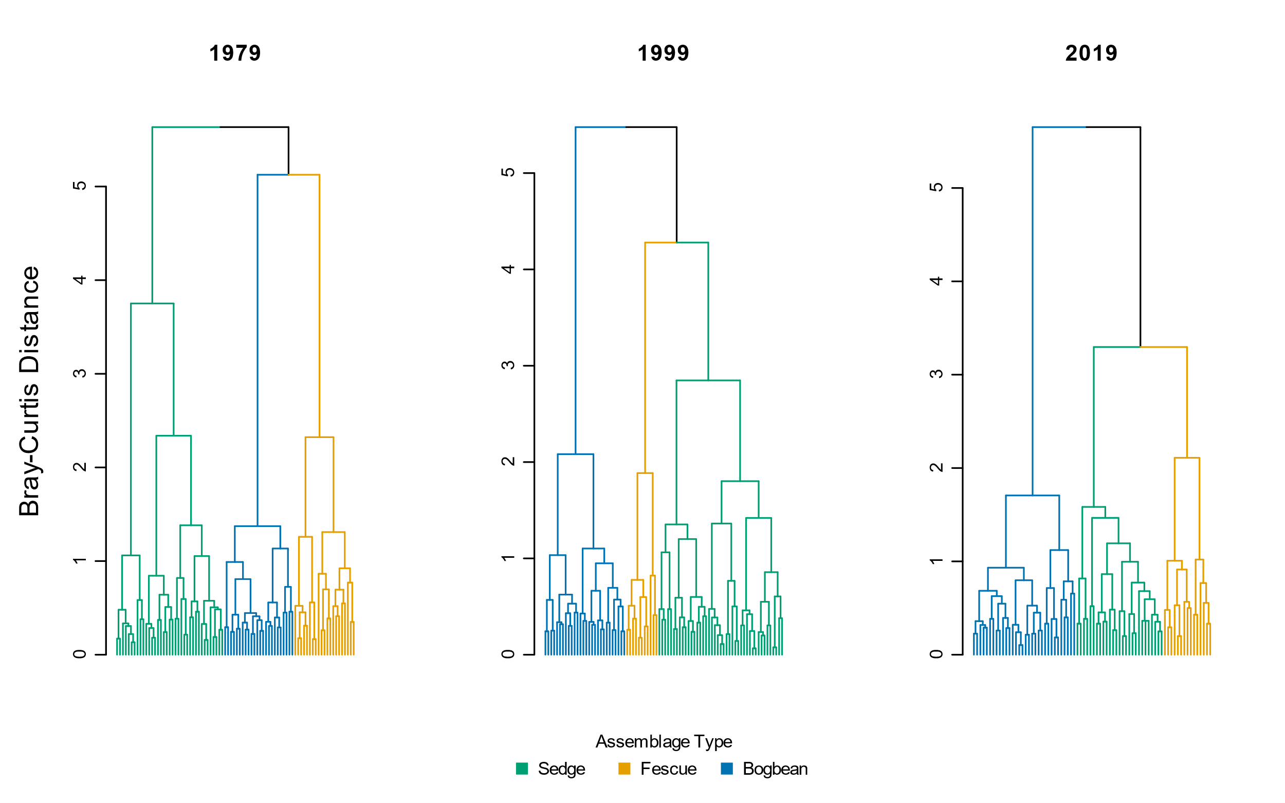

**Fig. S1** Cluster analysis using Bray-Curtis distance measure shows similar trends of increasing dissimilarity over time as when using Euclidean distance (Fig. 2)

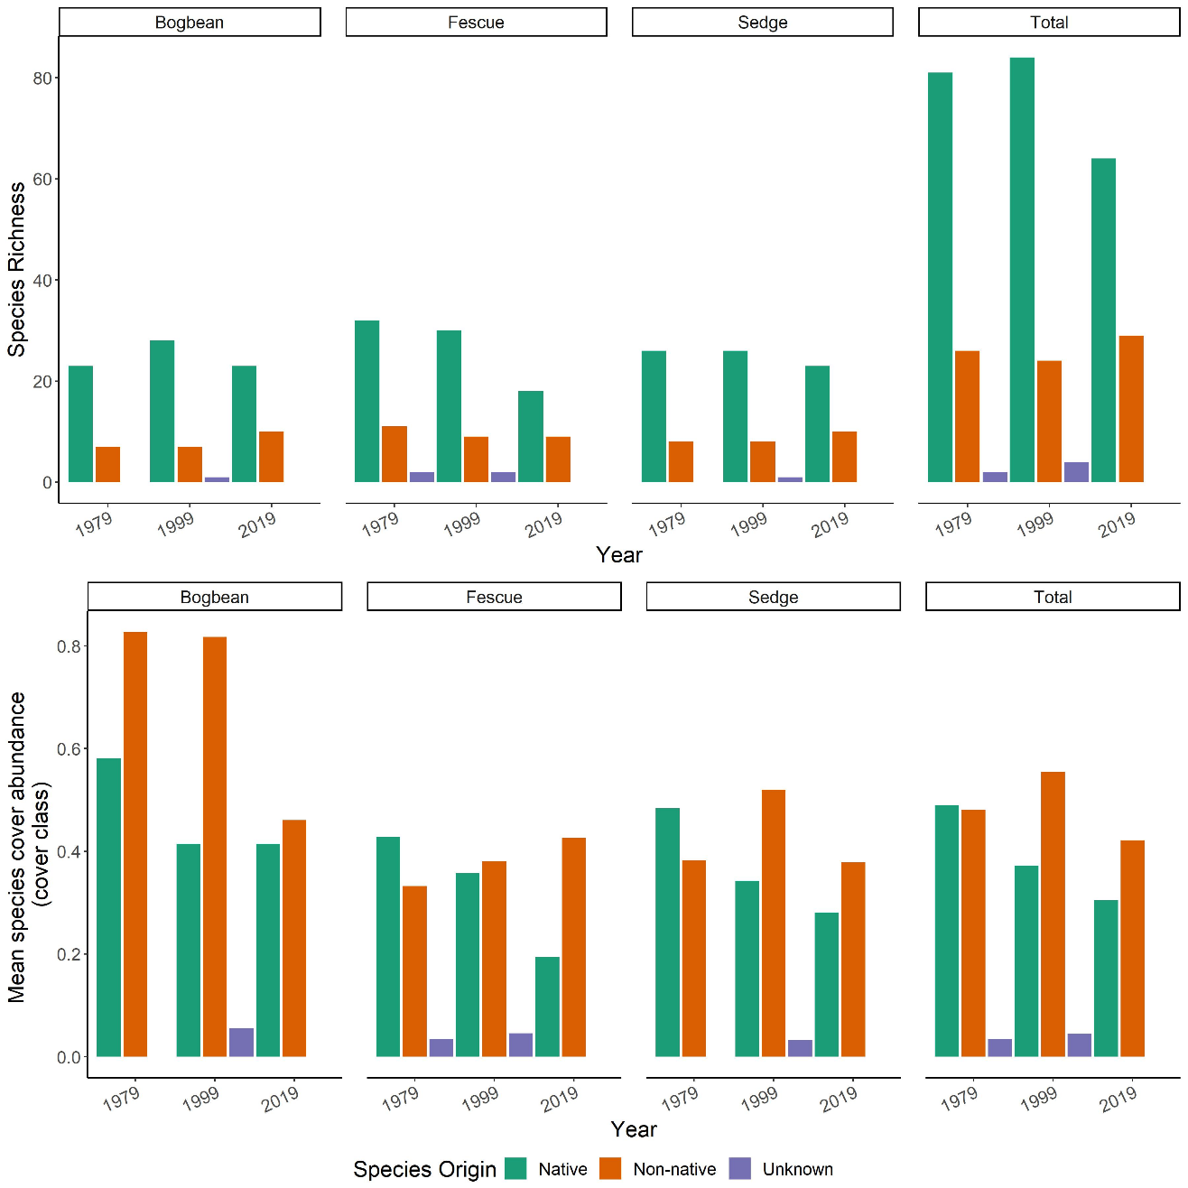

**Fig. S2** Top panel: Loss of native species richness over time across all assemblages is largely driven by loss of native species from the Fescue Assemblage. However, native species richness does not change substantially in the other two assemblages. Bottom panel: Native species cover is decreasing on average across all assemblages. Non-native species cover largely remains unchanged, although the ratio of native to non-native cover in Bogbean assemblage becomes more even by 2019. ‘Unknown’ species origin represents species identified only to genus, and assessment of native status cannot be made