# Introduction

* Global issue of plant species homogenization reduces ecosystem/community stability, especially in the face of shifting climatic conditions such as altered hydrologic regimes (rainfall, cumulative watershed-scale flow/stream permanence, and sea level rise).
  + Homogenization by non-native species invasion displaces native plants and altering community compositional structure.
  + Incorporate concept of alternative stable states/ecological thresholds. (context for why I expect assemblage-defining species to remain the same)
* Estuaries are at the terrestrial-marine interface where cumulative hydrologic stressors can shift ecological conditions required for sufficient habitat stability.
  + In North America, estuaries are of greater conservation importance in the PNW (limited space due to fjord geography, contrast to expansive alluvial plains of eastern North America).
  + Within estuaries, tidal freshwater marshes (TFMs) are of particular importance (early transitional habitat along salinity gradient for salmonids), and historically were more likely to be developed compared to salt marshes (more municipal, industrial development).
* Define TFM plant communities in the PNW, and assemblages as subsets within the community with microsite adaptations to inundation and saturation.
  + General herbaceous structure, dominated by sedges/rushes with some salinity tolerance, but with greater forb diversity unique to TFMs that don’t occur in non-tidal wetlands; Set the stage for habitat value, and concern for species gained/lost.
* A major challenge of measuring community stability is the lack of long-term monitoring of interannual changes. In absence of long-term monitoring, using historical datasets can provide a ‘snapshot’ of changes across time.
  + One such opportunity exists in Ladner Marsh, which escaped development through designation as protected habitat (Figure 1).
  + Two historical studies conducted in Ladner Marsh (Bradfield & Porter, 1982; Denoth & Myers, 2007) used similar methods to document floristic diversity, which provides the opportunity to repeat observations and characterize long-term plant community changes.
* The main objective of this work is to infer stability of plant community compositional structure in the absence of direct disturbance in a tidal freshwater marsh. I used three observational datasets spanning four decades to answer the following questions:

1. Are assemblages are still characterized by the same dominant species?
   1. In the absence of significant environmental disturbance, I expect the same species to dominate each assemblage as identified by Bradfield & Porter (1982).
2. Is diversity stable between assemblage types?
   1. I expect assemblages should have similar measures of dissimilarity (i.e., dendrograms 1979-2019 should look similar) if assemblages are stable.
3. Is diversity stable within assemblage types? (i.e., are diversity metrics measured in 2019 comparable to 1999 and/or 1979?)
   1. I expect assemblages should have similar α- and β-diversity if assemblages are stable.
4. Which species are gained or lost that drive changes in assemblage diversity?
   1. If assemblages have greater species homogenization within assemblages, I expect it to be driven by significant invasive species abundance.

# Methods

* Site context & plot selection composite figure; show overlay of 2019 transects on line drawing site figure from Bradfield & Porter (1982)? (Figure 1)
* Field methods
  + Historical data collection & site relocation.
  + Present data collection methods, with estimation of transect accuracy statement.
    - Taxonomy
* Statistical analyses (describe in same order as Questions/Results)
  + I chose specific tests/metrics (α- and β-diversity, cluster analysis w/ Euclidean distance) to be similar to Bradfield & Porter (1982). I used indicator species analysis to determine species dominating each assemblage in cluster analysis.
  + (1 & 2) cluster analysis to group sampling plots into three assemblages, then species indicator analysis to define the dominant species in each assemblage
  + (3) α- and β-diversity
  + (4) <*needs to be done – currently have only a stacked bar chart>*

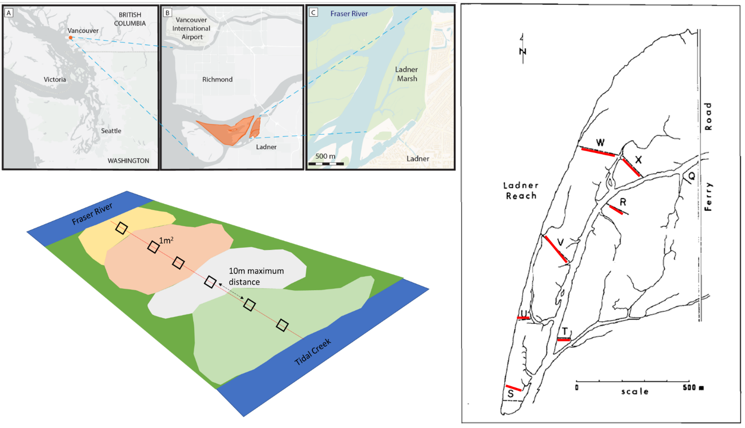

Figure 1. Clockwise from top left: Geographical site context, transect relocation method by overlaying 1982 publication figure onto Google Earth basemap, and field-testing accessibility, and plot sampling design.

# Results

1. Species indicator analysis of cluster analysis shows each assemblage is dominated by the same species in each dataset (Supplement).
2. There is greater dissimilarity, as shown by greater Euclidean distance, between assemblage types over time. This indicates each assemblage type is becoming more distinct; species homogenization not happening at community scale. (Figure 2)
   1. Decreasing dissimilarity, as shown by less Euclidean distance, *within* assemblage types. Species homogenization may be happening at plot scale within an assemblage type.
3. Sedge assemblage has most ‘stable’α-diversity, somewhat similar in bogbean assemblage (although losing α-diversity), and greatest loss of α-diversity in fescue assemblage (Table 1).
   1. Need a way to interpret β-diversity.
4. Different patterns of invasive species encroachment are observed across time: invasive abundance remains similar (on average) in bogbean assemblage, increases steadily in sedge assemblage, and more than doubles in fescue assemblage. (Figure 3)
   1. Pending further analysis, discuss specific species gained/lost.

Table 1. Fescue assemblage has half the a-diversity in 2019 as in 1979, but B-diversity remains similar. Need to make sure these analyses approach is more clear in methods; I thought PERMDISP/PERMANOVA (shown in draft at reatreat) was a way to test differences within an assemblage between datasets.

|  |  |  |  |  |  |
| --- | --- | --- | --- | --- | --- |
|  | Plot-level components | |  | Diversity components | |
| Assemblage Type | **No. quadrats** | **Total no. species** |  | **α diversity** | **β diversity** |
| Lyngbye's sedge |  |  |  |  |  |
| **1979** | 34 | 34 |  | 8.7 | 3.9 |
| **1999** | 31 | 35 |  | 8.3 | 4.2 |
| **2019** | 25 | 34 |  | 8 | 4.2 |
|  |  |  |  |  |  |
| Fescue |  |  |  |  |  |
| **1979** | 29 | 47 |  | 12.8 | 3.7 |
| **1999** | 33 | 41 |  | 9.7 | 4.2 |
| **2019** | 14 | 26 |  | 6.6 | 3.9 |
|  |  |  |  |  |  |
| Bogbean |  |  |  |  |  |
| **1979** | 19 | 32 |  | 12.8 | 2.5 |
| **1999** | 18 | 36 |  | 11.5 | 3.1 |
| **2019** | 28 | 34 |  | 10.5 | 3.2 |

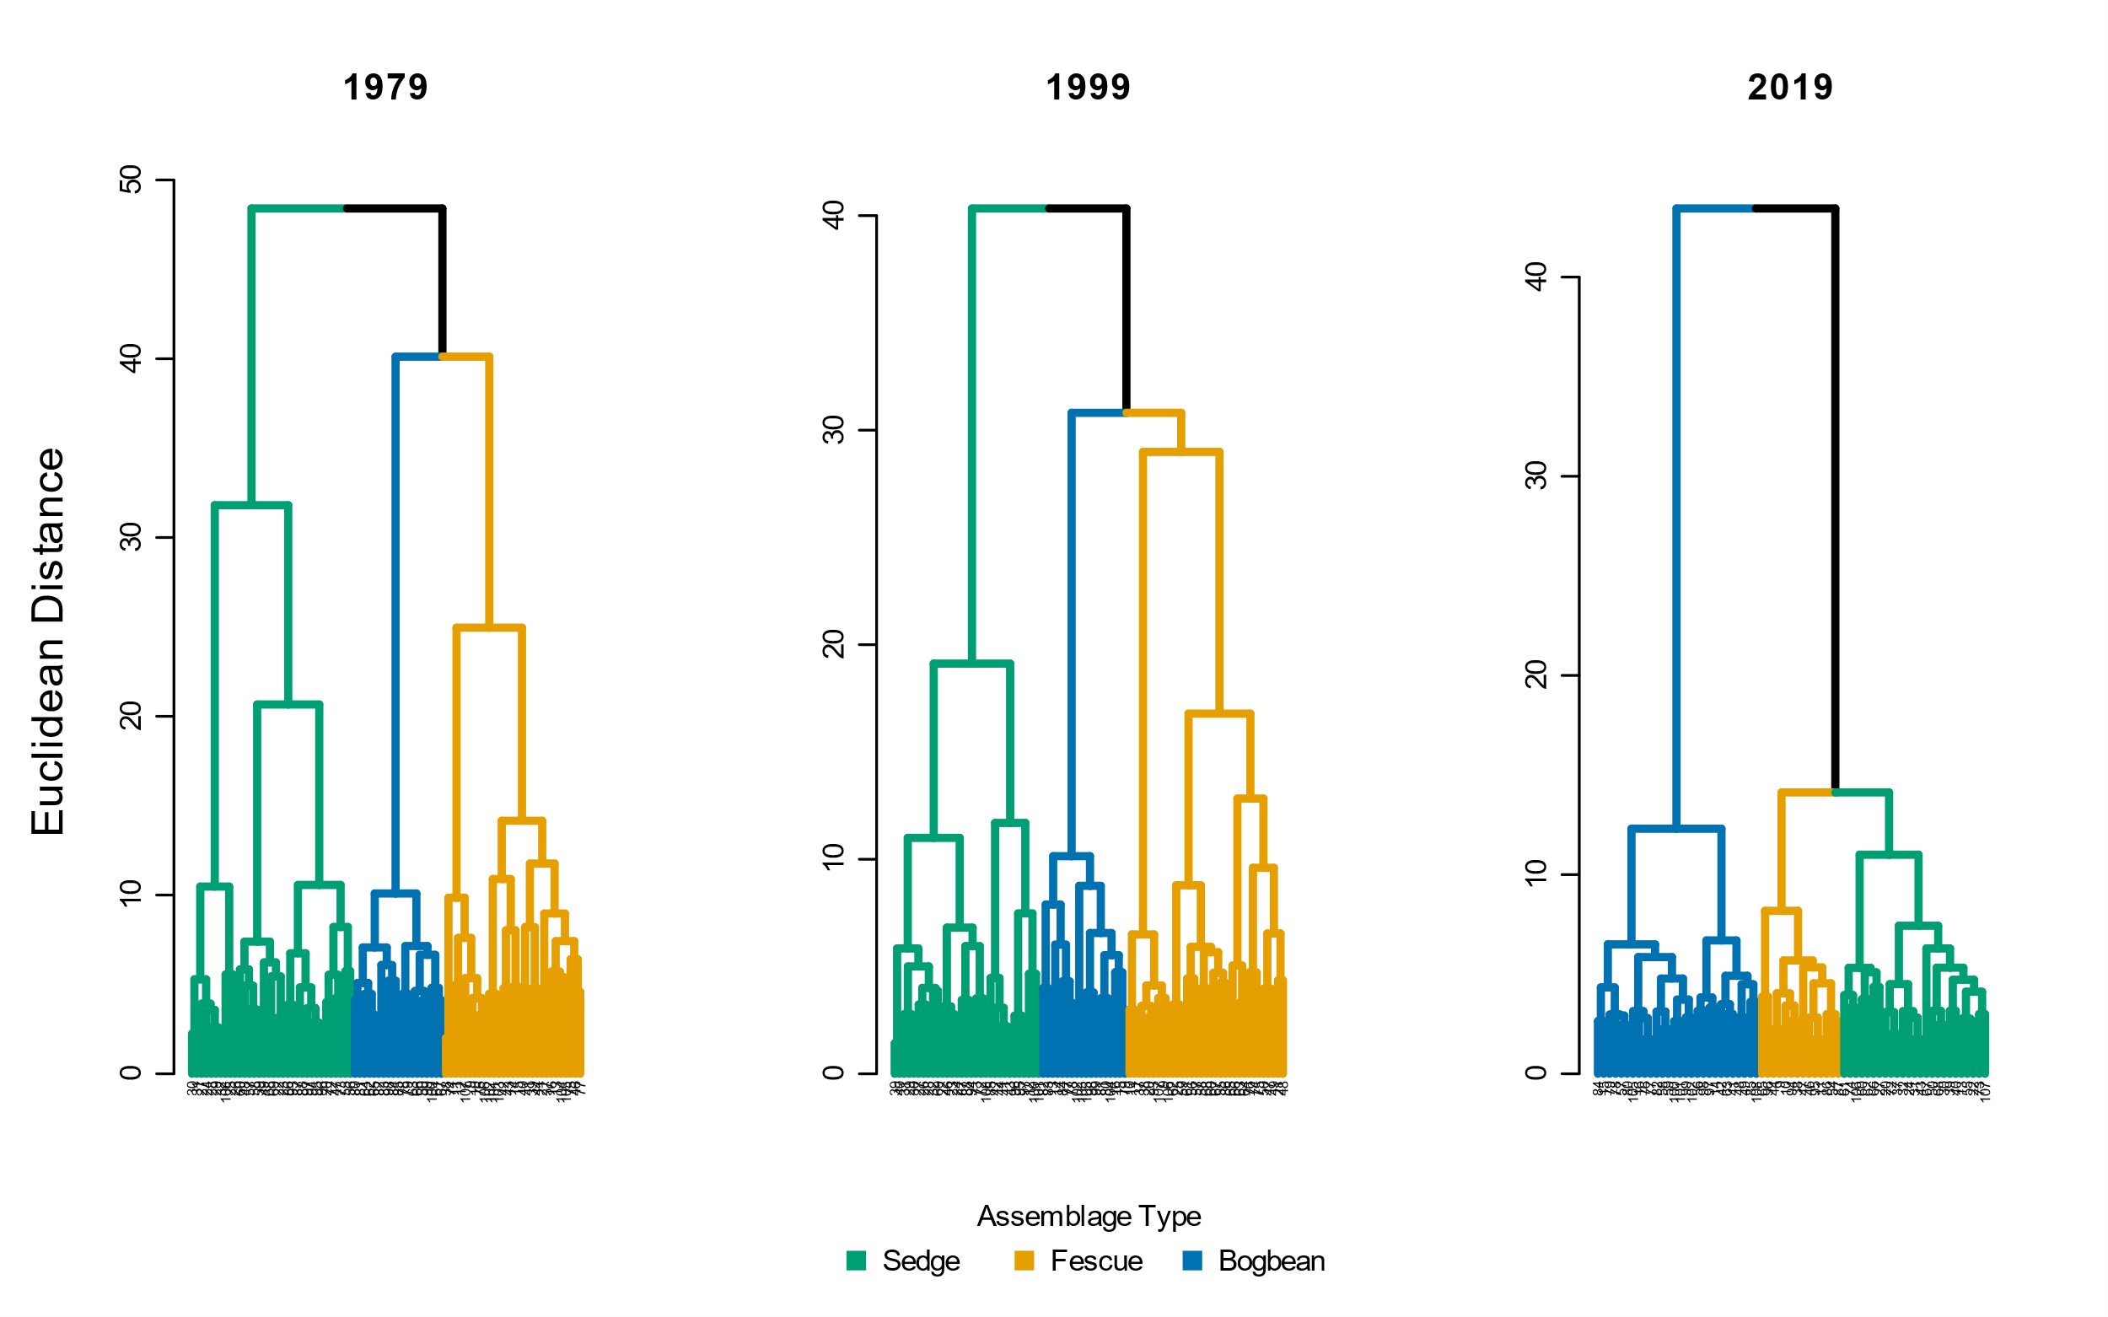

Figure 2. Assemblage diversity becomes more dissimilar over time, as shown by greater Euclidean distance between assemblage types. Euclidean distance chosen b/c that's what original authors did. I still need to take out plot #s at leaves.

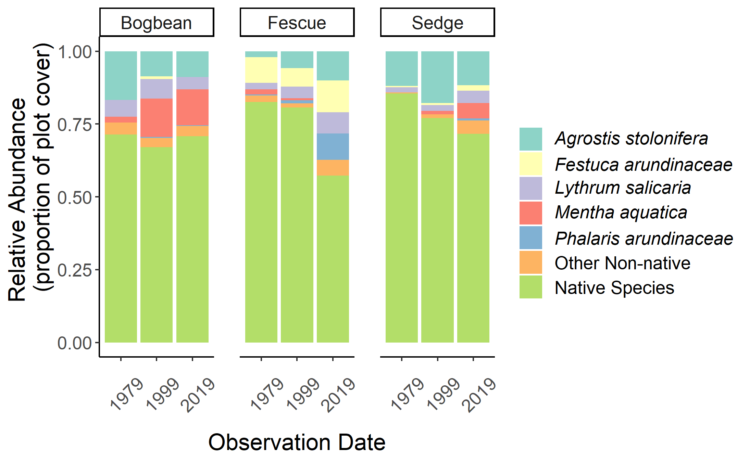

Figure 3. Fescue assemblage has greatest increase of invasive species abundance over time. Revise figure to show species gained/lost over time, and greatest shifts in gains/losses. Contextualize as management concern of invasive species encroachment, and potential loss of species of conservation interest (e.g., Henderson’s checkermallow)

# Discussion

* Answer questions/hypotheses:
  + (1) Key species defining TFM assemblage types have remained stable. Hypothesis not rejected.
  + (2) All assemblages show greater dissimilarity between assemblage types. Hypothesis rejected.
  + (3) Certain assemblages do not appear stable within assemblage type, although to varying degrees: Fescue assemblage shows greatest change in α- diversity; <*key result for β-diversity*> Hypothesis partially rejected.
  + (4) Significant changes of invasive species abundance were observed in the fescue community type, which showed the greatest species homogenization; <*loss of key native species abundance?*> Hypothesis not rejected.
* (1) Key species that define assemblage types, and together define TFM community compositional structure, have remained the same within Ladner Marsh. This indicates that overall environmental drivers of TFM ecosystem stability are largely unchanged, and functional capacity intact.
  + Briefly elaborate on key functions, especially for sedge (*Carex lyngbyei*) as early-season juvenile fish habitat.
* (2) Edaphic factors may be driving species selection by adaptation to saturation or drainage between assemblage patches, more strictly partitioning the diversity of species that can occupy an assemblage. Additionally, recruitment of new diverse individuals into the assemblage may be limited.
  + Bring in topics of sediment trapping vs. starvation, marsh subsidence. Can suggest that future studies to measure dendritic channel edge gains/losses through erosion and sedimentation rates may provide mechanistic insight to drivers of microsite edaphic conditions.
* (3) Loss of species diversity within each assemblage type may be driven by loss of recruitment of new diverse individuals. Additionally, expansion of invasive species, especially in fescue group, is likely preempting space for additional diversity.
  + Bring in topics of challenging environment for seed recruitment, and potential required clonal expansion from higher elevations. Cite my own APPS paper (pending publication)?
* (4) Invasive species of concern in the fescue assemblage are rhizomatous perennials that notoriously dominate communities, such as reed canary grass (*Phalaris arundinaceae*) and purple loosestrife (*Lythrum salicaria*). Surprisingly, creeping bentgrass (*Agrostis stolonifera*) is not as dominant in this assemblage, although it is of increasing dominance in the other two assemblage types.
  + Discuss key native species lost, with particular attention to blue-listed species such as Henderson’s checkermallow (*Sidalcea hendersonii*, globally nearly exclusive to the lower Fraser River Estuary per Lomer, 2008), and pointed rush (*Juncus oxymeris*, locally abundant but limited range within Fraser River Estuary).
* Discussion of inference limitations, and strengths of comparisons.
  + Acknowledge transect relocation and sampling method likely alters results, however still provides a ‘snapshot’ of marsh-wide conditions along a major tidal channel.
* Conservation and restoration of TFMs is a management priority (e.g., Canada’s Sea Level Rise Adaptation programs & major funding given to BC SRIF/CRF for salmonid habitat).
  + Major objectives of these programs focus on habitat creation, with success targeted on 50-100-year horizons.
  + Sites with a longer conservation history, such as the South Arm Marshes WMA are often used as ‘reference’ conditions for evaluating restoration success.
  + Therefore, it is important to understand what plant community stability looks like in TFMs, and whether remnant TFMs used as reference are persisting in a stable state over these timescales.
* I showed that plant communities are responding to environmental pressures, and baseline reference conditions are shifting to a more homogenized state within assemblage types, and more dissimilar between assemblage types. <*summary statement regarding species gain/loss*>
* These shifts over time should be of concern to managers working to conserve habitat for salmonid habitat, and to restoration practitioners using similar sites as thresholds for success.

# Literature Cited

Bradfield, G. E., & Porter, G. L. (1982). Vegetation structure and diversity components of a Fraser estuary tidal marsh. *Canadian Journal of Botany*, *60*, 440–451.

Denoth, M., & Myers, J. H. (2007). Competition between *Lythrum salicaria* and a rare species: Combining evidence from experiments and long-term monitoring. *Plant Ecology*, *191*, 153–161.