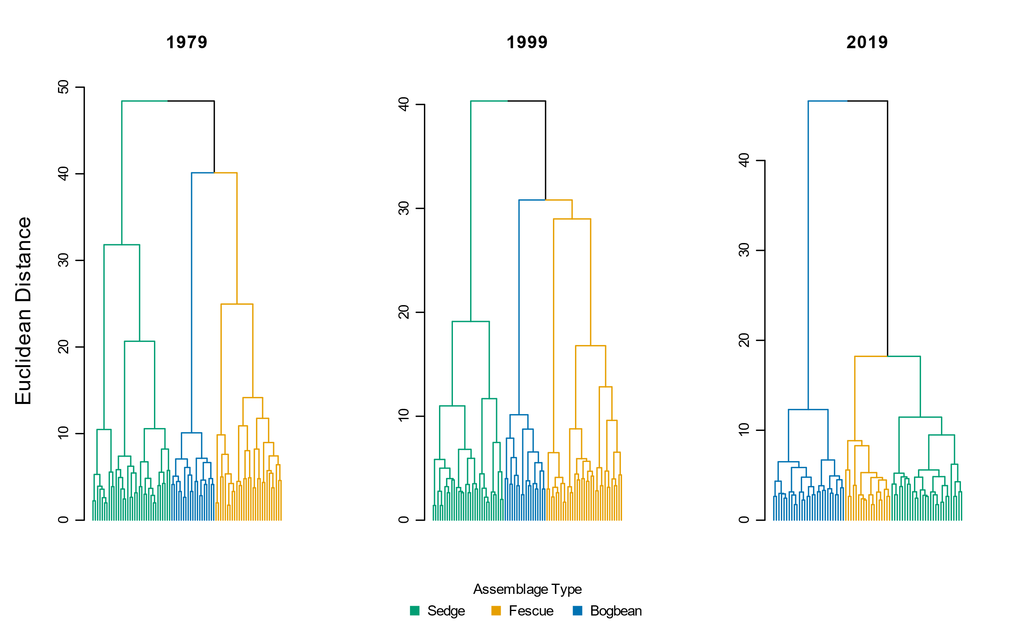

Cluster analysis shows greater distance, and thus *increased* *dissimilarity*, **between** *assemblages* based on *species* *cover abundance* at the plot scale. I interpret this to mean there is more distinction, and thus more heterogeneity, between assemblage types. There is less distance, and thus increased similarity, within each assemblage type. I interpret this to mean there is greater homogeneity of *cover abundance* within assemblages.

Diversity components show *increasing beta-diversity* **within** *assemblages*, based on *number of species* at the plot scale. This means fewer species were found in each plot, regardless of their cover abundance, so the ratio (beta-diversity = total # species/alpha-diversity) increases. I interpret this to mean plot-scale species composition within an assemblage is more variable, thus I say each assemblage is becoming more heterogeneous with respect to species presence.

|  |  |  |  |  |  |  |
| --- | --- | --- | --- | --- | --- | --- |
|  | **Plot-level components** | |  | **Diversity components** | | |
| **Assemblage** | **No. quadrats** | **No. species** |  | **α diversity** | **α diversity sd** | **β diversity** |
| **Sedge** |  |  |  |  |  |  |
| 1979 | 34 | 36 |  | 8.74 | 2.45 | 3.89 |
| 1999 | 31 | 35 |  | 8.26 | 1.98 | 4.24 |
| 2019 | 28 | 34 |  | 7.89 | 2.69 | 4.31 |
|  |  |  |  |  |  |  |
| **Fescue** |  |  |  |  |  |  |
| 1979 | 29 | 47 |  | 12.83 | 3.87 | 3.66 |
| 1999 | 33 | 41 |  | 9.69 | 3.96 | 4.23 |
| 2019 | 18 | 27 |  | 5.83 | 2.79 | 4.63 |
|  |  |  |  |  |  |  |
| **Bogbean** |  |  |  |  |  |  |
| 1979 | 19 | 32 |  | 12.84 | 3.61 | 2.49 |
| 1999 | 18 | 36 |  | 11.50 | 2.92 | 3.13 |
| 2019 | 28 | 34 |  | 10.46 | 1.90 | 3.25 |
|  |  |  |  |  |  |  |
| **Total** |  |  |  |  |  |  |
| 1979 | 82 | 48 |  | 9.96 | 3.41 | 4.82 |
| 1999 | 82 | 45 |  | 9.55 | 3.30 | 4.71 |
| 2019 | 74 | 43 |  | 8.36 | 3.03 | 5.14 |