Revisions were made according to Reviewer 2 & 3 comments; we thank these reviewers for their continued constructive critiques. We have explained these revisions according to each reviewer’s points:

# Reviewer #2

Reviewer 2 recommended increasing font size in Fig. 1; this was amended in the ms.

# Reviewer #3

**“In table S5 I think the actual values of mean cover would be easier for the readers than mean cover class values.”**

We agree actual cover values would be ideal; however, this is not possible as the 1979 and 1999 datasets only recorded cover class values. I.e., raw percent cover data are not available.

**“In table S5 the dominant fescue is given as Festuca arundinacea but everywhere else it is given by it's current name of Schedonorus arundinaceus.”**

Thank you for catching that inconsistency! This was corrected.

**With regard to cluster analysis & whether to maintain 3 main groups or evaluate subgroups (reviewer comment paragraphs 2-4):**

We wish to emphasize our appreciation for how investigation of species associated with the apparent subgroups may be of interest to readers; however, we strongly feel exploration of these finer subgroups introduces confounding subjectivity and analytical issues. We maintain that because the cluster analysis is agglomerative, defining the cluster groups at the three highest convergence points is a consistent way of evaluating the indicator species driving each of the clustered groups (as we have done in this paper, and indicated this in the Methods on line 218). We feel pursuing different numbers of subgroups in each year as suggested (e.g., the suggestion to identify 3 groups in 1979, 4 groups in 1999, and 3 groups in 2019), introduces a highly subjective method of evaluating the clusters, and would necessitate extra narrative throughout all sections of the paper to sufficiently justify the subgroups that is beyond the intended scope to evaluate broad changes in community dynamics over time. Moreover, this changes the scale of focus of our assessment: as the paper is presented, we are considering coarse community-level scales; assessment of subgroups results in a fine-grain focus that our data do not support.

If we were to define subgroups, we might propose defining these as the six highest convergence points in each sampling year. This would be consistent with our Methods to define the three main cluster groups at the three highest convergence points. We conducted an additional indicator species analysis for these six subgroups in each year, but we note this approach is problematic because there are not significant indicator species for all subgroups identified. We note this issue will be encountered regardless of how the subgroups are defined. Additionally, the indicator species common to all three datasets when only three clusters are used (sedge, fescue, bogbean) are not always included in the subgroups. We feel these issues result in loss of a focused narrative on changes within the major assemblages, and the approach does not yield clear insight to clear community trends or drivers of change. Please refer to Table A and Figure A at the end of this response: we include these to illustrate how trying to tease apart subgroups introduces confusion rather than clarification, and we do not recommend including these results in the publication.

**With regard to discussing spatial changes and Fig. S2 (reviewer comment paragraph 5):**

We feel further evaluation of spatial changes may be tenuous at best, as we’ve explained there are likely inconsistencies in relocation of some transects in the 1999 and 2019 sampling years (lines 294-299). Elaboration on spatial changes over time in the discussion may mislead readers to assuming stronger inference about the community dynamics.

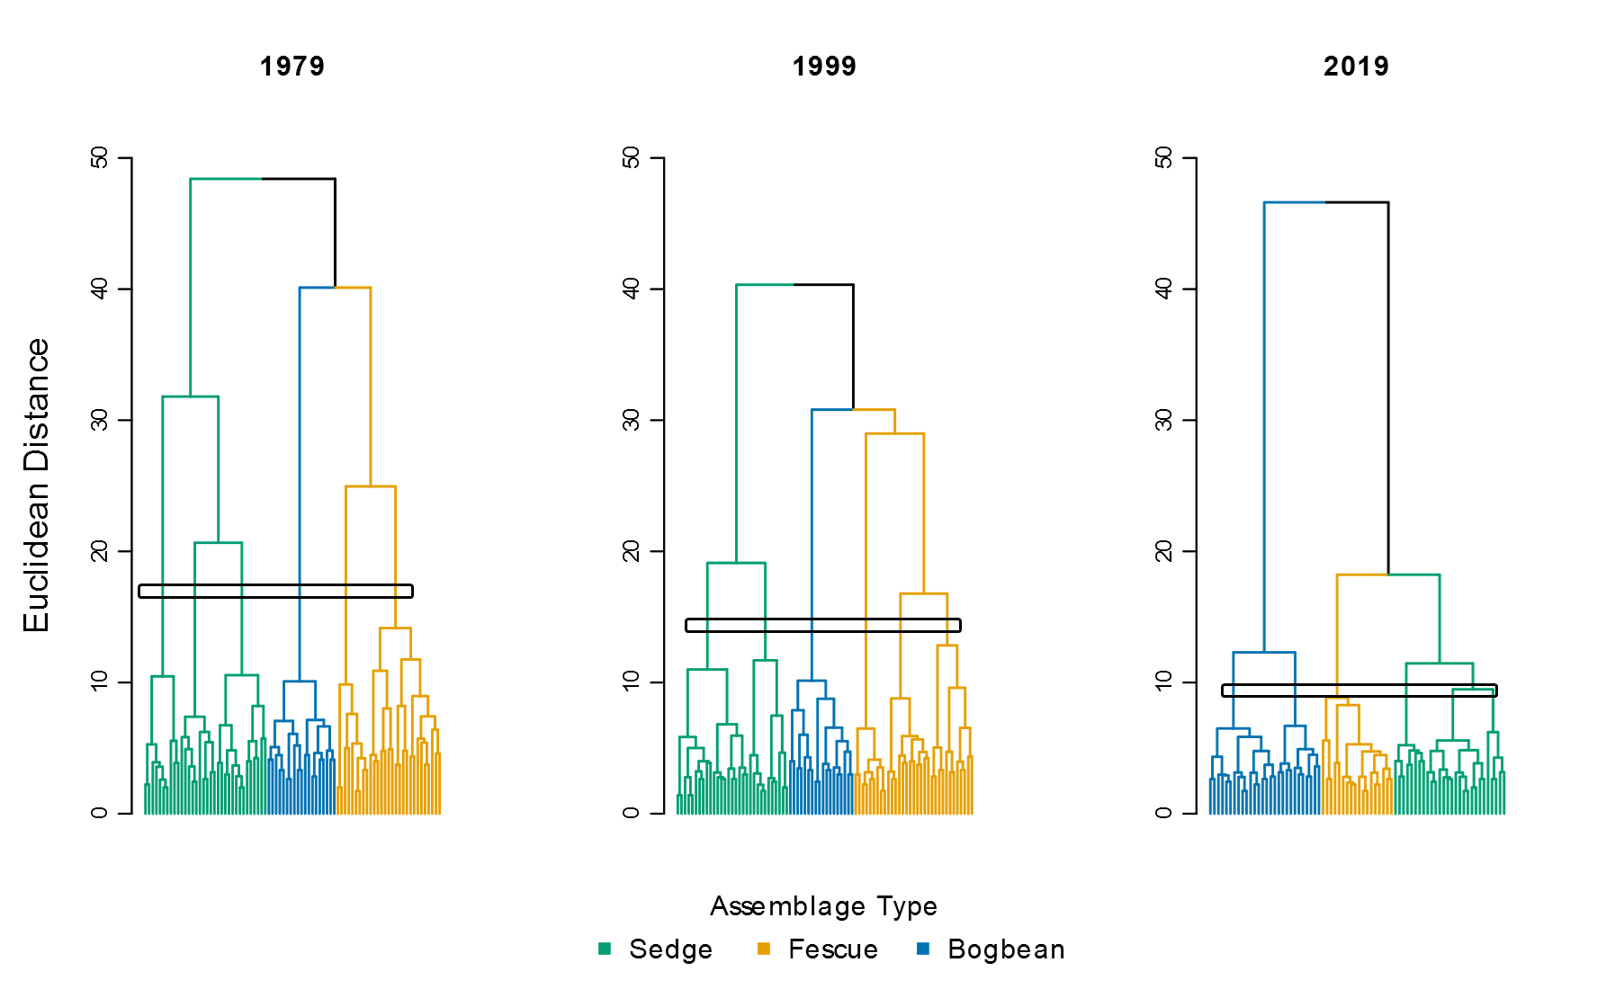

Figure A. Cluster analysis with six subgroups objectively identified in each sampling year. Subgroups are identified by the six branches at the highest levels of convergence. In 1979, this produces three, one, and two subgroups in the ‘Sedge,’ ‘Bogbean,’ and ‘Fescue’ clusters, respectively. In 1999, this produces two, one, and three subgroups in the ‘Sedge,’ ‘Bogbean,’ and ‘Fescue’ clusters, respectively. In 2019, this produces two, one, and three subgroups in the ‘Bogbean,’ ‘Fescue,’ and ‘Sedge’ groups, respectively. Indicator species characterizing these subgroups are presented in Table A.

Table A. Indicator species analysis for six subgroups identified in each sampling year as shown in Figure A. Note that not all subgroups identified have species with significant indicator values.

