# Introduction

* Broader theory: Disturbance & recovery toward historical or functional states; recovery of natural processes may proceed following disturbance release.
  + Quickly exemplify estuary ecosystems where varying degrees of natural disturbance are experienced in daily tides, seasonal storms, or over longer timescales of sedimentary processes such as marsh accretion, erosion, or subsidence.
* Grazing as a form of natural disturbance
  + Grazing removes vegetation which may be the source of local seed rain, but also a mechanism for trapping/retaining seeds at the site. Structural complexity of vegetation & role in seed trapping/preventing erosion
    - Vegetation in aquatic systems such as estuaries serves vital function of sediment trapping and preventing erosion.
      * ~~This structural complexity of tall (0.3-1 m) herbaceous vegetation also serves to trap seeds.~~
* Contextualize PNW estuaries as important, spatially restricted habitat, then transition to explain history of introduced resident Canada geese and how unmitigated grazing in conversion of vegetated habitat to grubbed mudflat.
  + Populations of resident Canada geese (*Branta canadensis,* hereafter CAGO) have been artificially inflated due to a breeding program to promote hunting tourism in the 1970s.
  + Resident populations on eastern Vancouver Island undergo their annual nesting and molt, where their grazing impacts can destroy marsh habitat.
    - Explain grubbing behavior results in removal of rhizomatous graminoid species, resulting in erosion through sediment washing into channels (raising channel depth, loss of stream shading).
    - While mudflats are ecologically productive, they do not provide the same quality of deep, shaded channels for juvenile salmonids.
  + Many estuary plant species reproduce clonally, however the extent to which these communities and their seed banks recover towards a reference condition have not been examined, and should be of high management concern to habitat managers.
* Recovery of species compositional diversity after grazing pressure is released is indicative of resilient community processes.
  + This may be represented by clonal expansion from adjacent patches.
  + SURFACE seed banks represent recent seed introduction, either from local above-ground parent plants, or from intertidal hydrochory.
    - Intertidal hydrochory may bring in seed from within the same estuary or other habitats connected by aquatic currents as far as XX km away.
    - Tidal inundation also drives sedimentation and erosion processes. Sedimentation is highly variable within and between years (cite), and thus can be very difficult to measure within a single year (cite). However, estimations of sedimentation rates in PNW estuaries are typically X-Y cm per year. This estimation of sediment processes allows some assumption that seeds deposited within the past A-B years may be found in the top 1 cm of estuary sediment.
  + Recovery from seed may not be the primary mechanism of plant community recovery, however it is important for the introduction of new species or genetic diversity.
    - Seed banks in many ecosystems, including wetlands, may be different from their above-ground counterparts (Thompson & Grime, 1979). This may mean that species observed in the above-ground plant community may be under-represented or absent in the seed bank, and thus a risk exists they may be competitively excluded by other species in the event of disturbance.
    - Invasive species presence in the seed bank should be a high management concern, as these species may displace native species should disturbance occur.
* If grazing pressure is released by physically excluding geese, vegetation should recolonize the mudflat through clonal expansion and/or opportunistic germination. However, the question remains whether the above-ground vegetation and surface seed banks recover to a state comparable to an undisturbed condition.

## Questions & Hypotheses

The main objective of this study is to examine estuary vegetation and seed bank resilience to grazing.

I wanted to know:

1. How are plant species and plant structural traits affected by time since grazing exclusion?
   1. If plant communities are resilient, I expect long-term exclusion sites (e.g., 10 years) will recover the same cover abundance of species and structural traits as undisturbed sites.
2. Does grazing disturbance have an effect on surface seed bank compositional abundance throughout the year; is surface seed bank compositional abundance more seasonally variable depending on disturbance condition?
   1. Because grubbed sites will have lower structural complexity of above-ground vegetation, I expect surface seed banks in these sites to have lower seasonal abundance and lower seasonal variability compared to long-term exclusion and undisturbed sites.
   2. Similarly, I expect undisturbed sites to have greater abundance and seasonal variability in compositional abundance because the taller vegetation will trap greater numbers and diversity of seeds dispersed locally or through water.
3. Do surface seed banks and vegetation exhibit resilience by returning to a ‘reference’ condition when grazing has been excluded for 10 years?
   1. I expect sites excluded for 10 years to have similar species compositional vegetation abundance to undisturbed sites due to clonal expansion from surrounding marsh vegetation. This vegetation structural complexity will trap seeds produced within or dispersed into the patch, leading to seed banks that resemble an undisturbed site.
4. Is seasonal surface seed bank compositional abundance highly similar to above-ground summer vegetation compositional abundance?
   1. Because grubbed sites will have lower structural complexity to trap a diversity of seeds brought in by tidal currents, I expect grubbed sites to have the greatest similarity between seasonal surface seed banks and above-ground summer vegetation. Similarly, I expect undisturbed sites to have the greatest dissimilarity between surface seed banks and the above-ground summer vegetation.

# Methods

## Study area & site history

* Site descriptions of Little Qualicum, Englishman, and Nanaimo River Estuaries as Wildlife Management Areas, grazing pressure history, and related studies (map).
* Wooden fencing was iteratively installed by restoration groups to physically prevent Canada geese from grazing vegetation, hereafter referred to as ‘exclosures.’
  + Exclosures were placed opportunistically along channel edges where intensive herbivory was observed to protect remnant marsh platform from further degradation.
* Different restoration urgencies have afforded observation of recovery timepoints 1 and 10 years post-grazing exclusion in two different estuaries (Table 1).
  + Exclosure sites were selected to represent comparable conditions within the exclosures over time; undisturbed and grubbed sites are not protected by an exclosure.

Table . Grazing disturbance conditions in the Little Qualicum River and Nanaimo Estuaries resulted in conversion of vegetated marsh to partially or fully grubbed mudflats; exclosures were installed to prevent further degradation into the marsh platform. Each disturbance category n = 4 for each estuary.

|  |  |  |  |
| --- | --- | --- | --- |
| **Estuary representation** | **Time Since Disturbance** | **Disturbance condition** | **Revegetation status** |
| Little Qualicum, Nanaimo, Englishman | 0 years (recent grubbing disturbance) | Grubbed | No transplants; sparse ruderal vegetation exists |
| Nanaimo | 1 year post-grazing disturbance | Partially grubbed | No transplants; vegetation recovery from remnant and adjacent vegetation |
| Little Qualicum | 10 years post-grazing disturbance | Partially grubbed | No transplants; vegetation recovery from remnant and adjacent vegetation |
| Little Qualicum, Nanaimo, Englishman | No known grazing disturbance | Undisturbed | No manipulations |

## Sampling methods

### Vegetation sampling

Vegetation sampling was conducted once in mid-July, 2021. Two 1 m2 vegetation plots (sites) were placed within the exclosures, at least 1 m from the bank edge and any exclosure boundary (n = 8 per disturbance condition in each estuary), and at least 3 m apart within the exclosure. Quadrats were placed so that the edge nearest creek was parallel to the bank.

All vascular species were identified according Hitchcock and Cronquist (1973), and currently accepted nomenclature standardized according to the PLANTS Database of the United States Department of Agriculture, Natural Resources Conservation Science [USDA NRCS]. Species were considered in the plot if at least half of their basal stem(s) were inside the quadrat boundary; overhanging vegetation was not considered. Aerial vegetated cover to the nearest 3 % (1/32 m2) was recorded. For any species present with less than 3 % cover, species were assigned 2% cover if > 20 individuals were present, 1 % cover if 2-20 individuals were present, and 0.1% cover for single individuals. Bare ground was estimated as the remainder of the plot area not covered by above-ground vegetation. Any plots with > 100% cover were standardized relative to 100%.

### Surface seed bank sampling & germination

Two surface seed bank samples were taken from each plot (n = 16 per disturbance condition in each estuary) in summer (July 2020), fall (October 2020), and spring (March 2021). A 10 cm diameter handheld bulb planter (e.g., [Husky 9 in. stainless Steel Bulb Planter sold by Home Depot, USA](https://www.homedepot.com/p/Husky-9-in-Stainless-Steel-Bulb-Planter-GD210314/317436441)) was used to excise sediment 1 cm deep to capture the surface seed bank. Vegetative roots, rhizomes, or other viable rooted material were removed before placing sample in a plastic zipper bag. All surface seed bank samples from the same estuary and disturbance condition were then homogenized in a clean bucket with 100 mL dechlorinated water. Samples were hand-sifted for any remaining root, rhizome, or vegetative material, then homogenized sample was transferred to a clean plastic zipper bag. Summer and fall 2020 samples were stored at 4o C for approx. 12 weeks to simulate overwinter cold stratification; samples collected in the spring of 2021 underwent natural winter conditions and did not require cold stratification.

Germination trials were conducted under greenhouse conditions with 15 hr daylength at ~ 20o C. Seedling pots (9 cm x 13 cm x 5.7 cm (depth), BRAND) were filled with moist, sterile potting media (Sunshine Mix No. 4, Sun Gro Horticulture, Agawam, MA, United States). Pots were placed in solid cache trays, and constantly bottom-watered with municipal tap water.

Seed bank samples were sown by pouring 75 mL sediment over the top of each seedling pot (n = 8 per estuary and disturbance condition) while constantly agitating the homogenized seed bank sample. Seeds were allowed to germinate for 5 weeks, at which time all individuals were counted and removed. The seedling trays were observed for any further germination for another 7-10 days, at which time the samples were discarded. Any species that could not be identified were labelled and transplanted into 38 P plug trays (BRAND) with the same growing media and growing conditions until a positive identification could be made. Representative seedlings and flowering individuals used to confirm identification were pressed and available as herbaria (UBC herbarium accession?).

## Analysis

Analysis plan outline:

1. How are plant species and plant structural traits affected by time since grazing exclusion?
   1. Descriptive analysis: species richness and evenness
      1. plot means ± SE of structural traits (Figure 1).
   2. Test statistical difference in cover abundance of structural groups and clades (groups show in Figure 1) with one-way ANOVA.
2. Does grazing disturbance have an effect on surface seed bank compositional abundance throughout the year; is surface seed bank compositional abundance more seasonally variable depending on disturbance condition?
   1. Descriptive analysis: plot means ± SE of seasonal abundances (Figure 5, Figure 6).
   2. Test statistical difference in seed abundance with PERMANOVA (a) between disturbance conditions within a season, and (b) between seasons for each disturbance condition.
3. Do surface seed banks and vegetation exhibit resilience by returning to a ‘reference’ condition when grazing has been excluded for 10 years?
   1. ***Uncertain:*** would a linear model be most appropriate here?
4. Is seasonal surface seed bank compositional abundance highly similar to above-ground summer vegetation compositional abundance?
   1. Visualize with NMDS (Figure 8); compare similarity between vegetation and seed bank compositional abundance with Sorenen’s similarity index
   2. Test statistical difference in compositional abundance by PERMANOVA; compare centroid distance between ‘disturbed’ and ‘undisturbed’ conditions.

# Results

1. How are plant species and plant structural traits affected by time since grazing exclusion?
   1. Contrary to my expectations, after 10 years of grazing exclusion in Little Qualicum Estuary, medium-height forbs (50-100 cm) and tall graminoids (> 100 cm tall) did not recover to the same abundance as in undisturbed sites. This cover abundance has been replaced by medium-height invasive graminoids, namely, *Agrostis* sp. (Figure 1)
   2. Across all estuaries, tall and medium height graminoids were absent or nearly so in grubbed sites, and reduced in sites excluded from grazing for 1 year. Short graminoids (< 50 cm tall) and bare ground each accounted for up to 50% of mean relative cover abundance in grubbed sites at all estuaries, illustrating a stark contrast in plant structure and species composition. (Figure 2, Figure 3, Figure 4)
2. Does grazing disturbance have an effect on surface seed bank compositional abundance throughout the year, and is surface seed bank compositional abundance more seasonally variable depending on disturbance condition?
   1. Grazing disturbance affects abundance of seed found in samples across all seasons. For example: Undisturbed sites at each estuary had a greater abundance of medium or tall graminoids, and medium-height forbs compared to grubbed sites. (Figure 5)
   2. Seed abundance did not seem to vary widely between seasons, although some exceptions were noted. For example: seed of tall forbs (Douglas aster, *Symphotrichium subspicatum*) was only found in Undisturbed sites in Nanaimo during the fall sampling period when seeds were dispersed. Interestingly, seeds of tall forbs were found in grubbed sites in Nanaimo the following spring. (Figure 6)
3. Do surface seed banks and vegetation exhibit resilience by returning to a ‘reference’ condition when grazing has been excluded for 10 years?
   1. Surface seed bank samples in sites excluded from grazing for 10 years were more similar to undisturbed sites than grubbed sites, supporting my expectation that grazing exclusion leads to surface seed bank resilience (Figure 7).
4. Is the surface seed bank compositional abundance throughout the year highly similar to above-ground summer vegetation compositional abundance?
   1. Consistent with my expectations, surface seed banks at grubbed and recently grazed sites were highly similar across seasonal samples at all estuaries. Compositional abundance at undisturbed sites and sites exclosed 10 years in Little Qualicum Estuary were more dissimilar between seasons (Figure 8).

## Vegetation trends

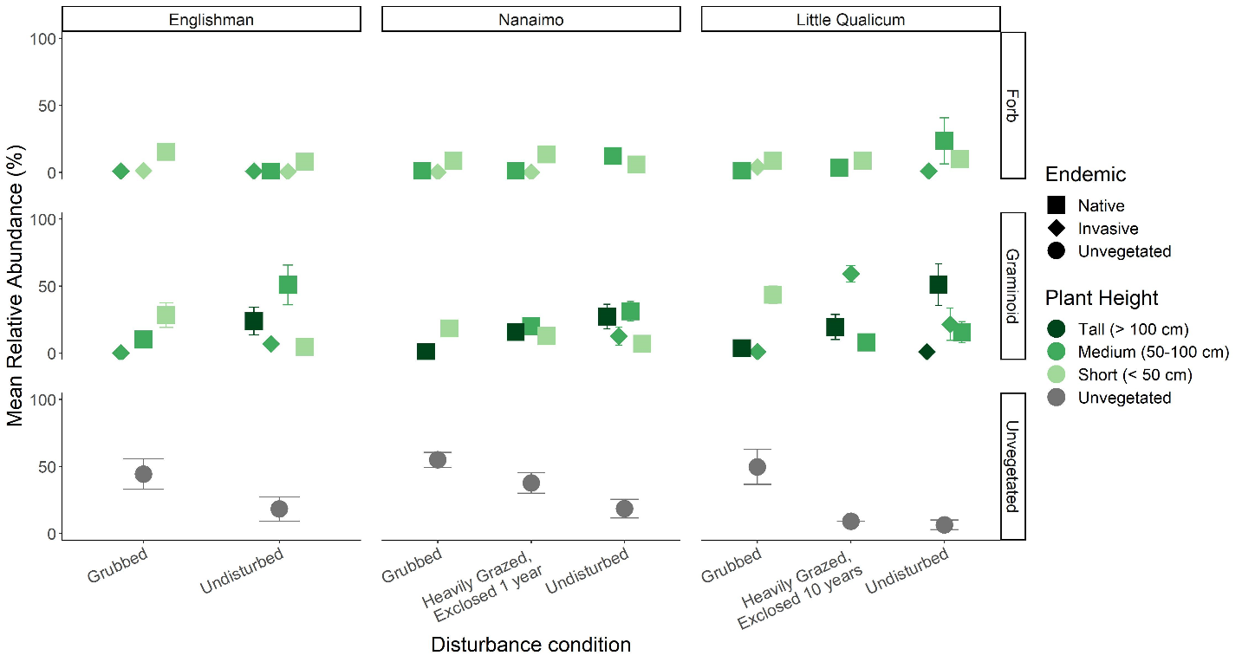

Figure . Across all estuaries, ~ 50% of mean relative cover abundance in grubbed sites is bare ground (unvegetated). All sites have some invasive species presence, however sites exclosed for 10 years in Little Qualicum Estuary have over 50% mean relative cover of invasive graminoids. After 10 years of exclosure in Little Qualicum estuary, tall native graminoids and medium-height forbs do not appear to recover to the same relative abundance as in undisturbed sites. (n = (8) 1 m2 plots in each disturbance condition and estuary).

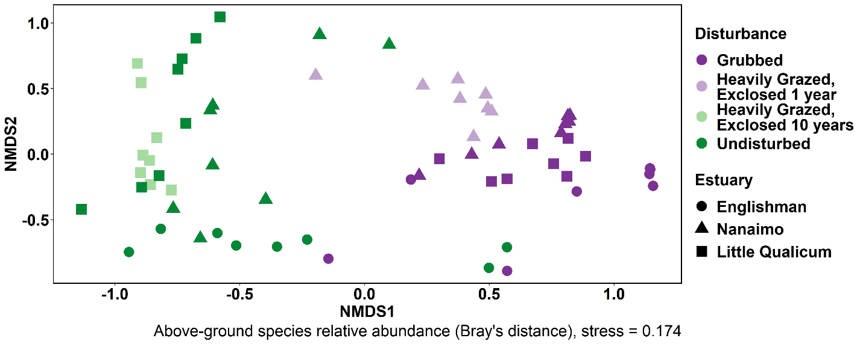

Figure . When above-ground vegetation from all sites and plots are analyzed together, trends show that across estuary, relative abundance of above-ground cover is highly similar in grubbed plots and heavily grazed plots exclosed 1 year, while grazed sites exclosed for 10 years are more similar to undisturbed sites than grubbed or heavily grazed sites exclosed 1 year. (n = (8) 1 m2 plots in each disturbance condition and estuary; stress = 0.174). I feel this plot is most informative, because it shows similar composition trends within and between all estuaries sampled. However, I would like opinions on whether NMDS is needed, and if so, whether Figure 2, Figure 3, or Figure 4 is more informative.

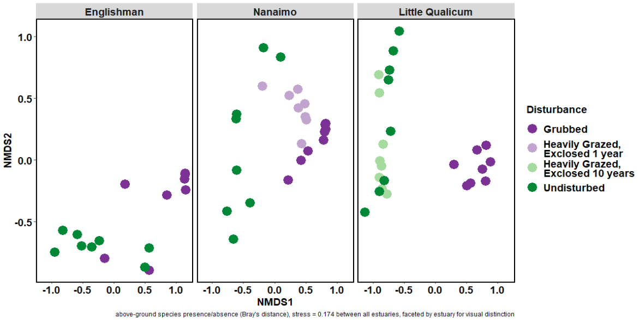

Figure . The same relative abundance vegetation NMDS score output as shown in Figure 2 may be faceted by estuary for visual distinction, however this removes the ability to compare similarity of vegetation abundance between estuaries. (n = (8) 1 m2 plots in each disturbance condition and estuary; stress = 0.174). I would like opinions on whether NMDS is needed, and if so, whether Figure 2, Figure 3, or Figure 4 is more informative.

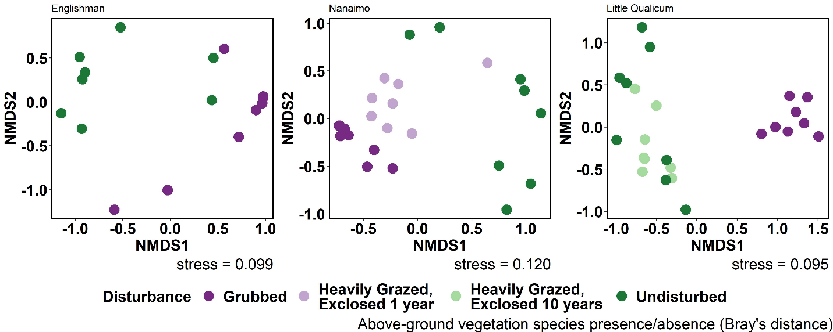

Figure . If NMDS is calculated for each estuary separately, we see a similar trend of dissimilarity of above-ground vegetation presence/absence between grubbed and undisturbed plots across all estuaries. By running NMDS separately for each estuary, this removes comparison of vegetation presence/absence between estuaries. I feel this plot may be less informative than Figure 2 because despite different environmental conditions, Figure 2 shows that compositional presence/absence is fairly consistent across all estuaries. (n = (8) 1 m2 plots in each disturbance condition and estuary; stress scores shown on each panel). I would like opinions on whether NMDS is needed, and if so, whether Figure 2, Figure 3, or Figure 4 is more informative.

## Surface seed bank trends

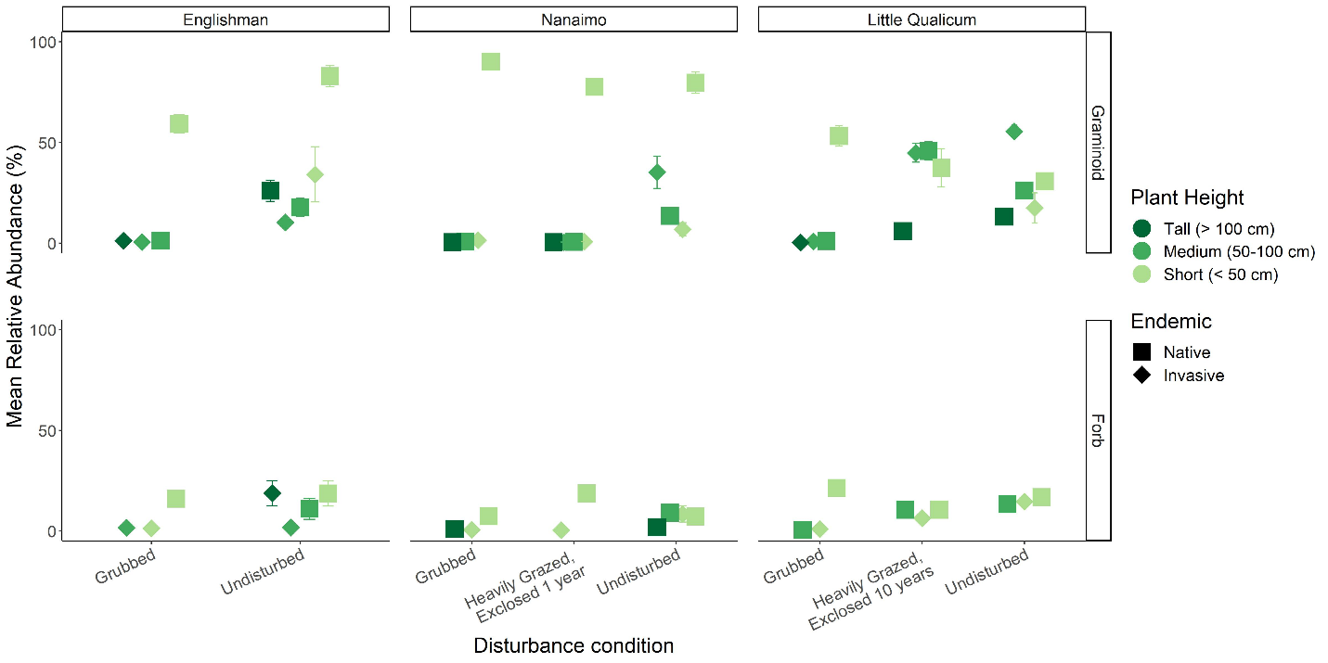

Figure . Mean seed abundance pooled from all seasons sampled show short-growing (< 50 cm) native perennial graminoids are often the most abundant group in surface seed banks across all estuaries. Notable exceptions are in the Little Qualicum Estuary at 10-year old exclosures and undisturbed sites, where invasive perennial graminoids are of equal or greater abundance. (n = (24) seed bank germination trials in each disturbance condition and estuary).

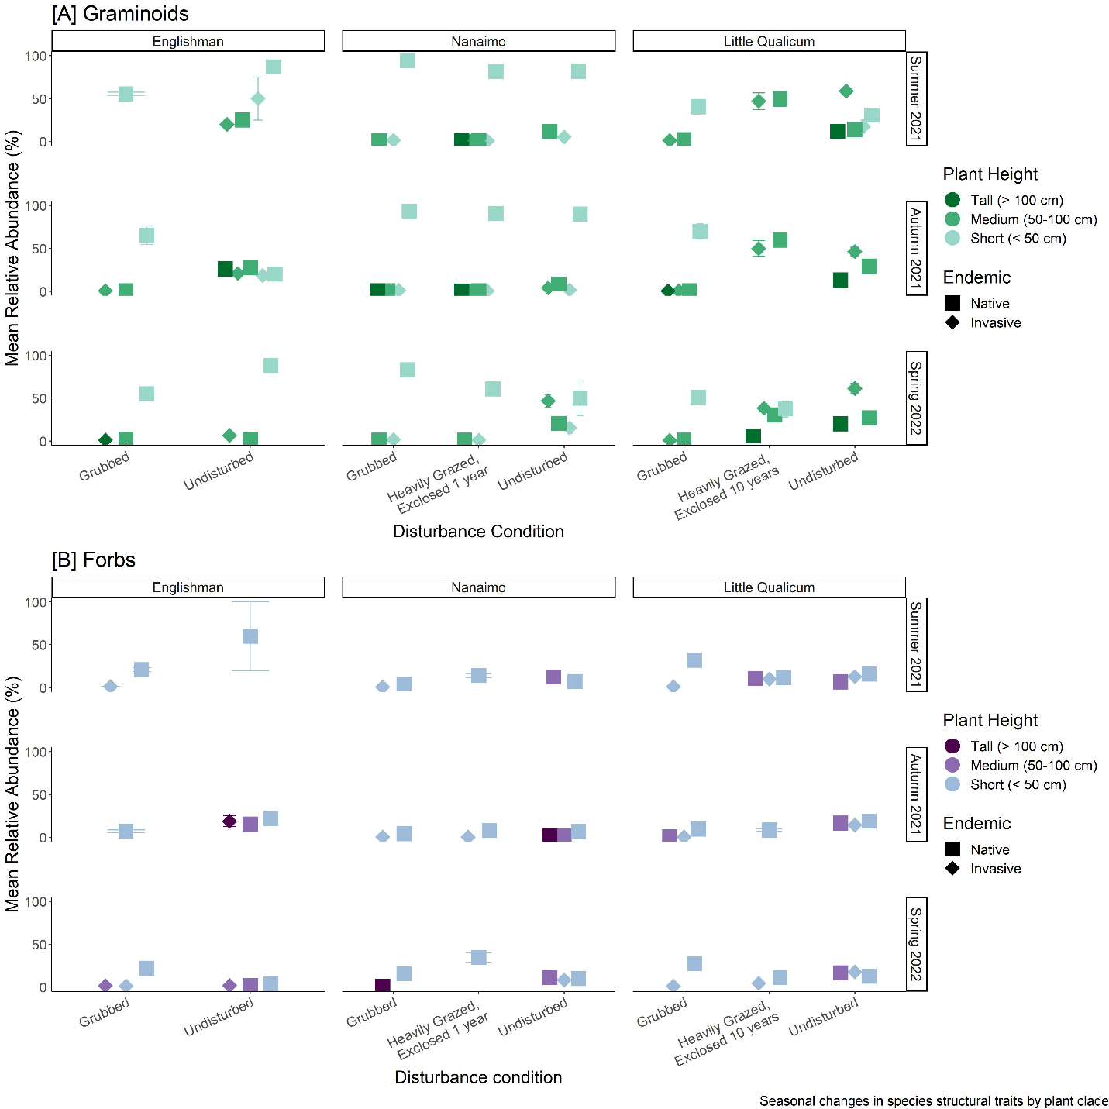

Figure . Relative abundance of most structural groups does not vary seasonally, although undisturbed sites in the Englishman Estuary had greater abundance of native forbs in Summer 2021, and invasive graminoids in Autumn 2021 (bottom panel). (n = (8) seed bank germination trials in each season, disturbance condition, and estuary)

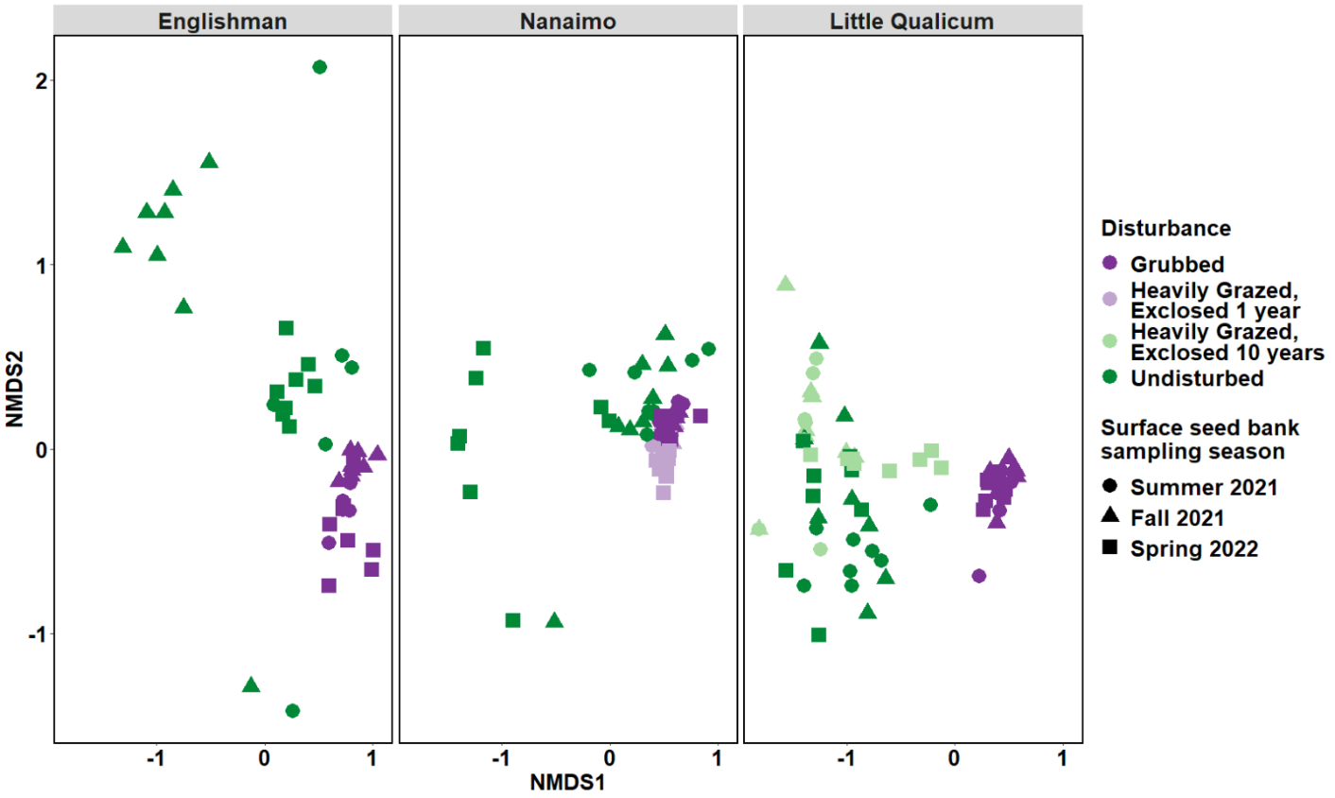

Figure . Relative abundance of surface seed bank species is most similar in grubbed and heavily grazed plots exclosed 1 year, regardless of estuary or season. There is more seasonally-driven variation in surface seed bank species compositional abundance in undisturbed sites and grazed sites exclosed for 10 years. (n = (8) seed bank germination trials per each disturbance condition, estuary, and season; stress = 0.132).

## Compare vegetation to seed bank

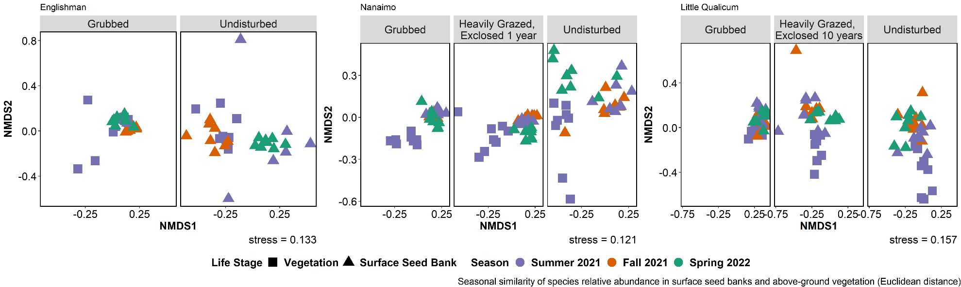

Figure . Surface seed bank species shift in similarity to summer above-ground vegetation depending on season sampled. Trends of similarity to above-ground vegetation are inconsistent between estuaries and disturbance conditions. Year-round surface seed bank composition is most similar to summer above-ground vegetation in grubbed plots in Little Qualicum Estuary. Seed banks appear to have the most seasonally-driven change in undisturbed plots in Englishman and Nanaimo Estuaries. Euclidean distance chosen to square dissimilarity (dissimilarities using Bray’s distance were too small to visualize differences). N = 8 1 m2 plots or 8 seed bank germination trials per each disturbance condition, estuary, and season.

# Discussion

Intensive grazing and grubbing impacts result in loss of structural complexity, leaving sparse ruderal vegetation that may alter the surface seed bank through structural capacity to trap seeds.

Anticipated discussion points:

* If above-ground vegetation richness/evenness recover towards the reference condition, this builds support that protection of remnant habitat is an effective strategy for recovering structural diversity and function of marsh vegetation.
* If seed banks show dearth of diversity along recovery trajectory, this builds support for transplanting activities to restore functional diversity.
  + If seed banks show increased diversity at any point along the recovery trajectory, this opens new questions to test whether species recover naturally from seed bank, or if there are additional limitations on recruitment.
* If seed bank shows high variability between seasons, this means… ???

Broader importance:

* Recovery of these habitats is important for supporting populations of juvenile salmonids, and for coastal resilience to sea level rise.

# Literature Cited

Hitchcock, C. L., & Cronquist, A. (1973). *Flora of the Pacific Northwest, an illustrated manual*. Seattle and London: University of Washington Press.

Thompson, K., & Grime, J. P. (1979). Seasonal Variation in the Seed Banks of Herbaceous Species in Ten Contrasting Habitats. *The Journal of Ecology*, *67*, 893.

# Supplemental

# Potential journals

## [Estuaries & Coasts](https://www.springer.com/journal/12237/aims-and-scope)

2020 IF 2.976 (Q1, Ecology/Aquatic Science)

“…The journal covers research on physical, chemical, geological or biological processes, as well as applications to management of estuaries and coasts. The journal publishes original research findings, reviews and perspectives, techniques, comments, and management applications. Estuaries and Coasts will consider properly carried out studies that present inconclusive findings or document a failed replication of previously published work. Submissions that are primarily descriptive, strongly place-based, or only report on development of models or new methods without detailing their applications fall outside the scope of the journal.”

## [Journal of Vegetation Science](https://onlinelibrary.wiley.com/page/journal/16541103/homepage/forauthors.html)

2020 IF 2.865 (Q1, Ecology/Plant Science)

The Journal of Vegetation Science publishes articles on all aspects of plant community ecology and macroecology of vegetation, with particular emphasis on articles that develop new concepts or methods, test theory, **identify general patterns**, or that are otherwise likely to interest a broad international readership. An article may focus on any aspect of vegetation science, e.g. community structure (including community assembly and plant functional types), **biodiversity (including species richness and composition)**, spatial patterns (including plant geography and landscape ecology), **temporal changes (including demography, community dynamics** and palaeoecology) and processes (including ecophysiology), provided the focus is on increasing our understanding of plant communities. The journal does not publish articles on the ecology of a single species, except for studies framed in the community context, especially of species that play a key role in structuring plant communities (e.g. stand dominants). **Articles that apply ecological concepts, theories and methods to the vegetation management, conservation and restoration, and articles on vegetation survey should be directed to our associate journal,** [Applied Vegetation Science](https://onlinelibrary.wiley.com/page/journal/1654109x/homepage/forauthors.html).

## [Wetlands Ecology & Management](https://www.springer.com/journal/11273/submission-guidelines" \l "Instructions%20for%20Authors_Article%20Types)

2020 SJR 2-yr IF 1.341, 4-yr IF 2.092 (Q2, Management & Monitoring; Q3, Ecology/Aquatic Science)

“… Wetlands Ecology and Management publishes refereed papers on topics relevant to freshwater, brackish and marine coastal wetland ecosystems. Such topics may span wetlands science, management, policy and economics.”