# Introduction

* Broader theory:
  + Hierarchy of predictability and variability in restoration, where strong environmental filters limit variability of predictable recovery trajectories (Brudvig et al., 2017).
  + Stable (resilient) communities have high functional and taxonomic redundancy (Török & Helm, 2017; others).
  + Disturbance destabilizes communities, and recovery to a functional state (analogous to historical function/condition) is desirable in restoration, especially recovery of recovery of natural processes following disturbance release.
* Grazing as a form of natural disturbance
  + Literature review of how grazing shifts above-ground composition, and subsequently impacts seed bank composition.
  + Mechanisms of vegetation as a source of local seed rain, and trapping/retaining seeds at the site.
* Unmitigated goose grazing in estuaries results in conversion of vegetated habitat to grubbed mudflat.
  + Populations of resident Canada geese (*Branta canadensis,* hereafter CAGO) have been artificially inflated due to a breeding program to promote hunting tourism in the 1970s.
  + Populations have exceeded carrying capacity of the estuaries on eastern Vancouver Island, resulting in grazing impacts that destroy marsh habitat.
* While mudflats are ecologically productive, they do not provide the same ecosystem function (e.g., erosion resistance, habitat) as rhizomatous vegetation. Restoration and recovery of vegetated habitat is important for ecological benefit, however predictability of recovery trajectories, especially rhizomatous graminoids, is important for understanding impacts to wildlife that use the habitat, such as juvenile salmonids.
  + Loss of vegetation (structural, physical filter) removes local seed rain inputs into seed bank, and change filtering/trapping capacity of patch to retain any seeds brought in by dispersal.
    - Explain that grubbing results in removal of rhizomatous graminoid species, leaving only sparse, ruderal vegetation.
    - This also promotes erosion and changes in abiotic conditions, shifting the potential recruitment niche for key functional species.
  + **Regional knowledge gap: should this lead to closer correlation between seed bank and above-ground vegetation?** Or, in PNW estuaries, should this lead to dissimilarities due to more frequent washing/erosion (e.g., seed rain washes away during winter storms in The Netherlands (Regteren et al., 2019))?
    - Note: literature from east coast estuaries indicates high diversity of seed banks following marsh creation: close similarity with local seed rain in vegetated sites (Mary A. Leck & Simpson, 1994), and *persistence in seed bank after vegetation decline* (M. A. Leck, 2003). However, in east coast estuaries with high annual cover, seed banks are highly variable and dissimilar from standing vegetation (Hopfensperger, Engelhardt, & Lookingbill, 2009). These studies do not address habitat conversion to mudflat and recovery to historically analogous conditions.
    - Seed bank studies in PNW are not as common
* Strong environmental filters in estuaries (elevation/inundation) may prevent recovery from seed, however seed banks may represent opportunistic recruitment potential. Alternatively, absence of species from the seed bank indicates requirement for clonal expansion from remnant individuals or adjacent plant communities.
  + If important functional groups (key rhizomatous graminoids, such as *Carex lyngbyei*) are absent in the seed bank, then this resilience is lost and recovery from clonal expansion is required.
  + However, if these functional groups are represented in the seed bank, then resilience by seed bank recruitment is possible if they can overcome abiotic conditions.
    - **Knowledge gap: Can functional groups stored in the seed bank be an expected source of estuary resilience following intense grazing pressure?**

## Questions

1. Does functional richness and evenness of rhizomatous graminoid vegetation recover to the same functional richness and evenness of undisturbed (reference) sites following grazing pressure release?
   1. I expect that the longer sites have been excluded, the more closely the above-ground cover richness and evenness of rhizomatous graminoid species will resemble undisturbed conditions due to restoration of abiotic processes that promote a specific functional composition.
2. Do estuary seed banks retain functional resilience after intense herbivory?
   1. Because there is opportunity for greater seed dispersal, I expect there to be greater evenness of species in unvegetated (grubbed) sites that could indicate functional resilience to recovery.
3. Is dissimilarity between seed bank and above-ground vegetation the same along a recovery trajectory?
   1. I expect there to be greater dissimilarity between the seed bank and above-ground cover in more recently disturbed (grubbed) sites, and greater similarity at reference sites.
4. Does functional diversity of the seed bank recover at the same rate as recovery of above-ground functional diversity, richness, and evenness?
   1. I expect the longer sites have been excluded, the more closely seed banks will match above-ground vegetation.

These questions can help predict likely recovery trajectories (both functional composition and timelines to functional restoration) in estuaries following grazing disturbance. Greater ability to predict recovery trajectories can help land manager prioritize protection of remnant vegetation, or determine priority sites for revegetation efforts.

# Methods

## Study area & sampling

* Paragraph: site histories of Little Qualicum, Englishman, and Nanaimo River Estuaries as Wildlife Management Areas and grazing pressure history (map).
* Fencing was installed iteratively to physically prevent CAGO from grazing vegetation, hereafter referred to as ‘exclosures.’
  + Exclosures were placed opportunistically where aggressive herbivory was observed to protect remnant marsh platform from further degradation.
* Longest history of exclosure is in the Little Qualicum River Estuary (10 years). Explain the history of mixed management over time (Table 1).
  + Exclosures in the Little Qualicum River Estuary constructed 1 year before this study began received transplants within 4 months of study observations. While this alters observed richness of above-ground vegetation, this is not expected to alter seed bank characteristics since no seed dispersal occurred during the study period.
  + Three exclosures in Englishman River Estuary were constructed 5 years before this study, however remnant vegetation and inclusion of transplants is highly variable, and exact locations of vegetation history is unknown.
    - Due to site uncertainties, seed bank samples were not included in this analysis.
    - However, above-ground vegetation can be used to estimate expected functional recovery trajectories.
* Exclosure sites were selected to represent consistent conditions within the exclosure: fully grubbed, partially grubbed. Undisturbed sites are not protected by an exclosure.
  + Two plots subsampled per exclosure, haphazardly placing 1 m2 quadrat in representative patches.
  + Above ground cover was assessed for every species to nearest 0.02m2.
  + Relative cover abundance was calculated when structural canopy layers caused cover to exceed 100%.
* Seed bank samples were taken with a 5 cm diameter gardening tool (bulb planter) to a depth of 1 cm. Two samples were taken per quadrat, for a total of 4 samples per exclosure. All samples for each exclosure age class were homogenized in the field. Emergent vegetation was removed with tweezers following field sampling.

Table . Grazing disturbance conditions in the Little Qualicum River (LQRE), Englishman (ERE), and Nanaimo (NRE) Estuaries resulted in conversion of vegetated marsh to partially or fully grubbed mudflats; exclosures were installed at various times to prevent further degradation into the marsh platform. Some limited mixed management includes transplants in the Little Qualicum River Estuary.

|  |  |  |  |  |  |
| --- | --- | --- | --- | --- | --- |
| **Time Since Disturbance** | **Estuary** | **Disturbance condition** | **Revegetation status** | **Avg. elevation** | **N** |
| 0 years (Ongoing disturbance) | LQRE | Grubbed | No transplants; sparse ruderal vegetation exists | 2.9 | 4 |
| ERE | 3.4 | 4 |
| NRE | 3.8 | 4 |
| 1 year post-disturbance (fenced in 2020) | LQRE | Grubbed | Transplants installed within 4 months of study observations | 3.0 | 4 |
| ~~ERE~~ | ~~Grubbed~~ | ~~No transplants; recovery from remnant vegetation~~ | ~~3.5~~ | ~~1~~ |
| NRE | Partially Grubbed | No transplants; recovery from remnant vegetation | 3.7 | 4 |
| 5 years post-disturbance | LQRE | Grubbed | No transplants; vegetation recovery by encroachment from adjacent marsh platform | 3.1 | 4 |
| ERE | Partially Grubbed | Limited transplants in two of three exclosures (unknown placement); majority of recovery from remnant vegetation | 3.5 | ~~3~~ |
| 10 years post-disturbance | LQRE | Partially Grubbed | No transplants; vegetation recovery by encroachment from adjacent marsh platform | 3.4 | 4 |
| Undisturbed Reference | LQRE | NA | NA | 3.4 | 4 |
| ERE | 3.6 | 4 |
| NRE | 3.9 | 4 |

## Analysis Plan

Answer the questions:

1. Does functional richness and evenness of rhizomatous graminoid vegetation recover to the same functional richness and evenness of undisturbed (reference) sites following grazing pressure release?
   * I expect that the longer sites have been excluded, the more closely the above-ground cover richness and evenness of rhizomatous graminoid species will resemble undisturbed conditions due to restoration of abiotic processes that promote a specific functional composition. **generalized** **linear model of above-ground functional richness.** 
     + Estuary and exclosure age as fixed effects, site disturbance (grubbed, partially grubbed, undisturbed) and sub-sampled plots within sites as random effects.
2. Do estuary seed banks retain functional resilience after intense herbivory?
   1. Because there is opportunity for greater seed dispersal, I expect there to be greater evenness of species in unvegetated (grubbed) sites that could indicate functional resilience to recovery. **PERMANOVA of Shannon’s index?**
3. Is dissimilarity between seed bank and above-ground vegetation the same along a recovery trajectory?
   1. I expect there to be greater dissimilarity between the seed bank and above-ground cover in more recently disturbed sites, and greater similarity at reference sites. **PERMANOVA, using species evenness data with Bray’s distance at the plot level.**
4. Does functional diversity of the seed bank recover at the same rate as recovery of above-ground functional diversity, richness, and evenness?
   1. I expect the longer sites have been excluded, the more closely seed banks will match above-ground vegetation. **Generalized linear model, visualized with NMDS**

# Results

Answer the questions:

1. Does functional richness and evenness of rhizomatous graminoid vegetation recover to the same functional richness and evenness of undisturbed (reference) sites following grazing pressure release?
   * GLM: Expect to say yes based on Fig. 1, Little Qualicum River Estuary.
2. Do estuary seed banks retain functional resilience after intense herbivory?
   1. PERMANOVA of evenness: Expect to say no based on Fig. 2.
3. Is dissimilarity between seed bank and above-ground vegetation the same along a recovery trajectory?
   1. PERMANOVA: Expect to say no based on comparing Figs. 1 & 2: appears 5-yr seed bank in Little Qualicum may be more dissimilar to above-ground vegetation than in other conditions.
4. Does functional diversity of the seed bank recover at the same rate as recovery of above-ground functional diversity, richness, and evenness?
   1. GLM+NMDS: expect to say yes only for some functional groups and/or specific Estuary. E.g., dearth of rhizomatous graminoid seeds in Nanaimo reference sites. May explore caveat of representation of invasive species.

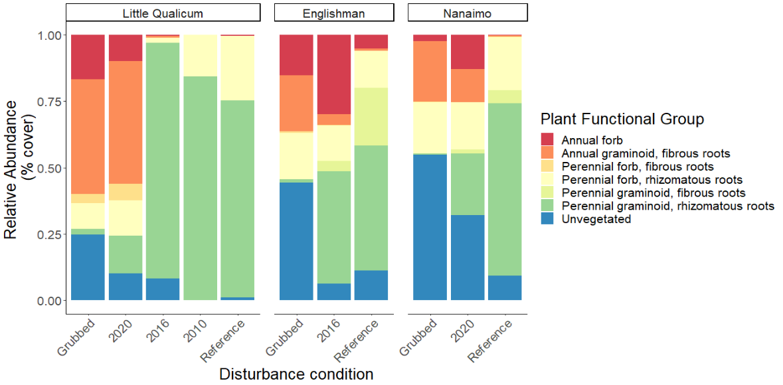

Figure . Annual life histories dominate above-ground cover at grubbed sites in the Little Qualicum River Estuary, while similar disturbance at Nanaimo Estuary results in bare, unvegetated soil. Perennial, rhizomatous graminoids overwhelmingly dominate patches within five years of herbivory release in Little Qualicum, and both estuaries are dominated by this functional group at reference sites. (n = 4 per age class and estuary, except Englishman 2016, n = 3).

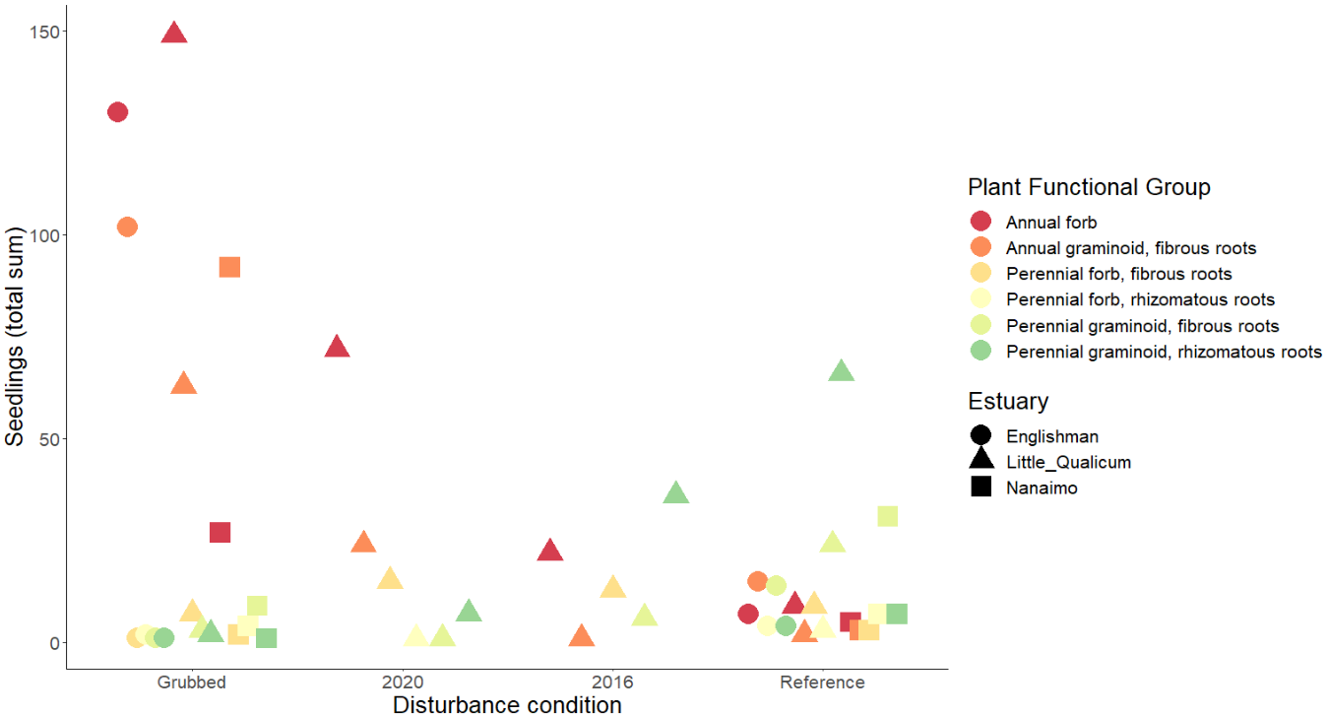

Figure . Similar to above-ground cover, annual species dominate seed bank at grubbed sites, and decrease in prevalence over time since herbivory release. Rhizomatous, perennial graminoids become increasingly prevalent in the seed bank over time, although they are not as prevalent in the Nanaimo Estuary. Results from pilot germination test in 0.02 m2 trays (n = 6 per age class and estuary); due to space constraints 2010 seed banks for Little Qualicum River Estuary and 2020 seed bank for Nanaimo and Englishman were not tested; seed bank samples for 2016 are not available for Nanaimo. Note that testing seed bank sample for ERE 1-5 yr disturbance removal conditions is not possible without further sampling (see note Table 1).

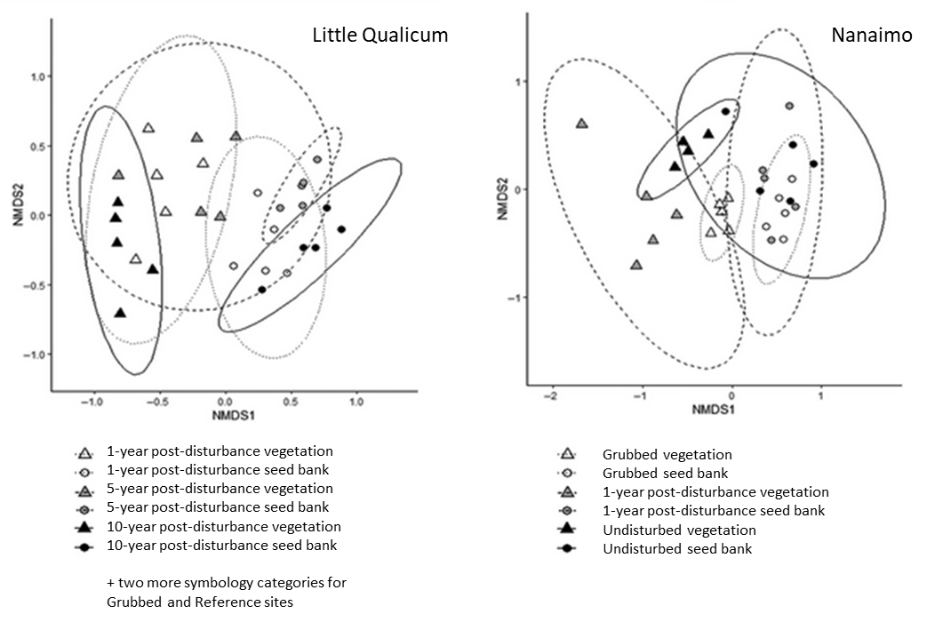

Figure . Example figure of mock results, modified from Fig. 4 in Rago et al., 2020. Because figure is not based on actual data from the Vancouver Island Estuaries, not all disturbance conditions for Little Qualicum River are represented in this figure. Englishman River mock results omitted.

# Discussion

Key messages:

* Simply by removing grazing pressure, plant communities recover functional diversity similar to reference conditions. This allows predictions of recovery timelines, and some certainty of restored conditions without further intervention.
* Presence of desirable functional groups are largely absent or rare in the seed bank following intense grazing, therefore seed banks should not be considered a strong source of resilience in estuaries disturbed by grazing.
* Recovery of some functional groups in the seed bank may take more time than recovery of above-ground vegetation by clonal expansion, and therefore opportunity for invasive species encroachment may be greater, or these habitats may have longer timelines to secondary richness recovery.

Anticipated discussion points:

* If above-ground vegetation richness/evenness recover towards the reference condition, this builds support that removal of the grazing disturbance and protection of remnant habitat are the most effective strategies for predictably recovering structural diversity and function of marsh vegetation (rather than relying on transplanting to recover functional richness).
* However, low abundance of functional richness in seed banks may build support for transplanting a variety of species to “jumpstart” seed rain and restore the seed bank.
  + If seed banks show greater diversity than the above-ground vegetation along recovery trajectories, this opens new questions to test whether species recover naturally from seed bank, or if there are additional limitations on recruitment.

Broader importance:

* Recovery of these habitats is important for supporting populations of juvenile salmonids, and for coastal resilience to sea level rise.

# Literature Cited

Brudvig, L. A., Barak, R. S., Bauer, J. T., Caughlin, T. T., Laughlin, D. C., Larios, L., … Zirbel, C. R. (2017). Interpreting variation to advance predictive restoration science. *Journal of Applied Ecology*, *54*, 1018–1027.

Hopfensperger, K. N., Engelhardt, K. a. M., & Lookingbill, T. R. (2009). Vegetation and seed bank dynamics in a tidal freshwater marsh. *Journal of Vegetation Science*, *20*, 767–778.

Leck, M. A. (2003). Seed-bank and vegetation development in a created tidal freshwater wetland on the Delaware River, Trenton, New Jersey, USA. *Wetlands*, *23*, 310–343.

Leck, Mary A., & Simpson, R. L. (1994). Tidal freshwater wetland zonation: Seed and seedling dynamics. *Aquatic Botany*, *47*, 61–75.

Rago, M. M., Urretavizcaya, M. F., Orellana, I. A., & Defossé, G. E. (2020). Strategies to persist in the community: Soil seed bank and above-ground vegetation in Patagonian pine plantations. *Applied Vegetation Science*, *23*, 254–265.

Regteren, M. van, Colosimo, I., Vries, P. de, Puijenbroek, M. E. B. van, Freij, V. S., Baptist, M. J., & Elschot, K. (2019). Limited seed retention during winter inhibits vegetation establishment in spring, affecting lateral marsh expansion capacity. *Ecology and Evolution*, *9*, 13294–13308.

Thom, R. M., Zeigler, R., & Borde, A. B. (2002). Floristic Development Patterns in a Restored Elk River Estuarine Marsh, Grays Harbor, Washington. *Restoration Ecology*, *10*, 487–496.

Török, P., & Helm, A. (2017). Ecological theory provides strong support for habitat restoration. *Biological Conservation*, *206*, 85–91.