# Introduction

* Contextualize broader theory: Disturbance and recovery toward historical or functional states (Pimm, 1984); recovery of natural processes and succession follows disturbance release.
  + Exemplify estuaries as ecosystems where varying degrees of natural disturbance are experienced in daily tides, seasonal storms, or over longer geomorphic timescales and processes such as marsh accretion, erosion, or subsidence (Pasternack, 2009).
  + Disturbance intensity and duration can push a habitat beyond its capacity for recovery. One measure of resilience may be to assess whether the habitat returns to a pre-disturbance state following the removal of the disturbance agent. (Standish et al., 2014)
  + Grazing may be considered a form of natural disturbance, however grazing pressure can alter site ecology and thus limit the capacity of the habitat to recover (Srivastava & Jefferies, 1996).
* With notable exceptions such as the Fraser and Columbia Rivers, most estuaries in the Pacific Northwest of North America (PNW) are spatially restricted by mountainous geography (Emmett et al., 2000), as opposed to broad alluvial plains like those on the Atlantic coast of North America (Bertness, 1999). Despite spatial restriction, these estuaries are of high ecological importance to migratory salmonids (Chalifour et al., 2019; Hodgson, Wilson, & Moore, 2020) and shorebirds (Canham, et al., 2021; Iverson, et al., 1996). PNW estuaries have also become home to introduced resident Canada geese, whose unmitigated grazing results in conversion of vegetated habitat to denuded mudflat.
  + Populations of resident Canada geese (*Branta canadensis*) have been artificially increased due to a breeding program to promote hunting tourism in the 1970s (Dawe & Stewart, 2010; Smith, Craven, & Curtis, 1999; Smith, 2000).
  + Resident Canada goose populations on eastern Vancouver Island undergo an annual nesting and molt which limits their movement, during which time their grazing impacts can destroy marsh habitat (Dawe, et al., 2011).
    - Goose grubbing behavior results in removal of rhizomatous graminoid species, resulting in erosion through sediment washing into channels (raising channel depth, loss of stream shading), loss of local plant propagules such as seeds, and loss of the vegetation structure which may trap seeds within the site (Bullock & Moy, 2004; Kerbes, Kotanen, & Jefferies, 1990).
    - While mudflats are ecologically productive, they do not provide the same habitat quality of deep, shaded channels for juvenile salmonids.
  + Recovery of native vegetation compositional diversity after grazing pressure is released is indicative of resilient community processes (Pearson et al., 2018).
    - This may be achieved by clonal expansion of vegetation from adjacent patches, or by recruitment from seed.
    - Many PNW estuary plant species reproduce clonally, however the extent to which these communities and their seed banks recover towards a reference condition have not been examined, and should be of high management concern to habitat managers
* Site structure, plant community structure, and seed dispersal phenology affect seed grounding and retention. In turn, introduction of seeds into the surface seed bank affect potential recruitment into the plant community.
  + Vegetation structure affects composition or abundance of seed retained, such as dense but flexible species retaining greater seed abundance than sparse, rigid species in higher elevation tidal marshes (Chang, et al., 2008). Additionally, riparian sites with high drift litter abundance retaining locally produced seed (rather than seed transported long distances through aquatic networks) (Vogt, Rasran, & Jensen, 2007).
    - These results indicate there may be a difference in seed composition retained at sites with different vegetation composition, and thus structural, characteristics.
  + Vegetation in aquatic systems such as estuaries serves vital functions of attenuating water flow (Bouma et al., 2005), which in turn prevents erosion and traps sediment to build up marsh platforms (Bouma, Vries, & Herman, 2010; Duggan-Edwards, et al., 2020).
    - This sediment trapping also serves to bury seeds in the surface seed bank (Zhu, et al., 2014).
    - Sedimentation is spatially and temporally variable (Pasternack & Brush, 1998; Temmerman, et al., 2003), and thus can be very difficult to measure within a single year. However, estimations of estuarine sedimentation rates in the Puget Sound and British Columbia estuaries are approx. 3 mm per year (Emmett et al., 2000). This estimation of sediment processes allows some assumption that seeds deposited within the past three years may be found in the top 1 cm of estuary sediment.
  + Seeds are locally dispersed from their parent plant, but they are also redistributed through water (hydrochory), and may be picked up and re-distributed by daily and monthly tidal patterns, or semi-annual storm or flood events.
    - Depending on buoyancy traits of the seed and tidal currents, seeds of herbaceous tidal marsh species may be transported for days to weeks and 10-20 km (Chang, et al., 2008; Koutstaal, Markusse, & de Munck, 1987; Shi et al., 2020).
  + Vegetation recovery from seed may not be the primary mechanism of estuary plant community recovery, however it is important for the introduction of new species or genetic diversity.
    - Seed banks in many ecosystems, including tidal wetlands, may be different from their above-ground counterparts (Neff & Baldwin, 2005; Thompson & Grime, 1979), and may have greater seed species richness in sites with greater successional age (Wolters & Bakker, 2002).
      * This may mean that species observed in the above-ground plant community may be under-represented or absent in the seed bank, especially in sites recently recovering from disturbance or early successional stages. Thus, seedlings of some species may be competitively excluded by other species following disturbance.
      * Invasive species presence in the seed bank should be a high management concern, as these species may displace native species should disturbance occur.
* If grazing pressure is released by physically excluding geese, vegetation should recolonize the mudflat through clonal expansion and/or opportunistic germination. However, the question remains whether the above-ground vegetation and surface seed banks recover to a state comparable to an undisturbed condition.

## Questions & Hypotheses

The main objective of this study is to examine estuary vegetation and seed bank resilience to grazing. I wanted to know:

1. How are plant species and plant community composition affected by time since grazing exclusion?
   1. If plant communities are resilient, I expect sites with a longer history of grazing exclusion will recover the same compositional and cover abundance as undisturbed sites.
2. Does grazing disturbance have an effect on surface seed bank compositional abundance throughout the year; is surface seed bank compositional abundance more seasonally variable depending on disturbance condition?
   1. Because grubbed sites will lack the dense, tall graminoid vegetation found in undisturbed sites and those with longer history of grazing exclusion, I expect surface seed banks in grubbed sites to have lower seasonal abundance and lower seasonal variability compared to long-term exclusion and undisturbed sites.
   2. Similarly, I expect undisturbed sites to have greater abundance and seasonal variability in compositional abundance because the tall, dense vegetation will trap greater numbers and diversity of seeds dispersed locally or through water.
3. Do surface seed banks and vegetation exhibit resilience by returning to a ‘reference’ condition when grazing has been excluded for 10 years?
   1. I expect sites excluded for 10 years to have similar species compositional vegetation abundance to undisturbed sites due to clonal expansion from surrounding marsh vegetation. This vegetation structural complexity will trap seeds produced within or dispersed into the patch, leading to seed banks that resemble an undisturbed site.
4. Is seasonal surface seed bank compositional abundance highly similar to above-ground summer vegetation compositional abundance?
   1. Because grubbed sites will have lower structural complexity to trap a diversity of seeds brought in by tidal currents, I expect grubbed sites to have the greatest similarity between seasonal surface seed banks and above-ground summer vegetation. Similarly, I expect undisturbed sites to have the greatest dissimilarity between surface seed banks and the above-ground summer vegetation.

# Methods

## Study area & site history

* Site descriptions of Little Qualicum, Englishman, and Nanaimo River Estuaries as Wildlife Management Areas, grazing pressure history, and related studies (map).
* Wooden fencing was iteratively installed by restoration groups to physically prevent Canada geese from grazing vegetation, hereafter referred to as ‘exclosures.’
  + Exclosures were placed opportunistically along channel edges where intensive herbivory was observed to protect remnant marsh platform from further degradation.
* Different restoration urgencies have afforded observation of recovery timepoints 1 and 10 years post-grazing exclusion in two different estuaries (Table 1).
  + Exclosure sites were selected to represent comparable conditions within the exclosures over time; undisturbed and grubbed sites are not protected by an exclosure.

Table 1. Grazing disturbance conditions in the Little Qualicum River and Nanaimo Estuaries resulted in conversion of vegetated marsh to partially or fully grubbed mudflats; exclosures were installed to prevent further degradation into the marsh platform. Each disturbance category n = 4 for each estuary.

|  |  |  |  |
| --- | --- | --- | --- |
| **Estuary representation** | **Time Since Disturbance** | **Disturbance condition** | **Revegetation status** |
| Little Qualicum, Nanaimo, Englishman | 0 years (recent grubbing disturbance) | Grubbed | No transplants; ruderal vegetation exists |
| Nanaimo | 1 year post-grazing disturbance | Partially grubbed | No transplants; vegetation recovery from remnant and adjacent vegetation |
| Little Qualicum | 10 years post-grazing disturbance | Partially grubbed | No transplants; vegetation recovery from remnant and adjacent vegetation |
| Little Qualicum, Nanaimo, Englishman | No known grazing disturbance | Undisturbed | No manipulations |

## Sampling methods

### Vegetation sampling

Vegetation sampling was conducted once in mid-July, 2021. Two 1 m2 vegetation plots (sites) were placed within the exclosures, at least 1 m from the bank edge and any exclosure boundary (n = 8 per disturbance condition in each estuary), and at least 3 m apart within the exclosure. Quadrats were placed so that the edge nearest creek was parallel to the bank.

All vascular species were identified according Hitchcock and Cronquist (1973), and currently accepted nomenclature standardized according to the PLANTS Database of the United States Department of Agriculture, Natural Resources Conservation Science [USDA NRCS]. Species were considered in the plot if at least half of their basal stem(s) were inside the quadrat boundary; overhanging vegetation was not considered. Aerial vegetated cover to the nearest 3 % (1/32 m2) was recorded. For any species present with less than 3 % cover, species were assigned 2% cover if > 20 individuals were present, 1 % cover if 2-20 individuals were present, and 0.1% cover for single individuals. Bare ground was estimated as the remainder of the plot area not covered by above-ground vegetation. Any plots with > 100% cover were standardized relative to 100%. To characterize plant structure, species were assigned to a height category tall (> 1 m), medium (50-100 cm), or short (< 50 cm) based on their maximum reported height in the Illustrated Flora of British Columbia (Douglas, Meidinger, & Pojar, 1998).

### Surface seed bank sampling & germination

Two surface seed bank samples were taken from each plot (n = 16 per disturbance condition in each estuary) in summer (July 2020), fall (October 2020), and spring (March 2021). A 10 cm diameter handheld bulb planter (e.g., [Husky 9 in. stainless Steel Bulb Planter sold by Home Depot, USA](https://www.homedepot.com/p/Husky-9-in-Stainless-Steel-Bulb-Planter-GD210314/317436441)) was used to excise sediment 1 cm deep to capture the surface seed bank. Vegetative roots, rhizomes, or other viable rooted material were removed before placing sample in a plastic zipper bag. All surface seed bank samples from the same estuary and disturbance condition were then homogenized in a clean bucket with 100 mL dechlorinated water. Samples were hand-sifted for any remaining root, rhizome, or vegetative material, then homogenized sample was transferred to a clean plastic zipper bag. Summer and fall 2020 samples were stored at 4o C for approx. 12 weeks to simulate overwinter cold stratification; samples collected in the spring of 2021 underwent natural winter conditions and did not require cold stratification.

Germination trials were conducted under greenhouse conditions with 15 hr daylength at ~ 20o C. Seedling pots (9 cm x 13 cm x 5.7 cm (depth), BRAND) were filled with moist, sterile potting media (Sunshine Mix No. 4, Sun Gro Horticulture, Agawam, MA, United States). Pots were placed in solid cache trays, and constantly bottom-watered with municipal tap water.

Seed bank samples were sown by pouring 75 mL sediment over the top of each seedling pot (n = 8 per estuary and disturbance condition) while constantly agitating the homogenized seed bank sample. Seeds were allowed to germinate for 5 weeks, at which time all individuals were counted and removed. The seedling trays were observed for any further germination for another 7-10 days, at which time the samples were discarded. Any species that could not be identified were labelled and transplanted into 38 P plug trays (BRAND) with the same growing media and growing conditions until a positive identification could be made. Representative specimens used to confirm seedling identification were pressed and made available as herbaria.

## Analysis

Analysis plan:

1. How are plant species and plant community composition affected by time since grazing exclusion?
   1. Descriptive analysis: species richness and evenness
      1. plot means ± SE of structural traits (Figure 1).
   2. Test statistical difference in cover abundance of structural groups and clades (groups show in Figure 1) with one-way ANOVA.
2. Does grazing disturbance have an effect on surface seed bank compositional abundance throughout the year; is surface seed bank compositional abundance more seasonally variable depending on disturbance condition?
   1. Descriptive analysis: plot means ± SE of seasonal abundances (Figure 5, Figure 6).
   2. Test statistical difference in seed abundance with PERMANOVA (a) between disturbance conditions within a season, and (b) between seasons for each disturbance condition.
3. Do surface seed banks and vegetation exhibit resilience by returning to a ‘reference’ condition when grazing has been excluded for 10 years?
   1. ***Uncertain:*** would a linear model be most appropriate here?
4. Is seasonal surface seed bank compositional abundance highly similar to above-ground summer vegetation compositional abundance?
   1. Visualize with NMDS (Figure 8); compare similarity between vegetation and seed bank compositional abundance with Sorenen’s similarity index
   2. Test statistical difference in compositional abundance by PERMANOVA; compare centroid distance between ‘disturbed’ and ‘undisturbed’ conditions.

# Results

1. How are plant species and plant community composition affected by time since grazing exclusion?
   1. Contrary to my expectations, after 10 years of grazing exclusion in Little Qualicum Estuary, medium-height forbs (50-100 cm) and tall graminoids (> 100 cm tall) did not recover to the same abundance as in undisturbed sites. This cover abundance has been replaced by medium-height invasive graminoids, namely, *Agrostis* sp. (Figure 1)
   2. Across all estuaries, tall and medium height graminoids were absent or nearly so in grubbed sites, and reduced in sites excluded from grazing for 1 year. Short graminoids (< 50 cm tall) and bare ground each accounted for up to 50% of mean relative cover abundance in grubbed sites at all estuaries, illustrating a stark contrast in plant structure and species composition. (Figure 2, Figure 3, Figure 4)
2. Does grazing disturbance have an effect on surface seed bank compositional abundance throughout the year; is surface seed bank compositional abundance more seasonally variable depending on disturbance condition?
   1. Grazing disturbance affects abundance of seed found in samples across all seasons. For example: Undisturbed sites at each estuary had a greater abundance of medium or tall graminoids, and medium-height forbs compared to grubbed sites. (Figure 5)
   2. Seed abundance did not seem to vary widely between seasons, although some exceptions were noted. For example: seed of tall forbs (Douglas aster, *Symphotrichium subspicatum*) was only found in Undisturbed sites in Nanaimo during the fall sampling period when seeds were dispersed. Interestingly, seeds of tall forbs were found in grubbed sites in Nanaimo the following spring. (Figure 6)
3. Do surface seed banks and vegetation exhibit resilience by returning to a ‘reference’ condition when grazing has been excluded for 10 years?
   1. Surface seed bank samples in sites excluded from grazing for 10 years were more similar to undisturbed sites than grubbed sites, supporting my expectation that grazing exclusion leads to surface seed bank resilience (Figure 7).
4. Is the surface seed bank compositional abundance throughout the year highly similar to above-ground summer vegetation compositional abundance?
   1. Consistent with my expectations, surface seed banks at grubbed and recently grazed sites were highly similar across seasonal samples at all estuaries. Compositional abundance at undisturbed sites and sites exclosed 10 years in Little Qualicum Estuary were more dissimilar between seasons (Figure 8).

## Vegetation trends

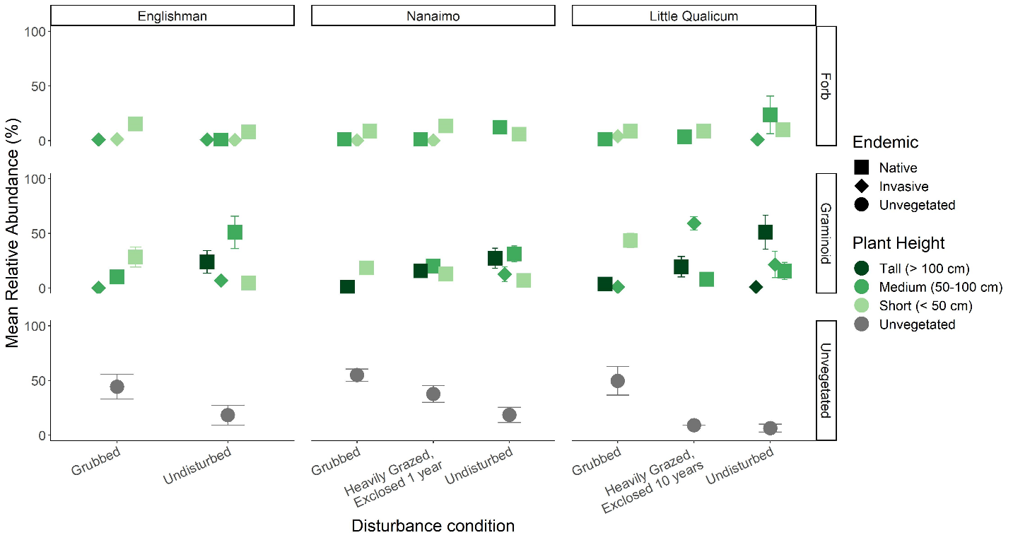

Figure 1. Across all estuaries, ~ 50% of mean relative cover abundance in grubbed sites is bare ground (unvegetated). All sites have some invasive species presence, however sites exclosed for 10 years in Little Qualicum Estuary have over 50% mean relative cover of invasive graminoids. After 10 years of exclosure in Little Qualicum estuary, tall native graminoids and medium-height forbs do not appear to recover to the same relative abundance as in undisturbed sites. (n = (8) 1 m2 plots in each disturbance condition and estuary).

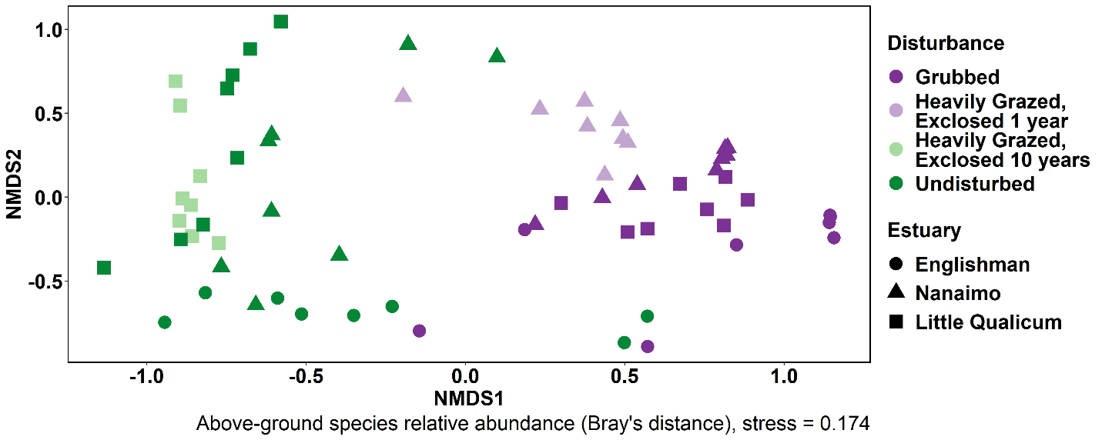

Figure 2. When above-ground vegetation from all sites and plots are analyzed together, trends show that across estuary, relative abundance of above-ground cover is highly similar in grubbed plots and heavily grazed plots exclosed 1 year, while grazed sites exclosed for 10 years are more similar to undisturbed sites than grubbed or heavily grazed sites exclosed 1 year. (n = (8) 1 m2 plots in each disturbance condition and estuary; stress = 0.174). I feel this plot is most informative, because it shows similar composition trends within and between all estuaries sampled. However, I would like opinions on whether NMDS is needed, and if so, whether Figure 2, Figure 3, or Figure 4 is more informative.

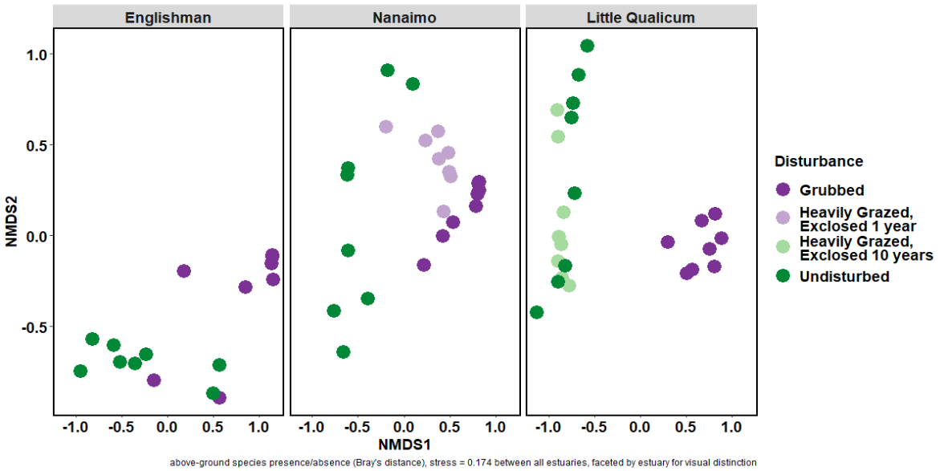

Figure 3. The same relative abundance vegetation NMDS score output as shown in Figure 2 may be faceted by estuary for visual distinction, however this removes the ability to compare similarity of vegetation abundance between estuaries. (n = (8) 1 m2 plots in each disturbance condition and estuary; stress = 0.174). I would like opinions on whether NMDS is needed, and if so, whether Figure 2, Figure 3, or Figure 4 is more informative.

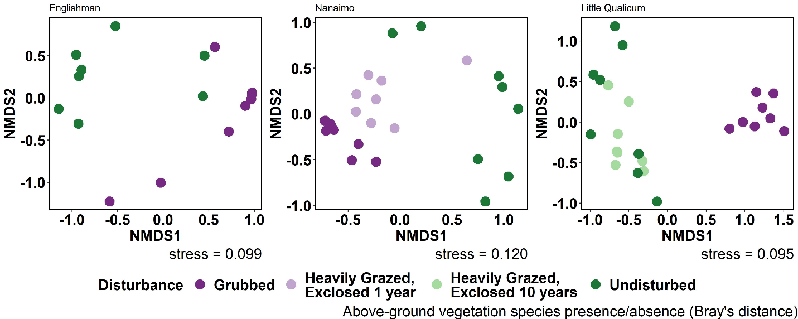

Figure 4. If NMDS is calculated for each estuary separately, we see a similar trend of dissimilarity of above-ground vegetation presence/absence between grubbed and undisturbed plots across all estuaries. By running NMDS separately for each estuary, this removes comparison of vegetation presence/absence between estuaries. I feel this plot may be less informative than Figure 2 because despite different environmental conditions, Figure 2 shows that compositional presence/absence is fairly consistent across all estuaries. (n = (8) 1 m2 plots in each disturbance condition and estuary; stress scores shown on each panel). I would like opinions on whether NMDS is needed, and if so, whether Figure 2, Figure 3, or Figure 4 is more informative.

## Surface seed bank trends

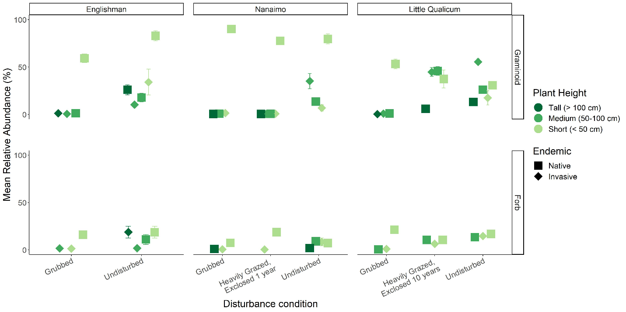

Figure 5. Mean seed abundance pooled from all seasons sampled show short-growing (< 50 cm) native perennial graminoids are often the most abundant group in surface seed banks across all estuaries. Notable exceptions are in the Little Qualicum Estuary at 10-year old exclosures and undisturbed sites, where invasive perennial graminoids are of equal or greater abundance. (n = (24) seed bank germination trials in each disturbance condition and estuary).

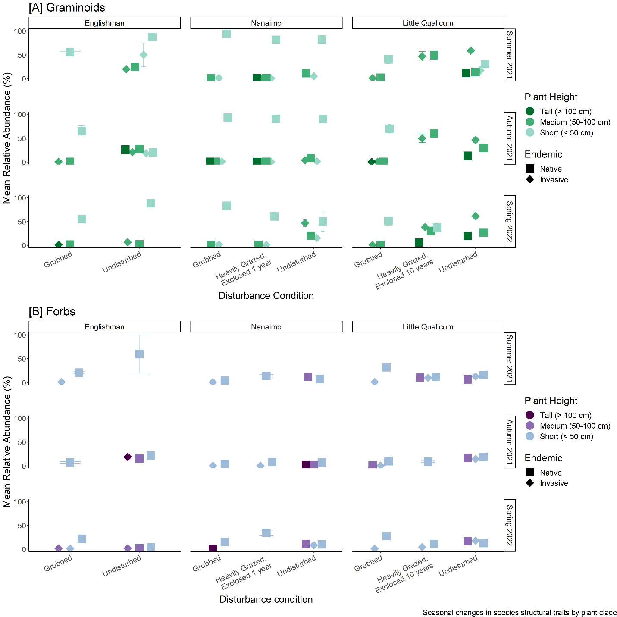

Figure 6. Relative abundance of most structural groups does not vary seasonally, although undisturbed sites in the Englishman Estuary had greater abundance of native forbs in Summer 2021, and invasive graminoids in Autumn 2021 (bottom panel). (n = (8) seed bank germination trials in each season, disturbance condition, and estuary)

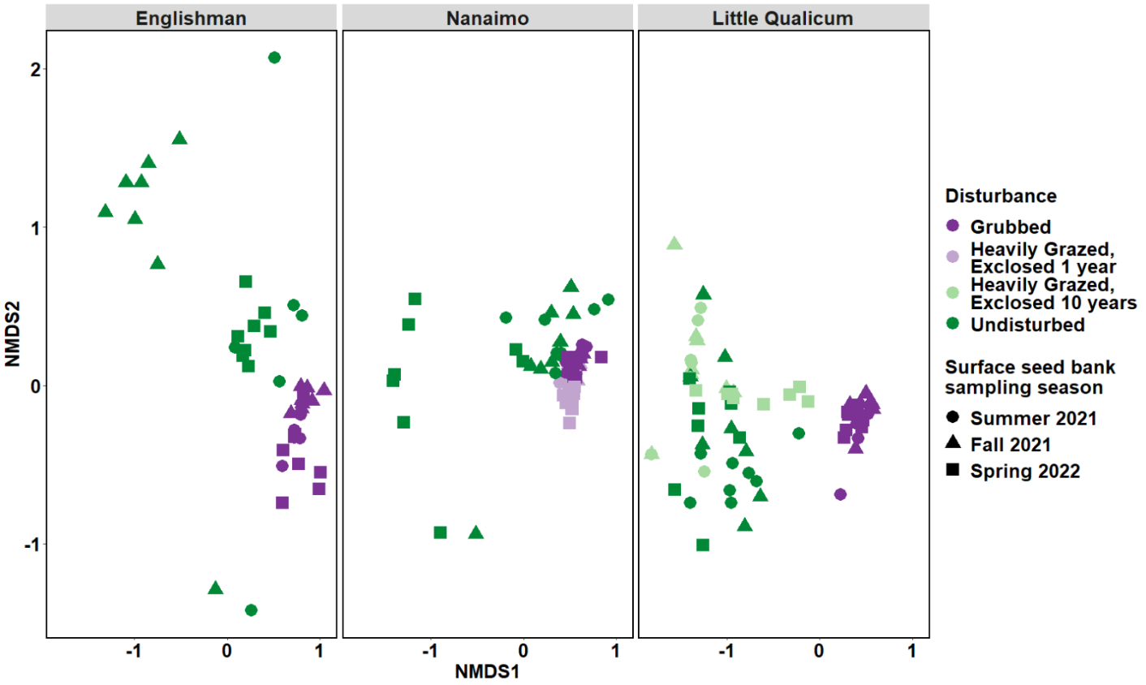

Figure 7. Relative abundance of surface seed bank species is most similar in grubbed and heavily grazed plots exclosed 1 year, regardless of estuary or season. There is more seasonally-driven variation in surface seed bank species compositional abundance in undisturbed sites and grazed sites exclosed for 10 years. (n = (8) seed bank germination trials per each disturbance condition, estuary, and season; stress = 0.132).

## Compare vegetation to seed bank

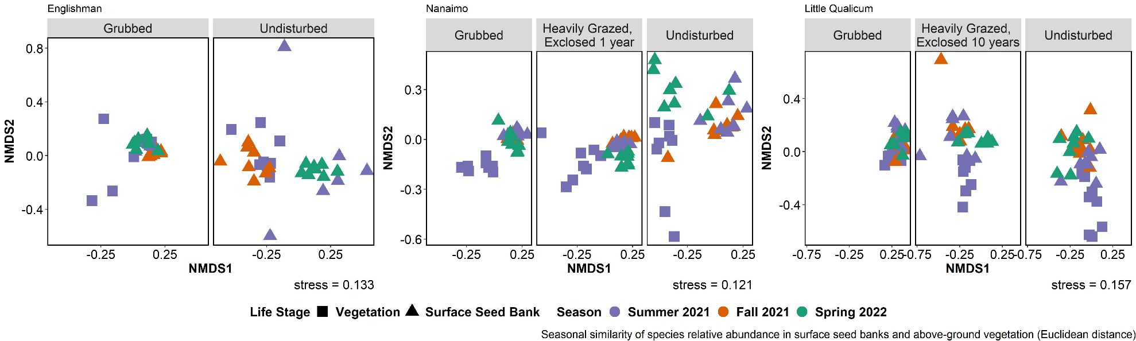

Figure 8. Surface seed bank species shift in similarity to summer above-ground vegetation depending on season sampled. Trends of similarity to above-ground vegetation are inconsistent between estuaries and disturbance conditions. Year-round surface seed bank composition is most similar to summer above-ground vegetation in grubbed plots in Little Qualicum Estuary. Seed banks appear to have the most seasonally-driven change in undisturbed plots in Englishman and Nanaimo Estuaries. Euclidean distance chosen to square dissimilarity (dissimilarities using Bray’s distance were too small to visualize differences). N = 8 1 m2 vegetation plots or 8 seed bank germination trials per each disturbance condition, estuary, and season.

# Discussion

Anticipated discussion points:

* Intensive grazing and grubbing impacts result in loss of tall, dense graminoids, leaving sparse ruderal vegetation and bare ground that alters the surface seed bank through structural capacity to trap seeds.
* While seed composition and abundance is seasonally diverse in undisturbed sites and sites with longer history of grazing exclusion, seed composition and abundance is highly similar in grubbed and recently exclosed sites, suggesting that seed deposition or recruitment is not a likely mechanism of habitat recovery in this ecosystem.
* Many native wetland species such as sedge (*Carex* sp.) are seed limited (Kettenring & Galatowitsch, 2011; Rand, 2000), which limit the propagule availability following disturbance. These results further support seed limitation of foundational species *Carex lyngbyei* in grazed and ungrazed sites, which emphasizes the urgent need for active restoration action (transplanting of desired species) in habitats impacted by goose grazing.

Limitations & next steps

* Short temporal scale provides a snapshot of a single season; longer-term studies would be useful to understand interannual fluctuations in seed diversity across different estuaries.
* Future studies may focus on diversity of surface seed banks in actively restored (transplanted) sites ­, and may test how transplant compositional diversity affects sediment and seed trapping. ­

Broader importance & recommendations:

* Ecological consequences will continue as long as uncontrolled goose grazing pressure exists.
  + Land managers must implement a coordinated, regional approach to reducing non-native resident Canada goose populations.
* Recovery of these habitats is important for supporting populations of juvenile salmonids, and for coastal resilience to sea level rise.
  + Increased funding towards restoration will be required to mitigate grazing impacts.

# Literature Cited

Bertness, M. D. (1999). *The ecology of Atlantic shorelines*. Sunderland, Mass: Sinauer Associates.

Bouma, T. J., Vries, M. B. D., & Herman, P. M. J. (2010). Comparing ecosystem engineering efficiency of two plant species with contrasting growth strategies. *Ecology*, *91*, 2696–2704.

Bouma, T. J., Vries, M. B., De, Low, E., Kusters, L., Herman, P. M., … Regenmortel, S. V. (2005). Flow hydrodynamics on a mudflat and in salt marsh vegetation: Identifying general relationships for habitat characterisations. *Hydrobiologia; Dordrecht*, *540*, 259–274.

Bullock, J. M., & Moy, I. L. (2004). Plants as seed traps: Inter-specific interference with dispersal. *Acta Oecologica*, *25*, 35–41.

Canham, R., Flemming, S. A., Hope, D. D., & Drever, M. C. (2021). Sandpipers go with the flow: Correlations between estuarine conditions and shorebird abundance at an important stopover on the Pacific Flyway. *Ecology and Evolution*, *11*, 2828–2841.

Chalifour, L., Scott, D. C., MacDuffee, M., Iacarella, J. C., Martin, T. G., & Baum, J. K. (2019). Habitat use by juvenile salmon, other migratory fish, and resident fish species underscores the importance of estuarine habitat mosaics. *Marine Ecology Progress Series*, *625*, 145–162.

Chang, E. R., Veeneklaas, R. M., Buitenwerf, R., Bakker, J. P., & Bouma, T. J. (2008). To move or not to move: Determinants of seed retention in a tidal marsh. *Functional Ecology*, *22*, 720–727.

Dawe, N., Boyd, S., Buechert, R., & Stewart, A. (2011). Recent, significant changes to the native marsh vegetation of the Little Qualicum River estuary, British Columbia; a case of too many Canada Geese (Branta canadensis)? *Journal of the British Columbia Field Ornithologists*, *21*, 11–31.

Dawe, N. K., & Stewart, A. C. (2010). The Canada Goose (Branta canadensis) on Vancouver Island, British Columbia. *British Columbia Birds*, *20*, 18.

Douglas, G. W., Meidinger, D., & Pojar, J. (Eds.). (1998). *Illustrated flora of British Columbia. Vols. 1-8*. Victoria, BC: B.C. Min. Environ., Lands and Parks, and B.C. Min. For.

Duggan-Edwards, M. F., Pagès, J. F., Jenkins, S. R., Bouma, T. J., & Skov, M. W. (2020). External conditions drive optimal planting configurations for salt marsh restoration. *Journal of Applied Ecology*, *57*, 619–629.

Emmett, R., Llansó, R., Newton, J., Thom, R., Hornberger, M., Morgan, C., … Fishman, P. (2000). Geographic signatures of North American West Coast estuaries. *Estuaries*, *23*, 765–792.

Hitchcock, C. L., & Cronquist, A. (1973). *Flora of the Pacific Northwest, an illustrated manual*. Seattle and London: University of Washington Press.

Hodgson, E. E., Wilson, S. M., & Moore, J. W. (2020). Changing estuaries and impacts on juvenile salmon: A systematic review. *Global Change Biology*, *26*, 1986–2001.

Iverson, G. C., Warnock, S. E., Butler, R. W., Bishop, M. A., & Warnock, N. (1996). Spring Migration of Western Sandpipers along the Pacific Coast of North America: A Telemetry Study. *The Condor*, *98*, 10–21.

Kerbes, R. H., Kotanen, P. M., & Jefferies, R. L. (1990). Destruction of Wetland Habitats by Lesser Snow Geese: A Keystone Species on the West Coast of Hudson Bay. *Journal of Applied Ecology*, *27*, 242–258.

Kettenring, K. M., & Galatowitsch, S. M. (2011). Seed Rain of Restored and Natural Prairie Wetlands. *Wetlands*, *31*, 283–294.

Koutstaal, B. P., Markusse, M. M., & de Munck, W. (1987). Aspects of seed dispersal by tidal movements. In A. H. L. Huiskes, C. W. P. M. Blom, & J. Rozema (Eds.), *Vegetation between land and sea: Structure and processes* (pp. 226–235). Dordrecht: Springer Netherlands.

Neff, K. P., & Baldwin, A. H. (2005). Seed dispersal into wetlands: Techniques and results for a restored tidal freshwater marsh. *Wetlands*, *25*, 392–404.

Pasternack, G. B. (2009). Chapter 3. Hydrogeomorphology and sedimentation in tidal freshwater wetlands. In A. Barendregt, D. F. Whigham, & A. H. Baldwin (Eds.), *Tidal Freshwater Wetlands* (pp. 31–40). Leiden, The Netherlands: Backhuys Publishers.

Pasternack, G. B., & Brush, G. S. (1998). Sedimentation cycles in a river-mouth tidal freshwater marsh. *Estuaries*, *21*, 407–415.

Pearson, D. E., Ortega, Y. K., Villarreal, D., Lekberg, Y., Cock, M. C., Eren, Ö., & Hierro, J. L. (2018). The fluctuating resource hypothesis explains invasibility, but not exotic advantage following disturbance. *Ecology*, *99*, 1296–1305.

Pimm, S. L. (1984). The complexity and stability of ecosystems. *Nature*, *307*, 321–326.

Rand, T. A. (2000). Seed dispersal, habitat suitability and the distribution of halophytes across a salt marsh tidal gradient. *Journal of Ecology*, *88*, 608–621.

Shi, W., Shao, D., Gualtieri, C., Purnama, A., & Cui, B. (2020). Modelling long-distance floating seed dispersal in salt marsh tidal channels. *Ecohydrology*, *13*, e2157.

Smith, A., Craven, S., & Curtis, P. (1999). *Managing Canada Geese in Urban Environments*. Ithaca, NY: Jack Berryman Institute Publication 16, and Cornell University Cooperative Extension.

Smith, D. W. (2000). Management of Canada Geese in the lower Fraser Valley, southwestern British Columbia. In *In Dickson, K. M. 2000. Towards conservation of the diversity of Canada Geese (Branta canadensis)* (pp. 151–158). Ottawa, Canada: Canadian Wildlife Service.

Srivastava, D. S., & Jefferies, R. L. (1996). A Positive Feedback: Herbivory, Plant Growth, Salinity, and the Desertification of an Arctic Salt-Marsh. *Journal of Ecology*, *84*, 31–42. JSTOR.

Standish, R. J., Hobbs, R. J., Mayfield, M. M., Bestelmeyer, B. T., Suding, K. N., Battaglia, L. L., … Thomas, P. A. (2014). Resilience in ecology: Abstraction, distraction, or where the action is? *Biological Conservation*, *177*, 43–51.

Temmerman, S., Govers, G., Wartel, S., & Meire, P. (2003). Spatial and temporal factors controlling short-term sedimentation in a salt and freshwater tidal marsh, Scheldt estuary, Belgium, SW Netherlands. *Earth Surface Processes and Landforms*, *28*, 739–755.

Thompson, K., & Grime, J. P. (1979). Seasonal Variation in the Seed Banks of Herbaceous Species in Ten Contrasting Habitats. *The Journal of Ecology*, *67*, 893.

Vogt, K., Rasran, L., & Jensen, K. (2007). Seed deposition in drift lines: Opportunity or hazard for species establishment? *Aquatic Botany*, *86*, 385–392.

Wolters, M., & Bakker, J. P. (2002). Soil seed bank and driftline composition along a successional gradient on a temperate salt marsh. *Applied Vegetation Science*, *5*, 55–62.

Zhu, Z., Bouma, T. J., Ysebaert, T., Zhang, L., & Herman, P. M. J. (2014). Seed arrival and persistence at the tidal mudflat: Identifying key processes for pioneer seedling establishment in salt marshes. *Marine Ecology Progress Series*, *513*, 97–109.

# Potential journals

## [Estuaries & Coasts](https://www.springer.com/journal/12237/aims-and-scope)

2020 IF 2.976 (Q1, Ecology/Aquatic Science)

“…The journal covers research on physical, chemical, geological or biological processes, as well as applications to management of estuaries and coasts. The journal publishes original research findings, reviews and perspectives, techniques, comments, and **management applications.** Estuaries and Coasts will consider properly carried out studies that present inconclusive findings or document a failed replication of previously published work. Submissions that are primarily descriptive, strongly place-based, or only report on development of models or new methods without detailing their applications fall outside the scope of the journal.”

## [Journal of Vegetation Science](https://onlinelibrary.wiley.com/page/journal/16541103/homepage/forauthors.html)

2020 IF 2.865 (Q1, Ecology/Plant Science)

The Journal of Vegetation Science publishes articles on all aspects of plant community ecology and macroecology of vegetation, with particular emphasis on articles that develop new concepts or methods, test theory, **identify general patterns**, or that are otherwise likely to interest a broad international readership. An article may focus on any aspect of vegetation science, e.g. community structure (including community assembly and plant functional types), **biodiversity (including species richness and composition)**, spatial patterns (including plant geography and landscape ecology), **temporal changes (including demography, community dynamics** and palaeoecology) and processes (including ecophysiology), provided the focus is on increasing our understanding of plant communities. The journal does not publish articles on the ecology of a single species, except for studies framed in the community context, especially of species that play a key role in structuring plant communities (e.g. stand dominants). **Articles that apply ecological concepts, theories and methods to the vegetation management, conservation and restoration, and articles on vegetation survey should be directed to our associate journal,** [Applied Vegetation Science](https://onlinelibrary.wiley.com/page/journal/1654109x/homepage/forauthors.html).

## [Wetlands Ecology & Management](https://www.springer.com/journal/11273/submission-guidelines" \l "Instructions%20for%20Authors_Article%20Types)

2020 SJR 2-yr IF 1.341, 4-yr IF 2.092 (Q2, Management & Monitoring; Q3, Ecology/Aquatic Science)

“… Wetlands Ecology and Management publishes refereed papers on topics relevant to freshwater, brackish and marine coastal wetland ecosystems. Such topics may span wetlands science, management, policy and economics.”