# Introduction

Competitive strategies drive vegetation succession

Competition is one successional process that shapes resulting community

Competitive dominance results in species-specific compositional states, which define ecosystem characteristics (e.g., forest succession theory, keystone species/functional groups, and resulting ecosystem processes/function)

Plants may exhibit different competitive advantages through alternative reproductive strategies, such as clonal reproduction or heavy seed production. Tradeoffs exist:

One competitive advantage may be at the expense of another, such as strong clonal expansion at expense of seed limitation (e.g., sp. like CALY; CITE). Or, plants may have equally strong clonal and seed reproductive capability, enabling community dominance (e.g., exotic sp.; CITE).

Species presence or introduction (succession) may be enhanced or negatively affected by parent plant/seed bank linkages and feedbacks (CITE).

Drivers of similarity between seed banks and above-ground vegetation.

Dissimilarity increases with greater time since disturbance in wetlands (Hopfensperger, 2007)

Local seed dispersal more likely, although vectors such as wind & water dispersal can carry seeds to colonize new sites.

Should one competitive strategy (seed or clonal) be removed from the population during disturbance, then recovery via succession would be influenced by the relative competitive strength of remaining propagative material. Successional outcomes may vary depending on the composition of the available propagative sources.

For example, if clonally propagative parts were removed form habitat, recovery would be obligated to reproduce by seed (or other dispersed propagules); OR, successional outcomes may be affected by the relative rate of recovery by alternative reproductive strategies. E.g., competitive seeds could take over faster than clonal regrowth from adjacent patches.

Recovery from seed requires the propagule to be dispersed from another population, and for those propagules to be retained in the site to be available during succession.

Ecosystem capacity for recovery via succession following disturbance, and grazing as a form of natural disturbance

Define resilience broadly as communities’ ability to recover following disturbance. In vegetation communities, seed/clonal strategies help post-disturbance recovery.

Disturbance intensity and duration can push a habitat beyond its capacity for recovery. One measure of resilience may be to assess whether the habitat returns to a pre-disturbance state following the removal of the disturbance agent. (Standish et al., 2014)

* 1. Some ecosystems experience regular disturbance, which may be environmental (estuaries), or from biotic interactions (grazing). Either of these can under some conditions promotes diversity/resilience/productivity (CITE). However, if disturbance is persistent or return intervals exceed recovery time, ecosystem shifts to alternate compositional or functional states (CITE).

Overstress, such as through overgrazing, would lead to reduced capacity for the community to recover through loss of reproductive members within plant populations. In the absence of predators, over-abundant populations must be excluded to allow passive recovery (cite examples from forestry/ag/riparian lit).

The Green World Hypothesis (Hairston, Smith, & Slobodkin, 1960) would posit that grazing pressure must be released as predators should take advantage of herbivore populations. However, if grazers are not limited by predation, then grazing pressure can alter site ecology and thus limit the capacity of the habitat to recover (Srivastava & Jefferies, 1996).

Interactions of different disturbance sources – some ecosystems may be highly adapted to strong disturbance if they experience disturbance of varying degrees regularly.

Estuaries, and local habitat/overgrazing context

Estuaries are ecosystems where varying degrees of natural disturbance are experienced in daily tides, seasonal storms, or over longer geomorphic timescales and processes such as marsh accretion, erosion, or subsidence (Pasternack, 2009). Estuaries around the Salish Sea along the Pacific northwest coast of North America may be spatially constrained by geography, and are often heavily impacted by human infrastructure (CITE). However, their immense habitat value to marine species such as salmonids and shorebirds is reflected in federal and international efforts for conservation and restoration (CITE).

Species composition in the presence/absence of traditional management

Introduce group of competitive dominant species, ‘perennial graminoids (> 10 cm tall).’ Describe zonation of *Carex lyngbyei* or *Juncus balticus* along channel edges, with secondary dominance by other sedges/rushes/grasses. (2- 3 sentences).

Emphasize rhizomatous clonal reproductive strategy, and note seed limitation of *Carex lyngbyei*.

Introduce topic of traditional management, which encouraged abundance of herbaceous, broadleaf flowering plants for root crop harvesting (include specific examples of *Potentilla pacifica-anserina* and *Trifolium wormskioldii*). (2 sentences)

Transition to indicate regional introduction of exotic grass species through farming/ranching practices (1 sentence)

Regional exotic introductions also include the Canada goose, which is a resident herbivore in these estuaries capable of extensive grazing.

Describe migratory history & regional introduction (1-2 sentences), life cycle/residency (non-migratory pops., 1 sentence), grazing/grubbing behavior (2-3 sentences, focusing on rhizome removal).

Describe exclosures & passive recovery as a means of restoration (broadly). Restoration goals may be to target keystone species, or key functional groups. Native vs. exotic composition is always a concern, and the increasing social priorities placed on ethnoecological restoration should not be overlooked.

Our main objective for this study was to understand surface seed bank and above-ground vegetation composition at discrete stages of recovery since grazing disturbance and grazing exclusion in two estuaries in the Salish Sea. Traditional succession models would say the most competitive species will increasingly dominate the plant community as time since disturbance increases. This would particularly be the case in a clonal ecosystem, where recovery is driven by species spreading clonally from adjacent undisturbed sites. If succession is happening the we expect:

1. Above-ground vegetation at older disturbance sites will be more similar to reference vegetation than recently disturbed (regardless of seed inputs)
   1. Alternatively, novel disturbance and novel seed inputs lead to alternative succession pathways, where new competitors from seed inputs derail the "slow encroachment" of the clonal dominant from the neighboring intact site.
2. Above-ground vegetation in recently disturbed sites will be highly similar to seed inputs than older disturbance vegetation similarity to seed, or reference vegetation similarity to seed

From a conservation and land management perspective, we should be cognizant of long-term grazing impacts on recovery of plant communities and the implications for alternate successional trajectories. This is especially the case in ecosystems that already experience natural and anthropogenic disturbance, such as estuaries, and wetlands more broadly.

# Methods

## Study area & site history

* Site descriptions of Little Qualicum and Nanaimo River Estuaries as Wildlife Management Areas (map).
* Grazing exclosure history
  + Wooden fencing was iteratively installed (cite GoMIES?) to physically prevent Canada geese from grazing vegetation, hereafter referred to as ‘exclosures.’
    - Exclosures were placed opportunistically along channel edges where intensive herbivory was observed to protect remnant marsh platform from further degradation.
  + Ongong restoration strategies have afforded observation of recovery timepoints 1 and 10 years post-grazing exclusion in two different estuaries (Table 1).
    - Exclosure sites were selected to represent comparable starting conditions of disturbance within the exclosures; undisturbed and grubbed sites are not protected by an exclosure.

Table . Grazing disturbance conditions in the Little Qualicum River and Nanaimo Estuaries resulted in conversion of vegetated marsh to partially or fully grubbed mudflats; exclosures were installed to prevent further degradation into the marsh platform. Each disturbance category n = 4 for each estuary.

|  |  |  |  |
| --- | --- | --- | --- |
| **Estuary** | **Time Since Disturbance** | **Disturbance condition** | **Revegetation status** |
| Little Qualicum, Nanaimo | 0 years (recent grubbing disturbance) | Grubbed | No transplants; ruderal vegetation exists |
| Nanaimo | 1-year post-grazing/grubbing disturbance | Partially grubbed | No transplants; vegetation recovery from remnant and adjacent vegetation |
| Little Qualicum | 10 years post-grazing/grubbing disturbance | Partially grubbed | No transplants; vegetation recovery from remnant and adjacent vegetation |
| Little Qualicum, Nanaimo | No known grazing disturbance | Undisturbed | No manipulations |

## Sampling methods

### Vegetation sampling

Vegetation sampling was conducted once in mid-July, 2021. Two 1 m2 vegetation plots were placed within the exclosures (sites, n = 4 per estuary), at least 1 m from the bank edge and any exclosure boundary, and at least 3 m apart within the exclosure. Quadrats were placed so that the plot edge nearest creek was parallel to the bank.

All vascular species were identified according Hitchcock and Cronquist (1973), and currently accepted nomenclature standardized according to the PLANTS Database of the United States Department of Agriculture, Natural Resources Conservation Science [USDA NRCS]. Species were considered in the plot if at least half of their basal stem(s) were inside the quadrat boundary; overhanging vegetation was not considered. Aerial vegetated cover to the nearest 3 % (1/32 m2) was recorded. For any species present with less than 3 % cover, species were assigned 2% cover if > 20 individuals were present, 1 % cover if 2-20 individuals were present, and 0.1% cover for single individuals. Bare ground was estimated as the remainder of the plot area not covered by above-ground vegetation. Any plots with > 100% cover were standardized relative to 100%. To characterize plant structure, species were assigned to a height category tall (> 1 m), medium (50-100 cm), or short (< 50 cm) based on their maximum reported height in the Illustrated Flora of British Columbia (Douglas, Meidinger, & Pojar, 1998).

### Surface seed bank sampling & germination

Two surface seed bank samples were taken from each plot (n = 16 per disturbance condition in each estuary) in summer (July 2020), fall (October 2020), and spring (March 2021). A 10 cm diameter handheld bulb planter (e.g., [Husky 9 in. stainless Steel Bulb Planter, Home Depot, USA](https://www.homedepot.com/p/Husky-9-in-Stainless-Steel-Bulb-Planter-GD210314/317436441)) was used to excise sediment 1 cm deep to capture the surface seed bank. Vegetative roots, rhizomes, or other viable rooted material were removed before placing sample in a plastic zipper bag. All surface seed bank samples from the same estuary and disturbance condition were then homogenized in a clean bucket with 100 mL dechlorinated water. Samples were hand-sifted for any remaining root, rhizome, or vegetative material, then homogenized sample was transferred to a clean plastic zipper bag. Summer and fall 2020 samples were stored at 4o C for approx. 12 weeks to simulate overwinter cold stratification to release seed dormancy (CITE); samples collected in the spring of 2021 underwent natural winter conditions and were not subjected to cold stratification.

Germination trials were conducted under greenhouse conditions with 15 hr daylength at ~ 20o C. Seedling pots (9 cm x 13 cm x 5.7 cm (depth), BRAND) were filled with moist, sterile potting media (Sunshine Mix No. 4, Sun Gro Horticulture, Agawam, MA, United States). Pots were placed in solid cache trays and constantly bottom-watered with municipal tap water.

Seed bank samples were sown by pouring 75 mL sediment over the top of each seedling pot (n = 8 per estuary and disturbance condition) while constantly agitating the homogenized seed bank sample. Seeds were allowed to germinate for 5 weeks, at which time all individuals were counted and removed. The seedling trays were observed for any further germination for another 7-10 days, at which time the samples were discarded. Any species that could not be identified were labelled and transplanted into 38 P plug trays (BRAND) with the same growing media and growing conditions until a positive identification could be made. Representative specimens used to confirm seedling identification were pressed and made available as herbaria.

## Analysis

We fit generalized linear models (package) to test significant differences in vegetation and surface seed bank response between disturbance categories. Where necessary, data were transformed to meet model assumptions (*describe how as needed*).

We used non-metric multidimensional scaling (NMDS, package) to visualize similarity in species compositional relative abundance between surface seed banks and above ground vegetation.

# Results

***Answer the questions:***

Traditional succession models would say the **most competitive species will increasingly dominate the plant community as time since disturbance increases**. This would particularly be the case in a clonal ecosystem, where recovery is driven by species spreading clonally from adjacent undisturbed sites. If succession is happening the we expect:

1. Above-ground vegetation at older disturbance sites will be more similar to reference vegetation than recently disturbed (regardless of seed inputs)
   1. Alternatively, novel disturbance and novel seed inputs lead to alternative succession pathways, where new competitors from seed inputs derail the "slow encroachment" of the clonal dominant from the neighboring intact site.
2. Above-ground **vegetation in recently disturbed sites will be highly similar to seed inputs** than older disturbance vegetation similarity to seed, or reference vegetation similarity to seed

* General summary results:
  + A total of 16 species from as many genera were found in above-ground vegetation (Table 2), and 22 species from 18 genera in the surface seed bank (Table 3).
* We found that recovery of above-ground vegetation of competitively dominant perennial graminoids (> 10 cm tall) in 10-year-old exclosures was not significantly different form Undisturbed sites, however, there was significantly greater abundance of exotic species (Figure 1).
  + Analysis of species abundance in the surface seed bank showed a near-absence of *Carex lyngbyei* in the seed bank in both estuaries. While above-ground cover of *C. lyngbyei* was not significantly different from Undisturbed sites after 1-year exclosure in Nanaimo, above ground cover was significantly lower than Undisturbed sites after 10 years exclosure in Little Qualicum Estuary. Meanwhile, above-ground cover of exotic *Agrostis stolonifera* was significantly higher in 10-year old exclosures than Undisturbed sites, and its seed abundance in both these disturbance categories in Little Qualicum Estuary was significantly greater than that of *Carex lyngbyei* (Figure 2).
* In both estuaries we found that relative abundance of seed and vegetation were most similar in the Grubbed and Reference sites, while 1- and 10-year old exclosures had the greatest dissimilarity between seed and vegetation composition (Figure 3).

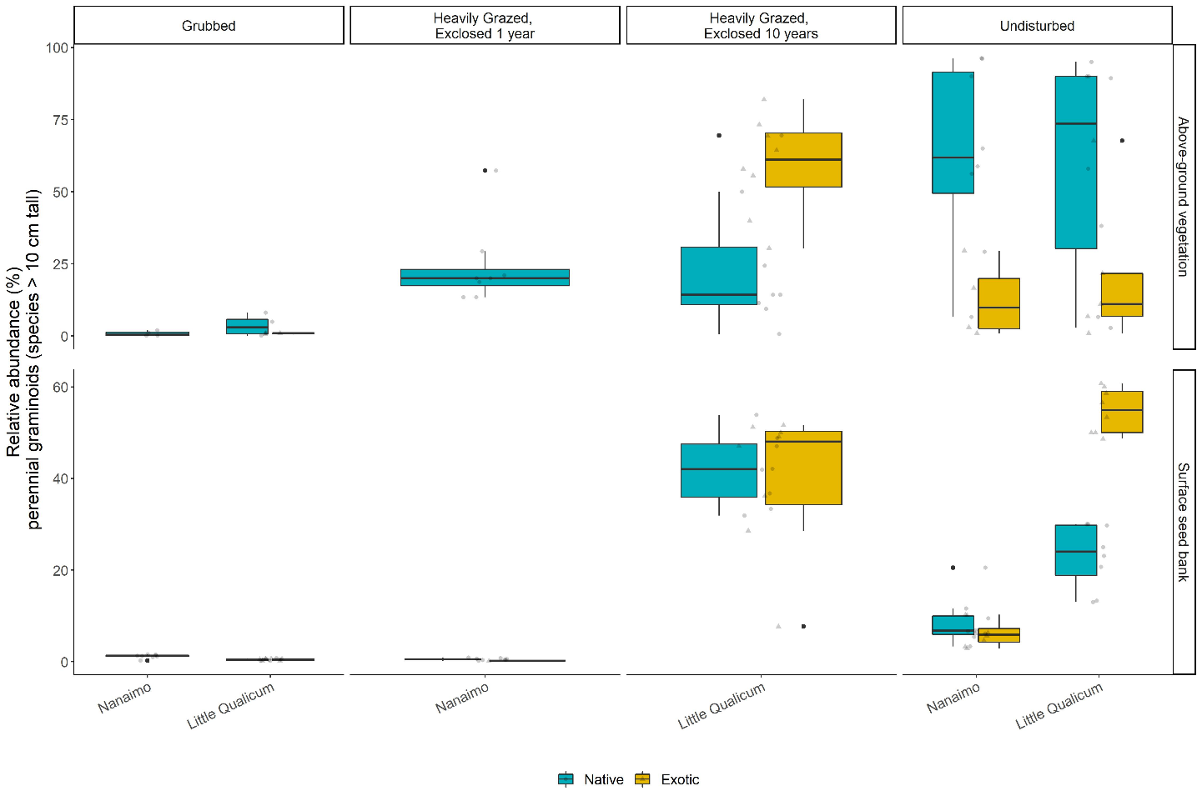

Figure . Above-ground cover abundance of key functional group ‘perennial graminoids (> 10 cm)’ is not significantly different from undisturbed (reference) sites after 10 years. However, this above-ground cover is dominated by exotic graminoid species. Moreover, seed bank abundance of tall, perennial graminoids is significantly higher in 10-year old exclosures compared to other disturbance conditions, including undisturbed (reference) sites. Notably, there is nearly equal abundance of exotic and native graminoid seed in 10-year old exclosures, and significantly greater representation of exotic than native graminoid seed in undisturbed sites in Little Qualicum Estuary.

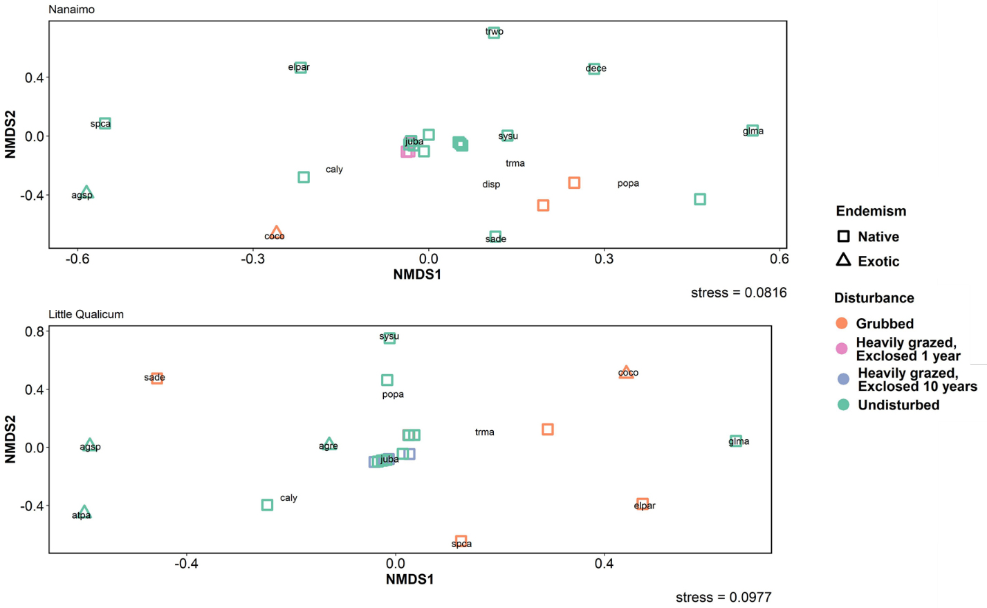

Figure . Similarity of above-ground vegetation relative abundance across disturbance conditions in Nanaimo and Little Qualicum River Estuaries (Euclidean distance). Species abbreviations may be found in Supplemental table X.

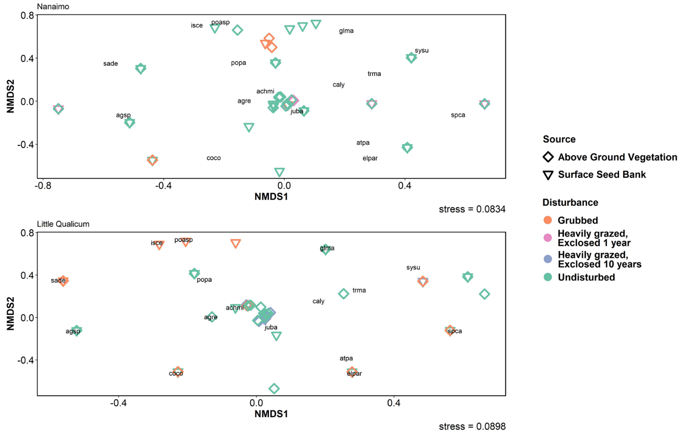

Figure . Species relative abundance had greatest similarity between above-ground vegetation and surface seed banks in grubbed sites in Nanaimo and undisturbed sites in both estuaries, and greatest dissimilarity in both exclosures (1 and 10 years post-grazing exclusion). Species abbreviations may be found in Supplemental table X

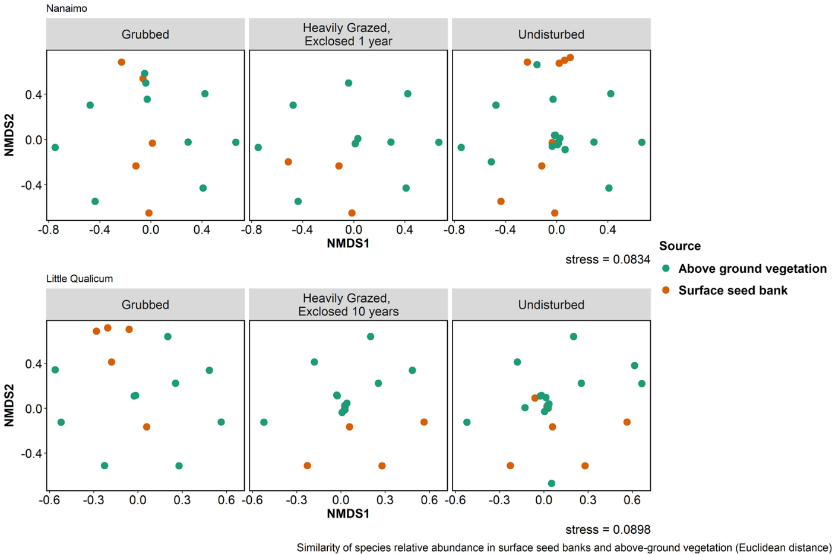

Figure .

# Discussion

1. Does the system recover? Explain whether expectations were or weren’t met.
   1. The competitively dominant species recovered according to our expectations, however the compositional quality has changed during recovery in the Little Qualicum Estuary. This supports our alternative hypothesis that introduction of competitively dominant species through seed inputs may alter successional trajectories following disturbance.
   2. Seed inputs were most similar in Grubbed and Undisturbed sites, and most dissimilar in the 1- and 10-Year Old Exclosures (YOEs). This partially contradicts our expectations of greatest similarity in the recently disturbed Grubbed and 1 YOE sites. Additionally, this showed that native seeds of competitively dominant functional groups are not dispersed to or retained in Grubbed sites, and rare in the 1 YOEs, thus their recovery is obliged to proceed from clonal strategy.
2. Broader implication: what does this mean about succession & recovery?
   1. Loss of native species during recovery, especially in seed bank, points to “ecological memory loss” following disturbance.
      1. Highest risk for species loss may be for seed-limited species. If disturbance removes clonally reproductive above-ground vegetation, then there are no (or very few) reproductive propagules left in the system, and regional dispersal is required to revitalize the population.
         1. Some species may produce more seed in response to grazing. This does not seem to be the case for *Carex lyngbyei*, although it is interesting to note *Juncus balticus* had a very high abundance of seed in Little Qualicum Estuary despite not having high abundance in the above-ground vegetation (Figure 2).
      2. I would like to include another case example of above point: streambank clover (*Trifolium wormskioldii*) is a species of significant cultural importance with greater historical abundance in estuaries, yet is now locally rare as a plant, and entirely absent from the seed bank.
      3. Alternatively, new ‘memories’ are being added via seed inputs of exotic species. E.g., exotic *A. stolonifera*.
   2. What does the species or functional identity/abundance mean (e.g., dominance of exotic *Agrostis* vs. native *Carex*)?
      1. Articulate concepts of species identity altering ecosystem function (even if functionally/cladistically similar), especially C or N contributions/sequestration (Waller et al., 2020).
   3. Extrapolate implications for other systems with other press disturbance types, such anthropogenic stressors (e.g., general wetland/riparian invasion). Contrast to ecosystems that experience regular pulse disturbance, keeping ecosystem in a relatively ‘young’ state (Odum, 1969).
      1. Local or regional dispersal limitations cannot rescue native populations if local seed or clonal competitive pressure from exotic species is greater. That is, this trend of both native species loss *and* increasing exotic cover is exacerbated by each species’ competitive dispersal and recruitment strategies.
      2. Seed-limited species that rely on clonal reproduction may be at greatest risk for being out-competed if the competitor(s) have greater seed and clonal reproductive rates.
      3. Here, we have demonstrated an example of alternative successional outcomes over the course of 10 years of recovery in the Little Qualicum River Estuary likely being driven by reproductive competitive strategies.
3. Limitations, management applications & opportunities
   1. Need to address limited data: two periods (1, 10 years) of recovery, each in different estuaries leave a lot of uncertainty, as does only collecting seed/vegetation data for one year. A major challenge is replication of restoration conditions, which should be addressed in restoration design.
   2. Passive restoration may be insufficient for recovery of species with a primarily clonal reproductive strategy, especially when exotic species with competitive reproductive advantage of both seed and clonal strategies are present. In these cases, active restoration through transplanting should be prioritized in ecosystems affected by these types of disturbance.
   3. Opportunities exist: if disturbance denudes a habitat, this effectively creates a ‘blank slate’ for restoration where land managers can choose specific restoration states (CITE). Besides ecosystem function, ethnoecological restoration opportunities could exist. In the PNW, this could be restoration of culinary root gardens (Turner, 2014).

# Literature Cited

Douglas, G. W., Meidinger, D., & Pojar, J. (Eds.). (1998). *Illustrated flora of British Columbia. Vols. 1-8*. Victoria, BC: B.C. Min. Environ., Lands and Parks, and B.C. Min. For.

Hairston, N. G., Smith, F. E., & Slobodkin, L. B. (1960). Community Structure, Population Control, and Competition. *The American Naturalist*, *94*, 421–425.

Hitchcock, C. L., & Cronquist, A. (1973). *Flora of the Pacific Northwest, an illustrated manual*. Seattle and London: University of Washington Press.

Hopfensperger, K. N. (2007). A review of similarity between seed bank and standing vegetation across ecosystems. *Oikos*, *116*, 1438–1448.

Odum, E. P. (1969). The Strategy of Ecosystem Development. *Science*, *164*, 262–270.

Pasternack, G. B. (2009). Chapter 3. Hydrogeomorphology and sedimentation in tidal freshwater wetlands. In A. Barendregt, D. F. Whigham, & A. H. Baldwin (Eds.), *Tidal Freshwater Wetlands* (pp. 31–40). Leiden, The Netherlands: Backhuys Publishers.

Srivastava, D. S., & Jefferies, R. L. (1996). A Positive Feedback: Herbivory, Plant Growth, Salinity, and the Desertification of an Arctic Salt-Marsh. *Journal of Ecology*, *84*, 31–42. JSTOR.

Standish, R. J., Hobbs, R. J., Mayfield, M. M., Bestelmeyer, B. T., Suding, K. N., Battaglia, L. L., … Thomas, P. A. (2014). Resilience in ecology: Abstraction, distraction, or where the action is? *Biological Conservation*, *177*, 43–51.

Turner, N. (2014). *Ancient Pathways, Ancestral Knowledge: Ethnobotany and Ecological Wisdom of Indigenous Peoples of Northwestern North America*. McGill-Queen’s Press - MQUP.

Waller, L. P., Allen, W. J., Barratt, B. I. P., Condron, L. M., França, F. M., Hunt, J. E., … Dickie, I. A. (2020). Biotic interactions drive ecosystem responses to exotic plant invaders. *Science*, *368*, 967–972.

# Supplemental

Table . Frequency (%) of species found in above-ground vegetation plot replicates for Nanaimo and Little Qualicum River Estuaries, combined, ranked by greatest frequency found in undisturbed plots.

|  |  |  |  |  |
| --- | --- | --- | --- | --- |
| **Species** | **Grubbed** | **Exclosed 1 Year** | **Exclosed 10 years** | **Undisturbed** |
| *Carex lyngbyei* | 31.3 | 100 | 100 | 100 |
| *Potentilla pacifica-anserina* | 31.3 | 0 | 87.5 | 87.5 |
| *Agrostis stolonifera* | 18.8 | 0 | 100 | 56.3 |
| *Glaux maritima* | 75 | 100 | 75 | 56.3 |
| *Juncus balticus* | 0 | 12.5 | 62.5 | 56.3 |
| *Triglochin maritima* | 50 | 12.5 | 37.5 | 43.8 |
| *Deschampsia cespitosa* | 12.5 | 37.5 | 0 | 25 |
| *Atriplex patula* | 0 | 0 | 0 | 18.8 |
| *Eleocharis parvula* | 100 | 75 | 0 | 12.5 |
| *Symphyotrichum subspicatum* | 0 | 0 | 0 | 12.5 |
| *Agropyron repens* | 0 | 0 | 0 | 6.25 |
| *Distichlis spicata* | 12.5 | 25 | 0 | 6.25 |
| *Salicornia depressa* | 62.5 | 25 | 0 | 6.25 |
| *Spergularia canadensis* | 100 | 100 | 0 | 6.25 |
| *Trifolium wormskioldii* | 0 | 0 | 0 | 6.25 |
| *Cotula coronopifolia* | 68.8 | 12.5 | 0 | 0 |

Table . Frequency (%) of species found in seed germination replicates for Nanaimo and Little Qualicum River Estuaries, combined, ranked by greatest frequency found in undisturbed samples.

|  |  |  |  |  |
| --- | --- | --- | --- | --- |
| **Species** | **Grubbed** | **Exclosed 1 Year** | **Exclosed 10 years** | **Undisturbed** |
| *Agrostis stolonifera* | 37.5 | 12.5 | 100 | 100 |
| *Juncus balticus* | 62.5 | 75 | 100 | 100 |
| *Spergularia canadensis* | 100 | 100 | 87.5 | 100 |
| *Eleocharis parvula* | 100 | 100 | 50 | 56.3 |
| *Cotula coronopifolia* | 56.3 | 12.5 | 37.5 | 50 |
| *Carex lyngbyei* | 6.25 | 25 | 25 | 43.8 |
| *Juncus tenuis* | 50 | 87.5 | 0 | 37.5 |
| *Potentilla pacifica-anserina* | 6.3 | 0 | 25 | 31.3 |
| *Glaux maritima* | 43.8 | 12.5 | 37.5 | 25 |
| *Juncus articulatus* | 0 | 0 | 0 | 25 |
| *Symphyotrichum subspicatum* | 6.3 | 0 | 0 | 18.8 |
| *Juncus ensifolius* | 0 | 0 | 0 | 12.5 |
| *Achillea millefolium* | 0 | 0 | 0 | 6.3 |
| *Epilobium ciliatum* | 6.3 | 0 | 0 | 6.3 |
| *Epilobium glaberrimum* | 0 | 0 | 0 | 6.3 |
| *Grindelia sp.* | 0 | 0 | 0 | 6.3 |
| *Isolepis cernua* | 18.8 | 0 | 0 | 6.3 |
| *Triglochin maritima* | 0 | 0 | 25 | 0 |
| *Deschampsia cespitosa* | 0 | 12.5 | 0 | 0 |
| *Distichlis spicata* | 0 | 0 | 0 | 0 |
| *Poa palustris* | 6.3 | 0 | 0 | 0 |
| *Salicornia depressa* | 43.8 | 37.5 | 0 | 0 |

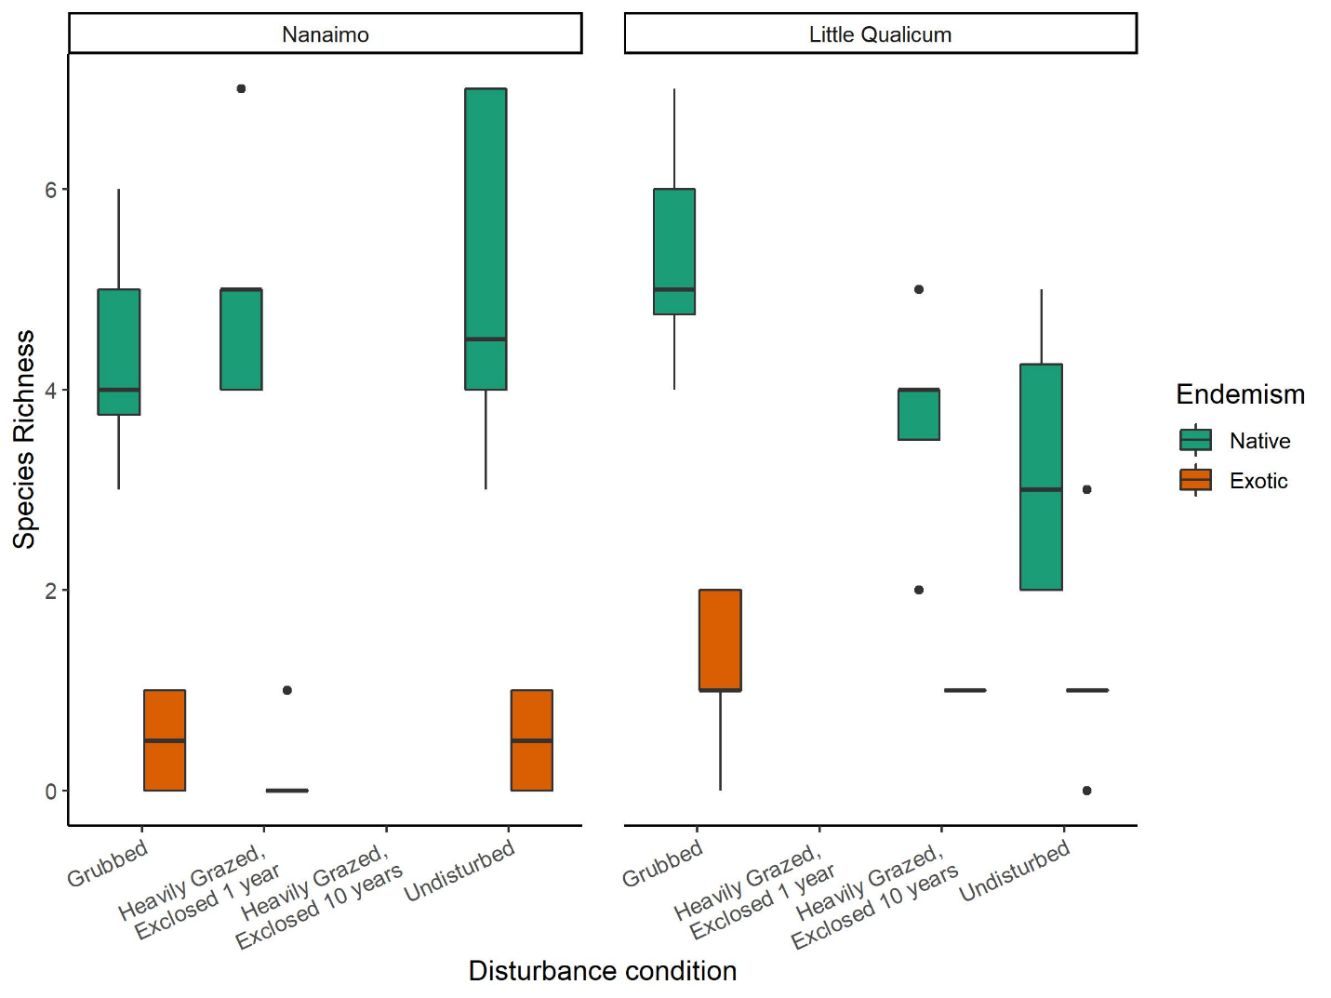

Figure . Native species richness is consistently significantly greater than exotic species richness in both estuaries and across all disturbance categories.

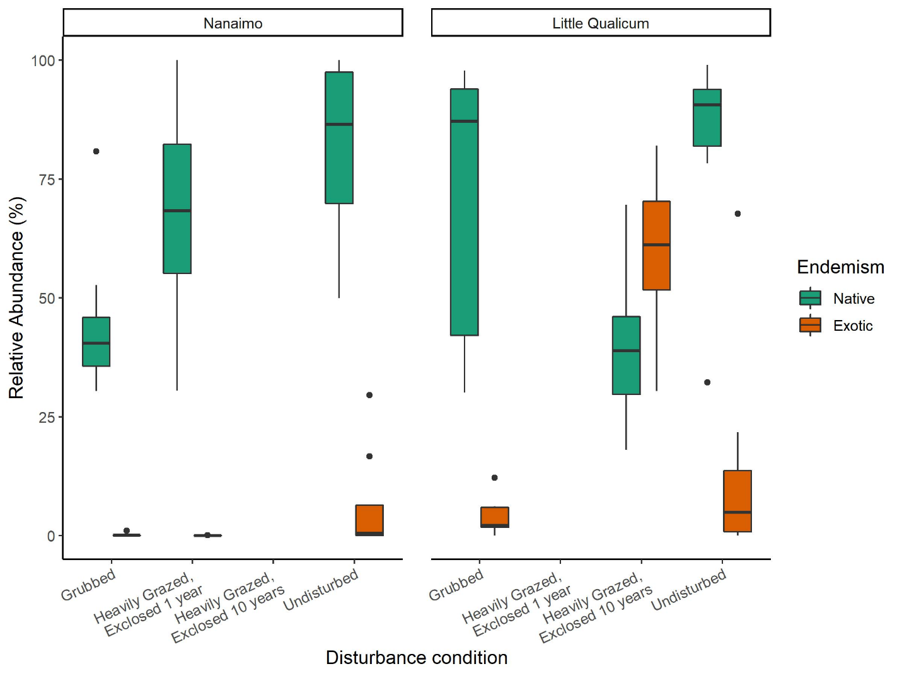

Figure . Above-ground cover abundance of native species is always significantly greater than exotic species cover, except in 10-year old exclosures in Little Qualicum River Estuary.

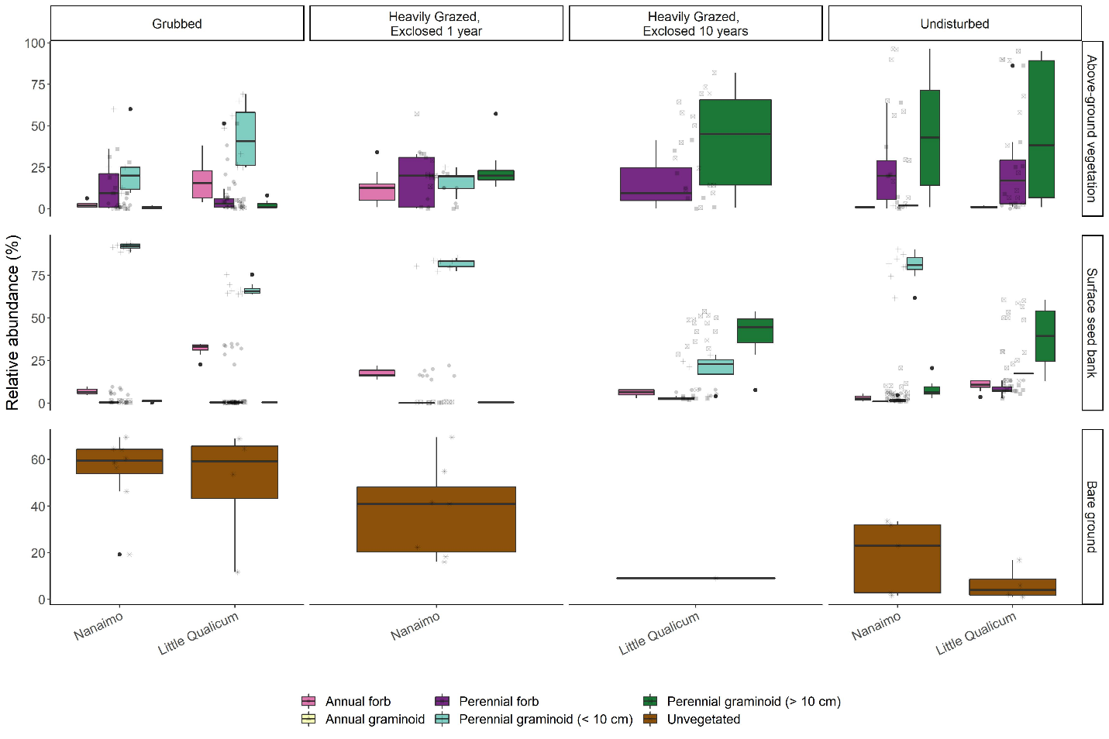

Figure . Recently grubbed and 1-year-old exclosures are dominated by > 50% mean cover of bare ground, with species relative abundance dominated by short perennial graminoid Eleocharis parvula and forbs in both above-ground vegetation and surface seed bank. After 1 year of exclosure, all plant functional groups have similar dominance in above ground vegetation, but surface seed banks do not show increased representation from perennial forbs or perennial graminoids > 10 cm. Bare ground significantly decreases after 10 years of exclosure, while relative abundance of perennial graminoids (> 10 cm) significantly increases in both above-ground vegetation and surface seed banks, not significantly different from undisturbed sites.