Estuary marsh habitat recovery following intensive grazing by an exotic herbivore

# Introduction

Vegetation communities and successional trajectories may be driven by plant competitive strategies.

Competition is one interaction that shapes community composition

Competitive dominance results in species-specific compositional states, which define ecosystem characteristics (e.g., forest succession theory, keystone species/functional groups, and resulting ecosystem processes/function).

Competitive dominance may be environmentally constrained as in estuaries where elevation gradients above sea level restrict species adapted to conditions at a given elevation (Bertness & Ellison, 1987).

Plants may exhibit different competitive advantages through alternative reproductive strategies, such as clonal reproduction or heavy seed production. Tradeoffs exist:

Competitive advantage in a given environment may be at the expense of another, such as strong clonal expansion at expense of seed limitation (e.g., *Carex lyngbyei*; CITE). Or, plants may have equally strong clonal and seed reproductive capability, enabling community dominance (e.g., exotic sp.; CITE).

Recruitment of a species (native or exotic) may be enhanced or negatively affected by parent plant/seed bank linkages and feedbacks (CITE).

Dissimilarity of seed banks and parent vegetation increases with greater time since disturbance in wetlands (Hopfensperger, 2007)

Local seed dispersal is more likely in estuarine wetlands, although vectors such as wind & water dispersal can carry seeds to colonize new sites (CITE).

Should one competitive strategy (seed or clonal) be removed from the population during disturbance, then recovery via succession would be influenced by the relative competitive strength of remaining propagative material in the disturbed area. Successional outcomes may vary depending on the composition of the available propagative sources.

For example, if clonally propagative parts were removed form habitat, recovery would be obligated to reproduce by seed (or other dispersed clonal propagules); OR, successional outcomes may be affected by the relative rate of recovery by alternative reproductive strategies. E.g., competitive seeds could take over faster than clonal regrowth from adjacent patches.

Recovery from seed requires that seed is dispersed and retained in the site to be available during succession.

Ecosystem capacity for recovery via succession following disturbance, and grazing as a form of natural disturbance

Define resilience broadly as communities’ ability to recover following disturbance. In estuarine plant communities, seed/clonal strategies help post-disturbance recovery.

Disturbance intensity and duration can push a habitat beyond its capacity for recovery. One measure of resilience may be to assess whether the habitat returns to a pre-disturbance state following the removal of the disturbance agent. (Standish et al., 2014)

* 1. Some ecosystems experience regular disturbance, which may be environmental (estuaries), or from biotic interactions (grazing). Either of these can under some conditions promotes diversity/resilience/productivity (CITE). However, if disturbance is persistent or return intervals exceed recovery time, ecosystem shifts to alternate compositional or functional states (CITE).

Overstress, such as through overgrazing, would lead to reduced capacity for the community to recover through loss of reproductive members (especially clonally reproductive parent vegetation) within plant populations.

In the absence of natural predators, over-abundant herbivore populations must be excluded to allow passive recovery (cite examples from forestry/ag/riparian lit).

The Green World Hypothesis (Hairston, Smith, & Slobodkin, 1960) would posit that grazing pressure must be released as predators should take advantage of herbivore populations. However, if grazers are not limited by predation, then grazing pressure can alter site ecology and thus limit the capacity of the habitat to recover (Srivastava & Jefferies, 1996).

Broadly, we need to understand whether habitat recovers following grazing disturbance. A key knowledge gap is to understand how recovery proceeds in an ecosystem which regularly experiences natural disturbance, such as estuaries.

Estuaries, and local habitat/overgrazing context

Estuaries are ecosystems where varying degrees of natural disturbance are experienced in daily tides, seasonal storms, or over longer geomorphic timescales and processes such as marsh accretion, erosion, or subsidence (Pasternack, 2009). Estuaries around the Salish Sea along the Pacific northwest coast of North America (PNW) may be spatially constrained by geography, and are often heavily impacted by human infrastructure (CITE). However, their immense habitat value to marine species such as salmonids and shorebirds is reflected in federal and international efforts for conservation and restoration (CITE).

High marsh species composition, especially in the PNW

Introduce group of competitive dominant species, ‘tall, perennial graminoids (> 10 cm tall),’ or TPGs. Describe zonation of *Carex lyngbyei* or *Juncus balticus* along channel edges, with secondary dominance by other sedges/rushes/grasses. (2- 3 sentences).

Emphasize rhizomatous clonal reproductive strategy, and note seed limitation of *Carex lyngbyei*.

Review of seed banks in estuaries, including similarity to parent vegetation, dispersal/retention, and recruitment; acknowledge most global lit is from Atlantic estuaries, thus need for PNW studies.

Explain regional exotic introductions also include the Canada goose, which is a resident herbivore in these estuaries capable of extensive grazing.

Describe migratory history & regional introduction (1-2 sentences), life cycle/residency (non-migratory pops., 1 sentence), grazing/grubbing behavior (~2 sentences, focusing on rhizome removal).

Describe exclosures & passive recovery as a means of restoration (broadly). Recovery goals target keystone species, or key functional groups.

The main objective of this study was to understand compositional changes of surface seed banks and above-ground vegetation at discrete stages of recovery since grazing disturbance and grazing exclusion in two Salish Sea estuaries. Traditional succession models would say the most competitive species will increasingly dominate the plant community as time since disturbance increases. This would particularly be the case in a clonal ecosystem, where recovery is driven by species spreading clonally from adjacent undisturbed sites, in addition to potential recruitment from the seed bank. If succession is happening the we expect:

1. Above-ground vegetation at older disturbance sites will be more similar to reference vegetation than recently disturbed (regardless of seed inputs), with respect to compositional abundance of tall, perennial graminoids (TPGs) which dominate this ecosystem.
   1. Alternatively, novel disturbance and novel seed inputs lead to alternative succession pathways, where new competitors from seed inputs derail the "slow encroachment" of the clonal dominant from the neighboring intact site.
2. Above-ground vegetation in recently disturbed sites will be highly similar to seed inputs than older disturbance vegetation similarity to seed, or reference vegetation similarity to seed, especially with respect to compositional abundance of TPGs.

From a conservation and land management perspective, we should be cognizant of long-term grazing impacts on recovery of plant communities and the implications for alternate successional trajectories. This is especially the case in ecosystems that already experience natural and anthropogenic disturbance, such as estuaries, and wetlands more broadly.

# Methods

## Study area & site history

* Site descriptions of Little Qualicum and Nanaimo River Estuaries as Wildlife Management Areas (map).
* Grazing exclosure history
  + Wooden fencing was iteratively installed (cite GoMIES?) to physically prevent Canada geese from grazing vegetation, hereafter referred to as ‘exclosures.’
    - Exclosures were placed opportunistically along channel edges where intensive herbivory was observed to protect remnant marsh platform from further degradation.
  + Ongong restoration strategies have afforded observation of recovery timepoints 1 and 10 years post-grazing exclusion in two different estuaries (Table 1).
    - Exclosure sites were selected to represent comparable starting conditions of disturbance within the exclosures; undisturbed and grubbed sites are not protected by an exclosure.

Table 1. Grazing disturbance conditions in the Little Qualicum River and Nanaimo Estuaries resulted in conversion of vegetated marsh to partially or fully grubbed mudflats; exclosures were installed to prevent further degradation into the marsh platform. Each estuary sampled n = 4 sites for disturbance category. Two 1 m2 plots were sampled within each site, and two surface seed banks samples were taken from each plot.

|  |  |  |  |  |  |  |  |
| --- | --- | --- | --- | --- | --- | --- | --- |
| **Estuary** | **Time Since Disturbance** | **Disturbance condition** | **Revegetation status** | **Protected by exclosure?** | **Number of sites** | **Number of sampling plots per site** | **Number of surface seed bank samples per plot** |
| Little Qualicum, Nanaimo | 0 years (recent grubbing disturbance) | Grubbed | No transplants; ruderal vegetation exists | No | 8 | 2 | 2 |
| Nanaimo | 1-year post-grazing/grubbing disturbance | Partially grubbed | No transplants; vegetation recovery from remnant and adjacent vegetation | Yes | 4 | 2 | 2 |
| Little Qualicum | 10 years post-grazing/grubbing disturbance | Partially grubbed | No transplants; vegetation recovery from remnant and adjacent vegetation | Yes | 4 | 2 | 2 |
| Little Qualicum, Nanaimo | No known grazing disturbance | Undisturbed | No manipulations | No | 8 | 2 | 2 |

## Sampling methods

### Vegetation sampling

Vegetation sampling was conducted once in mid-July, 2021. Two 1 m2 vegetation plots were placed within the exclosures (sites, n = 4 per estuary), at least 1 m from the bank edge and any exclosure boundary, and at least 3 m apart within the exclosure. Quadrats were placed so that the plot edge nearest creek was parallel to the bank.

All vascular species were identified according Hitchcock and Cronquist (1973), and currently accepted nomenclature standardized according to the PLANTS Database of the United States Department of Agriculture, Natural Resources Conservation Science [USDA NRCS]. Species were considered in the plot if at least half of their basal stem(s) were inside the quadrat boundary; overhanging vegetation was not considered. Aerial vegetated cover to the nearest 3 % (1/32 m2) was recorded. For any species present with less than 3 % cover, species were assigned 2% cover if > 20 individuals were present, 1 % cover if 2-20 individuals were present, and 0.1% cover for single individuals. Bare ground was estimated as the remainder of the plot area not covered by above-ground vegetation. Any plots with > 100% cover were standardized relative to 100%. To characterize plant structure, species were assigned to a height category tall (> 1 m), medium (50-100 cm), or short (< 50 cm) based on their maximum reported height in the Illustrated Flora of British Columbia (Douglas, Meidinger, & Pojar, 1998).

### Surface seed bank sampling & germination

Two surface seed bank samples were taken from each plot (n = 16 per disturbance condition in each estuary) in summer (July 2020), fall (October 2020), and spring (March 2021). A 10 cm diameter handheld bulb planter (e.g., [Husky 9 in. stainless Steel Bulb Planter, Home Depot, USA](https://www.homedepot.com/p/Husky-9-in-Stainless-Steel-Bulb-Planter-GD210314/317436441)) was used to excise sediment 1 cm deep to capture the surface seed bank. Vegetative roots, rhizomes, or other viable rooted material were removed before placing sample in a plastic zipper bag. All surface seed bank samples from the same estuary and disturbance condition were then homogenized in a clean bucket with 100 mL dechlorinated water. Samples were hand-sifted for any remaining root, rhizome, or vegetative material, then homogenized sample was transferred to a clean plastic zipper bag. Summer and fall 2020 samples were stored at 4o C for approx. 12 weeks to simulate overwinter cold stratification to release seed dormancy (CITE); samples collected in the spring of 2021 underwent natural winter conditions and were not subjected to cold stratification.

Germination trials were conducted under greenhouse conditions with 15 hr daylength at ~ 20o C. Seedling pots (9 cm x 13 cm x 5.7 cm (depth), BRAND) were filled with moist, sterile potting media (Sunshine Mix No. 4, Sun Gro Horticulture, Agawam, MA, United States). Pots were placed in solid cache trays and constantly bottom-watered with municipal tap water.

Seed bank samples were sown by pouring 75 mL sediment over the top of each seedling pot (n = 8 per estuary and disturbance condition) while constantly agitating the homogenized seed bank sample. Seeds were allowed to germinate for 5 weeks, at which time all individuals were counted and removed. The seedling trays were observed for any further germination for another 7-10 days, at which time the samples were discarded. Any species that could not be identified were labelled and transplanted into 38 P plug trays (BRAND) with the same growing media and growing conditions until a positive identification could be made. Representative specimens used to confirm seedling identification were pressed and made available as herbaria.

## Analysis

We fit generalized linear models (package) to test significant differences in vegetation and surface seed bank response between disturbance categories. Model validation?

We used indicator species analysis (package) to determine which species were significantly characterizing the above-ground vegetation and surface seed bank in each disturbance condition.

Needs to clearly answer original questions, so you’ll need to be explicit about how these two methods accomplish that.

# Results

Tall, perennial graminoids (TPG) are the response variable of interest because they are the dominant species group in high marsh estuarine communities.

* In above ground vegetation, there is no significant difference in cover abundance of TPGs between 10-year old exclosures and Undisturbed sites (Figure 1). This supports our first hypothesis.
  + Not surprisingly, Grubbed sites have significantly lower TPG above-ground cover than Undisturbed sites (p = 0.0236), and 1-year old exclosures have nearly significant less TPG cover than Undisturbed sites (p = 0.0906); (temp fig at Figure 7).
* Surface seed bank composition of TPGs varied by estuary and disturbance (Figure 1).
  + Nanaimo Estuary had significantly lower TPG seed abundance (p = 0.0242).
  + Grubbed sites have significantly lower TPG seed abundance, regardless of estuary (p = 0.0553); (temp fig at Figure 8).
* Despite the functional group of TPGs recovering according to expectation, species composition has significantly changed in the above-ground and surface seed bank (Table 2).
  + Indicator species analysis characterized above-ground vegetation in Undisturbed sites by two native TPGs and one native forb, while 10-year old exclosures were characterized by an exotic TPG. A second native forb may characterize both these disturbance conditions.
  + 10-year old and Undisturbed sites were both significantly characterized by exotic TPG in the surface seed bank.
  + Surface seed banks in 10-year old exclosures include native TPG *Juncus balticus* and native forb *Triglochin maritima*, which are the same indicator species as above-ground vegetation in Undisturbed sites.
    - However, the surface seed bank indicator species in 10-year old exclosures are different from the above-ground counterpart indicator species in 10-year old exclosures, *Agrostis stolonifera*. This suggests competitive recruitment of exotic species following disturbance.
* It is especially apparent that abundances of species present in the surface seed bank are not always proportional to the abundance of the same species in the above ground vegetation (Table 2, Figure 2).
  + Grubbed sites and 1-year old exclosures have greater species richness of indicator species in above-ground vegetation, but their surface seed banks are dominated by two species (neither of which are TPGs): *Eleocharis parvula*, and *Spergularia canadensis*.
  + Undisturbed sites and 10-year old exclosures have a greater richness in the surface seed bank, with some species of greater abundance similar to the Grubbed and 1-year old exclosures. Some TPG seeds had high abundance in the surface seed bank, such as native rush *Juncus balticus*, and exotic grass species *A. stolonifera*.
    - Notably, abundance of native keystone sedge *Carex lyngbyei* was greatest in Undisturbed sites in Little Qualicum Estuary, although this accounted for less than 20% of all seed relative abundance. However, *J. balticus* was twice as abundant, and *A. stolonifera* approx. five times as abundant in the surface seed bank.

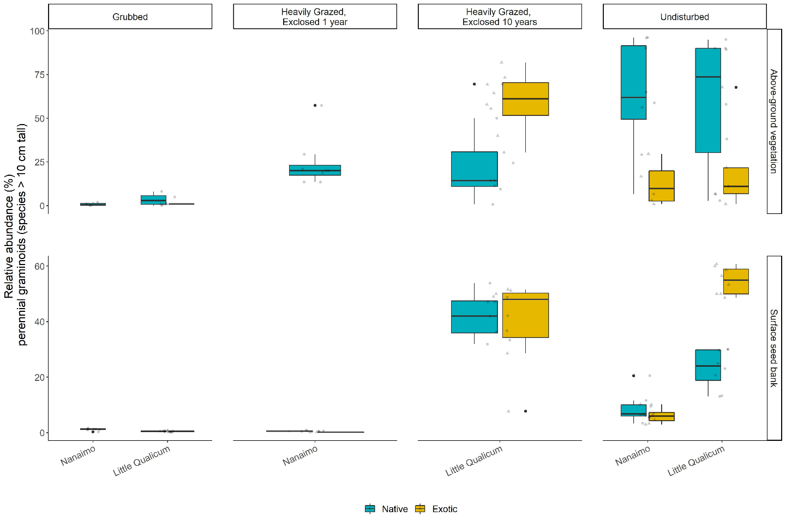

Figure 1. Above-ground cover abundance of key functional group ‘perennial graminoids (> 10 cm)’ is not significantly different from undisturbed (reference) sites after 10 years. However, indicator species analysis reveals this above-ground cover is dominated by exotic graminoid species Agrostis stolonifera. Moreover, seed bank abundance of tall, perennial graminoids is significantly higher in 10-year old exclosures compared to other disturbance conditions, including undisturbed (reference) sites. Notably, there is nearly equal abundance of exotic and native graminoid seed in 10-year old exclosures, and significantly greater representation of exotic than native graminoid seed in undisturbed sites in Little Qualicum Estuary.

Table 2. Indicator species analysis identifies which species significantly characterize the above-ground vegetation (left panel) and surface seed bank (right panel) for each disturbance condition, or combination of “recent” (1-year old exclosures and Grubbed sites) and “recovered” (10-year old exclosures and Undisturbed sites) disturbance conditions.

|  |  |  |  |  |  |  |  |  |
| --- | --- | --- | --- | --- | --- | --- | --- | --- |
| **Above-ground vegetation** | | | |  | **Surface seed bank** | | | |
|  | **Disturbance** | **Species** | **p-value** |  |  | **Disturbance** | **Species** | **p-value** |
| Above Ground | Grubbed | *Eleocharis parvula* | 0.0033 |  | Below Ground | Grubbed | *Salicornia depressa* | 0.0072 |
| *Cotula coronopifolia\** | 0.0397 |  | 10-year old | *Juncus balticus* | 0.0001 |
| 10-year old | *Agrostis stolonifera\** | 0.0001 |  | *Triglochin maritima* | 0.0458 |
| Undisturbed | *Juncus balticus* | 0.0192 |  | Undisturbed | *Carex lyngbyei* | 0.0156 |
| *Carex lyngbyei* | 0.024 |  | *Cotula coronopifolia\** | 0.0342 |
| *Triglochin maritima* | 0.0395 |  | *Juncus articulatus* | 0.0449 |
| 1-year old + Grubbed | *Spergularia canadensis* | 0.0091 |  | 1-year old + Grubbed | *Eleocharis parvula* | 0.016 |
| *Glaux maritima* | 0.0264 |  | *Spergularia canadensis* | 0.027 |
| 10-year old + Undisturbed | *Potentilla pacifica* | 0.0048 |  | 10-year old + Undisturbed | *Agrostis stolonifera\** | 0.0003 |

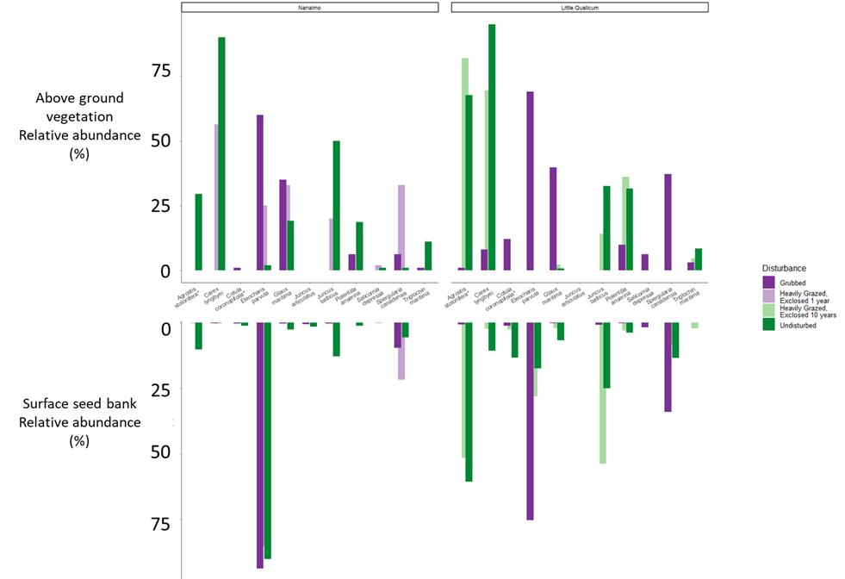

Figure 2. Relative abundance of species identified by indicator species analysis in above-ground vegetation and surface seed bank at each estuary sampled. Notably, abundance of key native TPGs such as Carex lyngbyei are absent from the seed bank, while others such as Juncus balticus are present in the seed bank but absent in above-ground vegetation, such as observed in 10-year old exclosures at Little Qualicum Estuary.

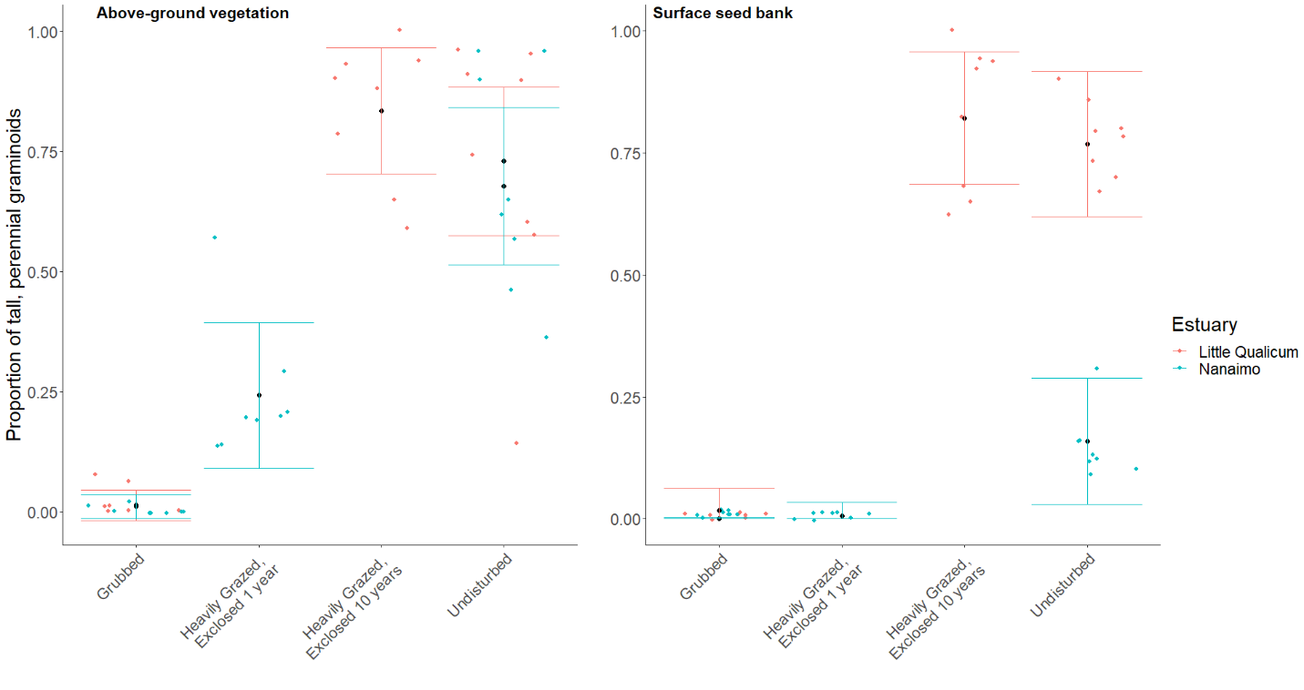

Figure 3. Actual vs. predicted values for proportion of tall, perennial graminoid in above-ground vegetation cover (left) and surface seed bank samples (right) based on disturbance condition. Actual values plotted as colored points; mean values black points with standard error color coded for each estuary.

# Discussion

We sought to understand whether the dominant plant functional group ‘tall, perennial graminoids’ (TPGs) recovers following disturbance, and whether surface seed bank composition reflects above-ground vegetation composition.

* We found that TPG functional group recovered according to our expectations, but with different compositional characteristics. Notably, exotic species *Agrostis stolonifera* dominates above-ground vegetation 10 years following grazing exclusion.
* We found high species richness in grubbed sites and 1-year old exclosures, but low abundance of seed similar to above-ground vegetation except for two species in these disturbance categories. This may indicate a loss of propagules in the surface seed bank, either by erosion or inability of the extant vegetation to trap seeds from local parent plants or any brought in by tidal inundation.
  + Our expectations for high similarity between surface seed banks and above-ground vegetation were partially met, however there was no strong partitioning according to time since disturbance.
* Whether vegetation is recovering predominantly by vegetative clonal growth, seed recruitment, or a combination of these mechanisms was not tested. Regardless, it appears exotic species are out-competing natives despite some native species’ presence in the surface seed bank.
  + We found low abundances of seed for some TPG in Undisturbed and 10-year old exclosures, notably a dearth of seed from C. lyngbyei.
    - This suggests that if vegetation is disturbed, seeds are not a likely source of propagative material for most species extant in the above-ground vegetation of Undisturbed sites.
  + The two TPG species with greatest representation in surface seed banks in Undisturbed at both estuaries and 10-year old exclosures in Little Qualicum Estuary were native *J. balticus* and exotic *A. stolonifera*. If these two species had comparable competitive traits, we might expect a similar proportion of cover abundance in the above ground vegetation in 10-year old exclosures. This was not the case, suggesting that exotic species *A. stolonifera* has a competitive recruitment advantage during the recovery period. Competitive advantage of *A. stolonifera* may especially be contributing to lack of recovery of seed-limited native TPGs, such as *C. lyngbyei*.
* Overall, relative abundance of most native indicator species was lower in the surface seed bank than the relative abundance of their above-ground vegetation counterparts. Over time and sustained disturbance, this may lead to ‘ecological memory loss’ of native species diversity and compositional abundance as above-ground vegetation is lost to grazing, and subsequently unable to contribute to the surface seed bank. Moreover, as both native vegetative clonal and seed reproductive mechanisms are lost from the habitat, there is a greater risk of exotic species replacing native species in estuaries.
  + Seed-limited species that rely on clonal reproduction may be at greatest risk for being out-competed if the competitor(s) have greater seed and clonal reproductive rates.
* Broadly, we may synthesize these findings to recommend areas of attention for habitat managers.
  + Most importantly, the data we present here show that while habitat recovers in terms of plant functional groups, it does not have the same species compositional abundance in above-ground vegetation or surface seed banks.
    - Thus, passive recovery may be insufficient for species with a primarily clonal reproductive strategy, especially when exotic species with competitive reproductive advantage of both seed and clonal strategies are present.
    - Whether the exotic species provide the same ecosystem functions such as leaf litter quality for primary productivity, sediment trapping, wave attenuation, etc., remains to be tested (e.g., Waller et al., 2020). Without knowing effects of these changes on habitat quality, best recommendations would be to prevent extensive grazing and grubbing.
    - Two periods (1, 10 years) of recovery, each in different estuaries leaves a lot of uncertainty, as does only collecting seed/vegetation data for one year. A major challenge is replication of restoration conditions, which should be addressed in restoration design and habitat management.
  + In the event of habitat disturbance, surface seed banks are not a reliable source of abundant native seed species to out-compete exotic species. Best recommendations would be to place a high priority on actively restoring desired species as soon as possible.
    - Local or regional dispersal limitations cannot rescue native populations if local seed or clonal competitive pressure from exotic species is greater. That is, this trend of both native species loss *and* increasing exotic cover is exacerbated by each species’ competitive dispersal and recruitment strategies.
    - Extrapolate implications for other systems with other press disturbance types, such anthropogenic stressors (e.g., general wetland/riparian invasion). Contrast to ecosystems that experience regular pulse disturbance, keeping ecosystem in a relatively ‘young’ state (Odum, 1969).
  + In instances where disturbance has resulted in extensive estuarine habitat loss, there exists the opportunity to intentionally restore diverse native species palettes, which can remedy known trends of biodiversity loss (Lane *et al.*, in preparation). Moreover, this offers a chance to enact reconciliation partnerships with local First Nations to use culturally important species, and potentially restore traditional land management practices (e.g., Turner, 2014).

# Literature Cited

Bertness, M. D., & Ellison, A. M. (1987). Determinants of Pattern in a New England Salt Marsh Plant Community. *Ecological Monographs*, *57*, 129–147.

Douglas, G. W., Meidinger, D., & Pojar, J. (Eds.). (1998). *Illustrated flora of British Columbia. Vols. 1-8*. Victoria, BC: B.C. Min. Environ., Lands and Parks, and B.C. Min. For.

Hairston, N. G., Smith, F. E., & Slobodkin, L. B. (1960). Community Structure, Population Control, and Competition. *The American Naturalist*, *94*, 421–425.

Hitchcock, C. L., & Cronquist, A. (1973). *Flora of the Pacific Northwest, an illustrated manual*. Seattle and London: University of Washington Press.

Hopfensperger, K. N. (2007). A review of similarity between seed bank and standing vegetation across ecosystems. *Oikos*, *116*, 1438–1448.

Odum, E. P. (1969). The Strategy of Ecosystem Development. *Science*, *164*, 262–270.

Pasternack, G. B. (2009). Chapter 3. Hydrogeomorphology and sedimentation in tidal freshwater wetlands. In A. Barendregt, D. F. Whigham, & A. H. Baldwin (Eds.), *Tidal Freshwater Wetlands* (pp. 31–40). Leiden, The Netherlands: Backhuys Publishers.

Srivastava, D. S., & Jefferies, R. L. (1996). A Positive Feedback: Herbivory, Plant Growth, Salinity, and the Desertification of an Arctic Salt-Marsh. *Journal of Ecology*, *84*, 31–42. JSTOR.

Standish, R. J., Hobbs, R. J., Mayfield, M. M., Bestelmeyer, B. T., Suding, K. N., Battaglia, L. L., … Thomas, P. A. (2014). Resilience in ecology: Abstraction, distraction, or where the action is? *Biological Conservation*, *177*, 43–51.

Waller, L. P., Allen, W. J., Barratt, B. I. P., Condron, L. M., França, F. M., Hunt, J. E., … Dickie, I. A. (2020). Biotic interactions drive ecosystem responses to exotic plant invaders. *Science*, *368*, 967–972.

# Supplemental

Table 3. Frequency (%) of species found in above-ground vegetation plot replicates for Nanaimo and Little Qualicum River Estuaries, combined, ranked by greatest frequency found in undisturbed plots.

|  |  |  |  |  |
| --- | --- | --- | --- | --- |
| **Species** | **Grubbed** | **Exclosed 1 Year** | **Exclosed 10 years** | **Undisturbed** |
| *Carex lyngbyei* | 31.3 | 100 | 100 | 100 |
| *Potentilla pacifica-anserina* | 31.3 | 0 | 87.5 | 87.5 |
| *Agrostis stolonifera* | 18.8 | 0 | 100 | 56.3 |
| *Glaux maritima* | 75 | 100 | 75 | 56.3 |
| *Juncus balticus* | 0 | 12.5 | 62.5 | 56.3 |
| *Triglochin maritima* | 50 | 12.5 | 37.5 | 43.8 |
| *Deschampsia caespitosa* | 12.5 | 37.5 | 0 | 25 |
| *Atriplex patula* | 0 | 0 | 0 | 18.8 |
| *Eleocharis parvula* | 100 | 75 | 0 | 12.5 |
| *Symphyotrichum subspicatum* | 0 | 0 | 0 | 12.5 |
| *Agropyron repens* | 0 | 0 | 0 | 6.25 |
| *Distichlis spicata* | 12.5 | 25 | 0 | 6.25 |
| *Salicornia depressa* | 62.5 | 25 | 0 | 6.25 |
| *Spergularia canadensis* | 100 | 100 | 0 | 6.25 |
| *Trifolium wormskioldii* | 0 | 0 | 0 | 6.25 |
| *Cotula coronopifolia* | 68.8 | 12.5 | 0 | 0 |

Table 4. Frequency (%) of species found in seed germination replicates for Nanaimo and Little Qualicum River Estuaries, combined, ranked by greatest frequency found in undisturbed samples.

|  |  |  |  |  |
| --- | --- | --- | --- | --- |
| **Species** | **Grubbed** | **Exclosed 1 Year** | **Exclosed 10 years** | **Undisturbed** |
| *Agrostis stolonifera* | 37.5 | 12.5 | 100 | 100 |
| *Juncus balticus* | 62.5 | 75 | 100 | 100 |
| *Spergularia canadensis* | 100 | 100 | 87.5 | 100 |
| *Eleocharis parvula* | 100 | 100 | 50 | 56.3 |
| *Cotula coronopifolia* | 56.3 | 12.5 | 37.5 | 50 |
| *Carex lyngbyei* | 6.25 | 25 | 25 | 43.8 |
| *Juncus tenuis* | 50 | 87.5 | 0 | 37.5 |
| *Potentilla pacifica-anserina* | 6.3 | 0 | 25 | 31.3 |
| *Glaux maritima* | 43.8 | 12.5 | 37.5 | 25 |
| *Juncus articulatus* | 0 | 0 | 0 | 25 |
| *Symphyotrichum subspicatum* | 6.3 | 0 | 0 | 18.8 |
| *Juncus ensifolius* | 0 | 0 | 0 | 12.5 |
| *Achillea millefolium* | 0 | 0 | 0 | 6.3 |
| *Epilobium ciliatum* | 6.3 | 0 | 0 | 6.3 |
| *Epilobium glaberrimum* | 0 | 0 | 0 | 6.3 |
| *Grindelia sp.* | 0 | 0 | 0 | 6.3 |
| *Isolepis cernua* | 18.8 | 0 | 0 | 6.3 |
| *Triglochin maritima* | 0 | 0 | 25 | 0 |
| *Deschampsia cespitosa* | 0 | 12.5 | 0 | 0 |
| *Distichlis spicata* | 0 | 0 | 0 | 0 |
| *Poa palustris* | 6.3 | 0 | 0 | 0 |
| *Salicornia depressa* | 43.8 | 37.5 | 0 | 0 |

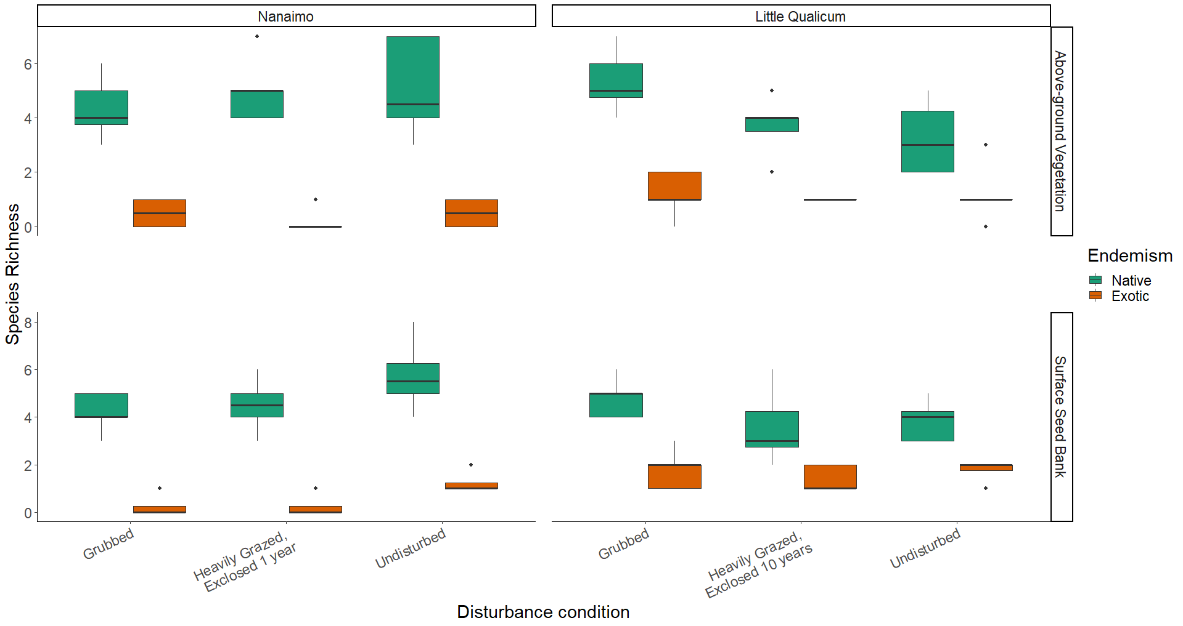

Figure 4. Native species richness is consistently greater than exotic species richness in both above-ground vegetation and surface seed banks for both estuaries and across all disturbance categories.

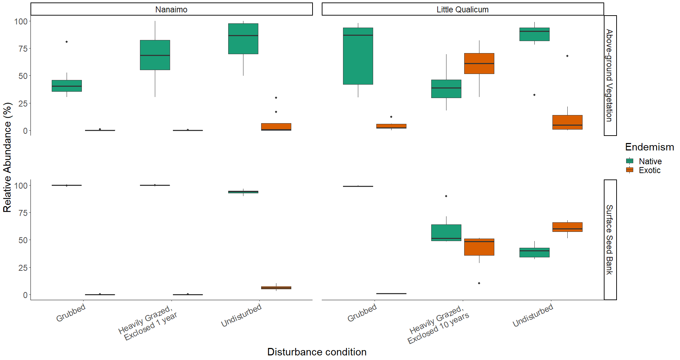

Figure 5. Above-ground cover abundance of all native species is always significantly greater than all exotic species cover, except in 10-year old exclosures in Little Qualicum River Estuary. Notably, exotic species abundance in the surface seed bank is low across all disturbance conditions in Nanaimo Estuary, but equal to or greater than native species in 10-year old exclosures or undisturbed sites, respectively, in Little Qualicum River Estuary.

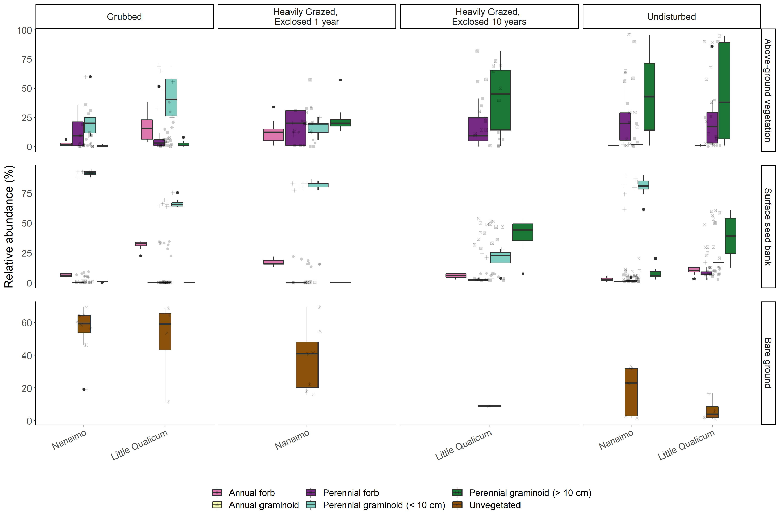

Figure 6. Recently grubbed and 1-year-old exclosures are dominated by > 50% mean cover of bare ground, with species relative abundance dominated by short perennial graminoid Eleocharis parvula and forbs in both above-ground vegetation and surface seed bank. After 1 year of exclosure, all plant functional groups have similar dominance in above ground vegetation, but surface seed banks do not show increased representation from perennial forbs or perennial graminoids > 10 cm. Bare ground significantly decreases after 10 years of exclosure, while relative abundance of perennial graminoids (> 10 cm) significantly increases in both above-ground vegetation and surface seed banks, not significantly different from undisturbed sites.

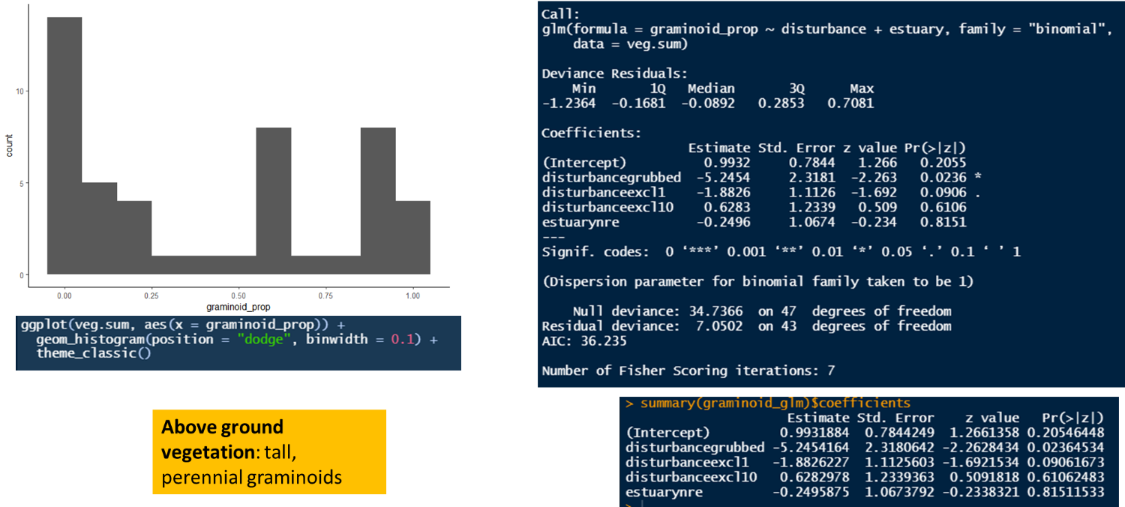

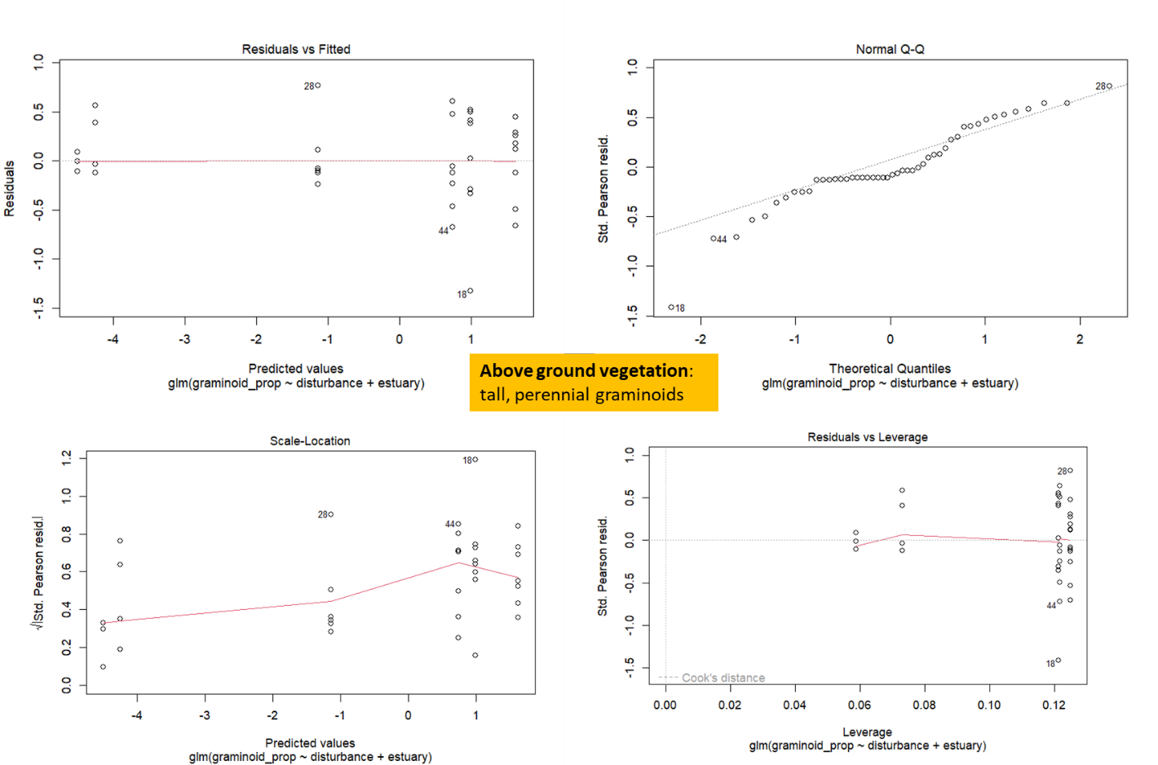

Figure 7. TEMP FIG - code output for in-text Results reporting glm trends in ABOVE-GROUND VEGETATION. Outliers are individual plots heavily dominated by perennial forbs (especially Douglas aster).

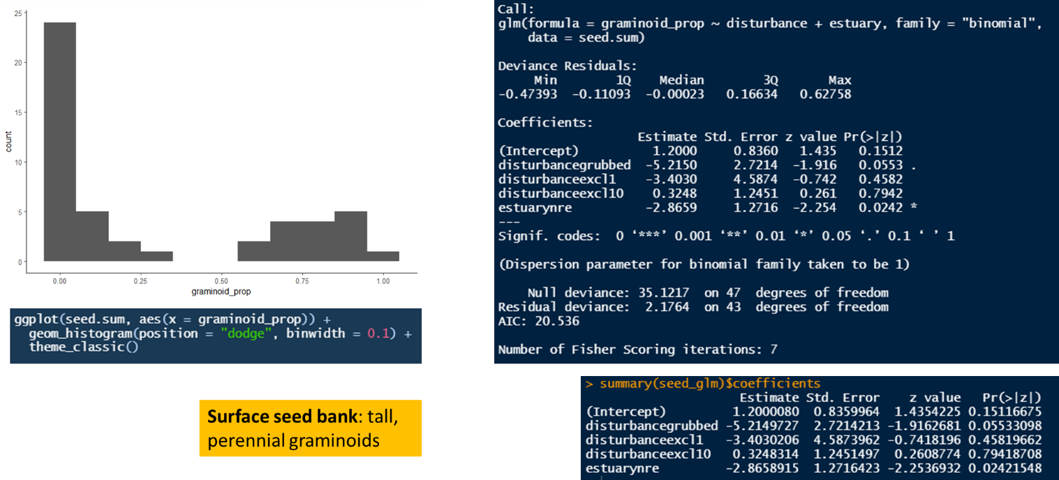

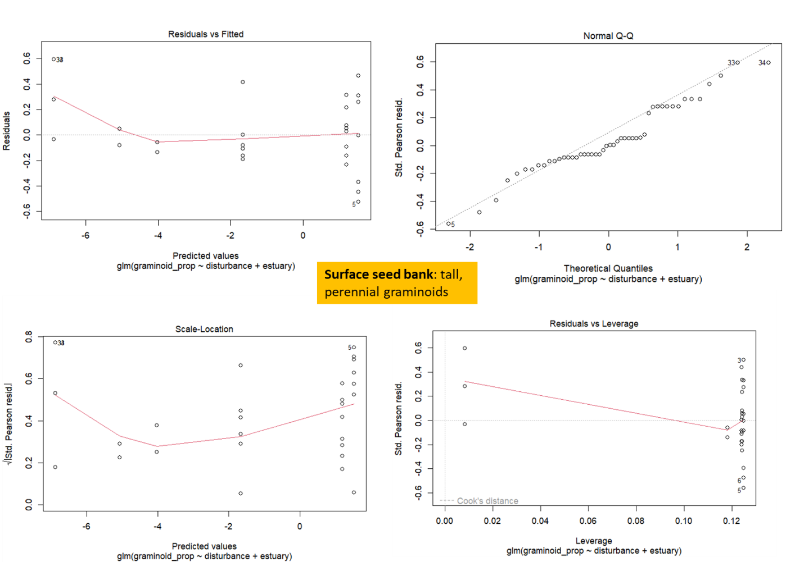

Figure 8. TEMP FIG - code output for in-text Results reporting glm trends in SURFACE SEED BANK. Outliers are samples dominated by forbs (especially Spergularia canadensis).