# Results

Tall, perennial graminoids (TPG) are the response variable of interest because they are the dominant species group in high marsh estuarine communities.

* In above ground vegetation, there is no significant difference in cover abundance of TPGs between 10-year old exclosures and Undisturbed sites (Figure 1). This supports our first hypothesis.
  + Not surprisingly, Grubbed sites have significantly lower TPG cover than Undisturbed sites (p = 0.0236), and 1-year old exclosures have nearly significant less TPG cover than Undisturbed sites (p = 0.0906).
* Surface seed bank composition of TPGs varied by estuary and disturbance (Figure 1).
  + Nanaimo Estuary had significantly fewer seed of TPGs (p = 0.0242).
  + Grubbed sites have significantly fewer TPG seed, regardless of estuary (p = 0.0553).
* Despite the functional group of TPGs recovering according to expectation, species composition has significantly changed in the above-ground and surface seed bank (Table 1).
  + Indicator species analysis characterized above-ground vegetation in Undisturbed sites by two native TPGs and one native forb, while 10-year old exclosures were characterized by an exotic TPG. A second native forb may characterize both these disturbance conditions.
  + 10-year old and Undisturbed sites were both significantly characterized by exotic TPG in the surface seed bank.
  + Surface seed banks in 10-year old exclosures include native TPG *Juncus balticus* and native forb *Triglochin maritima*, which are the same indicator species as above-ground vegetation in Undisturbed sites.
    - However, the surface seed bank indicator species in 10-year old exclosures are different from the above-ground counterpart indicator species in 10-year old exclosures, *Agrostis stolonifera*. This suggests competitive recruitment of exotic species following disturbance.
* It is especially apparent that abundances of species present in the surface seed bank are not equal to the abundance of the same species in the above ground vegetation (Figure 2).
  + Grubbed sites and 1-year old exclosures have greater species richness of indicator species in above-ground vegetation, but their surface seed banks are dominated by two species (neither of which are TPGs): *Eleocharis parvula*, and *Spergularia canadensis*.
  + Undisturbed sites and 10-year old exclosures have a greater richness in the surface seed bank, with some species of greater abundance similar to the Grubbed and 1-year old exclosures. Some TPG seeds had high abundance in the surface seed bank, such as native rush *Juncus balticus*, and exotic grass species *A. stolonifera*.
    - Notably, abundance of native keystone sedge *Carex lyngbyei* was greatest in Undisturbed sites in Little Qualicum Estuary. However, *J. balticus* was twice as abundant, and *A. stolonifera* approx. five times as abundant in the surface seed bank.

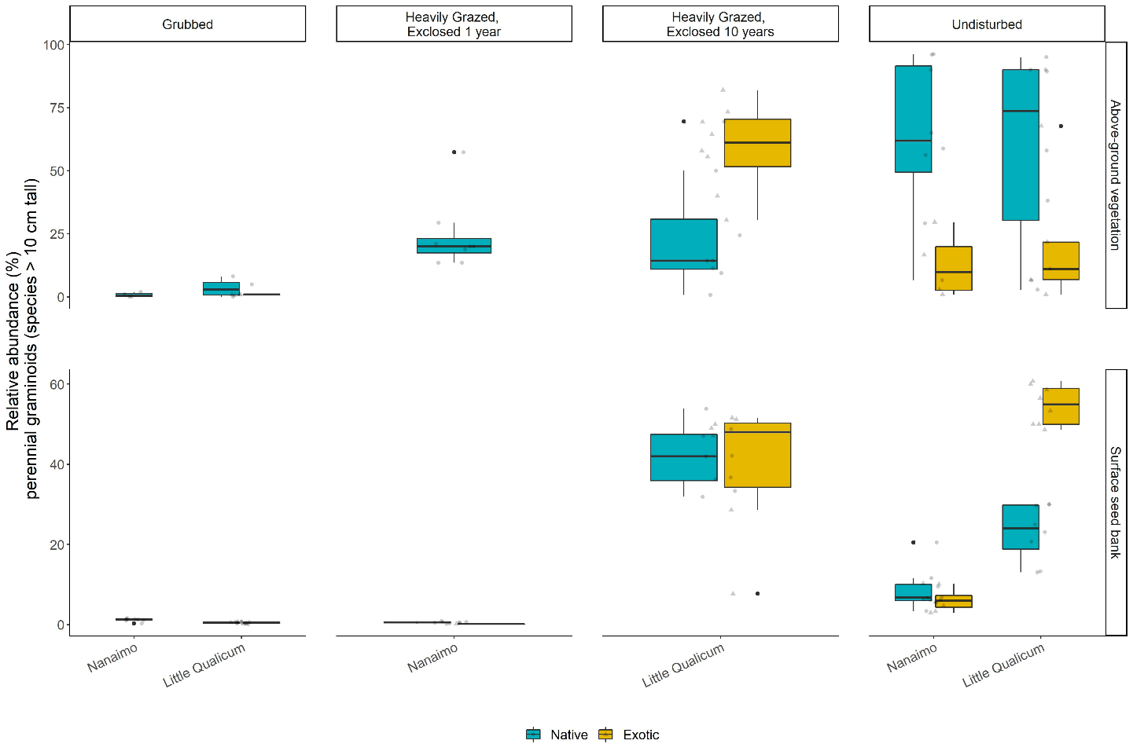

Figure 1. Above-ground cover abundance of key functional group ‘perennial graminoids (> 10 cm)’ is not significantly different from undisturbed (reference) sites after 10 years. However, indicator species analysis reveals this above-ground cover is dominated by exotic graminoid species Agrostis stolonifera. Moreover, seed bank abundance of tall, perennial graminoids is significantly higher in 10-year old exclosures compared to other disturbance conditions, including undisturbed (reference) sites. Notably, there is nearly equal abundance of exotic and native graminoid seed in 10-year old exclosures, and significantly greater representation of exotic than native graminoid seed in undisturbed sites in Little Qualicum Estuary.

Table 1. Indicator species analysis reveals which species significantly characterize the above-ground vegetation (left panel) and surface seed bank (right panel) for each disturbance condition, or combination of “recent” (1-year old exclosures and Grubbed sites) and “recovered” (10-year old exclosures and Undisturbed sites) disturbance conditions.

|  |  |  |  |  |  |  |  |  |
| --- | --- | --- | --- | --- | --- | --- | --- | --- |
|  | **Disturbance** | **Species** | **p-value** |  |  | **Disturbance** | **Species** | **p-value** |
| Above Ground | Grubbed | *Eleocharis parvula* | 0.0033 |  | Below Ground | Grubbed | *Salicornia depressa* | 0.0072 |
| *Cotula coronopifolia\** | 0.0397 |  | 10-year old | *Juncus balticus* | 0.0001 |
| 10-year old | *Agrostis stolonifera\** | 0.0001 |  | *Triglochin maritima* | 0.0458 |
| Undisturbed | *Juncus balticus* | 0.0192 |  | Undisturbed | *Carex lyngbyei* | 0.0156 |
| *Carex lyngbyei* | 0.024 |  | *Cotula coronopifolia\** | 0.0342 |
| *Triglochin maritima* | 0.0395 |  | *Juncus articulatus* | 0.0449 |
| 1-year old + Grubbed | *Spergularia canadensis* | 0.0091 |  | 1-year old + Grubbed | *Eleocharis parvula* | 0.016 |
| *Glaux maritima* | 0.0264 |  | *Spergularia canadensis* | 0.027 |
| 10-year old + Undisturbed | *Potentilla pacifica* | 0.0048 |  | 10-year old + Undisturbed | *Agrostis stolonifera\** | 0.0003 |

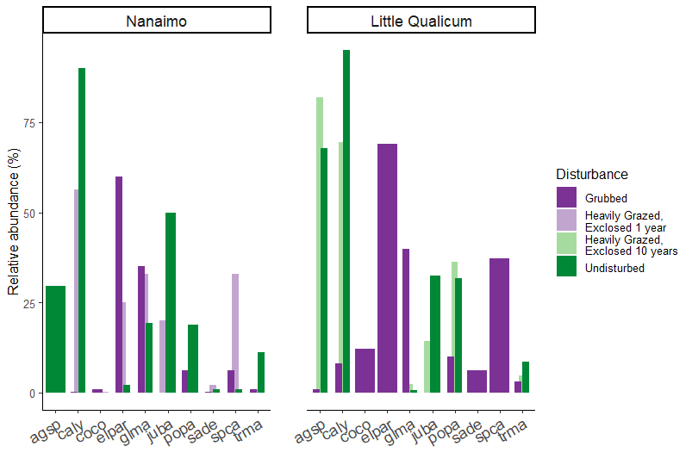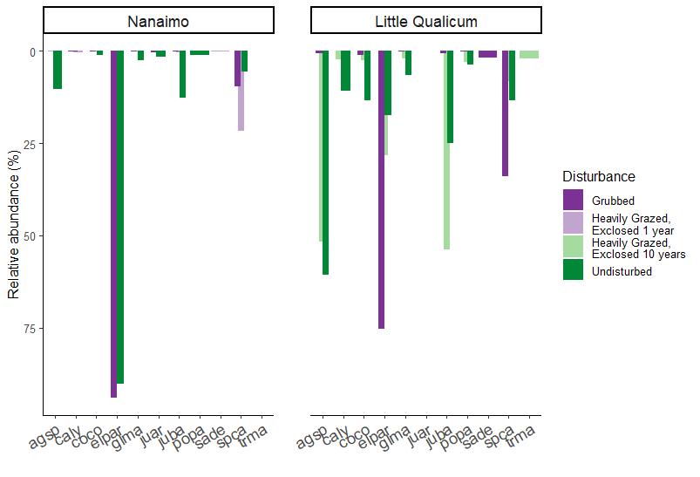

Above ground vegetation

Surface

seed bank

Figure 2. Relative abundance of species identified by indicator species analysis in above-ground vegetation and surface seed bank at each estuary sampled. Notably, abundance of key native TPGs such as Carex lyngbyei are absent from the seed bank, while others such as Juncus balticus are present in the seed bank but absent in above-ground vegetation, such as observed in 10-year old exclosures at Little Qualicum Estuary.

# Discussion

We sought to understand whether dominant plant functional groups recover following disturbance, and whether surface seed bank composition reflects above-ground vegetation composition.

* We found that TPG functional group recovered according to our expectations, but with different compositional characteristics. Notably, exotic species *Agrostis stolonifera* dominates above-ground vegetation 10 years following grazing exclusion.
* We found high species richness in grubbed sites and 1-year old exclosures, but low abundance of seed similar to above-ground vegetation except for two species in these disturbance categories. This may indicate a loss of propagules in the surface seed bank, either by erosion or inability of the extant vegetation to trap seeds from local parent plants or any brought in by tidal inundation.
  + Our expectations for high similarity between surface seed banks and above-ground vegetation were partially met, however there was no strong partitioning of seed species abundance in accordance to time since disturbance.
* Whether vegetation is recovering predominantly by vegetative clonal growth, seed recruitment, or a combination of these mechanisms was not tested. Regardless, it appears exotic species are out-competing natives despite some native species’ presence in the surface seed bank.
  + We found low abundances of seed for some TPG in Undisturbed and 10-year old exclosures, notably a dearth of seed from C. lyngbyei.
    - This suggests that if vegetation is disturbed, seeds are not a likely source of propagative material for most species extant in the above-ground vegetation of Undisturbed sites.
  + The two TPG species with greatest representation in surface seed banks in Undisturbed at both estuaries and 10-year old exclosures in Little Qualicum Estuary were native *J. balticus* and exotic *A. stolonifera*. If these two species had comparable competitive traits, we might expect a similar proportion of cover abundance in the above ground vegetation in 10-year old exclosures. This was not the case, suggesting that exotic species *A. stolonifera* has a competitive recruitment advantage during the recovery period. Competitive advantage of *A. stolonifera* may especially be contributing to lack of recovery of seed-limited native TPGs, such as *C. lyngbyei*.
* Overall, relative abundance of most native indicator species was lower in the surface seed bank than the relative abundance of their above-ground vegetation counterparts. Over time and sustained disturbance, this may lead to ‘ecological memory loss’ of native species diversity and compositional abundance as above-ground vegetation is lost to grazing, and subsequently unable to contribute to the surface seed bank. Moreover, as both native vegetative clonal and seed reproductive mechanisms are lost from the habitat, there is a greater risk of exotic species replacing native species in estuaries.
* Broadly, we may synthesize these findings to recommend areas of attention for habitat managers.
  + Most importantly, the data we present here show that while habitat recovers in terms of plant functional groups, it does not have the same species compositional abundance in above-ground vegetation or surface seed banks. Whether the exotic species provide the same ecosystem functions such as leaf litter quality for primary productivity, sediment trapping, wave attenuation, etc., remains to be tested. Without knowing effects of these changes on habitat quality, best recommendations would be to prevent extensive grazing and grubbing.
  + In the event of habitat disturbance, surface seed banks are not a reliable source of abundant native seed species to out-compete exotic species. Best recommendations would be to place a high priority on actively restoring desired species as soon as possible.
  + In instances where grazing/grubbing herbivory has resulted in extensive habitat loss, there exists the opportunity to intentionally restore diverse native species palettes, which can remedy biodiversity loss (Lane *et al.*, in preparation). Moreover, this offers a chance to enact reconciliation partnerships with local First Nations to use culturally important species, and potentially restore traditional land management practices (e.g., Turner, 2014).

# Supplemental

Table 2. Frequency (%) of species found in above-ground vegetation plot replicates for Nanaimo and Little Qualicum River Estuaries, combined, ranked by greatest frequency found in undisturbed plots.

|  |  |  |  |  |
| --- | --- | --- | --- | --- |
| **Species** | **Grubbed** | **Exclosed 1 Year** | **Exclosed 10 years** | **Undisturbed** |
| *Carex lyngbyei* | 31.3 | 100 | 100 | 100 |
| *Potentilla pacifica-anserina* | 31.3 | 0 | 87.5 | 87.5 |
| *Agrostis stolonifera* | 18.8 | 0 | 100 | 56.3 |
| *Glaux maritima* | 75 | 100 | 75 | 56.3 |
| *Juncus balticus* | 0 | 12.5 | 62.5 | 56.3 |
| *Triglochin maritima* | 50 | 12.5 | 37.5 | 43.8 |
| *Deschampsia cespitosa* | 12.5 | 37.5 | 0 | 25 |
| *Atriplex patula* | 0 | 0 | 0 | 18.8 |
| *Eleocharis parvula* | 100 | 75 | 0 | 12.5 |
| *Symphyotrichum subspicatum* | 0 | 0 | 0 | 12.5 |
| *Agropyron repens* | 0 | 0 | 0 | 6.25 |
| *Distichlis spicata* | 12.5 | 25 | 0 | 6.25 |
| *Salicornia depressa* | 62.5 | 25 | 0 | 6.25 |
| *Spergularia canadensis* | 100 | 100 | 0 | 6.25 |
| *Trifolium wormskioldii* | 0 | 0 | 0 | 6.25 |
| *Cotula coronopifolia* | 68.8 | 12.5 | 0 | 0 |

Table 3. Frequency (%) of species found in seed germination replicates for Nanaimo and Little Qualicum River Estuaries, combined, ranked by greatest frequency found in undisturbed samples.

|  |  |  |  |  |
| --- | --- | --- | --- | --- |
| **Species** | **Grubbed** | **Exclosed 1 Year** | **Exclosed 10 years** | **Undisturbed** |
| *Agrostis stolonifera* | 37.5 | 12.5 | 100 | 100 |
| *Juncus balticus* | 62.5 | 75 | 100 | 100 |
| *Spergularia canadensis* | 100 | 100 | 87.5 | 100 |
| *Eleocharis parvula* | 100 | 100 | 50 | 56.3 |
| *Cotula coronopifolia* | 56.3 | 12.5 | 37.5 | 50 |
| *Carex lyngbyei* | 6.25 | 25 | 25 | 43.8 |
| *Juncus tenuis* | 50 | 87.5 | 0 | 37.5 |
| *Potentilla pacifica-anserina* | 6.3 | 0 | 25 | 31.3 |
| *Glaux maritima* | 43.8 | 12.5 | 37.5 | 25 |
| *Juncus articulatus* | 0 | 0 | 0 | 25 |
| *Symphyotrichum subspicatum* | 6.3 | 0 | 0 | 18.8 |
| *Juncus ensifolius* | 0 | 0 | 0 | 12.5 |
| *Achillea millefolium* | 0 | 0 | 0 | 6.3 |
| *Epilobium ciliatum* | 6.3 | 0 | 0 | 6.3 |
| *Epilobium glaberrimum* | 0 | 0 | 0 | 6.3 |
| *Grindelia sp.* | 0 | 0 | 0 | 6.3 |
| *Isolepis cernua* | 18.8 | 0 | 0 | 6.3 |
| *Triglochin maritima* | 0 | 0 | 25 | 0 |
| *Deschampsia cespitosa* | 0 | 12.5 | 0 | 0 |
| *Distichlis spicata* | 0 | 0 | 0 | 0 |
| *Poa palustris* | 6.3 | 0 | 0 | 0 |
| *Salicornia depressa* | 43.8 | 37.5 | 0 | 0 |

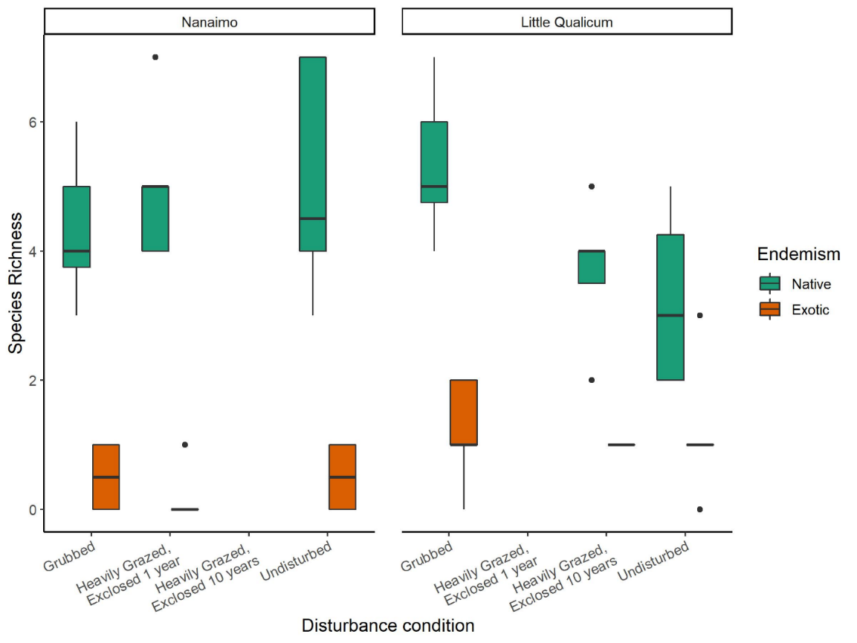

Figure 4. Native species richness in above-ground vegetation is consistently greater than exotic species richness in both estuaries and across all disturbance categories.

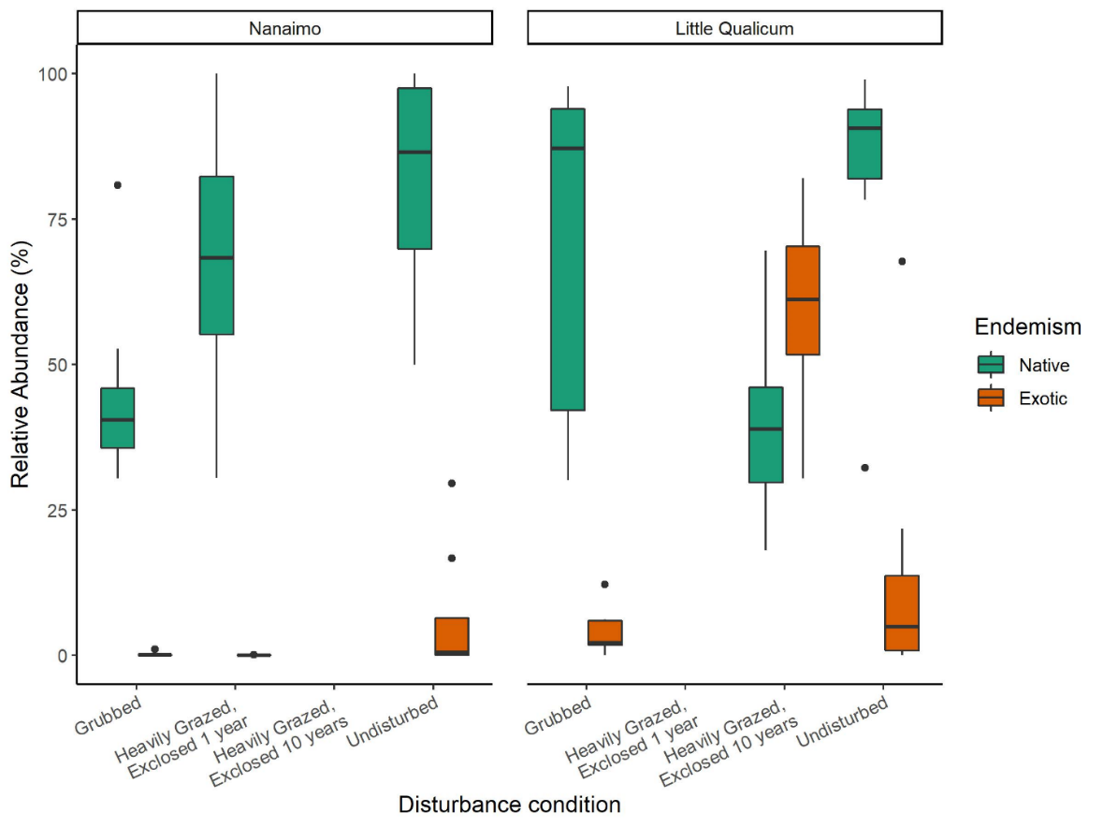

Figure 5. Above-ground cover abundance of all native species is always significantly greater than all exotic species cover, except in 10-year old exclosures in Little Qualicum River Estuary.

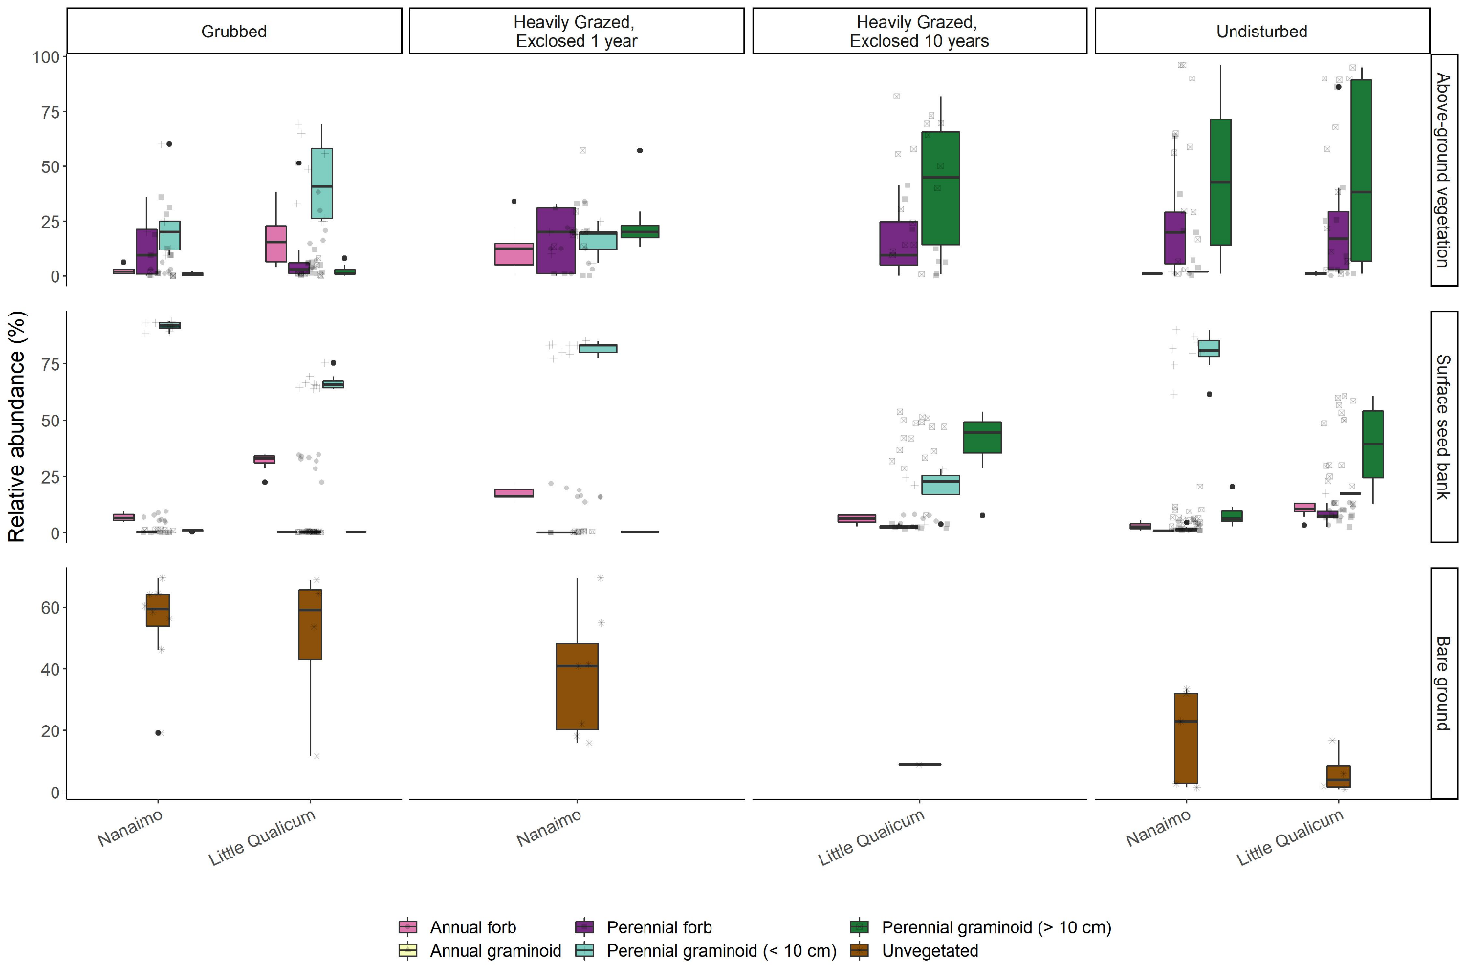

Figure 6. Recently grubbed and 1-year-old exclosures are dominated by > 50% mean cover of bare ground, with species relative abundance dominated by short perennial graminoid Eleocharis parvula and forbs in both above-ground vegetation and surface seed bank. After 1 year of exclosure, all plant functional groups have similar dominance in above ground vegetation, but surface seed banks do not show increased representation from perennial forbs or perennial graminoids > 10 cm. Bare ground significantly decreases after 10 years of exclosure, while relative abundance of perennial graminoids (> 10 cm) significantly increases in both above-ground vegetation and surface seed banks, not significantly different from undisturbed sites.