Framing:

Traditional succession models would say that the more distant past the disturbance, the more dominated the above ground community will be by competitive dominant species. This would be particularly the case in a clonal ecosystem, where recovery is driven by slowly encroaching clonal species from neighboring undisturbed sites.

We wanted to know if recovery following grazing disturbance is proceeding according to expected successional patterns. If succession is happening the way we expect, then:

1. Above-ground vegetation in recently disturbed sites will look MORE similar to seed inputs than older disturbance vegetation similarity to seed, or reference vegetation similarity to seed.
   1. Analysis: NMDS
   2. Result: This is true in Little Qualicum Estuary, but not the other estuaries (**Figure 1**).
2. Above-ground vegetation at older disturbance sites will be more similar to reference vegetation than recently disturbed (regardless of seed inputs)
   1. Analysis: NMDS
   2. Result: overall, this is supported by the data (**Figure 2**).
3. Alternatively, novel disturbance and novel seed inputs lead to alternative succession pathways, where new competitors from seed inputs derail the "slow encroachment" of the clonal dominant from the neighboring intact site.
   1. Analysis: Linear model or PERMANOVA (Not sure; I tried both)?
      1. beta regression was used (‘betareg,’ Cribari-Neto F, Zeileis A (2010)), transforming percent relative abundance to a proportion constrained 0 < x < 1 to fit the assumptions of a beta distribution.
   2. Result: **HALP**. not sure how to characterize “alternative succession,” and whether the alternative trajectory was due to seed input or competitive clonal strategy. E.g., how to parse out invasive vs. native, structure/function, evenness, etc.
      1. linear model: medium and tall species absent from disturbed sites, and absence of tall species from surface seed banks in older (10-yr) exclosures (Figure 3).
      2. Result, PERMANOVA: species composition and structure are clearly different between all categories (Table 2), multiple post-hoc tests seem laborious to show/explain.

Questions to pin down:

* Part of my initial curiosity was whether structure of the vegetation affects diversity/abundance of seed retention. **How can I frame an expectation about seasonal differences in seed retention in the context of succession**?
  + I had expected that structural differences in vegetation would lead to differences in species/abundance trapped, with older/reference sites trapping fewer but more diverse seeds. So, it sounds like I’m expecting that seeds don’t drive succession in this system, and that competitive clonal growth is driving recovery.
  + If the framing is around competition, should I be defining plant groups by competitive traits (eg, clonal/perennial species vs. annual/fibrous species?) rather than structural traits, or is there a way to include structure (e.g., plant height) as part of the competitive trait?
* **How can I show (or speculatively discuss) whether succession has taken an alternative path, and whether this was due to seed or clonal competitive strategy?**
* You suggested comparing centroid distances between ‘disturbed’ and ‘undisturbed.’
  + How is this done? What is the comparison test?

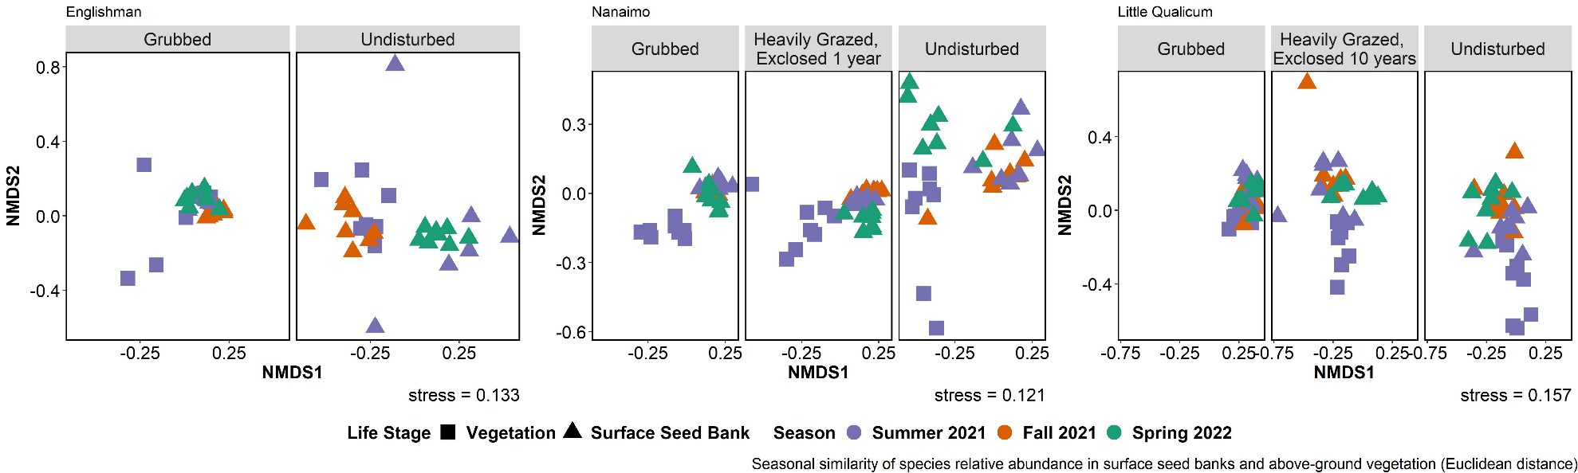

Figure . Surface seed bank species shift in similarity to summer above-ground vegetation depending on season sampled. Trends of similarity to above-ground vegetation are inconsistent between estuaries and disturbance conditions. Year-round surface seed bank composition is most similar to summer above-ground vegetation in grubbed plots in Little Qualicum Estuary. Seed banks appear to have the most seasonally-driven change in undisturbed plots in Englishman and Nanaimo Estuaries. Euclidean distance chosen to square dissimilarity (dissimilarities using Bray’s distance were too small to visualize differences). N = 8 1 m2 vegetation plots or 8 seed bank germination trials per each disturbance condition, estuary, and season.

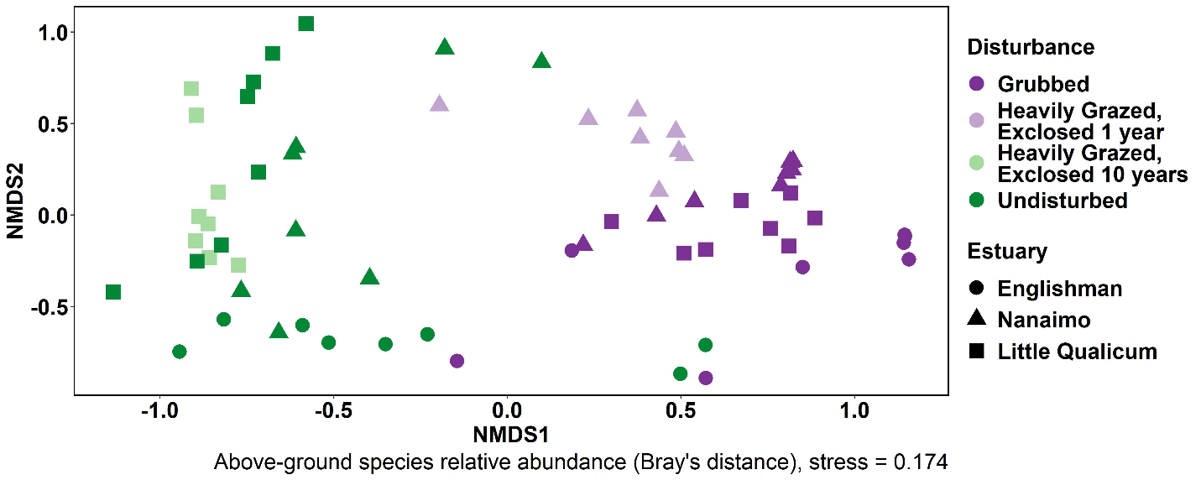

Figure . When above-ground vegetation from all sites and plots are analyzed together, trends show that across estuary, relative abundance of above-ground cover is highly similar in grubbed plots and heavily grazed plots exclosed 1 year, while grazed sites exclosed for 10 years are more similar to undisturbed sites than grubbed or heavily grazed sites exclosed 1 year. (n = (8) 1 m2 plots in each disturbance condition and estuary; stress = 0.174).

Table 1. Beta regression model summary. beta.model <- betareg(prop.abund ~ disturbance + obs + structure + estuary + season , data = ra.model.beta)

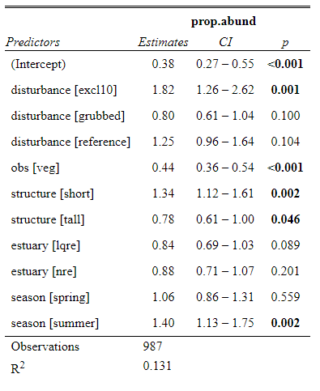

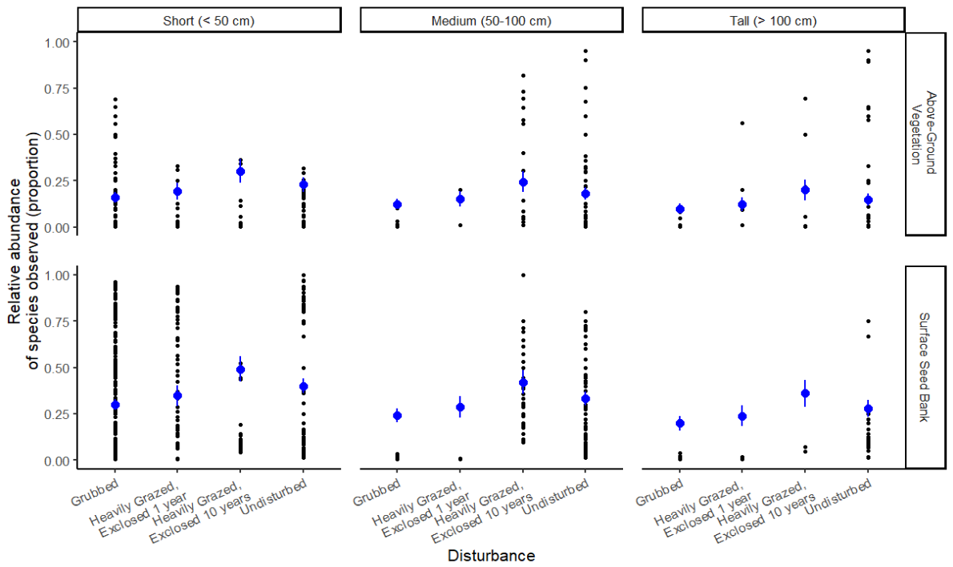

Figure 3. Relative abundance of tall species was less common in the surface seed bank than the above-ground vegetation across all estuaries and seasons of surface seed bank samples. Notably, surface seed banks at sites exclosed 10 years do not recover abundance of tall species comparable to undisturbed sites. Overall, medium-height and tall species were found less frequently found in grubbed and recently exclosed (1-year) sites. Blue points are model predicted values, blue bars are confidence intervals.

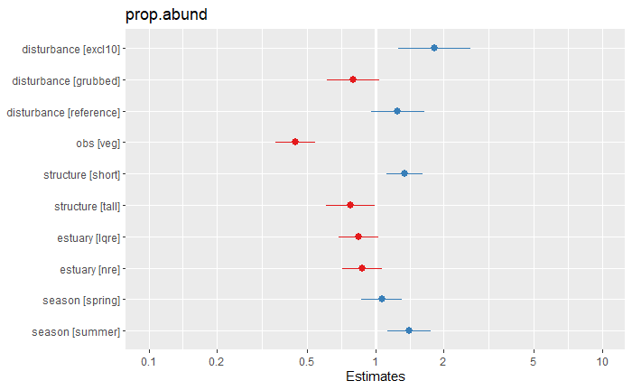

Figure . Effect size of model components

Table 2. PERMANOVA results show significant difference in relative abundance of species found in each disturbance category, estuary, and structural classes, as well as between surface seed bank and vegetation, season of surface seed bank sampling.

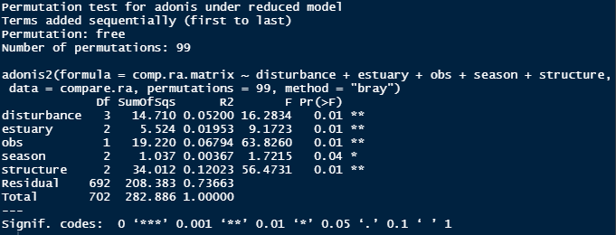

Table 3. Bonferroni-corrected post-hoc test shows relative abundance of above-ground vegetation cover is significantly different between all disturbance categories except for between grubbed sites and sites exclosed for one year (excl1).

