Natural disturbance and intermediate disturbance hypothesis

* In many plant communities, natural disturbance supports niche apportionment/successional dynamics (e.g., forest gap dynamics, fire disturbed landscapes, etc.).
* However, magnitude and/or duration of disturbance may destabilize communities, bringing about an alternative stable state.
  + In estuaries, successional compositional structure may include very short ground covering plants, and taller canopy-forming graminoids.
* Grazing as a form of natural disturbance
  + Grazing disturbance in many ecosystems; degree of disturbance related to herbivore population size.
  + Waterfowl grazing in estuaries is natural, although in the PNW may be exacerbated by introduced populations of Canada geese (*Branta canadensis*, “CAGO”)
  + Define grazing vs. grubbing, and seasonal patterns of this behavior.
  + Following intensive grazing/grubbing, graminoid habitat (densely covered by tall perennials with deep, rhizomatous roots) is converted to mudflat, populated by ruderal species (densely covered by short annuals with shallow, filamentous roots).
    - Recovery over time is possible if geese are excluded, and vegetation is allowed to recover from clonal expansion and/or seed.
    - These recovery mechanisms are dependent on vegetation dynamics

Vegetation dynamics, and facilitation of seed trapping and retention

* Above-ground vegetation facilitates seed trapping.
  + General information about seed bank retention:
    - Vegetation density/complexity facilitating seed trapping
      * Define ‘structural traits’ – pay attention to cover, height, life history strategies.
    - Site structural complexity drives grounding of intertidal hydrochorous dispersal
  + General info about seed production in estuaries
    - How often do plants of different groups produce seed (compared to vegetative clonal growth)
    - goose grazing can increase seed production of grazed plants (citation in press or Kathey Kelsey, personal comm.?)
* However, testing seed bank richness and abundance across different disturbance conditions and seasons has not been tested in Pacific Northwest estuaries. This is important to understand potential availability of native seed in the seed bank to regenerate following disturbance, or to identify potential pathways for invasive species to establish.

Estuary vegetation reproductive mechanisms and seed bank dynamics, focusing on the PNW

* Broadly define estuaries (define salinity regime & plant characteristics).
  + Explain basic geomorphologic details between coastal plain Atlantic estuaries and fjord-restricted PNW.
  + Explain both coasts dominated by perennial herbaceous graminoids, and studies typical focus on the Atlantic coast, although PNW evidence is increasing.
* Mostly perennial graminoids, with some annual species.
  + Several invasive species occur (Brass buttons, others?), however rhizomatous, perennial grasses may be of higher concern because of their ability to form clonal mats that exclude other species.
* Seasonal variation in seed bank richness & abundance
  + Seed sources may be local plants (“seed rain”), or intertidal hydrochory.
    - Most graminoid species disperse seed from the parent plant in autumn
    - Hydrochorous dispersal depends on buoyancy; buoyancy is highest at dispersal from the parent plant.
    - Seeds ‘ground’ following imbibition
  + Winter chilling is important for dormancy release; storms/tidal surges result in higher intertidal dispersal
  + Germination occurs in the late spring/early summer, provided sufficient WoO and competitive space.

The main objective of this research is to understand how vegetation structure affects surface seed bank dynamics in a grazing-disturbed ecosystem. We investigate the following: 1) How does CAGO grazing impact species and Plant Functional Groups (PFGs)? 2) How do species and PFGs respond over time since grazing exclusion? 3) How do seed banks respond over time since grazing exclusion? 4) Is seed bank composition similar to above-ground species composition?

# Methods

## Study area & site history

* Paragraph: describe site histories of Little Qualicum, Englishman, and Nanaimo River Estuaries as Wildlife Management Areas on eastern coast of Vancouver Island and grazing pressure history (Figure 1: map).
  + Historical loss of channel edge habitat, especially by geese grazing, has been characterized over decadal timescales (N. Dawe, Boyd, Buechert, & Stewart, 2011; N. K. Dawe & White, 1982; Kennedy, 1982).
* Invasive, non-migratory Canada geese (*Branta canadensis*, “CAGO”) grazing puts concentrated pressure on vegetation.
  + Repeated grazing pressure during late-spring molt season may exhaust graminoid root resources and result in plant communities not recovering during the growing season. Over time and continued grazing pressure, marsh habitat vegetated by perennial, rhizomatous gramminoids is reduced to mudflat vegetated by annual forbs with filamentous roots.
* Fencing was installed iteratively to physically prevent CAGO from grazing vegetation, hereafter referred to as ‘exclosures.’
  + Exclosures were placed opportunistically where aggressive herbivory was observed to protect remnant marsh platform from further degradation.
    - Exclosures compared in this study were constructed in Little Qualicum River Estuary (LQRE) in 2010 and 2020.
    - Exclosures were constructed in Nanaimo River Estuary (NRE) only in 2020.
    - No exclosures in the Englishman River Estuary (ERE) were used in this study.
* Characterize mixed management over time (Table 1).
  + Exclosures in the Little Qualicum River Estuary constructed in 2020 received transplants within 4 months of study observations. While this alters observed richness of above-ground vegetation, this is not expected to alter seed bank characteristics since no seed dispersal occurred during the study period.

## Plant functional groups & above-ground vegetation measures

* Functional groups are defined according to annual/perennial life history (indicator of species persistence in the site), fibrous/rhizomatous rooting system (importance to sediment consolidation), and forb/graminoid life history (majority of species in PNW estuaries are graminoids, but forbs provide floristic and detrital nutrient diversity).
  + This results in six functional groupings, plus ‘unvegetated’ cover in observations of above-ground vegetation cover.
* Two 1 m2 plots were sub-sampled in each age-class replicate (N = 4, except 2016 exclosures in ERE, N = 3). Species were identified to lowest taxonomic level (Hitchcock & Cronquist, 1973), and above-ground cover was estimated to the nearest 2% of plot cover. Species present with less than 2% cover but 20 or more individuals in the plot were recorded as 1%. Species with less than 2% cover but 2-20 individuals were recorded as 0.5% cover, and species presence of a single individual were recorded as 0.05% cover.
* When above ground cover exceeded 100% due to canopy structure, total abundance was was standardized to 100%.

# Results

Table . Grazing disturbance conditions in the Little Qualicum River (LQRE), Englishman (ERE), and Nanaimo (NRE) Estuaries resulted in conversion of vegetated marsh to partially or fully grubbed mudflats; exclosures were installed at various times to prevent further degradation into the marsh platform. Some limited mixed management includes transplants in the Little Qualicum River Estuary (1-year post-disturbance).

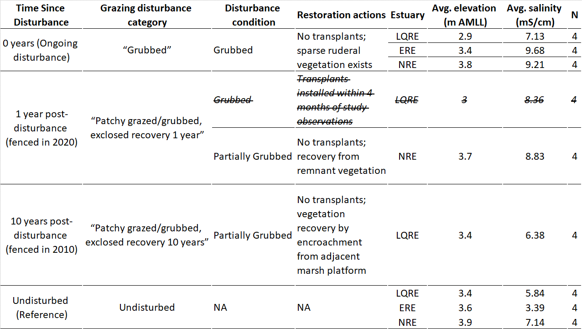

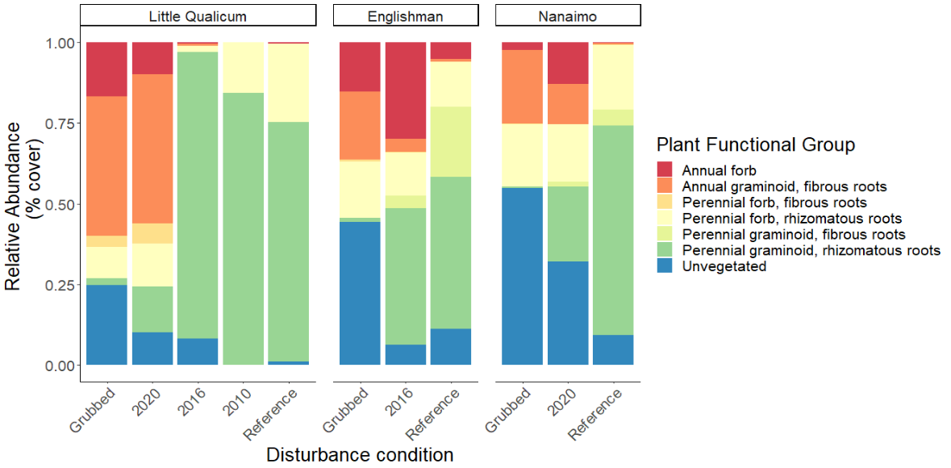

Figure . Annual life histories dominate above-ground cover at grubbed sites in the Little Qualicum River Estuary, while similar disturbance at Nanaimo Estuary results in bare, unvegetated soil. Perennial, rhizomatous graminoids overwhelmingly dominate patches within five years of herbivory release in Little Qualicum, and both estuaries are dominated by this functional group at reference sites. (n = 4 per age class and estuary, except Englishman 2016, n = 3).

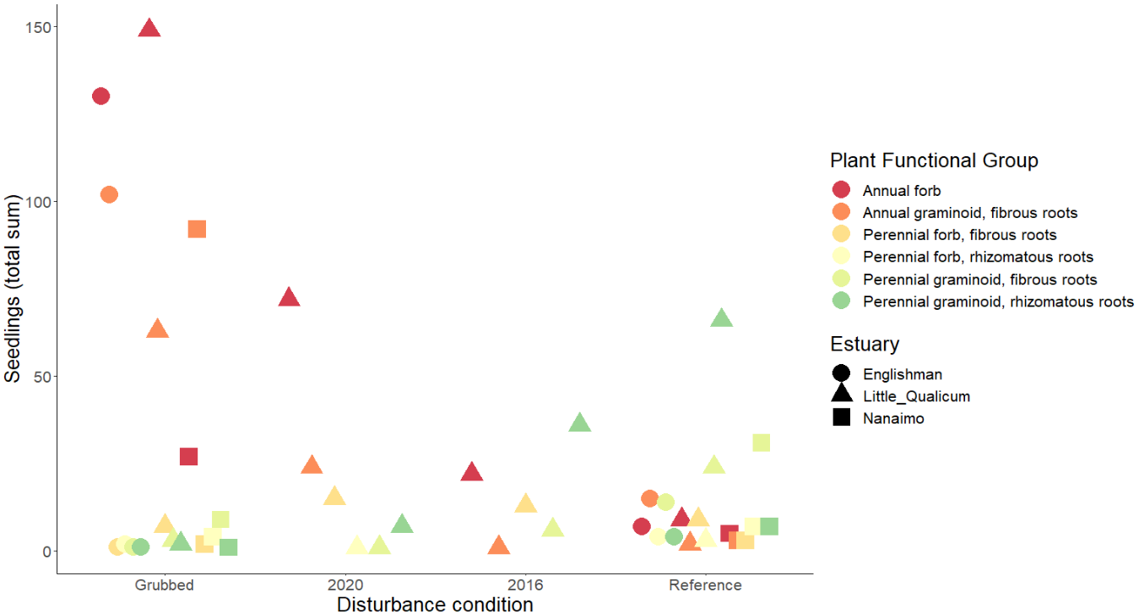

Figure . Similar to above-ground cover, annual species dominate seed bank at grubbed sites, and decrease in prevalence over time since herbivory release. Rhizomatous, perennial graminoids become increasingly prevalent in the seed bank over time, although they are not as prevalent in the Nanaimo Estuary. Results from pilot germination test in 0.02 m2 trays (n = 6 per age class and estuary); space constraints omitted 2010 seed banks for Little Qualicum River Estuary and 2020 seed bank for Nanaimo and Englishman were not tested; seed bank samples for 2016 do not exist in Nanaimo. Seed bank sample for 2016 seed banks in Englishman are not available due to site history misunderstanding at time of sampling.

# Literature Cited

Dawe, N., Boyd, S., Buechert, R., & Stewart, A. (2011). Recent, significant changes to the native marsh vegetation of the Little Qualicum River estuary, British Columbia; a case of too many Canada Geese (*Branta canadensis*)? *Journal of the British Columbia Field Ornithologists*, *21*, 11–31.

Dawe, N. K., & White, E. R. (1982). Some aspects of the vegetation ecology of the Little Qualicum River estuary, British Columbia. *Canadian Journal of Botany*, *60*, 1447–1460.

Kennedy, K. A. (1982). *Plant communities and their standing crops on estuaries of the east coast of Vancouver Island*. University of British Columbia, Vancouver, BC, Canada.