# Introduction

* Broader theory:
  + Hierarchy of predictability and variability in restoration, where strong environmental filters limit variability of predictable recovery trajectories (Brudvig et al., 2017).
  + Stable (resilient) communities have high functional and taxonomic redundancy (Török & Helm, 2017; others).
  + Disturbance destabilizes communities, and recovery to a functional state (analogous to historical function/condition) is desirable in restoration, especially recovery of natural processes following disturbance release.
* Grazing as a form of natural disturbance
  + Literature review of how grazing shifts above-ground composition, and subsequently impacts seed bank composition.
  + Mechanisms of vegetation as a source of local seed rain, and trapping/retaining seeds at the site.
* Unmitigated goose grazing in estuaries results in conversion of vegetated habitat to grubbed mudflat.
  + Populations of resident Canada geese (*Branta canadensis,* hereafter CAGO) have been artificially inflated due to a breeding program to promote hunting tourism in the 1970s.
  + Populations have exceeded carrying capacity of the estuaries on eastern Vancouver Island, resulting in grazing impacts that destroy marsh habitat.
  + Explain that grubbing results in removal of rhizomatous graminoid species, leaving only sparse, ruderal vegetation.
  + While mudflats are ecologically productive, they do not provide the same ecosystem function (e.g., erosion resistance) as rhizomatous vegetation.
* Strong environmental filters in estuaries (elevation/inundation) may prevent passive recovery of species diversity after grazing pressure is released, indicating altered ecosystem resilience.
  + Impacted patches may rely on clonal expansion from adjacent patches because recruitment from seed bank is not possible, either due to altered abiotic conditions (change in elevation), or loss of propagule input from the seed bank.
* If resilience is high, historically similar functional vegetation should recolonize into the mudflat to restore the site following grazing release.
  + Some functional groups may be slower to recover, arresting recovery until expansion occurs from remnant or adjacent individuals.

## Questions

* I wanted to know: **how are richness, evenness, and functional structure of estuary above-ground vegetation and surface seed bank affected by time since release of grazing disturbance**?
  + Does functional richness & evenness of vegetation recover to the same functional richness & evenness of undisturbed (reference) sites following grazing pressure release?
    - I expect that the longer sites have had exclusion, the more closely the above-ground and seed bank richness/evenness will resemble undisturbed conditions.
  + How closely does seed bank match above-ground vegetation diversity across a gradient of grazing pressure release? (Do estuary seed banks represent a source of species diversity compared to above ground vegetation?)
    - I expect that the longer sites have been excluded, the more closely seed banks will match above-ground vegetation.
    - Because there is more opportunity for seed dispersal in unvegetated (grubbed) sites, I expect the grubbed sites to have the greatest seed bank dissimilarity compared to above-ground vegetation.

# Methods

## Study area & sampling

* Paragraph: site histories of Little Qualicum and Nanaimo River Estuaries as Wildlife Management Areas and grazing pressure history (map).
* Fencing was installed iteratively to physically prevent CAGO from grazing vegetation, hereafter referred to as ‘exclosures.’
  + Exclosures were placed opportunistically where aggressive herbivory was observed to protect remnant marsh platform from further degradation.
* Longest history of exclosure is in the Little Qualicum River Estuary (10 years). Explain the history of mixed management over time (Table 1).
  + Exclosures in the Little Qualicum River Estuary constructed 1 year before this study began received transplants within 4 months of study observations. While this alters observed richness of above-ground vegetation, this is not expected to alter seed bank characteristics since no seed dispersal occurred during the study period.
  + Three exclosures in Englishman River Estuary were constructed 5 years before this study, however remnant vegetation and inclusion of transplants is highly variable, and exact locations vegetation history is unknown.
  + Exclosure sites were selected to represent consistent conditions within the exclosure: fully grubbed, partially grubbed. Undisturbed sites are not protected by an exclosure.

Table 1. Grazing disturbance conditions in the Little Qualicum River (LQRE), Englishman (ERE), and Nanaimo (NRE) Estuaries resulted in conversion of vegetated marsh to partially or fully grubbed mudflats; exclosures were installed at various times to prevent further degradation into the marsh platform. Some limited mixed management includes transplants in the Little Qualicum River Estuary.

|  |  |  |  |  |  |
| --- | --- | --- | --- | --- | --- |
| **Time Since Disturbance** | **Estuary** | **Disturbance condition** | **Revegetation status** | **Avg. elevation** | **N** |
| 0 years (Ongoing disturbance) | LQRE | Grubbed | No transplants; sparse ruderal vegetation exists | 2.9 | 4 |
| ERE | 3.4 | 4 |
| NRE | 3.8 | 4 |
| 1 year post-disturbance (fenced in 2020) | LQRE | Grubbed | Transplants installed within 4 months of study observations | 3.0 | 4 |
| ERE | Grubbed | No transplants; recovery from remnant vegetation | 3.5 | 1 |
| NRE | Partially Grubbed | No transplants; recovery from remnant vegetation | 3.7 | 4 |
| 5 years post-disturbance | LQRE | Grubbed | No transplants; vegetation recovery by encroachment from adjacent marsh platform | 3.1 | 4 |
| ERE | Partially Grubbed | Limited transplants in two of three exclosures (unknown placement); majority of recovery from remnant vegetation | 3.5 | 3 |
| 10 years post-disturbance | LQRE | Partially Grubbed | No transplants; vegetation recovery by encroachment from adjacent marsh platform | 3.4 | 4 |
| Undisturbed Reference | LQRE | NA | NA | 3.4 | 4 |
| ERE | 3.6 | 4 |
| NRE | 3.9 | 4 |

## Analysis: above-ground vegetation and seed bank richness

* Compare vegetation and seed bank richness & evenness among exclosure age classes (sites) using a generalized linear mixed model.
  + Estuary and exclosure age (site) were fixed effects, and the inherent site disturbance (grubbed, partially grubbed, undisturbed) and sub-sampled plots within sites were treated as random effects.
  + Response variables were total richness and evenness, and richness/evenness of native and exotic species.
* Vegetation and seed bank composition among exclosure age classes were assessed by PERMANOVA, using species evenness data with Bray’s distance at the plot level.

## Comparison between above-ground vegetation and soil seed bank composition

* PERMANOVA using species presence data at the plot level.
* Visualize above-ground vs. seed bank community data by NMDS based on species presence with Bray’s distance.

## Analysis Plan (notes to self)

* Analysis plan largely mirrors (Rago, Urretavizcaya, Orellana, & Defossé, 2020)
* Czekanowski Similarity Index to compare species composition & cover similarity within and between sites by year used in (Thom, Zeigler, & Borde, 2002)
* General germination protocol see (Hopfensperger, Engelhardt, & Lookingbill, 2009)

# Results

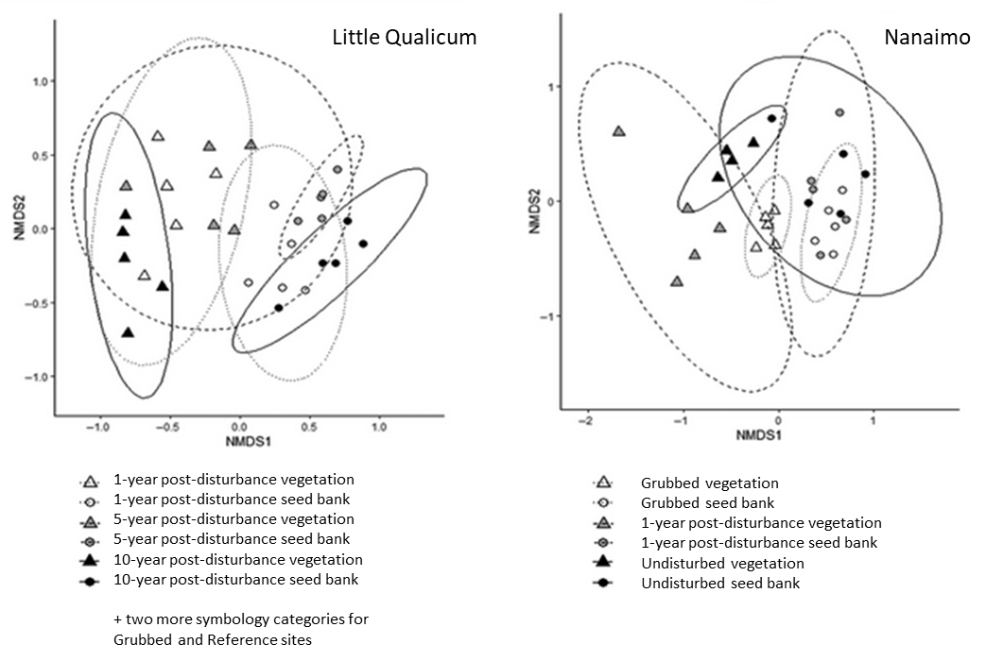

Figure 2. Example figure of mock results, modified from Fig. 4 in Rago et al., 2020. Because figure is not based on actual data from the Vancouver Island Estuaries, not all disturbance conditions for Little Qualicum River are represented in this figure. Englishman River mock results omitted.

# Discussion

Answer the questions:

* I expect that the longer sites have been excluded, the more closely the above-ground and seed bank richness/evenness will resemble undisturbed conditions.
* I expect that the longer sites have been excluded, the more closely seed banks will match above-ground vegetation.
* Because there is more opportunity for seed dispersal in unvegetated (grubbed) sites, I expect the grubbed sites to have the greatest seed bank dissimilarity compared to above-ground vegetation.

Anticipated discussion points:

* If above-ground vegetation richness/evenness recover towards the reference condition, this builds support that protection of remnant habitat is an effective strategy for recovering structural diversity and function of marsh vegetation.
* If seed banks show dearth of diversity along recovery trajectory, this builds support for transplanting activities to restore functional diversity.
  + If seed banks show increased diversity at any point along the recovery trajectory, this opens new questions to test whether species recover naturally from seed bank, or if there are additional limitations on recruitment.

Broader importance:

* Recovery of these habitats is important for supporting populations of juvenile salmonids, and for coastal resilience to sea level rise.

# Literature Cited

Brudvig, L. A., Barak, R. S., Bauer, J. T., Caughlin, T. T., Laughlin, D. C., Larios, L., … Zirbel, C. R. (2017). Interpreting variation to advance predictive restoration science. *Journal of Applied Ecology*, *54*, 1018–1027.

Hopfensperger, K. N., Engelhardt, K. a. M., & Lookingbill, T. R. (2009). Vegetation and seed bank dynamics in a tidal freshwater marsh. *Journal of Vegetation Science*, *20*, 767–778.

Rago, M. M., Urretavizcaya, M. F., Orellana, I. A., & Defossé, G. E. (2020). Strategies to persist in the community: Soil seed bank and above-ground vegetation in Patagonian pine plantations. *Applied Vegetation Science*, *23*, 254–265.

Thom, R. M., Zeigler, R., & Borde, A. B. (2002). Floristic Development Patterns in a Restored Elk River Estuarine Marsh, Grays Harbor, Washington. *Restoration Ecology*, *10*, 487–496.

Török, P., & Helm, A. (2017). Ecological theory provides strong support for habitat restoration. *Biological Conservation*, *206*, 85–91.