# Introduction

* Natural disturbance destabilizes plant communities; passive recovery of habitat and processes towards a functional state is desirable in conservation & restoration.
  + Passive restoration can be facilitated by disturbance release; resilient communities should recover without active restoration intervention.
  + When conservation of a specific community type is desirable for habitat value, “successful” recovery may target historical conditions (if known), or functionally analogous communities.
    - Plant function can be characterized in many ways, however these may be defined by life cycle (annual/perennial), root structure (rhizomatous/filamentous), or cladistic (graminoid/forb).
  + Properties of resilient communities include high functional and taxonomic redundancy (Török & Helm, 2017; others).
    - ***Is it worth*** linking importance of observing natural recovery to the context of predicting outcomes, especially when strong environmental filters will limit variability of recovery trajectories (Brudvig et al., 2017)?
* Grazing as a form of natural disturbance
  + Literature review of how grazing shifts above-ground composition, and subsequent loss of above-ground vegetation limits below-ground (seed bank) composition.
    - Above-ground vegetation acts as a source of local seed rain inputs to the seed bank, and trapping/retaining non-locally dispersed (ie, not from local seed rain) seeds at the site.
  + Intense grazing by geese leads to grubbing, which is the total loss of above- and below-ground vegetation, completely removing the species from the site.
* Unmitigated grazing, such as by geese in estuaries, results in conversion of plant community types. In estuaries in the Pacific Northwest, rhizomatous graminoid communities are grubbed away and converted to sparsely vegetated mudflat.
  + Grubbing results in removal of rhizomatous graminoid species, leaving sparse, ruderal vegetation that does not have the same above-ground structure to trap sediments/reduce erosion stress, or deep root structure to consolidate sediments.
    - While mudflats are ecologically productive, they do not provide the same ecosystem function (e.g., erosion resistance) as rhizomatous vegetation.
    - ***Is it useful*** to discuss threshold responses: after a sufficient grazing disturbance, the habitat becomes more vulnerable to other disturbance forces, such as tidal flow (I don’t measure this)
* Passive recovery may be achieved by clonal expansion from adjacent patches, or by recruitment from the seedbank.
  + However, recruitment from seed bank is not possible, either due to altered abiotic (elevation) conditions that limit the recruitment niche (Lane, 2022), or loss of propagule input from the seed bank (Leck, Bertness, others).
* Passive recovery is desirable from a land management (economic) perspective, however the resilience of these habitats to recover towards an undisturbed functional condition has not been measured.
  + Moreover, understanding whether the seed bank recovers functional diversity along a similar trajectory as above-ground vegetation may reveal whether resilient recovery of seed banks requires longer timescales.
    - This is important to infer biodiversity recruitment limitation from the seed bank.
* The main objective of this study is to determine whether passive recovery achieves functional restoration towards a reference state within a limited timeframe, and whether recovery of the seed bank can be expected along a parallel timeframe. I use goose herbivory exclosures constructed in three estuaries on Vancouver Island as an experimental chronosequence of passive recovery to answer the following questions:

1. Does resilience of above-ground communities lead to recovery of rhizomatous, perennial, graminoid cover towards a reference state within five years since grazing disturbance release?
   1. If resilience is high, I expect above-ground functional cover will not be significantly different from functional cover of undisturbed sites within five years.
      1. **ANALYSIS**: GLM of above-ground cover of functional groups
2. Do seed banks show resilience by recovering functional diversity and abundance within five years since grazing disturbance release?
   1. I expect that the longer sites have been released from grazing disturbance, seed bank diversity and abundance should approach the same diversity and abundance as undisturbed conditions.
      1. **ANALYSIS**: PERMANOVA, using germination abundance of functional groups.
3. Do seed banks show the same resilience in recovery timelines of total diversity as their above-ground community counterparts?
   1. Because seed rain inputs will be dependent on above-ground cover, I expect seed bank diversity to approach reference condition at a slower rate than above-ground clonal communities.
      1. **ANALYSIS**: GLM, visualized with NMDS of species presence to show ordination distance between above-ground and seed bank diversity.

# Methods

## Study area & site history

* Paragraph: describe site histories of Little Qualicum, Englishman, and Nanaimo River Estuaries as Wildlife Management Areas on eastern coast of Vancouver Island and grazing pressure history (Figure 1: map).
  + Historical loss of channel edge habitat, especially by geese grazing, has been characterized over decadal timescales (Dawe, Boyd, Buechert, & Stewart, 2011; Dawe & White, 1982; Kennedy, 1982).
* Canada geese (*Branta canadensis*, “CAGO”) are native, but introduced populations and grazing phenology puts concentrated pressure on vegetation.
  + CAGO as historically restricted to the northern end of Vancouver Island, but greater regional population size the result of 1970s artificial breeding program, which resulted in increased pressure on available habitat (N. K. Dawe & Stewart, 2010).
  + Repeated grazing pressure during late-spring molt season may exhaust graminoid root resources and result in plant communities not recovering during the growing season. Over time and continued grazing pressure, marsh habitat vegetated by perennial, rhizomatous gramminoids is reduced to mudflat vegetated by annual forbs with filamentous roots.
* Fencing was installed iteratively to physically prevent CAGO from grazing vegetation, hereafter referred to as ‘exclosures.’
  + Exclosures were placed opportunistically where aggressive herbivory was observed to protect remnant marsh platform from further degradation.
    - Exclosures were constructed in Little Qualicum River Estuary (LQRE) in 2010, 2016, and 2020.
    - Exclosures were constructed in Englishman River Estuary (ERE) in 2016 and 2020.
    - Exclosures were constructed in Nanaimo River Estuary (NRE) only in 2020.
* Characterize mixed management over time (Table 1).
  + Exclosures in the Little Qualicum River Estuary constructed in 2020 received transplants within 4 months of study observations. While this alters observed richness of above-ground vegetation, this is not expected to alter seed bank characteristics since no seed dispersal occurred during the study period.
  + Three exclosures in Englishman River Estuary were constructed in 2016, however remnant vegetation and inclusion of transplants is highly variable, and exact locations vegetation history is unknown.

## Plant functional groups & above-ground vegetation measures

* Functional groups are defined according to annual/perennial life history (indicator of species persistence in the site), fibrous/rhizomatous rooting system (importance to sediment consolidation), and forb/graminoid life history (majority of species in PNW estuaries are graminoids, but forbs provide floristic and detrital nutrient diversity).
  + This results in six functional groupings, plus ‘unvegetated’ cover in observations of above-ground vegetation cover.
* Two 1 m2 plots were sub-sampled in each age-class replicate (N = 4, except 2016 exclosures in ERE, N = 3). Species were identified to lowest taxonomic level (Hitchcock & Cronquist, 1973), and above-ground cover was estimated to the nearest 2% of plot cover. Species present with less than 2% cover but 20 or more individuals in the plot were recorded as 1%. Species with less than 2% cover but 2-20 individuals were recorded as 0.5% cover, and species presence of a single individual were recorded as 0.05% cover.
* When above ground cover exceeded 100% due to canopy structure, total abundance was was standardized to 100%.

Table 1. Chronosequence of time since grazing disturbance in the Little Qualicum River (LQRE), Englishman (ERE), and Nanaimo (NRE) Estuaries resulted in conversion of vegetated marsh to partially or fully grubbed mudflats; exclosures were installed at various times to prevent further degradation into the marsh platform. Some limited mixed management includes transplants in the Little Qualicum River Estuary.

|  |  |  |  |  |  |
| --- | --- | --- | --- | --- | --- |
| **Time Since Disturbance** | **Estuary** | **Disturbance condition** | **Restoration actions** | **Avg. elevation** | **N** |
| 0 years (Ongoing disturbance) | LQRE | Grubbed | No transplants; sparse ruderal vegetation exists | 2.9 | 4 |
| ERE | 3.4 | 4 |
| NRE | 3.8 | 4 |
| 1 year post-disturbance (fenced in 2020) | LQRE | Grubbed | Transplants installed within 4 months of study observations | 3.0 | 4 |
| NRE | Partially Grubbed | No transplants; recovery from remnant vegetation | 3.7 | 4 |
| 5 years post-disturbance | LQRE | Grubbed | No transplants; vegetation recovery by encroachment from adjacent marsh platform | 3.1 | 4 |
| ERE | Partially Grubbed | Limited transplants in two of three exclosures (unknown placement); majority of recovery from remnant vegetation | 3.5 | 3 |
| 10 years post-disturbance | LQRE | Partially Grubbed | No transplants; vegetation recovery by encroachment from adjacent marsh platform | 3.4 | 4 |
| Undisturbed (Reference) | LQRE | NA | NA | 3.4 | 4 |
| ERE | 3.6 | 4 |
| NRE | 3.9 | 4 |

## Analysis plan

1. Does resilience of above-ground communities lead to recovery of rhizomatous, perennial, graminoid cover towards a reference state within five years since grazing disturbance release?
   1. **ANALYSIS**: GLM of above-ground cover of functional groups
      1. Estuary, exclosure age, and undisturbed sites treated as categorical fixed effects; inherent site disturbance (grubbed, partially grubbed) and sub-sampled plots within sites treated as random effects. Response variable of rhizomatous perennial graminoid cover.
2. Do seed banks show resilience by recovering functional diversity and abundance within five years since grazing disturbance release?
   1. **ANALYSIS**: PERMANOVA, using germination abundance of functional groups.
      1. Suggested distance measures may be Bray’s at the plot level, or distance of each plot to centroid of reference.
3. Do seed banks show the same resilience in recovery timelines of total diversity as their above-ground community counterparts?
   1. **ANALYSIS**: GLM, visualized with NMDS of species presence to show ordination distance between above-ground and seed bank diversity.
      1. Same fixed/random effects as 1a, but response is species presence/absence.

# Results

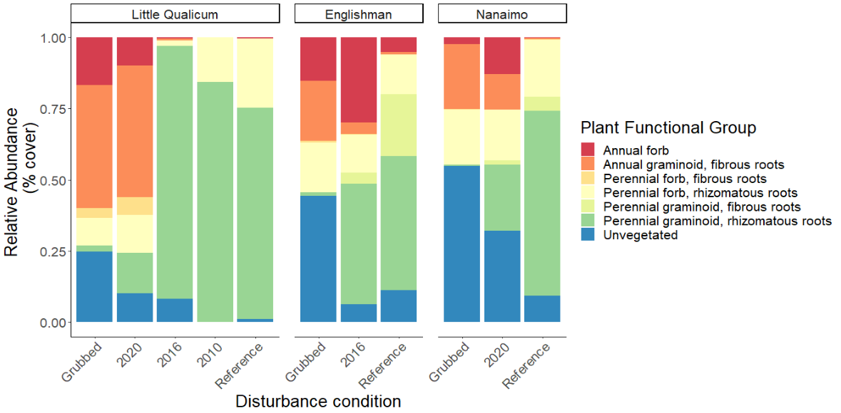

Figure . Annual life histories dominate above-ground cover at grubbed sites in the Little Qualicum River Estuary, while similar disturbance at Nanaimo Estuary results in bare, unvegetated soil. Perennial, rhizomatous graminoids overwhelmingly dominate patches within five years of herbivory release in Little Qualicum, and both estuaries are dominated by this functional group at reference sites. (n = 4 per age class and estuary, except Englishman 2016, n = 3).

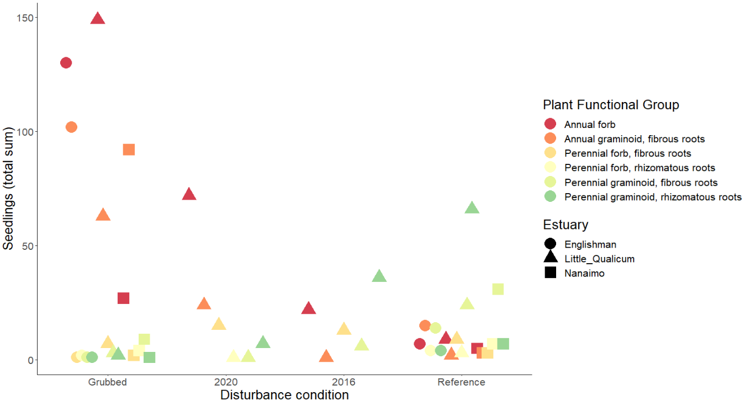

Figure . Similar to above-ground cover, annual species dominate seed bank at grubbed sites, and decrease in prevalence over time since herbivory release. Rhizomatous, perennial graminoids become increasingly prevalent in the seed bank over time, although they are not as prevalent in the Nanaimo Estuary. Results from pilot germination test in 0.02 m2 trays (n = 6 per age class and estuary); space constraints omitted 2010 seed banks for Little Qualicum River Estuary and 2020 seed bank for Nanaimo and Englishman were not tested; seed bank samples for 2016 do not exist in Nanaimo. Seed bank sample for 2016 seed banks in Englishman are not available due to site history misunderstanding at time of sampling.

# Discussion

1. Answer the questions
2. What broader pattern has been observed, and what does this mean for passive restoration?
   1. If above-ground functional cover recovers towards the reference condition, this builds support that protection of remnant habitat is an effective strategy for recovering structural diversity and function of marsh vegetation.
   2. If seed banks show a dearth of diversity along a recovery trajectory, or lower species diversity compared to above-ground vegetation (i.e., ordination distance on NMDS plot), this builds support for transplanting activities to restore functional biodiversity.
   3. If seed banks show increased diversity at any point along the recovery trajectory, this opens new questions to test whether species recover naturally from seed bank, or if there are additional limitations on recruitment.

Broader importance:

* Recovery of these habitats is important for supporting populations of juvenile salmonids, and for coastal resilience to sea level rise.

# Literature Cited

Brudvig, L. A., Barak, R. S., Bauer, J. T., Caughlin, T. T., Laughlin, D. C., Larios, L., … Zirbel, C. R. (2017). Interpreting variation to advance predictive restoration science. *Journal of Applied Ecology*, *54*, 1018–1027.

Dawe, N., Boyd, S., Buechert, R., & Stewart, A. (2011). Recent, significant changes to the native marsh vegetation of the Little Qualicum River estuary, British Columbia; a case of too many Canada Geese (Branta canadensis)? *Journal of the British Columbia Field Ornithologists*, *21*, 11–31.

Dawe, N. K., & Stewart, A. C. (2010). The Canada Goose (Branta canadensis) on Vancouver Island, British Columbia. *British Columbia Birds*, *20*, 18.

Dawe, N. K., & White, E. R. (1982). Some aspects of the vegetation ecology of the Little Qualicum River estuary, British Columbia. *Canadian Journal of Botany*, *60*, 1447–1460.

Hitchcock, C. L., & Cronquist, A. (1973). *Flora of the Pacific Northwest, an illustrated manual*. Seattle and London: University of Washington Press.

Kennedy, K. A. (1982). *Plant communities and their standing crops on estuaries of the east coast of Vancouver Island*. University of British Columbia, Vancouver, BC, Canada.

Lane, S. (2022). Using marsh organs to test seed recruitment in tidal freshwater marshes. *Applications in Plant Sciences*, *10*, in press.

Török, P., & Helm, A. (2017). Ecological theory provides strong support for habitat restoration. *Biological Conservation*, *206*, 85–91.