# Main Objective, Question, and Hypotheses

The main objective of this study is to assess whether grazing exclusion allows habitat to passively recover to a ‘reference’ condition. We wanted to know whether species compositional abundance in the above-ground vegetation is similar to that found in the surface seed bank at discrete timepoints since disturbance, and whether exotic species compositional abundance may be affecting recovery trajectories.

Traditional succession models would say the most competitive species will increasingly dominate the plant community as time since disturbance increases. This would particularly be the case in a clonal ecosystem, where recovery is driven by species spreading clonally from adjacent undisturbed sites. If succession is happening the we expect:

1. Above-ground vegetation at 10-year old exclosures will be more similar to reference vegetation than 1-year old exclosures (regardless of seed inputs).
   1. Alternatively, novel disturbance and novel seed inputs lead to alternative succession pathways, where new competitors from seed inputs derail the "slow encroachment" of the clonal dominant from the neighboring intact site.
2. Above-ground vegetation in recently disturbed sites will be highly similar to seed inputs than older disturbance vegetation similarity to seed, or reference vegetation similarity to seed.

We focus our analysis on the key species group of tall, perennial graminoids (> 10 cm tall), as these are the dominant species present in undisturbed sites within the estuaries sampled.

Story around models:

1. ~~TPG sig recovers in excl10 (glm p = )~~
   * ~~Indicator analysis shows this is driven by AGST~~
   * ~~AGST is sig greater in excl10 than undist. (glm p = )~~
   * ~~Other TPG species compared to reference ??~~
2. Seed bank of desired native sp slow to recover: CALY relabund in seed bank sig lower in all disturbance than undist. (glm p = )
   * Seed bank is dissimilar from AG veg in excl1, excl10 following dist (NMDS, anosim).

# Results

A total of 16 species from as many genera were found in above-ground vegetation (Table 1), and 22 species from 18 genera in the surface seed bank (Table 2).

We expected competitively dominant species would characterize the above-ground plant community with increasing time since disturbance. We found relative cover abundance of tall, perennial graminoids was significantly lower in the grubbed sites (p = 0.0236), and approaching significantly lower abundance in the 1-year old exclosures (p = 0.0906), as compared to undisturbed sites (Figure 1). Tall, perennial graminoids in 10-year old exclosures were not significantly different from undisturbed sites, supporting our hypothesis that these competitively dominant species would passively recover natural succession after grazing disturbance.

However, relative cover abundance of exotic species was significantly greater in grubbed (p = 9.65e-4) and 10-year old exclosures (p = 1.91e-14) than in undisturbed sites. Indicator species analysis showed above-ground cover of exotic forb *Cotula coronopifolia* defined grubbed sites in both estuaries (Table 3). Exotic grass *Agrostis stolonifera* drove compositional abundance in 10-year old exclosures (p = 0.0001) in the Little Qualicum Estuary, and had significantly greater cover abundance than in undisturbed sites (p = 6.67e-05).

Species-specific responses are useful to understand impacts to native assemblages of key functional group, tall perennial graminoids. Two native species in this functional group, *C. lyngbyei* and *Juncus balticus* characterized undisturbed sites by indicator species analysis, in addition to exotic *A. stolonifera* characterizing the 10-year old exclosures (Table 3). Relative cover abundance of keystone native species *C. lyngbyei* was significantly lower in grubbed sites (p = 0.0011) and 10-year old exclosures (p = 0.018), and nearly significantly lower in 1-year old exclosures (p = 0.063) than in undisturbed sites.

While cover of *C. lyngbyei* is significantly lower in 10-year old exclosures, seemingly by the competitive presence of *A. stolonifera*, cover of *J. balticus* is not. This in part may be due to the relative abundance of seed of these species in the seed bank.

* CALY has very low abundance, JUBA greater (how much greater than AGST?)
* Transition into general patterns of seed bank similarity (seed bank:AG veg, seed bank across disturbance categories)

Seed bank responses

* Moreover, seed abundance of *A. stolonifera* in both 10-year old exclosures and undisturbed sites in Little Qualicum Estuary was significantly greater than that of *C. lyngbyei* (glm p-value).
* Native keystone species *C. lyngbyei* was nearly absent in the surface seed bank at both estuaries (Figure 3).

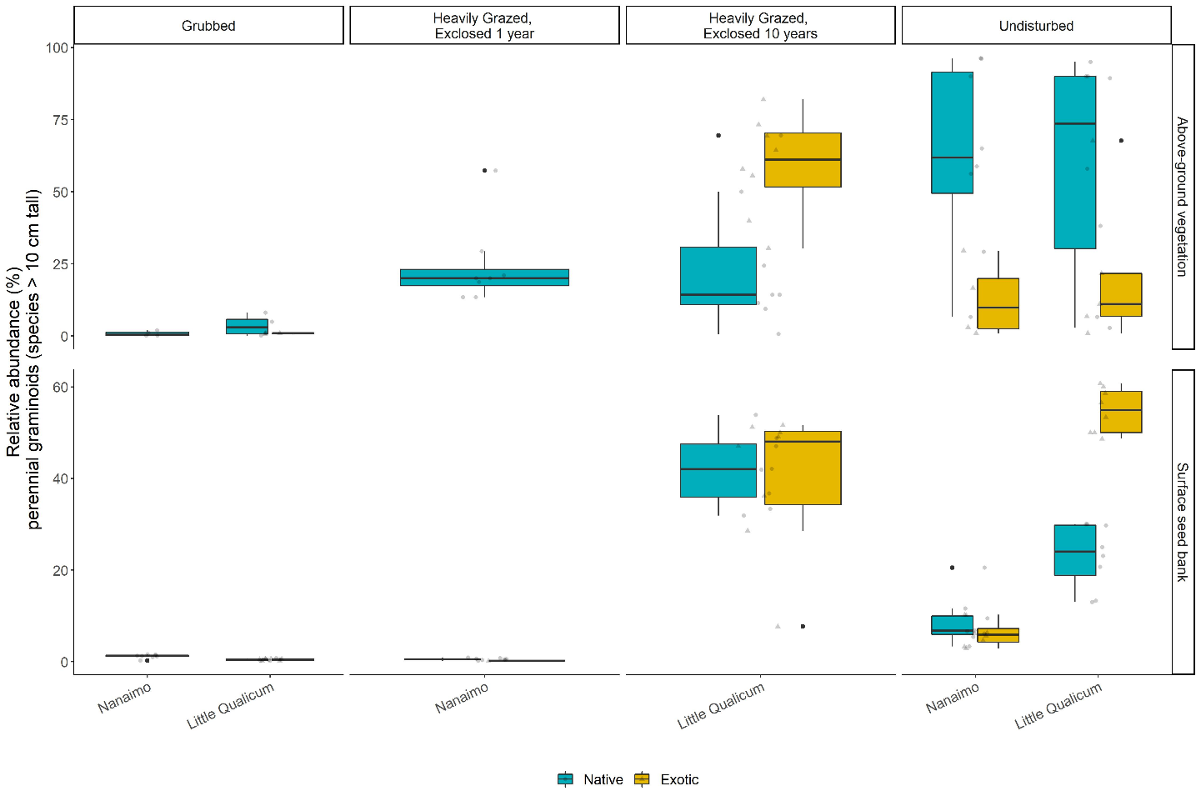

Figure 1. Above-ground cover abundance of key functional group ‘perennial graminoids (> 10 cm)’ is not significantly different from undisturbed (reference) sites after 10 years. However, indicator species analysis reveals this above-ground cover is dominated by exotic graminoid species Agrostis stolonifera. Moreover, seed bank abundance of tall, perennial graminoids is significantly higher in 10-year old exclosures compared to other disturbance conditions, including undisturbed (reference) sites. Notably, there is nearly equal abundance of exotic and native graminoid seed in 10-year old exclosures, and significantly greater representation of exotic than native graminoid seed in undisturbed sites in Little Qualicum Estuary.

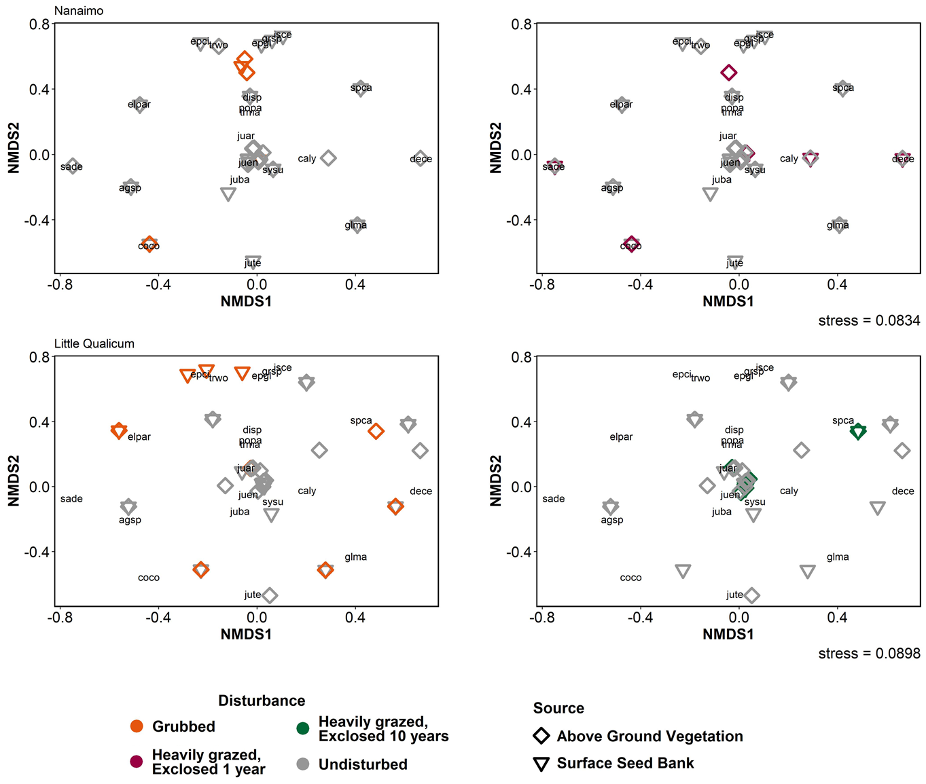

Figure 2. Similarity of above-ground vegetation relative abundance across disturbance conditions in Nanaimo and Little Qualicum River Estuaries (Euclidean distance). Species abbreviations may be found in Supplemental table X.

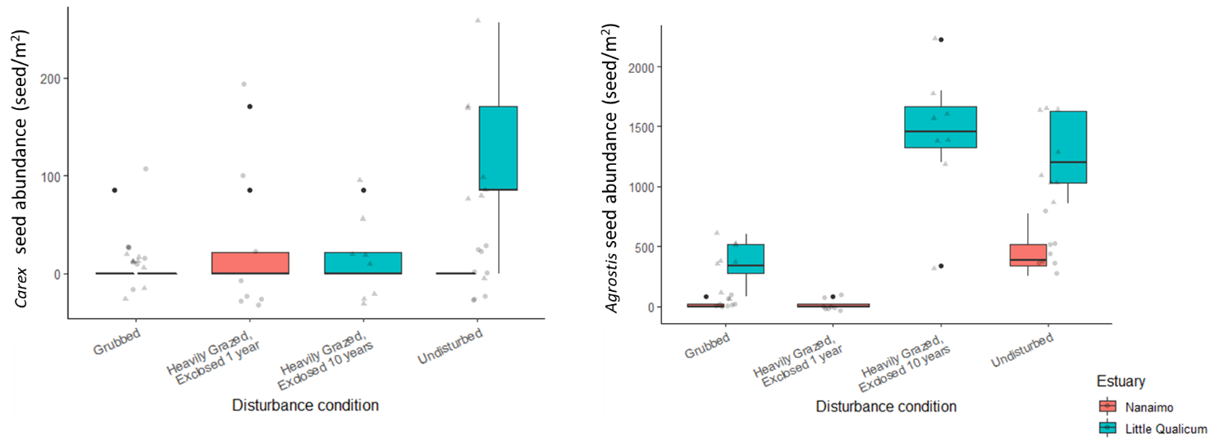

Figure 3. Mean abundance of sedge species Carex lyngbyei is nearly absent in all grazing disturbance conditions, and in Undisturbed sites in Nanaimo Estuary. Mean seed abundance in Undisturbed sites in Little Qualicum Estuary are significantly greater, however they are less than 1/10th of seed abundance of exotic species Agrostis stolonifera.

# Discussion

* What does this study say about succession & recovery of competitively dominant species?
* Ecological memory/redundancy
  + Presence in seed bank (JUBA/AGST), but different outcomes in AG cover (JUBA, excl10)
    - JUBA vs. AGST points to competitive exclusion
  + Absence in seed bank (CALY), reflected in AG cover
    - seed limitation of CALY + competitive exclusion = risk of ecological memory loss.

# Supplemental

Table 1. Frequency (%) of species found in above-ground vegetation plot replicates for Nanaimo and Little Qualicum River Estuaries, combined, ranked by greatest frequency found in undisturbed plots.

|  |  |  |  |  |
| --- | --- | --- | --- | --- |
| **Species** | **Grubbed** | **Exclosed 1 Year** | **Exclosed 10 years** | **Undisturbed** |
| *Carex lyngbyei* | 31.3 | 100 | 100 | 100 |
| *Potentilla pacifica-anserina* | 31.3 | 0 | 87.5 | 87.5 |
| *Agrostis stolonifera* | 18.8 | 0 | 100 | 56.3 |
| *Glaux maritima* | 75 | 100 | 75 | 56.3 |
| *Juncus balticus* | 0 | 12.5 | 62.5 | 56.3 |
| *Triglochin maritima* | 50 | 12.5 | 37.5 | 43.8 |
| *Deschampsia cespitosa* | 12.5 | 37.5 | 0 | 25 |
| *Atriplex patula* | 0 | 0 | 0 | 18.8 |
| *Eleocharis parvula* | 100 | 75 | 0 | 12.5 |
| *Symphyotrichum subspicatum* | 0 | 0 | 0 | 12.5 |
| *Agropyron repens* | 0 | 0 | 0 | 6.25 |
| *Distichlis spicata* | 12.5 | 25 | 0 | 6.25 |
| *Salicornia depressa* | 62.5 | 25 | 0 | 6.25 |
| *Spergularia canadensis* | 100 | 100 | 0 | 6.25 |
| *Trifolium wormskioldii* | 0 | 0 | 0 | 6.25 |
| *Cotula coronopifolia* | 68.8 | 12.5 | 0 | 0 |

Table 2. Frequency (%) of species found in seed germination replicates for Nanaimo and Little Qualicum River Estuaries, combined, ranked by greatest frequency found in undisturbed samples.

|  |  |  |  |  |
| --- | --- | --- | --- | --- |
| **Species** | **Grubbed** | **Exclosed 1 Year** | **Exclosed 10 years** | **Undisturbed** |
| *Agrostis stolonifera* | 37.5 | 12.5 | 100 | 100 |
| *Juncus balticus* | 62.5 | 75 | 100 | 100 |
| *Spergularia canadensis* | 100 | 100 | 87.5 | 100 |
| *Eleocharis parvula* | 100 | 100 | 50 | 56.3 |
| *Cotula coronopifolia* | 56.3 | 12.5 | 37.5 | 50 |
| *Carex lyngbyei* | 6.25 | 25 | 25 | 43.8 |
| *Juncus tenuis* | 50 | 87.5 | 0 | 37.5 |
| *Potentilla pacifica-anserina* | 6.3 | 0 | 25 | 31.3 |
| *Glaux maritima* | 43.8 | 12.5 | 37.5 | 25 |
| *Juncus articulatus* | 0 | 0 | 0 | 25 |
| *Symphyotrichum subspicatum* | 6.3 | 0 | 0 | 18.8 |
| *Juncus ensifolius* | 0 | 0 | 0 | 12.5 |
| *Achillea millefolium* | 0 | 0 | 0 | 6.3 |
| *Epilobium ciliatum* | 6.3 | 0 | 0 | 6.3 |
| *Epilobium glaberrimum* | 0 | 0 | 0 | 6.3 |
| *Grindelia sp.* | 0 | 0 | 0 | 6.3 |
| *Isolepis cernua* | 18.8 | 0 | 0 | 6.3 |
| *Triglochin maritima* | 0 | 0 | 25 | 0 |
| *Deschampsia cespitosa* | 0 | 12.5 | 0 | 0 |
| *Distichlis spicata* | 0 | 0 | 0 | 0 |
| *Poa palustris* | 6.3 | 0 | 0 | 0 |
| *Salicornia depressa* | 43.8 | 37.5 | 0 | 0 |

Table 3. Indicator species analysis for grazing disturbance recovery categories. (*) indicates exotic species

|  |  |  |
| --- | --- | --- |
| **Disturbance** | **Species** | **p-value** |
| Grubbed | *Eleocharis parvula* | 0.0033 |
| *Cotula coronopifolia\** | 0.0397 |
| 10-year old exclosure | *Agrostis stolonifera\** | 0.0001 |
| Undisturbed | *Juncus balticus* | 0.0192 |
| *Carex lyngbyei* | 0.024 |
| *Triglochin maritima* | 0.0395 |
| 1-year old exclosure + Grubbed | *Spergularia canadensis* | 0.0091 |
| *Glaux maritima* | 0.0264 |
| 10-year old exclosure + Undisturbed | *Potentilla pacifica-anserina* | 0.0048 |

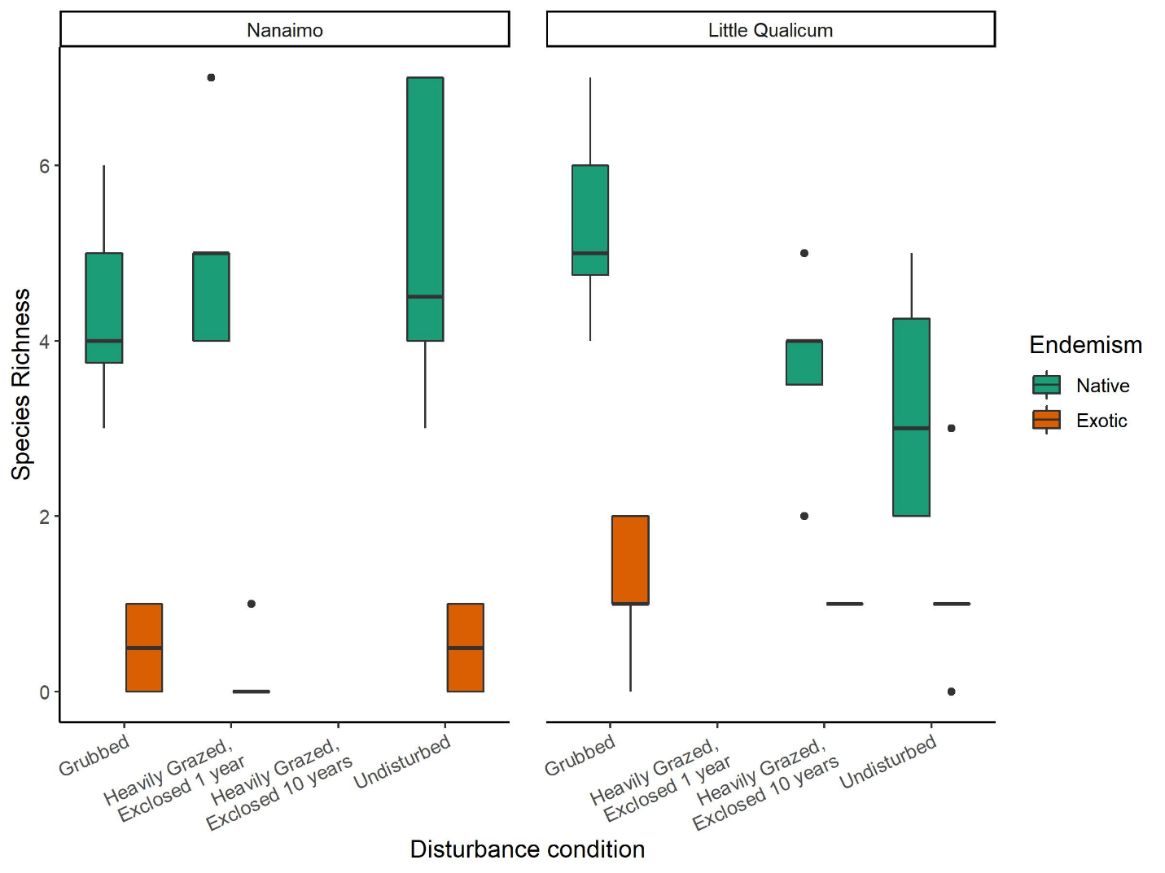

Figure 4. Native species richness in above-ground vegetation is consistently significantly greater than exotic species richness in both estuaries and across all disturbance categories.

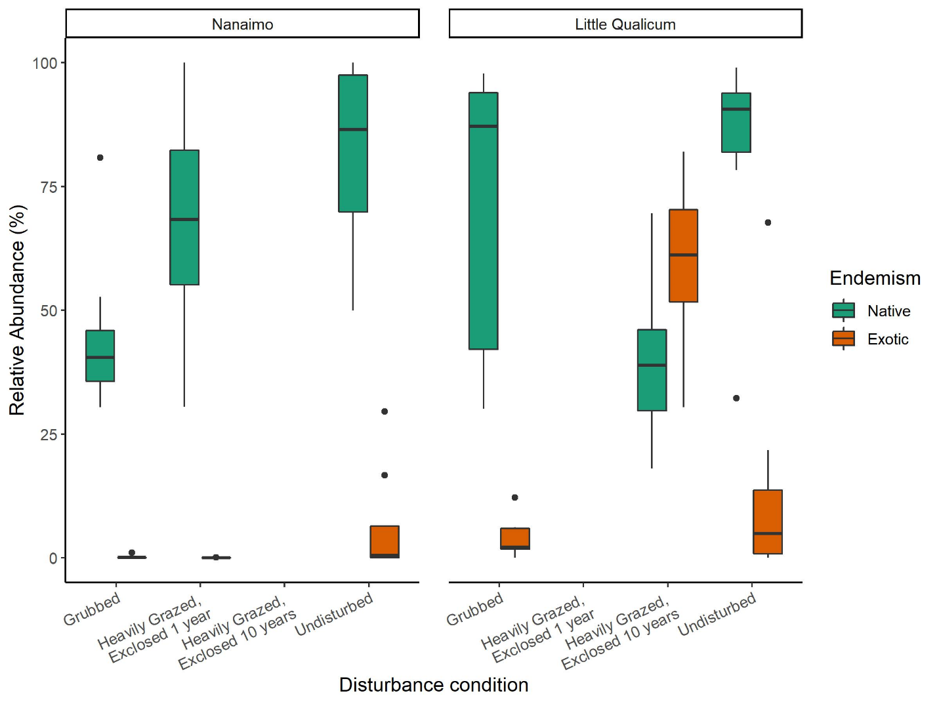

Figure 5. Above-ground cover abundance of native species is always significantly greater than exotic species cover, except in 10-year old exclosures in Little Qualicum River Estuary.

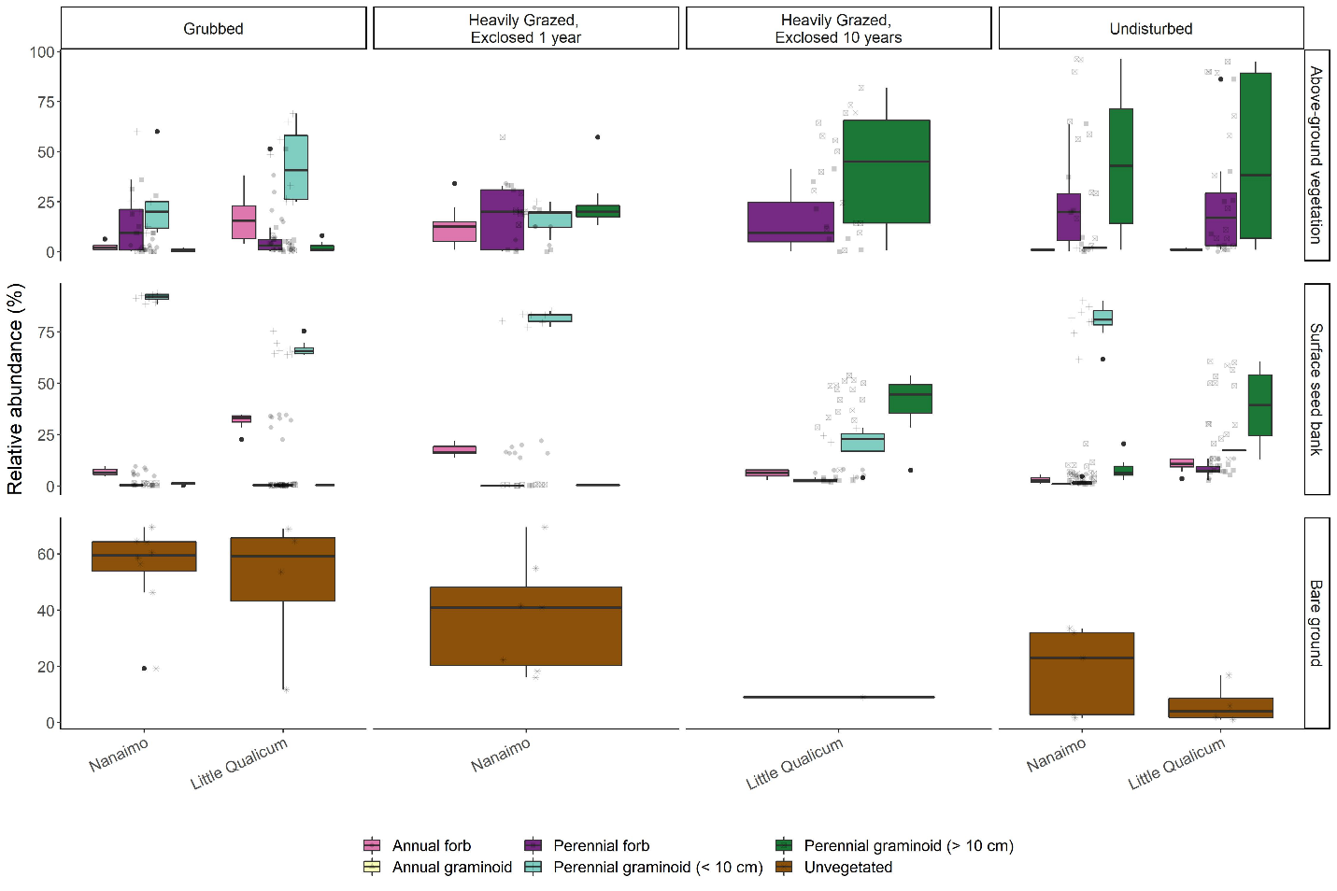

Figure 6. Recently grubbed and 1-year-old exclosures are dominated by > 50% mean cover of bare ground, with species relative abundance dominated by short perennial graminoid Eleocharis parvula and forbs in both above-ground vegetation and surface seed bank. After 1 year of exclosure, all plant functional groups have similar dominance in above ground vegetation, but surface seed banks do not show increased representation from perennial forbs or perennial graminoids > 10 cm. Bare ground significantly decreases after 10 years of exclosure, while relative abundance of perennial graminoids (> 10 cm) significantly increases in both above-ground vegetation and surface seed banks, not significantly different from undisturbed sites.