# Introduction

1. Estuaries around the world are under cumulative stress from a variety of natural and anthropogenic sources, which may occur over short or sustained periods of time.
   1. Recurring or ongoing stress reduces the capacity for the ecosystem to tolerate additional stressors.
      1. Disturbance pressures may be (1 sentence to cite pnw: conversion of estuarine FP leads to xyz (Finn)], while [cite Norway/pulse dist.)
   2. These disturbance pressures have ecosystem consequences, and their constituent plant communities.
   3. Consequences may be biodiversity loss, species homogenization, increased non-native invasive (?)
      1. On the whole, can lead to loss of ecological memory
2. Disturbance can have a positive or negative effect on communities.
   1. Exemplify grazing disturbance with positive (CITE) and negative (Srivastava & Jeffries, 2008).
   2. Removing the source of disturbance should allow the community to passively recover.
   3. However, intensity of grazing behaviors are important because they can reset succession
      1. Understanding successional trajectories in heavily grazed estuaries is an important KG.
3. Recovery of habitat by the dominant species recovery may be driven by competition (Bruno et al., 2005), however,
   1. grazing disturbance of introduced, hyper-dominant species can shift community composition (Gonzalez & Arcese, 2008)
   2. additional factor of feedbacks between plant/seed as transition statement (allude to competition pressure from seed bank)?
4. In PNW estuaries, competitive dominant plants are TPGs with variety of forbs interspersed. Many TPGs are competitively dominant by clonal reproduction, and some by seed recruitment; some are seed limited. However, many estuaries are under pressure of over-grazing and invasion by non-native species.
   1. PNW goose grazing behavior grubbing out clonal, which increases erosion and loss of seed banks (ecological memory)
      1. Stopped by exclosures
   2. Recovery thus must be from adjacent, remnant vegetation, or new seed bank inputs dispersed/retained/recruited in the site.

The main objective of this study was to understand compositional changes of surface seed banks and above-ground vegetation at discrete stages of recovery since grazing exclusion in two Salish Sea estuaries. We wanted to know if grazing exclusion allows compositional abundance of above-ground vegetation and surface seed banks to passively to similar compositional abundance of undisturbed sites.

Traditional succession models would say the most competitive species will increasingly dominate the plant community as time since disturbance increases. This would particularly be the case in a clonal ecosystem, where recovery is driven by species spreading clonally from adjacent undisturbed sites, in addition to potential recruitment from the seed bank. If succession is happening the we expect:

1. Above-ground vegetation at older disturbance sites will be more similar to undisturbed (reference) vegetation than recently disturbed sites, with respect to compositional abundance of tall, perennial graminoids (TPGs). Alternatively, novel disturbance can lead to alternative succession pathways, where new species can achieve competitive dominance through seed or clonal recruitment, derailing the “slow clonal encroachment” of historically dominant species from neighboring sites.
2. Because a longer post-grazing recovery period should facilitate greater seed bank diversity, we expect compositional abundance of surface seed banks should closely resemble the compositional abundance of above-ground vegetation in recently disturbed sites, and become more dissimilar and more diverse with time since disturbance.

# Results

## Above-ground vegetation

We found evidence that the dominant group of tall, perennial graminoids (TPGs) recovered similarly to undisturbed sites after grazing exclusion, however the compositional abundance became dominated by non-native, invasive species in older exclosure sites (FIG1). Dominant species were often the same as those identified by indicator species analysis in each disturbance category.

* In Grubbed sites, dominant species included c(d, e, f), while 1-yr old exclosures were dominated by c(g, h, i). Indicator species analysis for these disturbance categories differed in (ways) (TABLE).
* These recently disturbed sites differed from the dominant species in Undisturbed sites, which included c(x, y, z), and species c(a, b, c) in 10yo exclosures (FIG). Indicator species for the 10-yr old and Undisturbed disturbance categories were similar, with the notable difference of (blah) (TABLE).
  + Introduced pasture grass *Agrostis stolonifera* was both a dominant (>25% relative abundance) and indicator species for vegetation in the 10-year old exclosures in the Little Qualicum River Estuary (FIG).
* Generalized linear models showed Grubbed sites had significantly lower TPG above-ground cover than Undisturbed sites (p = 0.02), although this was not statistically significant in 1-year old exclosures (p = 0.09) (FIG3).

## Surface seed banks

We found that species diversity/richness was equal across disturbance categories, but compositional abundance was … [next sentence: answer the question, are seed banks more dissimilar from AG after 10 yrs?]

* In Undisturbed sites, dominant species included c(x, y, z), and species c(a, b, c) in 10yo exclosures (FIG). Indicator species for these disturbance categories were similar, with the notable difference of (blah) (TABLE).
  + *Agrostis stolonifera* was both a dominant (>25% relative abundance) and indicator species for the surface seed bank in Undisturbed and 10-year old exclosures in the Little Qualicum River Estuary (FIG).
* This was contrast by dominant species c(d, e, f) and c(g, h, i) in the Grubbed and 1yo exclosures, respectively (FIG). Indicator species analysis for these disturbance categories differed in (ways) (TABLE).
* Our generalized linear models showed Nanaimo River Estuary had significantly lower TPG seed abundance overall (p = 0.02), and Grubbed sites have significantly lower TPG seed abundance, regardless of estuary (p = 0.05) (FIG3)

## Comparisons between vegetation and seed banks

* Non-native invasive *A. stolonifera* is dominant in 10-year old and Undisturbed seed banks, and its dominance in above-ground vegetation is significantly greater at 10-year old sites than in Undisturbed sites.
* Native *Carex lyngbyei* recovers as dominant vegetation, but its seed bank presence is much lower in 10 yr old sites than Undisturbed.
* Native forb *Symphiotrichum subspicatum* was dominant in Undisturbed sites, but was absent or nearly absent from 10-year old exclosures. *Potentilla pacifica* recovered in both vegetation and surface seed bank. Thus, while TPGs may recover, other taxonomic floristic richness may be lost.

Table 1. Indicator species analysis identifies which species significantly characterize the above-ground vegetation (left panel) and surface seed bank (right panel) for each disturbance condition, or combination of “recently disturbed” (1-year old exclosures and Grubbed sites) and “recovered” (10-year old exclosures and Undisturbed sites) disturbance conditions. Non-native species are indicated by asterisk (*); tall perennial graminoids indicated by plus sign (+).

|  |  |  |  |  |  |  |
| --- | --- | --- | --- | --- | --- | --- |
| Above Ground Vegetation | | |  | Below Ground Seed Bank | | |
| **Disturbance** | **Species** | **p-value** |  | **Disturbance** | **Species** | **p-value** |
| Grubbed | *Eleocharis parvula* | < 0.01 |  | Grubbed | *Salicornia depressa* | 0.01 |
| *Cotula coronopifolia\** | 0.04 |  |
| Grubbed + 1-year old exclosures | *Spergularia canadensis* | < 0.01 |  | Grubbed + 1-year old exclosures | *Eleocharis parvula* | 0.02 |
| *Glaux maritima* | 0.03 |  | *Spergularia canadensis* | 0.03 |
| 10-year old exclosures | *Agrostis stolonifera*+* | < 0.01 |  | 10-year old exclosures | *Juncus balticus+* | < 0.01 |
|  | *Triglochin maritima* | 0.05 |
| 10-year old exclosures + Undisturbed | *Potentilla pacifica* | < 0.01 |  | 10-year old exclosures + Undisturbed | *Agrostis stolonifera*+* | < 0.01 |
| Undisturbed | *Juncus balticus+* | 0.02 |  | Undisturbed | *Carex lyngbyei+* | 0.02 |
| *Carex lyngbyei+* | 0.02 |  | *Cotula coronopifolia\** | 0.03 |
| *Triglochin maritima* | 0.04 |  | *Juncus articulatus+* | 0.04 |

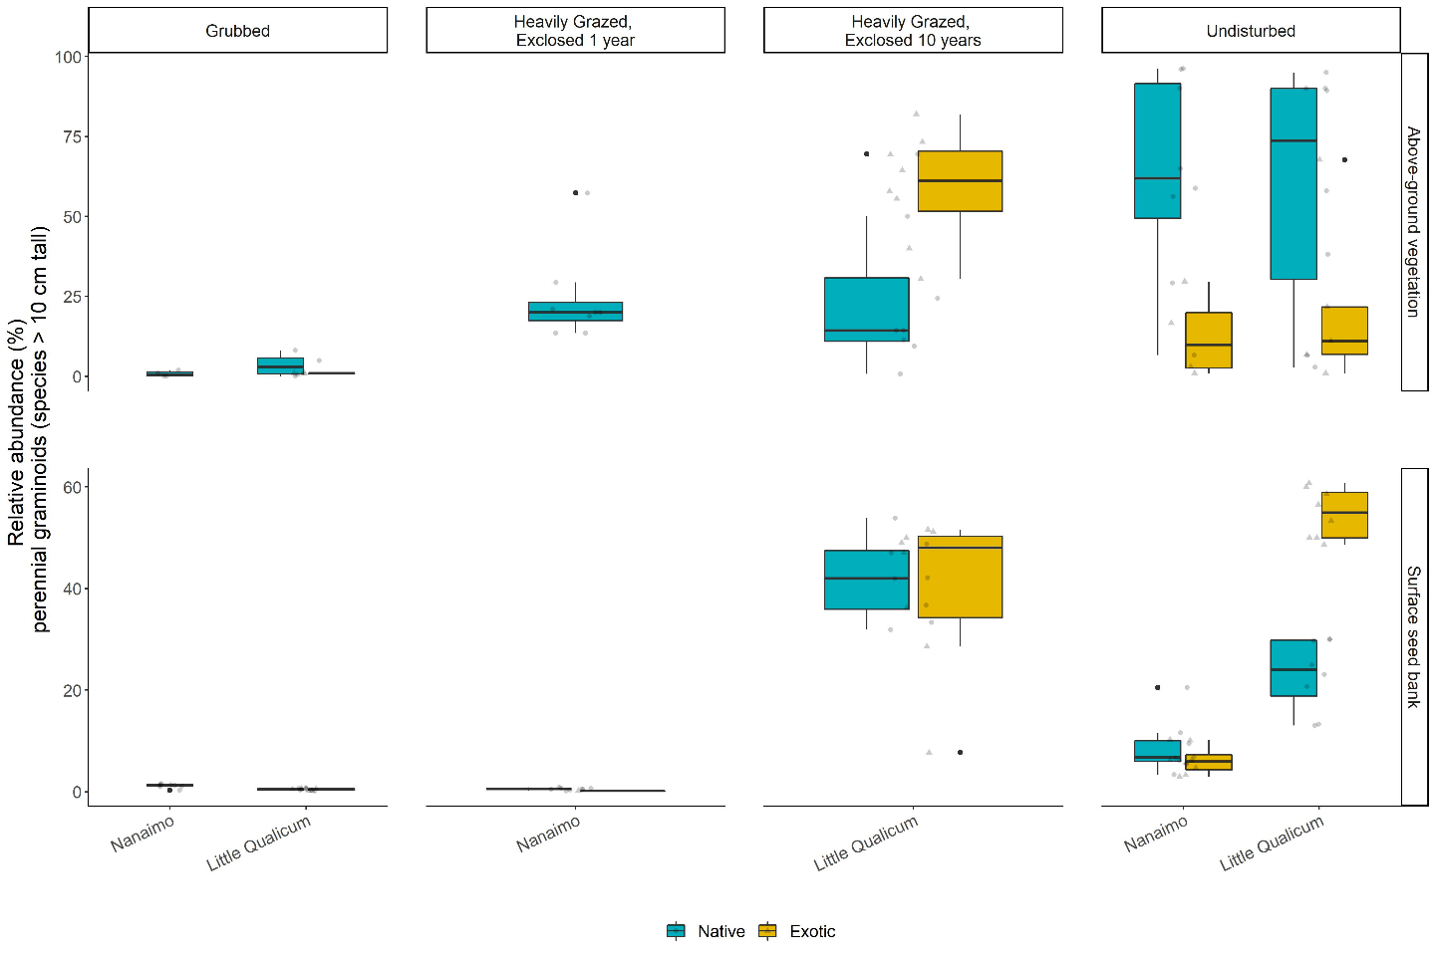

Figure 1. Above-ground cover abundance of key functional group ‘tall, perennial graminoids’ is not significantly different from undisturbed (reference) sites after 10 years. However, indicator species analysis reveals this above-ground cover is dominated by non-native graminoid species Agrostis stolonifera. Moreover, seed bank abundance of tall, perennial graminoids is significantly higher in 10-year old exclosures compared to other disturbance conditions, including undisturbed (reference) sites. Notably, there is nearly equal abundance of non-native and native graminoid seed in 10-year old exclosures, and significantly greater representation of non-native than native graminoid seed in undisturbed sites in Little Qualicum Estuary.

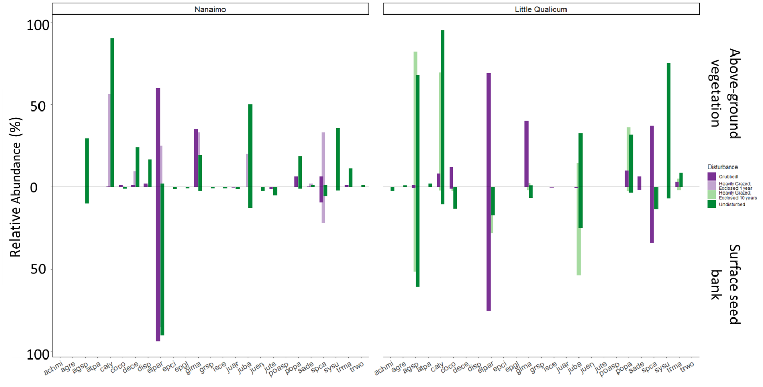

Figure 2. Mean relative abundance of all species in above-ground vegetation and surface seed bank at each estuary sampled. Notably, abundance of key native TPGs such as Carex lyngbyei are absent from the seed bank, while others such as Juncus balticus are present in the seed bank but absent in above-ground vegetation, such as observed in 10-year old exclosures at Little Qualicum Estuary.

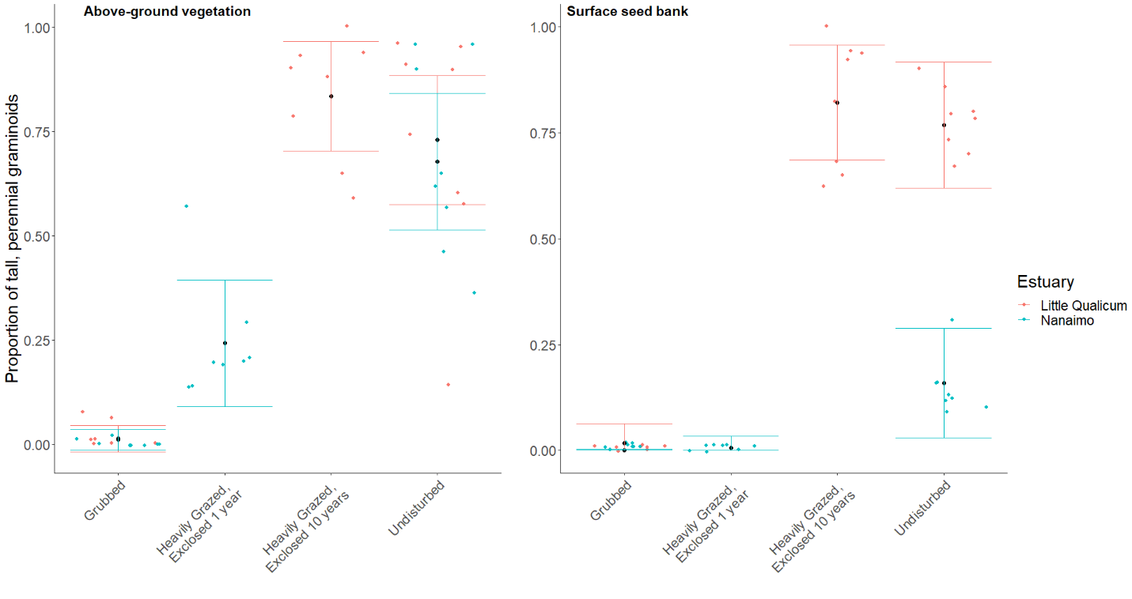

Figure 3. Actual vs. predicted values for proportion of tall, perennial graminoid in above-ground vegetation cover (left) and surface seed bank samples (right) based on disturbance condition. Actual values plotted as colored points; mean values black points with standard error color coded for each estuary.

# Discussion

* Preservation of remnant vegetation and transplanting native species along the ‘leading edge’ should be prioritized to get ahead of non-native invasion during recovery.
  + Forbs like *S. subspicatum* don’t appear to recover, and seeds were only found in Undisturbed seed bank samples. Interspersing diverse plantings may be necessary to restore forb richness (non-dominant species).
* Many species in this system are perennial, and do not appear to have a strong representation in the seed bank, especially in newly disturbed areas (eg, glma vs spca).
* Novel seed inputs may happen sometime between ‘recent disturbance’ (1yr) and ‘older disturbance’ (10 yr), OR seed inputs are present even in undisturbed sites, and disturbance opens new space for new competitive succession.
  + Propagule pressure combined with competitive dominance alters successional trajectory during the recovery time period.

#~#~#~#~#~#~#~#~#~#~#

# From v. 2.3-NAS

#~#~#~#~#~#~#~#~#~#~#

We sought to understand whether the dominant plant functional group ‘tall, perennial graminoids’ (TPGs) recovers following disturbance, and whether surface seed bank composition reflects above-ground vegetation composition.

* We found that TPG functional group recovered according to our expectations, but with different compositional characteristics. Notably, exotic species *Agrostis stolonifera* dominates above-ground vegetation 10 years following grazing exclusion.
* We found high species richness in grubbed sites and 1-year old exclosures, but low abundance of seed similar to above-ground vegetation except for two species in these disturbance categories. This may indicate a loss of propagules in the surface seed bank, either by erosion or inability of the extant vegetation to trap seeds from local parent plants or any brought in by tidal inundation.
  + Our expectations for high similarity between surface seed banks and above-ground vegetation were partially met, however there was no strong partitioning according to time since disturbance.
* Whether vegetation is recovering predominantly by vegetative clonal growth, seed recruitment, or a combination of these mechanisms was not tested. Regardless, it appears exotic species are out-competing natives despite some native species’ presence in the surface seed bank.
  + We found low abundances of seed for some TPG in Undisturbed and 10-year old exclosures, notably a dearth of seed from C. lyngbyei.
    - This suggests that if vegetation is disturbed, seeds are not a likely source of propagative material for most species extant in the above-ground vegetation of Undisturbed sites.
  + The two TPG species with greatest representation in surface seed banks in Undisturbed at both estuaries and 10-year old exclosures in Little Qualicum Estuary were native *J. balticus* and exotic *A. stolonifera*. If these two species had comparable competitive traits, we might expect a similar proportion of cover abundance in the above ground vegetation in 10-year old exclosures. This was not the case, suggesting that exotic species *A. stolonifera* has a competitive recruitment advantage during the recovery period. Competitive advantage of *A. stolonifera* may especially be contributing to lack of recovery of seed-limited native TPGs, such as *C. lyngbyei*.
* Overall, relative abundance of most native indicator species was lower in the surface seed bank than the relative abundance of their above-ground vegetation counterparts. Over time and sustained disturbance, this may lead to ‘ecological memory loss’ of native species diversity and compositional abundance as above-ground vegetation is lost to grazing, and subsequently unable to contribute to the surface seed bank. Moreover, as both native vegetative clonal and seed reproductive mechanisms are lost from the habitat, there is a greater risk of exotic species replacing native species in estuaries.
  + Seed-limited species that rely on clonal reproduction may be at greatest risk for being out-competed if the competitor(s) have greater seed and clonal reproductive rates.
* Broadly, we may synthesize these findings to recommend areas of attention for habitat managers.
  + Most importantly, the data we present here show that while habitat recovers in terms of plant functional groups, it does not have the same species compositional abundance in above-ground vegetation or surface seed banks.
    - Thus, passive recovery may be insufficient for species with a primarily clonal reproductive strategy, especially when exotic species with competitive reproductive advantage of both seed and clonal strategies are present.
    - Whether the exotic species provide the same ecosystem functions such as leaf litter quality for primary productivity, sediment trapping, wave attenuation, etc., remains to be tested (e.g., Waller et al., 2020). Without knowing effects of these changes on habitat quality, best recommendations would be to prevent extensive grazing and grubbing.
    - Two periods (1, 10 years) of recovery, each in different estuaries leaves a lot of uncertainty, as does only collecting seed/vegetation data for one year. A major challenge is replication of restoration conditions, which should be addressed in restoration design and habitat management.
  + In the event of habitat disturbance, surface seed banks are not a reliable source of abundant native seed species to out-compete exotic species. Best recommendations would be to place a high priority on actively restoring desired species as soon as possible.
    - Local or regional dispersal limitations cannot rescue native populations if local seed or clonal competitive pressure from exotic species is greater. That is, this trend of both native species loss *and* increasing exotic cover is exacerbated by each species’ competitive dispersal and recruitment strategies.
    - Extrapolate implications for other systems with other press disturbance types, such anthropogenic stressors (e.g., general wetland/riparian invasion). Contrast to ecosystems that experience regular pulse disturbance, keeping ecosystem in a relatively ‘young’ state (Odum, 1969).
  + In instances where disturbance has resulted in extensive estuarine habitat loss, there exists the opportunity to intentionally restore diverse native species palettes, which can remedy known trends of biodiversity loss (Lane *et al.*, in preparation). Moreover, this offers a chance to enact reconciliation partnerships with local First Nations to use culturally important species, and potentially restore traditional land management practices (e.g., Turner, 2014).