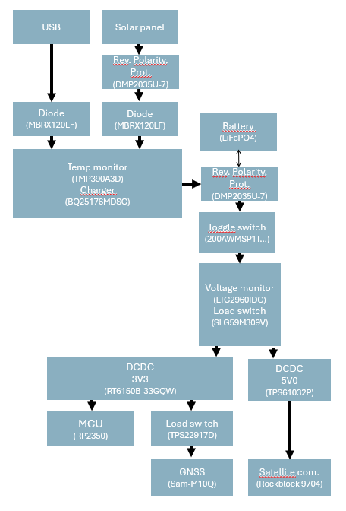
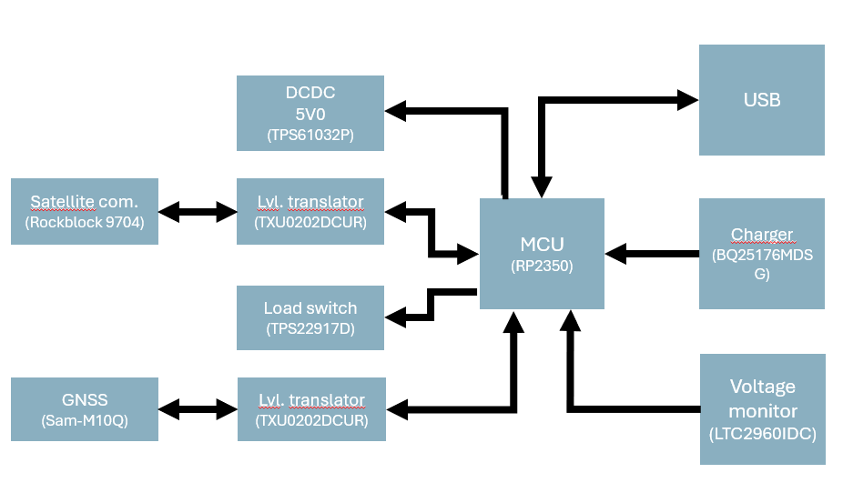

Power management

Battery
For the battery, LiFePO4 is chosen as it offers high temperature stability and long lifetime. LiFePO4 has a voltage range from 2.5V to 3.6V. A typical discharge curve looks like the following:
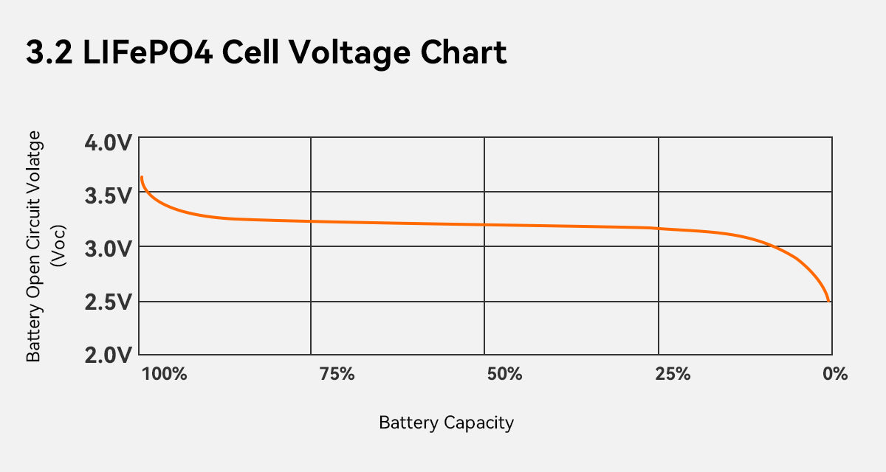
Battery size is 26550, which leads to roughly 3000mAh depending on manufacturer.

Reverse polarity protector (Battery & solar panel)
To protect the system against a wrongly oriented battery, a P-channel enhancement mode mosfet is used. Inspiration from Reverse Voltage Protection With A P-FET | Hackaday. The 5.1V Zener diode protects the gate against voltages above 5.1V. This is not necessary for battery protection, but it is for solar panel reverse voltage protection. Relevant specs are:
- Rds_on < 45mOhm (1A leads to 45mV drop, ~1% loss)
- Vgs_threshold = -0.7V (Lowest source goes is 2.5V – 1V body diode =1.5V)
- Vgs_breakdown = +-10V (Battery max is 3V6)
- Vds_breakdown = -20V (Battery max is 3V6)
Normal operation mode:
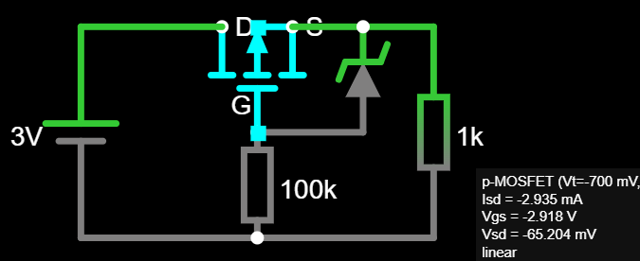
Reverse polarity:
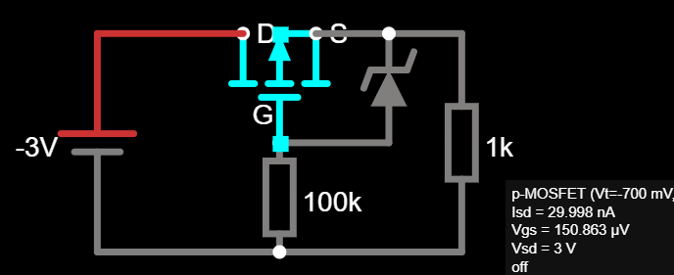
Charging:
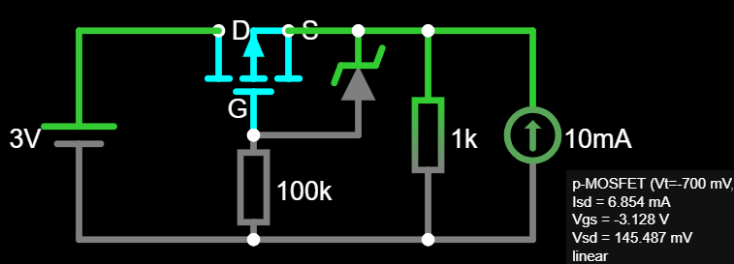

Reverse polarity indicator (Battery & solar panel)
To indicate that the battery is placed in reverse polarity, we use a reverse placed LED with a resistor. Typical reverse breakdown voltage is 5V. This is good enough for battery. For solar panel, we need to use a ‘stronger’ diode in series. Inspired by: From the Q and A | Nuts & Volts Magazine.
This design uses 1N4148W. Important specs are:
- Leakage current <1 uA
- Max Forward voltage = 1V
- Max Reverse voltage = 75V

Typical LED <0.1uA
Because the leakage current is different and unpredictable ,we need resistors in parallel to make sure the 1N4148 diode ‘carries’ all the voltage. For this we use Resistors in a higher order of magnitude so the leakage current of the diodes themselves is negligible.
10uA parallel resistors: R=U/I = 20V/10uA = 2Mohm. To give the 1N4148 90% of the voltage, we give it a parallel resistor of 1.8Mohm. The LED is given 200kOhm. Verified in Fallstad:
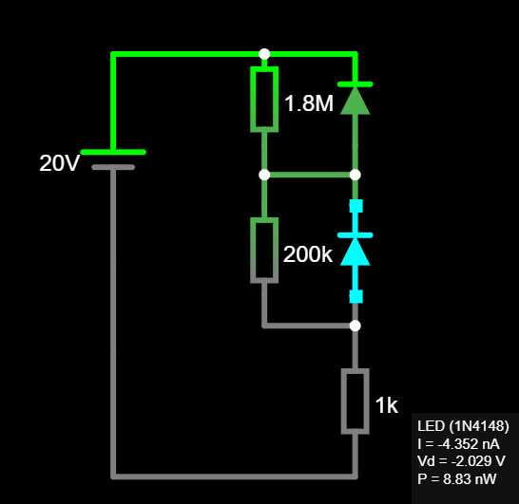
For practical reasons, 2.2Mohm and 220Kohm are used.
Led series resistance (18V-0.7V-0.7V)/3mA = 5.6k). A typical solar panel will give much lower current, but hopefully the LED will still be visible.

Charging
The BQ25176M solar charger IC is used. It is particularly marketed for ‘solar harversting’ Important specifications are:
- Linear
- Battery tracking Input Voltage Dynamic Power Management (VINDPM)
- No timeout timer (Not needed)
Both solar panel and Vbus input are connected to input through a diode. MBRX120LF-TP is used. These have a ‘super low’ forward voltage drop of 0.2V. USB is open solderjumper because usb connected without battery plugged in is undefined behaviour of the BQ25176M. Caps are according to datasheet
ISET:
Icharge = 300 / Riset. 600Ohm 500mA max charging current. With typical battery this is 0.15C.
VSET
100Kohm 3.5V max charge voltage
/PG
Open drain Active low power good. It means the input voltage is OK. Connected to MCU. 10Kohm pullup according to datasheet. Open solderjumper to LED. R = (3.3V-0.7V) / 3mA ~= 1Kohm
STAT
Open drain Active low Charging status. 10Kohm pullup according to datasheet. Connected to MCU. Open solderjumper to LED. R = (3.3V-0.7V) / 3mA ~= 1Kohm
Bias
Bias pin is connected through 10kOhm to ground. Tolerance is unknown so 1% used. BIAS pin can be pulled down to disable charging. This is used for temperature monitoring of the battery. It is connected to the output of the programmable temperature switch TMP390A3D.

TMP390A3D
Programmable temperature switch. Open drain active low outputs connected together. On both hot and cold trip the bias pin from the charger is pulled down. Output pins need 10kOhm pullup, but to not interfere with the bias resistor of the BQ25176M, it is not placed. This component is placed close to the GND of the batter for best heat transfer possible. 1 cap according to datasheet.
SET A
9.09 Kohm 60 degrees hot trip
SET B
21.5 Kohm 0 degrees cold trip. This also sets the hysteresis to 5% for both hot and cold trip.

Undervoltage protection
After a toggle switch (200AWMSP1T2A1M2RE) a load switch (SLG59M309V) is placed to disconnect all power-draining components. If one of these switches in series is disconnected, charging via solar panel or USB still functions.

SLG59M309V
On is connected to active low empty_bat. This is the signal coming from the voltage monitor (LTC2960IDC-1). 10nF capacitor on CAP pin 2.5ms rise time.

LTC2960IDC-1
Voltage monitor. Connected directly after the polarity protection. Quite specialized IC to configure programmable voltage thresholds (low battery & empty battery) and programmable hysteresis. 1 cap according to reference schematics
ADJ input below 400mV pulls RST low open drain active low empty bat
IN+ input below 400mV pulls OUT low open drain active low low bat
Low bat triggers at 0.4V / 49.9 x (340 + 49.9) = 3.13V
Empty bat is more complex. It has huge hysteresis to account for the voltage dip at the end of the LiFePO4 battery capacity. The 100K pull-up resistor on empty bat makes the circuit a bit more complex. Out / Lowbat does not have a pull-up resistor as this is already integrated into the MCU and performance is not critical. (So software mistake does not cause problems)
Falling threshold: 0.4V / 49.9 x (316 || (1.5M + 100k) + 49.9) = 2.51V
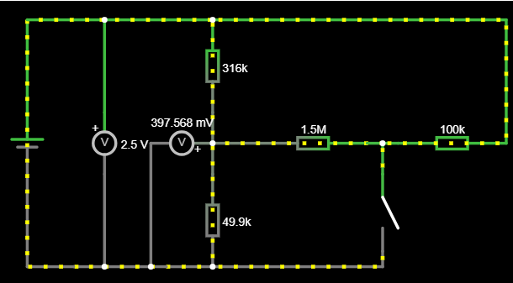

When empty bat is pulled low, the battery voltage must rise higher because the voltage divider used for the threshold is pulled down extra by the empty bat output. The internal hysteresis of 10mV in the voltage monitor IC is also taken into account.
Rising threshold: 0.4V / (49.9 || 1500) x ((49.9 || 1500) + 316)) = 3.09V
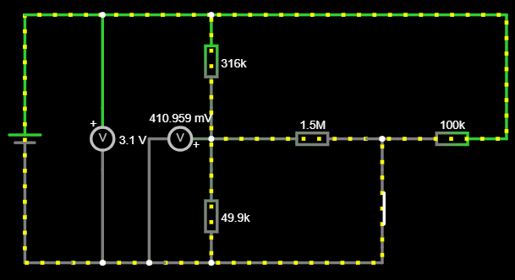

Values are found with Python Sympy.
RT
Connected to VCC for a 200ms reset timeout delay.

5V DCDC Boost convert
To create 5V from Vsys for the Rockblock, the TPS61032P is used. This seems a bit overkill, as it can supply 4A from 1.8V input. The Rockblock draws 500mA according to datasheet However, tests have shown (at least, the hypothesis is) that the input spike it draws is much higher. This caused problems in the prototype. Therefore, the 5V DCDC in this design is comfortably overkill.
For the inductor, CDRH124–6R8 is used according to datasheet (max power solution)
Vbat has 20uF cap (10uF is max power solution)
Output cap is 220uF tantalum low esr with a 2.2uF X5R capacitor (both from max power solution). An extra slot is available to double the capacitance if necessary.
LBI & LBO
Can be used for low battery indication. Unused. LBI is connected to GND as it cannot be left floating.
SYNC
Power save mode is disabled through Closed solderjumper by connecting SYNC to VSYS
TPS22917DBV
EN
Enables the DCDC. Connected to MCU. Pulled down with 100k
FB
Only used for adjustable versions. The TPS61032P is fixed at 5V

3V3 DCDC Buck boost converter
The RT6150B-33GQW creates 3V3 from the Vsys. It has to be buck boost as VSYS swings around 3V2. This DCDC is always on as it powers the mcu. Caps overspecced according to datasheet. Inductor according to datasheet.
FB
Connected to VOUT for non-adjustable versions
PS
Power save mode connected to GND through closed solderjumper to enable power save mode operation.

GNSS load switch
To enable the GNSS, the SLG59M309V (Same as for battery undervoltage lockout) is used. Previously, the TPS22917 was used, but its replaced by this IC for the sole reason of less different components. Connections same as other SLG59M309V

GNSS
The SAM-M10Q is used. This has also been used in the prototype. No requirements on caps.
Timepulse
Can be enabled by soldering the jumpersolder, this enables a blinking orange LED when GNSS signals are received. Max 2mA according to datasheet. R = (3.3V-0.7) / 2mA = 1.3kOhm. 2kOhm used.
EXTINT
No reason to use, but connected to MCU anyway with open solderjumper.
SAFEBOOT & RESET & SDA & SCL
Unused
RXD & TXD
Uart is used for communication with the MCU. Tests have show that the gnss is backpowered through UART when VCC is off. This is prevented by using a Level translator.

Level translator
TXU0202DCUR is used to protect the gnss module (and the rockblock) against backpowering. Caps according to datasheet.
OE
Output enable. Enabled by the same signal that turns the load switch (or 5Vdcdc for rockblock) on, coming from the MCU. When disabled all outputs are isolated.

Satellite communication
The rockblock 9704 is a standalone module that is used to connect with the Iridium network. The following pins are used:
I_EN
Enables the module
I_BTD
Signals to the MCU that the supercapacitor is charged
I_WK_I / I_WK_O
Unused but connected so MCU anyway for later wake functionality
TXD / RXD
Uart, also connected through TXU0202DCUR

USB
USB-C connector is used. According to Universal Serial Bus Type-C Cable and
Connector Specification, release 2:
CC1 and CC2:
Need 5.1k pull-down (p. 236) 1% tolerance just to be sure
VBUS:
Max capacitance = 10uF (p. 234)

MCU
The RP2350A is used. This was also used on the prototype with a Raspberry Pi Pico 2. All design according to schematic followed from Raspberry Pi Pico 2 Datasheet: An RP2350-based microcontroller board. Layout rules followed from this guideline: Hardware design with RP2350: Using RP2350 microcontrollers to build boards and products.
Voltage regulator layout guidelines are strictly followed. AOTA-B201610S3R3-101-T Inductor is used.

Watchdog
To enable low power savings and watchdog functionality, the TPL5010 is used. The configuration is in such a manner that it signals the MCU every ~60seconds. The MCU must respond with DONE. If the MCU fails to do so, it pulls the RST pin low which is connected to the RUN pin of the MCU. RST has a pullup. Cap according to spec.
Delay
The delay resistor is set to 22.1Kohm which corresponds to roughly 1 minute. This means the wake signal is given every minute. This way, it can also be used to sleep for 1 minute.

