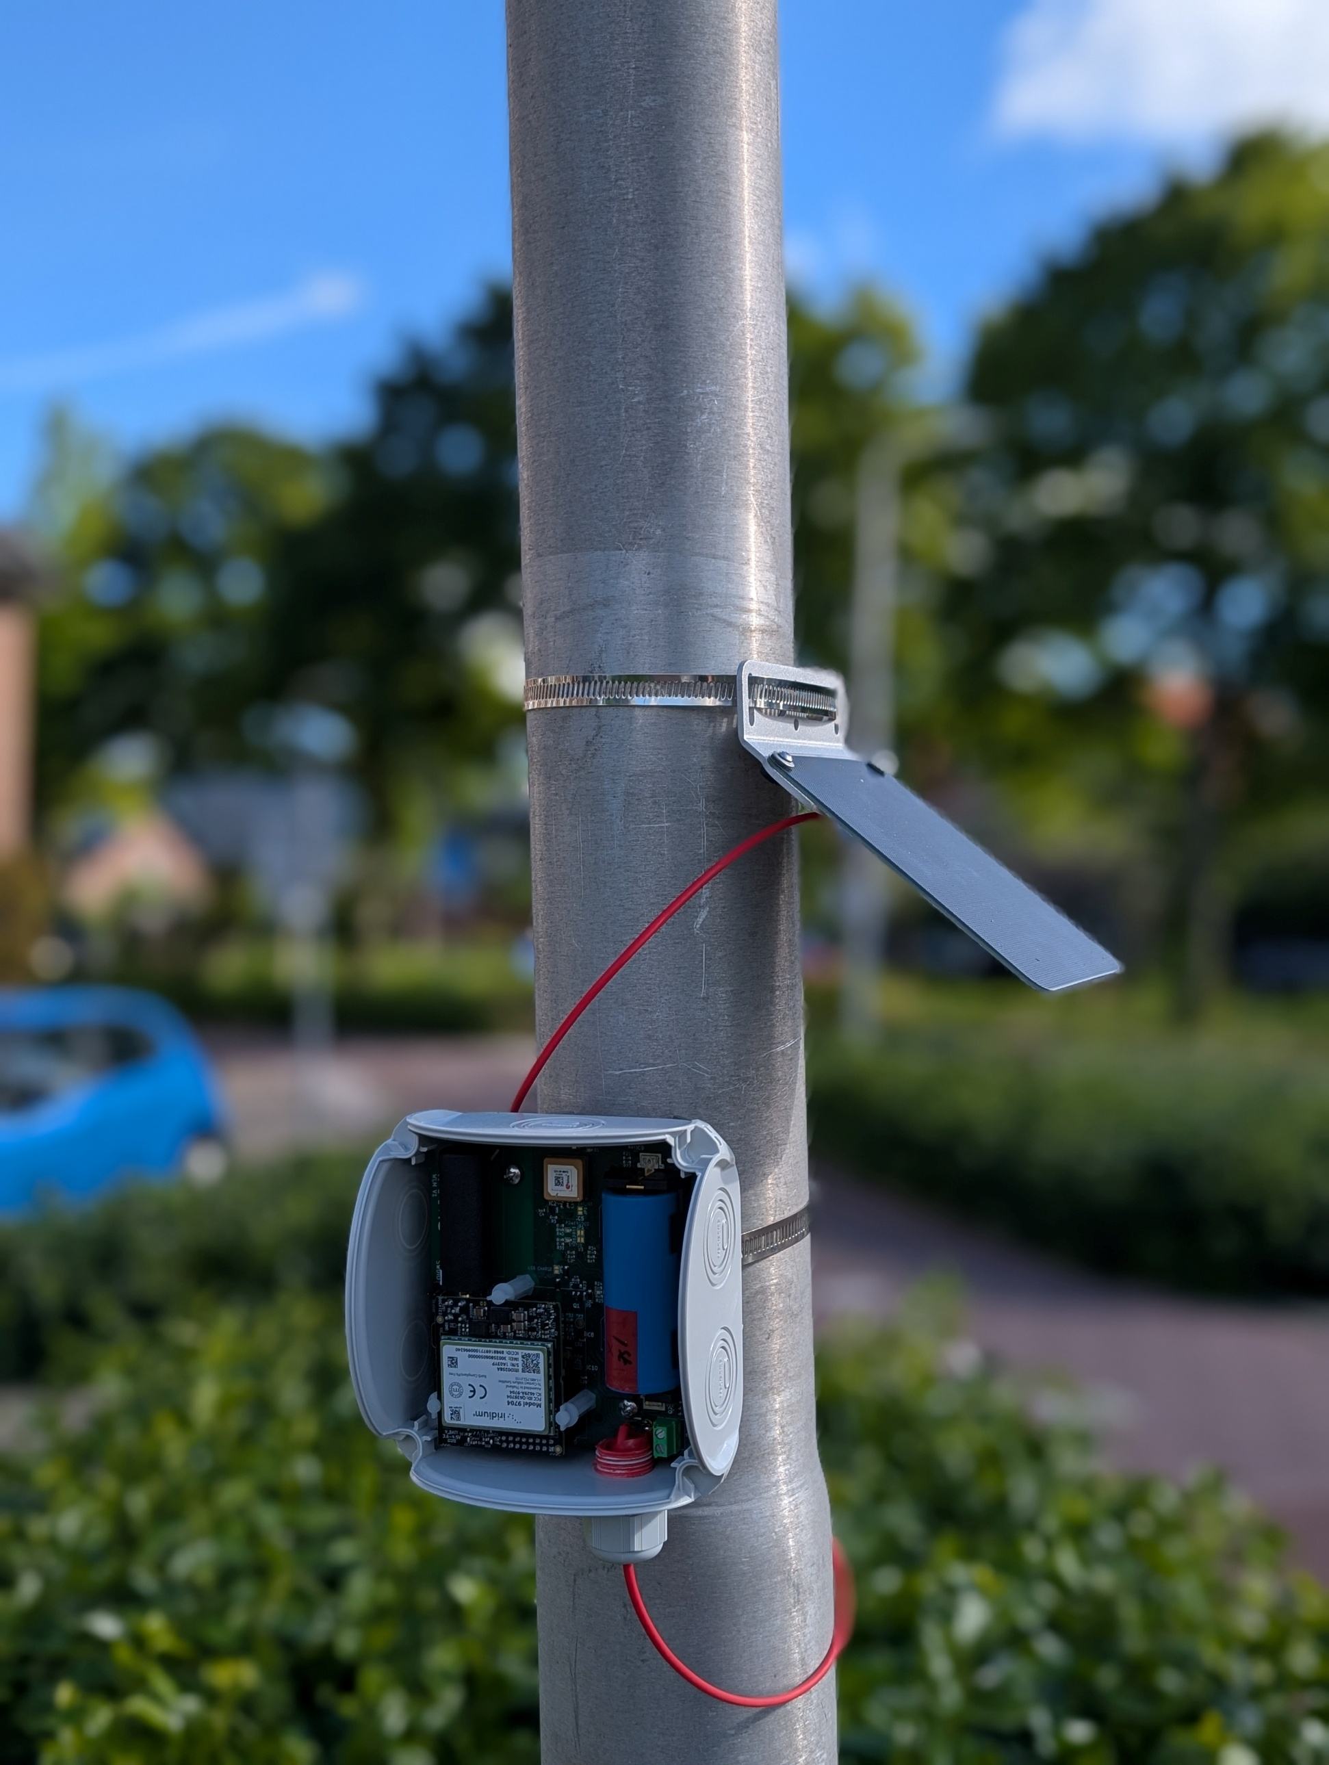

WLM Assembly Manual

TAHMO Water Level Monitor system

Component overview

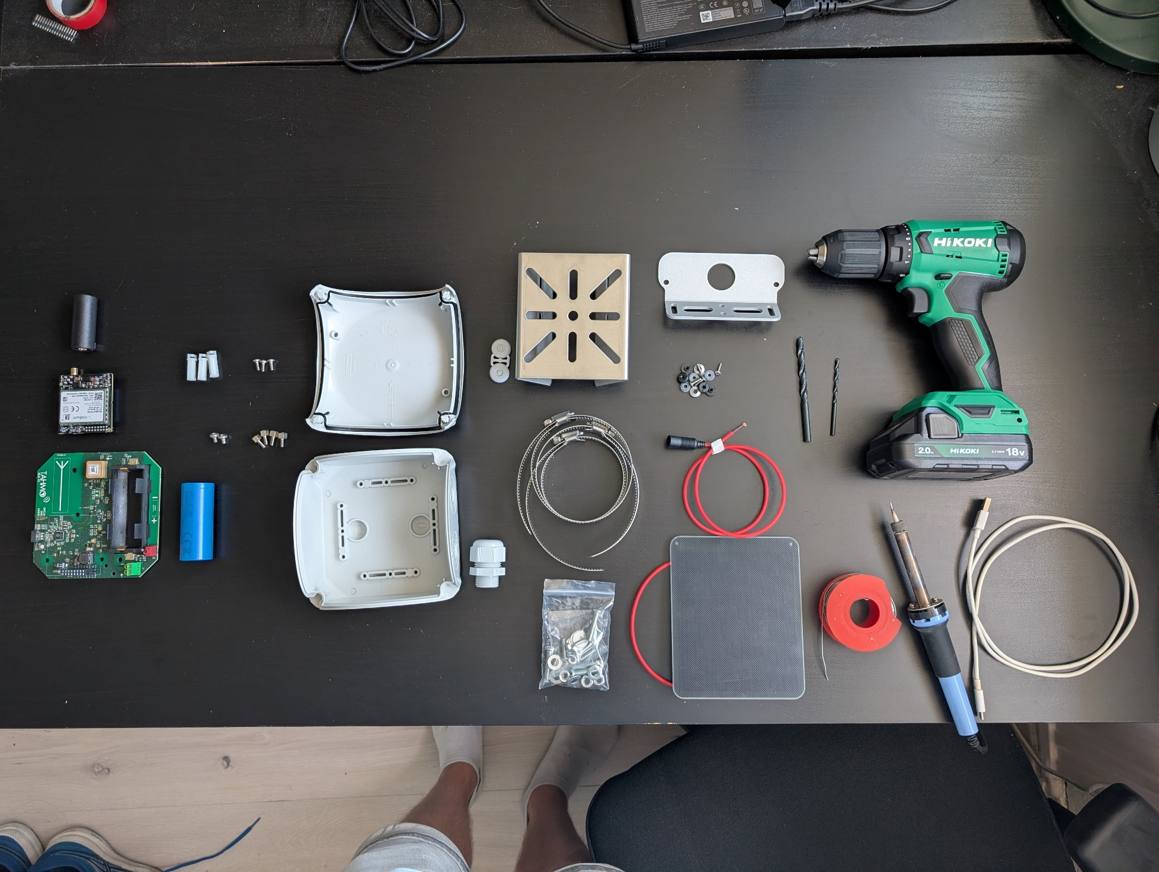

Assembly WLM device
Remove one knockout.
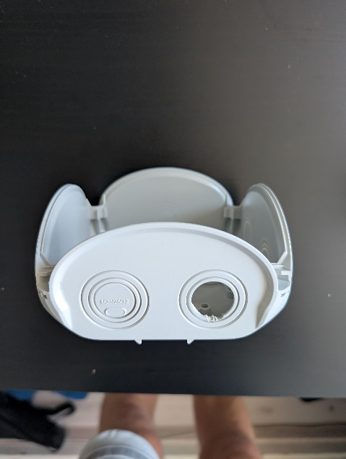

Drill 2 holes (green indicated) in the bottom, using 6mm drill bit. Also, bore out the holes indicated in red with 3.5mm.
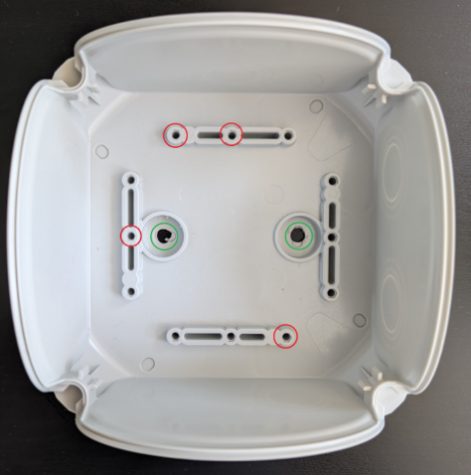

Screw the spacers in.
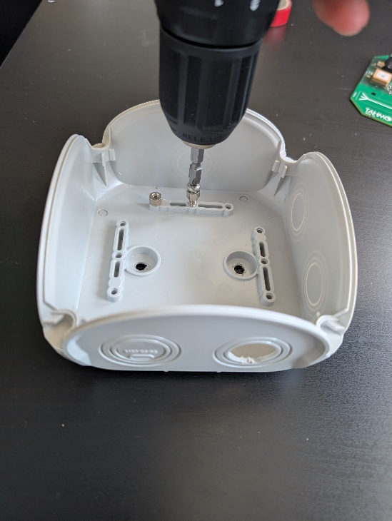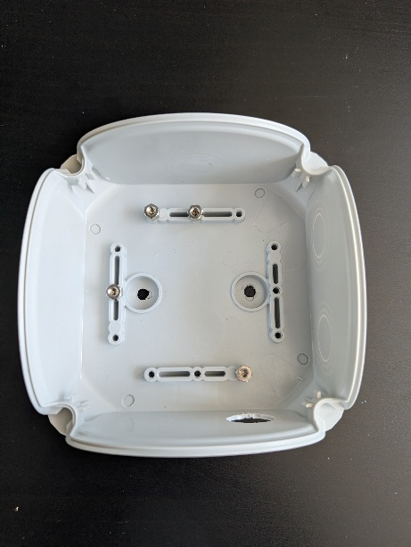

Mount the bracket using two bolts, washers and nuts.
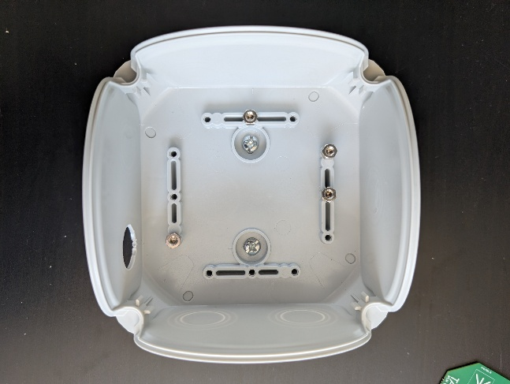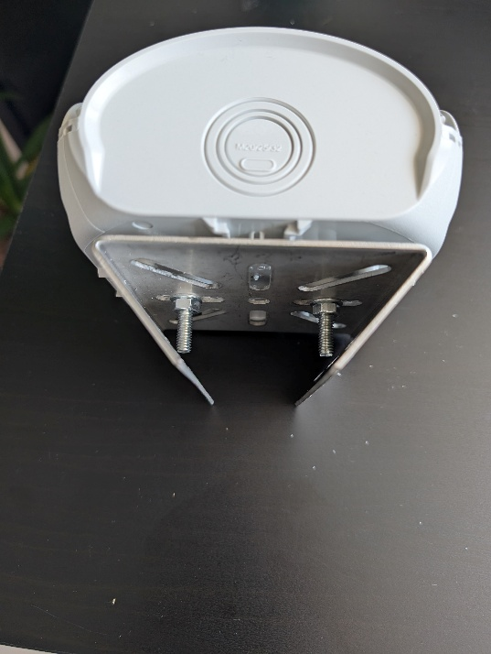

Insert the plugs to make the enclosure watertight.
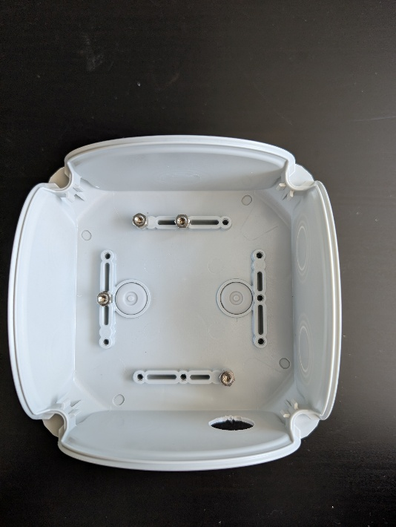

Screw the plastic spacers loosely on the PCB. Make sure you are still able to wiggle them.
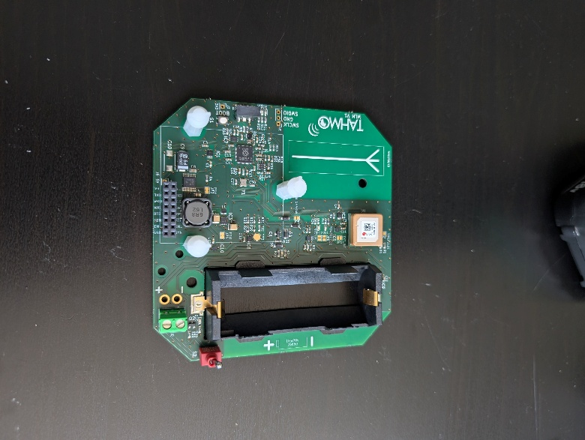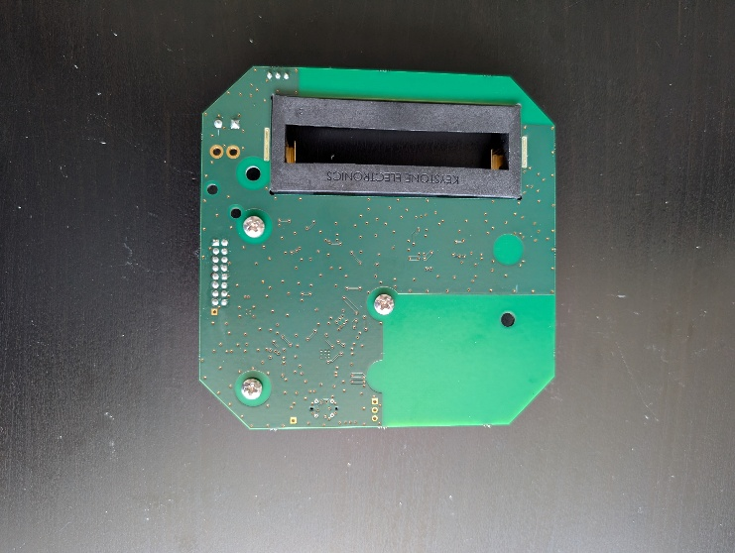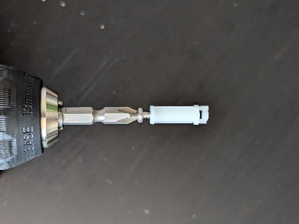
Mount the Rockblock and tighten the spacers.
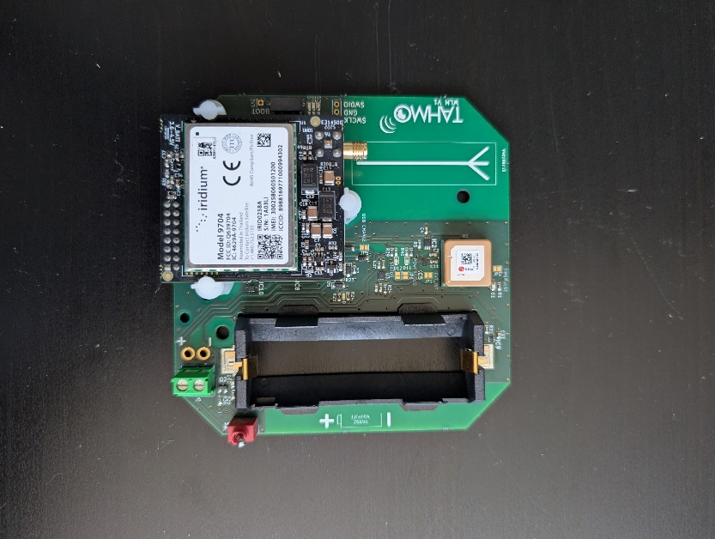
Solder the extension cable to the PCB. Alternative: Use the screwterminal.
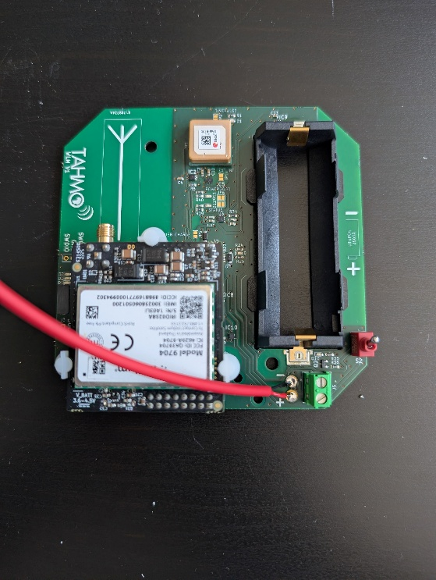
Mount the PCB in the enclosure with two bolts.
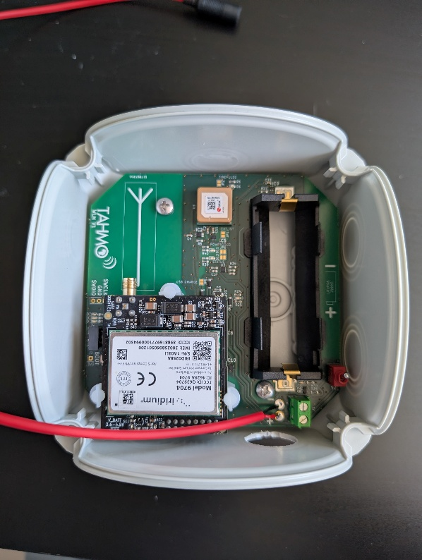
Add a bit of tape around the swivel to give it more grip into the enclosure. Pull the cable through and screw it into the enclosure.
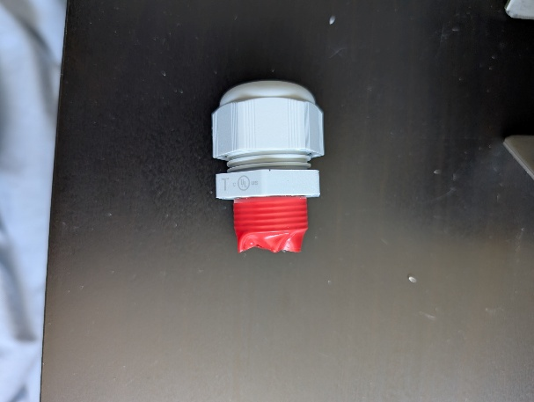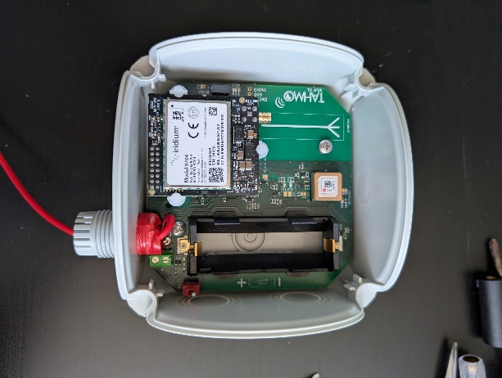
Add a bit of tape around the cable to increase its diameter. Tighten the swivel.
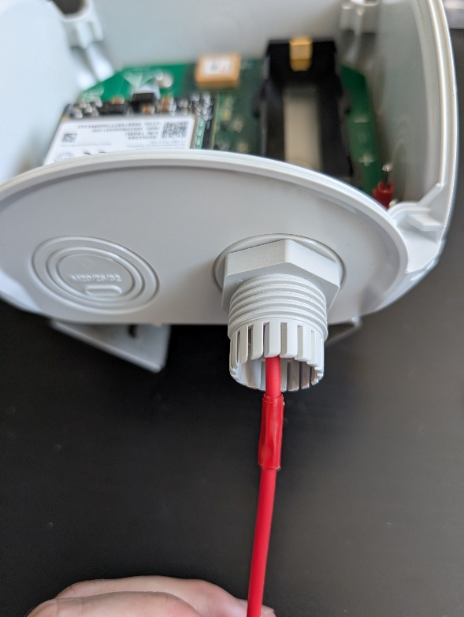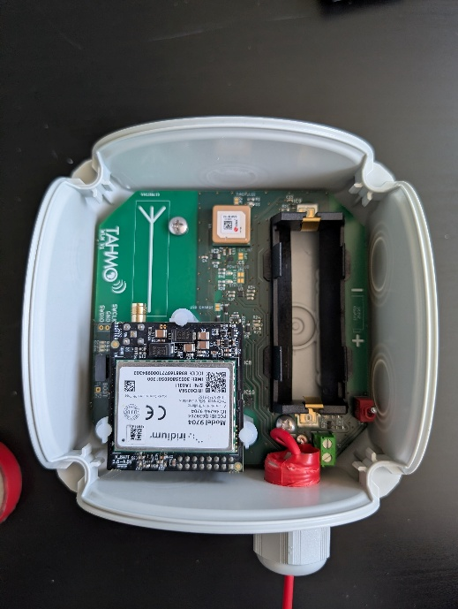
Screw the antenna on and mount the battery.
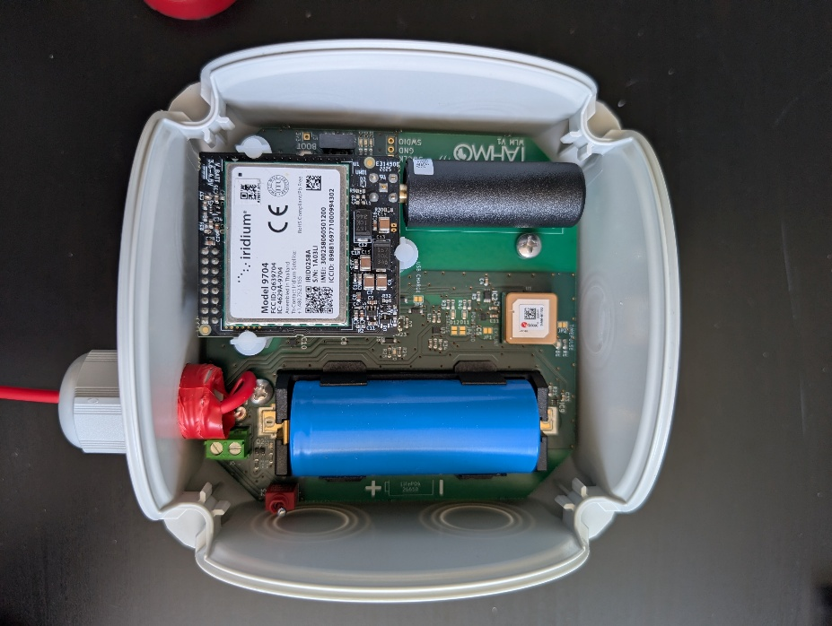

Close the lid.
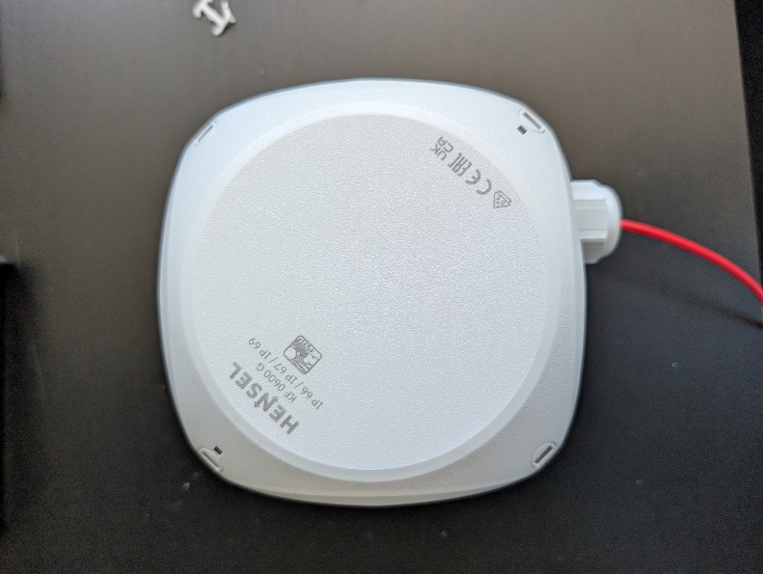

Enable USB charging
If charging over USB is required, the pads marked ‘USB Charge’ should be connected with a drop of solder. This will draw 500mA from any
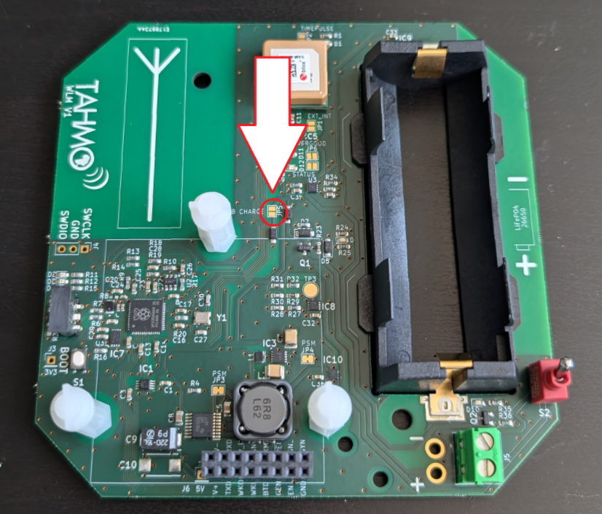

Assembly Solar panel
Drill the two holes with 3.5mm.
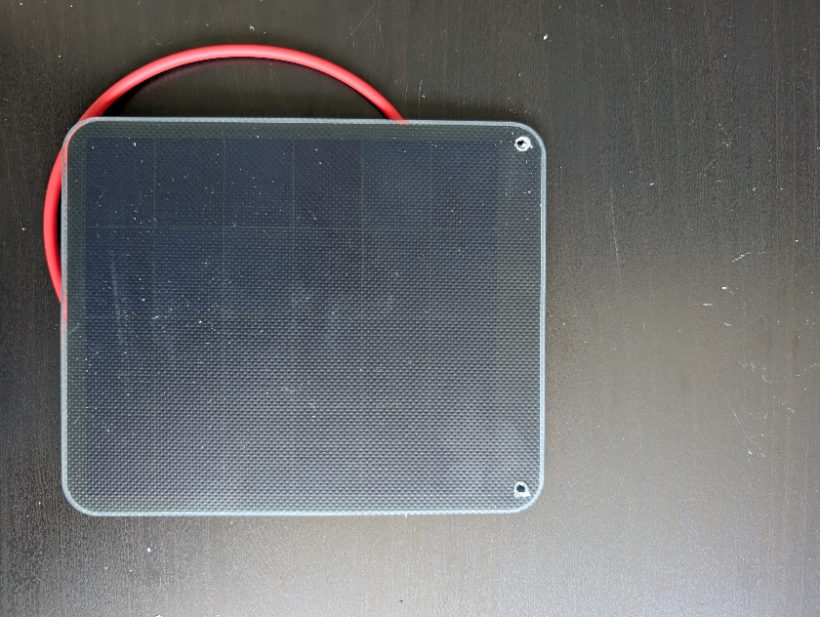
Attach bracket with bolts and nuts. (Orientation depends on how it will be mounted)
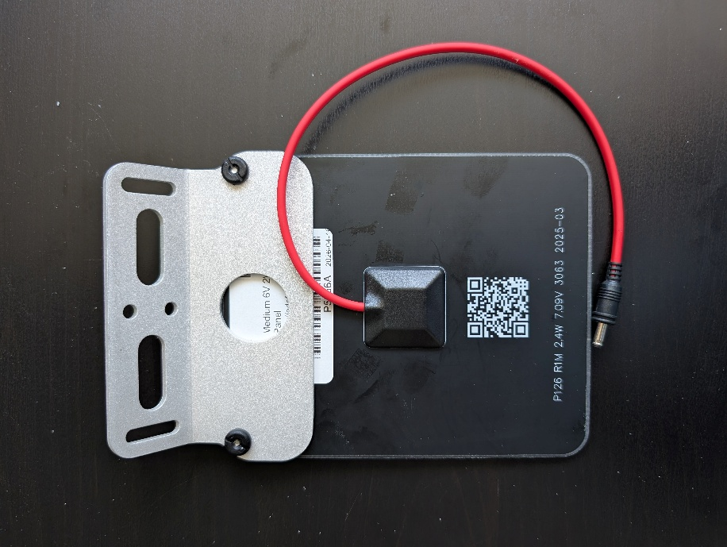

Flashing firmware
To deploy the firmware on the device, follow the steps using https://stefanloen.github.io/tahmo/flash.html.

