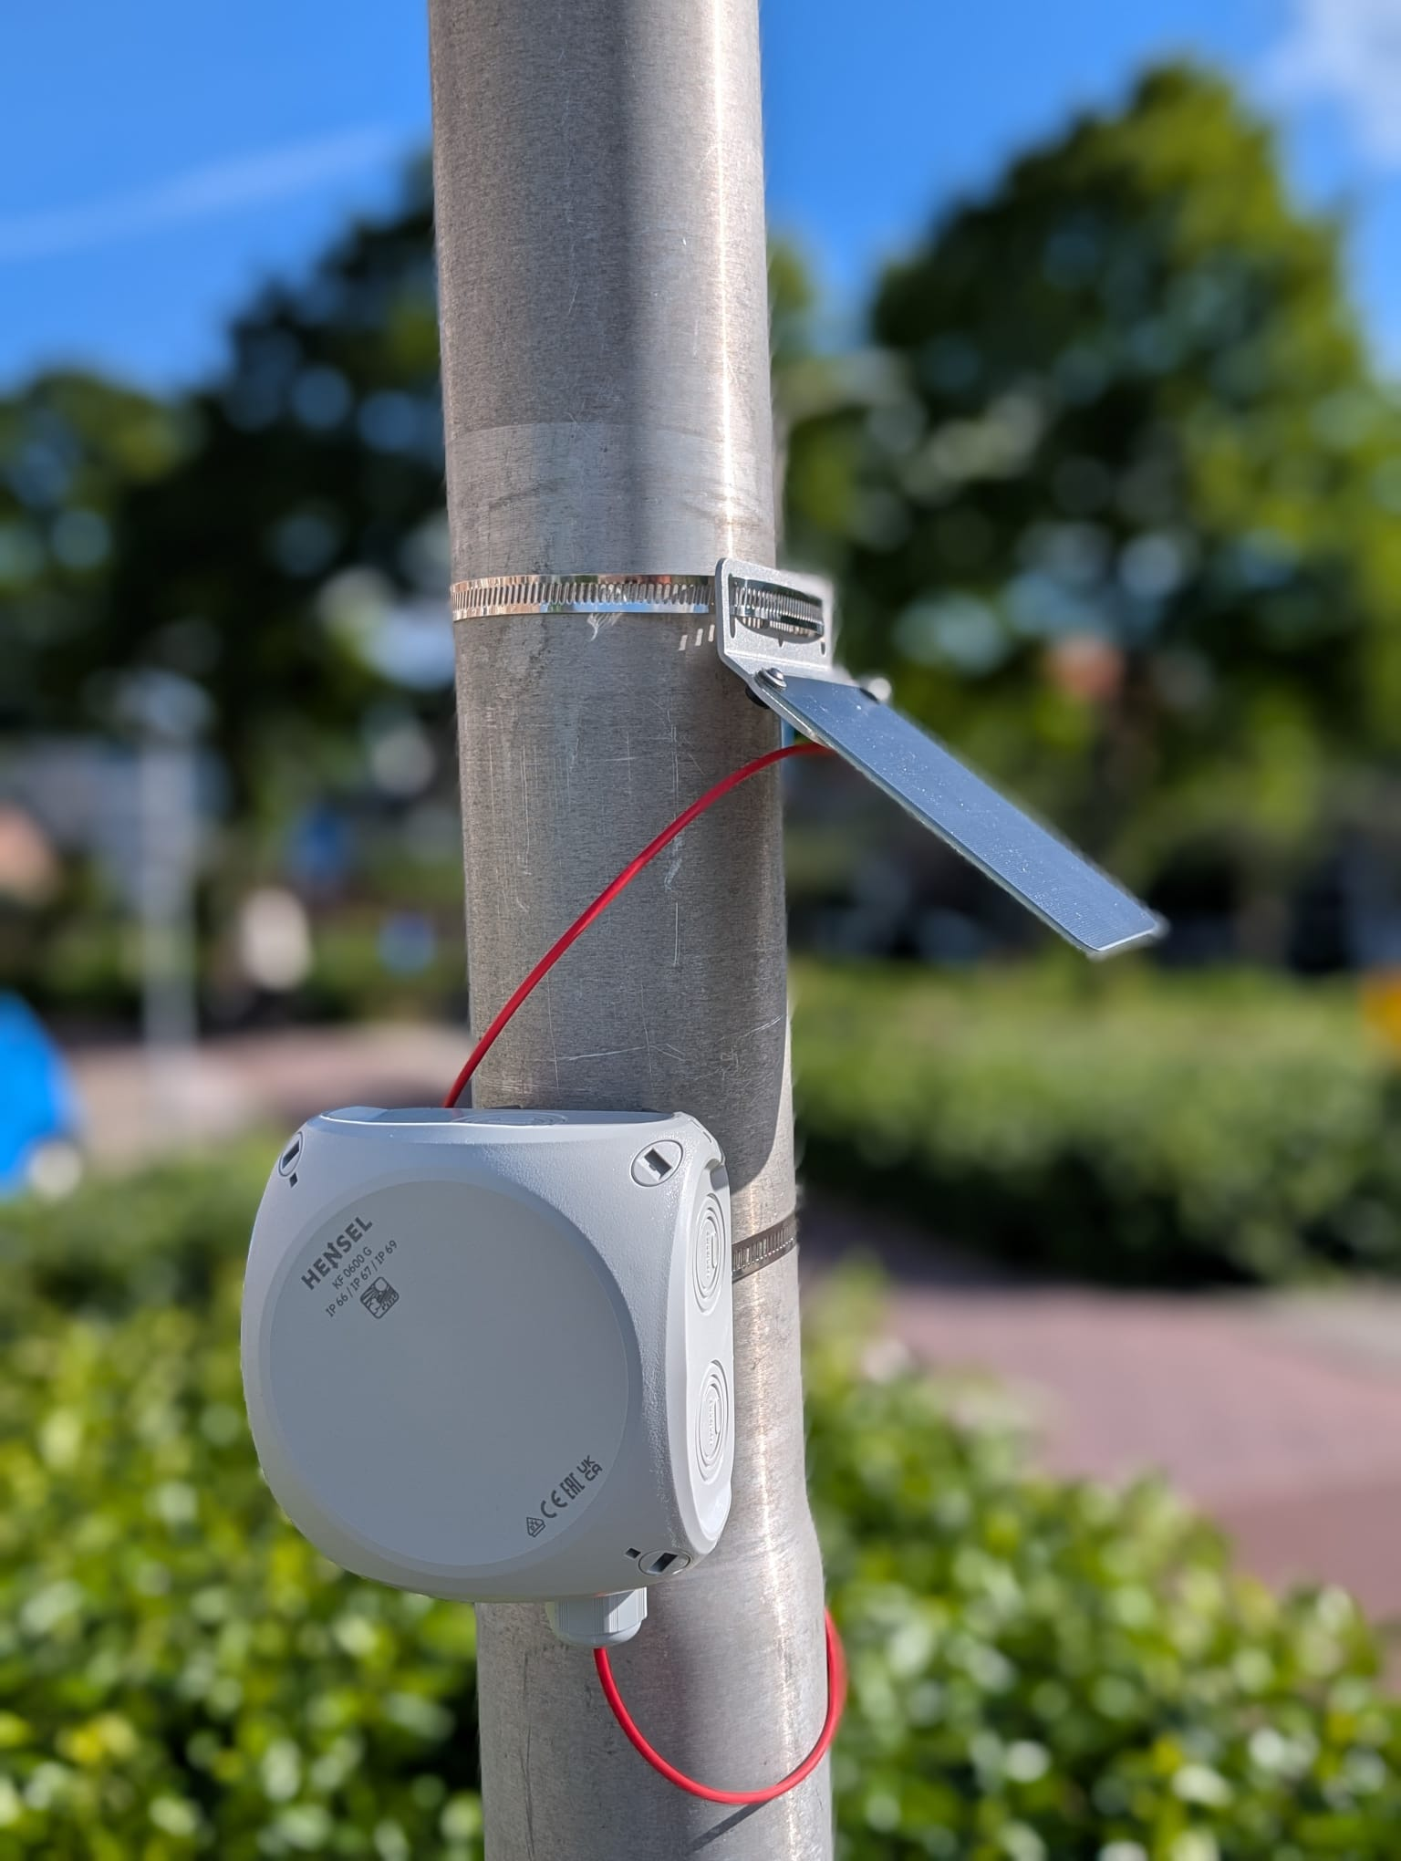

WLM User Manual

TAHMO Water Level Monitor system

This manual assumes that the device is already fully assembled including the battery and firmware. See assembly manual first if that is not the case.

Feature overview
- GNSS: L1 Band, (GPS L1 C/A, QZSS L1 C/A L1S, GLONASS L1OF, BeiDou B1C, and Galileo E1B/C)
- Satellite communication: Iridium network
- Solar panel: 5V, device regulates 500mA maximum.
- Operating temperature: -20°C to 60°C (however, solar panel will not work <0°C)
- Operation time without solar panel: > 2 days.
- 17 hours raw data storage
- Configuration via USB
- Power toggle switch. When on green LED blinks every 5 seconds.
- Charging using USB (Note: If enabled on PCB, No indicator)
- Reverse polarity protection, Battery & Solar panel. LED indicator

Installation
Place the system next to the water. Positioning is very important. The system needs to see reflections from the water. The spherical sector with an unobstructed view of the water should be as large as possible. The spherical sector is defined by the min-max azimuth and min-max elevation/altitude. A useful tool to see the reflection zones is https://gnss-reflections.org/rzones
Recommended elevation: 5° to 30°
Recommended azimuth: 90° minimal window. Bigger window is always better.

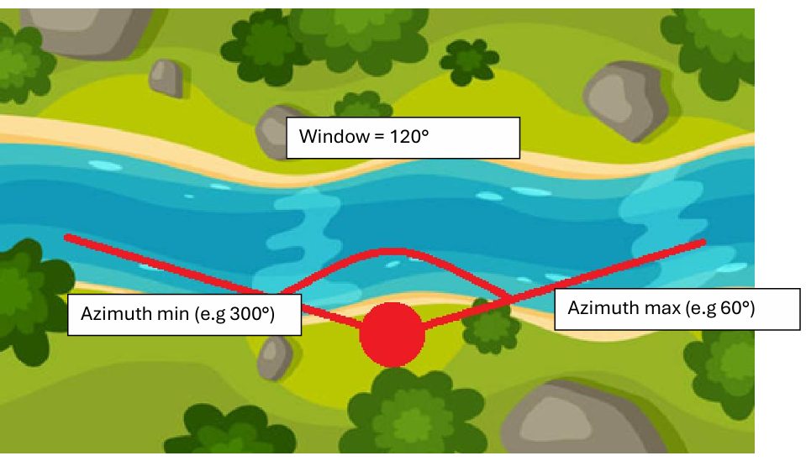
Figure 1: Example setup

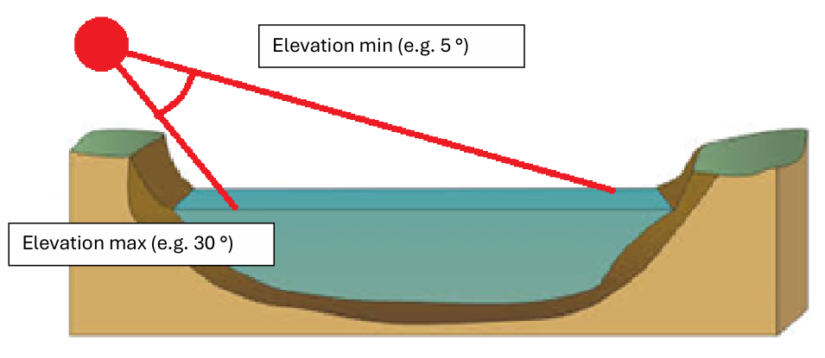
Figure 2: Example elevation setup
Other positioning requirements:
- The solar panel should be facing the sun.
- The cover of the system needs to roughly face the water. Orientation is okay as long as the azimuth window is on the cover side of the system.
- View to the sky should be as unobstructed as possible.
- Large reflective surfaces (e.g. a car) close to the system should be avoided

Measurement details
There are a couple things that need to be configured:
Min and max azimuth window: This is where the water is located relative to the sensor. Finding the correct values can be done using a map or compass.
Min and max elevation window: This is how far the sensor should ‘look down’ towards the water.
Min and max relative height: This is the range of heights relative to the system for which measurements are expected. Setting this range larger than necessary might result in incorrect measurements.
Measurement midpoints and duration: Measuring is a matter of averaging over a long time. This defines when and how long measurements should be taken. Longer measurements are always better but consume more power. The measurements schedule is defined by a start-time, number of measurements per day, and the sector duration. For example, start-time=00:00:00, number=4, duration=120 minutes results in the following schedule:
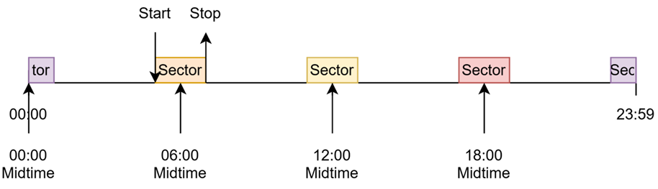

Configuration
The device can be configured using any device capable of serial USB communication. The dedicated webpage to do this is https://stefanloen.github.io/tahmo/console.html, but other applications such as Serial USB Terminal on Android or SST Simple Serial Terminal on Windows will work as well. This manual focuses on the webpage console.

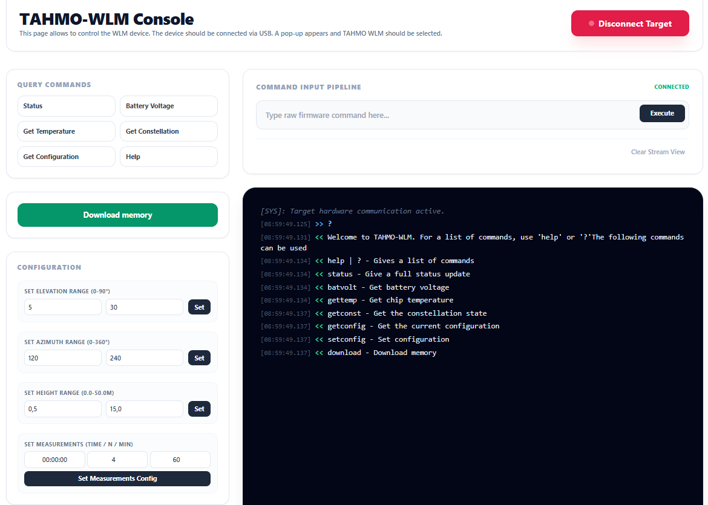
Figure 3: TAHMO-WLM Console is used to connect to the WLM device and set the configuration

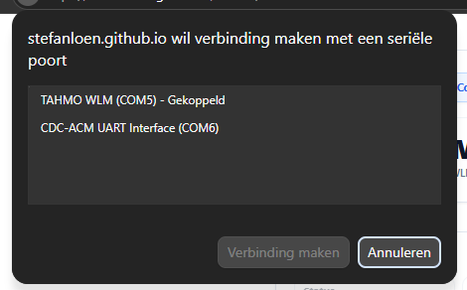
Figure 4: Popup where "TAHMO WLM" should be selected

The console is built on top of a plain text communication terminal, which is always visible in the serial viewer. The user can either send raw commands using the command input pipeline or use the Query Commands and Configuration shortcuts.
 | There are certain edge cases where configuration is set incorrectly. After setting configurations, always check with getconfiguration.

 | Communication sometimes fails, resulting in the message ‘aborted’. If this happens simply try again.

When a connection is established, the following message will appear:
Welcome to TAHMO-WLM. For a list of commands, use 'help' or '?'

Available commands:
help
Returns a list of available commands.

status
Returns the status of the device. It shows for example when the following measurement will be taken and which measurement is ready to be transmitted.

batvolt
Returns the battery voltage.

gettemp
Return the chip temperature

getconst
Returns the current constellation state, this might take a minute or two. This can be used to test the Rockblock. If constellation is not visible, installment location might be incorrect. Incorrect installment locations include under trees. However, even when constellation is not currently visible. It might be visible when satellites change positions. For the curious, satellite positions can be found on this website, https://iridiumwhere.com/.

getconfig
Returns the current configuration.

setconfig help
Returns a list of commands that can be combined with the setconfig command.

setconfig elevation <min> <max>
Sets the min and max elevation.
Example use: setconfig elevation 5 30

setconfig height
Sets the min and max relative height that is expected to be measured. It helps the system filtering out signals that fall outside of this range.
Example use: setconfig height 0.5 15

setconfig azimuth <min> <max>
Sets the min and max azimuth.
Example use: setconfig azimuth 120 240

setconfig measurements <midpoint> <n> <duration>
Sets the measurements schedule. It is defined by a midpoint (UTC+0), the number of measurements per day and the duration of a measurement in minutes.
Example use: setconfig measurements 00:00:00 4 120

download
This command triggers a full dump of memory over the serial USB connection. To store the raw data, one should use the ‘Download memory’ button on the webpage. This will call the ‘download’ command automatically and provides a ZIP file with data.

Collecting measurements
All transmitted measurements are stored at https://data.cloudloop.com/. Data can be downloaded with the export function. The retrieved .CSV file can be viewed using https://stefanloen.github.io/tahmo/cloudloop.html. This plots the battery voltage, temperature and measured relative height over time. The decoded transmitted packets can also be found in table format.
Explanation F/NO/CH/ST Fractions:
This represents the states from the charge controller since the last transmission. It tells which fraction of the time it was in each state:
F: Fault
No: No input (Sun is not shining or solar panel is not connected
CH: Charging
Standby: Solar power available but not charging because battery is full or charging is blocked by temperature limits.

Collecting raw data
To collect the raw data directly from the device, use https://stefanloen.github.io/tahmo/console.html. Connect and click ‘download’. This will extract the data and provide a ZIP file. The ZIP file contains 4 .CSV files. For the explanation of these files, one is advised to look at the firmware code.

