## TOC

Contents

TOC 1

History 1

FW-update 2

FW-update with 'new' repo 'wireless_wifi' 3

#eof 5

## History

v1.5: successful version using current wireless-repo 'wireless_wifi' (SL, 15.11.22)

## FW-update

HW setup for FW-update

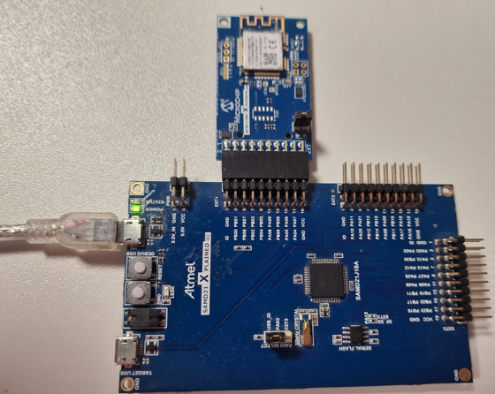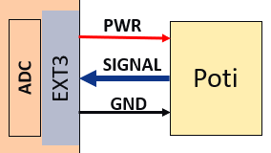

### FW-update with 'new' repo 'wireless_wifi'

Follow steps from C:\mchp\mTools\harmony\v3\wireless_wifi\docs\index.html

Steps that need to be done to update the WINC1500-FW are

1. create image with 'image_tool'
2. program serial_bridge.X into SAMD21
3. download new image (->'1') into WINC1500

#### create new image with image_tool

Tried to run from different directories BUT only work if run from

$RunDir=<h3>\wireless_wifi\utilities\wifi\winc\files\winc1500\

Instructions on index.html mentioned cmd line to use:

(dos)> image_tool.exe -c winc1500_19.6.1\config.txt -o winc1500_19.6.1.prog -of prog

but that doesn't work -> working cmdLine looks like this (must run from $RunDir -> see Test1,2!!):

(dos: winc1500\)> ..\..\tools\image_tool.exe \  
-c winc1500_19.7.7\flash_image.config -o winc1500_19.7.7.prog -of prog

First fails as provided flash_image.config has an invalid statement '[gain table]' -> just removed and now successfully creates $runDir\winc1500_19.7.7.prog'

#### serialBridge-FW

next need to download FW-update prj into SAMD21-xpl + WINC1500=EXT1 -> this creates a serial-bridge from 'hostPC-uart -> SAMD21 -> EXT1 -> WINC1500-uart' so you can download the new FW in step3 through this path.

Start MPLABX and load FW-update-prj <h3>\wireless_wifi\apps\serial_bridge\firmware\sam_d21_xpro_winc1500.X

Now make+download -> AND then press HW-reset button or power-cycle board

->now you've the new winc1500-image (->'1') and prepared your setup to provide a bridge from hostPC where the new image created in '1' is located to the WINC1500 (->'2'), so you can continue to download the new WINC1500-FW next

#### _

#### Update FW on winc1500

**!! For the FW-update which uses the uart-IF, make sure you don't have a terminal-program like terraTerm/putty open on the vCOM-IF !!**

Now update the WINC1500-FW created in '1' through bridge from host-2-winc (->'2) with this cmdline (again must run from $runDir! and find vCOM-port of your SAMD21):

(dos: winc1500\)> ..\..\tools\winc_programmer_uart.exe \  
-p COM8 -d winc1500 -i winc1500_19.7.7.prog -if prog -w -r \  
-pfw 19.7.7\firmware\programmer_firmware.bin

->while FW-update is running the orange STATUS-LED on the SAMD21 is on

-> the final msg 'verify passed' informs about successful FW-update of the WINC1500

# #eof