MPLAB X IDE - Generating binary file - xc32 Compiler
This article gives steps to generate .bin file for MPLAB X project (with XC32 compiler)
Feb 26, 2020•Knowledge

Article URL:
https://microchipsupport.force.com/s/article/MPLAB-X-IDE---Generating-binary-file---xc32-Compiler

Question:
How to create/get the .bin file for my MPLAB X project?
Answer:
MPLAB X does not create .bin file by default. So, we need to use post build commands to generate the .bin file.
Go to Project Properties -> Building. Enable the ‘Execute this line after build’ option and insert the following command.
${MP_CC_DIR}\xc32-objcopy -I ihex -O binary "${DISTDIR}/${PROJECTNAME}.${IMAGE_TYPE}.hex" "${DISTDIR}/${PROJECTNAME}.${IMAGE_TYPE}.bin"
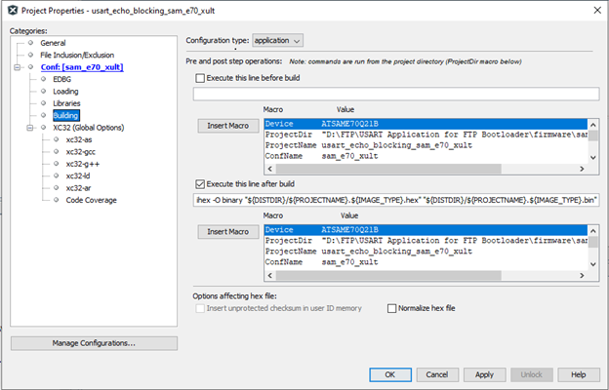
Build the project (F11), and the bin file output can be found in the following path: <your_project>.X\dist\..\production\
URL Name
MPLAB-X-IDE---Generating-binary-file---xc32-Compiler

