Load Testing Report - Warehouse Management System
Author: Nikola Bandulaja
Date: January 26, 2026
Course: Napredne web tehnologije

1. System Specifications

Test Environment
Component | Specification
Operating System | Windows 11 Pro
Processor | Intel Core i5 10600
RAM | 16 GB DDR4
Storage | Samsung SSD 512GB
Java Version | OpenJDK 23

Application Stack
- Backend: Spring Boot 3.x with JPA/Hibernate
- Databases: PostgreSQL (relational), InfluxDB (time-series)
- Load Testing Tool: Locust 2.x (Python)

2. Test Objectives
The goal was to evaluate the performance of warehouse and product management endpoints under high load (1000 concurrent users).

Endpoints Tested (12 total)
# | Endpoint | Method | Description
1 | /api/v1/warehouses/paged | GET | Paginated warehouse listing
2 | /api/v1/warehouses/search/paged | GET | Warehouse search with pagination
3 | /api/v1/warehouses/{id} | GET | Get warehouse by ID
4 | /api/v1/warehouses/{id}/availability/stats | GET | Availability statistics (InfluxDB)
5 | /api/v1/warehouses/countries | GET | Get countries list
6 | /api/v1/warehouses | POST | Create warehouse (multipart)
7 | /api/v1/products/paged | GET | Paginated product listing
8 | /api/v1/products/search | GET | Product search with filters
9 | /api/v1/products/{id} | GET | Get product by ID
10 | /api/v1/products/{id}/availability | GET | Product stock availability
11 | /api/v1/orders | POST | Create order
12 | /api/v1/orders/my-orders | GET | Customer order history

3. Test Scenario

Stress Test: 1000 Concurrent Users
Parameter | Value
Concurrent Users | 1000
Spawn Rate | 200 users/second
Duration | 5 minutes
Total Requests | 128,341
Failed Requests | 0 (0%)

4. Test Results

Summary Statistics
Metric | Value
Total Requests | 128,341
Failed Requests | 0 (0%)
Requests/sec | 427.5
Median Response Time | 9 ms
Average Response Time | 15.3 ms
95th Percentile | 43 ms
99th Percentile | 150 ms
Max Response Time | 1314 ms

Per-Endpoint Performance
Endpoint | Requests | Avg (ms) | Median (ms) | 95th (ms) | Max (ms)
GET /warehouses/paged | 10,060 | 17.8 | 12 | 41 | 436
GET /warehouses/search/paged | 8,044 | 21.5 | 15 | 47 | 513
GET /warehouses/{id} | 13,555 | 13.1 | 7 | 34 | 437
GET /warehouses/{id}/availability/stats | 6,876 | 24.1 | 18 | 48 | 463
GET /warehouses/countries | 2,006 | 13.1 | 7 | 38 | 460
POST /warehouses | 2,085 | 23.5 | 12 | 69 | 504
GET /products/paged | 10,077 | 12.9 | 7 | 34 | 476
GET /products/paged (Customer) | 14,513 | 12.6 | 7 | 36 | 328
GET /products/search | 8,309 | 13.0 | 7 | 33 | 461
GET /products/search (Customer) | 10,861 | 12.2 | 7 | 34 | 321
GET /products/{id} | 10,198 | 12.2 | 7 | 31 | 437
GET /products/{id} (Customer) | 10,913 | 12.4 | 7 | 34 | 430
GET /products/{id}/availability | 6,659 | 12.4 | 6 | 32 | 485
GET /products/categories | 3,416 | 12.7 | 7 | 34 | 320
POST /orders | 3,707 | 35.5 | 13 | 98 | 1314
GET /orders/my-orders | 7,057 | 17.4 | 12 | 43 | 347

5. Performance Analysis

Charts
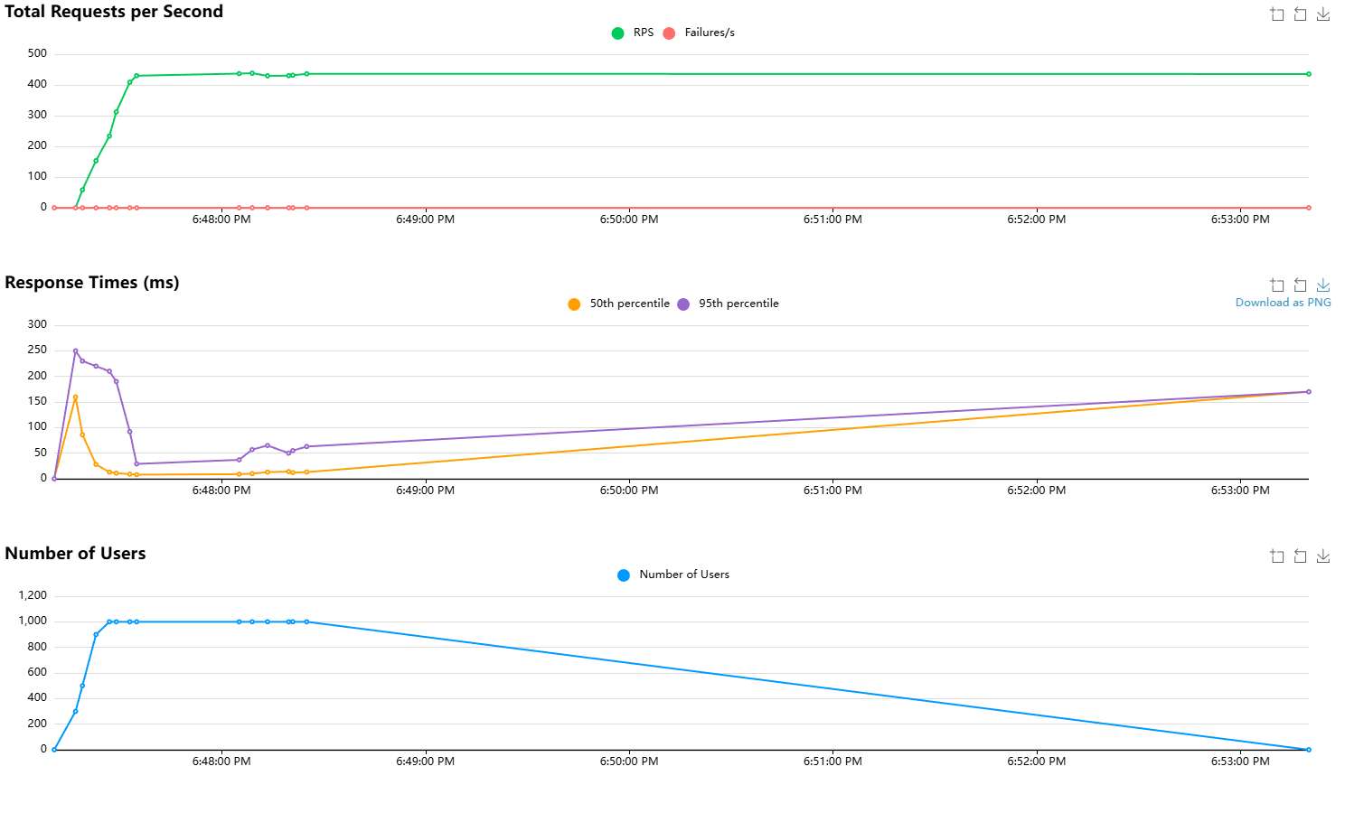

Observations

✅ Well-Performing Endpoints
- GET /products/{id}/availability - Fastest (6ms median)
- GET /products/{id} - Very fast (7ms median)
- GET /warehouses/{id} - Excellent performance (7ms median)
- GET /products/paged - Good response (7ms median)

⚠️ Slower Endpoints
- POST /orders - Slowest endpoint
  - Average: 35.5ms, Max: 1314ms
  - Reason: Order creation involves multiple database operations (insert order, order items, update stock)
- GET /warehouses/{id}/availability/stats - Second slowest
  - Average: 24.1ms, 95th: 48ms
  - Reason: Queries InfluxDB time-series data with aggregations
- GET /warehouses/search/paged - Higher latency
  - Average: 21.5ms, Median: 15ms
  - Reason: Full-text search operations

6. Performance Bottlenecks & Improvements

Identified Bottlenecks
Bottleneck | Endpoint | Cause
Transaction overhead | POST /orders | Multiple DB operations in single transaction
InfluxDB Queries | /availability/stats | Time-range aggregations
Search Queries | /search/paged | Text search without proper indexing

Implemented Improvements

1. Database Indexing (PostgreSQL)
CREATE INDEX idx_warehouses_name ON warehouses(name);
CREATE INDEX idx_warehouses_city ON warehouses(city_id);
CREATE INDEX idx_products_name ON products(name);
CREATE INDEX idx_products_category ON products(category);
CREATE INDEX idx_orders_customer ON orders(customer_id);
CREATE INDEX idx_warehouse_sectors_warehouse ON warehouse_sectors(warehouse_id);

2. Pagination Implementation
All list endpoints use server-side pagination (default: 20 records).

3. Connection Pooling
HikariCP configured with maximum-pool-size=20.

Recommended Future Improvements
Improvement | Priority | Estimated Impact
Redis caching for warehouse/product lists | High | -50% response time
Async order processing | High | -40% for POST /orders
InfluxDB query optimization | Medium | -30% for stats endpoints
Read replicas for PostgreSQL | Low | Improved read scalability

7. Conclusions

Key Findings
- System handles 1000 concurrent users excellently with 0% error rate
- High throughput achieved: 427.5 requests/second
- Response times remain low: 9ms median, 15.3ms average
- Order creation is the bottleneck - needs optimization for higher loads

Performance Acceptance Criteria
Criterion | Target | Actual (1000 users) | Status
Average Response Time | < 100ms | 15.3ms | ✅ PASS
95th Percentile | < 500ms | 43ms | ✅ PASS
Error Rate | < 1% | 0% | ✅ PASS
Throughput | > 100 req/s | 427.5 req/s | ✅ PASS

Final Assessment
The warehouse management system demonstrates excellent performance under 1000 concurrent users with zero failures. The architecture is production-ready and can scale further with recommended optimizations.

8. Appendix

Test Files
- Locust script: load-testing/warehouse/locustfile.py
- HTML Report: Locust_2026-01-26-18h47_locustfile.py_http___localhost_8080.html

How to Run Tests
pip install locust
python -m locust -f locustfile.py --host=http://localhost:8080

