Multi-criteria optimization of budget allocation for resilience improvement of interdependent critical infrastructures exposed to natural hazards

Santiago Taguado Menza
Department of Energy, Politecnico di Milano, Via la Masa 34, 20156, Milano, Italy. E-mail: santiago.taguado@polimi.it
Thomas Matteo Coscia
Department of Energy, Politecnico di Milano, Via la Masa 34, 20156, Milano, Italy. E-mail: thomasmatteo.coscia@polimi.it
Stefano Marchetti
Department of Energy, Politecnico di Milano, Via la Masa 34, 20156, Milano, Italy. E-mail: stefano.marchetti@polimi.it

The resilience of interdependent Critical Infrastructures (CIs) can be strengthened through targeted investments to mitigate the economic and social consequences of disruptive natural events. The optimal allocation of limited resources is challenged by the dynamic and conflicting preferences of decision-makers, as well as by the uncertainty associated with Climate Change (CC) impact on natural hazards frequency and magnitude. In this work, the budget allocation problem is formulated as a Sequential Decision Problem (SDP), which is solved with Deep Reinforcement Learning to identify the investment policy that minimizes the expected losses caused by disruptive events and the investments cost during the CIs lifetime. The novelty of the approach lies in the integration of: i) multi-criteria decision making to account for evolving stakeholder preferences within the SDP, ii) the probabilistic modelling of investments effectiveness according to CIs response to CC-induced natural hazards. The framework is applied to interdependent power and gas networks subject to coastal flood-induced disruptions. Results show that the method can adapt to changes in stakeholder preferences as well as changes in natural hazards intensity, providing a flexible approach for resilience-oriented investment planning under uncertainty.

Keywords: Critical Infrastructures (CIs), Resilience, Sequential Decision Problem (SDP), Climate Change (CC), Deep Reinforcement Learning (DRL).

- Introduction
Critical Infrastructures (CIs) are networks of independent systems (e.g., gas networks, power systems) that provide essential commodities and services (Ouyang 2014). Because of their interdependency, CIs are exposed to cascading failures, exacerbated by the increasing severity and frequency of extreme natural hazards (e.g., floods, droughts, landslides, and forest fires) due to Climate Change (CC) (Ouyang 2014; Fang et al. 2019). Thus, resilience, i.e., the capacity to absorb and recover from such events, is key (Cimellaro et al. 2010; Liu et al. 2021). Given these considerations, long-term investment planning targeted at enhancing CIs resilience focuses on proactive decisions (e.g., hardening, upgrades, and redundancy) to reduce future disruptions and accelerate recovery.
Choosing an efficient sequence of resilience improvement actions is a challenging decision-making problem due to: i) the scarcity of allocated budget, which is typically subdivided on a multi-decadal time scale, ii) the stochastic response of CIs to improvement actions, and iii) the dynamic evolution of stakeholder preferences during such long-term investment horizon. Therefore, adaptive sequential decision-making frameworks are required, that integrate multiple models (e.g., CI, natural hazard, fragility, recovery actions) to explore the consequences of extreme events and to capture the non-stationary effects of CC on hazard frequency and intensity (Nozhati 2021) as well as changes in stakeholder preferences.
Conventional approaches mainly use various optimization methods (e.g., Dynamic Programming (DP), Approximate Dynamic Programming (ADP)) to derive near-optimal recovery and investment decisions under time-dependent resource constraints (Nozhati 2021). Examples include stochastic and multi-level investment optimization recovery planning under hazard and climate uncertainty (Abdin et al. 2019; Fang et al. 2019; Bakhtiari et al. 2025). However, these are limited to discrete state and action spaces, and the derived solutions may not generalize beyond the conditions assumed during optimization.
To address these limitations, Reinforcement Learning (RL) approaches are employed (Papakonstantinou and Shinozuka 2014; Nozhati et al. 2019; Nozhati et al. 2020). More recently, Deep reinforcement learning (DRL) has been used to enhance recovery policies beyond conventional baselines, and transfer learning has shown to reduce the training burden for scenarios that fall outside training conditions (Hosseini and Parvania 2022; Akashi et al. 2023; Jacob et al. 2024; Yang et al. 2024; Liang et al. 2026).
However, existing DRL studies do not address both the changing stakeholder preferences over time (i.e., static preferences) and climate-driven non-stationarity (Wang et al. 2024). To address these limitations, we propose a novel adaptive DRL policy for sequential resilience investment planning that integrates multi-criteria preferences into the reward function and accounts for CC-driven hazard uncertainty through a probabilistic evaluation of investment effectiveness. The approach is demonstrated on a realistic case study of interdependent power and gas networks exposed to coastal flooding. Results show that the learned policy adapts to evolving preferences and improves resilience outcomes under uncertainty.
The paper outline is as follows: Section 2 describes the proposed framework, Section 3 introduces the case study, Section 4 presents the results, and Section 5 concludes.

2. Proposed framework
The proposed framework consists of: i) a network-based model of the interdependent CIs which account for cascading failures (Section 2.1), ii) a copula-based model of the time dependent hazard intensity-duration relationship (Section 2.2), iii) a DRL based optimization of the budget allocation scheduling for resilience improvement (Section 2.3).
2.1. Critical infrastructure model
We consider a set of interdependent CIs indexed by $i=1,2,…,I$. Each $i$-th CI is modeled as a directed graph:
$$G_{i}=\left(N_{i},E_{i}\right)$$ | (1)
where $N_{i}$ is the set of nodes and $E_{i}⊆ N_{i}×N_{i}$ is the set of directed edges internal to the $i$-th CI. Interdependencies are modeled through directional edges between different CIs, which for any couple $\left(i,j\right),$ with $j∈ \left\{1,2,….,I\right\}$ and $j≠i$, are defined as:
$$E_{\left(i→j\right)}⊆ N_{i}×N_{j}$$ | (2)
The overall interconnected CIs model is obtained by combining $G_{i}$ and $E_{\left(i→j\right)}$ $∀i≠j$, into a directed multilayer network (Clavijo Mesa et al. 2024; Clavijo Mesa et al. 2025).
Nodes are assumed to potentially fail due to a Disruptive Event (DE) of intensity $H$. Thus, for each node $n∈N_{i}$, a fragility function $F_{i}^{n }$ is defined, so that the probability of node failure can be defined as:
$$P\left(x_{i}^{n }=0 | H\right)=F_{i}^{n }\left(H\right)$$ | (3)
Where $x_{i}^{n }∈ \left\{0,1\right\}$ is a Boolean variable representing the $n$-th node post-DE state (0 failed, 1 working). Edges do not fail directly; instead, a directed edge is removed when one of its endpoint nodes fails, so that edge loss is induced by node failures. Consequently, nodes that are not directly failed can be disrupted by the loss of directed edges.
For each $i$-th CI, the magnitude of the disruption is quantified as the reduction of the supplied demand $U_{im}^{ } ∈ \left[0,1\right]$ due to the loss of connectivity between supplier nodes $N_{i}^{s } ⊂ N_{i}$ and consumer nodes $N_{i}^{c }⊂ N_{i}$ ($N_{i}=N_{i}^{s }∪N_{i}^{c }$), where $m=1, 2,…, M$ index the considered consumer categories. Let us define $d_{im}^{c }$ as the demand associated with the $m$-th consumer category supplied by the $c$-th consumer node of the $i$-th CI, with $c=1, 2,…, \left|N_{i}^{c }\right|$, and the Boolean variable $z_{i}^{c}∈\{0,1\}$ (equal to 1 if consumer $c$ is supplied after the DE) as:
$${ z}_{i}^{c}=1\left\{x_{i}^{c}=1∧∃s∈N_{i}^{s} :s⇝c\right\}$$ | (4)
where $s⇝c$ denotes the existence of at least one directed path from any supplier node $s∈ N_{i}^{s}$ to the $c$-th consumer node in the post-DE network. Then, the fraction of supplied demand is:
$$U_{im}\left(H\right)=\frac{\sum_{c=1}^{\left|N_{i}^{c}\right| }{d_{im}^{c } z_{i}^{c }}}{\sum_{c=1}^{\left|N_{i}^{c}\right|}{d_{i}^{c }}}$$ | (5)
It is worth mentioning that if all the consumer nodes are correctly supplied, i.e., $z_{i}^{c }=1 ∀c∈N_{i}^{c}$, then $U_{im}=1$. When a node fails, the associated restoration time $T_{i}^{n }$ is modeled as the DE event duration $T_{H}$, which is assumed to be correlated to the DE intensity, plus a repair time $T_{i}^{nr }$:
$T_{i}^{n }=T_{H}+T_{i}^{nr}$, $T_{ i}^{nr}\sim f_{i}^{n }\left(∙\right)$ | (6)
where $f_{i}^{n }\left(∙\right)$ is the specific repair-time Probability Density Function (PDF) of the $n$-th node. We assume that one repair crew is assigned to each failed node and that all repair actions start at the same time, so that the disruption experienced by the $m$-th consumer category due to the DE is evaluated as:
$$D_{im}\left(H\right)=\left(1-U_{im}\left(H\right)\right)\max_{n}\left(T_{i}^{n}\right)$$ |  | (7)

2.2. Natural hazard model
In this work, DE caused by natural hazards are of interest. For the sake of performing resilience assessment, a natural hazard can be characterized by a pair of random variables, namely: i) hazard intensity $H>0$ and ii) the associated duration time $T_{H}>0$. These variables are typically positively correlated (i.e., more severe events tend to persist longer), hence their joint modelling should not assume independence. Let $Y={\left\{\left(h^{l},t_{h}^{l}\right)\right\}}_{l=1}^{L}$ denote a collection of historical data, where $h^{l}$ is an observed realization of hazard intensity and $t_{h}^{l}$ is the corresponding hazard duration. The marginal Cumulative Distribution Functions (CDFs) of $H$ and $T_{H}$ are estimated from $Y$ using standard univariate inference, so that:
${ F}_{H}\left(h\right)=P\left(H≤h\right)$, $F_{T_{H}}^{ }=P\left(T_{H}≤t_{h}\right)$ | (8)
with associated PDFs $f_{H}\left(h\right)$ and $f_{T_{H}}\left(t_{h}\right)$, respectively. Dependence between $H$ and $T_{H}$ is quantified via correlation measures (Kendall’s $τ$ and Spearman’s $ρ_{ }$) estimated from $Y$ and modelled through a copula function $C\left(∙\right) : {\left[0,1\right]}^{2}→\left[0,1\right]$. The joint CDF is given by Sklar’s theorem as:
$$F_{{H,T}_{H}}^{ }\left(h,t_{h}\right)= C\left(F_{H}\left(h\right),F_{T_{H}}^{ }\left(t_{h}\right),ϑ\right)$$ | (9)
where $ϑ$ are the copula parameters. At discrete future times $T_{k}$ indexed by $k=1, 2,…,K$, correlated realizations of $\left(h_{k},t_{hk}\right)$ are generated as follows. For each $T_{k}$, a pair $\left(u_{k},v_{k}\right) ∈ {\left[0,1\right]}^{2}$ is sampled from $C\left(∙\right)$ (Salvadori and De Michele 2004) and by applying the probability integral transform theorem, we obtain:
$h_{k}^{0}{=F}_{H}^{-1}\left(u_{k}\right)$, $t_{hk}=F_{T_{H}}^{-1}\left(v_{k}\right)$ | (10)
to include non-stationarity (CC and anthropogenic effects), an additive time dependent factor of change ${∆h}_{k}$ is applied to the hazard intensity as (Kirezci et al. 2020):
$h_{k}=h_{k}^{0}+{∆h}_{k}$ | (11)
It is worth noting that this is a simplified hazard formulation which preserves the dependence structure identified from $Y$ (Copula parameters $ϑ$ are stationary) while shifting the hazard intensity over time.

2.3. Budget allocation optimization
In this work, the budget allocation problem is defined as an SDP which is characterized by the set $Σ,Α,Π, R,$ $γ$, where (Sutton and Barto 2018):
- $Σ$ is the state space (i.e., the set of all possible system states, where each state is a vector of variables that fully describes the state of the system);
- $Α$ is the action space (i.e., the set of possible investments );
- $Π$ is the set of transition probabilities (i.e., $π(σ_{k+1}|σ_{k},α)∈Π$ is the probability to make a transition from state $σ_{k}$ to state $σ_{k+1}$ when an action $α$ is performed);
- $R$ is the reward function (i.e., $R(σ_{k+1}|σ_{k},α)$ is the reward corresponding to the state change from $σ_{k}$ to $σ_{k+1}$ because of $α$);
- $γ∈[0,1]$ is the discount factor, which is used to evaluate the present value of future rewards.
The SDP aims at finding the optimal investment policy, which determines, for each state $σ$, the sequence of actions to be adopted at each decision time $T_{k}$ to maximize the reward over the mission time $T_{M}$. Since resilience investments must reflect decision-maker preferences, their optimal allocation depends on how different infrastructure commodities (e.g., electricity and gas) and impacts (i.e., social and economic) are valued. To capture this aspect, the proposed framework uses a multi-criteria preference structure, defined through a set of normalized weights $w_{i}$ associated with different commodities and, for each commodity, a set of impact-specific normalized weights $w_{ip}$. For the sake of simplicity, the dependence from the hazard intensity $H$ is omitted in what follows. These weights are embedded in the reward function of the SDP, defined as:
$$R\left(σ_{k+1}|σ_{k},α\right)=\sum_{i=1}^{I}{w_{i}\sum_{p=1}^{P}{w_{ip} Δ{\overline{I}}_{ip}}\left(σ_{k+1}|σ_{k}\right)}-Γ\left(α\right)$$ | (12)
where $Γ\left(α\right)$ is the cost of action $α$ and $Δ{\overline{I}}_{ip}(σ_{k+1}|σ_{k})$ is the difference between the expected p-th impact of the i-th commodity between system states $σ_{k}$ and $σ_{k+1}$ (i.e., the change due to action $α$). In this work, the impacts $I_{ip}\left(σ\right)$ are defined as follows:
- social impact: $I_{i1}\left(σ\right)=D_{i1}\left(σ\right)$, representing the disruption experienced by residential consumers;
- economic impact: $I_{i2}\left(σ\right)=\frac{D_{i1}\left(σ\right)+D_{i2}\left(σ\right)}{2}$, representing the aggregated disruption experienced by both residential and industrial consumers.
Each expected impact ${\overline{I}}_{ip}(σ_{k})$ is estimated with a Monte Carlo simulation with $N_{MCS}$ trials, sampling the hazard magnitude and duration and the CIs nodes failures and repair times.
The SDP is solved by Proximal Policy Optimization (PPO) (Schulman et al. 2017), which is a state-of-the-art actor-critic DRL implementation.
3. Case study
The framework of Section 2 is applied to a simplified model of the gas and electric network of Houston, Texas, USA, which is exposed to frequent costal floodings caused by the combination of extreme rainfall and storm surge during hurricanes (Valle-Levinson, Olabarrieta, and Heilman 2020). Moreover, the future vulnerability of this region to costal floods is exacerbated by the projected Sea Level Rise (SLR) due to CC (Miller and Shirzaei 2021) and by the concurrent subsidence of inland area due to groundwater and oil and gas extraction (Coplin and Galloway 1999). The considered time horizon of the budget allocation problem for resilience improvement is from 2025 to $T_{M}=$ 2100 with five years intervals between investments, for a total of $K=15$ sequential decisions.
3.1. CIs model
Fig. 1 depicts the CI system under study. The CI consists of a multilayer network composed of $I$ independent systems $i=1,2$, each represented by a directed graph $G_{i}=(N_{i},E_{i})$. For each i-th CI, nodes are divided into supplier nodes, $N_{i}^{s }$, and consumer nodes, $N_{i}^{c}$, where $N_{i}=N_{i}^{s}∪N_{i}^{c}$. Fig. 1 shows the CI systems under study and their interdependency (i.e., interlayer edges). Supplier nodes, $N_{i}^{s}$, include thermal generation units (i.e., coal and gas plants), Liquified Natural Gas (LNG) supply stations, compressors and renewable power plants (i.e., wind parks and solar farms), whereas consumer nodes, $N_{i}^{c}$, are modeled as county level electrical distribution stations (GridInfo 2026; Global Energy Monitor 2026). The asset catalog for $N_{i}^{s}$ and $N_{i}^{c}$ are reported in Table I and Table II, respectively. Notably, compressors interconnect the CI layers, but are omitted from the asset catalog as they represent artificial nodes, as opposed to the other realistically deployed supplier nodes. Also, in this representation, coal, solar and wind units compose the electrical layer, whereas gas units, LNG supply stations and compressors compose the gas network.
Table I. Supplier Node $N_{i}^{s}$ Catalog.
Name | Unit type, | Power (MW) | Lat. ($°$) | Long. ($°$) | Area ($km^{2})$
Roy S. Nelson | Coal | 841 | 30.28 | -93.29 | 2.4
Sabine | Gas | 1811 | 30.02 | -93.88 | 2.5
Lake Charles 1 | Gas | 2444 | 30.27 | -93.30 | 3.4
Cedar Bayou | Gas | 1530 | 29.75 | -94.93 | 2.1
Cottonwood | Gas | 1432 | 30.26 | -93.74 | 2.0
Channel-view | Gas | 918 | 29.84 | -95.12 | 1.3
Bacliff | Gas | 1036 | 29.49 | -94.98 | 1.4
Galveston | Gas | 1630 | 29.38 | -94.93 | 2.3
Free Port | Gas | 1344 | 28.99 | -95.41 | 1.9
Porth Arthur | Gas | 888 | 29.89 | -93.95 | 1.2
Calcasieu Pass | LNG | 1400 | 29.77 | -93.32 | 1.9
Cotton-wood Bayou | Solar | 428 | 29.26 | -95.26 | 54.3
Liberty 1 | Solar | 259 | 29.96 | -94.85 | 32.9
Trinity river | Solar | 409 | 30.01 | -94.49 | 51.9
Myrtle solar | Solar | 538 | 29.23 | -95.43 | 68.2
Red Bluff Road Solar | Solar | 360 | 29.62 | -95.07 | 45.7
Brazoria West | Solar | 540 | 29.19 | -95.66 | 68.5
Galveston 1 | Wind | 1659 | 28.86 | -94.52 | –
Galveston 2 | Wind | 1567 | 28.35 | -94.72 | –
Lake Charles | Wind | 1659 | 29.39 | -93.56 | –

Table II. Consumer Nodes $N_{i}^{c}$ Catalog.
County | Pop. Size | Number of plants | Lat. ($°$) | Long. ($°$) | Ind.  (%) | Res. (%)
Brazoria | 372 k | 49 | 29.17 | 95.43 | 77% (253T BTU) | 23% (76T BTU)
Galveston | 351 k | 25 | 29.30 | 94.80 | 64% (129T BTU) | 36% (72T BTU)
Chambers | 47 k | 9 | 29.75 | 94.69 | 83% (46T BTU) | 17% (9T BTU)
Orange | 85 k | 7 | 30.13 | 93.89 | 67% (36T BTU) | 33% (17T BTU)
Hardin | 56 k | 3 | 30.34 | 94.39 | 57% (15T BTU) | 43% (11T BTU)
Liberty | 92 k | 2 | 30.06 | 94.80 | 35% (10T BTU) | 65% (18T BTU)
Harris | 4731 k | 96 | 29.78 | 95.31 | 34% (495T BTU) | 66% (974T BTU)
Fort Bend | 823 k | 29 | 29.57 | 95.81 | 47% (149T BTU) | 53% (169T BTU)
Jefferson | 665 k | 13 | 29.89 | 94.14 | 33% (67T BTU) | 67% (137T BTU)

Land use requirements for each units type, $u_{i},$ are used to estimate floodwall investment costs, and were approximated by a scaling factor to installed power capacity, $c_{i} (km^{2}$/MW). Specifically, $c_{i}$ equals 1.3$⋅{10}^{-1}$, 1.2$⋅{10}^{-5}$, 6.3$⋅{10}^{-3}$, 2.8$⋅{10}^{-3}$ and 1.4$⋅{10}^{-3}$ for solar, substations, compressors, coal and gas units, respectively (Stevens 2017). In addition, county level power demand shares were derived for residential (i.e., social value) and industrial (i.e., economic value) consumption using state statistics (listed on Table III) scaling proxies. For instance, residential demand, which aggregates commercial and transportation sectors demand as well, was downscaled according to population shares (i.e., county level population by state population), whereas industrial demands were downscaled in proportion to the number of power plants (i.e., county plant count by state total).
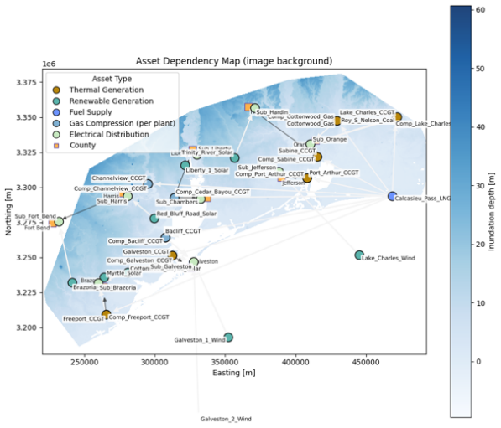Fig. 1. Case Study
Table III. Texas Overall Energy Consumption by Sector and Normalization Parameters (U.S. Energy Information Administration 2025).
Parameters | Value
Industrial Demand | 7,691 T BTU
Transportation | 3,323 T BTU
Residential | 1,565 T BTU
Commercial | 1,558 T BTU
Population Size | 31.3 M
Number of Plants | 1,489

When the CIs are disrupted by a DE $k$, each node is exposed to a spatially dependent flood level intensity as described in Section 2.1 and 2.2. The probability of failure of each node is then computed by a lognormal fragility model (i.e., a standard normal CDF). The median, $θ_{u_{i}}^{f}$, and dispersion, $σ_{u_{i}}^{f}$, parameters for each unit dependent fragility distribution are reported in Table IV (Asaridis et al. 2025).
Table IV. Fragility Distributions Parameters for each unit type.
Unit type | Fragility Median, $θ_{u_{i} }^{f}$ | Fragility Dispersion, $σ_{u_{i}}^{f}$
Solar | 1.0 | 0.5
Substation | 3.0 | 0.20
Compressor | 3.0 | 0.20
Coal | 5.0 | 0.30
Gas | 8.0 | 0.30

Repairs are modeled using unit dependent piecewise constant mean repair times, $μ_{r}\left({FL}_{k}^{n}\right)$, that vary depending on unit structural complexity and food intensity. In particular, substations and compressors use baseline depth-dependent mean repair times, whereas thermal units and solar units are scaled by a factor of 1.5 and 0.8, respectively. Repair models are reported in Table V (Espinoza et al. 2020; Movahednia and Kargarian 2022; Rahman et al. 2020). Other important assumptions include: i) constant population and power demand at each consumer node over the mission time $T_{M}$, ii) wind units are considered invulnerable due to their offshore location, heights and robust foundations, and iii) consumer nodes failure only occurs if adjacent nodes fail.
Table V. Mean Repair Time, $μ_{r}$(hrs.) by unit type and inundation depth.
Unit type | Inundation Depth Interval (m)
 | (0.0, 0.5] | (0.5, 0.6] | (0.6, 0.8] | (0.8, 0.9] | (0.9, 1.1] | > 1.1
Solar | 9.8 | 11.3 | 14.2 | 15.5 | 18.5 | 20
Substation | 12.3 | 14.1 | 17.7 | 19.4 | 23.1 | 25
Compressor | 12.3 | 14.1 | 17.7 | 19.4 | 23.1 | 25
Coal | 18.5 | 21.2 | 26.6 | 29.1 | 34.7 | 37.5
Gas | 18.5 | 21.2 | 26.6 | 29.1 | 34.7 | 37.5

3.2. Hazard model
Historical data are extracted from National Oceanic and Atmospheric Administration (NOAA) gauge station 8770777 Manchester, TX (NOAA accessed Jan. 16, 2025). Water level time series from 1950-08-01 to 2025-07-31 (hourly sampled) are elaborated with a Peak Over Threshold (POT) methodology to extract flood data, by employing a threshold of $μ=1.405$ meters above NAVD88A (corresponding to a medium flood level for the selected gauge station). The resulting $L=24$ pairs of observed flood heights $h_{ }^{l}$ and durations $t_{h}^{l}$ are plotted in Fig. 2.
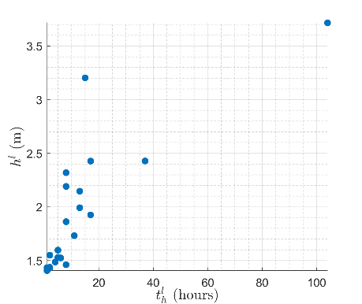
Fig. 2. Historical data of flood intensity and duration (interval of time above $μ$) for the considered gauge station.

The two parameters Generalized Pareto Distribution (GPD) is used to fit the marginal CDF of $F_{H}\left(h\right)$ (Han et al. 2018):
$$F_{H}\left(h\right)=1-{\left\{1+\left[\frac{ξ\left(h-μ\right)}{β}\right]\right\}}^{-\frac{1}{ξ}}$$ | (13)
where $ξ$ and $β$ are the GPD shape and scale parameters, respectively. Instead, a gamma distribution is used to fit the marginal CDF of $F_{T_{H}}\left(t_{h}\right)$. The estimated parameters of the marginals are listed in Table XX along with the corresponding Kolmogorov-Smirnov (KS) test statistics.
Table XX. Marginal distributions parameters.
Variable | $$ξ$$ | $$β$$ | KS | p-value
$$H$$ | 0.801 | 0.195 | 0.149 | 0.605
$$T_{H}$$ | 0.783 | 15.484 | 0.162 | 0.503

To assess the dependence between $H$ and $T_{H}$ two rank correlation statistics are calculated, namely the Spearman rho $ρ_{S}$ and the Kendall tau $τ$, which suggest an high degree of positive correlation (Table XXI).
Table XXI. Rank correlation between $H$ and $T_{H}$ (bootstrap percentile confidence interval $Q_{0.05}-Q_{0.95}$ is estimated with 5000 resamples).
Statistic | Estimate | $$Q_{0.05}$$ | $$Q_{0.95}$$
$$ρ_{S}$$ | 0.908 | 0.797 | 0.967
$$τ$$ | 0.765 | 0.590 | 0.872

A set of three Archimedean copulas families are fitted to the historical data and are evaluated with respect to their log-likelihood $\ln\left(L\right)$, their Akaike Information Criteria (AIC) and their Bayesian Information Criteria (BIC) (Table XXII). The Gumbel copula is selected due to the highest $\ln\left(L\right)$, the lowest AIC-BIC and for modelling upper tail dependence.
Table XXII. Estimated copula parameters.
Family | $$ϑ$$ | $$\ln\left(L\right)$$ | AIC | BIC
Gumbel | 3.816 | 20.108 | -38.216 | -37.038
Frank | 13.392 | 19.412 | -36.824 | -35.646
Clayton | 4.014 | 17.559 | -33.118 | -31.942

The effect of time dependent CC is introduced by considering the SLR projections from IPCC6 (Fox-Kemper et al. 2021; Kopp et al. 2023, Garner et al. 2021) plotted in Fig. 3.

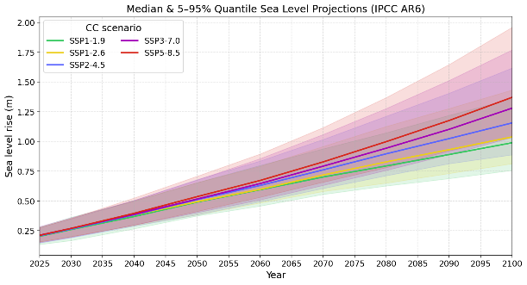
Fig. 3. Downscaled SLR projections for the Houston Bay area (ensemble median and $Q_{0.05}-Q_{0.95}$).

Thus, for any $k$-th decision time, the additive correction factor ${∆h}_{k}$, is calculated as:
${∆h}_{k}={SLR}_{k}+ Δsub (T_{k+1}-T_{k})$ | (14)

Where $Δsub$ denotes the land subsidence, which for the Houston Bay area is estimated as 6.7 mm/year (Buzzanga et al. 2025). For any realization of $\left(h_{k},t_{hk}\right)$ the Height Above Nearest Drainage (HAND) methodology (Murphy et al. 2025; Zheng et al. 2018) is used to derive a spatial map of the flood level in correspondence of each node of the CIs.

3.3. Sequential Decision Problem
The SDP for the considered case study is defined as follows:
- State space: at each decision time $T_{k}$, the system state is characterized by $σ_{k}=\left[O_{k},Δh_{k}^{*},w_{k}^{*}\right]$, where $O_{k}=\left[O_{k1},…,O_{kn^{c}},…,O_{kN^{c}}\right]$, with $N^{c}=N_{1}^{c}∪N_{2}^{c}$, is the vector of the current flood wall heights for each non-consumer node in the CIs, $Δh_{k}^{*}=Δh_{k}+ϵ_{kh}$ is the noisy measure of the hazard intensity change due to sea level rise and land subsidence, with $ϵ_{kh}\sim N\left(0,0.02Δh_{k}\right)$ and $w_{k}^{*}=\left[w_{k1}^{*},w_{k2}^{*},w_{k11}^{*},w_{k12}^{*},w_{k21}^{*},w_{k22}^{*}\right]$ is the noisy vector of the preference weights, where each $w_{k}^{*}=w_{k}+ϵ_{kw}$ with $ϵ_{kw}\sim N\left(0,0.1w_{k}\right)$;
- Action space: the considered investments are discrete increases of the floodwall heights. The action at decision time $k$ is then characterized by the vector $α_{k}=\left[ΔO_{k1},…,ΔO_{kn^{c}},…,ΔO_{kN^{c}}\right]$, containing the discrete wall increases for each non-consumer node in the CIs. The discrete values considered are $ΔO_{k}∈\left[0, 0.5, 1, 1.5, 2, 2.5, 3\right] m$ and the associated cost is calculated as follows:
$$Γ\left(ΔO_{{kn}^{c}}\right)=ΔO_{kn^{c}}L_{n^{c}}Γ_{wall}$$ | (15)
where $L_{n^{c}}$ is the perimeter of the n^{c}-th non-consumer node and $Γ_{wall}=3.31\frac{M€}{km m}$ is the unit cost per $km$ of floodwall and meter of heightening [ref cost model];
- Transition probabilities: we consider each action to have a deterministic effect on the system, which is an increase in the floodwalls height, leading to an updated state from decision time $k$ to $k+1$ equal to $σ_{k+1}=\left[O_{k+1},Δh_{k+1}^{*},w_{k+1}^{*}\right]$, where $O_{k+1}=O_{k}+α_{k}$, $Δh_{k+1}^{*}=Δh_{k+1}+ϵ_{(k+1)h}$ and $w_{k+1}^{*}=w_{k+1}+ϵ_{(k+1)w}$ are the updated preferences, which follow six different predefined scenarios shown in Fig. X.
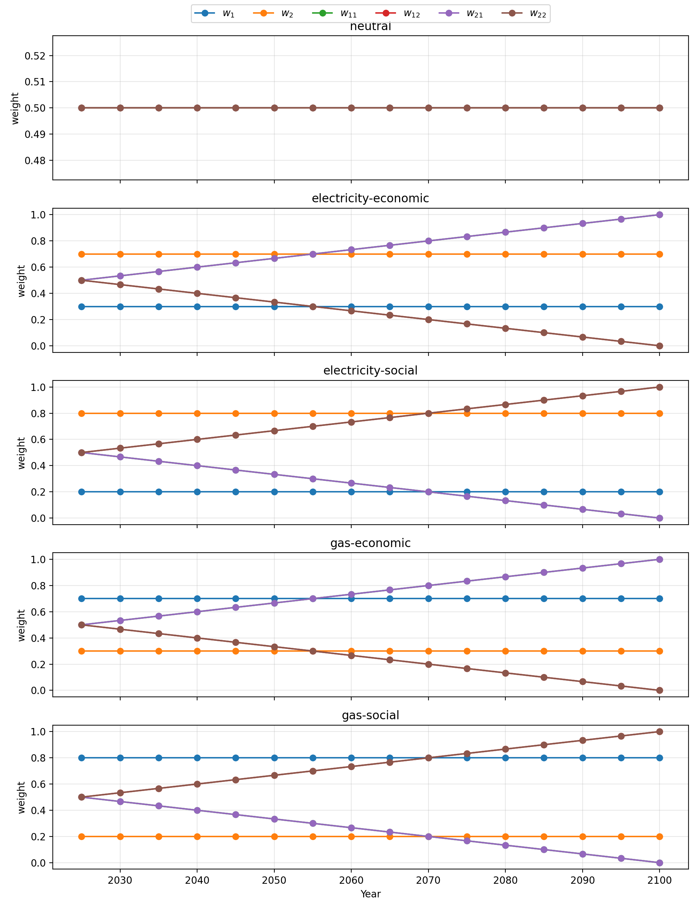
Fig. X. Decision maker preferences scenarios.

- Reward calculation: the reward is calculated modifying Eq. (11) adding a penalty term to avoid overbudget $P_{b}$ and a penalty term to avoid consecutive improvements of the same node $P_{c}$:
$${ R}^{P}\left(σ_{k+1}|σ_{k},α\right)=R\left(σ_{k+1}|σ_{k},α\right)-P_{b}-P_{c}$$ | (16)
$P_{b}$ and $P_{c}$ are equal to 1 if the total cost of an action is larger than the budget $B=50 M€$ and if consecutive improvements are present, respectively. To estimate the expected impacts, $N_{MCS}={10}^{4}$ Monte Carlo trials are used.
4. Results
The framework presented in Section 2 has been applied to the case study of Section 3. The following hyperparameters have been used for the PPO:
- actor and critic models: multi-layer perceptron with two hidden layers of 128 neurons each and a learning rate $lr=5∙{10}^{-4}$;
- discount factor $γ=0.99$;
- clipping parameter $ϵ=0.2$;
The agent has been trained until convergence of the reward, and it has been tested using the SLR projections from the SSP5-8.5 scenario and the weights of Fig. X, unseen during training, in which the decision maker preferences switch from gas to electricity after the first 30 years.
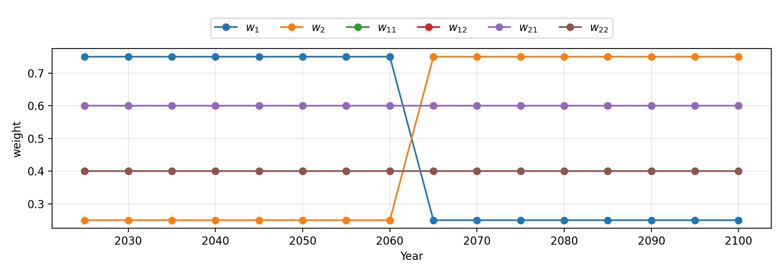
Fig X. Test decision maker preferences.
The test results have been compared with a benchmark expert-based policy, in which the budget is always divided equally among the three most fragile assets at each decision time, in terms of expected gas and electricity supply. The comparison is shown in Fig. X+1.
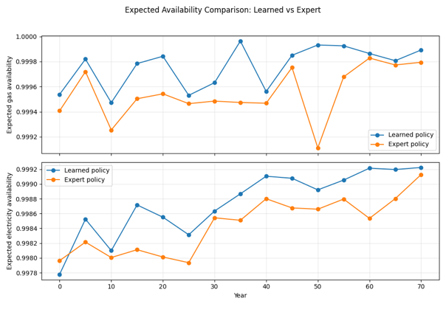
Fig X+1. Comparison.
As shown in the figure, the DRL agent (blue line) outperforms the expert-based policy (orange line) for both commodities during the whole life of the system. Also, as shown in Fig. X+2, the cumulative expenditures correctly shift from gas to electricity after the first 30 years, following the evolving preferences.
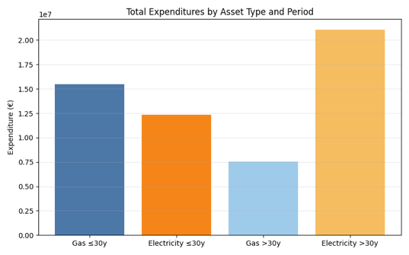
Fig X+2. Expenditures per commodity.
5. Conclusions
This work introduces a deep reinforcement learning (DRL)-based decision-making framework for long-term resilience investment planning in interdependent CIs subjected to natural hazards. The resilience budget allocation problem is formulated as a SDP, enabling the explicit representation of non-stationary hazard conditions and time-varying stakeholder preferences through a multi-criteria reward function. Application to an integrated power-gas network exposed to coastal flooding shows that the proposed method consistently outperforms an expert-based benchmark, while dynamically reallocating investments in response to changes in hazard intensity and stakeholder preferences. These findings highlight the flexibility and robustness of the framework for resilience-oriented decision making under CC uncertainty. Future work will be aimed at relaxing simplifying assumptions in the CI modeling and extending the framework to account for multi-hazards, time-dependent evolution of the network topology (including the introduction of new asset types), and multiple potentially conflicting stakeholders, thereby further enhancing its applicability to realistic resilience planning.
Acknowledgement
The work of Santiago Taguado Menza is supported by the Italian Ministry of University and Research (MUR/MIUR, PRIN 2022 Program) and by the European Union’s NextGenerationEU initiative under Grant No. 2022TAFXZ5, within the project ARISTOTELES (ARtificial Intelligence and STOchasTic simulation for the rEsiLience of critical infrastructurES). The work of Thomas Matteo Coscia is supported by PE RETURN SPOKE VS4 (CUP D43C22003030002, codice progetto PE0000005), for the project titled “MULTI RISK SCIENCE FOR RESILIENT COMMUNITIES UNDER A CHANGING CLIMATE”, funded by the NextGenerationEU – Piano Nazionale di Ripresa e Resilienza (PNRR) (Missione 4, componente 2, Investimento 1.3). We thank the projection authors for developing and making the sea-level rise projections available, multiple funding agencies for supporting the development of the projections, and the NASA Sea-Level Change Team for developing and hosting the IPCC AR6 Sea-Level Projection Tool. We acknowledge the CINECA award under the ISCRA initiative, for the availability of high performance computing resources and support.
The authors thank the organizers of the 1st Young Researcher Bilateral Workshop on Reliability & Risk Assessment in Uncertain Environments and the supporting institutions (Politecnico di Milano, the European Safety and Reliability Association (ESRA) and Leibniz Universität Hannover) for providing the forum and support for presenting the conceptualization of this work. The authors also acknowledge Professor Giovanni Sansavini and Professor Ibrahim Ahmed for their guidance in the conceptualization of this study.
References
Abdin, A. F., Yi-Ping Fang, and Enrico Zio. 2019. “A Modeling and Optimization Framework for Power Systems Design with Operational Flexibility and Resilience against Extreme Heat Waves and Drought Events.” Renewable and Sustainable Energy Reviews 112: 706–19.
Akashi, K., N. Fukuda, S. Kanai, and K. Tayama. 2023. “Deep Reinforcement Learning for Network Service Recovery in Large-Scale Failures.” In 2023 19th International Conference on Network and Service Management (CNSM), 1–5.
Asaridis, Konstantinos, Francesca Molinari, Francesco Di Maio, Francesco Ballio, and Enrico Zio. 2025. “A Probabilistic Modeling and Simulation Framework for Power Grid Flood Risk Assessment.” International Journal of Disaster Risk Reduction 120: 105353.
Bakhtiari, Soheil, Mohammad Reza Najafi, Katsuichiro Goda, and Hassan Peerhossaini. 2025. “A Dynamic Bayesian Network Approach to Characterize Multi-Hazard Risks and Resilience in Interconnected Critical Infrastructures.” Reliability Engineering & System Safety 257: 110815.
Buzzanga, B., M. Govorcin, F. Kremer, J. E. Schubert, D. P. S. Bekaert, B. Schaeffer, P. Milillo, et al. 2025. “Satellite-Based Vertical Land Motion for Infrastructure Monitoring: A Prototype Roadmap in Greater Houston, Texas.” Scientific Reports 15: 17041.
Cimellaro, Gian Paolo, Andrei M. Reinhorn, and Michel Bruneau. 2010. “Framework for Analytical Quantification of Disaster Resilience.” Engineering Structures 32 (11): 3639–49.
Clavijo Mesa, Maria Valentina, Francesco Di Maio, and Enrico Zio. 2024. “Inoperability Assessment of Interdependent Critical Infrastructures by Minimal Inoperability Sets Analysis.” In 2024 8th International Conference on System Reliability and Safety (ICSRS), 291–295. https://doi.org/10.1109/ICSRS63046.2024.10927577.
Clavijo Mesa, Maria Valentina, Francesco Di Maio, and Enrico Zio. 2025. “Dynamic Inoperability Input-Output Modeling of a System of Systems Made of Multi-State Interdependent Critical Infrastructures.” Reliability Engineering & System Safety 264: 111303.
Coplin, Laura S., and Devin L. Galloway. 1999. “Houston-Galveston, Texas: Managing Coastal Subsidence.” In Mining Ground Water, 35–48.
Espinoza, Sebastián, Alan Poulos, Hugh Rudnick, Juan Carlos de la Llera, Mathaios Panteli, and Pierluigi Mancarella. 2020. “Risk and Resilience Assessment with Component Criticality Ranking of Electric Power Systems Subject to Earthquakes.” IEEE Systems Journal.
Fang, Yi-Ping, Giovanni Sansavini, and Enrico Zio. 2019. “An Optimization-Based Framework for the Identification of Vulnerabilities in Electric Power Grids Exposed to Natural Hazards.” Risk Analysis 39 (9): 1949–69.
Fox-Kemper, Baylor, Helene T. Hewitt, C. Xiao, G. Aðalgeirsdóttir, S. S. Drijfhout, T. L. Edwards, N. R. Golledge, et al. 2021. “Ocean, Cryosphere and Sea Level Change.” In Climate Change 2021: The Physical Science Basis. Contribution of Working Group I to the Sixth Assessment Report of the Intergovernmental Panel on Climate Change, edited by V. Masson-Delmotte, P. Zhai, A. Pirani, S. L. Connors, C. Péan, S. Berger, et al., 1211–1362. Cambridge: Cambridge University Press. https://doi.org/10.1017/9781009157896.011.
Garner, Gregory G., Thomas Hermans, Robert E. Kopp, Aimée B. A. Slangen, T. L. Edwards, Anders Levermann, S. Nowicki, et al. 2021. IPCC AR6 Sea Level Projections. Version 20210809. Dataset. Zenodo. Accessed January 19, 2026.
Global Energy Monitor. n.d. “Global Energy Monitor.” Accessed January 19, 2026.
GridInfo. n.d. “GridInfo.” Accessed January 19, 2026.
Han, Chao, Shuguang Liu, Yiping Guo, Hejuan Lin, Yuyin Liang, and Hong Zhang. 2018. “Copula-Based Analysis of Flood Peak Level and Duration: Two Case Studies in Taihu Basin, China.” Journal of Hydrologic Engineering 23 (6): 05018009. https://doi.org/10.1061/(ASCE)HE.1943-5584.0001661.
Hosseini, M. M., and M. Parvania. 2022. “Resilient Operation of Distribution Grids Using Deep Reinforcement Learning.” IEEE Transactions on Industrial Informatics 18 (3): 2100–2109.
Jacob, Roshni Anna, Steve Paul, Souma Chowdhury, Yulia R. Gel, and Jie Zhang. 2024. “Real-Time Outage Management in Active Distribution Networks Using Reinforcement Learning over Graphs.” Nature Communications 15 (1): 4766.
Kirezci, Ebru, Ian R. Young, Roshanka Ranasinghe, Sanne Muis, Robert J. Nicholls, Daniel Lincke, and Jochen Hinkel. 2020. “Projections of Global-Scale Extreme Sea Levels and Resulting Episodic Coastal Flooding over the 21st Century.” Scientific Reports 10: 11629.
Kopp, Robert E., Gregory G. Garner, Thomas H. J. Hermans, Shubham Jha, Praveen Kumar, Andrew Reedy, Aimée B. A. Slangen, et al. 2023. “The Framework for Assessing Changes To Sea-Level (FACTS) v1.0: A Platform for Characterizing Parametric and Structural Uncertainty in Future Global, Relative, and Extreme Sea-Level Change.” Geoscientific Model Development 16: 7461–7489.
Liang, Huangbin, Beatriz Moya, Francisco Chinesta, and Eleni Chatzi. 2026. “Resilience-Based Post Disaster Recovery Optimization for Infrastructure System via Deep Reinforcement Learning.” Reliability Engineering & System Safety 265: 111478.
Liu, Xing, Yi-Ping Fang, Elisa Ferrario, and Enrico Zio. 2021. “Resilience Assessment and Importance Measure for Interdependent Critical Infrastructures.” ASCE-ASME Journal of Risk and Uncertainty in Engineering Systems, Part B: Mechanical Engineering 7 (3).
Miller, Megan M., and Manoochehr Shirzaei. 2021. “Assessment of Future Flood Hazards for Southeastern Texas: Synthesizing Subsidence, Sea-Level Rise, and Storm Surge Scenarios.” Geophysical Research Letters 48: e2021GL092544.
Movahednia, Mohadese, and Amin Kargarian. 2022. “Flood-Aware Optimal Power Flow for Proactive Day-Ahead Transmission Substation Hardening.” arXiv:2201.03162.
Murphy, Sean, Mark Wang, Chih-Shen Cheng, Paola Passalacqua, and Fernanda Leite. 2025. “Land-Use Analysis Using Infrastructure Representations and High-Resolution Flood Inundation Mapping Techniques.” International Journal of Disaster Risk Reduction 123: 105518.
National Oceanic and Atmospheric Administration. n.d. “Tides & Currents: Station 8770777 (Manchester, TX)—Water Levels.” Accessed January 19, 2026. https://tidesandcurrents.noaa.gov/waterlevels.html?id=8770777.
Nozhati, Saeed. 2021. “A Resilience-Based Framework for Decision Making Based on Simulation-Optimization Approach.” Structural Safety 89: 102032.
Nozhati, Saeed, Yugandhar Sarkale, Bruce Ellingwood, Edwin K. P. Chong, and Hussam Mahmoud. 2019. “Near-Optimal Planning Using Approximate Dynamic Programming to Enhance Post-Hazard Community Resilience Management.” Reliability Engineering & System Safety 181: 116–26.
Nozhati, Saeed, Yugandhar Sarkale, Edwin K. P. Chong, and Bruce R. Ellingwood. 2020. “Optimal Stochastic Dynamic Scheduling for Managing Community Recovery from Natural Hazards.” Reliability Engineering & System Safety 193: 106627.
Ouyang, Min. 2014. “Review on Modeling and Simulation of Interdependent Critical Infrastructure Systems.” Reliability Engineering & System Safety 121: 43–60.
Papakonstantinou, K. G., and M. Shinozuka. 2014. “Planning Structural Inspection and Maintenance Policies via Dynamic Programming and Markov Processes. Part II: POMDP Implementation.” Reliability Engineering & System Safety 130: 214–24.
Rahman, Shams A., Alex G. D. McLellan, John Taylor, and Neil R. Osborne. 2020. Compressor Station Facility Failure Modes and Related Effect Analysis for CO₂ Pipeline Quantitative Risk Assessment. Luxembourg: Publications Office of the European Union. https://doi.org/10.2760/67609.
Salvadori, G., and C. De Michele. 2004. “Frequency Analysis via Copulas: Theoretical Aspects and Applications to Hydrological Events.” Water Resources Research 40: W12511.
Schulman, John, Filip Wolski, Prafulla Dhariwal, Alec Radford, and Oleg Klimov. 2017. “Proximal Policy Optimization Algorithms.” arXiv:1707.06347 (cs.LG).
Stevens, Landon. 2017. The Footprint of Energy: Land Use of U.S. Electricity Production. Report. Strata Policy, June 2017.
Sutton, Richard S., and Andrew G. Barto. 2018. Reinforcement Learning: An Introduction. 2nd ed. Cambridge, MA: The MIT Press. http://incompleteideas.net/book/the-book-2nd.html.
U.S. Census Bureau. 2024. “QuickFacts: Texas.” Accessed January 19, 2026. https://www.census.gov/quickfacts/fact/table/TX/PST045224.
U.S. Energy Information Administration. 2025. “Texas: State Profile and Energy Estimates.” Accessed January 19, 2026. https://www.eia.gov/beta/states/states/tx/overview.
Valle-Levinson, Arnoldo, Maitane Olabarrieta, and Lorraine Heilman. 2020. “Compound Flooding in Houston–Galveston Bay during Hurricane Harvey.” Science of the Total Environment 747: 141272.
Wang, Feng, Jin Tian, Chenli Shi, Jiamu Ling, Zian Chen, and Zhengguo Xu. 2024. “A Multi-Stage Quantitative Resilience Analysis and Optimization Framework Considering Dynamic Decisions for Urban Infrastructure Systems.” Reliability Engineering & System Safety 243: 109851.
Yang, Sen, Yi Zhang, Xinzheng Lu, Wei Guo, and Huiquan Miao. 2024. “Multi-Agent Deep Reinforcement Learning Based Decision Support Model for Resilient Community Post-Hazard Recovery.” Reliability Engineering & System Safety 242: 109754.

