Current state of GFM Literature [No One knows…]

The authors of [...] audited 152 papers about Geospatial Foundation Models and argue that the current GFM literature is much less comparable and reproducible than it looks from individual papers. They were able to capture a snapshot of what is actually going on with GFMs. Starting from a bit of uncertainty about the naming itself; the authors found that 46% of the 152 papers selected actually call their proposed model a “foundation model” in the title, abstract or contributions. The rest are older SSL RS models that previous GFM surveys already treat as part of the lineage of GFMs. This is only relevant due to the methodology they used to reconstruct the lineage. They started from well known FMs surveys and made their way back exploiting the reference linkage. Ending up with the aforementioned corpus. The actual methodology was the following, they seeded the corpus from prior GFM surveys and extended it with two expansion passes: an OpenAlex and Semantic Scholar citation-graph expansion (to add 2024-2025 papers not covered by the survey), and a keyword sweep over 2019-2023 RS SSL papers that predate FMs terminology (“foundation model”). Final corpus contains 152 papers (2019-2025). Current year discarded because it is still on going. Extraction of metadata was done with commercial LLMs while being under human supervision.

Following, a snapshot of the current state of GFMs literature.

Model Weights Are Not Published

Across the publication corpus 39% of the papers release no model weights, which is the minimum precondition for downstream reuse and comparison. Another 19% ship a public core repository with no released model artifact, so reuse would require attempting to retrain the model with the author’s codebase. Without the model files, the community cannot compare models on shared benchmarks or rerun baselines.

The Field Does Not Converge On A Shared Set Of Benchmarks
The 152 papers in the corpus report evaluations on 401 distinct benchmarks. 10.6% of all evaluations are done using the three most-used benchmarks (EuroSAT[...], NWPU-RESISC45[...], AID[...]); the remaining 89.4% is spread over 398 benchmarks, most appearing in only one or two papers. Heavy use of a few benchmarks is not bad per se. The problem is on the per-paper side. For each paper, they computed the fraction of its downstream benchmarks that overlap the top-10. The mean is 0.27, and 50/143 papers (35%) have zero overlap with the top-10 (Gini coefficient). The Gini coefficient is stable after 2023 and the count of benchmarks that appear in only one paper grew from 13 to 2022 to 98 in 2025. The GFMs has his own benchmark lottery problem, this creates a fundamental issue; without comparable results there is no direct evidence allowing you to rank a model against another, leaving the definition of “best” to other directly comparable features but performance (model size, modality, downstream support…).
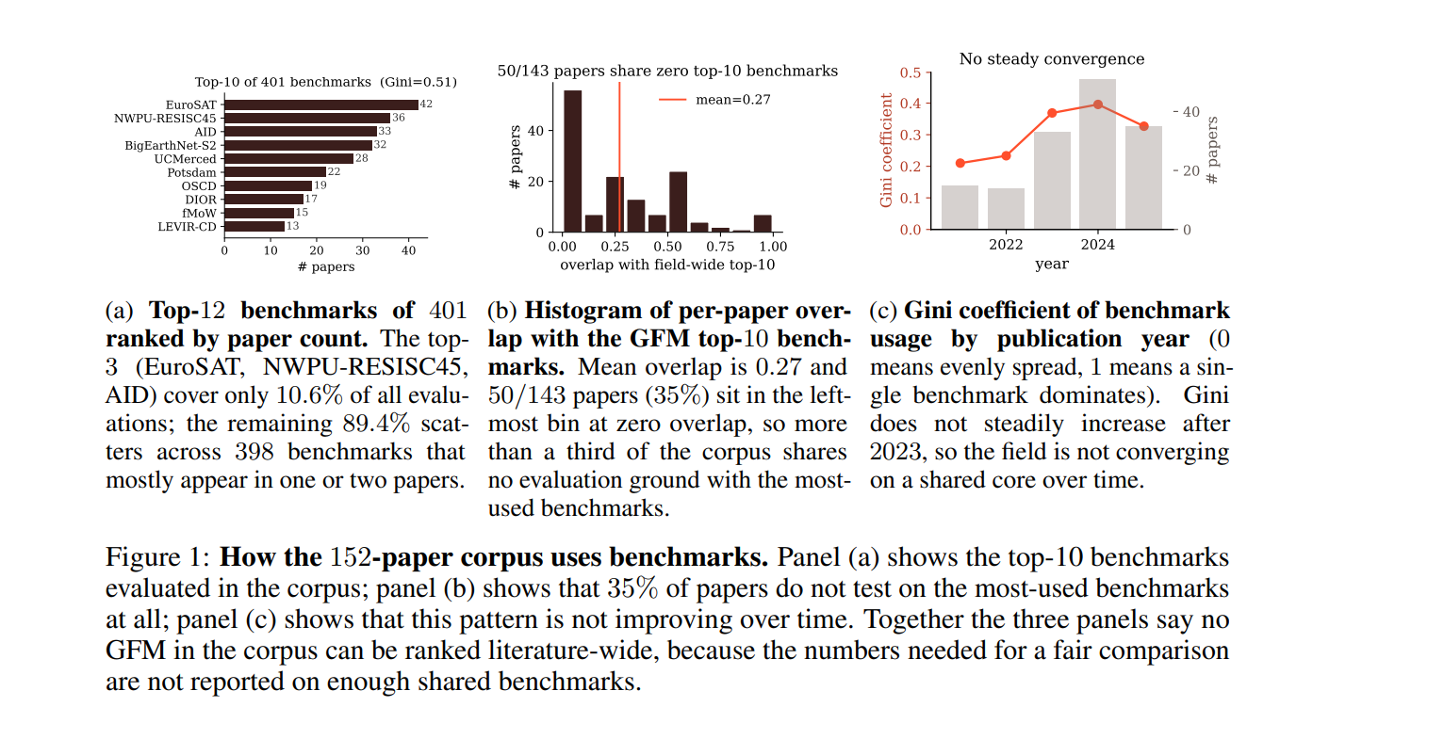

Reported Metric Values Diverge By Tens Of Points Across Papers, At Fixed Protocol

The authors mined every (model, benchmark, metric, evaluation-protocol, train-regime) tuple in the 152-paper corpus (10,817 results after the benchmark and metric normalisation), and bucket by protocol (finetune, linear probe, kNN probe, zero-shot, few-shot). It was discovered that despite papers implemented the same model, same benchmark and nominally the same evaluation protocol, the reported numbers disagree enormously. They tried search for (Model, Benchmark,Protocol) which if present in different papers should roughly produce comparable numbers. They identified 301 such model-benchmark-protocol combinations reported by at least two papers. For each one, they calculated spread= max(reported score) - min(reported score) and they found 76/301 had a difference of at least 5 percentage points; while 46/301 at least of 10 points; and 20/301 had at least 20 points. For example for (Scale-MAE, NWPU-RESISC45, linear probe) one paper reports 33.0 while the original Scale-MAE paper reports 89.6, a difference of 56.6 percentage points. Same model checkpoint. Same dataset. Same protocol (both use linear probing). Obviously “linear probe” alone does not sufficiently specify an experiment. There are lots of hidden choices: optimiser, learning rate, #epochs, image crop, normalisation, data augmentation, which representation/layer is probed, tr/v/te split, adaptation recipes, class subsets, sensor channels. Apparently neither paper documented enough of those details to explain the discrepancy. Another example is GPT-4o on UCMerced, where zero-shot spans 43.5 [32] -> 88.8[63] and neither paper discloses in detail the prompting used.

Could this be just random-seed noise?
The authors argue no, most repeated experiments actually agree fairly well, median spread circa 0, so the whole field is not random chaos, but the 90th percentile spread is 12.7 percentage points. Typical random-seed variation for something like a fixed linear classifier would usually be much smaller than that. So they interpret the large tail as evidence of hidden protocol differences.

Lack of an evaluation harness

Current GFM work includes dataset bundles (datasets, splits, loaders and perhaps example scripts) like GeoBench[], PANGAEA[], Earthshift[], TorchGeo[].
But the researcher can still make many choices, so two papers can still say “we evaluated on GeoBench” but still run substantially different experiments. An evaluation harness is stricter (dataset, task definition, protocol, metric, versioning, automatic execution/checking). A good comparison would be with the LLM world. The idea is model → shared harness → standardised result. Running two models through the same harness makes the many degrees of freedom disappear. A harness is necessary but not sufficient. If the dataset itself is misleading, like datasets suffering from spatial autocorrelation of testing-training patches, then also the evaluation can be wrong for a deployment claim. A good harness might give every model the same search budget. Enforcing the same parameters across models can introduce bias. Each model should be placed in the condition of giving its best.

Architecture And Pretraining Data Are Confounded

Another important aspect, is that when testing architectures it is better to use the same pretraining data, so that only architecture changes. Change one factor at a time. So if a GFM beats U-Net, the scientifically interesting question isn't simply: “Is a foundation model better?” but more about “Which part of the GFM pipeline produced the advantage?”
The authors say that Corley et al. [..] found that apparent GFM gains over supervised ImageNet baselines on BigEarthNet became much smaller or disappeared once the pretraining and downstream distributions were held constant. The point is not that this always happens, but that some gains attributed to “better models” may really come from better-matched pretraining data. Kaur et al. [...] is used for the same argument: changing the pretraining dataset alone can shift downstream accuracy by an amount as large as, or larger 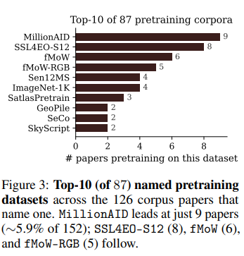
The authors’ claims are even stronger given that they prove that only a small amount of FMs actually share the same pretraining (25% shares its complete pretraining configuration with at least another paper) while the rest have a unique configuration.
So most GFM papers are not only comparing different architectures. They are comparing: different architectures, different pretraining, different protocols.

What Can Be Done?

