1
A simple tutorial
This chapter will briefly introduce you the user interface (UI) of darktable and will guide you through the development of your digital negative.

Starting darktable
You can start darktable from a console or through the graphic shell like GNOME or KDE.
I suggest to run it from the the console, since it prints any error that may happen during the startup.
For example to start it from the console in KDE, you go to the bin directory then start it by issuing the darktable command, or darktable-faster if you want the “faster” version that copies the database in memory to speed up the operations.
The user interface of darktable (which will be described in the next chapter) will be similar to the following figure (your mileage may vary, for example you will probably see a different version):
Figure 1: Screenshot of darktable UI at first start

Lighttable mode
This is the lighttable mode, one of the three modalities you can use in darktable. In this mode you can import single photos, entire directories, and from camera, do file handling (like delete, rename), tag your photos, and use the tethered shooting mode of darktable. These options will be thoroughly described in chapter (TODO: insert number of the chapter where the UI is described)

Importing a film roll
After you have run darktable, you have to import a film roll to develop your digital negatives.
Along with this tutorial you can find a sample directory with some example photos.
TODO : specify the remote URL of the directory
To import a film roll, click on the button folder located in the import group in the top right angle of the window
Figure 2: Importint a film roll
Choose the directory to import (TODO : define the directory location as an assumption and specify the assumptions at the start of the tutorial or the document ), then click OK
After you clicked OK the main window should be similar to the following figure :
Figure 3: Main window after photo import
You can zoom the photos in lighttable mode by pressing CTRL+mouse wheel on the main central area.

Importing from camera
In this section we will import photos from the camera.
Figure 4: Importing from camera
To open the import dialog click on scan for devices. If a message saying no supported devices found make sure your camera is in PTP(picture transfer protocol) mode. If the no supported devices found message is still there it means that either your camera is not supported or that GNOME automatically mounted it. If it is the latter case just go to the desktop, right-click the device and select unmount.
When a device is detected you will notice there is Figure 5: Camera Detected an added tab like shown below:
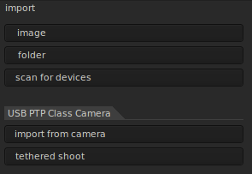Figure 6: Camera Detected
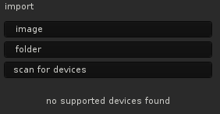Figure 7: No Camera Detected

Developing one (or more) photo(s)
In this section we will develop the photos we just imported. We start by rotating a distorted photo.

Rotating a distorted photo
Select the image showing a tower, it is called Valencia.CR2. You can see the name of the file and the photo information in the box on the bottom left corner. It is titled Image information, as you can see in the following figure.
Figure 8: Image information dialog

Now, double click on the photo, the software will switch to darkroom mode :
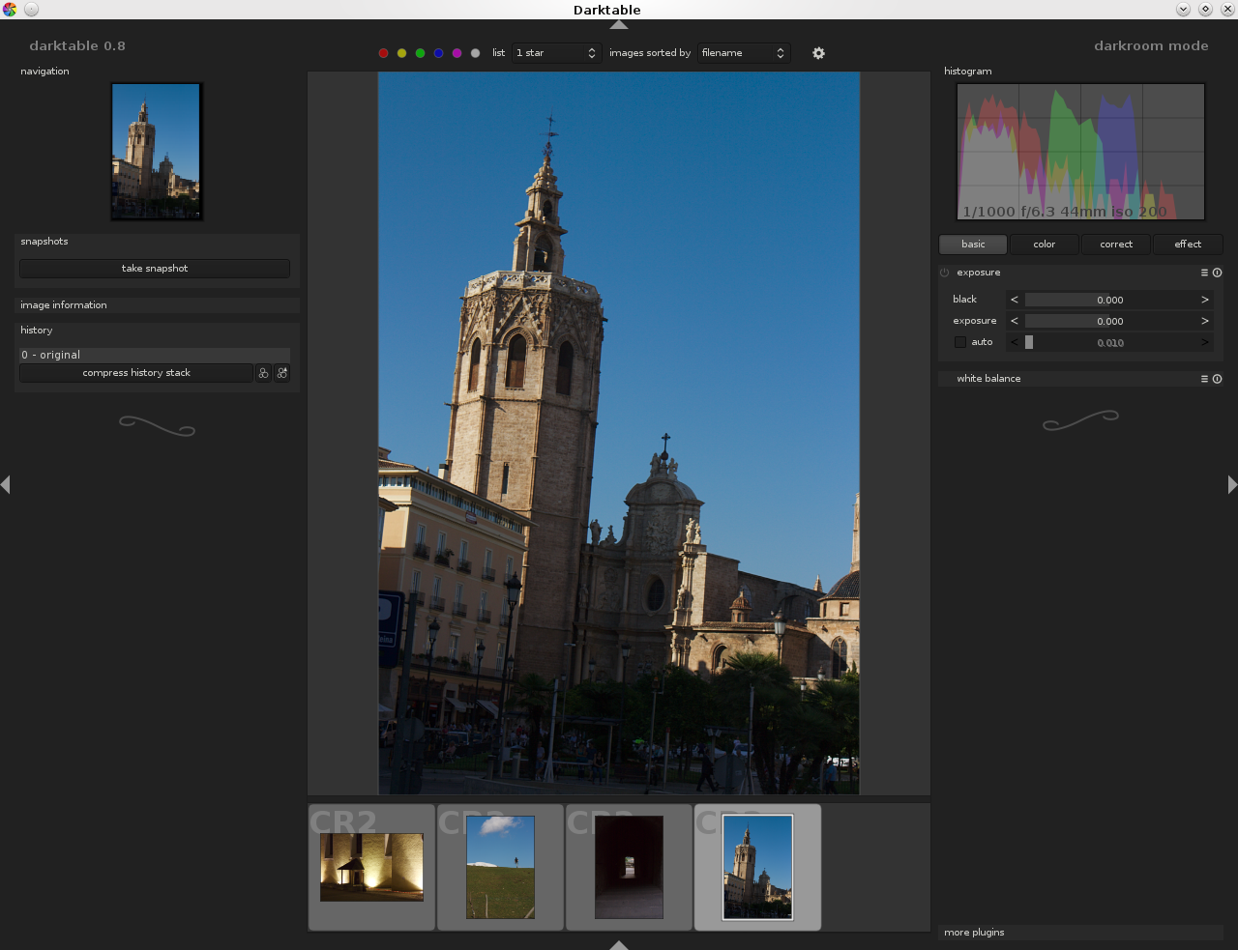Figure 9: Interface of darkroom mode

Darktable mode
We'd like to rotate the photo a bit to have the edge of the cathedral tower aligned to the border of the photo frame.
To use the rotate tool, click on the correct button on the right side of the window
Figure 10: Darkroom filter categories

These buttons represent the filter categories you can apply to your photos. Under the correct category you should see at least the crop and rotate and the sharpen filter
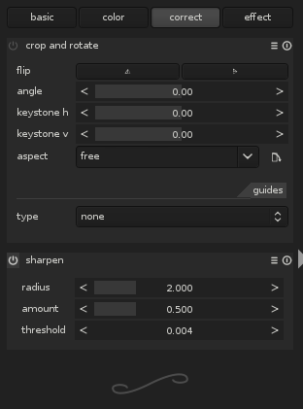Figure 11: Darkroom correct category

To rotate the image click with the right mouse button on the angle slider, then insert the value -4.8
Darktable will rotate the image as soon as you press enter, giving a rough preview while computing. The result should be similar to the one in figure below.

Figure 12: Image after rotation
Please not also that the history panel in the right changed; now the first element is “1 – crop and rotate (on)”. If you're not happy of the result you can press on the previous value, in this case “0 – original” to revert to the previous state.

Cropping the photo
Now that the lines are more or less straight, we'd like to crop the photo to remove its bottom and give all the space to the cathedral.
Click on the type button on the crop and rotate panel, a list of guide style will be shown.
Click on none, a transparent box will be overlayed to the image.

