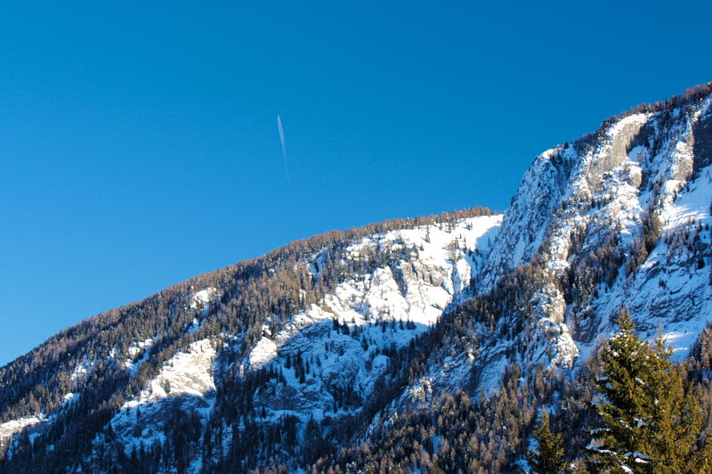
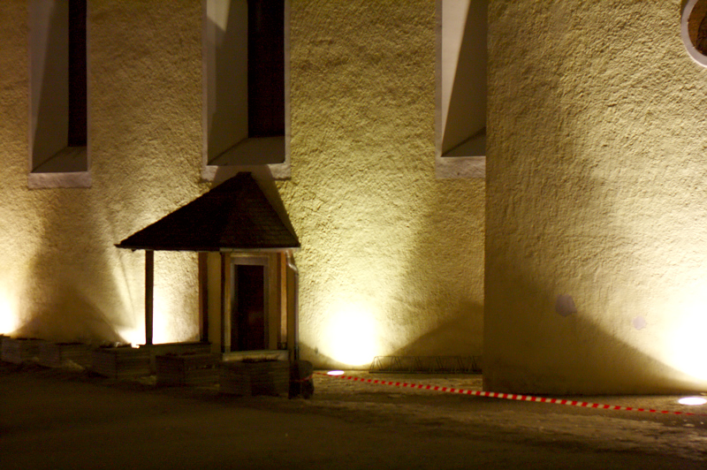
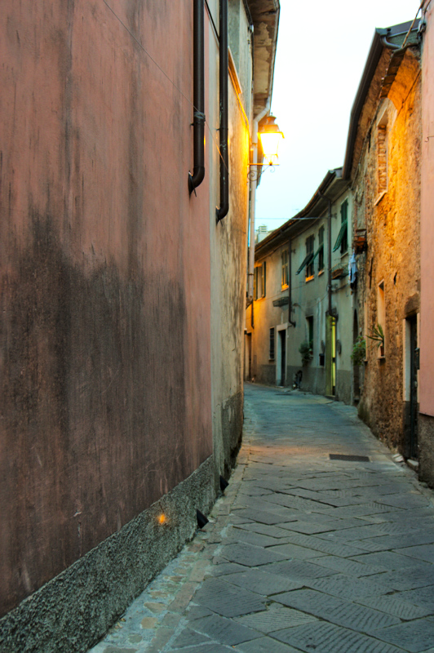
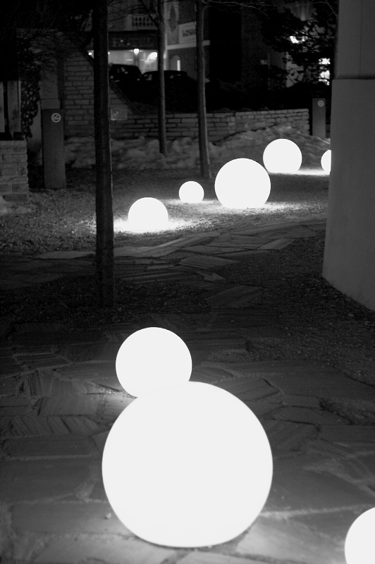
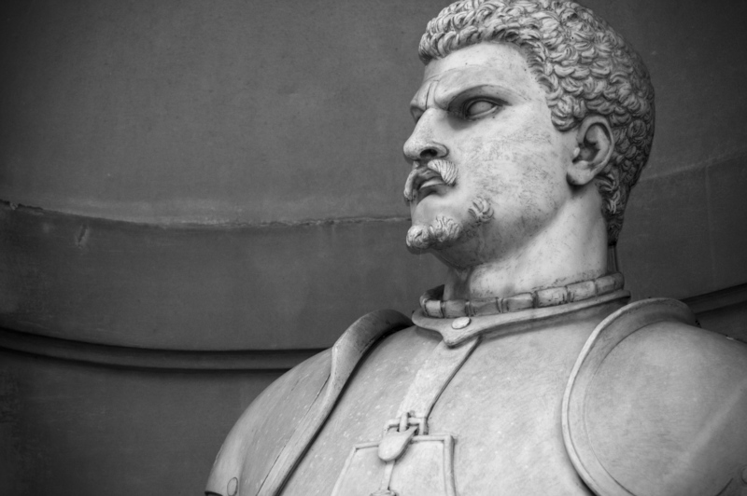
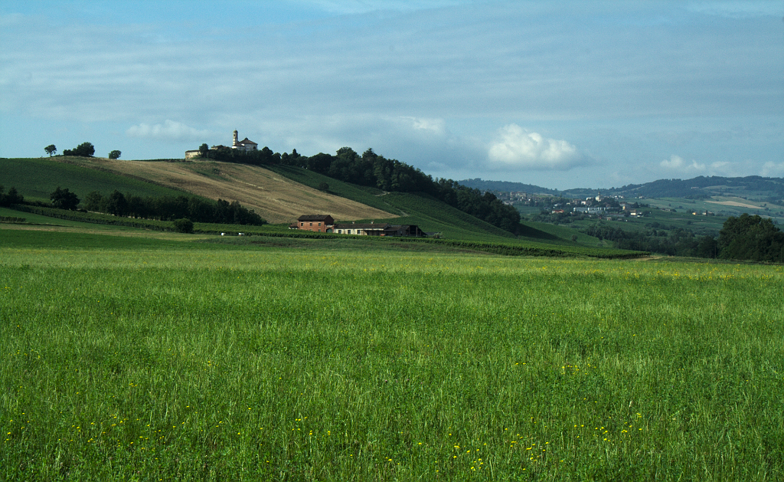
Darktable
Digital photo development with

Digital photo development with Darktable
Manage and develop your digital images with Darktable v0.8.

Stefano Fornari, Mario Latronico, Nicholas Manea

Copyright and License
Copyright © 2011 Stefano Fornari, Mario Latronico, Nicholas Manea
The book Darktable is distributed in the hope that it will be useful, but WITHOUT ANY WARRANTY; without even the implied warranty of MERCHANTABILITY or FITNESS FOR A PARTICULAR PURPOSE.
This work is licensed under a Creative Commons Attribution-ShareAlike 3.0 Unported License.

Table of Contents
Digital photo development with Darktable 2
Copyright and License 3
Preface 7
Credits 7
Who should read this book 7
Conventions 7
A simple tutorial 8
Starting darktable 8
Lighttable mode 10
Importing a film roll 10
Developing one (or more) photo(s) 11
Rotating 12
Darkroom mode 12
Darkroom mode 12
Cropping 15
Correcting colors 16
Exporting images 19
Darktable user interface 21
Darktable views 21
Lighttable view 21
The light table 22
Bottom bar 23
Top bar 23
Left and right panels 24
Darkroom view 27
Darkroom modules 28
Navigation 29
Snapshots 30
Snapshots 30
Metadata 30
History 31
History 31
Histogram 31
Histogram 31
Plugins 32
Plugins 32
More plugins 32
More plugins 32
Lighttable 33
Importing 33
Working with collections 39
Image information 40
Working with selections 40
Exporting 42
Exporting to a web album 43
Exporting to disk 45
File formats 46
Global options 47
Styles 48
Tagging 49
Metadata 50
Darkroom 51
RAW image format 51
Basic workflow 51
White balance 51
Color temperature 52
White balance with red, green, blue adjustments 53
White balance with red, green, blue adjustments 54
White balance with preset values 55
The grey card 56
White balance many pictures at the same time 56
Composition enhancing workflow 57
Photographic composition 57
Center of interest 58
Placement of the subject 58
Simplicity 63
Balance 64
Shapes and lines 65
Patterns 66
Lighting 66
Framing 67
Perspective 73
Mergers 73
Headroom 74
Improving composition in darktable 75
Lens correction plug-in 75
Crop and rotate plugin 79
Crop 79
Rotate 81
Distortion 81
Black and white workflow 82
The daguerreotype 82
Perception of color by human eye 83
Sensors, filters and colors 84
Conversion to black and white 85
Using monochrome plugin 85
Color filters 86
Using the channel mixer 87
Using the color zones plugin 90
Adjusting contrast with the tone curve plugin 92
Adding sepia (or other) toning with the plit tone plugin 95
Appendices 98
Appendix A - Shortcuts 98
Appendix B – plugin reference 99
Basic 99
Color 101
Correct 104
Effects 106
Appendix C – Installation 109
Installation 109
Installing on Ubuntu 109
Installing on Fedora 110
Building current release from source 110
Running 110
Appendix D – Tips and tricks 111

Preface

Credits
Authors
Stefano Fornari, Mario Latronico, Nicholas Manea
Reviewers
Be the first reviewer: send your review to darktable-users@lists.sourceforge.net!
Contributors
Be the first contributor: send your contribution to darktable-users@lists.sourceforge.net!

Who should read this book
Darktable is an application to manage and develop digital photographs. In some ways, it is a digital photo editing software like Photoshop or the GIMP, but it is something more and something less.
With darktable we can organize, rate, tag, sort and search our photograph collections in an easy and intuitive way. We can also develop our digital photographs adjusting colors and composition and applying corrections and filters. Darktable is a not-destructive image processing software that allows you to post-process the images without losing the original picture. Photos can then be exported in the most commonly used formats.
Darktable is not, however, a photo painting software like Photoshop or GIMP, which instead have many more painting effects and functionality.
This book was written by beginners for beginners. It drives the reader through a smooth learning process, starting with a simple tutorial first, then exploring the many functionalities provided by the program and finally explaining the most common processing workflows and the concepts behind them.

Conventions
In this book, a number of styles of text are used to distinguish between different kinds of information. Here are a list of these styles and an explanation of their meaning.
A command line input or output is written as follows:
$ bin/darktable
Starting darktable...Digital photo development with Darktable
New terms and important words are shown in italics, like in the following sentence: “The user interface of darktable (which will be described in the next chapter) will be similar to Figure 1 (your mileage may vary, for example you will probably see a different version), which illustrates what in darktable is called lighttable mode”. The same for keys or command elements of a UI.
 | Tips and noticeable information are shown in an information box like this.

A simple tutorial
This chapter will briefly introduce the user interface (UI) of darktable and will guide through the development of your digital negative.

Starting darktable
Darktable can be started either from a console or by using a graphic shell like GNOME or KDE: go to the Applications/Graphics menu and select Darktable Photo Workflow Software.
The user interface of darktable (which will be described in the next chapter) is similar to Figure 1, which illustrates what in darktable is called lighttable mode.

Lighttable mode
Figure 1: darktable window at first start
The lighttable mode is one of the three modalities darktable provides. In this mode we can import photos from the file system or directly from the camera, manage picture files and tag photos. These options will be thoroughly described in Chapter 1, but this tutorial provides the basis to get started with darktable and develop our first RAW photos.

Importing a film roll
The first thing to do to after launching darktable for the first time, is to import some RAW photo files (a film roll) and start to develop our digital negatives.
The images used in this tutorial and in the following chapters are bundled together with the book. Unzipping darktable-book-<version>.zip, you will find the sample images under the directory photos.
To import a film roll, click on the button folder located in the import group at the top left of the window (see Figure 2). This will import all pictures of a selected folder.
Choose the directory to import, then click OK. For example, to import the photos of this tutorial select the photos directory under where the book package was installed. Darktable will import the pictures and show them as illustrated in Figure 3.
Figure 2: importing a film roll
Figure 3: main window after photo import
Photos in lighttable mode can be zoomed by pressing Ctrl and moving the mouse wheel on the main central area.

Developing one (or more) photo(s)
In this section we will develop the photos we just imported. Let's start by rotating a crooked photo.

Rotating
Select the image showing a tower, it is called Valencia.CR2. The name of the file and the photo metadata is displayed in the box at the bottom left corner (see Figure 4).
Figure 4: image information dialog
Changes to a photo are applied in the darkroom mode. Double clicking on the photo, darktable will switch to darkroom as illustrated in Figure 5.
Note that darktable has a set of predefined shortcuts for common tasks, described in Appendix A. Instead of double clicking on the image you can press the e key to switch to the darkroom mode.
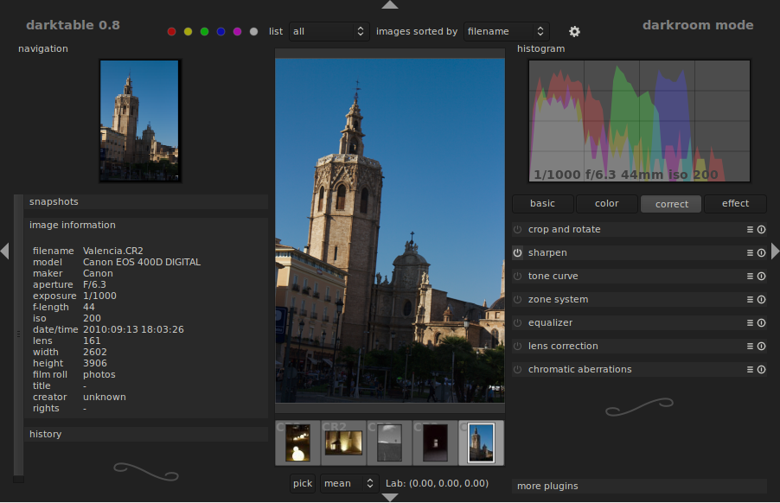Figure 5: darkroom mode window

Darkroom mode
Darkroom mode is covered in detail in Chapter 1, while this section introduces some basic elements of the UI and functionality of this mode to quickly familiarize with darktable and digital photo development.
As a first step, we want to rotate the photo a bit to have the edge of the cathedral tower aligned to the border of the photo frame.
To use the rotate tool, click on the correct button on the right side of the window (see Figure 6).
These buttons represent the plugin categories you can apply to your photos. Under the correct category, crop and rotate plugin will be shown (see Figure 7) .
Figure 6: darkroom filter categories
To rotate the image click with the right mouse button on the angle slider, then insert the value -4.8. Darktable will rotate the image as soon as you press enter, giving a rough preview while computing.
Figure 7: crop and rotate plugin
The result should be similar to what illustrated in Figure 8.
Note that the history panel in the bottom-left corner changed; now the first element is “1 – crop and rotate (on)”. If you are not happy of the result you can press on the previous value, in this case “0 – original” to revert to the previous state.
Figure 8: photo after rotation

Cropping
Now that the lines are straight, we would like to crop the photo to remove its bottom and give all the space to the cathedral.
Click on the type button of the crop and rotate panel, a list of guide styles will be shown. Click on rule of thirds, a transparent box divided in nine parts will be overlaid on the image.
The rule of thirds
Sometimes, when you look at a photograph or you try to compose a shot, you immediately recognize the subject from the background and the other (possibly) distracting elements. Usually, when you compose a photo, there are some guidelines on where to pose the subject of the photo frame to let the viewer's eye be caught by it and not distracted by other elements. One of such rules is the rule of thirds.
For example, consider the image on the left: projecting an imaginary grid over the photo frame, which splits the frame in nine equal parts, you obtain something similar to the figure on the right.
The rule of third states that the subject should lie at one of the intersections of the lines. Please note that this is an empirical rule, you don't have to “blindly” follow this rule when you compose the photos. For details on the rule of thirds see Chapter 3.
Clicking on the image, a crop box appears highlighting the part of the image to keep. The edges of the box can be dragged to resize the cropping box as necessary as illustrated in Figure 9.
When the crop box is satisfactory, press Enter to validate the crop. The part of the image outside the box will be removed.
Figure 9: crop with rule of thirds grid

Correcting colors
In the previous sections of the tutorial, we rotated and cropped the image of the cathedral in darkroom mode. Come back to lighttable mode by pressing e.
In the case you started from scratch and you just launched darktable, you will be already in lighttable mode.
Select the image Fosdinovo.CR2 and double click on it, switching to darkroom mode. The image of Figure 10 is displayed.
As can be noted, this image has a strong magenta color cast, which we would like to correct to give a warmer tone to the photo. There are two ways to do it, by using color correct in the color filter category or the white balance filter in the basic group. We choose the latter since it is easier to accomplish our purposes.
Figure 10: image with a strong magenta cast
Click on the basic filter category (see Figure 6), and expand the white balance filter clicking on the title bar; the white balance filter will show the values illustrated in Figure 11.
Figure 11: white balance filter

Change the red, green, blue values respectively to 1.566 , 1.000, 1.257 to obtain a less reddish image like in Figure 12.

Exporting images
Figure 12: white balance corrected image
Now that we are satisfied with the development of our pictures, we are ready to export them into a different format, for example JPG so that we can post the pictures on the Web.
Press e to switch to lighttable mode, then select the first image edited (Valencia.CR2) and holding the Ctrl key click also on the second image (Fosdinovo.CR2). The two pictures will appear selected as illustrated in Figure 13 (note the light gray border around the picture).
To export the selected pictures we use the export selected tab in the right side of the interface (Figure 14).
Figure 13: Selected photos
For the target storage we will select file on disk and then we select a directory where to export the pictures. There are some variables we can use, which will be explained in more details in Chapter 2. In this example $(FILE_NAME) means the original file name without the extension, for example Valencia and Fosdinovo. The extensions will be added by darktable based on the file format chosen. Since we plan to use the images on a web site, we can accept some quality degradation in exchange of having a smaller file, therefore we set quality to 85%.
Figure 14: the export tab
We will set both spinner max size to 0 in the global options section meaning that the image will not be resized. A more elaborated description of these options will be given in the next chapters.
By clicking the export button the selected images will be stored as described earlier and a dialog will tell us how many image are exported and where they are located, as illustrated in Figure 15.
This ends the tutorial. We learned the basics of darktable and its modes, how to import RAW files, develop them and then export the pictures in a readable format. The following chapters explain in detail all features of darktable and how to get out the best from your photos.

Figure 15: Image export finished

1
Darktable user interface
This chapter guides to the different aspects of the darktable user interface (UI). The first impact with darktable may seem a bit odd to a beginner who is used to other Linux applications. But after a little, darktable shows how its powerful user interface is also very easy to use. All sections and functionality are available in very few clicks and many things can be done with very intuitive gestures.
Some concepts have been already introduced in the tutorial, this chapter will describe in more detail how to access all darktable features and functionality.

Darktable views
Darktable consists of three views, also called modes: lighttable view, darkroom view and camera tethering view. This section describes the first two, as they are the ones we spend most of our time with.

Lighttable view
Those who come from analog photography is probably already familiar with the concept of lighttable, but those coming from digital photography may not know that the light table is a real tool. A light table is a viewing table that is used to review photographic film or artwork placed on top of it. It provides even illumination of the subject from below through a translucent cover and fluorescent lights that emit little heat.
The same concept is used in darktable: lighttable is the mode where we organize and manage our “films” and developed photos. Again, film is a term taken from the times of analog photography, when photos were impressed on a film roll and therefore they were naturally grouped by those films. In the digital era the concept of film roll is much weaker and represents a collection of photos that maybe we have taken at the same place or in the same day; at the same time, the concept of lighttable is here much wider: in darktable this view is where we group, rate, tag and color-label with color our photos. We can also easily apply the same set of development tasks to multiple photos and import and export images. All these functions are described in the following sections.
Lighttable main window (illustrated in Figure 1) has five important sections: (1) light table, (2) top bar, (3) left panel, (4) right panel and (5) bottom bar.
Figure 1: lighttable main window
Press F11 to go full-screen so that all window decorations will be hidden and darktable expands to all available space. Press F11 again to return to the normal window.
Press Tab to hide/show the left and right panel in once.
The top, bottom, left and right panels can be collapsed pressing the small arrow on the border of the panel ( , , and ) so to give more space to the light table.

The light table
The middle area of the main window is the light table. Here all images (or better, all images in the selected collection as we will see later) are represented by their thumbnail.
Figure 2: thumbnail information
When the main window is resized the light table resizes accordingly showing smaller or bigger thumbnails.
In addition to displaying a small version of the image, thumbnails bring also more information about the photo (metadata), which is shown when the mouse moves over one of the image, as illustrated in Figure 2.
The top area of the thumbnail frame shows color labeling (the red, yellow and green dots), the image type (CR2) and if the image has been modified in darkroom (the symbol ). The bottom area of the frame shows the rating (3 of 5) given to the picture. To rate a picture we can simply click on the star that represents the increasing rate we give to the image. If the rate is one star, clicking on the first star will make the picture unstarred.
It is also possible to flag a picture as rejected pressing the small in the bottom left corner. Starring will disappear and the cross becomes red. Clicking again on the reject button will make the picture unstarred so that it can be rated again.
When the mouse is over one thumbnail frame, the metadata can be manipulated with the simple key accelerators below:
1-5 | Change the rating from 1 to 5 stars. If pressed when rate is 1 the image becomes unrated.
F1-F5 | Toggle the colorlabel of the image: F1: red, F2: yellow, F3: green, F4: blue, F5: purple.
Ctrl-c | Copy the history stack of the image in the clipboard.
Ctrl-v | Paste (apply) the history stack from the clipboard to the image.
e | Open the image in darkroom for development.
z | Show the image in full screen mode.
For a complete list of all key shortcuts and accelerators, refer to Appendix A.
An image can be selected by clicking the left button on its frame and multiple images can be selected holding Ctrl while selecting.
There are two ways the light table displays thumbnails: file manager and zoomable light table. When in file manager mode, images can be scrolled up and down with the mouse wheel and the up and down arrows keys. In addition, the same can be achieved pressing the keys w and s.
Pressing Ctrl while rolling the mouse wheel changes the number of thumbnails displayed on each row, resizing the thumbnail frame as appropriate.
When in zoomable light table mode, the light table shows all pictures (their thumbnails) in strips that can be navigated and moved in different ways. One is to use the arrow keys: the up and down keys move the strip down and up; the left and right keys move the highlighted image to the previous or next image, scrolling the strip if needed so to show the highlighted thumbnail in the light table. When in this mode, the mouse wheel zooms in and out the thumbnails and clicking on the strip and holding the right button, the strip can be dragged around the light table.

Bottom bar
The purpose of the bottom bar is pretty simple. It allows to select the light table mode (file manager or zoomable) and the maximum number of thumbnails to display in a row. Changing the number the images will be resized accordingly.

Top bar
The top bar has three purposes:
- apply or remove color labeling;
- specify sorting and filtering for the images to show in the light table;
- access darktable settings.
Selected images can be tagged/untagged with the wanted colors by clicking the colored dot in the top panel. A shortcut to remove all colors is clicking on the gray dot.
Another function of the top bar is to select which images will be shown in the light table and in which order. As illustrated in Figure 3, images can be filtered by their rating and sorted by filename, time, rating, id and color label. Note that selecting for example to list all images with two stars will display all images with two or more stars.
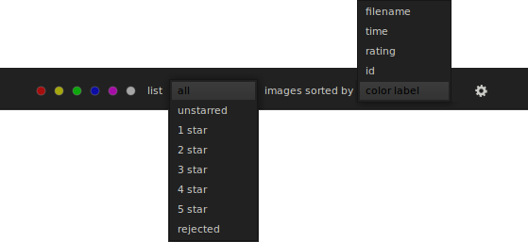Figure 3: listing and filtering options
Darktable settings can be accessed pressing the small button . In most of the cases default settings are appropriate and we do not need to change any parameter.

Left and right panels
Figure 4: right side panels
At the left and at the right of the light table there are two panels that collect most of the functionality of the lighttable view. Each functionality is delivered by a darktable module. For example, Figure 4 shows the right panel modules.
For a detailed description of each panel, see Chapter 2. The goal of this section is instead to familiarize you with the basic darktable UI aspects.
The figure shows seven modules: select, selected image[s], styles, metadata editor, tagging and export selected. Select is expanded showing some other elements of the module UI (the buttons select all, select none, invert selection, select film roll, select untouched). All other modules are collapsed so that only the module title bar is shown. To expand (when collapsed) or collapse (when expanded) a module just click on the title.
For example, clicking on metadata editor, the module is expanded as illustrated in Figure 5.
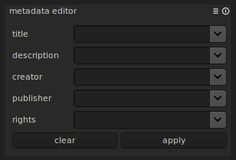Figure 5: metadata panel
The module title bar has three elements: the module title, an optional menu (accessed through the button) and a reset button (). When a module is expanded it can accommodate more widgets as appropriate for the functionality provided by the module; the examples given in this section are quite simple, but in the next chapters of the book more complex widgets and UI elements will be unveiled.
Some modules are provided with a menu bar to access additional functionality or commonly used pre-sets of the module parameters. In the case of the metadata editor, the menu button brings the options in Figure 6.
The reset button is used to reset the panel parameters to its default values.
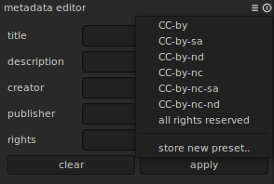Figure 6: metadata editor menu

Darkroom view
Those who come from analog photography should be familiar with the darkroom. A darkroom is a room that is dark and it is where films are developed. In darktable, the concept is very similar: we “develop” RAW images (.cr2, .nef, .dng ,etc.), which are the digital version of film. Back in the days, after shooting a film, the film would have been developed in a darkroom with a well defined chemical process. In the darkroom, the film would be dodged and burned, exposure would be adjusted, etc. After that, the film would have been put in the developing liquids and then after all those steps, the final image would come to life. Now, thanks to digital photography and RAW photo development software like darktable all these steps can be done on the computer.
Figure 7 is a screenshot of what you will see when you enter darktable's darkroom mode. The window structure is similar to lightview; in darkroom, though, the middle area shows the picture that is under processing. The top bar is the same as in lighttable view and the two left and right panels contain the modules used to show information about the photo or to apply the steps of digital development.
Figure 7: darkroom main window
The bottom bar allows you to find the color values in Lab color space of a spot on the image; by clicking pick and drawing a box over the desired area the values of L, a and b change accordingly. It is possible to chose to show the minimum, maximum or mean value of the pixels in the selected box.
To go back to lighttable at any time, press the accelerator key e or click on the label darkroom mode at the top-right corner.
A useful tool in darkroom mode is the filmstrip, just below the image. It is toggled by pressing Ctrl-f and when visible shows the other photos available in the same film, so that it is easier to switch between images without exiting to lighttable and then back to darkroom.
The image in the middle area can be zoomed in and out pressing the Ctrl button and rolling the mouse wheel. In addition, Alt+1 and Alt+2 zoom the image to two predefined zoom factors, while Alt+3 makes the image fit the available middle area.

Darkroom modules
The darkroom mode provides a number of general purpose modules which show useful information on the picture under development and on the development process. The following sections describe in more detail the modules of the left and right panels.
Darkroom modules have the same behavior of lighttable modules. For example, they can be expanded/collapsed clicking on the title bar, or reset settings to the default values clicking the reset button ().
Navigation
In the left panel, the navigation module shows a small view of the entire picture and which part of it is currently displayed in the middle area (see Figure 8).

Snapshots
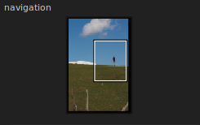Figure 8: navigation module
Often it is useful to compare the result of applying an effect with a snapshot of the image taken without that effect. This is what the snapshots module is for. Clicking on take snapshot a snapshot of what displayed in the main area is taken and added to the list of the snapshots. Selecting one of the snapshots will divide the photo area in two: the left part of the image shows the snapshot, the right half shows the current image. For example, Figure 9 shows a snapshot comparing the original image with a black and white version. It is possible to take more than one snapshot, even if only one of them can be selected at a time.
Note that snapshots are not stored on disk. They will be discarded when darktable is closed.
Figure 9: snapshots module
Metadata
The metadata module shows metadata information about the image being processed. The parameters in the table below are shown in the metadata module.
Metadata field | Description
Filename | Picture file name on the disk
Model | Camera model
Maker | Camera manufacturer
Aperture | Aperture used to take the picture (e.g. F/8.0)
Exposure | Exposure used to take the picture (e.g. 1/100)
F-length | Focal length used (e.g. 50)
ISO | ISO used to take the picture (e.g. 100)
Date/time | Date and time of when the picture was taken (e.g. 2011:03:17 15:58:16)
Lens | The lens used (e.g. Canon EF 50mm f/2.5 Macro)
Width | Picture width (e.g. 3888)
Height | Picture height (e.g. 2592)
Film roll | The film roll the picture belongs to (e.g. 20110317)

History
Figure 10: history stack module
The history stack is the stack of all processing and effects applied to the image. It always starts with the original picture (0 – original) and then grows with the manipulations done on the pictures. Figure 10 shows the stack after adjusting the exposure and cropping the original image.
While manipulating the image, we usually do not care too much the order in which we apply the effects. We can also turn the same effect on and off multiple times, making the stack grow but without actually affecting the image. It is therefore possible to compress the stack to the minimum steps possible by clicking the compress history stack button.
A set of effects can also be stored in a style to be used later on other images. This functionality is better described later in chapter 2.

Histogram
The histogram of the photo being processed is displayed in the histogram module. As illustrated in Figure 11, the histogram shows the different light components and the basic shooting data (exposure time, aperture, focal length and ISO). The histogram is divided in two sections that are highlighted when the mouse pointer goes over the left or right sections. The histogram can be directly manipulated with the mouse, left-clicking and dragging left or right. Modifying the left part of the histogram will change the black point, while modifying the right section will change the exposure. Double clicking the histogram will reset black point or exposure to the original values.

Plugins
Figure 11: histogram module
Most of the area of the right panel is occupied by the plugins module. Plugins are the means to develop our digital images.
Plugins are grouped in basic, color, correct and effect groups. Clicking on the group tab shows the plugins of the selected category, like illustrated in Figure 12. Clicking on the selected tab unselects all tabs and all plugins will be displayed.
Plugins UI is very similar to modules with the addition that they can be turned on or off, meaning their effect is applied or not to the image. To switch a plugin on/off, just click the icon in the title bar.
Darktable plugins will be described in detail in chapter 3.
Figure 12: plugin groups

More plugins
Plugins can be hidden from the plugins module. To hide/show a plugin, use the more plugins module (see Figure 13) and click on the icon of the plugin to switch.
Figure 13: more plugin module
Highlighted plugins are displayed, darkened plugins are hidden.

2
Lighttable
This chapter describes how to manage RAW files in lighttable. Managing photos can be easy or hard, depending on how many photos and what tools are used to do the job. The process of managing, sorting, importing, rating, organizing and tagging is commonly called digital asset management (DAM).
Darktable, and in particular its lighttable view, addresses all aspects of our digital asset management needs with the easy to use interface introduced in chapter 1.

Importing
The first thing to do to be able to develop a digital photo in darktable is to import it, which is the equivalent of storing a film roll in a physical storage. Digital images are usually stored temporarily on SD cards or similar or cameras' internal memory or, if already moved, other types of storage like hard drives. When imported into darktable, images are not physically moved to a different place. Simply, darktable remembers where the photos are stored in its own database, together with other meta information about the picture. This includes also a thumbnail of the photo so that even in the case the original image is not available at a given time, darktable (and specifically lighttable) is able to show at least a small version of it.
There are three ways to import photos: import a single image, import an entire folder of images and import from camera. All three methods are accessible from the import module at the top-left corner of lighttable (Figure 14).
Clicking the image button the file selector of Figure 15 pops up. It is a darktable-like version of the standard file system browser, therefore there is nothing in particular to add to this description. We can select one or more images and click Open so to make them available to darktable.
Figure 14: import plugin
The import folder button opens a similar file chooser to the one of Figure 15, but with the possibility of selecting only folders and with the addition of two options (in the form of check boxes): import directory recursively and ignore jpeg files. Marking the former, darktable will not only import the selected folder, but also all sub-folders recursively. This is very useful to import an existing collection organized in a tree of folders on the file system. The latter option, when marked, tells darktable to not import jpeg files. This is particularly useful when importing a collection where there are two versions of the same picture: the RAW version and the jpeg version generated by a RAW development software or the camera itself. In this case we very likely want to have in darktable the RAW version only and keep the jpeg version still on the storage media, but without listing it in the program.
Figure 15: import image selection window
The last method to import pictures into darktable is directly from the camera. When the camera is connected to the system, clicking on scan for devices will show the camera in a separate tab. For example, in Figure 14, darktable has detected a Canon EOS 1000D. Below the tab, the button import from camera brings up the dialog of Figure 16 that shows the pictures found in the camera memory.
First of all we associate a jobcode to the import so that darktable knows how to refer to the imported images, then we select the images to import. Pressing import completes the operation. Darktable creates a new collection named (by default) <import date>_<jobcode>. Note that in this case pictures are copied (if not moved) from the camera memory to the local file system, normally under the directory <HOME>/Pictures/<import date>_<jobcode>. These and other parameters can be changed from the settings tab of the import from camera dialog box (Figure 17).
Figure 16: importing from camera
As illustrated, importing photos from the camera can be controlled in many ways. In the general section, we can decide to import the RAW version only clicking on ignore jpeg files. Or we can tell darktable to delete the original files marking delete originals after import. It is also possible to change the date darktable uses as import date (today's date by default) with the override today's date import option.
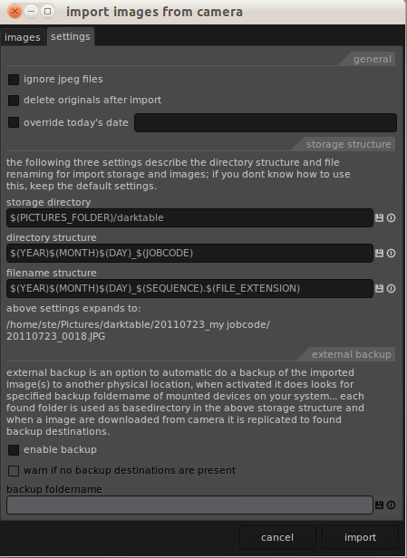Figure 17: import from camera settings
Storage structure settings describe the directory structure (on the local file system) and file renaming that tells darktable where to copy or move the images. Storage directory is the destination directory in the local file system where images are imported. Under this base directory, darktable creates a subdirectory tree as specified by the directory structure setting. Finally, each image is renamed accordingly to the rule defined in filename structure.
It is also possible to instruct darktable to make a backup of the imported photos after import. To enable this functionality mark enable backup then specify the location of the backup file system. In this way, each image downloaded from the camera it is also replicated to the found backup destinations.

Working with collections
Figure 18: collect images module
After importing images, we may wish to group and organize them in collections. This is done using the collect images module. The basic idea is that a collection is defined by a filter or a combination of filters on image properties like import roll, color label, tags, metadata and ratings.
The collect images module has two main sections as shown in Figure 18. The first section at the top of the module is used to create filters. The first selection box is used to choose the filter criteria between film roll, camera, tag, date, history, color label, title, description, creator, publisher and rights. The entry field next to the selection box is used to set the value of the filter.
The list box below the filter section shows possible values for the selected filter type. If, for example, film roll is chosen as filter type, all imported film rolls will be listed. Double clicking on one of the listed values will set the collection to the images belonging to the selected film roll.
Image filtering in darktable is pretty smart so that editing the filter value restricts or relax the search. For example, if we imported images from a <Year>/<Month>/<Day> directory structure under /home/ste/Pictures (e.g. /home/ste/Pictures/2011/...) choosing film roll as filter type will show a list of subdirectory as in the figure. Typing in the filter value /home/ste/Pictures/2011 will show all film rolls under 2011; typing the value /home/ste/Pictures/2011/01 will list all fill rolls imported in January 2011 (as directories). Selecting the film roll will set the collection of images displayed on the light table.
Another example is filtering by dates. Choosing date as filter type, the list box shows all timestamps for which at least one picture taken at that time exists. Editing the filter value to for example just a date (e.g. 2009:10:17) will list all timestamps of that day. Removing the day (e.g. 2009:10) will list all timestamps of the 10th month.
In addition to the above, the wildcard '%' can be used in the filter value to specify an unknown sequence of characters. For example the pattern 2011:%:01 for a date will filter all pictures taken the first of any month of 2011.
Another interesting aspect of filters is that we can create more filters and combine them. Clicking on the little arrow next to the filter value entry filed the options of Figure 19 appear.
Figure 19: filter options
Clear this rule removes the filter so that all available values for the filter type will be listed in the listbox. Narrow down search adds a rule in AND with the existing rules, fundamentally reducing the set of pictures in the collection. Add more images add a new filter in OR, resulting in adding more images to the collection. Exclude images adds a rule in AND NOT with the existing rules, with the result that some images will be removed from the selection.
Figure 20: complex filter
For example, the query of Figure 20 selects all pictures taken in January and February 2011 and whose format is not jpg.
Darktable remembers the 10 most recently collections used so that they can be easily accessed in a later moment. These are listed in the recently used collections like illustrated in Figure 21.

Image information
Figure 21: recently used collections
The last module of the left strip of the lighttable UI is used to display the basic image metadata. This is done by the image information module, which shows the data of the last image the mouse pointer moved over. An example is illustrated in Figure 22.

Working with selections
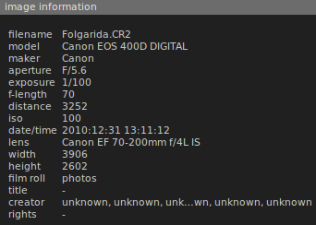Figure 22: image information module
Selecting and manipulating photo selections is straightforward. Clicking on a single image toggles its selection state. If the crtl button is pressed when clicked, the image is added to or removed from the selection. Pressing shift selects/unselects all images from the last selected to the image on which the mouse button is pressed.
There are also some shortcuts accessible through the select module at the top of the right modules area (Figure 23). Select all selects all images currently on the light table. At the contrary, select none, removes any selection. If some photos are selected, invert selection toggles the selection status of all pictures currently on the light table. Select film roll is more interesting: if there are photos from different film rolls on the light table (for example because we selected more than one film roll in the collect images module), selecting one picture and then pressing this button adds to the selection all pictures belonging to the same film roll. Finally, select untouched selects all pictures that have not been modified yet in darktable.
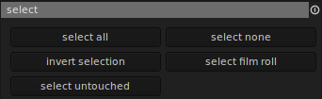Figure 23: select module
The selected images can be manipulated by the means of the selected image[s] module (Figure 24).
Remove removes the selected images from the darktable database. This means that those images will not be available anymore in darktable, but the image files are still preserved on the file system they are located. Delete instead, in addition to what remove does, deletes also the selected images from the file system (after asking confirmation of the operation). Create HDR creates a new high dynamic range image resulting from an HDR merge of the selected images. Duplicate creates new images from the selected ones duplicating the original photos (discarding any plugin execution). The two buttons with a curved arrow change the image orientation counter-clockwise and clockwise, while reset rotation restores the original orientation of the selected images.
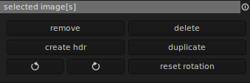Figure 24: selected images module
In many cases it is useful to apply the plugin pipe (or history stack) defined on an image to one or more other images. In fact, as noted earlier, darktable never touches the original image. Instead, it saves the tasks that were performed on a RAW image in a internal database and, optionally, into a separate file called sidecar file. Since this is the default behavior, it can be noticed listing a directory that contains images already imported into darktable: for each imported RAW file darktable creates the corresponding sidecar file, which has the same name of the original file, but with extension .xmp. This can be disabled from the settings, unmarking in the core tab of the settings dialog, the option write a redundant sidecar file for each image (see Figure 25).
The history stack can be manipulated with the history stack module, illustrated in Figure 26.
Figure 25: core settings dialog
Copy copies the history stack of the first image in the selection to the clipboard. Discard discards the history stack of all selected images. This means that they will go back to their originals, without without any plugin applied. Paste pastes a previously copied stack to all selected images. Darktable provides two ways to do so: overwrite and append. The former discards the stack of the selected images and then applies the pasted stack. The latter appends the stack in the clipboard to the one of the selected images.
Figure 26: history stack module
Load sidecar file is useful when we want to apply a history stack coming from other sources (maybe generated by other programs or received by email). Clicking the button opens the standard file chooser so we can choose the file from where it is stored on the file system. The history stack in the sidecar file will then be applied to all selected images. Write sidecar files does the opposite operation: it saves the sidecar files of the selected images. This is useful to make sure that all information regarding anything done on a RAW photo are exported in the sidecar file (certain operations are stored by darktable into the database instead the .xmp file) or when the write a redundant sidecar file for each image is disabled. It can also be used to share and exchange the history stack with other people.
Figure 27: export selected module

Exporting
Exporting a picture is usually the last step in developing a RAW photograph, which consists in persisting into one of the most common picture formats the result of applying the history stack to the original RAW data.
Darktable can export photos to different media or in different formats, varying from web services like flickr and picasa to normal files on a disk. This is done by the export selected module.
Figure 27 shows the available export options, which are described in the table below.
option | description
file on disk | Probably the most common. It exports the selected photo(s) into a file on a disk. This will be described in more detail later.
flickr webalbum | If you have a flickr (http://www.flickr.com) account, you can export directly into a flickr photoset. When selected, you can specify the flickr username, if the images will be public, if tags should be included in the export and the photoset into which you wish to upload the pictures.
picasa webalbum | If you have a picasa (http://picasa.google.com) account, you can export directly into a picasa album. When selected, you can specify the picasa username and password, if tags should be included in the export and the album into which you wish to upload the pictures. See below for an example.
send as email | Exports the photograph and sends it by email with the email client currently configured as default.
website gallery | Creates a surfable site on the file system that can then be published to a web server. When selected, we can specify the destination directory and the title of the gallery.

Exporting to a web album
As an example of exporting to a web album (or to the cloud as it is called nowadays), we will see how to publish a photo to picasa. In lighttable, select Folgarida.CR2 and in the export selected module pick picasa webalbum as target storage and edit your picasa credentials. We want to put the image in a new picasa album, so click on the circular arrow next to the albums selection list. If the credentials are validated, the listbox is filled of all existing albums. Click the list and pick the first item, create new album. Set its title and keep description and visibility to the default.
Under the file format tab, select 8-bit jpeg at 100% quality.
Under the global options tab, select max size 1024x1024, intent perceptual and profile sRGB.
Finally, click on export. Darktable gives us a visual feedback that the export is in progress and will notify us once done. To see the result of this example, go to your picasa account and click on the newly created album. The content of the album will be similar to Figure 28.

Exporting to disk
Figure 28: export to picasa
Most of the times we want to store our developed pictures on a disk or local file system. This is as simple as exporting to a web album with the difference that of course it is not required to provide any credentials.
To export the selected images to disk, pick file on disk as target storage. A new entry field appears to specify in which directory the photos shall be exported. We can select a specific directory clicking on , or specify the path manually. The latter case can be very convenient because darktable expands some place holders at runtime, so that we can specify something like:
$(FILE_DIRECTORY)/$(FILE_NAME)
which will be expanded into something like:
/media/Foto/darktable-book/Folgarida.jpg
In the above $(FILE_DIRECTORY) expands to /media/Foto/darktable-book and $(FILE_NAME) to Folgarida. The extension is picked up by the the chosen file format.
All possible placeholders are listed in the following table.
placeholder | description
$(ROLL_NAME) | Roll of the image being exported
$(FILE_DIRECTORY) | Directory of the image being exported
$(FILE_NAME) | Basename of the image being exported
$(FILE_EXTENSION) | Extension of the image being exported
$(SEQUENCE) | Sequence number
$(YEAR) | Year of the exporting date
$(MONTH) | Month of the exporting date
$(DAY) | Day of the exporting date
$(HOUR) | Hour of the exporting time
$(MINUTE) | Minutes of the exporting time
$(SECOND) | Seconds of the exporting time
$(EXIF_YEAR) | Year of the creation date (as recorded in the exif metadata)
$(EXIF_MONTH) | Month of the creation date (as recorded in the exif metadata)
$(EXIF_DAY) | Day of the creation date (as recorded in the exif metadata)
$(EXIF_HOUR) | Hour of the creation time (as recorded in the exif metadata)
$(EXIF_MINUTE) | Minutes of the creation time (as recorded in the exif metadata)
$(EXIF_SECOND) | Seconds of the creation time (as recorded in the exif metadata)
$(STARS) | Star rating of the image being exported
$(LABELS) | Colorlabels of the image being exported
$(PICTURES_FOLDER) | User picture folder (i.e. /home/ste/Pictures)
$(HOME_FOLDER) | User home (i.e. /home/ste)
$(DESKTOP_FOLDER) | User desktop folder (i.e. /home/ste/Desktop)
After selecting where to store the generated pictures and selecting the proper format, pressing export will do the job. We will be notified of the progress as described above.

File formats
The file format section of the export selected module controls the format photos are exported to. The available formats are described in the table below.
format | description
16-bit ppm | 16-bit version of ppm, which is a plain RGB conversion of the image data where each pixel is represented with a triple of 16-bit values (big endian byte order for compatibility with netpbm).
8-bit jpg | The well known jpeg format, 8 bit per channel. Since jpg compression is potentially not lossless, when selected we can also choose the quality of the output image on a scale 0-100%. The less the quality, the more compressed the resulting file will be. 100% quality means no data loss.
8/16-bit png | The well known png format, lossless compressed. When selected, we can chose between 8 and 16 bits per channel.
8/16-bit tiff | The well known tiff format, lossless compressed. When selected, we can chose between 8 and 16 bits per channel.
copy | It is not a real format. It tells darktable to do a 1:1 copy of the selected images. Note that global options will not be applied.
float pfm | Similar to the PPM format, but records pixel data in floating point.
openexr | OpenEXR is a high dynamic-range (HDR) image file format developed by Industrial Light & Magic for use in computer imaging applications.

Global options
Independently of where to export our photos and in which formats, there are some global exporting options that control different aspects of the output image. These are grouped under the global options section of the export selected module and are described in the table below.
format | description
max size | Maximum width and height of the final picture. Set to 0 to keep the same size of the original image. Usually it is enough to set both to the desired size of the longest side of the image. The other side will be resized by darktable keeping the aspect ratio. For example, specifying 1024 to both max width and height, an image which is 3906x2602 will be exported to a picture 1024x862 pixels. An image which is 1272x1838 will result into a 708x1024 picture.
intent | This setting controls which color conversion should be applied from the image color space (sRGB or Adobe RGB) to the output image. A deep description of how color management is done is out of the scope of this book, but some information is useful to understand how to use at best these options.  Since different devices don't have the same gamut, they need some rearrangement near the borders of the gamut. Some colors need to be shifted to the inside of the gamut as they otherwise cannot be represented on the output device and would simply be clipped. For instance the dark highly saturated purplish-blue color of a typical computer monitor’s “blue” primary is impossible to print on paper with a typical CMYK printer. The nearest approximation within the printer’s gamut will be much less saturated. Conversely, an inkjet printer’s “cyan” primary, a saturated mid-brightness greenish-blue, is outside the gamut of a typical computer monitor. The color management system can utilize various methods to achieve desired results and give experienced users control of the gamut mapping behavior.  Darktable supports the following methods:  - image settings: use the image settings rendering intent  - perceptual and relative colorimetric: these are probably the most useful conversion types for digital photography. Each places a different priority on how they render colors within the portion of not matching gamut. Relative colorimetric maintains a near exact relationship between in gamut colors, even if this clips out of gamut colors. In contrast, perceptual rendering tries to also preserve some relationship between out of gamut colors, even if this results in inaccuracies for in gamut colors.  - absolute colorimetric: it is similar to relative colorimetric in that it preserves in gamut colors and clips those out of gamut, but they differ in how each handles the white point. The white point is the location of the purest and lightest white in a color space.  - saturation: it tries to preserve saturated colors, and is most useful when trying to retain color purity in computer graphics when converting into a larger color space. If the original RGB device contained pure (fully saturated) colors, then saturation intent ensures that those colors will remain saturated in the new color space — even if this causes the colors to become relatively more extreme. Note that saturation intent is not desirable for photos because it does not attempt to maintain color realism. Maintaining color saturation may come at the expense of changes in hue and lightness, which is usually an unacceptable trade-off for photo reproduction.
profile | The color profile to be used to represent colors. A choice of image settings (what's embedded in the image), sRGB (usually chosen for web content), Adobe RGB, system display profile, and linear RGB.

Styles
An interesting and powerful feature of darktable is the ability to save history stacks for later use. This is done in darkroom saving a history stack into a style. For example, open the warrior picture and click on the icon at the bottom of the history module. The pop up of Figure 29 appears. Give a name and a description to the style and go back to lighttable.
Once in light table, the styles module (Figure 30) is used to manage and apply styles.
Figure 29: creating a style in darkroom
The central area of the module lists all available styles (note the style we just created in darkroom). On top of it, an entry field (where the caret cursor is at in the picture) is used to search the list starting to write the name of a style. All styles starting with the inserted characters will be displayed. To apply a style, it is sufficient to double click on it in the list. If the create duplicate check box is marked, new images will be created and the style applied to the duplicates. Otherwise the history stack will be applied directly to the selected images.
Figure 30: styles module
To delete a style, just click on the delete button.
Styles can also be exported to a file or imported from a file with the export and import buttons.
Note that when creating a style in darkroom, checking the advanced edit of style, it is possible to select the plugins to include in the style. This is useful to exclude processing strongly dependent on a particular image. For example, a crop is likely to be good for the image under development, but unlikely to be applied to any other image in the same way.

Tagging
Tags are a way to associate some information to the pictures. This information can be of any type and can have a general meaning or meaning local to just a picture or a set of pictures. It is completely up to us.
Darktable itself uses tags to identify some properties of the picture like the format of the image, if the image has been touched or which styles have been applied. Tags are stored in the sidecar file so that they can be used in other programs too. As seen in section about collections, tags are also used to select which pictures show on the light table.
Figure 31: tagging module
Tags are displayed and managed by the tagging module, illustrated in Figure 31. The panel is divided into two parts: the upper part contains the tags currently set for the image either under mouse (if mouse is over an image) or selected (if mouse is outside the lighttable). The lower part contains all tags available; those can be filtered thanks to the upper text box.
To set a tag for the selected images, select the desired tag in the list and click the attach button. Detach does the opposite: it removes the selected tags from the current image selection.
It is also possible to create new tags: write the tag in the search entry field and click the new button. The newly created tag will be shown in the list.
To delete tags from the global list, select it and press the delete button.

Metadata
In many cases it is desirable to attach additional metadata information to the exported images. Darkable allows to do it with the metadata editor module (Figure 32). Like illustrated in the picture, the following metadata can be added. Title gives a title to the image and it is saved in the EXIF field Exif_Image_ImageDescription. Description is a longer description of the image and is saved in the EXIF field Exif_Photo_UserComment. Creator represents the photographer that created the photograph and is stored in the EXIF field Exif_Image_Artist. Publisher is the publisher of the photograph and in the current version of darkable is not exported to an EXIF field (it will be in a future version). Finally, rights represent the copyright of the photograph and is stored in the EXIF field Exif_Image_Copyright.
Figure 32: metadata editor module
To save the edited metadata in the selected photos, press the apply button. The clear button is used instead to clear all fields.

3
Darkroom
In this chapter we will talk about the darkroom and in particular how to develop RAW photos. The process of developing a photo can be as simple as just generating a viewable picture in JPG or very complex, made of many steps each producing some effect on the original data. This chain of picture manipulations are commonly called workflows. This chapter covers some common workflows, from very simple to more complex ones. In doing so, many darktable plugins are explained in detail so that at the end of this section, the reader will have a deep understanding of the many possibility given by darktable and digital RAW files development.

RAW image format
In digital photography, the RAW file plays the role that photographic film plays in film photography. RAW files thus contain the full resolution (typically 12- or 14-bit) data as read from the camera's image sensor pixels. RAW image files are sometimes called digital negatives, as they fulfill the same role as negatives in film photography: that is, the negative is not directly usable as an image, but has all of the information needed to create an image. Likewise, the process of converting a RAW image file into a viewable format is often called developing a RAW image, by analogy with the film development process used to convert photographic film into viewable prints. The selection of the final choice of image rendering is part of the process of white balancing and color grading.
Depending on the technology the sensor is built, the data representing the pixels may not be in the common RGB form we are used to (in which each pixel color is represented by the amount of the primary colors red, green and blue it contains); instead the pixels may be stored as a mosaic of values that need to be interpreted and rendered in a RGB form before being visualized.

Basic workflow
Let's start by using basic plugins to develop an image.

White balance
White balance is a common name for the process of adjusting the intensities of the colors of a photo, also called color balance. In particular, the goal of white balance is to render neutral colors correctly. Neutral colors are colors with same level of primary colors (red, green, blue). Another way of looking at white balance is the process of removing unrealistic color casts, so that objects that are white in the real scene appear white in the photo.
White balance is arguably the most important first correction for any raw conversion. Until that aspect has been determined, we really can not reliably do any other correction, except maybe cropping and/or rotating (even if it is still suggested to set the proper white balance first because cropping may remove neutral colors that help with setting the correct white balance).
The undesired color cast can be due to many factors, the most important one is the color of the light itself. Any light source in fact has a particular color, called “color temperature”, which refers to the relative warmth or coolness of white light.
Color temperature
The color temperature of a light source is the temperature of an ideal black-body radiator that radiates light of comparable hue to that of the light source. A black-body is an object which absorbs all incident light — neither reflecting it nor allowing it to pass through. Color temperature is conventionally stated in the unit of absolute temperature, the kelvin, having the unit symbol K.
The color temperature of some common light sources is represented in the table below:
Color temperature | Light source
1000-2000 K | Candlelight
2500-3500 K | Tungsten bulb (household variety)
3000-4000 K | Sunrise/Sunset (clear sky)
4000-5000 K | Fluorescent lamps
5000-5500 K | Electronic flash
5500-6500 K | Daylight with clear sky (sun overhead)
6500-8000 K | Moderately overcast sky
9000-10000 K | Shade or heavily overcast sky

The human eye is very good at judging what is white under different light sources, but digital cameras often have great difficulty with auto white balance (AWB) and can create unsightly blue, orange, or even green color casts.
Most cameras provide a few white balance presets, usually represented by the icons below.
Auto white balance
Custom
Kelvin
Tungsten
Fluorescent
Daylight
Flash
Cloudy
Shade
The first three white balances allow for a range of color temperatures. Auto white balance is available in all digital cameras and uses a best guess algorithm within a limited range — usually between 3000/4000 K and 7000 K. Custom white balance allows you to take a picture of a known gray reference under the same lighting, and then set that as the white balance for future photos. With "Kelvin" you can set the color temperature over a broad range.
The remaining six white balances are listed in order of increasing color temperature, however many compact cameras do not include a shade white balance. Some cameras also include a "Fluorescent H" setting, which is designed to work in newer daylight-calibrated fluorescents.
Using the presets provided by the camera sometimes can be not enough. The final image can still present some undesired cast that would be better to correct. Shooting in RAW format gives the possibility to correct color casts and perform white balance in software; in darktable, this is done using the white balance plugin, already introduced in the tutorial and illustrated again in Figure 1.
There are three ways to affect the white balance of a picture:
Figure 1: white balance plugin
- changing tint, temperature in and temperature out;
- modifying the values of red, green and blue;
- and using presets or custom white balance.
Keeping in mind the goal of white balance is to render neutral colors (colors with the same amount of red, green and blue) as they are in the real scene, the basic strategy for white balance is to act on the various parameters so to remove the color cast. Being the color cast a linear function that applies to all colors of the pictures, each parameter has a linear effect on the entire picture. Sometimes, we are lucky to have an area of originally neutral color in the photo so we can focus on that area and make sure it is rendered neutral.
White balance with red, green, blue adjustments
White balance with tint and temperature is based on adjusting the light temperature so to warm or cool the colors of the picture. Temperature in and temperature out represents the scale of light temperature from a minimum of 3000 K to a maximum 12000 K. Temperature in varies from blue to yellow, while temperature out changes the balance from yellow to blue. They are one the inverse of the other, so they null each other (if both are set to the same temperature value, the balance will not change). This gives a real scale of changes which is double of each temperature scale (maximum warmth is reached when temperature in is 12000 K and temperature out is 3000 K, maximum coolness is reached when temperature in is 3000 K and temperature out is 12000 K).
Tint varies from 0.1 to 5 and changes the picture from cyan to green. The following figures illustrate the photo Fosdinovo.CR2 with different values of tints and temperature.
Usually it is enough to work with tint and temperature in. For example, the correct version of the picture of the above images is illustrated in Figure 6.
Figure 2: T: 0.1, Ki: 5000, Ko: 5000
Figure 3: T: 5, Ki: 5000, Ko: 5000
Figure 4: T: 1, Ki: 3000, Ko: 12000
Figure 5: T: 1, Ki: 12000, Ko: 3000
Figure 6: T: 1,316, Ki: 4709, Ko: 5000
White balance with red, green, blue adjustments
Another way to white balance a picture is acting on the color channels, adjusting the red, green and blue sliders to give more or less of each color component to the pictures. All channels have a range from 0 to 5. The figures below shows some extreme values, and Figure 10 shows the correct values.
White balance with preset values
Figure 8: R:1, G: 5, B: 1
Figure 7: R: 5, G: 1, B: 1
Figure 9: R: 5, G: 1, B: 1
Figure 10: R: 1.566, G: 1, B: 1.257
Darktable provides a number of presets of white balance suitable to the most common lighting conditions. These are:
- Camera white balance
- Spot white balance
- Passthrough
- Daylight
- Shade
- Cloudy
- Tungsten
- White fluorescent
- Flash
Camera white balance uses the white balance information stored in the RAW file from the camera. Passthrough white balance does not apply any correction to the image data stored in the RAW format. In this way, darktable shows exactly the color data read from the sensor of the camera without any color balance.
More interesting is the spot white balance. It is not really a preset, because it allows to spot in the picture an area of neutral color that darktable will use to automatically balance all other colors. When chosen, a selection box appears on the photo being developed. Point the mouse to the area with neutral color and drag the mouse to satisfaction. This will set the new white balance for the picture. Figure 11 and Figure 12 illustrate white balance with two different spots.
The next six presets are based on different kind of lighting conditions, which correspond, for the image used in this section, to the color temperatures in the table below.
Figure 11: spot white balance I
Figure 12: spot white balance II
Preset | Tint | Temperature
Daylight | 0.978 | 5285 K
Shade | 0.952 | 6523 K
Cloudy | 0.964 | 5870 K
Tungsten | 1.064 | 3641 K
White fluorescent | 0.962 | 4129 K
Flash | 0.941 | 6641 K
The grey card
One technique that can be very useful in white balance is to use a gray card. This is a middle gray reference used also to produce consistent exposures.
A gray card is a flat object of a neutral gray color that derives from a flat reflectance spectrum which usually has a 18% reflectance across the visible spectrum and a white reverse side which has a 90% reflectance. The 18% value comes from the non linear way our eye and brain perceive reflectance so that 18% reflectance is perceived like middle gray. The gray card is designed to appear neutral under any lighting.
Being a well defined neutral color reference, a gray card is a convenient reference for white balance allowing the camera or a post-processing software to compensate for the light color in a scene. In darktable this can be used with the spot white balance preset. Just draw the spot rectangle inside the card and darktable will set the white balance point for the whole image.
White balance many pictures at the same time
Often many pictures are taken under the same light conditions. In these cases it would be nice to have the possibility to adjust the white balance only once and then apply the same settings to all pictures with similar lighting. Darktable provides many ways to do so.
First, search for an image with a neutral area so it will be easier to make sure it will look neutral in the final image. One good way to be prepared to this is to take a picture with the gray card in it. Once a suitable image has been selected, white balance it with one of the methods described in the above sections.
We now have a set of tint/temperature or RGB channels that can be applied to all images taken under same light conditions. The first method to apply those settings it to manually take note of the values and apply them with the white balance plug-in in all desired images.
A shortcut for the above method is to click on the presets button and store the current values in a new preset. This can then be applied to all desired images selecting the preset created in the images used as reference.
Another method, probably the quickest, is to open the image that we want to use as reference and correct the white balance as appropriate. Do not apply any other correction and exit darkroom. In lighttable, select the reference picture and click on the copy button of the history stack module (see chapter 2 for a detailed description of how to use lighttable). Now it is sufficient to select all images the same settings should be applied and press the paste button. This will apply the workflow previously copied to all selected images.
Figure 13: store new preset

Composition enhancing workflow
Composition is a key element for a good shot. The reason why composition is so important lays in the fact that what a camera sees is different from what we see. When we look at a scene we selectively see only the important elements in it, while we almost ignore everything else. Instead, the sensor of the camera records exactly what it sees, in a very different way than we do: the camera records only a small part of the scene, reduces it to only two dimensions, frames it and freezes it. Plus it records colors in a different way then we are capable of perceiving and with a more difficult color balance. The camera records all the details that our brain tend to discard making it more difficult to highlight the point of interest that the photographer wants to show.
A good photographer makes all his/her best to have a good composition in camera before shooting, but sometimes the conditions do not permit it or simply a shot is planned to be adjusted later in post production. In any case, digital photography makes it easy to adjust the composition of a picture by rotating and cropping the scene recorded by the camera.
This section covers some basic principles of photographic composition first and then describes how to use the darktable crop and rotate plugin to improve the composition of photos during RAW development.

Photographic composition
Good pictures are seldom created by chance. The way the elements of a scene are arranged catches the viewer's attention, catches the eyes, makes a clear statement or tells a story; all qualities of a good composition.
There are three important guidelines to keep in mind when composing a photograph. Theme, Emphasis and Simplicity. All three things help to focus the attention on the subject. The subject is what the photographer intended to take a picture of, placing emphasis on it, and simplifying the background.
Theme expresses what is the universal message of this photograph, what it implies, what it says and what kind of statement the photographer wants to make. For example, is it about love, or childhood, or parents, or growing old? Is it about the beauty in nature, or the ugliness of poverty? Is about the tremendous power of the weather or the gentleness of a lamb? What makes this photo worth taking? Why do you want to take this image? Theme is what makes a photograph different from a snapshot. Theme is what makes a timeless image. It is what moves and inspires the viewer to look at the photograph again and again and maybe hang it on the wall instead of forgetting it in a box.
Emphasis is about what is the subject, where it is and where the viewer should look to find out what is important. There are many techniques used to show emphasis. The photographer can show emphasis through framing choice, whether she uses a vertical or horizontal format. Or she might show emphasis by the placement of the subject. Or she might use selective focus to simplify the background or by drawing the viewers attention to a certain spot within the frame using perspective.
Simplify is the work to simplify the composition by assuring that nothing in the frame distracts from the subject so that nothing in the photograph weakens the theme or compete with the main subject. It is important that everything visible in the photograph helps to support the theme and the background does not distract from the subject but adds to the composition. Simplicity will be additionally covered later in this section.
Good composition cannot be defined precisely and there is no silver bullet rule that makes a well composed photo. There are only principles and elements that when applied properly help in achieving a pleasant composition. Some of these are explained in the following sections.
Center of interest
One important principle for good composition is that the picture should have one clear principal idea, a center of interest to which the viewer's eyes are attracted. Secondary elements in the picture must support the primary topic, otherwise they become disturbances, diminishing the power of the main message.
Note that center of interest does not mean that the interesting elements of the picture must be located in the center of the frame. And actually, as seen later, this is not the case in most good pictures.
A picture without a dominant center of interest or one with more than one dominant center of interest is puzzling to a viewer. Subsequently, the viewer becomes confused and wonders what the picture is all about. A photographer can use many elements within the picture area to draw or direct attention to the primary. For example, lines, shapes, human figures, tone, and texture are all good means to lead the viewer's eyes to the wanted point of interest.
Human figures attract attention more strongly than almost any other subject matter and unless they are the main object of the photograph should probably be kept out of the picture. When people are included in a scene for comparative size of objects or just for atmosphere, a good practice is to keep them from looking directly at the camera. When people look at the camera and therefore at the viewer of the picture, the viewer tends to return their gaze by looking directly back into their eyes, distracting from the intended point of interest. When people are subordinate elements within the picture and they are looking in a direction other than at the camera, the viewer’s attention is directed from the people to what they are looking at, which should be the center of interest.
Placement of the subject
It has been found that certain points in a picture's composition automatically attract the viewer's attention. Similarly, many natural or man-made objects and scenes with certain proportions (whether by chance or by design) automatically please us. In photographic composition there are several guides to suggest the position of the point of interest, the most known of them being the rule of thirds. Figure 14 shows the good locations for the point of interest as recommended by the rule of thirds.
The frame is divided in three columns and three rows all of the same width and height. The intersections between such lines are the candidates of where to place the center of interest.
Figure 14: rule of thirds
The rule of thirds is a simplified version of the golden section rule where the intersecting lines are drawn at a different ratio than 1/3, called golden section.
The golden section is a line segment divided according to the golden ratio: the total length a + b is to the length of the longer segment a as the length of a is to the length of the shorter segment b. Dividing the frame with golden lines with golden sections we obtain a grid like in Figure 16.
Figure 15: the golden section
Another rule used to place the main point of interest is rule of dynamic symmetry, illustrated in Figure 17.
Figure 16: golden section rule
Differently from the above rules, the diagonal rule suggests to place the important elements of the picture along a diagonal frame formed as illustrated in Figure 18.
Figure 17: dynamic symmetry

Another interesting composition principle is the rule of odds, which states that by framing the object of interest in an image with an even number of surrounding objects, it becomes more comforting to the eye, thus creates a feeling of ease and pleasure. It is based on the assumption that humans tend to find visual images that reflect their own preferences/wishes in life more pleasing and attractive. An image of a person surrounded/framed by two other persons, for instance, where the person in the center is the object of interest in that image, is more likely to be perceived as friendly and comforting by the viewer, than an image of a single person with no significant surroundings.
Figure 18: diagonal rule
Simplicity
The reason why we take a picture is most of the times obvious to us. But it is not obvious to a viewer, therefore the picture must make it clear. The simpler and more direct a picture is, the clearer and stronger is the resulting statement, making it easily readable by a viewer.
For example, the starfish in Figure 19 is against a cluttered background, thus not immediately recognizable. The starfish in Figure 20 is instead against a neutral and cleaner background, making the subject of the picture immediately recognizable.
Figure 19: starfish against a cluttered background
Figure 20: starfish against a neutral background
A good practice in looking for simplicity is to first select a subject that allows a simple arrangement of the objects in the scene.
Secondly try different viewpoints and camera angles. Move around the scene or object being photographed. Most of the subjects being photographed are three-dimensional and should be captured from an angle (to the right or left of and/or from higher or lower than the subject) that allows the viewer to see more than one side of the subject. View the scene through the camera viewfinder. Look at the foreground and background. Try high and low angles as well as normal eye-level viewpoints. Evaluate each view and angle. We should take the picture only after considering all possibilities. Make sure there is nothing in the background to distract the viewer's attention from the main point of the picture and check that there is not any other object that can attract the viewer's attention instead of the intended object.
Another principle to consider is to tell only one story, or express only one idea. Nothing in the frame should distract from the intended main object (or group of objects); all other elements should merely support and emphasize the main object.
Balance
Balance in composition is a matter of making the picture look harmonious. Each object in a scene has a weight in comparison to all other elements so that the entire picture is balanced when each object has the proper weight in the frame. A key role in composition balance is played by symmetries and asymmetries.
Symmetrical, or formal, balance in a photograph is achieved when elements on both sides of the picture (against the horizontal or vertical axis) are of equal weight.
Asymmetrical, or informal, balance occurs when several smaller items on one side are balanced by a large item on the other side, or smaller items are placed further away from the center of the screen than larger items. One darker item may need to be balanced by several lighter items. Although asymmetrical balance may appear more casual and less planned, it is usually harder to use because the artist must plan the layout very carefully to ensure that it is still balanced. An unbalanced picture creates a feeling of tension, as if the image might tip, or things might slide off the side, just as the unbalanced balance beam would tip to one side.
Another type of balance is called radial balance, where all elements radiate out from a center point in a circular fashion. It is very easy to maintain a focal point in radial balance, since all the elements lead your eye toward the center.
There are other factors to consider in order to make pictures appear balanced. Some of these are:
- An object far from the center of the picture seems to have more weight than one near the center.
- Objects in the upper part of a picture seem heavier than objects of the same size in the lower part of a picture.
- Isolation seems to increase the weight of an object.
- Intensely interesting objects seem to have more compositional weight.
- Regular shapes seem to have more weight than irregular shapes.
- Elements on the right side of an asymmetrical picture appear to have more weight than elements of the same size on the left side of the picture.
- The directions in which figures, lines, and shapes appear to be moving within the picture area are important to balance; for example, a person may be walking in a direction, or his eyes may be looking in a direction, or the shape of some element creates a feeling of movement. When the feeling of direction is present within a scene, it tends to upset the balance if judged on the size of the subject alone.
Understanding the factors required to create graphic balance is essential to produce good pictures; the good news is that once we gain an understanding of the principles of balance, achieving it becomes an easy process.
Shapes and lines
Shapes and lines are important elements in photographic composition that can be used by the photographer to create the desired effect.
Shape and forms are usually the main means by which a viewer identifies objects inside a picture. Shapes are fundamentally two-dimensional while forms are three-dimensional.
Figure 21: example of silhouette - A silhouette of the Statue of Liberty in New York.
Even if a picture is a two-dimensional representation of a scene, with the proper application of lights and shadows shapes can obtain a three-dimensions aspect that makes them pop up from the background. A great use of shapes are also silhouettes (Figure 21).
Lines can be effective elements of composition, because they give structure to photographs. Lines can unify composition by directing the viewer's eyes and attention to the main point of the picture or lead the eyes from one part of the picture to another. They can lead the eyes to infinity, divide the picture, and create patterns. Through linear perspective, lines can lend a sense of depth to a photograph.
The viewer's eyes tend to follow lines into the picture (or out of the picture) regardless of whether they are simple linear elements such as fences, roads, and a row of phone poles, or more complex line elements, such as curves, shapes, tones, and colors. Lines that lead the eye or direct attention are referred to as leading lines. A good leading line is one that starts near the bottom corner of the scene and continues unbroken until it reaches the point of interest. It should end at this point; otherwise, attention is carried beyond the primary subject of the photograph. The apparent direction of lines can often be changed by simply changing viewpoint or camera angle.
Horizontal lines can be powerful in creating photos that are peaceful. They may have the ability to convey restfulness and stability. An idea of this can be a romantic couple laying in long grass. The most common horizontal lines to be found in photographs are normally horizons, but be careful not to run the horizon directly through the center of the photograph dividing the equal amounts of the sky and landscapes. This may often have a negative effect and possibly create a dull image. Although this is not always considered the rule. A great practice to pick out the more impressive part of your scene, for example sunsets with dramatic clouds. Also keep in mind that broken horizons may lead to a dull feeling photograph.
Vertical lines can convey various different moods from grandeur and dignity to rigidity. Objects such as buildings and people represent vertical lines. To create a very powerful and dynamic picture combine vertical lines with horizontal lines. To emphasize the power of the vertical line, try switching the camera to the vertical plane. As with all photography this is not always the rule. If you want the lines to appear as if they are moving out of the top of the image, it then becomes useful to leave the camera in a landscape format and take the photo so that the lines move from the top to the bottom of your image.
Diagonal lines are often considered the most interesting. They represent movement and speed. They can lead the viewer into the frame of the photo and to the center of interest. A good idea is to avoid splitting the frame of an image in two by running diagonal lines from one corner of the picture to the other. This may cause the image to lose it’s drive.
Curved lines within your frame can also be representative of moods such as grace and dignity.
Patterns
Patterns, both natural and man-made, bring a sense of visual rhythm and harmony to photographs that, like a series of repeating notes in a melody, capture the imagination. Patterns appear whenever strong graphic elements—lines, colors, shapes, or forms—repeat themselves.
Figure 22: an example of pattern (by Giovanni Dall'Orto)
Like lines and shape, real life scenes are full of patterns that we do not notice at a first glance. It takes some practice to see them but after becoming a bit accustomed, we will spot them out of ordinary scenes.
Patterns can be effectively used in two ways: emphasizing the pattern or breaking the pattern.
To emphasize the pattern, make it fill the entire frame. If necessary go close to the subjects so that the pattern covers the entire available space to give the sense of a big number of the pattern element indefinitely repeated.
The other use of a pattern is to have an element that breaks the recurring of the pattern elements.
For example an element with the same shape but different color or other contrasting element (different shape or texture) or removing the repeating object. When this technique is used, make sure the braking pattern is well emphasized for example by positioning it following one of the composition rules seen earlier and carefully controlling the depth of field so that the breaking pattern is at the maximum level of detail.
Lighting
Lighting can be used in composition to create areas of light and shadows so to give a photo a particular mood, to draw attention to an area, to modify or distort shapes, or to bring out form and texture in the subject. Usually harsh and black shadows are not desirable in good photographs because too dark areas do not have details of interest. However, they can be very useful to balance a scene or leading the attention of the viewer to the desired point of interest.
Also pay attention to areas that are too lit. White and bright strongly attract the human eye and therefore can distract the viewer's attention from the main point of interest.
Framing
Framing is a technique used to bring the focus to the subject. Frames serve the double purpose of making a more aesthetically pleasing image and keeping the focus on the framed object(s). They add depth to the image, and can add a great deal to the picture when the frame is something related to the object being framed, which is emphasized and looks separate from the rest of the scene.
In addition to framing objects inside the scene, remember there is always an additional frame: the picture frame. One important choice to make in framing a photo is how the camera should be turned: horizontal or vertical?
Figure 23: the blue Sky and white sand acts as a frame of the main object, the wooden fence
The frame shape should always match the shape of the subject. For instance, if shooting a skyline scene, the only choice is horizontal, because a skyline is horizontal, it follows the horizon. On the other hand, if the subject is a skyscraper, the choice would be vertical, because skyscrapers are vertical buildings. The shape of the frame isolates the subject. The frame should compliment, not distract from, the total composition. Like many (if not all) other rules in photography this rule can be broken if there is a very good reason for doing so and only if the frame choice adds to the statement of the picture.
Perspective
Perspective is about the relationship of imaged objects in a photograph. Another way to see at perspective in photographic composition is the way a three-dimensional scene is reproduced on a two-dimensional plane. In essence it is the ability to create the illusion and sensations of volume, space, depth and distance.
Mergers
Figure 24: example of common merger to avoid in portraits
A merger is when the main subject, usually in foreground, merges with the background in a unpleasant way. A typical case of undesired merger is when a vertical object seems to come out of the head of the subject of a portrait. Mergers appear more obvious in photographs than the real scene because our eyes are used to distinguish between the subject of interest and the background (in particular in three-dimensional space). But a photograph is a two-dimensional partial representation of a real scene and space and lines are compressed in the image. Composition is therefore essential to help the viewer to easily identify all elements in the scene.
Figure 24 illustrates an example of this kind of merges. The vertical stick and the horizontal wood shelf coming out of the head of the person are examples of mergers to avoid.
Another type of merger to avoid is the border merger. This happens when people are cut in half or their heads or feet are trimmed. An example is illustrated in Figure 25.
Figure 25: an example of border merger
Headroom
Headroom refers to the distance between the top of the subject's head and the top of the frame. The amount of headroom that is considered aesthetically pleasing is a dynamic quantity; it changes relative to how much of the frame is filled by the subject. The rule of thumb taken from classic portrait painting techniques and mentioned earlier, the rule of thirds, is that the subject's eyes, or the center of interest, is ideally positioned one-third of the way down from the top of the frame.
Below some examples of different headroom.
Excessive amount of headroom, with the subject's nose centered in the frame (a common mistake).
A subtle lack of headroom with the subject's eyes only 28% of the way down from the top, not 33%.
Good composition, with the subject's eyes one-third of the distance down from the top of the frame, following the rule of thirds.

Improving composition in darktable
Now that we learned the basics of photographic composition we realize composition must be primarily determined before taking the picture. Sometimes however this is not possible (for example when we capture a scene that quickly changes) or the result in the camera does not meet the desired result. Or simply a photo presents composition errors that we would like to fix.
In many cases darktable can help, in particular with the use of the two plug-ins: lens correction and crop and rotate.
Lens correction plug-in
This plug-in can be used in many workflows, not only to improve the composition, but it is worth to mention it here because it affects many aspects covered earlier.
The reason why there is a lens correction plugin is because all lenses are imperfect thus they introduce distortions to the captured images. There are two types of distortions: geometric and chromatic aberrations. Geometric distortions can be related to the geometry or the scale. Chromatic aberrations are errors in capturing the images due to the inability of the lens system to focus all colors on the same convergence pixel on the sensor under certain circumstances, for example around transitions between a dark foreground and a bright background, like illustrated in Figure 26.
Figure 26: example of chromatic aberration
Because these distortions are introduced by the lens, they apply to all pictures in the same way under the same conditions. Therefore, darktable can try to fix such defects in software. To do so, darktable uses a database of camera models and lenses, together with the information about the distortions they introduce. Darktable automatically detects the camera and the lens used if available in the metadata of the picture being used, so that it presents default values for the correction to apply. Thus, when a photo is opened in darktable, the lens correction plugin is similar to what illustrated in Figure 27.
In most of the cases, to properly correct the distortions introduced by a lens it is enough to turn on the plugin (thanks to the fact that darktable detects the equipment the picture was taken with). If instead the camera and/or the lens are not detected correctly, the right values can be selected from the list that shows up when pressing on the camera or lens button. If the result is still not acceptable, we can manually set the correction parameters from the plugin UI. Geometry and scale work on geometric aberration, tca r and tca b on chromatic aberration.
Figure 27: lens correction plugin
Geometry corrects geometric distortions as illustrated in Figure 28.
The same plugin allows to correct chromatic aberration. This is done with the two settings tca r and tca b, which act on the red and blue channels respectively. Like in the case of geometry correction, usually the default settings are enough to improve the photo, but if the result is still not satisfactory, the parameters above can be tweaked accordingly. Figure 29 shows different values of tca r and tca b applied to a particular of Figure 26. The version on the left is with minimal values of correction (0.99 for both tca r and tca b); the version on the right with maximum values of correction (1.01 for both).
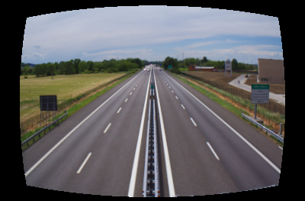Figure 28: geometry lens corrections: original, rectilinear, fish-eye, panoramic, equirectangual
Crop and rotate plugin
Figure 29: chromatic aberrations correction with tca r 0.99 and tca b 0.99 (left) and tca r 1.01 and tca b 1.01 (right)
Another tool to improve composition after a shot is taken is the crop and rotate plugin. This plugin can be used for many purposes:
- to crop the image so to change the composition;
- to rotate the image to correct composition problems;
- to correct keystone distortion.
Crop
Cropping an image means selecting a rectangular area of the picture to keep. All outside the selected frame is discarded. This simple technique is very powerful to improve the composition of a photograph because it allows to apply many of the photographic composition principles seen in the section above. For example, by cropping away undesired or unpleasant sections, the photo can be made cleaner and simpler, the main subject can be made more evident, the statement can be made clearer. By cropping, we can also improve the placing of the main subject, for example to follow one of the composition rules such as the rule of thirds.
Figure 30: Piandulares.CR2 original and cropping by golden mean rule
Note, however, that cropping means removing pixels from the image, and therefore information. This may preclude the quality of a printing in particular for big sizes.
For example, consider the photograph already mentioned in the tutorial called Piandulares.CR2, here illustrated in Figure 30 for the sake of simplicity.
It is a nice picture that transmits a sense of peace walking toward a relaxing place. There is also a fence in the bottom as a natural frame for the picture. The main subject is clear and recognizable. However the horizon is placed in the middle of the frame locking the ground and the sky to a static equally important role. Is the statement more walking toward the freedom of the sky or about the effort to climb a hill? In addition, the fence is not very visible becoming more of a disturbing element than an element that supports the main subject.
An easy way to change some of those elements is by cropping the image so to re-frame the main subject and provide a different perspective. To do so, enable the crop and rotate plugin (Figure 31).
Figure 31: crop and rotate plugin
When the plugin is enabled, moving the mouse over the borders of the image will show a dragging guide; drag the guides to determine the area of the photograph to keep (darktable will darken the area that will be discarded). Darktable provides also easy guides to visually represent the spot of interest based on various composition rules. The type dropbox of the guides section at the bottom of the plugin allows to select amongst grid, rule of thirds, diagonal method, harmonious triangles and golden mean. Also, the aspect dropbox helps in making a crop with a fixed aspect ration. The default is free, which allows a free aspect ratio of the crop, while the other values are: image, golden cut, 1:2, 3:2, 4:3, square, din, 16:9. We can also type a custom ratio in the form width:height (for example 3:5).
Figure 32: cropping with golden mean guides
One approach to make the statement of the image more direct and clearer is to lay the horizon close to a golden mean guide and the person in a golden intersection. To do so, select image aspect ratio and type golden mean. Set the crop selection to something like Figure 32 and press enter.
Another approach that could be taken is to follow the principle about framing that tells that the frame of the picture should follow the frame of the subject. For example, in the picture used earlier the skyline suggests an horizontal frame. We can try the effect again using the crop and rotate plugin. To do so, select golden cut as aspect ratio and rule of thirds for the guides. Note that the guides and the cropping rectangle are still vertical. Click on the swap aspect ratio or press Ctrl-X Position the horizon on the bottom third guide line and the subject close to the right third guide to obtain a picture similar to Figure 33.
Figure 33: horizontal crop
This second crop is more drastic that the first one; this means that the amount of information discarded is quite relevant at the point to reduce considerably the use that can be done of the picture. Digital development makes it very easy to apply this kind of processing to an image, but it is important to remark that even though technology helps and will help even more in the future, nothing more than thinking about a good composition before pressing the shutter will make a great photograph.
Rotate
Keeping vertical lines fully vertical and horizontal lines fully plain seems an easy task; instead, even professional photographers sometimes have issues with straight lines, although the effect on the photograph is particularly annoying. For example a sunset on the sea where the horizon is sloping results usually in a bad sense because the water in the sea does not fall down. With darktable fixing these issues rotating a picture is quite easy, as already seen in the tutorial. There are two simple ways to rotate a picture. One is by writing in the angle field of the crop and rotate plugin the degrees the image shall be rotated. Positive values rotate clockwise, negative values rotate counter clockwise.
The other way is to activate the plugin and draw a line on the picture on one of the edges that look sloping. To do so right click on the first point of the line and drag the mouse where necessary (see Figure 34).
Figure 34: rotating by selecting the line to strengthen
Then release the right button, the image will be rotated to make the line straight.
Distortion
The keystone effect is a common geometric distortion. It can be easily noticed when an image is projected on a plane which is not perfectly parallel to the plane of the projector with the effect that the frame of the image looks trapezoidal instead of rectangular. In photography, this effect is quite common when taking a picture for example of a tall building the camera is inclined so that the lens is not parallel with the plane of the building any more. As illustrated in Figure 35, the perspective is distorted and the elements of the building seem to fall apart.
These types of distortion can be corrected with the crop and rotate plugin acting on the keystone h and keystone v settings. The former corrects the horizontal keystone effect, while the latter corrects the vertical keystone affect. The first image in Figure 35 shows the typical keystone effect introduced by a wide-angle lens inclined to include the entire building in the frame; setting keystone v to -0.19 corrects the effect producing the image on the right of Figure 35.
A similar effect can be introduced on the horizontal axis and can be corrected changing the value of keystone h.
Figure 35: image with keystone effect and image corrected

Black and white workflow
Sometimes a photo has an entirely different mood when seen in black and white and that's why many photographers want to convert their images to black and white. Since its inception with the first daguerreotype, photographies were captured in black and white by millions of photographers. Today, with modern digital cameras, all the pictures taken are shot in color but most, if not all, cameras allow the user to convert the image to black and white or sepia tone by enabling an option in a menu.
The daguerreotype
In the first half of the nineteenth century, precisely in 1839, Louis Daguerre, presented his new invention to the public. This revolutionary discovery consisted in exposing a brass plate to the light in a properly built wooden box, called the “black chamber” which contains a lens that let the light hit the plate. A tiny stratus of silver were applied to the plate to sensitize it to the light. This process produced a latent image, which is an image that must be developed to form the final picture.
Capturing black and white photos forces a different point of view for photographers, because human beings see in color and the world is full of color, but a black and white image is only defined by contrast among lights and shadows.
Why someone would someone want to shoot in black and white ? The answer is multi-faceted: for example, to concentrate on shapes and discard what is considered “unuseful” information (like color) or to underline the force of shadows and light for a particular composition. This workflow explains how to convert an image to black and white (B/W from now on) with darktable. But before delving into the darktable interface a bit of color theory is needed.

Perception of color by human eye
The light is part of the electromagnetic spectrum visible by the human eye. This part is only a fraction of the entire spectrum, as shown in Figure 36.

In particular, the human eye, illustrated in Figure 37, can see the wavelenghts between around 400 and 780 nanometers (nm) or, in terms of colors, from violet to red. The retina, which is the light-sensitive tissue inside the eye, is scattered of rods and cones. The former are concentrated at the outer edges of the retina and are used in peripheral vision, working better in dim light, for example at night. The cone cells work at best in bright light and are situated in the fovea, leaving the place to rods in peripheral parts of the retina.
Figure 36: The electromagnetic spectrum (from Wikimedia Commons, by Inductiveload)
Figure 37: The human eye
Usually the ratio of rods over cones is 20:1 (4.5 million cone cells and 90 million rod cells).
However, even if the cones are less sensitive to light than rods, they allow the eye to be sensitive to color, in particular there are three different types of cones in the retina and each type is sensible to a different part of the visible spectrum: the three types of cones are L, M, and S, which have pigments that respond best to light of long (especially 560 nm), medium (530 nm), and short (420 nm) wavelengths respectively, as shown in Figure 38.

Sensors, filters and colors
Figure 38: S, M and L cones response to different wavelenght stimulus
Until now we have seen how the light is “captured” by the human eye, but to explain how a picture is captured by a digital camera, we must understand how the light hits the sensor from the environment, in particular how it goes from an illuminant (a light source) to the sensor by passing through the lens.
The main components of any digital camera are the lens and the image sensor. A ray of light hits the lens, which focuses it to a part of the sensor. The energy of the ray is converted to an electronic signal, which in turn is converted to a color value to be stored in a file in the memory card of the camera.
However, in most digital cameras, there is another object placed between the sensor and the lens, called color filter array (CFA), that is used to capture the color information. The CFA is a grid of microfilters that filters the light by its wavelength range. One of the most used filters is the Bayer filter (Figure 39), which has a pattern composed of 50% green, 25% red and 25% blue, because the human eye is more sensitive to green.
Figure 39: Bayer filter over a sensor (from Wikimedia Commons, by Colin M.L. Burnett)

Conversion to black and white
It was important to introduce some basic information about colors even in this section about black and white because, as mentioned, all images are captured in color by the camera sensor, due to the filter posed between the lens and the sensor. The RAW image, therefore, contains also color information and the conversion to black and white tones shall be done during image development. This is different from film photography where black and white was achieved directly on film at the time of shooting.
Now, by starting with a colour photo and converting it to black and white in darktable, we have complete control over the conversion. Darkening a blue sky is easy, once we know how, and one can decide exactly how dark he or she wants it to be.
Most digital SLRs (and some compacts) have a black and white mode. In this case, the camera does the conversion but the results are usually poor, flat, washed out photos.
There is no silver bullet to describe what makes a good black and white photo and a lot is a matter of taste; but some guidelines can be highlighted. First of all, the foundation of a black and white image are the colors black and white. Blacks shall be very black and whites very white. Between black and white there is a range of tonal gradations that should be distributed so that there is enough contrast to pop up all points of interest of the image. If all the tones in the range are too close, the image becomes an overall blur of gray tones. A good black and white image should show shadows with details and at the same time highlights with details.
Lastly, simplicity. Getting rid of colors lets the photographer focus on the composition, lines, subtleties and nuances in the shadows... the absence of colors is an invitation to the viewer to use imagination without the constraint of real hues.
Using monochrome plugin
The first and most important darktable plugin to convert an image to black and white is the monochrome plugin. Open the file Lamps.CR2, darktable shows the image as illustrated in Figure 40.
Figure 40: Darkroom with Lamps.CR2 opened

Note on the right panel the monochrome plugin (in the Effect group) expanded but not activated yet. Activate it by clicking on the symbol on its top left bar, the image will convert to black and white (Figure 41).
Figure 41: Image with monochrome plugin activated
The naïve way to convert a color image to a grayscale one is performed by applying the formula :
Grayscale pixel = 30%Red, 59%Green, 11%Blue of the original pixel
Usually it is possible to convert an image to black and white in different ways, because a different use of the color channels simulates the effect of shooting a film with colored photographic filters on the cameras. This is possible to achieve also with darktable, by using the virtual color filter, which is represented as a circle inside a color grid.
You can move it by clicking it and moving the mouse in the frame. With the middle mouse scroll button is it possible to change the diameter of the circle. The lesser the diameter of the circle, the fewer the colors taken into consideration when converting to black and white. This is useful to emphasize a detail which in the original image had a particular color. A larger diameter uses a large spectrum of colors to convert to black and white.
Color filters
Figure 42: Lens filters, (from Wikimedia Commons, by Ashley Pomeroy)
When photos were shot in film, the lens filters were an essential component to the photographer tools. Usually they are glass disks that can be screwed on the lens, but there are also square shaped ones.
Among the most used filters, especially in the digital age, are the UV filter and the polarizer, which are used, respectively, to cut haze or to reduce reflections (for example when the subject reflects the light, like a water surface or a person wearing glasses).
A particular class of filter are the color filters, which are divided in two categories: the conversion filters and the colored filters used to enhance a color component. The formers were used with film, because each film type is white balanced to a particular temperature, for example 5600K or 3200K (tungsten light), and the filter can adapt the ambient temperature with the temperature of the film. For example, a daylight-calibrated film must be used with a blue filter when the only available light is tungsten (usually at 3200°K) in order to cool down the temperature.
The other category, the colored filters, are used also to manipulate the contrast in the photo, and that's why they are interesting when a picture is converted to black and white. A colored filter reduces the non filtered components of the light that passes through it. For example a red filter lightens the red color and darkens yellows and blues. So if a sunset has the clouds illuminated in red by the sun, a red filter will lighten those clouds. Such a filter usually darkens the sky (which is almost blue) and brings out the reds. A more attenuated version of the red filter is the orange filter.
Figure 43: A blue filter (80B) to use with daylight film and tungsten light, (from Wikimedia Commons, by mestesso)
A nature shot can be enhanced by a green filter, which brings out the trees (and especially the leaves) and darkens the sky.
Using the channel mixer
One of the most used ways of converting a color picture to black and white is using the channel mixer. Basically it is used to balance the composition of red, green and blue colors in the image. Its panel is illustrated in Figure 44.
The output channel tab has only one dropdown option, which is used to choose the channel to regulate. In case of black and white conversion the gray channel will be used, otherwise the other options are the color channels (red, green, blue) and hue, saturation and value.
Figure 44: The channel mixer panel
By default all source channels are zeroed. The image will be converted to black and white only when all bars (red, green and blue) have values different from zero.
For example, by setting the red and green to 0.5 the photo remains unchanged (Figure 45).
Figure 45: The channel mixer, set to the gray channel, with only two source channel modified does not modify the image
By setting also the third channel, in this case the blue, the image is converted to black and white, taking into account the values assigned to each component. The sum of the values assigned to the channel should sum up to one, for example by setting red to 0.4, green to 0.4 and blue to 0.2 (see Figure 46), otherwise the photo will be overexposed, like in Figure 47.
Figure 46: Channel mixer with channel values set to (0.4, 0.4, 0.2)
The channel mixer has the advantage over the other methods that it is simple to give more control on how to convert particular colors by increasing or decreasing the contribution of the red, green and blue channels.
Figure 47: Channel mixer with values that overexpose the image
By default there are some presets for black and white conversion, illustrated in Figure 48.
The default b/w preset assigns the values 0.210 , 0.720 , 0.070 to the channels red, green and blue.
Figure 48: Channel mixer presets
Let's compare it with another one with more emphasis on the red channel as in Figure 50.
Figure 49: Default values for black and white preset
In this case the lamps, which originally have a red color cast, have more emphasis on them due to the increased red channel value.
Figure 50: Channel mixer with more emphasis on the red channel
Using the color zones plugin
Another way to convert to black and white is to lower the saturation by using the color zones plugin under the color group.
Open Lamps.CR2 and click on the color group; select the saturation tab like in Figure 51.
Now pick with the left mouse the dots in the middle of the frame and drag them to the bottom. You can change the influence of each dot with the mouse scroll wheel. The result should be something like Figure 52. The advantage of this method over the use of the monochrome plugin is that it is possible to choose to desaturate only some colors in the image.
Figure 52: Image converted to sepia tone by lowering the saturation
Figure 51: Lamps image, on the right the color zones panel with the saturation tab open
On the opposite side, with this plugin it is more difficult to create an homogeneous and natural effect, therefore for most conversions to black and white, the monochrome or channel mixer plugins do a better job.

Adjusting contrast with the tone curve plugin
An important quality in photographic images in general, and in particular in the case of black and white images, is contrast. In a black and white image the space of colors is limited compared to color images; if tones between black and white are too close the image looks washed and all-gray.
Darktable helps improving the contrast of an image in an easy way with the tone curve plugin. Note that this plug in can be used on color images too, but it is almost a must for a black and white workflow. For example, consider the image of Figure 53.
The image is quite pale by itself, and the color space used is limited compared to all the other available colors. This is well shown by the image histogram, as in Figure 54.
Figure 53: A picture of a warrior to be converted to black and white
Colors do not add much value to this image making it an easy candidate for black and white conversion; since there won't be the help of colors, to make the image more interesting we want to highlight the texture and the subtle shades so to give more depth to the scene. After increasing sharpness with the sharpen plugin (setting amount = 2.0), a simple conversion to black and white provides the result of Figure 55.
Figure 54: Histogram of the RAW image

As it can be noticed, the image seems quite flat and washed out. This result is similar to what most cameras can do when automatically converting a color photo to monochrome. In the following paragraphs we will see how the tone curve plugin can help.
Figure 55: Simple conversion to black and white
Turn on the plugin, its content becomes similar to in Figure 56.
It is a square quadrant with the histogram in the background and a crossing line from left-bottom to top-right. The plugin works on the luminosity channel (L) of an image allowing to amplify or reduce the luminosity of the image pixels.
Figure 56: Tone curve plugin turned on
On the horizontal axis are the L channel values of the image being processed (input), from L=0 to its maximum level. Above this axis the plugin shows the histogram of the channel, plotting for each value of L how many pixels of the image have that value. The vertical axis shows the L values of the final image (output), after the plugin has been applied to the photo data. The line crossing the quadrant (the curve) tells the output L-value darktable should use for pixels that originally have the corresponding input L-value.
For example, in the left section of Figure 57, the tone curve leaves all input values unchanged: after applying the plugin, pixels with L=0.5 will still have L=0.5. Being the line linear and with slope of 45°, this will be true for all input values. Similarly, in the right portion of the figure, since the slope is reduced to 22.5°, the luminosity of pixel with L=0.5 will be reduced to 0.25 and the ones with L=1 will be rendered as L=0.5. One simple rule to remember is that the greater the slop angle of the curve the higher the contrast between the tones.
The line that controls how tones are rendered is called curve because it can actually be not linear, so to give much more control on how all tones shall be represented in the final image. A quite common curve used to improve contrast, for example, is the typical S curve, as illustrated in Figure 58.
Figure 57: Tone curve plugin examples
The tone curve can be directly manipulated with the mouse: when the pointer goes over the curve, darktable shows a small circle on the curve and a light gray shadow around it (see Figure 59); this tells how much the curve can be changed in one gesture without making changes that would look unnatural. Click on the circle and drag the line as desired. The new curve is immediately applied to the image so that the result can be checked in real-time. The four little triangles at the bottom of the horizontal axis are guides that help darktable change the curve while dragged keeping some continuity. They can be slid as well to achieve the wanted curve.
Figure 58: S tone curve
Figure 59: tone curve editing
The best way to familiarize yourself with the tone curve plugin is to try the effect of the different gestures and the resulting curves to an image. Take some time to do it now with the image of the warrior.
There are also two presets: mid contrast and high contrast. Try those predefined curves as well.
Back to the photo, the first improvement is to redistribute the tones so to use the entire spectrum. This can be done changing the curve like in Figure 60 obtaining the result illustrated.
Figure 60: The warrior after redistributing the tones
The image is now improved. The higher contrast highlights the details of the texture and gives the image depth and the feeling of the determination and value of the warrior. With a small additional touch, we can darken the background a bit, so that the main subject pops up more from it. This can still be done easily by darkening the low-L tones of the image more like illustrated in Figure 61.
Figure 61: Darkening the low L-values makes the subject pop up from the background

Adding sepia (or other) toning with the plit tone plugin
One very common visual effect many monochrome photos can benefit from is called split toning, with its most known incarnation sepia toning. This technique, coming from film photography, consists of filling highlights and mid-tones with a tone different from gray, typically sepia, while shadows remain untouched. In the digital era, split toning becomes even more powerful making it possible to use different tones for highlights and shadows.
In darktable, split toning is applied by the split toning plugin, illustrated in Figure 62. Its use is simple, just choose one tint for shadows and one for highlights by dragging the hue and saturation sliders. We can also bring up the tone picker (Figure 63) clicking on the colored preview square next to the slider.
Figure 62: split toning plugin
The two other options are balance, which defines whether the shadows tone or the highlights tone gets a larger share of tonal range to tint, and compress, which defines how much tinted shadows and highlights there will be.
Figure 63: tone picker
For example using the values below, the warrior pictures becomes the one of Figure 64.
shadows tint | #4188BE
highlights tint | #CC8C33
balance | 0.35
compression | 35%
Figure 64: tone splitting applied

Appendices

Appendix A - Shortcuts
Below is a table with all of the darktable shortcuts.
Keybindings | Action
Common
F11 | Switch between fullscreen and window mode
Tab | Show/hide sidebars
e | Switch between lighttable and darkroom modes
F7 | Ctrl-X Decrease UI contrast
F8 | Increase UI contrast
Lighttable Mode
alt-1 | Zoom in on image under cursor
alt-2, 3 | Adjust zoom
alt-4 | Zoom out completely
q | Zoom out to fit all images in one row inside viewport, center on image under cursor
a, s, d, w | Move around (arrows also work)
1, 2, 3, 4 | Star rating
ctrl-backspace | Strip all stars (reject image)
F1, F2, F3, F4, F5 | Color labels: toggle red, yellow, green, blue and purple respectively
ctrl-a | Select all
ctrl-shift-a | Select none
ctrl-g, ctrl-shift-g | Move to top, bottom respectively
ctrl-e | Export selected images
Darkroom Mode
alt-1, 2, 3 | Zoom out to fit all images in one row inside viewport, center on image under cursor
ctrl-f | show/hide film strip
While cropping: Enter/Backspace | apply/revert currently selected cropping frame
While cropping: ctrl-x | Swap cropping box aspect ratio
With colourout module in focus: space | Enable softproof

Appendix B – plugin reference
This appendix is a quick reference to darktable plugins. For more detailed explanation on how to use the various plugins in the development of RAW photos, please refer to chapter 3.

Basic
Basecurve
Description | A base curve color balance darktable applies to the RAW data to improve colors and contrast.
Usage | Select the basecurve preset to achieve the desired result. The curve can then be changed directly dragging it or adjusting the four curve control points at the bottom of the curve.
Highlight reconstruction
Description | This plugin tries to reconstruct the color information of the areas of the picture where colors are “burned”. It can be used in two ways: clip highlights and reconstruct in LCh.
Usage | Clip highlights  Sets the clipped channels of burned pixels to the minimum value of all channels.  Blending LCh  Transforms all pixels with at least one channel clipped in LCh color space to linearly mix the channels.
Exposure
Description | This plugin is used to adjust the exposure of the picture.
Usage | Black  Adjust the black levels.  Exposure  Adjust exposure.  Auto  Adjust the exposure based on a region of the image of choice.
Tone mapping
Description | This plugin allows you to recreate some contrast for HDR pictures.
Usage | Contrast compression  Set the amount of compression the plugin should apply to the contrast for it to fit in the dynamic range.  Spatial extent  Set the spatial extent of the plugin.
Demosaic
Description | This plugin controls the demosaic process of RAW data.
Usage | Edge threshold  Set the threshold of the median pass.  Color smoothing  Number passes for color smoothing.  Match greens  Green correction (necessary for some cameras).
White balance
Description | This plugin is used to change the white balance of a picture. There are three ways to use it: set the tint, temperature in and temperature out; set the values for each color channel; or choose predefined white balance sets.
Usage | Tint and temperature  Set the tint, temperature in and temperature out (between 3000 K and 120000 K) to adjust white balance to the wanted balance.  Channels  Set the value of each color channel (each value from 0 to 5).  Presets  Choose one of the following preset:  - Camera white balance  - Spot  - Passthrough  - Daylight  - Shade  - Cloudy  - Tungsten  - White fluorescent  - Flash  Camera white balance applies the same balance as the camera applied; Spot allows to white balance based on a selected area of the picture; Passthrough does not apply any white balance.
Stuck pixels
Description | This plugin shows and allows to correct hot pixels applying a local contrast effect.
Usage | Strength  The amount of the local contrast effect

Color
Overexposed
Description | When enabled, this plugin shows overexposed areas in red and underexposed areas in blue.
Usage | Lower Threshold  Threshold of what should be considered underexposed.  Upper Threshold  Threshold of what should be considered overexposed.
Velvia
Description | This plugin enhances the saturation in the image; it increases saturation more on lower saturated pixels than on higher saturated pixels.
Usage | Saturation  This increases the amount of saturation the plugin applies.  Vibrance  This increases the amount of vibrance the plugin applies.  Mid-tone bias  This slider controls saturation preservation in the mid-tones. It is shown as the lightness repartition between mid-tones and shadows/highlights. The greater the first number, the stronger the effect is, and vice-versa.
Channel Mixer
Description | This plugin is a powerful tool to mix channels. As input, it manipulates red, green and blue channels. It can output to the: RGB channels(red, green, blue, gray) or the HSL(hue, saturation, lightness).
Usage | Choose an output channel and then set how much of each channel to use in the output.  Below is a table with values that you can use to simulate various films.  Remember to set your output channel to gray.
  Film type | Red | Green | Blue
  AGFA 200X | 0.18 | 0.41 | 0.41
  Agfapan 25 | 0.25 | 0.39 | 0.36
  Agfapan 100 | 0.21 | 0.40 | 0.39
  Agfapan 400 | 0.20 | 0.41 | 0.39
  Ilford Delta 100 | 0.21 | 0.42 | 0.37
  Ilford Delta 400 | 0.22 | 0.42 | 0.36
  Ilford Delta 3200 | 0.31 | 0.36 | 0.33
  Ilford FP4 | 0.28 | 0.41 | 0.31
  Ilford HP5 | 0.23 | 0.37 | 0.40
  Ilford Pan F | 0.33 | 0.36 | 0.31
  Ilford Sfx | 0.36 | 0.31 | 0.33
  Ilford XP2 Super | 0.21 | 0.42 | 0.37
  Kodak T-Max 100 | 0.24 | 0.37 | 0.39
  Kodak T-Max 400 | 0.27 | 0.36 | 0.37
  Kodak Tri-X 400 | 0.25 | 0.35 | 0.40
  Normal Contrast | 0.43 | 0.33 | 0.30
  High Contrast | 0.40 | 0.34 | 0.60
  Generic B&W | 0.24 | 0.68 | 0.08
Output color profile
Description | This plugin is used to set the output color profile.
Usage | Output intent  Here you can choose the rendering intent. For a description of the rendering intents you should check out this link: http://en.wikipedia.org/wiki/Color_management#Rendering_intent  Output profile  Here you can set the profile to which your picture should be converted to.  Display intent  Refer to the output intent section for more information.  Display Profile  Here you can set the profile of your monitor if you have a ICC profile. The profile can be obtained by color profiling/calibrating your monitor using a special device like a Spyder 3. In general it is highly recommended to calibrate your monitor if you need to have accurate/true colors.
Color correction
Description | This plugin can be used to change the global saturation of the picture or to give a tint to the the entire image.
Usage | Use the saturation slider to modify the global saturation.  You can also select an area on the color chart to give/change the tint of the whole image.
Color zones
Description | This plugin lets you selectively modify the colors in your image. It is very useful and allows every change possible in the LCh colorspace.
Usage | The horizontal axis represents the different values you can change. The vertical axis shows the changes you can make.  For both horizontal and vertical axes you can work on Luminance (L), Colorness (C) or hue (h). As a reminder, colorness is a notion close to saturation but changing colorness does not modify the perceived lightness unlike saturation can.
Input color profile
Description | This plugin is used to set the input color profile
Usage | Choose the color matrix/profile to apply. Darktable offers many profiles along with an enhanced color matrix processed by the Darktable team in order to provide a look close to the manufacturer's one or to the JPEG directly out from the camera.
Unbreak input profile
Description | This plugin corrects an input profile. (NOTE: This plugin has some specific use cases, and it is usually not needed. So, it is fine to hide it by unselecting it from the 'more plugins' tab.)
Usage | Linear  Linear correction.  Gamma  Gamma correction.

Correct
Crop and rotate
Description | This plugin can be used to crop, rotate and correct the perspective of your picture. It also includes many guidelines that help you use the module.
Usage | First, choose what aspect ratio you want and change the crop boundaries by dragging the border and corner handles. Use ctrl-x or the button to the right of the aspect box, to swap between portrait and landscape mode for the crop selection. You can move the crop box around by holding down the left mouse button and moving around. When you are done and want to do the cropping, hit ENTER or double click in the crop box. (TIP: Hit "backspace" to reset the crop.)  Flip  Use these buttons to flip the picture horizontally and/or vertically.  Angle  This is the rotation angle to correct, for example, a crooked horizon. You can either type a numerical value or use your mouse directly on the image. To use your mouse, right-click, hold it down and draw a line along the horizon; the image is then rotated so that the line you drew matches the horizontal axis or otherwise said the image is rotated so that the line you drew is straight along the horizontal axis.  Keystone h and v  This tool is used to correct any perspective distortions in your image. Useful when you shoot a high building from the ground, pointing upwards with the camera at a short focal length for example.  Aspect  Here you can change what aspect ratio you want your cropped image to have, thus constraining the ability to drag the crop rectangle out of the aspect ratio that you selected.  Guides  Many self-explaining guides are available to help you recompose your picture when cropping.
Sharpen
Description | This is a standard UnSharp mask filter for sharpening an image.
Usage | Please visit the websites below to learn more about the unsharp mask:  http://www.cambridgeincolour.com/tutorials/unsharp-mask.htm  http://www.digicamhelp.com/processing-photos/advanced-editing/unsharp-mask/
Tone curve
Description | This module is a classical tool in digital photography. The lightness of the picture is represented on the horizontal and vertical line. Thus, a straight line does not change anything. A point above the default diagonal increases the lightness whereas a point under decreases it.
Usage | Keep in mind that the tone-curve plugin only works on the lightness channel.  The horizontal axis is split in 5 zones thanks to 4 triangles. Those triangles have a constant vertical value, thus moving them modifies the curve so that their output value is kept.  When your mouse hovers the curve, brighter zones are shown to let you see the degree of liberty of mouvement you have without damaging your picture too much.
Equalizer
Description | This versatile module can be used to achieve a variety of effects, such as: bloom, denoising, and local contrast enhancement. It works in the wavelet domain, and parameters can be tuned for each frequency band separately.
Usage | For a detailed explanation of the usage of this plugin, complete with screenshots, visit: http://darktable.sourceforge.net/documentation.shtml and look for equalizer II.
Lens correction
Description | The lens correction plugin corrects lens distortion and vignetting.
Usage | The lens used to take a shot is usually detected by darktable from the photo metadata. Most of the time it is just required to turn it on.  Cam  Click on Cam to select the camera the picture was taken with.  Lens  Click on Lens to select the lens the picture was taken with.  Geometry  Set the geometry correction to apply between: rectilinear, fish-eye, panoramic and equirectangular.  Scale  The scale of the correction.  Reverse  Apply the distortion instead of correcting it.  Tca r  Override transversal chromatic aberration for red channel (from 0.99 to 1.01, default 1.0).  Tca b  Override transversal chromatic aberration for blue channel (from 0.99 to 1.01, default 1.0).
Chromatic aberrations
Description | This plugin corrects chromatic aberrations.
Usage | This plugin corrects the chromatic aberrations automatically, you only have to enable it.

Effects
Watermark
Description | The watermark module provides a way to render an vector-based overlay onto your image. Watermarks are standard SVG documents and can be designed using Inkscape. Darktable's SVG processor also substitutes strings within the SVG document which gives the opportunity to include image information in the watermark such as aperture, exposure time and other metadata.  User-designed watermarks are placed into the directory ~/.config/darktable/watermarks; once in place, use the reload button at the right of the watermark file name to update the list of available watermarks to use.
Usage | Marker  Choose the watermark you want to apply. If applicable, use the reload button next to the combo-box to repopulate the list with any newly added watermarks.  Opacity  Set the opacity of the watermark.  Scale  Scale the watermark (pixel independent).  Alignment  Use these controls to align the watermark to any edge or to the center of the picture.  X offset  Pixel-independent offset relative to the alignment on x-axis.  Y offset  Pixel-independent offset relative to the alignment on y-axis.
Split Toning
Description | The original way of split-toning creates a two color linear toning effect where the shadows and highlights are represented by two different colors.  Darktable split-toning module has more parameters that impact on the default behavior, we have balance which offsets the 50% gray level in image and compression that compresses toning in the shadows and highlights which leaves a gap that is untouched by the effect.  The split-toning plugin does not convert images to black and white and works nice on color images, so if you want to do traditional split-toning, then use the monochrome module to make the image black and white before playing around with the split-toning module.
Usage | Shadows and Highlights color  These controls are used to set the color of the split-toning effect. You can select the desired color and saturation for both shadows and highlights and you can also click on the color preview box to bring up a common color picker dialog.  Balance  The balance is presented a ratio bar (the default value is 50/50 which means that 50% of lightness range in the picture is used for shadow toning and the other 50% for highlight toning).  Compression  Compression is a percentage of the total lightness range that not is affected by color toning, default value is set to 33% which is not the default behavior of a original split-toning, that would be 0% compression. The choice of 33% as default is to invite you to experiment with these options and see how it extends the original split-toning method.
Vignetting
Description | This plugin is used to create vignetting.
Usage | The vignetting module has many settings to precisely tune the effect.  Scale  Change the radii of the vignetting beginning.  Fall-off strength  Change the progressiveness of the fall-off of the vignette.  Strength  Modify the strength of the effect.  Uniformity  Set the uniformity of the effect.  B/s ratio  Set the ratio of brightness and saturation the vignetting should apply on.  Saturation  Invert the effect of saturation. By default the vignetting desaturates at the corners. Using this button you can saturate it thus making the vignette lighter instead of darker.  Fall-off  Invert the effect of brightness. By default the vignetting darkens at the corners. Using this button you can brighten it.
Grain
Description | This plugin is used to create an artistic effect that simulates the grain of film.
Usage | The grain is processed on the L* channel from CIELAB.  Coarseness  Set the grain size, which has been scaled to simulate an ISO number(Keep in mind that ISO settings don't create a linear amount of grain, while this does).  Strength  Set the strength of the effect.
Fill light
Description | This module allows local modification of the exposure based on pixel lightness.
Usage | The module applies a Gaussian curve to the lightness, centered on a given lightness, with a given width in lightness.  Exposure  Set the fill-light exposure in [EV].  Center  Set the median lightness being impacted by the fill-light directly on the gray scale or by using the button on the right and then selecting an area on the picture.  Width  Set the width of the Gaussian curve. It is expressed in zone, the whole dynamic being 10 zones. The Gaussian being symmetric, only even numbers can be entered.
Monochrome
Description | This plugin is a fast and easy way to convert your image to black and white. You can simulate a color filter in order to modify your conversion. The filter can be changed in size and color center.
Usage | You can change the filter size by using the slider below the diagram or directly with mouse scrolling above it. And you can move it by just dragging the filter to the desired location.
Graduated neutral density
Description | Simulates the effect of a neutral density filter.
Usage | Density  Sets the density of the filter in f-stops (EV). Higher values mean stronger effect.  Compression  Controls how how progressive the gradient is from the more dense side to the less dense side. Lower values correspond to smoother transition.  Split  Percentage of the available area that will be affected by the filter. 50% corresponds to the center line, smaller values are above the center line, greater values are below the center line.  Rotation  The filter can be applied with rotate clock-wise or counter clock-wise of the given degrees. Negative values turn clock-wise, positive values counter clock-wise.  Hue  The gradient can be colored with the given Hue.  Saturation  The gradient can be more or less saturated based on this value.

Appendix C – Installation

Installation
There are many ways you can install darktable. Below are the instructions for installing darktable on Ubuntu from Pascal De Bruijn' s PPA(personal package archive) or on Fedora.
Installing on Ubuntu
Step 1- Open up the terminal
Step 2- Run sudo apt-add-repository ppa:pmjdebruijn/darktable-release-plus
Step 3- Wait for that to finish then run then run sudo apt-get update
Step 4- You are almost done! After that finishes just run sudo apt-get install darktable then enter y when it asks you to confirm.
Step 5- You're done! See below for instructions on running it if you need them.
Installing on Fedora
Step 1 – Open up the terminal
Step 2 – Run sudo yum install darktable enter y when it asks you to confirm.
Step 3 – You're done!
Building from source
Building darktable from the source code giveit's only needed if you use gconf. else removing
~/.config/darktable/darktablerc would do the trick (sorry for short
emails btw, time is pretty packed here atm..).
s an additional useful command: darktable-faster. This is a faster version of darktable that copies the database in memory to speed up the operations.

Building current release from source
To build darktable from source, follow the simple steps below:
- grab dartable-x.y.z.tar.gz
- $ tar xvjf darktable-x.y.z.tar.gz && cd darktable-x.y.z
- either do
$ ./build.sh
or, manually
$ mkdir build && cd build/
- $ cmake -DCMAKE_BUILD_TYPE=Release -DCMAKE_INSTALL_PREFIX=/usr -DDT_GCONF_SCHEMA_DIR="xml:readwrite:${HOME}/.gconf" ..
- $ make -j5
- # make install
- $ darktable
Building darktable from the source code gives an additional useful command: darktable-faster. This is a faster version of darktable that copies the database in memory to speed up the operations.

Running
The easiest way to run darktable is from the Applications > Graphics menu or from the menu your linux distribution uses.
Darktable can also be started from the console typing
$ darktable
and then pressing Enter. Darktable will then open and output a flow of logging messages in the console.
Another possibility with the command line, is to start darktable using an in-memory database instead of the database on the file system, which is the standard behavior. This makes working with darktable quicker, speeding up the access to information like the photos imported, rating, color labels, tags, etc.
To do so, run:
$ darktable-faster

Appendix D – Tips and tricks
Q: how to delete all darktable settings to retrieve the default ones ?
A:
rm ~/.config/darktable/*
gconftool-2 --recursive-unset /apps/darktable

