Technical Report

for the joint laboratory project for the courses

"Advanced Software Engineering Techniques" and
"Computational Lexicology, Morphology and Syntax"

"Alexandru Ioan Cuza" University of Iasi, Faculty of Computer Science
Computational Linguistics Master Studies

Project coordinators:

Conf. Dr. Adrian Iftene
Lect. Dr. Diana Trandabat

Team members:

Răzvan-Gabriel Rotari
Ionuţ Hulub
Ştefan Oprea
Mihaela Plămadă Onofrei
Alina Beatrice Lorenţ
Raluca Preisler

October 2016 - January 2017
Problem presentation

The project’s task was the participation in the SemEval-2017 Task 2 “Multilingual and Cross-lingual Semantic Word Similarity”. According to the organizers’ website, “SemEval (Semantic Evaluation) is an ongoing series of evaluations of computational semantic analysis systems”.
SemEval-2017 Task 2 consists in the automatic measurement of semantic similarity between two words. The input consists of a list of word pairs, whereas the output consists of a list of scores corresponding to those word pairs. Scoring is done on a rating scale of 0 to 4, as follows
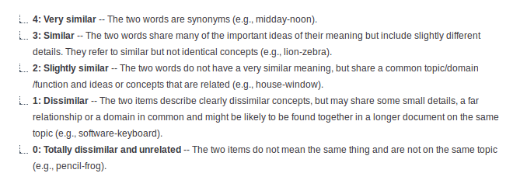
Figure 1. Rating Scale

State of the art

The organizers state that this task “provides a reliable benchmark for the development, evaluation and analysis” of:
- Word embeddings - monolingual word embeddings, as well as bilingual and multilingual word embeddings which have a unified semantic space for the languages;
- Similarity measures that use lexical resources;
- Supervised systems that combine multiple measures.

Our initial option was word embedding. The most prominent word embedding software tools are:
1. “Word2Vec was created by a team of researchers led by Tomas Mikolov at Google.”³ It is an algorithm with the explicit goal of producing word embeddings. It produces embeddings that encode general semantic relationships.⁴ Some implementations exist.
2. GloVe has a similar aim as Word2Vec. Its authors stress present GloVe mainly as an unsupervised learning algorithm, but they also offer an implementation.⁵
3. Deeplearning4j is an open source deep learning library for Java. It implements both Word2Vec and GloVe, among other algorithms.⁶
4. Principal Component Analysis and T-Distributed Stochastic Neighbour Embedding are two algorithms that reduce the dimensionality of already generated word embedding vectors.⁷

Our solution

After our inital option for using only word embedding, we realized that it would yield better results to aggregate multiple techniques, and thus resolved to use a supervised system which combines multiple techniques.
The supervised system is a neural network that is trained as follows: We use a list of word pairs for which we have a gold standard. We run each of the component techniques on the list of word pairs and obtain a list of scores. The neural network is trained by comparing the lists of scores to the gold standard.

For this we needed a gold standard. From the organizers we already knew that the evaluation of the SemEval task is done according to a manually generated gold standard. In order to construct a manually-generated gold standard, we constructed a set of word pairs, as well as a web site that allowed human users to rate each word pair on the scale of 0 to 4. The human users were classes of students from the Faculty of Letters who thus had a proficient and professional knowledge of the English language.

Implementation details and Results

A. Gold standard, Website

To train the neural network we needed a set of word pairs and a gold standard. The SemEval website said that they use a human-generated gold standard. So we built a set of word pairs and human users rated those word pairs.
For building the list of wordpairs we used Daniel Defoe’s novel “Robinson Crusoe”. We picked Nouns at random from the novel and built pairs (for testing that a word is a Noun, we used WordNet). These wordpairs obtained mostly scores of 0 to 2. So to obtain scores of 3 and 4, we built some pairs from a Noun from the novel and one of the words in its synset.
The user group was comprised of students from the Faculty of Letters who had proficient and professional knowledge of the English language. To assist their voting, we built a web site that offers word pairs and saves the votes in a database. We used a session cookie to avoid giving the same word pair to a session twice.
After the website was up, there was the additional requirement that students should be graded according to the number of pairs they voted on. We added a username field to sessions, as well as a statistics page which collected the total number of votes for a student for all his sessions.

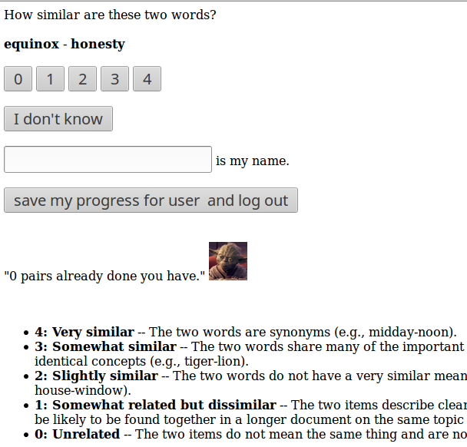
Figure 2. The website for rating wordpairs

Since the students would be graded, one of our priorities has been the maintenance of the website and quick fixing of bugs, in order to avoid losing data about sessions and the number of votes each student has done.
On the other hand, because of the grading, there existed the danger that some would cheat by scoring the word pairs at random. We took the precaution that we kept a record of all votes for a word pair, and thus could single out a suspect-looking vote.
The site also contained the original description of the rating scale, from the SemEval website, such that our gold standard would be similar to that used by the organisers.
In this way we obtained a gold standard of 5747 pairs, and the distribution of scores is satisfactory.

B. Word embedding

From word vectors we can find out the similarity of two words using the dot product of their vectors. One drawback is that most existing implementations load all vectors into RAM, which requires gigabytes of RAM. Given word vector files which can be obtained from various word embedding algorithms, the supervised system can use each of those vectors to obtain a score file, and train the neural network.

Future work

Furthermore, we will compute the scores for the test data released by the SemEval organisers, and send in our score to the SemEval. After the results are published in early February, we will see the ranking of all submissions.
In the future we could refine the components of the supervised system. Given more time, we could get an even larger gold standard using our site, which will allow us to even better train our neural network.
We could also implement word embedding software that efficiently uses hard disk space, rather than loading all vectors into RAM at once. On the other hand, we could use a distributed computing approach.

Conclusions

Thus we used the solutions specified by the organisers, in using a supervised system that aggregated corpus based techniques as well as word embedding techniques.

http://alt.qcri.org/semeval2017/
http://alt.qcri.org/semeval2017/task2/index.php?id=task-details
http://alt.qcri.org/semeval2017/task2/index.php?id=data-and-tools
http://alt.qcri.org/semeval2017/task2/
http://sebastianruder.com/word-embeddings-1/
https://en.wikipedia.org/wiki/Word2vec
http://sebastianruder.com/word-embeddings-1/
http://nlp.stanford.edu/projects/glove/
https://en.wikipedia.org/wiki/Word_embedding#Software
The novel is in the public domain and is available on Project Gutenberg.
In addition to our technical precaution, the site contains a picture of Master Yoda that reminded the students that an option, cheating is not.

