|  |
| --- |
| PERSONAL INFORMATION |

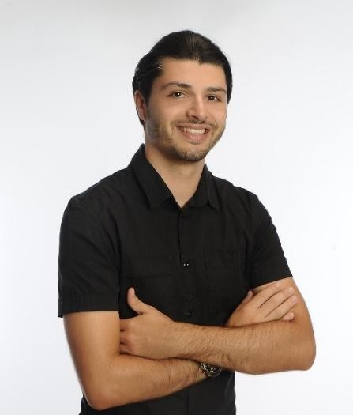**STEFANOS S.CHATZILEFTHERIS**

Date of Birth: 28/12/1993

Address: Agion Panton 18 PO BOX 71601 Heraklion,Greece

Email: stefanoschatz13@gmail.com

Mobile: +306947914291

PERSONAL PROFILE

I am looking for a job which offers me the opportunity to develop new skills while strengthening those I already possess. I am an energetic and enthusiastic person who enjoys challenges and to achieving personal goals .I have combined my studies with work and other commitments showing myself to be self-motivated, organized and capable of working under pressure. I have a clear, and logical mind with a practical approach to problem solving and a drive to see things through to completion. I enjoy working on my own initiative or in a team. Summing up I am reliable, trustworthy, hardworking and eager to learn.

EDUCATION

**2012 –2018** **Technological Educational Institute of Eastern Macedonia and Thrace: Oil and Gas Engineering**

Courses have included:

|  |  |  |  |
| --- | --- | --- | --- |
| ▪ | Energy Technologies | ▪ | Geosciences in Exploration and Production |
| ▪ | Fundamental Concepts in Safety Engineering | ▪ | Project Management |
| ▪ | Oil and Gas Chemistry | ▪ | Facilities Engineering |
| ▪ | Flow Assurance | ▪ | Design Engineering Programs |
| ▪ | Physicochemistry | ▪ | Geology |
| ▪ | General Chemistry | ▪ | Environmental Protection |

Knowledge gained: Reservoir modelling, sequence stratigraphy, geochemistry, basin analysis, exploration processes and hydrocarbon indicators. Gained an extensive overview of the oil and gas industry.

My Thesis was in: **Offshore oil well and the equipment**.

**2009 - 2012** **Secondary School Certificate, 1st High school of Heraklion, Crete**

|  |  |  |  |  |  |  |  |
| --- | --- | --- | --- | --- | --- | --- | --- |
| WORK EXPERIENCE | | | | | | | |
| **04/2018 - 10/2018** | | | | | **UNIVERSITY OF THE BASQUE COUNTRY SAN SEBASTIAN, SPAIN**  Intern at Chemical and Environmental Engineering Department   * Bibliography revision of separation methods * Selection of the methods to be tested at laboratory scale * Experimental work * Design of simulation of the separation process with Aspen Plus | |  |
| **04/2017 - 10/2017** | | | | | **XTRAICE SYNTHTETIC ICE RINKS SEVILLA, SPAIN**  Intern atTechnical Department of Design Engineering   * Pieces design * Simulations (Ansys) * 3D design * Photoshop | |
| **2014 – 2016** | | | | | **LITTLE GARDEN HERAKLION GREECE**  I worked as a Waiter   * Customer Service * Barista * Floor Manager | |
| **2013 – 2014** | | | | | **QUEEN - PIRATE CLUB KAVALA GREECE**   * PR * Barman * Meson | |
| **2009 – 2012** | | | | | **ARGONAFTES - LOTOFAGI SUMMER CAMP KOKKINI GREECE**  I worked as a Team Leader   * Supervisor of 20Children * Referee in games * Organizer of teamwork | |
| SEMINARS | | |  | | | | |
| **15/11/2013** | | | Workplace safety and hygiene “Prevention of occupational hazards”. | | | | |
| **18/03/2015** | | | Logistics chain management. Levers of development for the global economy. | | | | |
| **21/11/2016** | | | Riparian and deltaic ECOSYSTEM: practice management and prospects for sustainable development. | | | | |
| **30/04/2018** | | | From Biomass to Bio products. | | | | |
| LANGUAGES | | |  | | | | |
| Greek: | Native | | |
| English: | Full professional proficiency. Level C1 IESOL and ISESOL | | |
| Spanish: | Beginner | | |

|  |  |
| --- | --- |
| **IT SKILLS** |  |
| Knowledge of :   * Autocad | * Hysys |
| * Photoshop Cs6 | * Solidworks |
| * Sketchup | * Microsoft tools Office |
| * Matlab | * Fluent use of internet services |
| * Aspen Plus |  |
| OTHER ABILITIES / SKILLS |  |

Excellent verbal communication skills, Good at problem solving, Good organizer, Work for long hours, Hardworker, Reliable and honest, Able to work under pressure, Outgoing and friendly, Able to work autonomously, International Driver’s License - Categories B and A1.

INTERESTS

Enjoy playing football, I am interested in Photography and I love Traveling

Current Affairs: Interested in keeping up to date with current affairs and particularly issues related to the environment and renewable energies to complement my current knowledge.

REFERENCES

|  |  |
| --- | --- |
| Mr. Angel Macias Ramos  Engineering Department  Tel: +34 664 218 043  Email: ingenieria@xtraice.com | Ms. **Maria González Alriols**  Chemical and Environmental Engineering  Tel: +34 943 018740  Email: [maria.gonzalez@ehu.es](mailto:maria.gonzalez@ehu.es) |