Project Proposal — Deliverable 2
Contents
1. Project Title and Team Members 2
2. Data understanding 3
2.1 Dataset overview 3
2.2 Dataset size and structure 3
2.3 Preview of the dataset 3
2.4 Missing values 4
3. Exploratory data analysis (EDA) 5
3.1 Univariate analysis - numerical features 5
3.2 Univariate analysis - categorical features 6
3.3 Target distribution and imbalance 8
3.4 Feature-target relationships 9
3.5 Correlation analysis 10
4. Data pre-processing 11
4.1 Data Cleaning 11
4.2 Train-Test Split 11
4.3 Handling Outliers - Transformation Techniques 11
4.4 Missing Value Imputation 13
4.5 BMI Ordinal Feature 13
4.6 Feature Scaling 14
4.7 Feature Selection 14
4.8 Imbalanced Data Handling 14
5. Pre-processed dataset versions 15
6. Selected machine learning techniques 16
6.1 Logistic Regression 16
6.2 Random Forest 16
6.3 Gradient Boosting 16
6.4 Support Vector Machine (SVM) 17
6.5 Feedforward Neural Network (MLP) 17
7. References 18

1. Project Title and Team Members
Project title: Predicting Stroke Risk from Demographic, Lifestyle, and Clinical Factors
Role / Background | Name | Student ID
Computer Science | Λουκία Σιήκκη | UC1066315
Computer Science | Στέφανος Παντελή | UC1065916
Computer Science | Ραφαήλ Μυτιληναίος | UC1066383

2. Data understanding

2.1 Dataset overview
We use the Stroke Prediction dataset from Kaggle. Each row is a patient record. The task is binary classification, where the target stroke is 1 if a stroke occurred and 0 otherwise.

2.2 Dataset size and structure
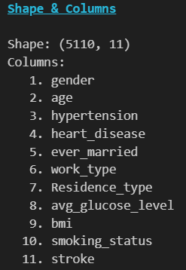
The dataset contains 5110 rows and 12 columns (including id). Since id is only an identifier, it is dropped right away, leaving 11 features.
- Numerical: age, avg_glucose_level, bmi
- Binary: hypertension, heart_disease, stroke (target)
- Categorical: gender, ever_married, work_type, Residence_type, smoking_status

2.3 Preview of the dataset
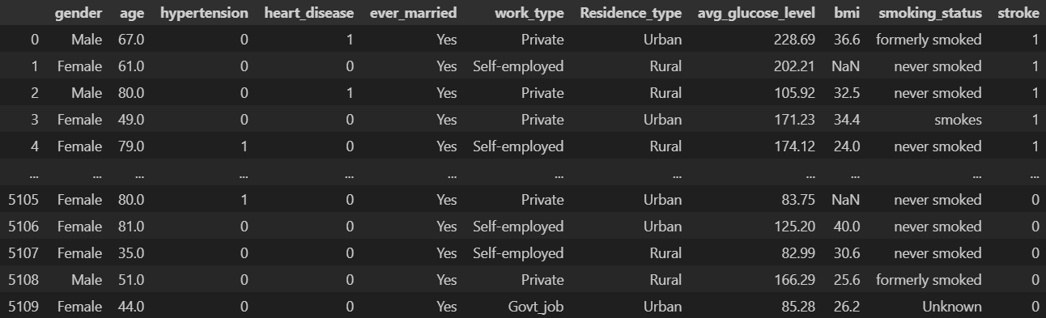
A preview of the first few rows confirms that features are a mix of numerical and categorical fields, with the target column, stroke, located at the end. This initial inspection also helps to understand how category names and numerical fields are formatted.

2.4 Missing values
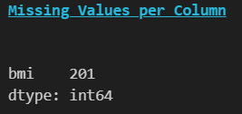
The dataset contains missing values only in:
- bmi: 201 missing values, which is approximately 3.9% of the dataset, however, 16% of all rows with stroke have a missing bmi value.
No other columns contain missing entries. Because BMI is an important health-related feature and the dataset is imbalanced, we avoid dropping these rows and instead handle missing BMI through imputation in a leakage-safe preprocessing pipeline.
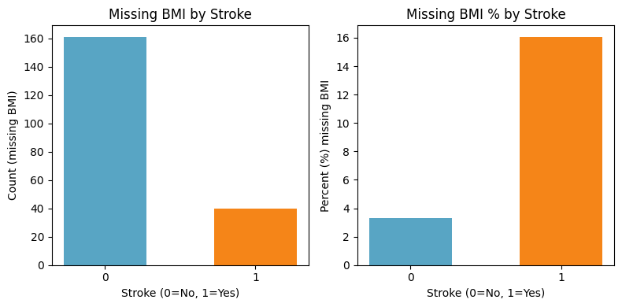

3. Exploratory data analysis (EDA)

3.1 Univariate analysis - numerical features
We examined the continuous variables age, avg_glucose_level, and bmi using histograms (with KDE) and boxplots.
Age:
The age distribution spans from very young ages to the elderly. For patients with stroke=1, the distribution shifts clearly toward older ages, with the majority of stroke cases being above 50 years old. 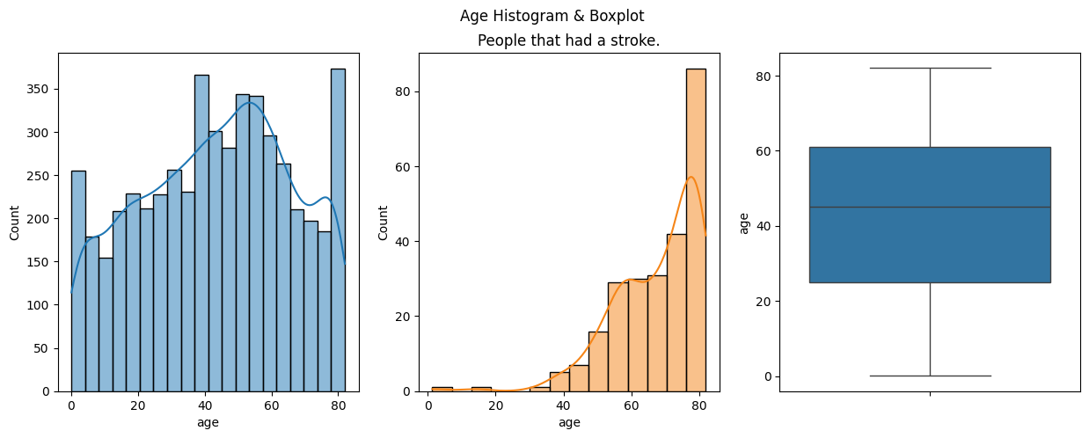

Average glucose level:
The distribution is right-skewed with a long tail and extreme values. This indicates that robust preprocessing may help scale-sensitive models. Moreover, the distribution of the average glucose level of people that experienced a stroke, closely resembles the histogram of the whole dataset.
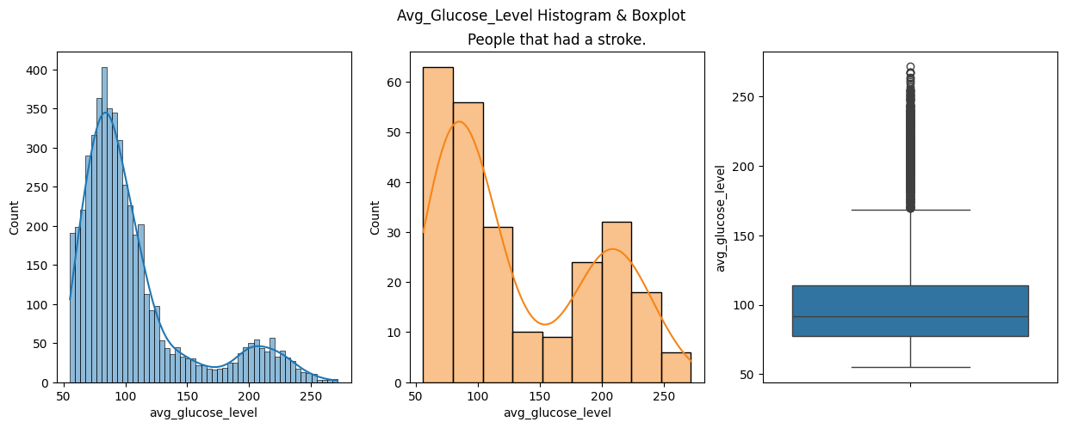

Body mass index:
BMI is also right-skewed with extreme values. In addition, bmi is the only feature with missing values, so it requires imputation during preprocessing.
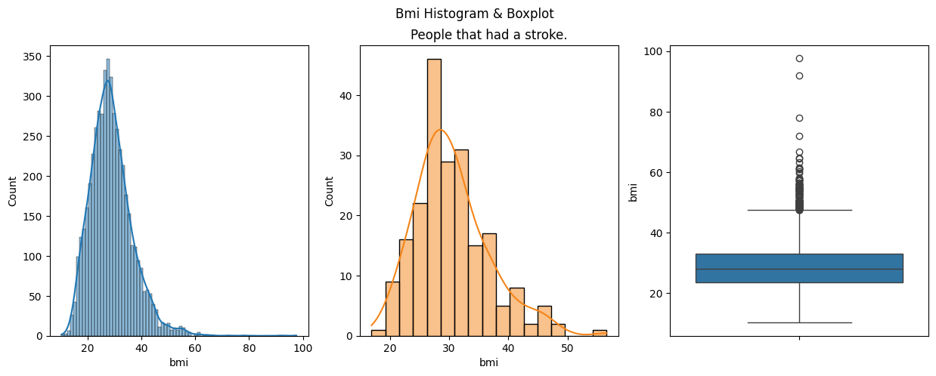

3.2 Univariate analysis - categorical features
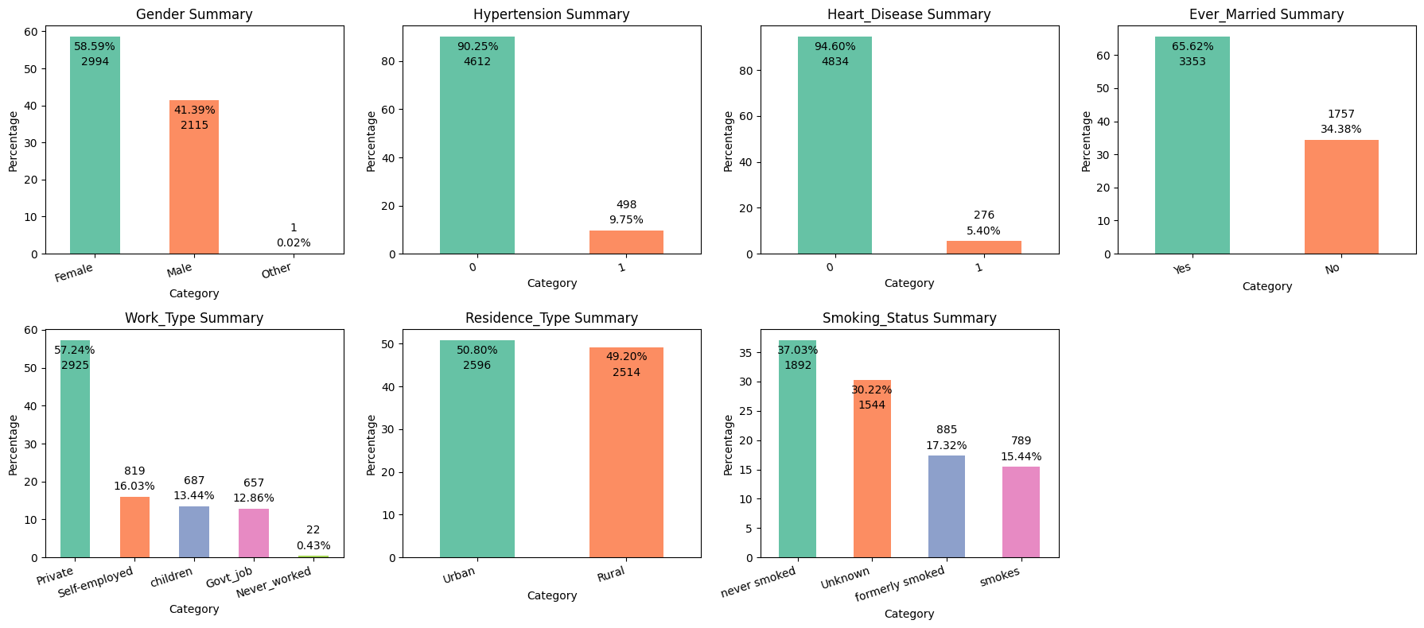
We analyzed categorical variables using bar charts to identify dominant categories and rare classes.
Gender:
- Female: 58.59% (2994)
- Male: 41.39% (2115)
- Other: 0.02% (1)

Hypertension (0/1):
- No: 90.25% (4612)
- Yes: 9.75% (498)
Heart disease (0/1):
- No: 94.60% (4834)
- Yes: 5.40% (276)
Ever married:
- Yes: 65.62% (3353)
- No: 34.38% (1757)
Work type:
- Private: 57.24% (2925)
- Self-employed: 16.03% (819)
- Children: 13.44% (687)
- Govt job: 12.86% (657)
- Never worked: 0.43% (22)
Residence type:
- Urban: 50.80% (2596)
- Rural: 49.20% (2514)
Smoking status:
- Never smoked: 37.03% (1892)
- Unknown: 30.22% (1544)
- Formerly smoked: 17.32% (885)
- Smokes: 15.44% (789)

We also visualised the categorical data of stroke rows only.
- The gender does not have a significant role on the stroke
- Hypertension seems to have little impact, however the percentage more than doubled from the initial distribution.
- Heart Disease is the same case, however the percentage has more than tripled.
- Married people seem to have a greater possibility of having a stroke.
- Children have the least risk of having a stroke, and no person that never worked experienced a stroke, probably because they were the great minority.
- A slight increase on the percentage of Urban residents.
- Former Smokers' percentage rose drastically.
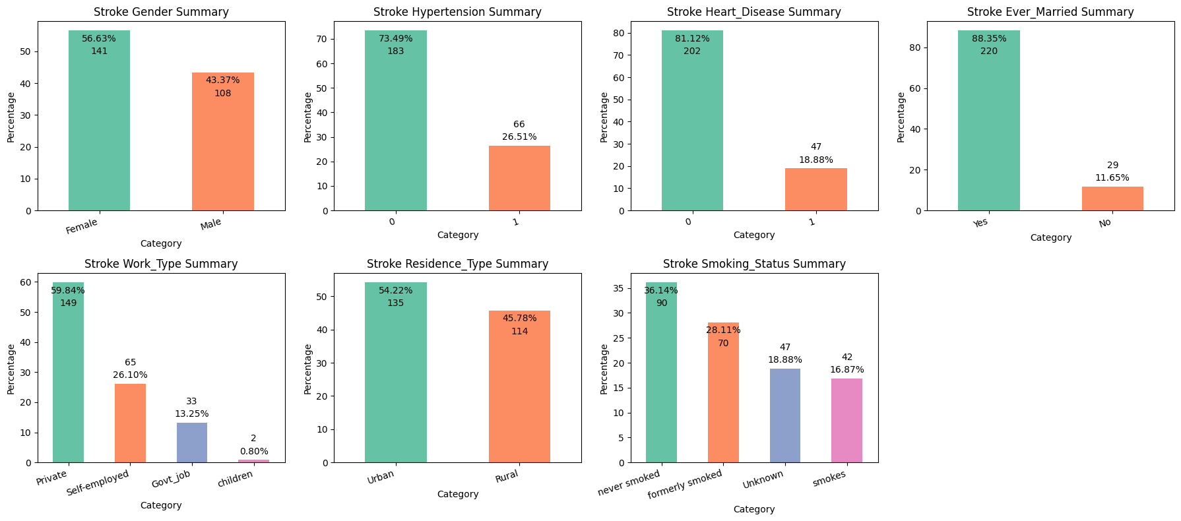

3.3 Target distribution and imbalance
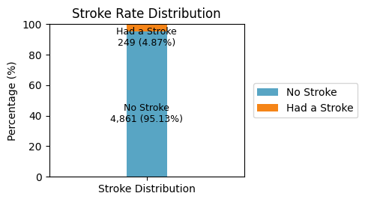
The target variable stroke is highly imbalanced. It corresponds to a stroke rate of approximately 4.9%. Therefore, we use stratified splitting and consider imbalance-aware strategies.

3.4 Feature-target relationships
To identify signals useful for prediction, we compared feature distributions across stroke status.
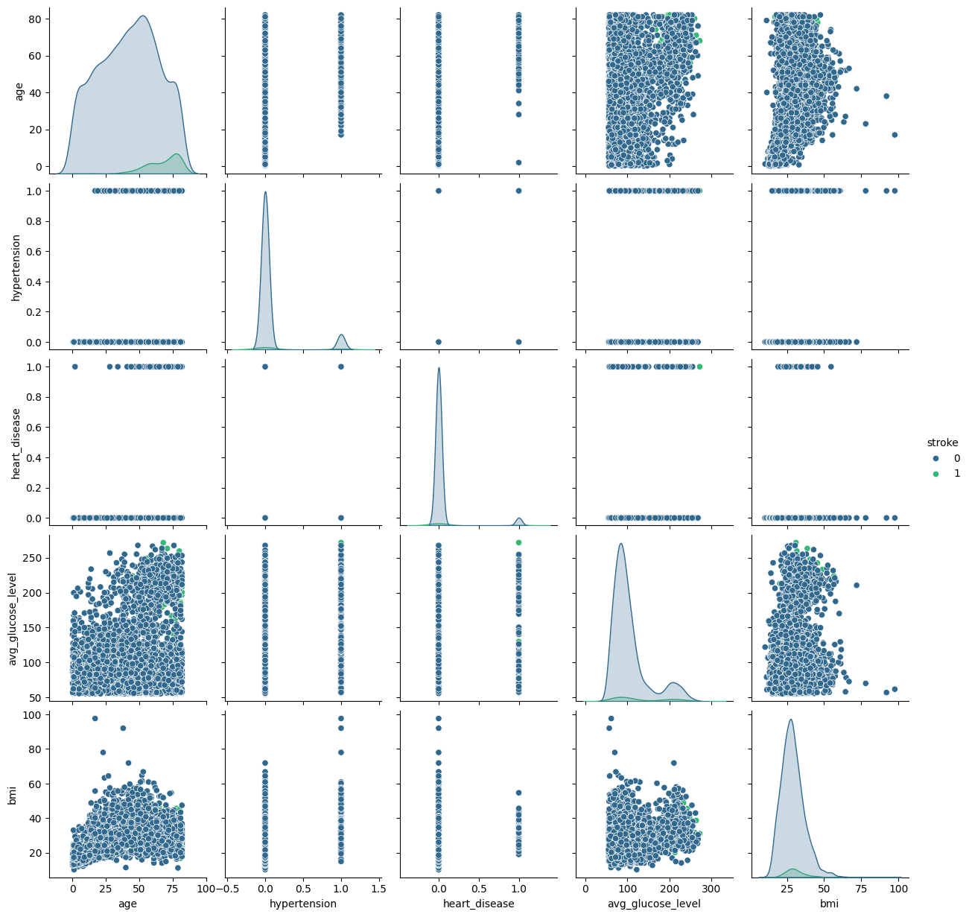
Categorical features: (stroke = 1 subset) Within the 249 stroke cases, several categories appear more frequent than in the full dataset. In particular, hypertension is present in 26.51% of stroke cases (vs 9.75% overall) and heart disease in 18.88% (vs 5.40% overall). Formerly smoked is also higher among stroke cases (28.11% vs 17.32% overall). In contrast, gender and residence type show only small shifts. The high proportion of ever_married among stroke cases (88.35%) likely reflects confounding with age.
Numerical features: Stroke cases are concentrated at higher ages, making age the clearest single predictor visually. avg_glucose_level and bmi show skewness and outliers, which motivates using robust preprocessing and transformations when training scale-sensitive models.

3.5 Correlation analysis
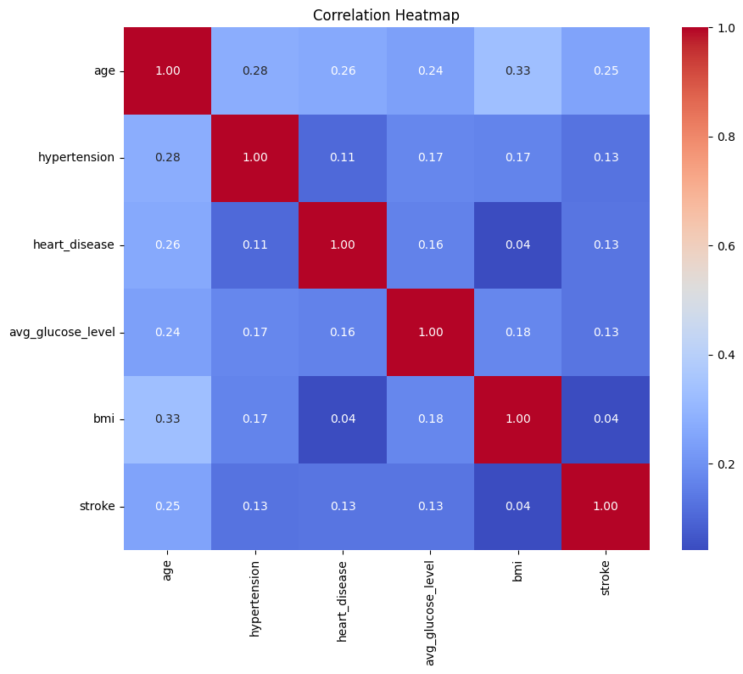
We computed a Pearson correlation heatmap for numeric features.
The correlations with stroke are weak to moderate: age (0.25, largest), hypertension (0.13), heart_disease (0.13), avg_glucose_level (0.13), and bmi (0.04).
Overall, no single feature shows a strong linear relationship with stroke, which is expected given the class imbalance and potential non-linear effects. This motivates exploring non-linear models and feature interactions during modelling.

4. Data pre-processing

4.1 Data Cleaning
The raw dataset was cleaned before any modelling steps. Firstly, the string-valued columns were scanned for common missing-value markers like “N/A” or “na” and leading/trailing whitespace was stripped. In addition, the categorical columns were normalized to lowercase, and spaces or hyphens were replaced by underscores to ensure consistent category names. Moreover, the numeric columns were cast to float, non-parseable values were coerced to NaN, duplicate rows were removed and the index was reset.
The id column was already removed at the dataset loading stage since it is just an identifier and it wouldn’t provide any useful information. Binary columns were already encoded as 0/1 integers, hence, they didn’t need any further encoding. Lastly, the categorical columns were encoded using one-hot encoding and we used drop_first=False to retain all categories including rare ones to prevent information loss.

4.2 Train-Test Split
The dataset was split into training (80%) and testing (20%) sets using a stratified split on the target variable. This way we ensure that the stroke rate (4.9%) is preserved in both training and testing set. To prevent data leakage between splits, all imputers and scalers are fitted exclusively on the training data and then applied to the test set.

4.3 Handling Outliers - Transformation Techniques
The EDA showed that the average glucose level and the bmi are right skewed with notable outliers. To address skewness and reduce the influence, we applied two variance-stabilizing transformations.
- Logarithmic:
We applied log(1+x) to both bmi and average glucose level and we noticed that the distributions became considerably more compact, although some outliers are still present.
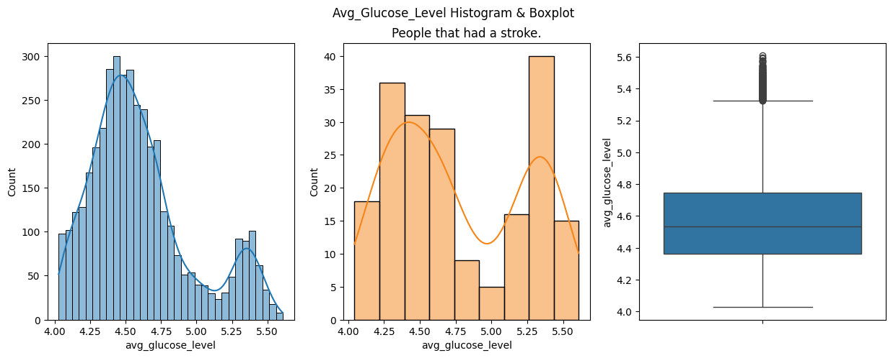
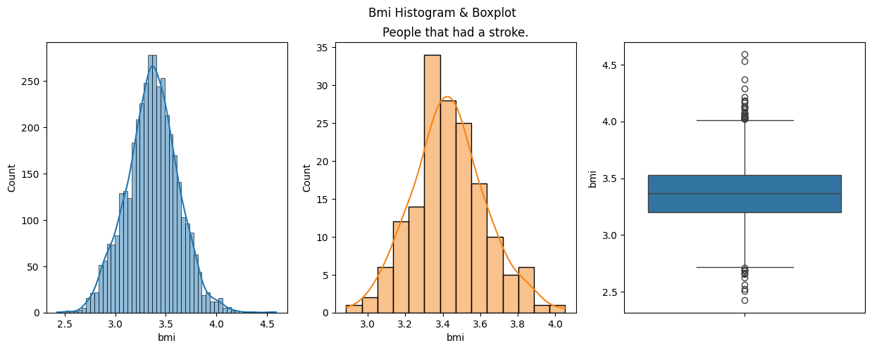

- Yeo-Johnson:
We applied this transformation using sklearn’s PowerTransformer. It produces distributions even closer to Gaussian than the logarithmic transformation. As a result, the bmi column reached a near normal distribution with a small number of outliers. Furthermore, the column of average glucose level has no outliers with this method of transformation.
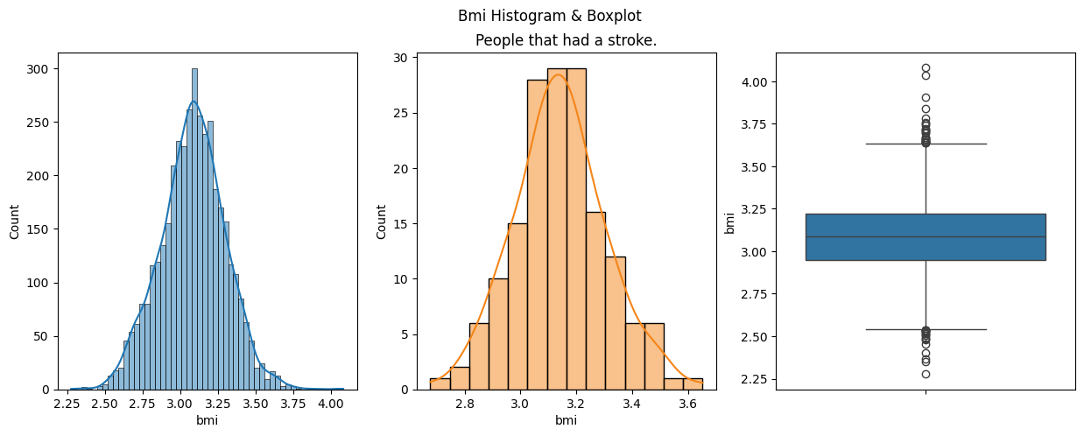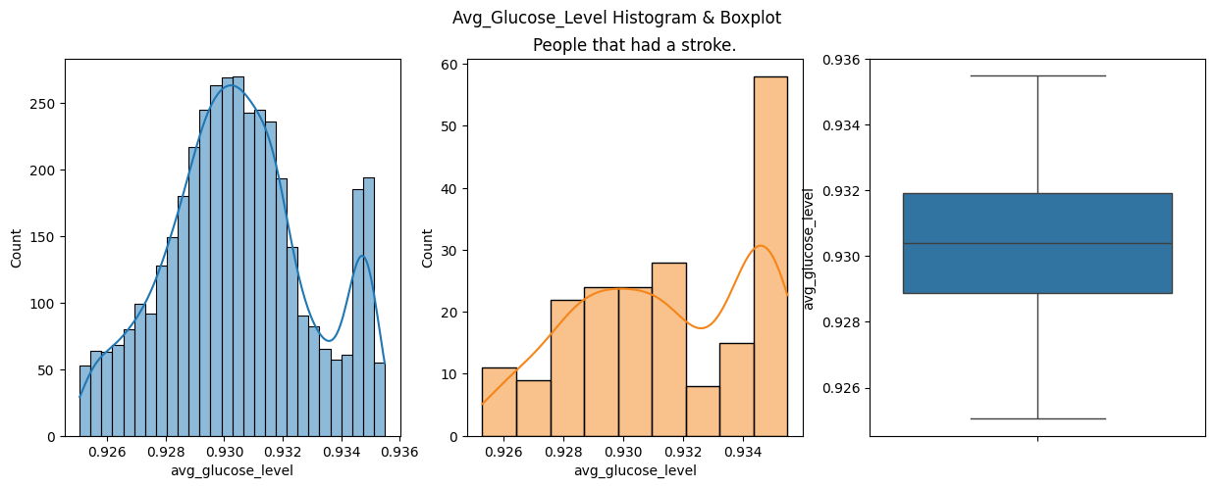

4.4 Missing Value Imputation
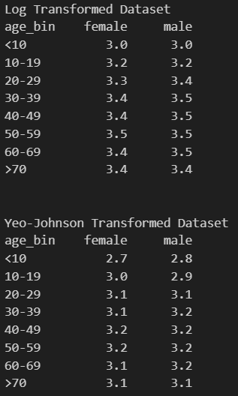
BMI is the only column with missing values. We didn’t drop these rows because the approximately 20% of them belong to stroke-positive patients. We used two imputation strategies to fill those missing values.
- Mean BMI per gender and age group:
We used the gender and age as distinct buckets. We created 16 buckets, 8 for each gender representing an age group of 10 years. In each bucket, we took the mean of the bmi values of all the users in the bucket and imputed the missing bmi values with the mean value of their group.

The numbers seen in each table are after applying the transformations to the bmi column.

It can be observed that males and females share a similar mean bmi per age group. However, the age groups show an increase in bmi until the group of 50-59 years old, where it slightly decreased for older people.

- K-Nearest Neighbour (K-NN):
We used the provided function of KNNImputer to impute the missing values based on their k nearest neighbours (using all numerical columns).

4.5 BMI Ordinal Feature
After we impute the bmi missing values, we create a new bmi_class feature to separate the bmi values into the four standard categories:
- Underweight (<18.5)
- Normal (18.5 - 24.9)
- Overweight (25 - 29.9)
- Obese (>=30)
Note that, because the bmi values have been transformed, the category boundaries have been transformed through the same transformations to correctly categorise the people.
After categorising, the new column is ordinally encoded with the values 0-3, because they can be logically ordered.

4.6 Feature Scaling
We applied RobustScaler (sklearn) to all numerical columns in every dataset version because of its ability to handle outliers. Scaling is useful for distance-based and gradient-based algorithms and helps regularised models converge more efficiently.

4.7 Feature Selection
We applied feature selection using the Random Forest Classifier to visualize the importance of the features. From the image below, age is the most important feature, closely followed by bmi and average glucose level. As expected, gender_other and work_type_never_worked are not important due to their low frequency.
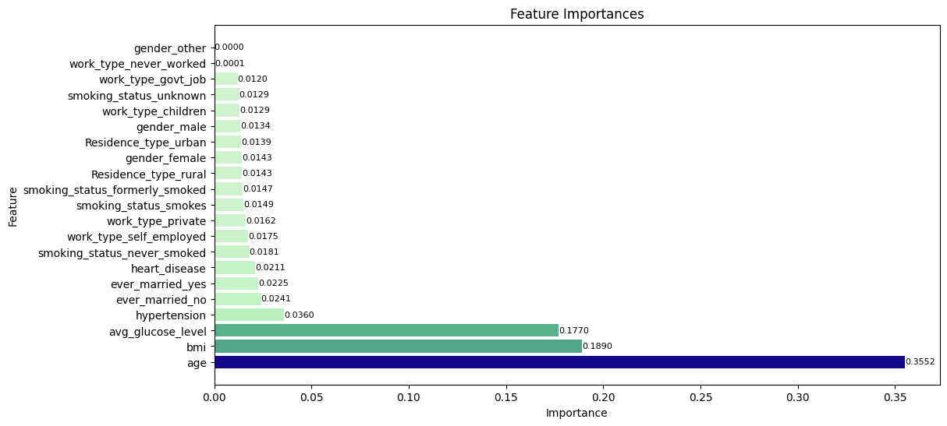
Importances of features are shown for the original training set. The created versions have really similar feature importance as the image above. The new column bmi_class ranks near the feature bmi for all versions.

4.8 Imbalanced Data Handling
We used SMOTE to balance the dataset since the stroke positive cases are represented only by the 4.9% of the training set. We apply SMOTE directly to the four pre-processed datasets we created. As a result, the training set for each version becomes balanced. Note that SMOTE is not applied to the test set.

5. Pre-processed dataset versions
We combined the two outlier transformation techniques with the two BMI imputation strategies and as a result we created four pre-processed dataset versions. All the versions share the same base cleaning steps and the same RobustScaler normalization as described above. We also apply SMOTE for each dataset version, therefore, we have 8 dataset versions in total.

- Logarithmic Transformation + Mean MBI Imputer
- Yeo-Johnson Transformation + Mean BMI Imputer
- Logarithmic Transformation + K-NN BMI Imputer
- Yeo-Johnson Transformation + K-NN BMI Imputer
- Logarithmic Transformation + Mean MBI Imputer + SMOTE
- Yeo-Johnson Transformation + Mean BMI Imputer + SMOTE
- Logarithmic Transformation + K-NN BMI Imputer + SMOTE
- Yeo-Johnson Transformation + K-NN BMI Imputer + SMOTE

6. Selected machine learning techniques
We selected five classification algorithms to cover a broad spectrum of model families, from interpretable linear methods to flexible non-linear ensembles and neural networks.

6.1 Logistic Regression
Logistic Regression is a linear probabilistic classifier that models the log-odds of the positive class as a linear combination of the input features. It estimates the probability of stroke using the sigmoid function and classifies a sample as stroke-positive when this probability exceeds a threshold. The model is trained by maximising the penalised log-likelihood, and converges efficiently when features are well-scaled, making it compatible with our RobustScaler preprocessing.
In this project Logistic Regression serves primarily as a baseline. Its main advantages are speed, interpretability, and calibrated probability outputs. Its limitations include the assumption of a linear decision boundary and an inability to capture interaction effects between features without explicit feature engineering. Given that the EDA indicated likely non-linear relationships, we expect this model to underperform compared to ensemble methods.

6.2 Random Forest
Random Forest is a bagging ensemble of decision trees, where each tree is trained on a bootstrap sample of the training data and considers a random subset of features at each split. Predictions are made by majority vote across all trees. This randomisation reduces the variance of individual trees and yields a model that generalises well. Random Forest is invariant to feature scaling, handles categorical features naturally, and produces reliable feature importance scores, which we already exploited in the feature selection step.
For imbalanced datasets, the class_weight=“balanced_subsample” option re-weights the Gini impurity criterion within each bootstrap sample, effectively forcing each tree to pay more attention to minority-class samples. Key hyperparameters to tune include the number of trees, the maximum depth of each tree, and the number of features considered per split. Random Forest is expected to be one of the stronger performers given the non-linear structure of the data.

6.3 Gradient Boosting
Gradient Boosting builds an ensemble sequentially: each new tree is trained to correct the residual errors of the current ensemble by fitting the negative gradient of a loss function. Unlike bagging, boosting reduces bias as well as variance, allowing it to model complex decision boundaries. The learning rate and number of estimators jointly control the speed and depth of learning and must be carefully balanced to avoid overfitting.
We will use sklearn’s GradientBoostingClassifier (or optionally XGBoost/LightGBM for computational efficiency). Gradient Boosting has proven highly competitive on tabular medical datasets and supports sample weighting for class imbalance. Its main drawback is higher training time compared to Random Forest, especially during hyperparameter search. Important parameters include n_estimators, learning_rate, max_depth, and subsample (which introduces stochasticity to reduce overfitting).

6.4 Support Vector Machine (SVM)
A Support Vector Machine finds the maximum-margin hyperplane that separates the two classes in a feature space. When classes are not linearly separable, the kernel trick implicitly maps the data into a higher-dimensional space where linear separation becomes possible without explicitly computing the transformation. For this project we can use an RBF kernel, which is well-suited to complex non-linear boundaries and performs robustly on medium-sized datasets of this kind.
SVM is highly sensitive to feature scaling, making the RobustScaler preprocessing step particularly important. Class imbalance is addressed via the class_weight=“balanced” parameter, which scales the penalty C for each class inversely proportional to its frequency. Key hyperparameters to tune are C and γ. SVM’s main limitation for this dataset is computational cost during cross-validation and grid search, as training complexity scales approximately quadratically with the number of training samples.

6.5 Feedforward Neural Network (MLP)
A Multilayer Perceptron (MLP) is a fully connected feedforward neural network where each neuron applies a non-linear activation function (ReLU in hidden layers, sigmoid in the output layer for binary classification) to a weighted sum of its inputs. By stacking multiple hidden layers, an MLP can represent arbitrarily complex decision boundaries and learn higher-order feature interactions automatically. This makes it the most flexible model in our set and potentially the most powerful if the dataset is sufficiently large and the architecture is well-regularised.
The MLP is trained by minimising the binary cross-entropy loss via backpropagation and stochastic gradient descent (or Adam). Important hyperparameters include the number and size of hidden layers, dropout rate, learning rate, and batch size. Like SVM, the MLP requires scaled inputs and will use class weighting or SMOTE-augmented training batches to compensate for class imbalance. We will implement the MLP using sklearn’s MLPClassifier for initial experiments and potentially switch to a PyTorch/Keras implementation if more architectural control is needed.

7. References
[1] M. U. Emon, M. S. Keya, T. I. Meghla, M. M. Rahman, M. S. A. Mamun, and M. S. Kaiser, “Performance analysis of machine learning approaches in stroke prediction,” in Proc. 2020 4th Int. Conf. Electronics, Communication and Aerospace Technology (ICECA), Coimbatore, India, Nov. 2020, pp. 1464–1469, doi: 10.1109/ICECA49313.2020.9297525.
[2] S. Dev, H. Wang, C. S. Nwosu, N. Jain, B. Veeravalli, and D. John, “A predictive analytics approach for stroke prediction using machine learning and neural networks,” Healthcare Analytics, vol. 2, art. no. 100032, Nov. 2022, doi: 10.1016/j.health.2022.100032.
[3] E. Dritsas and M. Trigka, “Stroke Risk Prediction with Machine Learning Techniques,” Sensors, vol. 22, no. 13, Art. no. 4670, 2022, doi: 10.3390/s22134670.
[4] H. K. Singhai, P. K. Shukla, and V. S. Dhaka, “An experimental analysis of brain stroke prediction using machine learning algorithms,” in Proc. 2024 IEEE Int. Conf. Interdisciplinary Approaches in Technology and Management for Social Innovation (IATMSI), Gwalior, India, 2024, pp. 1–6, doi: 10.1109/IATMSI60426.2024.10503299.
[5] T. Aljrees, “Improving prediction of cervical cancer using KNN imputer and multi-model ensemble learning,” PLoS ONE, vol. 19, no. 1, Art. no. e0295632, Jan. 2024, doi: 10.1371/journal.pone.0295632.

