# Prometheus, Alertmanager and Grafana Installation Guide

## Install Prometheus

Our first task is to install Prometheus locally on our machines. To do that, you can download a pre-compiled binary from here: <https://prometheus.io/download/>

Extract the downloaded archive to a directory of your choice.

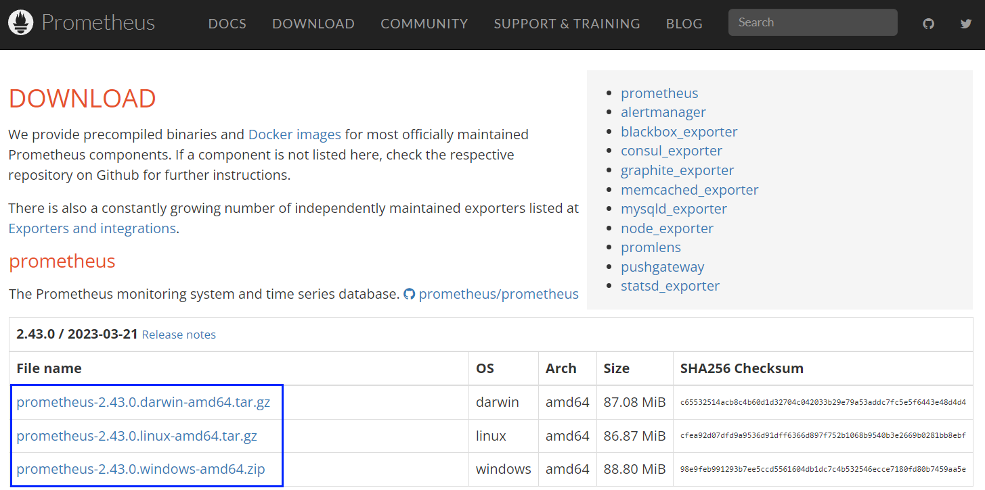

↓



↓

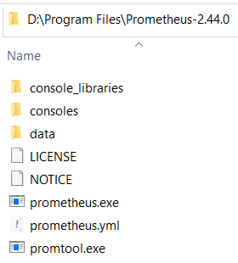

Now, navigate to the directory of the extracted archive and open the **prometheus.yml** file in a text editor.

This YAML file is the primary configuration file for Prometheus.

You'll need to **modify it** to **define the targets** you want to be scraped or you can create and use a **new file.**

This **YAML file** has a **sample configuration** in which **Prometheus scrapes data from its own server:**

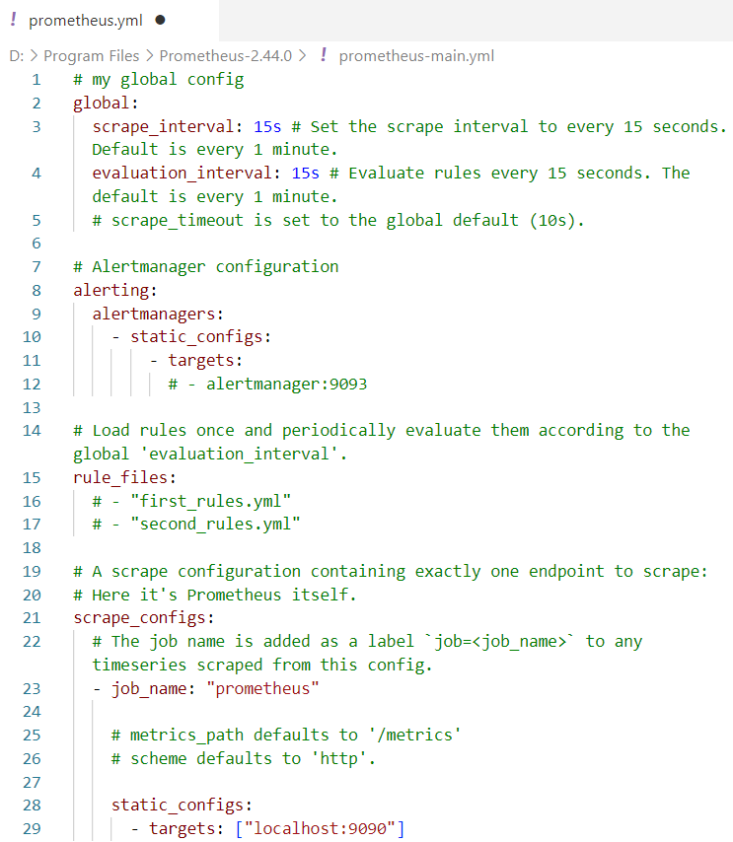

## Install Alertmanager

Now, it's time to install Alertmanager. Its installation is pretty straight-forward.

**Install Alertmanager** using a **pre-compiled binary** from the same URL as Prometheus: <https://prometheus.io/download/>. **Extract the downloaded archive** to a directory of your choice



↓

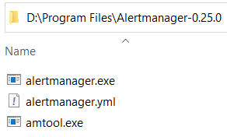

↓

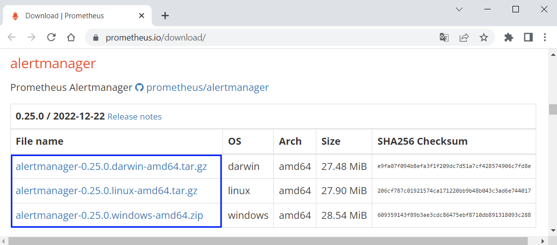

## Install Grafana

Let's install Grafana. In order to do so, download an installer from here: <https://grafana.com/grafana/download?platform=windows>:

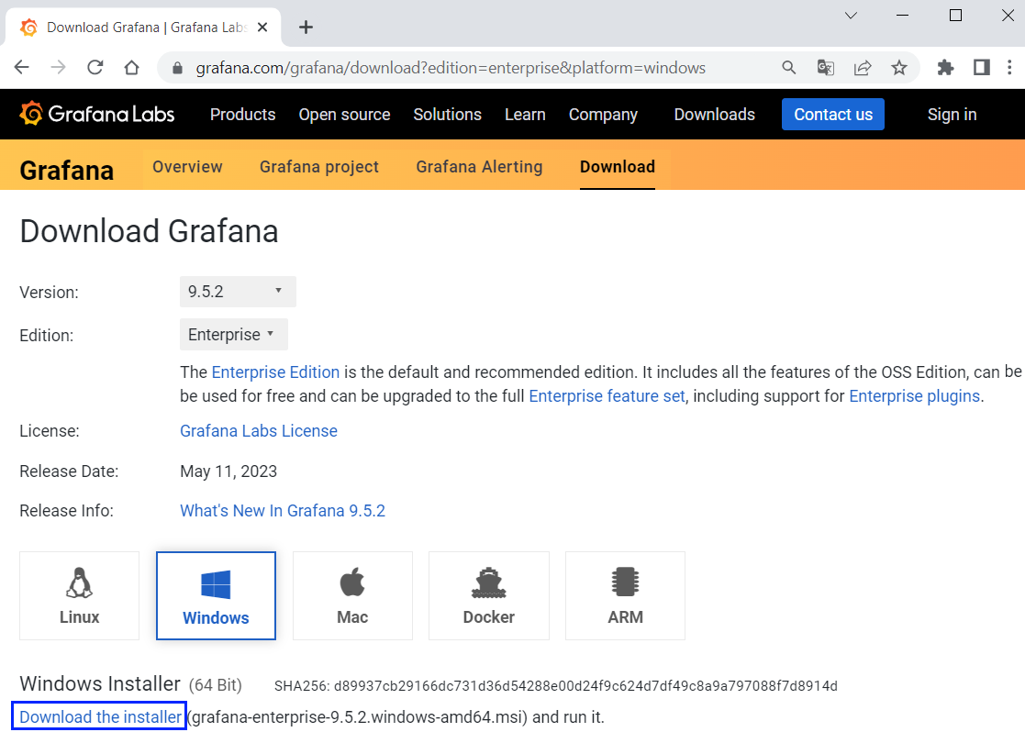   
Choose **latest version**, "**Enterprise**" **edition** and **your OS.**

Click on the **installer file**



**Follow the setup wizard to install Grafana**