# Documentation for “NoTitleRPG”

### Active team members

1. Димитър Керезов (username: Mitko.Kerezov)
2. Владимир Стефанов (username: stefanov2081)

### Inactive team members

1. Мартин Белев (username: mbelev)
2. Слави Славчев (username: slavi_slavchev)
3. Стайко Недев (username: Zakkgard)
4. Светлозар Тодоров (username: Svetlozaurus)

### Project explanation

***Note - The game is 16+ Megabytes, please download it from this link:***

<https://github.com/stefanov2081/NoTitleGame>

##### **Main Instructions**

* We have designed and implemented a game for Windows called “NoTitleRPG”.
* The game “NoTitleRPG” consists of a couple of characters fighting against each other.
* Use the keys **left** and **right** to move and **enter** to jump. The “Inventory” tab is expandable by clicking on it with the **left mouse button**

##### **Brief Description**

The game consists of a couple of characters trying to kill each other off. It features destroyable terrain.

##### **Class Diagram**

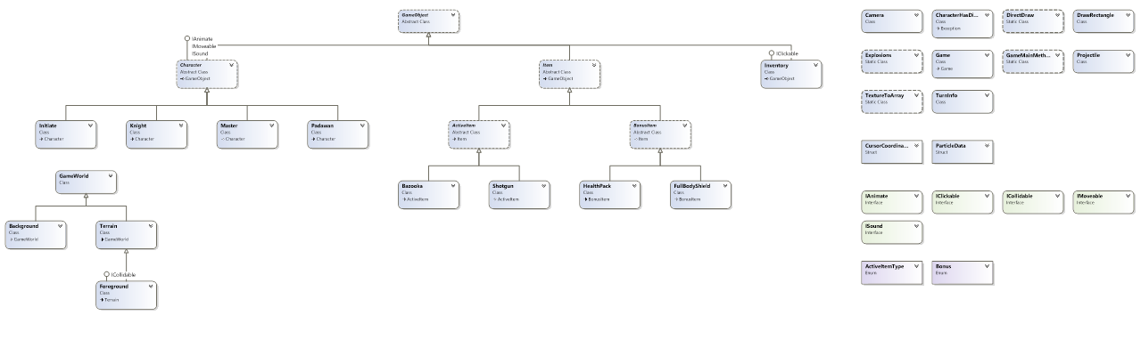

### Project implementation

The project “NoTitleRPG” was created using Microsoft XNA Game Studio.  
The following assets are implemented in the project “NoTitleRPG”:

* **Interfaces**
* **Classes**
* **Abstract classes**
* **An exception class**
* **Polymorphism usages**
* **Structures**
* **Enumerations**
* E**vents**

### The URL of the Git repository

We have used **GitHub** to keep the project source code and for team collaboration.

Here we provide the URL of the project Git repository:

The game is 16+ Megabytes, please download it from the link:

<https://github.com/stefanov2081/NoTitleGame>