Description of the model

Our model is based on a previous work by J. M. Epstein. We use an agent based simulation featuring four different types of agents: civilians, policemen and two rivalling gangs. The 'world' on which the simulation takes place is a bounded rectangular grid. Every agent may interact with their surroundings (their vision), which are determined by a Moore neighbourhood of range one. Agents at the border have only limited vision, i.e. our world is flat, not toroidal. Agents may also move to a neighbouring free cell. So, every timestep a randomly chosen agent moves and another randomly chosen agent becomes active. The possible actions for an active agent are described in the following paragraphs.

Gangs fight each other

Naturally, the gang members want to dominate over the police and the other gang. In order to achieve this goal, they have two possibilities. The first one of these is to kill the other gang members (policemen are never attacked). Because not every gang member is equally keen to wipe out his enemies, we used an attack probability (real number between 0 and 1) local to each agent;
only if a randomly generated number r between 0 and 1 is smaller than the attack probability, the active agent cares to attack at all. So suppose the active agent is willing to kill an enemy in his vision. He chooses his target using the following rationale:
“The less enemies and police and the more fellow gang members are near, the better my chances are”. Formally, the gang agent calculates a risk for attacking a possible target of the other gang i:

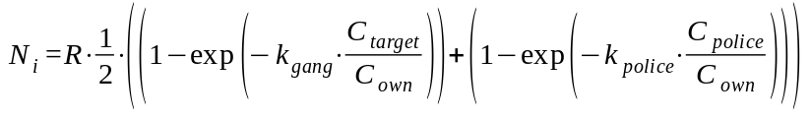

where
- R is the risk aversion of the active agent (real number from 0 to 1)
- C_target is the number of enemy gang members the active agent sees (integer from 1 to 8)
- C_police is the number of policemen the active agent sees (integer from 1 to 8),
- C_own is the number of fellow gang members the agent sees
(including themselves, integer from 1 to 9)
- k_gang and k_police are real positive constants to make the values reasonable [FÜGE UNSERE WERTE FÜR K EIN]

Having calculated all the risks N_i, the agent attacks the enemy agent with the minimal risk if it is below an attack threshold T. Or, if there are at least two minima, they choose one at random.

Now two agents engage in a fight to the death. To determine the survivor we introduce a parameter 'efficiency' for each gang agent and the policemen too. If a randomly generated number r satisfies

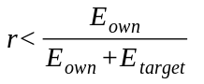

where
- E_own is the efficiency of the attacking agent
- E_target is the efficiency of the target

then the attacking agent kills their target. Otherwise the attack fails and the target kills the active agent. The dead agent is then replaced by a newly generated civilian.

The police fights the gangs

The mechanics of fights between the police and the gangs are almost the same. Policemen also have an attack probability and an efficiency, but it makes no sense to include the policemen themselves in the risk calculation, I.e the risk for every possible gang target becomes

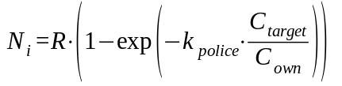

Then an attacking policemen proceeds analogously as an attacking gang member. The only difference is that a policeman never dies, so if an attack fails nothing happens.

Civilians get hurt

Naturally, as in any armed conflict (and in the model of Epstein too), there is 'collateral damage' among the civilians, which hurts them and makes them angry but in our model doesn't kill them. We modelled this fact introducing an accuracy for the gang members and the policemen and an anger value for each civilian against the police and each gang. Every time a civilian is near two fighting agents, which means they are in the vision of an attacking agent he might get hurt depending on the accuracy of the attacking agent: For each civilian near a fight, a random number r_i is generated. If this number is greater than the accuracy α of the attacking agent, the civilian gets hurt. Their anger value at the type of the attacker A_type increases:

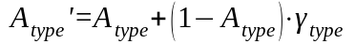

where
- type is the type of attacking agent: police, gang 1 or gang 2
- A_type is the anger before the fight
- A_type' is the anger after the fight
- gamma_type is the change rate of the anger;
it is global for the civilians, and the same for each gang
(γ_gang1 = γ_gang2)

Civilians become gang members

Similarly to Epstein's model, in our model if a civilian is much more angry at the police than at a gang, they may choose to become a member of that gang. As policemen never die, a civilian also can't become a policeman. Otherwise after a few timesteps there would be too many policemen.
Whether a civilian chooses to take part in illegal activities in a gang is calculated using the following algorithm:

- for every gang g calculate the anger difference
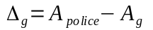
- Consider only those 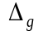 which are above the corresponding conversion
threshold 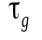
- Choose one of these at random if there is one.
- The civilian is now a gang member of the corresponding gang g

Other than becoming a gang member, a civilian doesn't do anything.

Gang members help civilians

As for now, if a gang member chose not to attack a rival gang member, they simply idled away time. As an extension of the model of Epstein, non attacking gang members help nearby civilians (those in the vision), making these civilians less angry at their gang g:

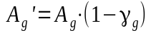

where
- A_g' is the anger of the civilian at the gang g after being helped
- A_g is the anger of the civilian at the gang before being help
- gamma_g is again the change rate of anger, as before

Police members help civilians

Like non attacking gang members, non attacking policemen also help nearby civilians using the analogous formula

