6/16/2013

Stefan Pleava

Pleava Productons

The Sorting Visualizer

User Guide

Table of Contents

# Introduction Page 2

# Loading Instructions Page 3

# Menu Items Page 4

# Terms Page 5

# How to Use / Legend Page 6

# Credits Page 7

# Warranty Page 8

Introduction

# Description:

The Sorting Visualizer is a program where the main objective is to allow the user to visualize various sorting algorithms on random data in order to better understand the algorithms and see how they work.

# Programmer’s Name:

The programmer who made this game is called Stefan Pleava.

# Completion:

This program was completed at on June 16, 2014.

Loading Instructions

Upon first starting the program you will be required to put in a password. The password required to unlock the game is “thesortingvisualizer2014”. Afterward inputting the password you will be sent to main menu. The next page in this user guide will tell you how to navigate the main menu.

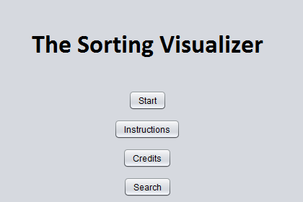Menu Items

Sort:

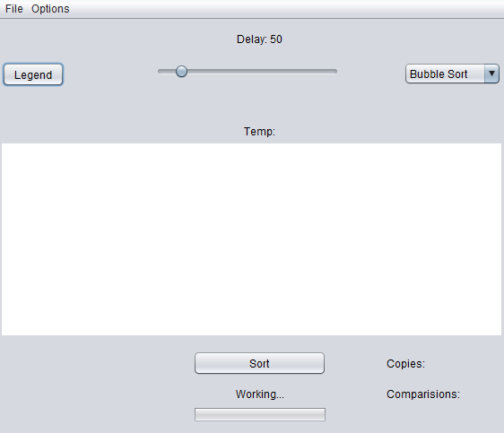In order to start sorting you just have to click on the start button. This will close the main menu and bring you to the sorting window.

Instructions:

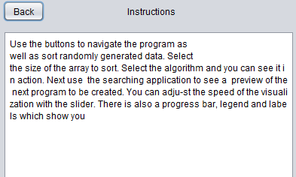In order to view the in-game help, you must press on the instructions button. To go back just press the back button.

Credits:

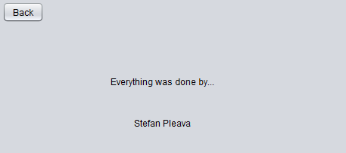In order to view the in-game credits, you must press on the credits button. To go back just press the back button.

Search:

In order to view the in-game mini, you must press on the search button. Close when finished.

Terms

Delay:

The delay between each step of the sort.

Amount:

This is the amount of items that need to be sorted.

Combo Box:

Select the sorting algorithm with this drop down menu.

Copies:

The amount of times data was copied in the array during that algorithm.

Comparisons:

This is the amount of times data was compared to see which is greater or lesser.

Temp:

This is the temporary variable that is being used to store data in the algorithms.

Legend:

This opens another window which displays the meaning of all the graphics.

How to Play

You move around using the arrow keys and try to go over squares that are yellow and red. When you are playing the game you must be careful to not run into squares that are bigger than you. Squares that are bigger than you will be blue and red in color. If you try to move off the screen you will be teleported to the other side of the screen instantly. If an enemy tries to move off the screen you will be teleported as well as being given a burst of speed. You get a temporary invincibility buff once you get hurt by a creature so that you can get away from it.

Legend

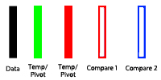

Credits

Lead Programmer: Stefan Pleava

Lead Artist: Stefan Pleava

Director: Stefan Pleava

CEO: Stefan Pleava

Business Manager: Stefan Pleava

Art Manager: Stefan Pleava

Story Manager: Stefan Pleava

Play Tester: Stefan Pleava

Warranty

**You may need only simple instructions to correct a problem with your product. Try our web site at www.Pleava Productions.com or call our Consumer Assistance Hotline at 1-800-255-3700, rather than going to your retailer.** Hours of operation are 6 a.m. to 7 p.m., Pacific Time, Monday - Sunday (times subject to change). If the problem cannot be solved with the troubleshooting information available on-line or over the telephone, you will be offered express factory service through Pleava Productions or referred to the nearest PLEAVA PRODUCTIONS AUTHORIZED REPAIR CENTER. Please do not send any products to Pleava Productions without contacting us first.  
 **HARDWARE WARRANTY**  
Pleava Productions of America Inc. ("Pleava Productions") warrants to the original purchaser that the hardware product shall be free from defects in material and workmanship for twelve (12) months from the date of purchase. If a defect covered by this warranty occurs during this warranty period, Pleava Productions or a PLEAVA PRODUCTIONS AUTHORIZED REPAIR CENTER will repair the defective hardware product or component, free of charge. The original purchaser is entitled to this warranty only if the date of purchase is registered at point of sale or the consumer can demonstrate, to Pleava Productions's satisfaction, that the product was purchased within the last 12 months.

**GAME & ACCESSORY WARRANTY**  
Pleava Productions warrants to the original purchaser that the product (Game Paks and accessories) shall be free from defects in material and workmanship for a period of three (3) months from the date of purchase. If a defect covered by this warranty occurs during this three (3) month warranty period, Pleava Productions or a PLEAVA PRODUCTIONS AUTHORIZED REPAIR CENTER will repair the defective product, free of charge.

**SERVICE AFTER EXPIRATION OF WARRANTY**  
Please try our web site at www.PleavaProductions.com or call the Consumer Assistance Hotline at 1-800-255-3700 for troubleshooting information and/or referral to the nearest PLEAVA PRODUCTIONS AUTHORIZED REPAIR CENTER. In some instances, it may be necessary for you to ship the complete product, FREIGHT PREPAID AND INSURED FOR LOSS OR DAMAGE, to the nearest service location. Please do not send any products to Pleava Productions without contacting us first.

**WARRANTY LIMITATIONS**

THIS WARRANTY SHALL NOT APPLY IF THIS PRODUCT: (a) IS USED WITH PRODUCTS NOT SOLD OR LICENSED BY PLEAVA PRODUCTIONS (INCLUDING, BUT NOT LIMITED TO, NON-LICENSED GAME ENHANCEMENT AND COPIER DEVICES, ADAPTERS, AND POWER SUPPLIES); (b) IS USED FOR COMMERCIAL PURPOSES (INCLUDING RENTAL); (c) IS MODIFIED OR TAMPERED WITH; (d) IS DAMAGED BY NEGLIGENCE, ACCIDENT, UNREASONABLE USE, OR BY OTHER CAUSES UNRELATED TO DEFECTIVE MATERIALS OR WORKMANSHIP; OR (e) HAS HAD THE SERIAL NUMBER ALTERED, DEFACED OR REMOVED.

ANY APPLICABLE IMPLIED WARRANTIES, INCLUDING WARRANTIES OF MERCHANTABILITY AND FITNESS FOR A PARTICULAR PURPOSE, ARE HEREBY LIMITED IN DURATION TO THE WARRANTY PERIODS DESCRIBED ABOVE (12 MONTHS OR 3 MONTHS, AS APPLICABLE). IN NO EVENT SHALL PLEAVA PRODUCTIONS BE LIABLE FOR CONSEQUENTIAL OR INCIDENTAL DAMAGES RESULTING FROM THE BREACH OF ANY IMPLIED OR EXPRESS WARRANTIES. SOME STATES DO NOT ALLOW LIMITATIONS ON HOW LONG AN IMPLIED WARRANTY LASTS OR EXCLUSION OF CONSEQUENTIAL OR INCIDENTAL DAMAGES, SO THE ABOVE LIMITATIONS MAY NOT APPLY TO YOU.