CI/CD Exercise 1
Stefan Penzinger - S2310455002

Table of Contents
Part 1 - GIT Basics 2
Ramping Up 2
1: Detach yo’ HEAD 2
2: Relative Refs (^) 2
3: Relative Refs #2 (~) 3
4: Reversing Changes in Git 3
Moving Work Around 4
1: Cherry-pick Intro 4
2: Interactive Rebase Intros 4
A Mixed Bag 5
1: Grabbing Just 1 Commit 5
2: Juggling Commits 6
3: Juggling Commits #2 6
4: Git Tags 7
5: Git Describe 7
Advanced Topics 8
1: Rebasing over 9000 times 8
2: Multiple parents 9
3: Branch Spaghetti 10
Part 2 - GIT Remotes 11
Push & Pull -- Git Remotes! 11
1: Clone Intro 11
2: Remote Branches 11
3: Git Fetchin’ 12
4: Git Pulin’ 12
5: Faking Teamwork 13
6: Git Pushin’ 13
7: Diverged History 14
8: Locked Main 14
To Origin And Beyond -- Advanced Git Remotes! 15
1: Push Main! 15
2: Merging with remotes 16
Part 3 - GIT Interactive Rebase 20
Checkout topic and start interactive rebase 20
Changing the commit history 20
Squash B and C 20
Split commit D 21
Finishing the rebase 22
Part 4 - GIT ReReRe 23

Part 1 - GIT Basics

Ramping Up

1: Detach yo’ HEAD
Commands:
- git checkout C4

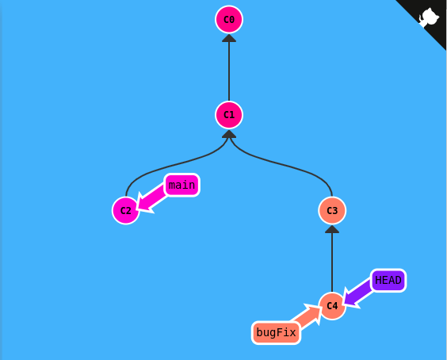
2: Relative Refs (^)
Commands:
- git checkout bugFix^
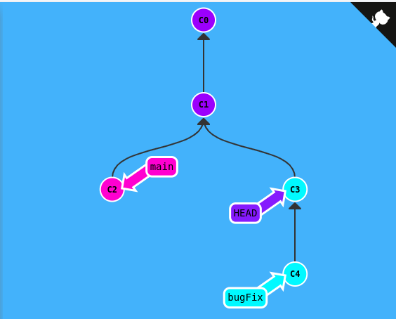

3: Relative Refs #2 (~)
Commands:
- git branch -f main C6
- git checkout HEAD^
- git branch -f bugFix HEAD^

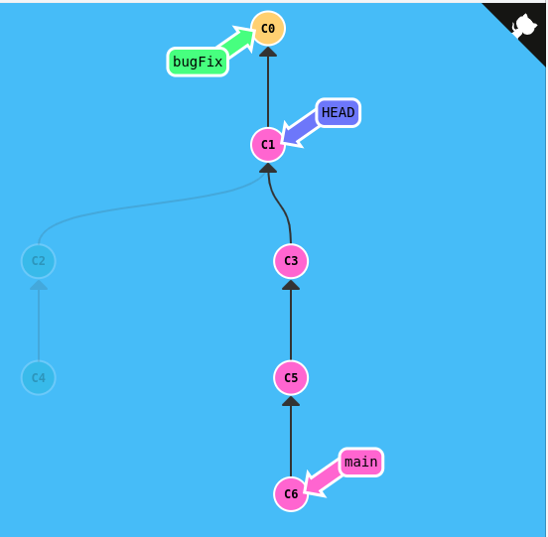
4: Reversing Changes in Git
Comamnds:
- git reset local^
- git checkout pushed
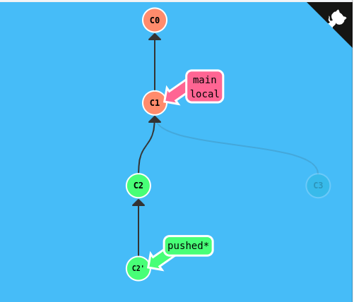
- git revert pushed

Moving Work Around

1: Cherry-pick Intro
Commands
- git cherry-pick bugFix side^ another
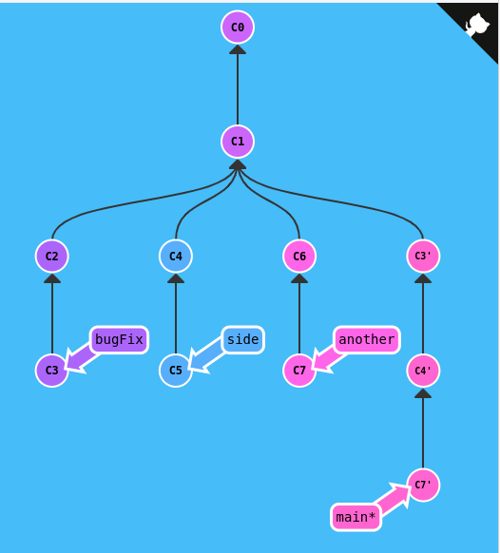

2: Interactive Rebase Intros
Commands:
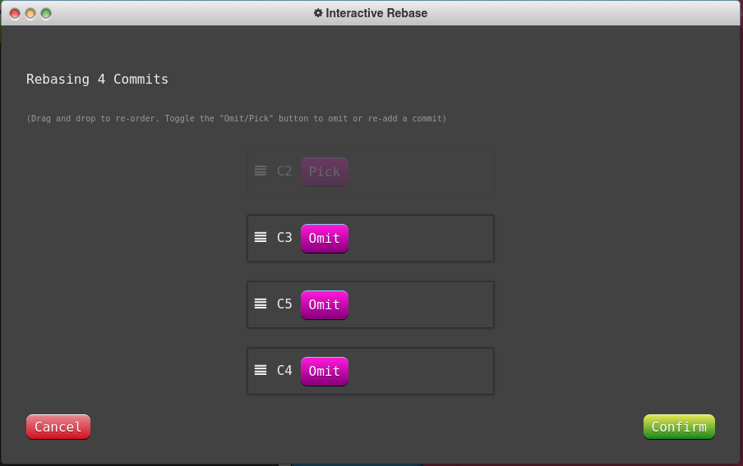
- git rebase overHere -i

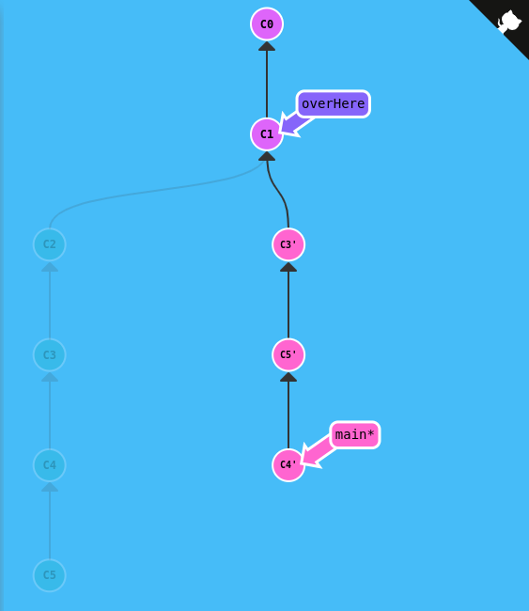
A Mixed Bag

1: Grabbing Just 1 Commit
Commands:
- git checkout main
- git cherry-pick bugFix
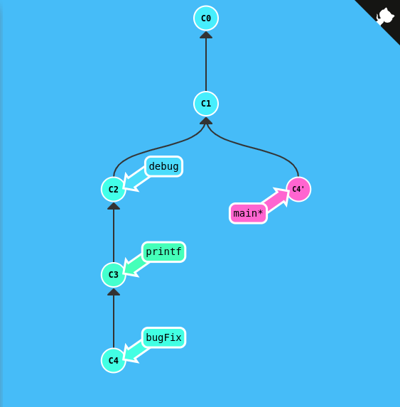

2: Juggling Commits
Commands:
- git rebase main caption -i
- git commit –amend
- git rebase main caption -i
- git checkout main
- git rebase caption

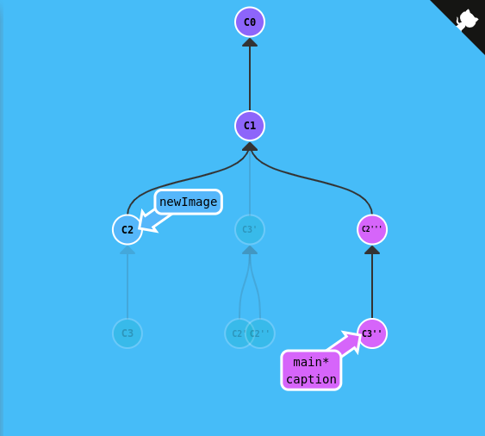
3: Juggling Commits #2
Command:
- git checkout main
- git cherry-pick newImage
- git commit –amend
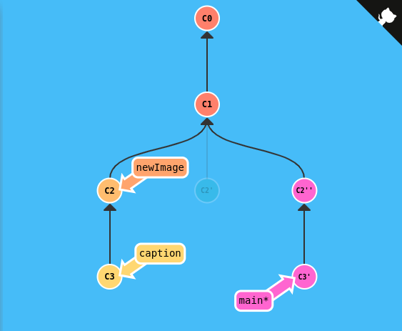
- git cherry-pick caption

4: Git Tags
Commands:
- git tag v0 C1
- git tag v1 C2
- git checkout v1
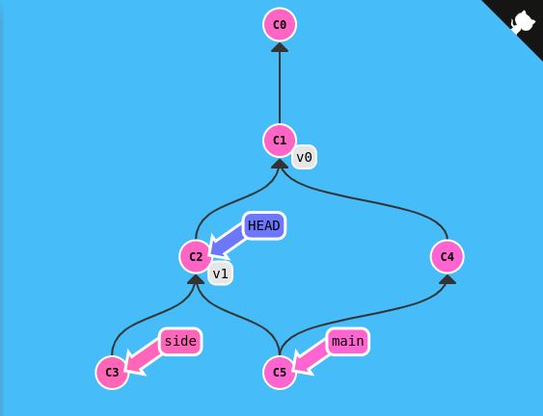

5: Git Describe
Commands:
- git describe main
  - v0_2_gC2
- git describe side
  - v1_1_gC4
- git describe bugFix
  - v1_2_gC6

Advanced Topics

1: Rebasing over 9000 times
Commands:
- git rebase main bugFix
- git rebase bugFix another^
- git rebase HEAD side
- git rebase side another
- git rebase another main
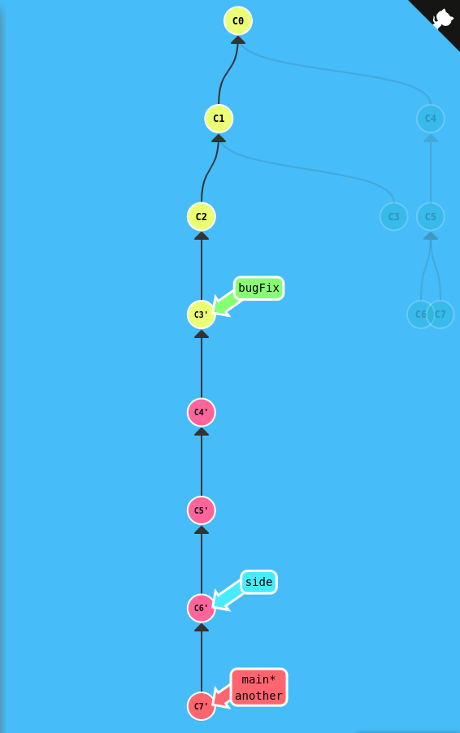

2: Multiple parents
Commands:
- git branch bugWork HEAD~^2^
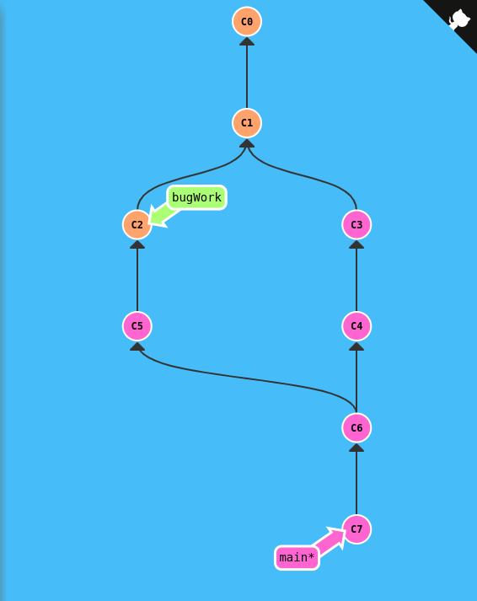

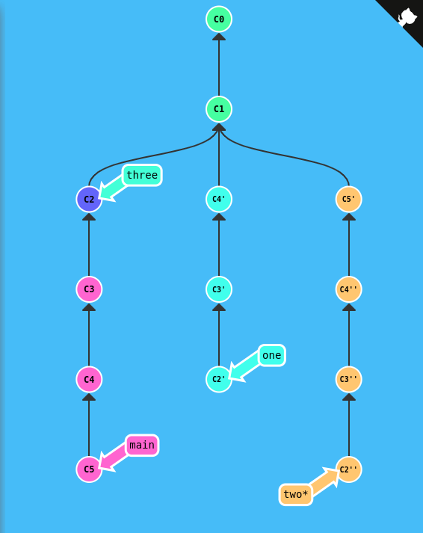
3: Branch Spaghetti
Commands:
- git checkout 3
- git reset main~3
- git checkout one
- git cherry-pick main~ main~2 three
- git checkout two
- git cherry-pick main one~2 one~ one
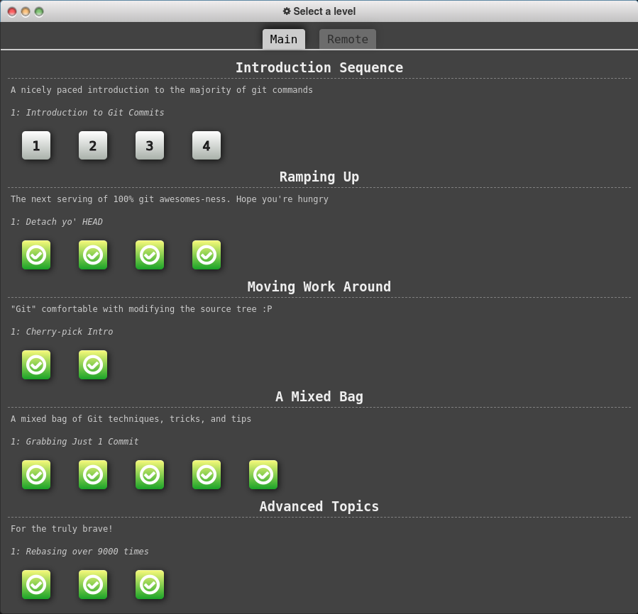

Part 2 - GIT Remotes

Push & Pull -- Git Remotes!

1: Clone Intro
Commands:
- git clone

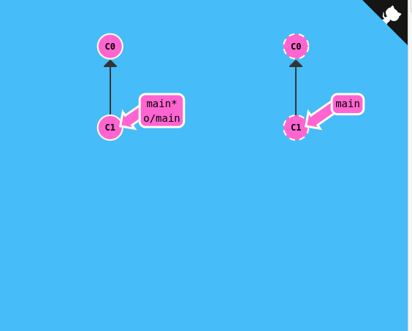
2: Remote Branches
Commands:
- git commit
- git checkout o/main
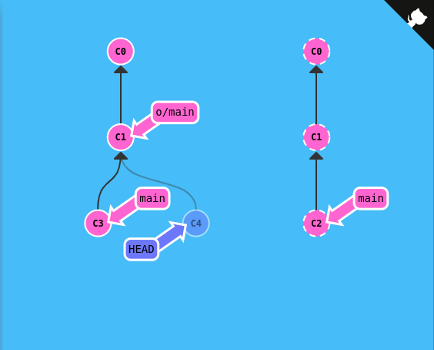
- git commit

3: Git Fetchin’
Command:
- git fetch

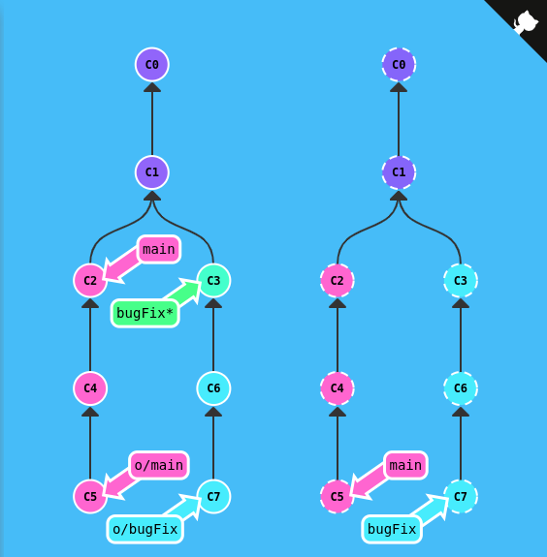
4: Git Pulin’
Command:
- git pull
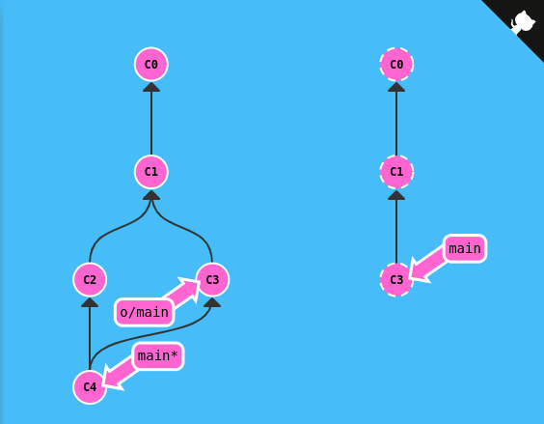

5: Faking Teamwork
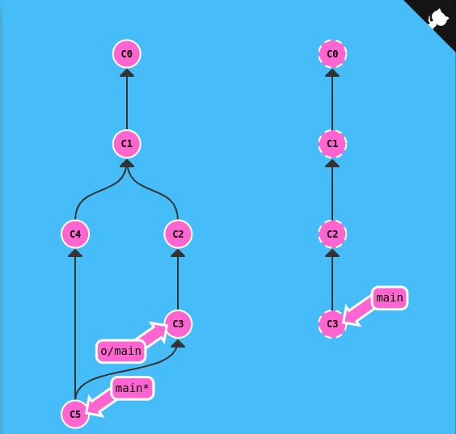
Commands:
- git clone
- git fakeTeamwork 2
- git commit
- git pull

6: Git Pushin’
Commands:
- git commit
- git commit
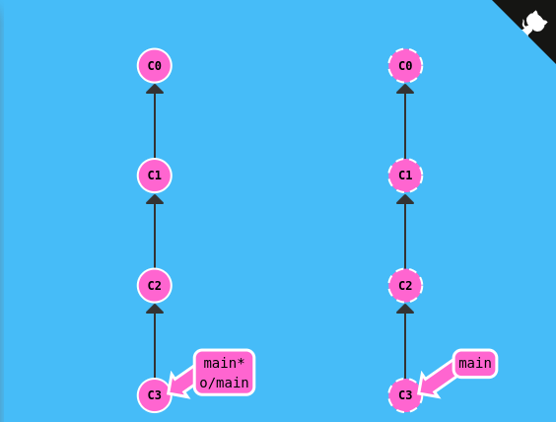
- git push

7: Diverged History
Commands:
- git clone
- git fakeTeamwork
- git commit
- git pull –rebase
- git push

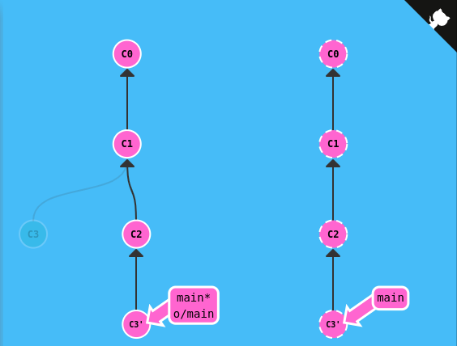
8: Locked Main
- git switch -c feature
- git push
- git checkout main
- git reset HEAD^
- git checkout feature
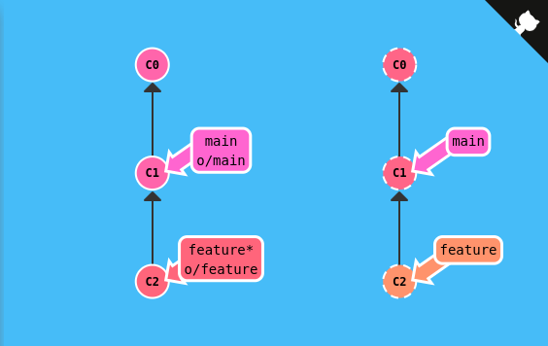

To Origin And Beyond -- Advanced Git Remotes!

1: Push Main!
Commands:
- git fetch
- git rebase o/main side1
- git rebase side1 side2
- git rebase side2 side3
- git rebase side3 main
- git push
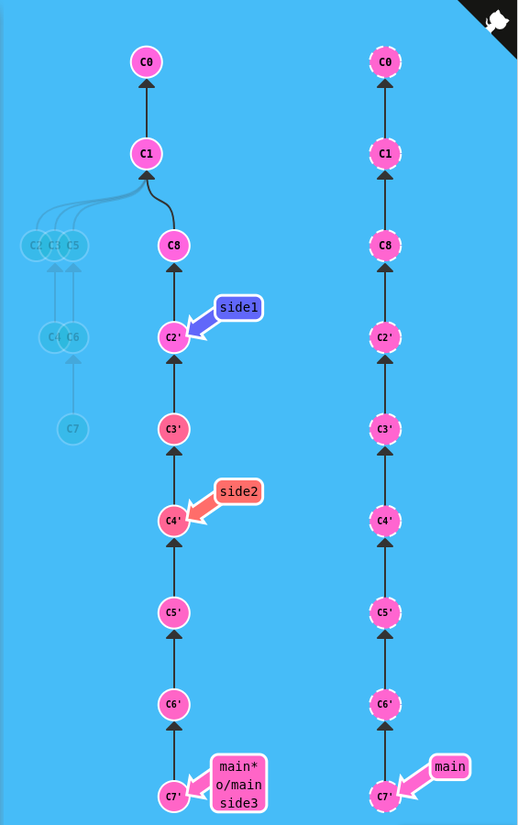

2: Merging with remotes
Commands:
- git checkout main
- git pull –rebase
- git merge side1
- git merge side2
- git merge side3
- git push
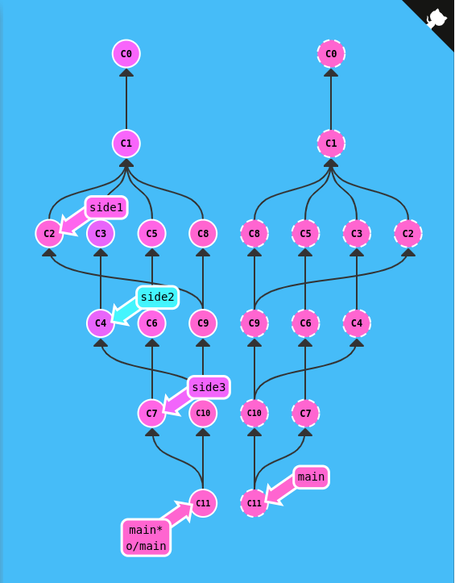
3: Remote Tracking
Commands:
- git checkout -b side o/main
- git commit
- git pull –rebase
- git push
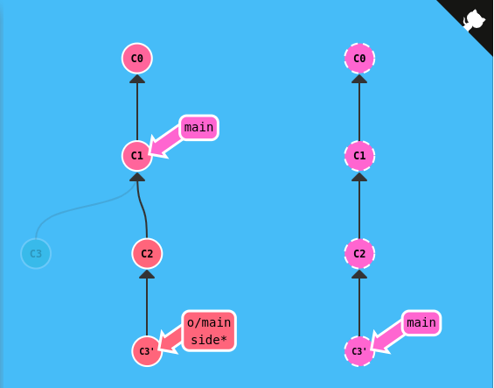
4: Git push arguments
Commands:
- git push origin main
- git push origin foo
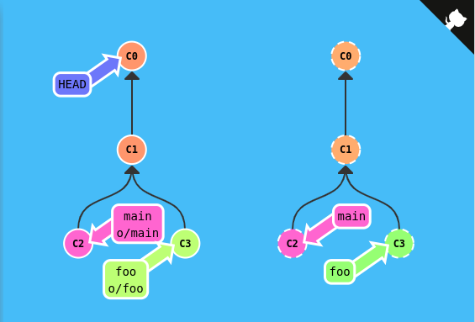
5: Git push arguments – Expanded!
Commands:
- git push origin foo:main
- git push origin main^:foo
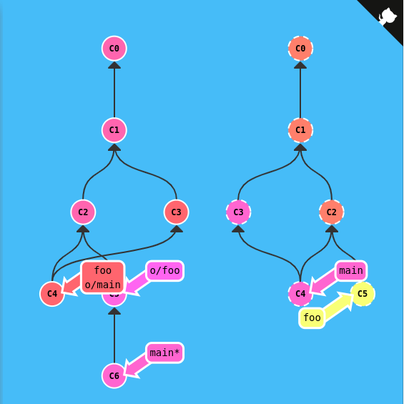
6: Fetch Arguments
Commands:
- git fetch origin main^:foo
- git fetch origin foo:main
- git checkout foo
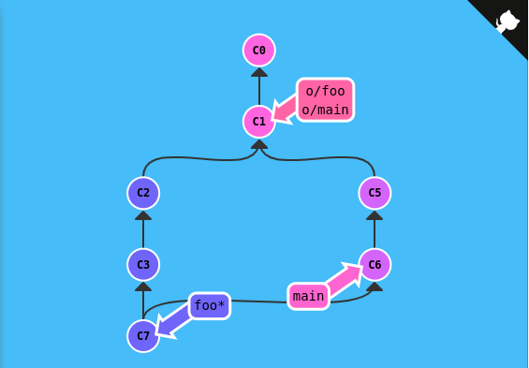
- git merge main

7: Source of nothing
Commands:
- git push :foo
- git fetch origin :bar
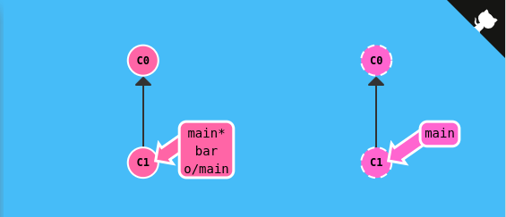
8: Pull arguments
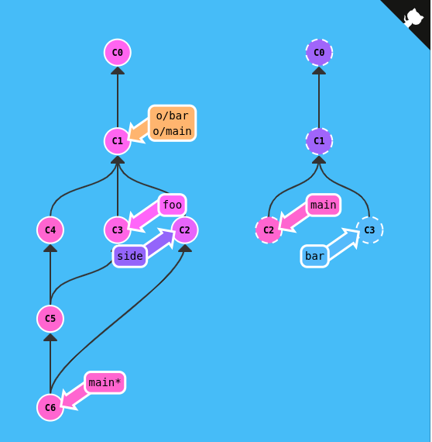
Commands:
- git pull origin bar:foo
- git pull origin main:side
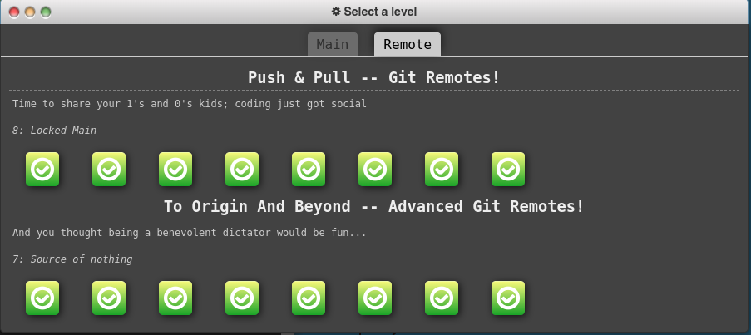

Part 3 - GIT Interactive Rebase

Checkout topic and start interactive rebase

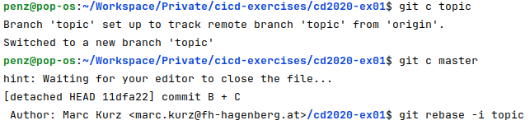
Changing the commit history
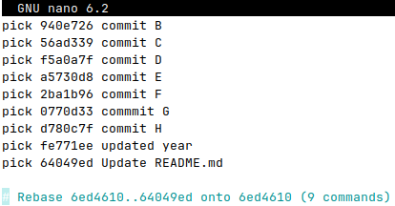
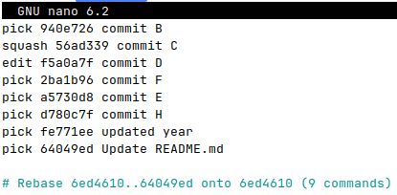
Above the necessary changes to the commit history can be seen.
- Delete G
- Swap E and F
- Squash B and C
- Split D to 3 separate commits (see later)
This needs to be saved now.

Squash B and C
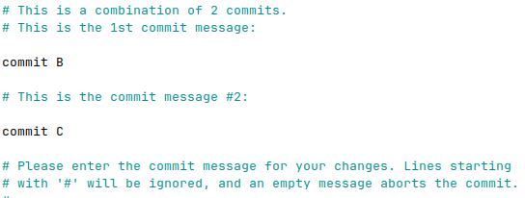
After saving a window pops up in which the commit message can be adapted.
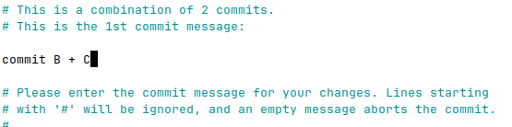
On the rights side can be see that the commit message is now “commit B + C”. This needs now to be saved. Now the commit D has to be changed in the next step.

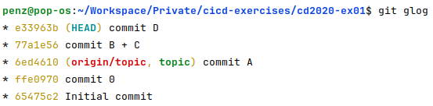
Split commit D
Now the edit of commit D has to be made.
After saving, the HEAD is set to the current commit (commit D) which needs to be edited.
Now, the HEAD can be set 1 node before the current commit in order to revert that all files of D are committed at once.
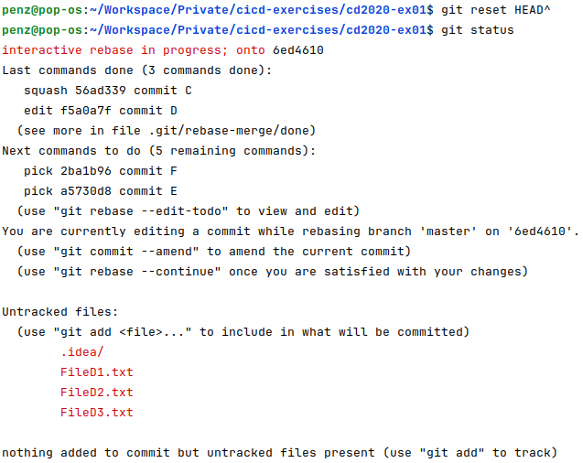
Now the files can be added and committed 1 by 1.
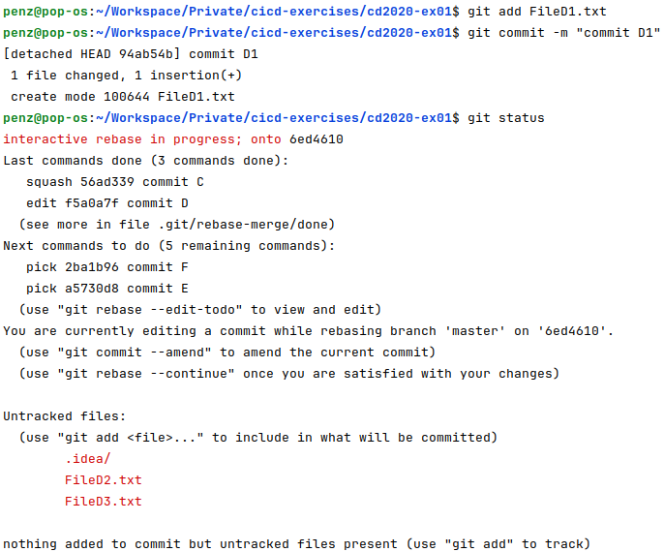

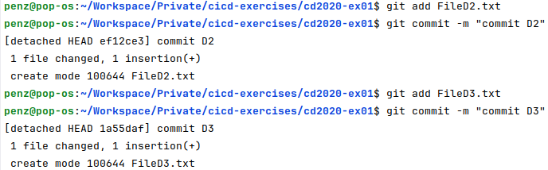
The same goes for D2 and D3

Finishing the rebase
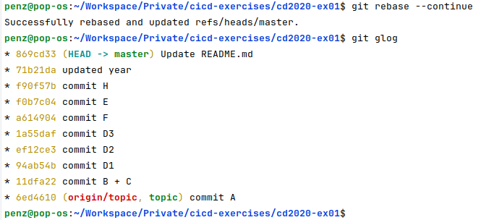
Now the rebase needs to be continued and it can be finished successfully:

Part 4 - GIT ReReRe
ReReRe stands for reuse recorded resolution.
The intention is to solve already happened conflicts (like merge conflicts) automatically. It can be enabled by running the following config setting:
$git config --global rerere.enabled true

If there is a long lived branch one can occasionally merge, resolve the conflicts and then back out of the merge. How to solve this particular conflict is now remembered. When the long-lived branch is then finally merged with the destination branch, those conflicts can the be solved automatically.

