2021

Done by: Rawan Alhabsi (467287), Stanislav Petkov (4222024), Biser Yusufi (3869709), Hristo Tanchev (4251423)

PRJ-CB07 – Group02 – version 1.4

6/18/2021

Tutor: Sabina Pencheva

User Requirement Specifications

REVISION HISTORY

|  |  |
| --- | --- |
| Version | Changes |
| 0.1 | -Initial version |
| 0.2 | - Revision history added  - Update 2.1.1 C# application- Administration  -Update 2.1.4 Website- Employees  -Update 4. GUI |
| 0.3 | -Adding new use cases  -Updating GUI figures and description  -Updating functional requirements |
| 1.0 | -Updating Agreements with client  -Updating functional requirements  -Adding Website Wireframes  -Updating Use Cases |
| 1.1 | -Updating Agreements with client  -Updating functional requirements  -Adding Website Wireframes  -Updating Use Cases |
| 1.2 | -Updating Agreements with client  -Updating User Requirements  -Updating Use Cases  -Updating GUI  -Updating Website wireframes |
| 1.3 | -Update Agreements with client  -Update User Requirements  -Updating Use Cases  -Update GUI  -Update Website wireframes |
| 1.4 | -Update Agreements with client  -Update User Requirements  -Updating Use Cases  -Update GUI  -Update Website wireframes |

Contents

1. Agreements with the client 4

2. User Requirements 5

2.1 Functional requirements 5

2.1.1 C# application – Administration 6

2.1.2 C# application – Management 7

2.1.3 Website – Employees 8

Non-Functional requirements 12

3. Use Cases C# Application 13

UC-01: Adding a new employee to the system. 13

UC-02: Removing an employee from the company’s system. 13

UC-03: Assigning an employee to a work shift. 14

UC-04: Logging into the application 15

UC-05: Logging out of the application. 15

UC-06: Indicating that an employee is no longer part of the company. 16

UC-07: Editing employee’s data. 16

UC-08: Canceling a work shift. 17

UC-09: Viewing different individual statistics about an employee. 18

UC-10: Viewing employees statistics. 18

UC-11: Viewing employee’s statistics in a selected time period 19

UC-12: Viewing individual product statistics. 19

UC-13: Viewing overall product statistics. 20

UC-14: Adding a product to the system 21

UC-15: Modify a product 21

UC-16: Removing a product from the system 22

UC-17: Selling a product through the Cashier Form 22

UC-18: Accepting restock request through Depot Worker Form 23

UC-19: Rejecting restock request through Depot Worker Form 23

UC-20: Admin adding a department 24

UC-21: Admin modifying department 24

UC-22: Admin remove a department 25

UC-23: Logging into the employees’ website 26

UC-24: Logging into the employees’ website 26

UC-25: Employee editing some of his personal data 27

UC-26: Employee viewing his work-schedule 27

UC-27: Employee indicating days where he/she’s unavailable 28

UC-28: Employee changing his password 29

UC-29: Employee Check-ins for his scheduled work shift 29

UC-30: Employee Check-outs for his scheduled work shift 30

UC-31: Employee call in sick 30

UC-32: Setting Employee’s profile picture 31

4. GUI 32

4.1 Administration Form 32

4.1.1 Employees management page 32

*4.1.1.1.3 Register employee page* 34

4.1.1.1.4 Edit employee’s personal information page 35

4.1.2 Work shifts schedule page. 36

4.1.3 Product Management page 37

4.2 Manager Form 41

4.2.1 Statistics page 41

4.3 Login Form 43

4.4 Cashier Form 44

4.5 Depot Form 45

4.6 Department Form 46

5. Website 49

5.1 Home page 49

5.2 Account Page 50

5.3 “Change password” page 50

5.4 “First time login” page 51

5.1.5 Login page 52

5.1.6 Check-in/ Call Sick page 53

1. Agreements with the client

The first six weeks of working on this project, we have agreed to create a C# application, that will allow our client’s administration to manage their employees,

manager being able to view the statistical information on employees and stock, manually schedule work shifts, and display them in a calendar.

For the First iteration of second phase of the project, the requirement of the client is to create a website supporting the company’s employees with a deadline on 18.04.2021. A user-friendly website is needed to be developed so the employees can view and manage their work schedule, as well as edit some of their personal data.

For the Second iteration of second phase of the project, the requirement of the client is to continue the C# application and create a Product management form for adding, editing, removing Products from the system also a Cashier form for selling the products and Depot form for stock requests.

For the Third Iteration of the third phase of the project, the requirements of the client is to continue working on the C# application and additional features on the employee website. On the C# application the client requires an Automated work shift scheduling besides the manual one. The client also required a management system for department and the same features of product/employee management such as add, delete, view and update features. In addition to that, it should be possible to view statistics of the employees/products per department and based on that another type of user is going to be added to the system and that is Department Manager. For the website the employees should be able to indicate attendance for the current date by checking in through the website.

For the fourth Iteration of third phase of the project, additional requirements were added. The client asked to add “Call-In Sick “functionality where employee can indicate this through the website, in this case this employee will be removed from the work shift of current date and administrator should place another employee to work shift manually.

# User Requirements

## Functional requirements

The application’s functional requirements can be seen below, prioritized following the MoSCoW model. This is a technique, which is used to reach common understanding with stakeholders on the importance placed on each of the functionalities regarding a product. The term MoSCoW itself is an acronym derived from the first letter of each of four prioritization categories: M - Must have S - Should have C - Could have W - Won't have.

### 2.1.1 C# application – Administration

|  |  |
| --- | --- |
| FR | Priority (MSCW) |
| FR-01: User must be able to manually assign work shifts for each of the employees. | M |
| FR-02 User must be able to auto assign all of the unassign employees to a work shift | M |
| FR-03: User must be able to unassign work shifts for an employee. | M |
| FR-04: User must be able to display all of the employees’ work shifts in a calendar. | M |
| FR-05: User must be able to store data about the employees into the system: -First name; Last name; Gender; Birth date; Username; Password; Email address; Contract type; First working date; Street name; Street number; Zip code; Town; Country; Hourly wage; last working day; department | M |
| FR-06: User should be able to edit data about the employees. | S |
| FR-07: User must be able to remove employees from the company’s system. | M |
| FR-08: User should be able to hire employees ahead of time. | S |
| FR-09: User should be able to indicate that an employee is no longer part of the company. | S |
| FR-10: User must be able to view the list of employees and search for individuals by ID. | M |
| FR-11: User must be able to log in. | M |
| FR-12: User must be able to log out. | M |

### 2.1.2 C# application – Management

|  |  |
| --- | --- |
| FR-13: User must be able to view individual statistics about each of the company’s workers:  * Total numbers of hours worked. * Attendance rate. * Total days at the company. | M |
| FR-14: User must be able to view the following statistics for a selected date (cannot be in future): Total number of employees.  Total salary paid.  Total number of hours worked.  Attendance rate | M |
| FR-15: User must be able to view the following statistics for a selected time period (cannot be in future): Total amount of salaries paid.  Total numbers of hours worked.  Average hourly wage per employee  Average numbers of hours worked by an employee.  Average number of employees per work shift  Attendance rate | M |
| FR-16 User must be able to filter the employees by department. | C |
| FR-17 User must be able to view individual statistics of each product of the company in a selected time period: Turnover of the product.  Number of items sold. | M |
| FR-18 User must be able to view overall statistics of the products in a selected period. | M |
| FR-19 User must be able to filter products by department. | C |
| FR-20: User must be able to log in. | M |
| FR-21: User must be able to log out. | M |

### 2.1.3 Website – Employees

|  |  |
| --- | --- |
| FR-22 User must be able to log in. | M |
| FR-23 User must be able to log out. | M |
| FR-24 When a user logs in for the first time, he/she should be greeted with a mandatory request to change his/her password. | M |
| FR-25 User must change his/her password through the request when first log in. | M |
| FR-26 Employee will be able to change his/her Family name through the website. | M |
| FR-27 Employee will be able to change his/her Password through the website. | M |
| FR-28 Employee will be able to change his/her Address through the website. | M |
| FR-29 Employee will be able to change his/her Profile Picture through the website. | C |
| FR-30 User must be able to view his work-schedule. | M |
| FR-31 An employee can indicate a non-preferable working days. | M |
| FR-32 An employee can indicate that she/he doesn’t a non-preferable working on a night shift. | S |
| FR- 33 Employee can Check-in when his work shift begins | M |
| FR-34 Employee can Check-out at the end of his work shift | M |
| FR-35 Employee can call Sick | M |
| FR-36 Employee can upload a profile picture | C |

2.1.4 C# Application – Product Management

|  |  |
| --- | --- |
| FR-37 User must be able to add new product to the stock system of department. | M |
| FR-38 User must be able to view the products and the data of the products. | M |
| FR- 39 User must be able to select a product from the table. | S |
| FR-40 User must be able to remove a product form the form system. | M |
| FR-41 User must be able to modify a product and its details. | M |
| FR-42 Product must be marked in red when the stocks of it is low. | M |
| FR:43 User must be able to store data about the products into the system:  * name, cost price, selling price, number of products in stock, maximum capacity, threshold, size and number of sold products, department. | M |

2.1.5 C# Application – Cashier Form

|  |  |
| --- | --- |
| FR-44 User must be able to select a product. | M |
| FR-45 User must select quantity of the selected product to sell it. | M |
| FR-46 User must be able to sell the selected product. | M |
| FR-47 User can search for product by name. | S |
| FR-48 User must be able to view products prices. | M |
| FR-49 User must be able to get the total price of selected price and quantity | M |

2.1.6 C# Application – Depot Form

|  |  |
| --- | --- |
| FR-50 User must be able to select a restock request. | M |
| FR-51 User must be able to accept the selected restock request. | M |
| FR-52 User must be able to reject the selected restock request. | M |

**2.1.7 C# Application – Department Management**

|  |  |
| --- | --- |
| FR – 53 User must be able to add a department. | M |
| FR-54 User must be able to remove a department. | M |
| FR-55 User must be able to modify department. | M |
| FR-56 User must be able to search a department by ID. | C |
| FR-57 User must be able to view active employees in a selected department. | M |
| FR-58 User must be able to view all employees on a selected department. | M |
| FR-59 User must be able to add a department manager to the Department. | M |
| FR-60 User must be able to view departments | M |

## Non-Functional requirements

* The Program can be extended in the future. The code is maintainable and readable, which allows future developers to easily understand how the application works and allows them to add new features without having to communicate with the previous developers.
* The program is reliable, which means the state of the application is going to be stable and will not have frequent crashes. This can be achieved by writing a high-quality code, which can avoid many of the errors a program can usually encounter while running. Proper error-handling will be implemented as well as different object-oriented concepts such as inheritance, interfaces and others.

# 3. Use Cases C# Application

## UC-01: Adding a new employee to the system.

* + FR: 05, 08
  + Actor: Administrator
  + Pre-condition: Must be logged in as an administrator.
  + Trigger: New worker has been employed to the company
  + Main success scenario:

1. The administrator presses “Add employee” button.
2. New form “Register employee” pops up.
3. The administrator puts in the personal details of the new employee, first working date, hourly wage and all other data that are mentioned in FR-04.
4. The administrator presses the add button.
5. The software adds the new employee’s details to the system and sends a confirmation message box.
   * Extensions:

4a: There is an option where user can cancel action by pressing cancel button.

5a: There is one or more fields with missing or syntactically incorrect information.

1. The system shows a notification, that you must input information in the required fields.
2. Return to MSS step 3.

## UC-02: Removing an employee from the company’s system.

* + FR: 06
  + Actor: Administrator
  + Pre-condition: Must be logged in as an administrator.
  + Trigger: An employee has been fired or left the company for various reasons.
  + Main success scenario:

1. Administrator inputs ID of the employee and presses the search button.
2. The employee is found and displayed on the screen.
3. Administrator selects it and presses the delete button.
4. The software removes the employee from the system and displays confirmation text.
   * Extensions:

2a: Employee with this name has not been found.

3a: If the employee was scheduled to work shift in future a message will pop up to inform the user.

1. System displays a message that, there is no employee with this ID.
2. End of case.

## UC-03: Assigning an employee to a work shift.

* + FR: 01, 03
  + Actor: Administrator
  + Pre-condition: Must be logged in as an administrator.
  + Trigger: The administrator wants to assign an employee to a certain work shift
  + Main success scenario:
    1. Administrator opens the “Work Shifts Schedule” tab.
    2. Administrator selects the date, he wants to assign a shift for.
    3. Administrator selects type of shift, he wants to assign.
    4. Administrator gets a list with available employees for the selected date and type shift.
    5. Administrator selects an employee from the list.
    6. Administrator presses the assign button.
    7. Employee is assigned by the system and the administrator gets a confirmation notification.
    8. The shift is displayed in a calendar.

## UC-04: Logging into the application

* + FR: 11, 20
  + Actor: User
  + Pre-condition: Application must be already running on the device.
  + Trigger: User wants to log in his account
  + Main success scenario:
    1. User is shown the login screen.
    2. User enters his credential (username and password)
    3. User presses the “Login” button.
    4. User gets confirmation and access to the application features of either manager or administrator. (Depends on the account he has)
  + Extensions:

3a: User can cancel the action by pressing exit button then the system will be closed.

4a: User with these credentials has not been found.

* + - 1. System displays a message that, there is no user with these login details.
      2. Return to MSS step 2.

## UC-05: Logging out of the application.

* + FR: 12
  + Actor: Administrator
  + Pre-condition: Must be logged in as an administrator.
  + Trigger: User wants to log out of his account
  + Main success scenario:
    1. Administrator presses the “Log out” button in the top-right corner of the administration’s form.
    2. Administrator gets message: “Are you sure you want to log out?”
    3. Administrator selects: “Yes”.
    4. Administrator is sent back to login form.
  + Extensions:

3a: Administrator selects: “No”.

* + - 1. Administrator remains in the admin form.
      2. End of case.

## UC-06: Indicating that an employee is no longer part of the company.

* + FR: 09, 10, 11
  + Actor: Administrator
  + Pre-condition: Must be logged in as an administrator.
  + Trigger: Administrator wants to cancel an employee’s contract
  + Main success scenario:
    1. Administrator enters the ID of the employee in the text field on the right of the “Search by ID” button.
    2. Administrators presses the “Search by ID” button.
    3. Employee with this ID is found and displayed in the list below the search button.
    4. Administrator selects the employee from the list and presses the “Cancel contract” button.
    5. New form is displayed.
    6. Administrator selects last working date and reason for removing the employee from the company.
    7. Administrator presses the “Remove” button.
    8. Administrator gets confirmation and the form is closed.
  + Extensions:

7a: User can cancel the action by pressing cancel button.

3a: Employee with this ID has not been found.

* + - 1. Return to MSS step 1.

## UC-07: Editing employee’s data.

* + FR: 06
  + Actor: Administrator
  + Pre-condition: Must be logged in as an administrator.
  + Trigger: Administrator wants to edit an employee’s data
  + Main success scenario:
    1. Administrator enters the ID of the employee in the text field on the right of the “Search by ID” button.
    2. Administrators presses the “Search by ID” button.
    3. Employee with this ID is found and displayed in the list below the search button.
    4. Administrator selects the employee from the list and presses the “Edit personal details” button.
    5. New form “Edit personal info” is displayed.
    6. Administrator fills in the fields related to the information he wants to edit.
    7. Administrator presses the “Edit” button.
    8. Administrator gets confirmation and the form is closed.
  + Extensions:

3a: Employee with this name has not been found.

* + - 1. Return to MSS step 1.

6a: Administrator presses the “Cancel” button.

* + - 1. No Data is changed
      2. Form is closed.
      3. End of case

7a: User can cancel the action by pressing cancel button.

## UC-08: Canceling a work shift.

* + FR: 03
  + Actor: Administrator
  + Pre-condition: Must be logged in as an administrator.
  + Trigger: Administrator wants to cancel an employee’s work shift
  + Main success scenario:
    1. Administrator opens the “Work Shift Schedule” tab.
    2. Administrators selects a date from the calendar.
    3. All of the scheduled shifts for this day are displayed in a list on the right of the calendar.
    4. Administrator selects the shift he wants to cancel.
    5. Administrator presses the “Remove shift button”.
    6. Administrator receives confirmation, that the shift has been removed successfully.
  + Extensions:

3a: No scheduled shifts for the selected day have been found.

* + - 1. End of case.

## UC-09: Viewing different individual statistics about an employee.

* + FR: 13
  + Actor: Manager
  + Pre-condition: Must be logged in as a manager.
  + Trigger: Manager wants to view various statistics about a single employee
  + Main success scenario:

1.Manager enters employee’s ID in the text field or selects him from the list next to the “View” button.

2.Manager clicks on the button “View” and a new window pops up with the individual statistics and the scheduled shifts for the selected employee.

3. End of case.

* + Extensions:

2a: No employee with this ID has been found.

* + - 1. Return to MSS step 1.

## UC-10: Viewing employees statistics.

* + FR: 14,
  + Actor: Manager
  + Pre-condition: Must be logged in as a manager.
  + Trigger: Manager wants to view overall statistics about the company
  + Main success scenario:

1.Manager selects a date.

2.Manager clicks on the “View” button on the “current employees” box.

3.All of the necessary statistics show on the “current employees” box.

4.End of case.

## UC-11: Viewing employee’s statistics in a selected time period

* + FR: 14,
  + Actor: Manager
  + Pre-condition: Must be logged in as a manager.
  + Trigger: Manager wants to view overall statistics about the company
  + Main success scenario:

1.Manager selects a time period on the “For selected time period” box.

2.Manager click on the “View” button.

3.All of the necessary statistics show on the “For selected time period”.

4.End of case.

* + Extensions:

1a: Managers enters invalid date period.

1b: A massage pops on indicating invalid date period.

Return to MSS step 1.

## UC-12: Viewing individual product statistics.

* + FR: 17,19
  + Actor: Manager
  + Pre-condition: Must be logged in as a manager.
  + Trigger: Manager wants to view overall statistics about the company
  + Main success scenario:
    1. Manager clicks on the “View product statistics” on the Manager Form.
    2. General Manager Form opens.
    3. Manager filters the displayed products on the list by departments.
    4. Manager enters the product ID on the search bar, or he selects the product on the list with the displayed products.
    5. Managers selects a time period on the “Individual statistics” box.
    6. Manager clicks on the “View” button.
    7. All of the necessary statistics are displayed on the “Individual statistics” box.
    8. End of case.
  + Extensions:

1a: Managers enters invalid date.

1b: A massage pops on indicating invalid date.

Return to MSS step 1.

## UC-13: Viewing overall product statistics.

* + FR: 18,19
  + Actor: Manager
  + Pre-condition: Must be logged in as a manager.
  + Trigger: Manager wants to view overall statistics about the company
  + Main success scenario:
    1. Manager clicks on the “View product statistics” on the Manager Form.
    2. General Manager Form opens.
    3. Manager filters the displayed products on the list by departments.
    4. Manager selects a time period on the “Overall statistics” box.
    5. Managers click on the “View” on the “Overall statistics” box.
    6. The necessary statistics appear on the “Overall statistics” box.
    7. End of case.
  + Extensions:

4a: Manager enters invalid date period.

4b: A massage pops on indicating invalid date period.

Return to MSS step 3.

## UC-14: Adding a product to the system

* FR: 39
* Actor: Admin
* Pre-condition: Admin must be logged in.
* Trigger: Admin wants to add a new product to the system.
* Main success scenario:

1.Admin clicks the “Add” button on the Product management form.

2. Add product form pops up.

3. Admin enters the necessary data for the product.

4. Admin clicks the save button.

5. Confirmation massage pop up confirming that the product has been added to the system.

* + Extensions:

3a. There is one or more fields with missing or syntactically incorrect information.

4a. Admins clicks the “Cancel” button and the process of adding a product has been canceled.

5a. Admin gets an error massage to fill all of the necessary data for the product before saving it.

## UC-15: Modify a product

* + FR: 38,40
  + Actor: Admin
  + Pre-condition: Admin is already logged in
  + Trigger: Admin wants to modify a product.
  + Main success scenario:
    1. Admin selects a product from the table of the Product management form.
    2. Admin clicks the ”Modify” button.
    3. Product modify form opens.
    4. Administrator fills in the fields related to the information he wants to edit.
    5. Administrator presses the “Modify” button on the Modify Product form.
    6. Administrator gets confirmation and the form is closed.

## UC-16: Removing a product from the system

* + FR:34, 39
  + Actor: Admin
  + Pre-condition: Admin is already logged in
  + Trigger: Admin wants to remove a product from the system.

Main success scenario:

* + 1. Admin selects a product from the grid table on the Product management form.
    2. Admin clicks the “Remove” button.
    3. Administrator gets confirmation that the product is removed.

## UC-17: Selling a product through the Cashier Form

* + FR:43, 44, 45, 46, 48
  + Actor: Cashier
  + Pre-condition: Cashier is already logged in
  + Trigger: Cashier wants to sell product/s.

Main success scenario:

1a. Cashier selects a product he/she wants to sell.

1b. Cashier searches for the product he/she wants to sell by fill in name of product.

2.Cashier selects the necessary amount of product he/she wants to sell.

3. Cashier clicks on the “Sell” button.

4. Cashier gets confirmation that the product has been sold.

* + Extensions:

2a: Cashier selects higher quantity of the product than own

* + - 1. Cashier gets an alert message that there is not enough stock.
      2. Return to MSS step 1.

## UC-18: Accepting restock request through Depot Worker Form

* + FR: 49, 50
  + Actor: Depot worker
  + Pre-condition: depot worker is already logged in
  + Trigger: depot worker wants to accept restock request.

Main success scenario:

1. User selects a restock request from the table.

2. User clicks “Accept” button.

3. The selected product will be restocked.

4. User gets confirmation message that the product has been restocked successfully.

## UC-19: Rejecting restock request through Depot Worker Form

* + FR: 49, 51
  + Actor: Depot worker
  + Pre-condition: depot worker is already logged in
  + Trigger: depot worker wants to reject restock request.

Main success scenario:

1. User selects a restock request from the table.

2. User clicks “Reject” button.

3. User gets confirmation message that the product has been rejected.

## UC-20: Admin adding a department

* + FR: 51
  + Actor: Admin
  + Pre-condition: Admin is already logged in
  + Trigger: Admin wants to add a department to the system
  + Main success scenario:
    1. User clicks on the “Add” button to open the Department Management form.
    2. A new form opens where the user can add a new department.
    3. User enters the necessary information and clicks “Add”
    4. Confirmation massage pop up indicating that department has been created.
    5. End of case.
  + Extensions:

3a: User click the “Cancel” button.

* + - 1. Return to MSS step 1.

## UC-21: Admin modifying department

* + FR: 53
  + Actor: Admin
  + Pre-condition: Admin is already logged-in, Admin has already added and employee to the system.
  + Trigger: Admin wants to modify a department
  + Main success scenario:
    1. User selects a department from the list of departments.
    2. User clicks on “Modify” button to open the Modify Department Form.
    3. Modify Department Form Opens where the user can change the details of the Department and edit the Department Manager.
    4. User selects an employee.
    5. User selects “Done” to add the selected employee as a department manager and the modified name of department will be saved.
    6. User is back to the Department Management Form.
    7. End case.
  + Extensions:

2a: User click the “Cancel” button.

* + - 1. Return to MSS step 1.

## UC-22: Admin remove a department

* + FR: 53
  + Actor: Admin
  + Pre-condition: Admin is already logged in system.
  + Trigger: Admin wants to remove a department
  + Main success scenario:
    1. User selects a department on the Department Management Tab

2.User click on “Remove” button.

3. Confirmation for removing a department pop up

4 End case.

3.1 Use Cases of Website

## UC-23: Logging into the employees’ website

* + FR: 22
  + Actor: Employee
  + Pre-condition: Website URL must be opened already
  + Trigger: Employee wants to log into his account
  + Main success scenario:
    1. Employee enters his login credentials.
    2. Employee presses the “Login” button.
    3. Employee gets confirmation for successful login.
    4. Employee accesses the home page of the website.
    5. End of case.
  + Extensions:

3a: Employee with the entered credentials has not been found.

* + - 1. Return to MSS step 1.

## UC-24: Logging into the employees’ website

* + FR: 19
  + Actor: Employee
  + Pre-condition: It’s the first time the employee is logging into the website, the employee has already entered correct login credentials
  + Trigger: Employee wants to log into his account
  + Main success scenario:
    1. Enter the login credentials
    2. Employee presses the “Login” button.
    3. Employee is redirected to a new page for changing the password, he has been given by the company

(only if that is his first time logging in).

* + 1. Employee enters new desired password and repeat password.
    2. Employee successfully changes his password.
    3. Employee is granted access into the website.
    4. End of case.
  + Extensions:

4a: The “new password” and the “repeat password” fields do not match.

* + - 1. Return to MSS step 3.

## UC-25: Employee editing some of his personal data

* + FR: 24,25,26,27,28,29,32
  + Actor: Employee
  + Pre-condition: Employee is already logged in
  + Trigger: Employee wants to edit his personal information
  + Main success scenario:
    1. Employee selects the “profile” page from the navigation bar.
    2. Employee is redirected to his “profile” page with all of his personal data.
    3. Employee changes the desired information, which is also editable by him.
    4. Employee clicks the “Edit personal information” button.
    5. Information is changed and employee gets confirmation of successful action.
    6. End of case.
  + Extensions:

5a: Some of the information has been entered in a wrong format.

* + - 1. Employee gets notification “Information entered in an invalid format.”.
      2. Return to MSS 3.

## UC-26: Employee viewing his work-schedule

* + FR: 30
  + Actor: Employee
  + Pre-condition: Employee is already logged in
  + Trigger: Employee wants to view his work shift-schedule
  + Main success scenario:
    1. Employee presses the “home” button from the navigation bar.
    2. Employee is redirected to his “schedule” page, where a list with all of his work shifts is shown.
    3. Employee views his work-schedule.
    4. End of case.
  + Extensions:

2a: There are currently no shifts assigned to the employee.

* + - 1. Employee gets notification “You currently don’t have any scheduled shifts”.
      2. End of case.

## UC-27: Employee indicating days where he/she’s unavailable

* + FR: 31, 32
  + Actor: Employee
  + Pre-condition: Employee is already logged in, Employee has a fixed-term contract (32-40 working hours)
  + Trigger: Employee wants to indicate on which days he is unavailable for work.
  + Main success scenario:
    1. Employee presses the “home” button from the navigation bar.
    2. Employee is redirected to his “schedule” page, where a list with all of his work shifts is shown.
    3. On the right side of his schedule, a tab with options for availability is displayed.
    4. Employee selects up to two days, when he is not available for work and also whether he is available for night shifts or not, from the “availability” tab.
    5. Employee presses the “confirm” button.
    6. Employee gets confirmation for successful indication.
    7. End of case.

## UC-28: Employee changing his password

* + FR: 27
  + Actor: Employee
  + Pre-condition: Employee is already logged in
  + Trigger: Employee wants to change his current password.
  + Main success scenario:
    1. Employee presses the “login credentials” button from the navigation bar.
    2. Employee is redirected to a new page, where he can change his password.
    3. Employee enters his current password.
    4. Employee enters his new desired password (more than 5 characters) and a repeat of it.
    5. Employee presses the “confirm” button.
    6. The password is changed and the employee gets confirmation for successful action.
    7. End of case.
  + Extensions:

6a: Employee has entered wrong current password.

* + - 1. Employee gets notification “You have entered wrong current password.”
      2. Return to MSS 3.

6b: The entered “new password” doesn’t match the “repeat new password” field.

1. Employee gets notification “The passwords don’t match”
2. Return to MSS 4.

## UC-29: Employee Check-ins for his scheduled work shift

* + FR: 33
  + Actor: Employee
  + Pre-condition: Employee is already logged in
  + Trigger: Employee wants to check-in to his work schedule.
  + Main success scenario:
    1. Employee presses the “Check-in” button from the navigation bar.
    2. Employee is redirected to a new page, where he can check-in to his work schedule
    3. Employee clicks on the check-in button
    4. Employee get a conformation massage that he has checked in successfully.
    5. End of case.

## UC-30: Employee Check-outs for his scheduled work shift

* + FR: 34
  + Actor: Employee
  + Pre-condition: Employee is already logged in
  + Trigger: Employee wants to check-out from his work schedule.
  + Main success scenario:
    1. Employee presses the “Check-out” button from the navigation bar.
    2. Employee is redirected to a new page, where he can check-out from his work schedule
    3. Employee clicks on the check-out button
    4. Employee get a conformation massage that he has checked out successfully.
    5. End of case.

## UC-31: Employee call in sick

* + FR: 35
  + Actor: Employee
  + Pre-condition: Employee is already logged in
  + Trigger: Employee wants to call in sick.
  + Main success scenario:
    1. Employee presses the “Check-in” button from the navigation bar.
    2. Employee is redirected to a new page, where he can call in sick
    3. Employee clicks on the “Call in sick” button
    4. A message will be shown “Are you sure you want to call in sick”
    5. Employees clicks yes.
    6. Employee gets a conformation massage.
    7. End of case.

## UC-32: Setting Employee’s profile picture

* + FR: 36
  + Actor: Employee
  + Pre-condition: Employee is already logged in
  + Trigger: Employee wants to set profile picture.
  + Main success scenario:
    1. Employee presses the “Account” button from the navigation bar.
    2. Employee is redirected to a new page, where he can edit personal information.
    3. Employee clicks on the “Choose file” button.
    4. Employee selects picture.
    5. Press Edit button.
    6. A message will be shown “Confirm changes?”
    7. Press yes
    8. Picture will be shown in picture area and confirmation message will pop up.

# 4. GUI

## 4.1 Administration Form

### 4.1.1 Employees management page

#### 4.1.1.1 Add/Remove employee page.

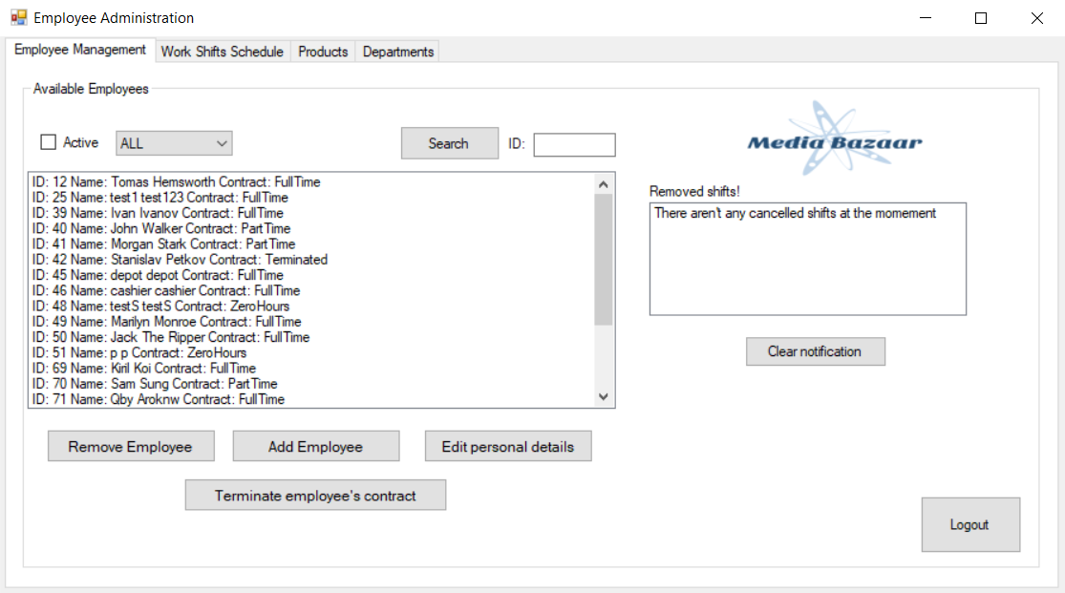

Functionality of this page:

1. User (administrator) can add new employees to department by clicking the “Add Employee” button, when this button is clicked a new register form (shown below) would pop-up, where the user should fill in all of the required information about an employee and again press the add button in the new form to store this information in the system.
2. A function where the user can search for specific employee by his ID, also user can find a drop-down list (that indicate “All”) which would display all the employees in the company in the list area as shown above. It’s also possible to view employees by selecting a department through drop-down list.
3. User can remove employees by selecting them from the list and press button which says, “Remove Employee”.
4. By pressing the “Cancel employee’s contract” button, a new form is open, where the administrator selects last working day of selected employee and fills in a reason for cancelation of employee’s contract. After that a button “Done” is pressed, which indicates that the employee is no longer part of the company. (The form can be found below.)
5. User can find list of cancelled work shift schedule.
6. User can log out by pressing the “Log out” button.

#### 4.1.1.1.2 Cancelation of employee’s contract form

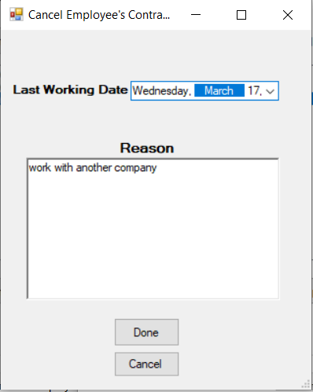

Functionality of this page:

* + - * 1. Administrator selects last date of employees contract and enters a reason for departure of selected employee. After that the “Done” button is pressed and the employee is no longer part of the company.
        2. Administrator can cancel this action by pressing cancel button.

### 4.1.1.1.3 Register employee page

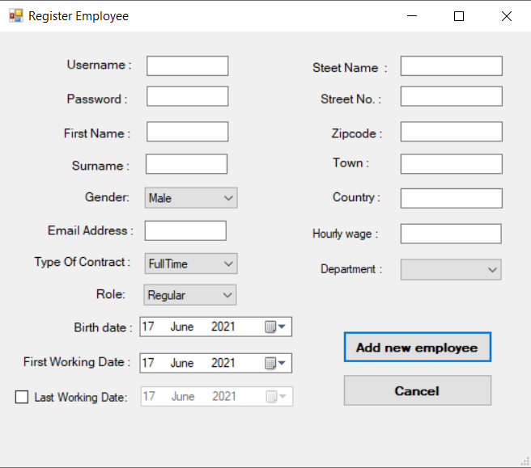

Functionality of this page:

1. This page is opened when an administrator wants to add a new employee to the system. He is required to fill in all of the fields shown above, after a successful input of all of the information about an employee, the “Add” button is clicked and a new employee is added. If there is a field with a wrong input, the field/s with invalid information must be filled again.
2. Administrator can cancel this action by pressing cancel button.
3. If the user wanted to set the last working date, he needs to check the box “Last Working Date” first.

### 4.1.1.1.4 Edit employee’s personal information page

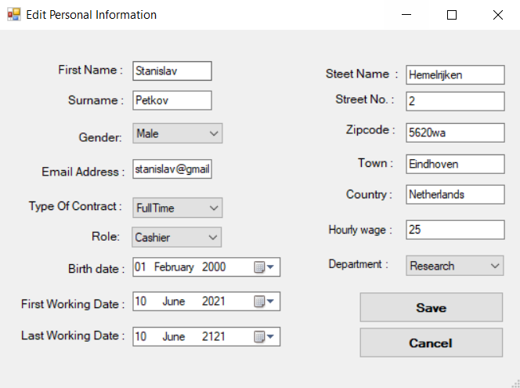

Functionality of this page:

1. In this form the administrator can edit all of the employee’s data except his username and password, but last working date need to be filled in. The new details are saved by pressing the “Save” button.
2. The administrator can cancel this process and exit the form by pressing the “Cancel” button.

### 4.1.2 Work shifts schedule page.

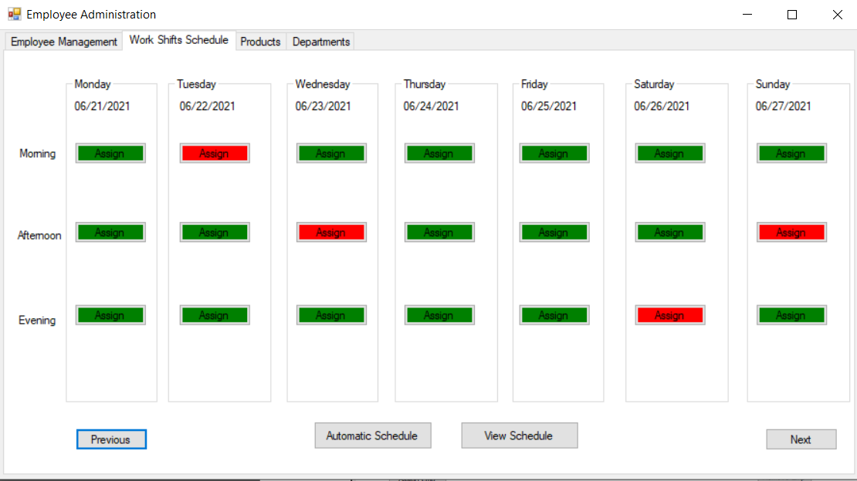

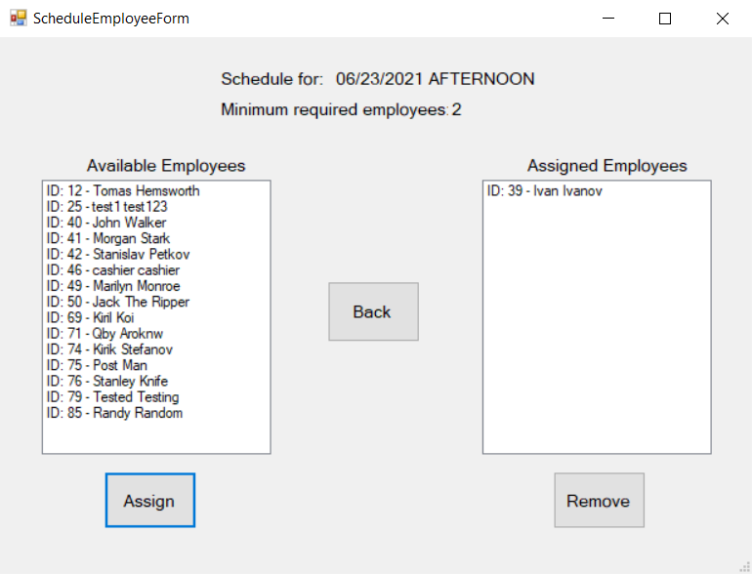

Functionality of this page:

1. In this page the user can choose available date to assign employees in work shifts (red color means more employees needed and the green means sufficient) by pressing a “Assign” button which indicate date, period and the day.

There are three types of shifts:

* Morning shift: from 7 am to 3 pm.
* Afternoon shift: from 3 pm to 11 pm.
* Night shift: from 11pm to 7 am.

1. After pressing the button, user need to select an employee and press “Assign” button then the employee with the work shift will be added in the list area.
2. The user can also click on the Automatic Schedule button to assign all unassign employees to a work shift.
3. The user can also cancel an employee’s work shift by selecting the date of the shift in the calendar and then clicking on the one assigned to the employee in the list with current shifts. After that the button “Remove shift” should be clicked and the selected shift will be removed from the schedule.

### 4.1.3 Product Management page

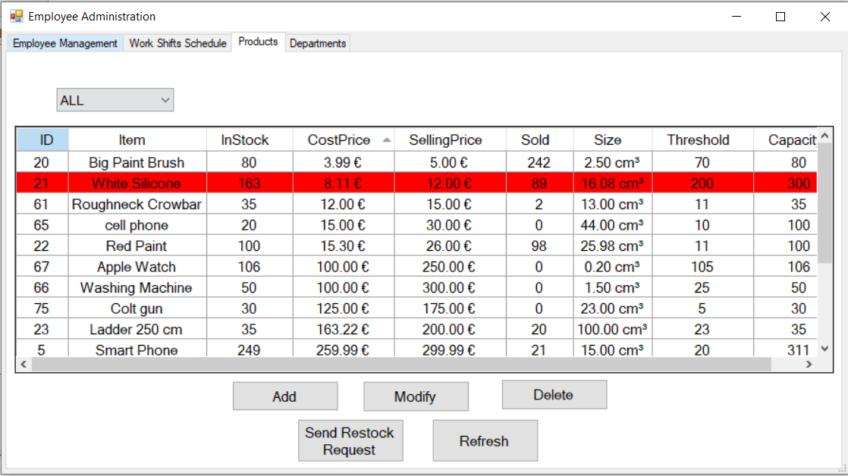

The Product Management page can be found on the third tab in the Administrator Form. The User (Admin) can Add, View, Remove and Modify products in the Product Management Form.

Products that went below certain threshold are colored with red to notify the user.

#### 4.1.3.1 Adding product form

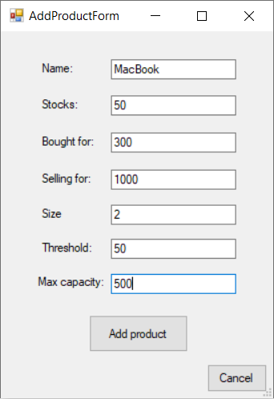

By clicking the button “Add” on the Product Management form the Add Product form pop out and lets the user add a product to the system. User doesn’t have accesses to add a product to the system without filling all the necessary detail needed. After all the spaces are filled with the necessary data the user clicks the button “Add” on the Add Product Form to save the product, else the user clicks the “Cancel” button to cancel the process and get back to product management form.

#### 4.1.3.2 Modify Product Form

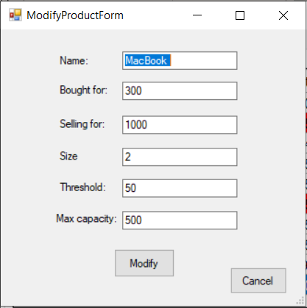

The User selects the product by clicking the row of it on the table and then clicks on the “Modify” button on the Product Management Form to open the Modify Product Form. The user is given the opportunity to modify one or multiple product data. When the user is done with editing the necessary data on a product the “Modify” button on the Modify Product Form is necessary to be click so the changes can be saved, else the user clicks the “Cancel” button so the action can be canceled.

#### 4.1.3.3 Product Management – Remove Product

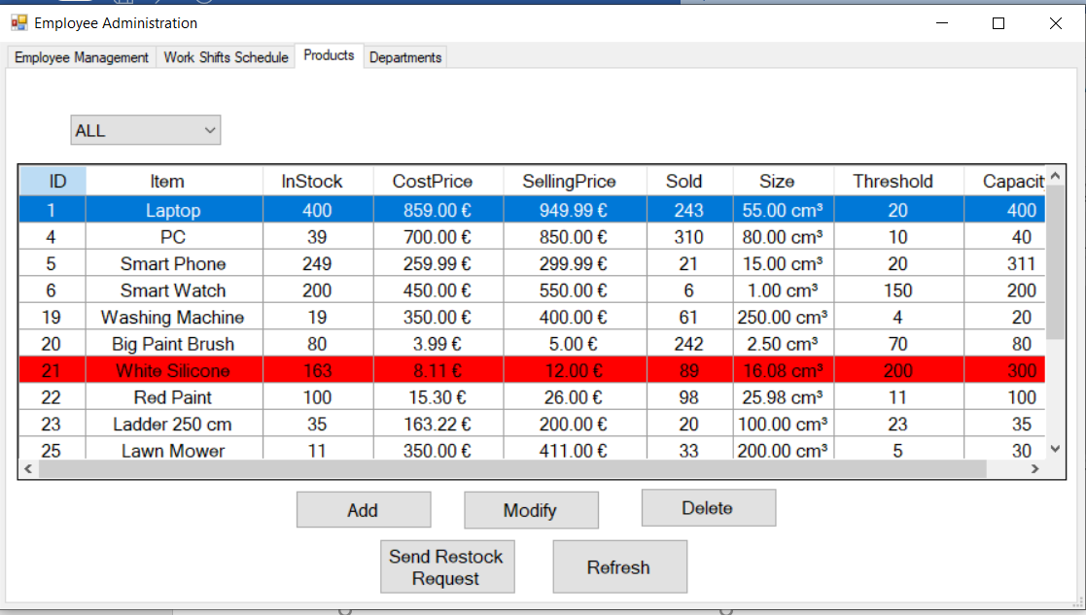

To remove a product from the system the user must selects the product by clicking the row of it on the table and then by clicking the “Delete” button on the Product Management Form a message will pop confirming the product deletion.

## 4.2 Manager Form

### 4.2.1 Statistics page

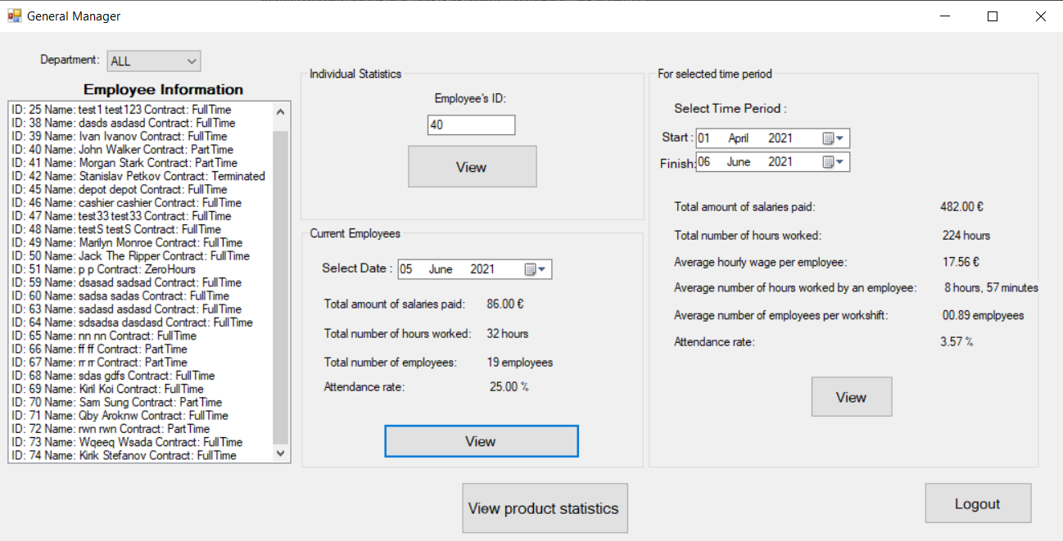In this page, User (manager) can view statistics of employees. For instance:

1. In the section which indicates “Individual Statistics”, the manager can search for a specific employee by filling in his ID and pressing the “View” button. After that a window will pop with various statistic will be shown about the selected employee including his work shift attendance. The ID field will be automatically filled, if the user selects and employee from the list on the left side as well.

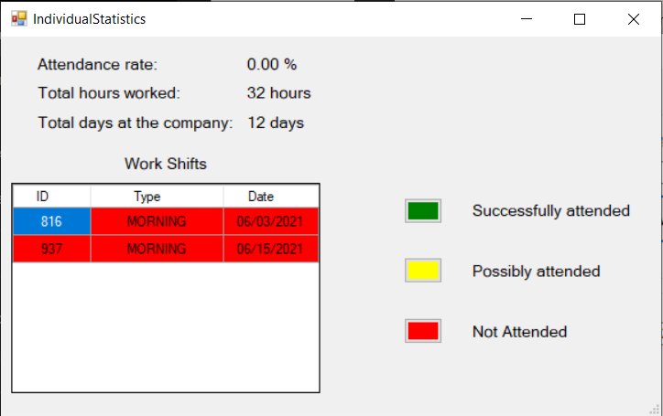

1. In the “Current Employees” section, the manager can select a Date and view the required statistics for that specific date by pressing buttons which indicate them.
2. In the “For specific time period” section, manager can specify the time period by fill in start and finish dates and press show button to view all the statistics for that specific period.
3. Pressing the “View product statistics” button will display the following form:

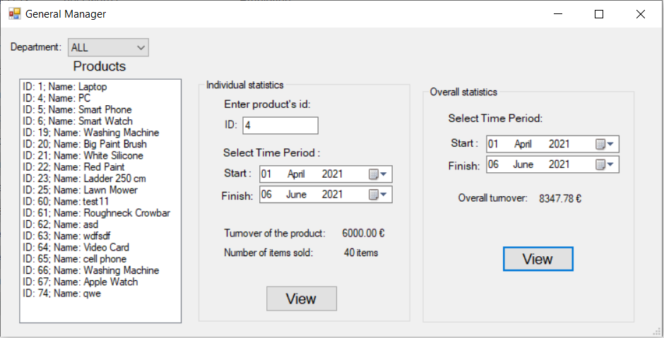

* 1. In this form, the user can either select a product from the left side or enter and ID manually and check what’s the profit made off this product and how items of this product have been sold during a selected time period.
  2. By selecting a department on the combo box above the product list it will display app the products that are based in the selected department.
  3. User can also select a time period to view what’s the total amount of profit for this period on the right side of the form.

In addition to that, the manager can log out from this form by pressing the “Log out” button and by pressing the “Show all employees” button, all of the current employees are displayed in the list above the button.

## 4.3 Login Form

Functionality of this page:

Here the user needs to enter username and password to be able login. If the user logged in as a Manager, Manger form will be shown and if the user is logged as an administrator, he will be able to see the Employee Administration form.

Addition to that, user can find exit button to close login form and the system.

## 4.4 Cashier Form

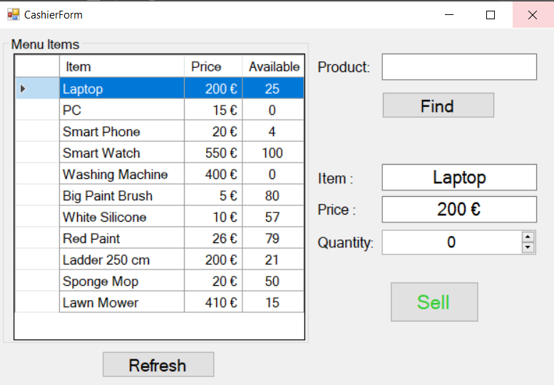

Functionality of this page:

1.The user (Cashier) must select the product on the table to display it on the sell panel.

2. Or the user can type the name of the product to display it on the sell panel. If the user types the name of the product wrong a message will pop alerting the user that there is no such product in the system.

3.Before selling the product the user must select the quantity of the product. If the user tries to sell a higher quantity of the selected product that is owned at the moment an error message will pop indicating that there isn’t enough stock of the selected item to sell.

## 4.5 Depot Form

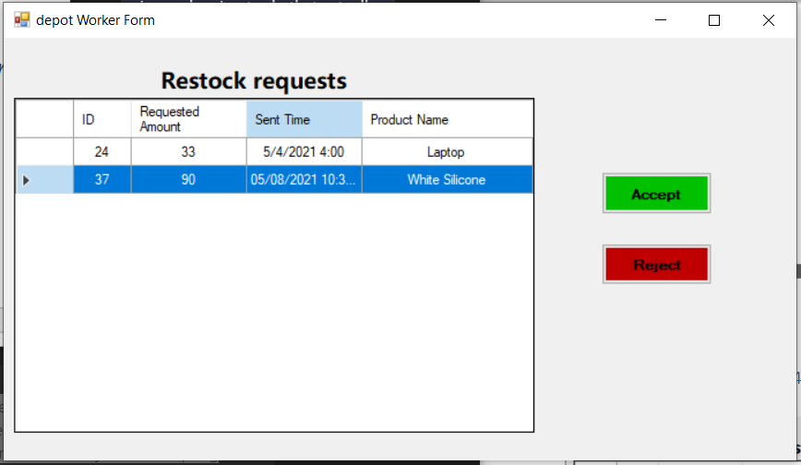

Functionality of this page:

When a product stock ends lower than the given threshold the system automatically sends a request to the Depot Form for a restock. The depot worker needs to select a restock request from the table, then he/she is given two options to Accept or Reject the request. When a request is accepted, the product amount in stock is increased by the requested amount.

## 4.6 Department Form

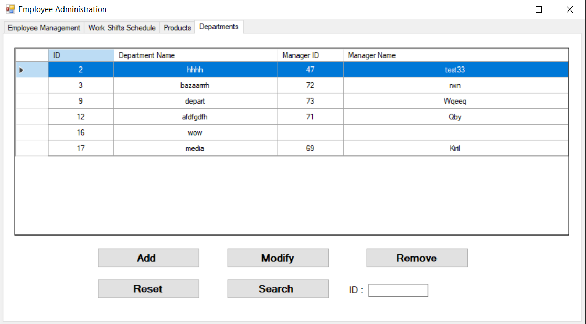

The Department Management page can be found on the fourth tab in the Administrator Form. The User (Admin) can Add, Remove and Modify departments in the Department Management Form.

4.6.1 Adding a department

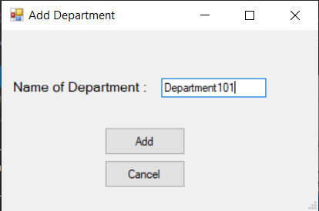

By clicking the “Add” button on the Department Manager on the Administrator Form a window will pop up where the User (Admin) can add a Department.

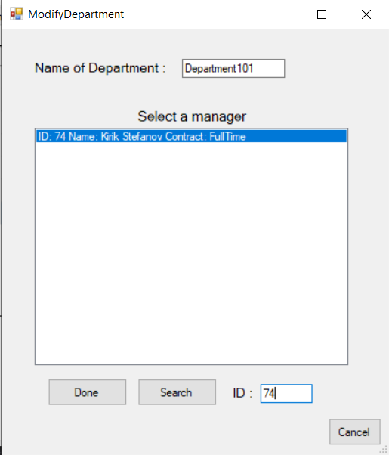4.6.2 Modifying a department

To modify a department the User must select an department and click the “Modify” button where there a “ModifyDepartment” window will pop up.

The user will find himself in front of a list with all of the assign employees in this department. The user must select an employee to make him or her a manager of the department by selecting the employee and after that clicking on the “Done” button to complete the action. If the user is looking for one particular employee to be the department manager, he can type his or her ID on the search bar.

# 5. Website

## 5.1 Home page

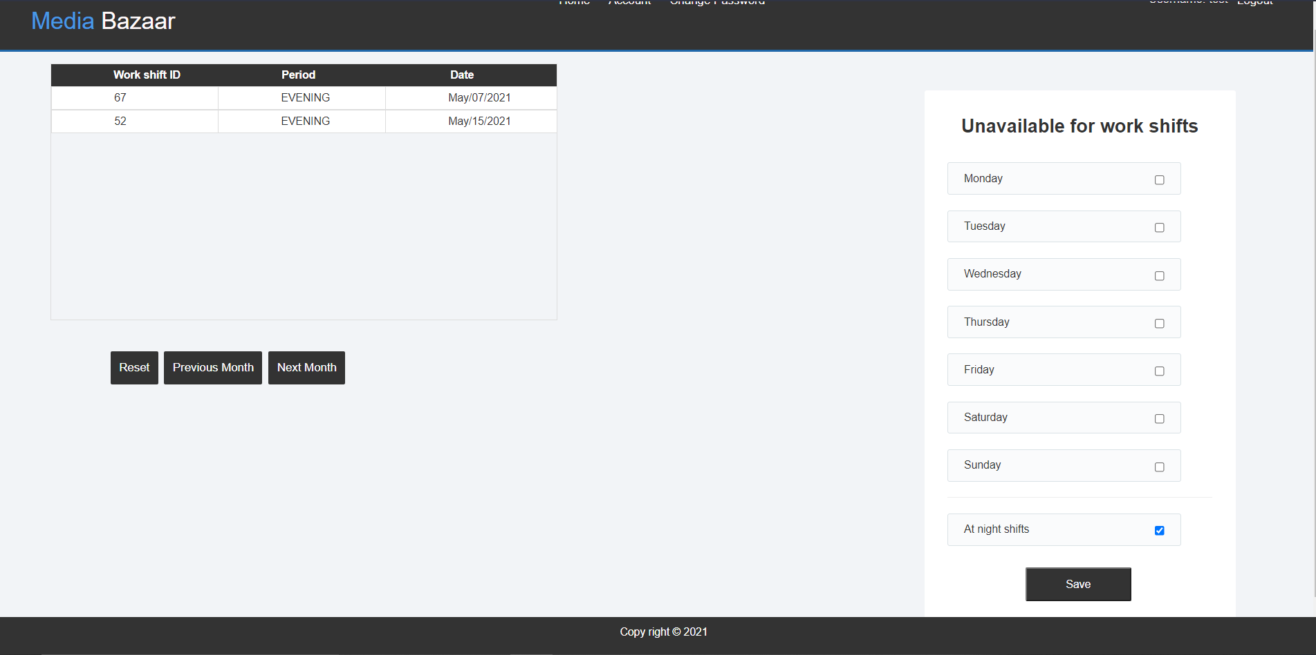

Home page is where users can view the work shifts schedule (it’s also possible to view the work shifts of previous month/next month by pressing the button that indicates it) and edit their unavailability for work shift through the checkboxes to indicate whether an employee is available on these days of the week.

## 5.2 Account Page

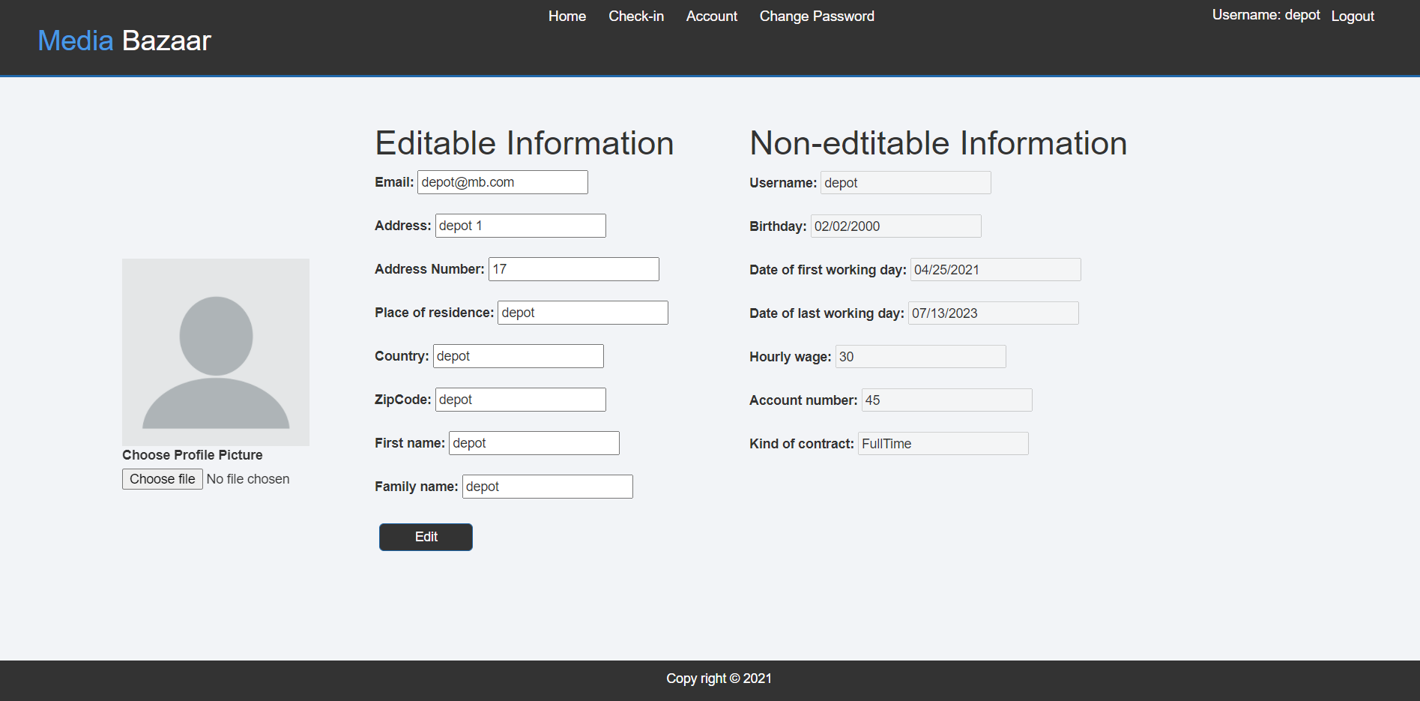

Account page is where the user can see and edit his personal information and set profile picture.

## 5.3 “Change password” page

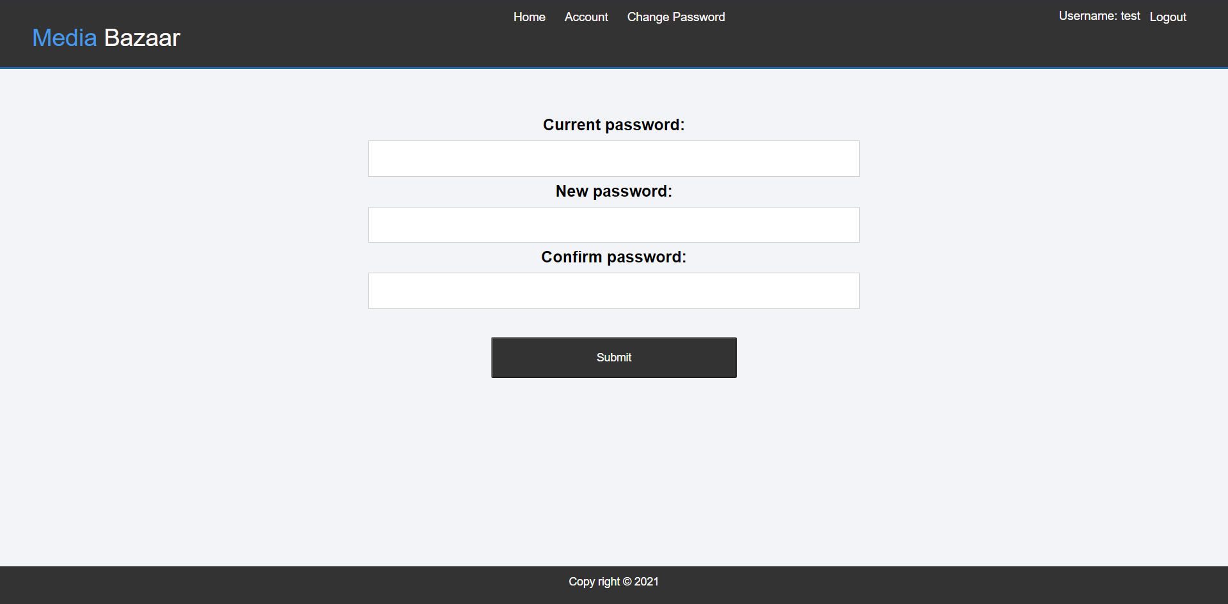

Change password page is where the user can change his password by setting first the current password, then set the new password that an employee prefer.

## 5.4 “First time login” page

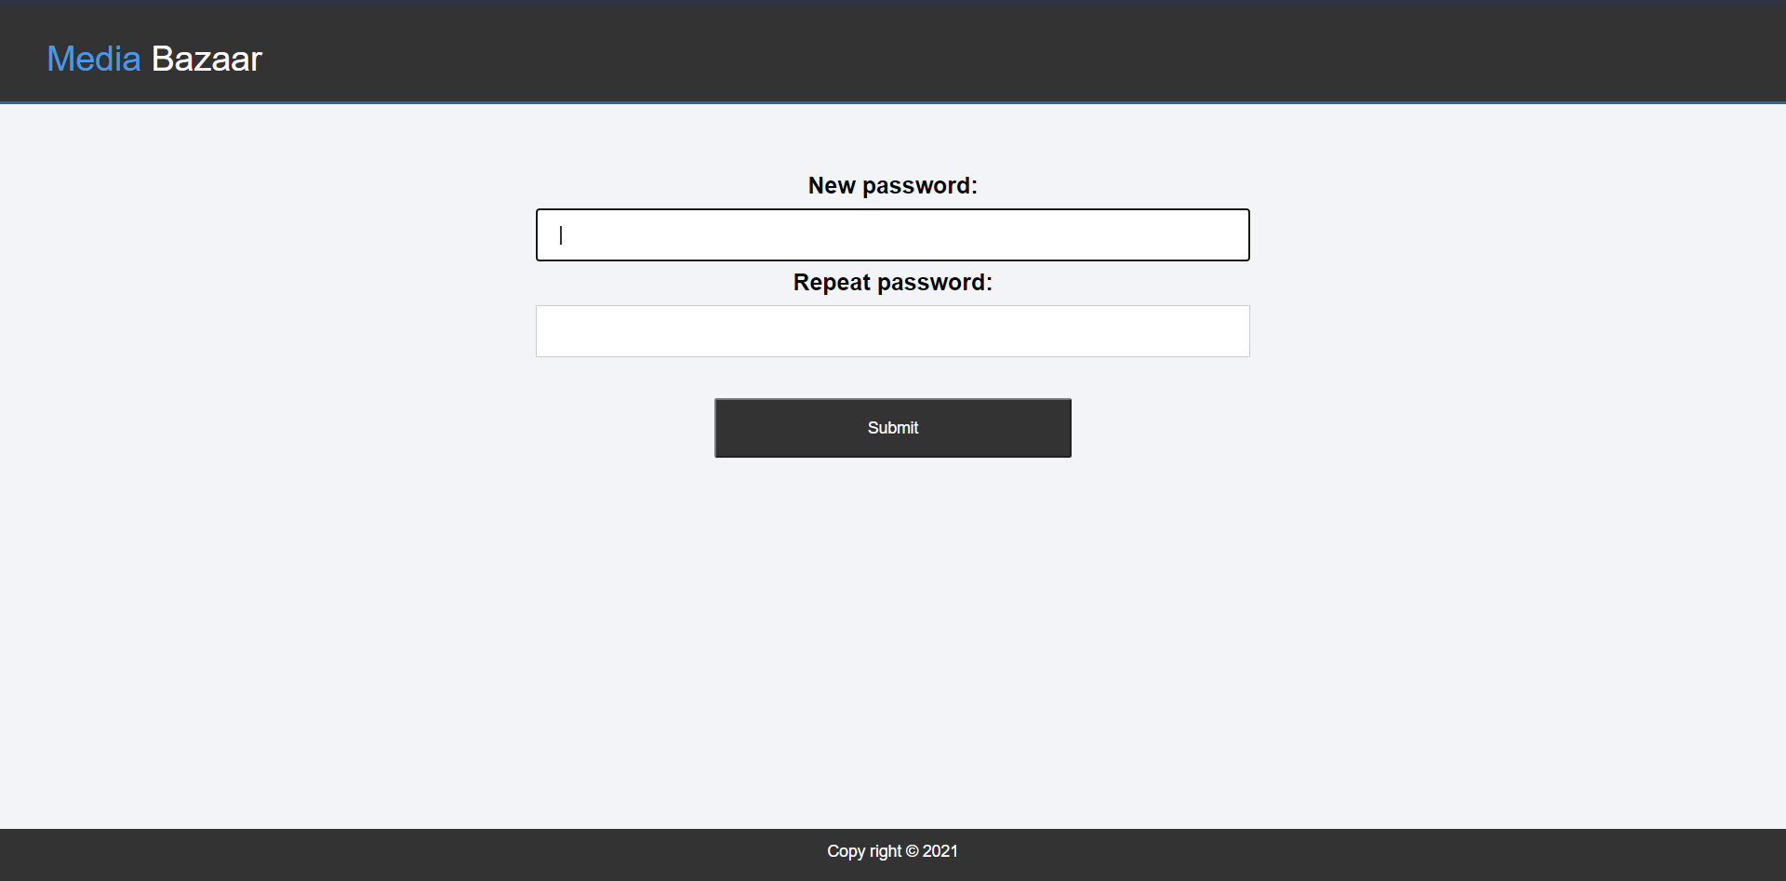

First time login page is when the user logs in for the first time and is given a mandatory request to change his password. User can’t exit this page until he has entered a new password.

## 5.1.5 Login page

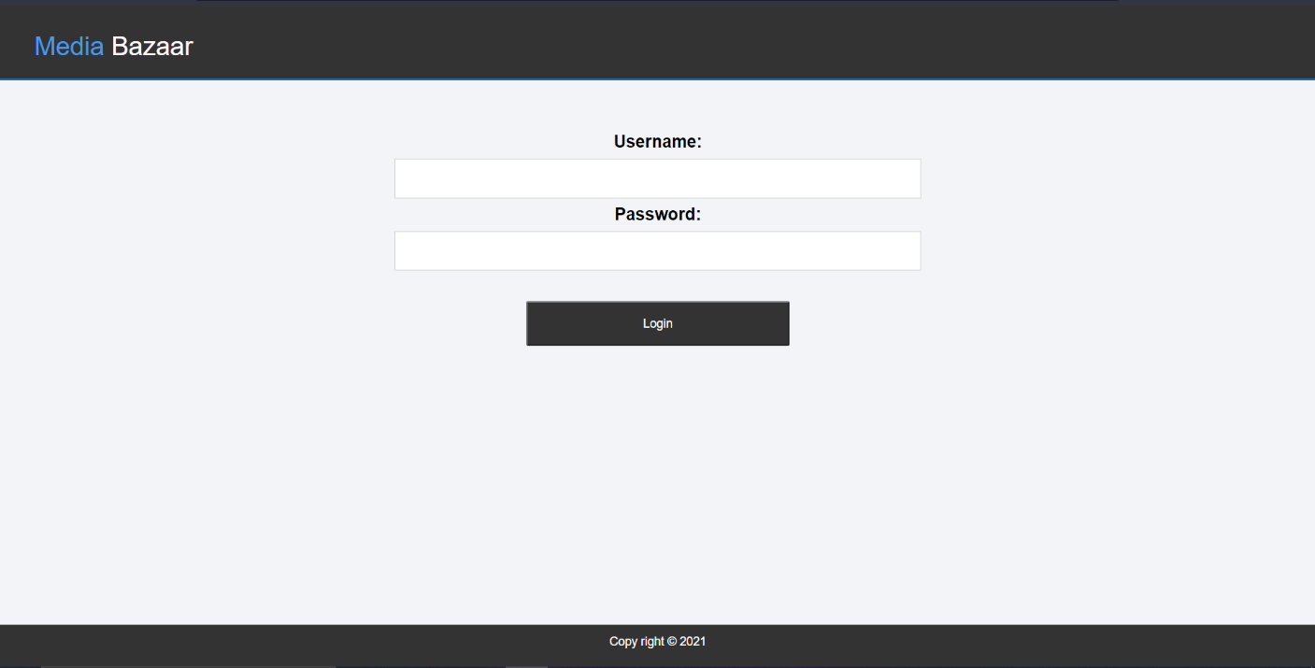

Log in page is where the user needs to insert username and password to login, in order to get access to the site’s features.

## 5.1.6 Check-in/ Call Sick page

Check-in page can be found on the navigation bar. The Check-in is where the employee can check-in on the current workday and check-out after the workday so the manager can view the attendance rate for specific employee or for all of the employees.

Call sick button is use when an employee is sick and though the Call Sick feature, he can indicate that he won’t be available to join work.

