User Requirements

Specification

# 1. Introduction:

Date: 16/1/2022 Location: MS Teams

Members:

* Rawan Alhabsi
* Stefan Popescu
* Anna Kowalewska
* Hristo Tanchev

Tutor: Georgiana Manolache

# 2. Revision table:

|  |  |  |  |
| --- | --- | --- | --- |
| Version/ Status | Description | Author | Date |
| 0.1 | Started the URS | Stefan Popescu, Rawan  Alhabsi, Anna  Kowalewska, Hristo  Tanchev | 09/09/2021 |
| 0.2 | Updating GUI C# Application |  | 12/10/2021 |
| 0.3 | Update after the first iteration phase |  | 21/11/2021 |
| 0.4 | Updating User Cases  Adding new screenshots of GUI |  | 16/01/2022 |

Table of Contents

1. Introduction: 1

2. Revision table: 2

3. Agreements with client: 3

4.Function Requirements 4

4.1 C# application – HR Manager 4

4.3 Website – Employees 6

5. Non-Functional requirements 9

6. Use cases: 9

7. GUI C# Application .................................................................................................................................. 19

# 3. Agreements with client:

* Agreed to schedule meeting on site based on the client’s program

The project is going to have 3 phases but the one we are going to focus on is the first one:

* The first phase has to be focused on:
* Delivering an URS document containing a revision table, a table of contents, agreements with client section, functional requirements, use cases, and also a GUI
* Coming up with a logo and also a team name
* The start of coding for an intermediate version
* Focus on delivering the add/remove (but still keeping his old data)/update employee function and schedule(assign/edit/view) of the employees and also see the statistics of the employees

-The 2nd phase will be divided in multiple Iterations starting with the first one we decided to focus on:

-Creating a website available for the employees working for Media bazaar -The website should present the following features: login, see schedule, statistics and the feature to edit information about employees (name, phone number, address) -In the 2nd iteration we decided to focus on:

-Creating the product management system that presents the following features:

add/view/edit/remove products, see stocks, add stock requests, sell products -Creating the form for the deport workers in which they will see the stock requests and either approve or deny them, moreover they can see the stock request history.

-A 2nd version of the website in which the employee can say when they are not available

-In the 3rd iteration we decided to focus on:

-Developing an automated scheduling system that will take into account different parameters such as: contract type, days off

-Creating the department management system in which the admin can create/view/edit/remove departments and also assign employees to it.

# 4.Function Requirements

### 4.1 C# application – HR Manager

|  |  |  |  |
| --- | --- | --- | --- |
| FR | | Priority (MSCW) | |
| FR-01: User must be able to manually assign work shifts for each of the employees. | | M | |
| FR-02 User must be able to auto assign all of the unassigned employees to a work shift | | M | |
| FR-03: User must be able to unassign work shifts for an employee. | | M | |
| FR-04: User must be able to display all of the employees’ work shifts in a calendar. | | M | |
| FR-05: User must be able to store data about the employees into the system:  -First name; Last name; Gender; Birth date; Username; Password; Email address; Contract type; First working date; Address; Hourly wage; Last working day; Department | | M | |
| FR-06: User should be able to edit data about the employees. | | S | |
| FR-07: User must be able to remove employees from the company’s system. | | M | |
| FR-08: User should be able to hire employees ahead of time. | | S | |
| FR-09: User should be able to indicate that an employee is no longer part of the company. | | S | |
| FR-10: User must be able to view the list of employees and search for individuals by ID. | | M | |
| FR-11: User must be able to log in. | | M | |
| FR-12: User must be able to log out. | | M | |
| FR-13: User must be able to add a department. | | M | |
| FR-14: User must be able to remove a department. | | M | |
| FR-15: User must be able to modify department. | | M | |
| FR-16: User must be able to search a department by ID. | | C | |
| FR-17: User must be able to view active employees in a selected department. | | M | |
| FR-18: User must be able to view all employees on a selected department. | | M | |
| FR-19: User must be able to add a department manager to the Department. | | M | |
| FR-20: User must be able to view departments | | M | |

### 4.3 Website – Employees

|  |  |
| --- | --- |
| FR-30: User must be able to log in. | M |
| FR-31: User must be able to log out. | M |
| FR-32: When a user logs in for the first time, he/she should be greeted with a mandatory request to change his/her password. | M |
| FR-33: User must change his/her password through the request when first log in. | M |
| FR-34: Employee will be able to change his/her Family name through the website. | M |
| FR-35: Employee will be able to change his/her Password through the website. | M |
| FR-36: Employee will be able to change his/her Address through the website. | M |
| FR-37: Employee will be able to change his/her Profile Picture through the website. | C |
| FR-38: User must be able to view his work-schedule. | M |
| FR-39: An employee can indicate a non-preferable working days. | S |
| FR-40: An employee can indicate that she/he doesn’t prefer to on a night shift. | S |
| FR-41: Employee can Check-in when his work shift begins | M |
| FR-42: Employee can Check-out at the end of his work shift | M |
| FR-43: Employee can call in sick | M |
| FR-44: Employee can upload a profile picture | C |

4.4 C# Application – Product Management

|  |  |
| --- | --- |
| FR-45: User must be able to store new product info to the system:   * price( for buying and selling) * brand * description * measurements * size (for stock purposes- small, medium, big) | M |
| FR-46: After the user enters the data about the product the products should be stored on a selected shelf by the user | M |
| FR-47: User must be able to view the products and the data of the products. | M |
| FR- 48: User must be able to select a product from the table. | S |
| FR-49: User must be able to remove a product form the form system. | W |
| FR-50: User must be able to modify a product and its details. | S |
| FR- 51: User must be able to View Restock Requests | M |
| FR- 52: User must be able to accept restock request | M |
| FR-53: User must be able to Reject Restock Request | S |

4.5 C# Application – Store Management

|  |  |
| --- | --- |
| FR-54: User must be able to create a shelf | S |
| FR-55: User must be able to View shelf | M |
| FR-56: User must be able to Add products to shelf | M |

4.6 C# Application – Depot Form

|  |  |
| --- | --- |
| FR-57: User must be able to select a restock request. | M |
| FR-58: User must be able to accept the selected restock request. | M |
| FR-59: User must be able to reject the selected restock request. | M |

4.7 C# Application – Store Manager Form

|  |  |
| --- | --- |
| FR- 60: User must be able to add a shelf to the system. | M |
| FR-61: User must be able to remove shelfs from the system | C |
| FR-62: User must be able to edit a selected shelf | S |
| FR-63: User must be able to view a list of all of the shelfs in the system. | M |

## 5. Non-Functional requirements

* The Program can be extended in the future. The code is maintainable and readable, which allows future developers to easily understand how the application works and allows them to add new features without having to communicate with the previous developers.
* The program is reliable, which means the state of the application is going to be stable and will not have frequent crashes. This can be achieved by writing a high-quality code, which can avoid many of the errors a program can usually encounter while running. Proper error-handling will be implemented as well as different object-oriented concepts such as inheritance, interfaces and others.

# 6. Use cases:

1. Logging in

|  |  |
| --- | --- |
| Description | User attempts to log in into the application. |
| Actors | HR Manager, Products Manager, Store Manager, General Manager. |
| Precondition | User must be an employee of Media Bazaar. |
| Trigger | User opens the application. |
| Normal flow | 1. User enters username and password. 2. User’s credentials are approved by the system. 3. System checks what type of user they are. 4. System displays a view based on the user’s type. |
| Alt. flow | 2.a) User’s credentials are not recognized by the system.  − System displays an error message.  − Return to step 1. |

1. Adding employee

|  |  |
| --- | --- |
| Description | HR hires a new employee and must add them to the system. |
| Actors | HR Manager. |
| Precondition | User is logged in as a HR Manager and is viewing the add employees’ section. |
| Trigger | User intends on creating new entry in the employee management window. |
| Normal flow | 1) User introduces all requested data in the form. 2) User presses the “add” button. |
|  | 1. System asks for confirmation. 2. User confirms by clicking the “yes” button. 3. System stores new data and shows a success message. |
| Alt. flow | 2.a) System declines the data.  − System displays an error message. − Return to step 1.  4.a) User clicks “no”.  − Return to step 1. |

1. Removing employee

|  |  |
| --- | --- |
| Description | HR has to remove an employee from the system. |
| Actors | HR Manager. |
| Precondition | User is logged in as a HR Manager and is viewing the employees’ section. |
| Normal flow | 1. User selects the required employee from the list. 2. System highlights the selected employee. 3. User clicks the “remove” button. 4. System asks for confirmation. 5. User confirms by clicking the “yes” button. 6. System removes the data and shows a success message. |
| Alt. flow | 5.a) User clicks “no”. − Return to step 1. |

1. Editing employee information

|  |  |
| --- | --- |
| Description | User wishes to edit information of a specific user. |
| Actors | HR Manager. |
| Precondition | User is logged in as a HR Manager and is viewing the employees’ section. |
| Normal flow | 1. User selects the employee from the list. 2. System highlights the selected employee. 3. User modifies desired data. 4. User clicks the “save” button. 5. System saves the data and shows a success message. |
| Alt. flow | 5.a) System shows an error message because of wrong data. − Return to step 3. |

1. Assigning shifts

|  |  |
| --- | --- |
| Description | User wishes to create the weekly schedule. |
| Actors | HR Manager. |
| Precondition | User is logged in as a HR Manager and is accessing the shifts section. |
| Normal flow | 1. User selects desired day. 2. User selects a desired working-shift. 3. System opens a tab containing all available employees. 4. User selects the desired employee and assigns them. 5. System asks for confirmation. 6. User confirms by clicking the “yes” button. 7. System completes and shows a success message. |
| Alt. flow | 6.a) User clicks “no”. − End of use case. |

1. Removing shifts

|  |  |
| --- | --- |
| Description | User wishes to remove specific shifts. |
| Actors | HR Manager. |
| Precondition | User is logged in as a HR worker and is accessing the shifts section. |
| Normal flow | 1. User selects the desired date. 2. User selects the employee. 3. User clicks the “remove” button. 4. System asks for confirmation. 5. User confirms by clicking the “yes” button. 6. System completes and shows a success message. |
| Alt. flow | 1.a) User selects a date which has no employee assigned to it.  − Return to step 1.  3.a) User doesn’t select the employee.  − Show error message and return to step 2.  5.a) User clicks “no”. − End of use case. |

1. Viewing shifts

|  |  |
| --- | --- |
| Description | User wishes to view the weekly schedule. |
| Actors | HR Manager. |
| Precondition | User is logged in as a HR Manager and is accessing the shifts section. |
| Normal flow | 1. User selects a date from the calendar. 2. System shows a new window with all shifts and assigned employees. |

1. Adding product

|  |  |
| --- | --- |
| Description | User wants to add a new product. |
| Actors | Product Manager. |
| Precondition | User is logged in as a Product Manager and is viewing the product management section. |
| Normal flow | 1. User fills in required data. 2. User clicks on “add product” button. 3. System registers a new product and shows a success message. |
| Alt. flow | 2.a) System declines the data.  − System displays an error message.  − Return to step 1. |

1. Editing product

|  |  |
| --- | --- |
| Description | User wants to edit a specific product. |
| Actors | Product Manager. |
| Precondition | User is logged in as a Product Manager and is viewing the product management section. |
| Normal flow | 1. User chooses the product. 2. System loads the current product data and shows it in separate fields. 3. User modifies desired data. 4. User clicks the “edit” button. 5. System saves changes and shows a success message. |
| Alt. flow | 4.a) System declines the data.  − System displays an error message.  − Return to step 1. |

1. Removing products

|  |  |
| --- | --- |
| Description | User wishes to remove specific product. |
| Actors | Product Manager. |
| Precondition | User is logged in as a Product Manager and is accessing the product management section. |
| Normal flow | 1. User selects the desired product. 2. User clicks the “delete” button. 3. System asks for confirmation. 4. User confirms by clicking the “yes” button. 5. System completes and shows a success message. |
| Alt. flow | 4.a) User clicks “no”. − End of use case. |

1. Viewing product stock

|  |  |
| --- | --- |
| Actors | Product Manager. |
| Precondition | User is logged in as a Product Manager and is accessing the product management section. |
| Normal flow | 1. User selects a date from the calendar 2. System shows a new window with all shifts and assigned employees. |

1. Making a stock request

|  |  |
| --- | --- |
| Actors | Product Manager. |
| Precondition | User is logged in as a Product Manager and is accessing the product management section. |
| Trigger | A product in the store must be supplemented. |
| Normal flow | 1. User makes a new stock request. 2. System opens a new form. 3. User enters the required details and confirms the request. 4. System sends request to the Stock Requests Form. |
| Alt. flow | 3.a) User does not provide information on name, quantity or department.  − System displays a message asking for filling in the required information.  − Return to step 4.  4.a) There is not enough stock in the depot.  − System displays a message with information that it is not possible due to the stock unavailability.  − Return to step 4. |

1. Accepting or denying a stock request

|  |  |
| --- | --- |
| Actors | Depot Worker. |
| Precondition | User is logged in as a depot worker and is viewing the Stock Requests Form. |
| Trigger | Product Manager sends a stock request. |
| Normal flow | 1. System loads all stock requests and displays them in the form. 2. User chooses ‘accept’ or ‘deny’ next to any of the stock requests. 3. System performs the requested action and updates the database and the application. |

1. Adding a department to the system

|  |  |
| --- | --- |
| Actors | HR Manager |
| Precondition | User is logged in as a HR Manager |
| Trigger | User is logged in as a HR Manager and is accessing the Department Management to add a department |
| Normal flow | 1. User should type a name of the new department. 2. User should pick a department manager from the drop-down menu. 3) User should click the button “Add Department” after filling all of the necessary inputs.   4) The system creates a department where it display on the date view grid. |

1. Removing a department from the system

|  |  |
| --- | --- |
| Actors | HR Manager |
| Precondition | User is logged in as HR Manager |
| Trigger | User is logged in as a HR Manager and is accessing the Department Management to remove a department |
| Normal flow | 1. User must select a department from the data grid view. 2. User must click on the “Remove Department” button. 3. The system sends a conformation massage if the user is sure if he/she wants to complete this action. 4. User clicks “Yes” and the system deletes the department. |
| Alt. flow | 4.a) User clicks “No” .  - The system cancels the deletion action of the department |

1. Editing a department in the system

|  |  |
| --- | --- |
| Actors | HR Manager |
| Precondition | User is logged in as a HR Manger |
| Trigger | User I logged in as HR Manger and accessing the Department Management to edit a department |
| Normal flow | 1. User must select a department from the data grid view. 2. The fields get fields with data and the user edits the field he/she wants to edit. 3. User click the “Edit department” button and gets a conformation massage that the department was successfully edited. |

1. Logging into the Employee web application

|  |  |
| --- | --- |
| Actors | Employee |
| Precondition | User must be an employee of Media Bazaar. |
| Trigger | User opens the web application. |
| Normal flow | 1)User enters username and password.  2)User’s credentials are approved by the system.  3) System redirects user to “Home” page. |
| Alt. flow | 2.a) User’s credentials are not recognized by the system.  − System displays an error message. − Return to step 1. |

1. Log out of web application

|  |  |
| --- | --- |
| Actors | Employee |
| Precondition | User must be logged in on the Employees website. |
| Normal flow | 1)User clicks the “Log out” button on the navigation bar.  2)System logs the user out.  3) User can no longer access the website (until they login). |

1. Terminate employee’s contract

|  |  |
| --- | --- |
| Actors | HR Manager. |
| Precondition | User is logged in as a HR Manager and is viewing the employees’ section. |
| Normal flow | 1. User selects the desired employee from the list. 2. System highlights the selected employee. 3. User clicks the “terminate contract” button. 4. System opens new tab. 5. User chooses the end date and enters a reason for terminating the contract. 6. System saves the information and marks the employee’s contract as terminated. |
| Alt. flow | 5.a) User does not provide own data.  − System sets the end date to the current day and departure reason to “Not given.”  − Continue to step 6. |

1. Search employee

|  |  |
| --- | --- |
| Actors | HR Manager. |
| Precondition | User is logged in as a HR Manager and is viewing the employees’ section. |
| Normal flow | 1. User enters any data in the search bar. 2. System checks the employees’ list for any matches. 3. Employee(s) having the matching data is displayed in the list. |
| Alt. flow | 3.a) No employee is matching the entered data. − List stays empty. |

1. View employees' statistics

|  |  |
| --- | --- |
| Actors | HR Manager. |
| Precondition | User is logged in as a HR Manager and is viewing the employees’ section. |
| Normal flow | 1) User clicks the “View statistics” button 2) System opens new form with tabs.  3) System loads the statistics charts one per each tab. |

1. View employee’s schedule in the web application

|  |  |
| --- | --- |
| Description | User wishes to view their schedule. |
| Actors | Employee |
| Precondition | User is logged in on the website. |
| Normal flow | 1. User navigates to the schedule page. 2. System displays user’s shifts for this month. |

1. Adding a product to a shelf (Moving from main depot to store shelf)

|  |  |
| --- | --- |
| Description | User wishes to add a product to a shelf |
| Actors | Employee |
| Precondition | User is logged in on the Store Manager Form |
| Normal flow | 1. User must select a Floor from the data grid for shelfs where he/she wants to move a product. 2. User must select the “Add product to shelf” button. 3. User is found on a new Form where the user can view all of the products from the main form and where the user can move products to the selected shelf. 4. User selects a product. 5. User sets a number of products the user wants to move to the selected shelf. 6. User clicks on the “Move product to shelf” button. 7. User is redirected back to the Store Manager Form where the user can view the added product to the selected shelf. |
| Alt. flow | 1a) User doesn’t select a shelf.  2) User must select the “Add product to shelf” button.  2a) User gets greeted by Massed displaying “User must select a shelf to proceed the action!” |
| Alt. flow 2 | 4a) User doesn’t select a product  6) User clicks on the “Move product to shelf” button.  6a) User gets greeted by Massed displaying “User must select a product to proceed the action!” |

1. Add a shelf to the system

|  |  |
| --- | --- |
| Description | User wishes to add a shelf to the system. |
| Actors | Employee |
| Precondition | User is logged in on the Store Manager Form. |
| Normal flow | 1. User select a Floor from the dropdown menu where the user wants to add a shelf. 2. User clicks “Add Shelf”. 3. Date grid gets updated and user can view the new shelf created in the system. |
| Alt. flow | 1a) User does not select a Floor from the dropdown menu where the user wants to add a shelf.  2) User clicks “Add shelf”.  2a) User gets a message displaying “User must select a floor where he wants to create”. |

1. User returns a product from shelf to the main depot.

|  |  |
| --- | --- |
| Description | User wishes to return shelf product to main depot. |
| Actors | Employee |
| Precondition | User is logged in on the Store manager form. |
| Normal flow | 1. User selects a shelf from the Data Grid. 2. User select a product from the list. 3. User clicks “Return Product” button. 4. List gets updated and user can view the selected product has despaired. |
| Alt. flow | 1a) User doesn’t select a shelf from Data Grid.  2a) User doesn’t select a product from the list.  3) User clicks “Return Product” button.  3a) User gets a message where is displayed “User Must select a shelf and a product to return” |

1. Accepting restock request through Depot Worker Form

|  |  |
| --- | --- |
| Description | Accepting restock request through Depot Worker Form |
| Actors | Employee |
| Precondition | User is logged in on the Store Manager Form. |
| Normal flow | 1) User navigates to the schedule page.  System displays user’s shifts for this month.  2) User clicks “Accept” button.  3) The selected restock request will be restocked.  4) User gets confirmation message the product has been restocked successfully. |

1. Rejecting restock request through Depot Worker Form

|  |  |
| --- | --- |
| Description | Rejecting restock request through Depot Worker Form |
| Actors | Employee |
| Precondition | User is logged in on the Store Manager Form. |
| Normal flow | 1) User navigates to the schedule page.  System displays user’s shifts for this month.  2) User clicks “Reject” button.  3) User gets confirmation message the product has not been restocked successfully. |

1. Viewing Employee Statistics

|  |  |
| --- | --- |
| Description | User wants to view employee statics |
| Actors | Employee |
| Precondition | User is logged in on the HR Form |
| Normal flow | 1. User clicks “View Statistics” located in the “Employee Manager” tab. 2. User gets redirected to a new for where he can view the employee statics |

1. Viewing Product Statistics

|  |  |
| --- | --- |
| Description | User wants to view product statics |
| Actors | Employee |
| Precondition | User is logged in on the Stock Manager Form |
| Normal flow | 1. User clicks “View Statistics” located in the “Stock Manager” tab. 2. User gets redirected to a new for where he can view the product statics |

Here the User is in the Log in form where he/she can log in as one of the many manager roles from the company.

7.

GU

I

C# Application

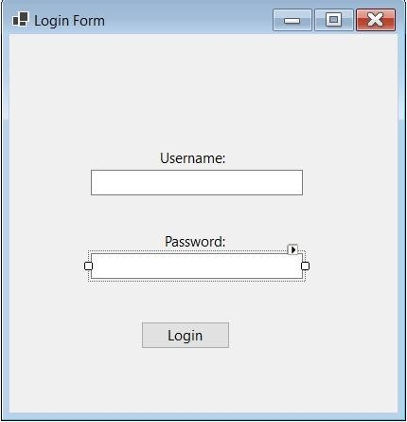

Here the User is in the Employee Manager Form where he/she has access to Create, Read,

Update, Delete (CRUD) functions. The user is also able to search and employee by providing any data in the search bar and view employees’ statistics form.

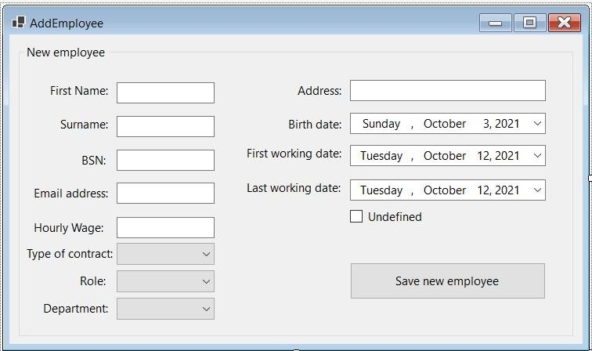This is the add employee form in which the admin can register an employee in the system

*The contract type is split in 2:

* Part time: 32 hours of work/week

* Full time: 40 hours of work/week

Here the User is in the Edit/Update Employee where the employee information can be changed. To get to this page the user must select an employee from the data grid in HR Manager and click the “Update” button.

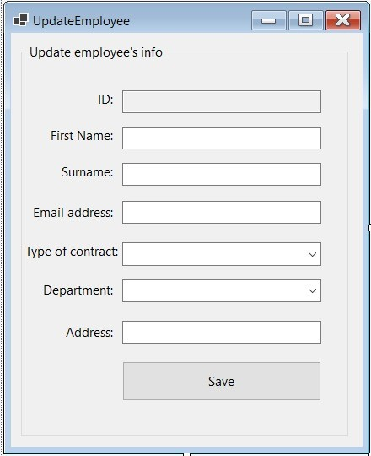

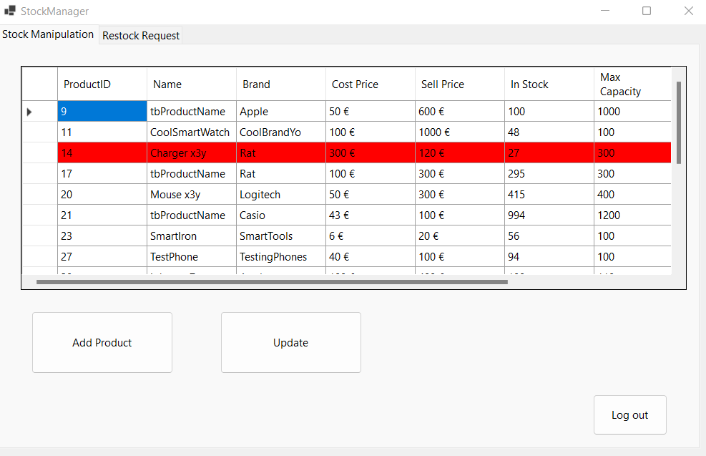

This is the Product Manager Form where the admin can manage products.

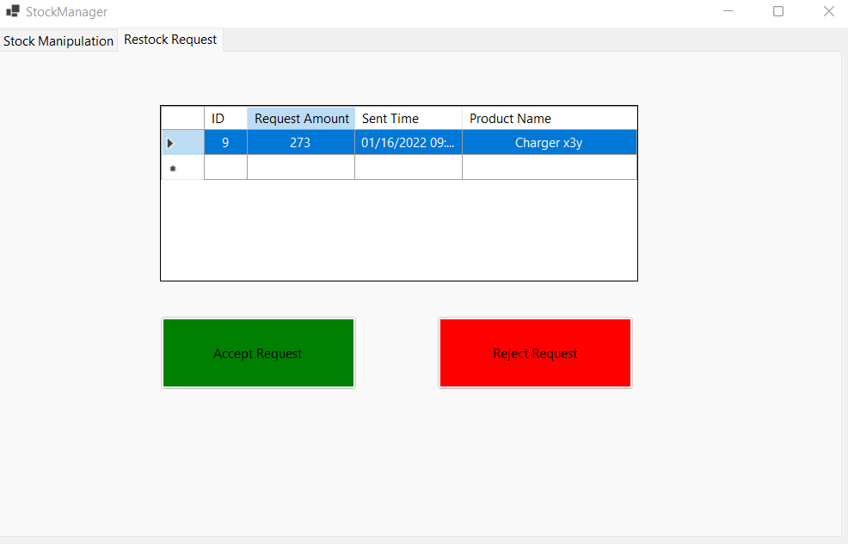

This is the other tab of the stock manager where the user can Accept or Reject restock requests.

Here the user can Add/Create a product to the system. To open this window the user must click the “Add” button.

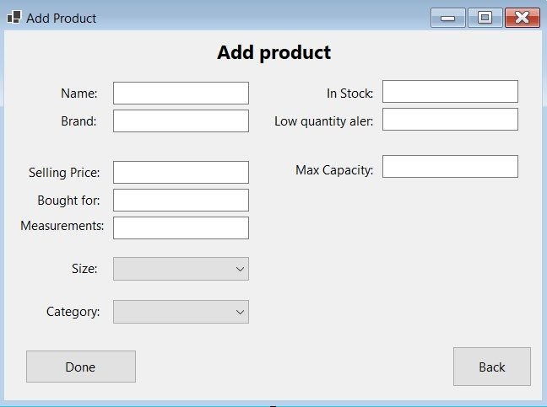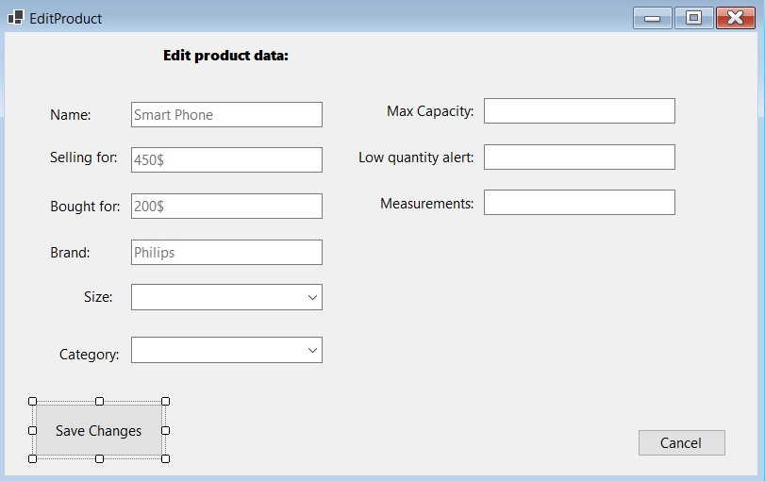

Here the user can Edit/Update a selected product. To open this window the user must select a product from the data grid and click the “Update” button.

“View” button.

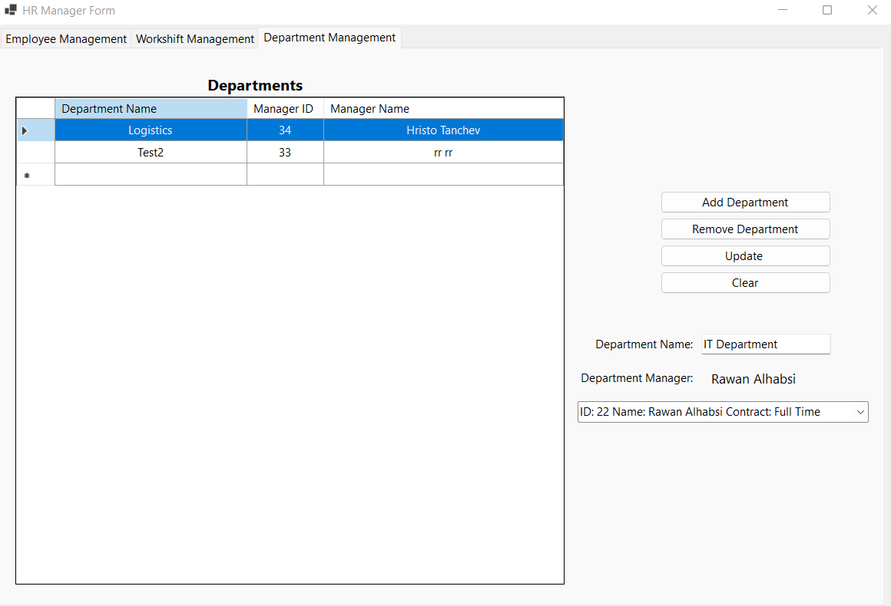

This is the department manager tab where the admin can Create, Read, Update, Delete (CRUD) departments.

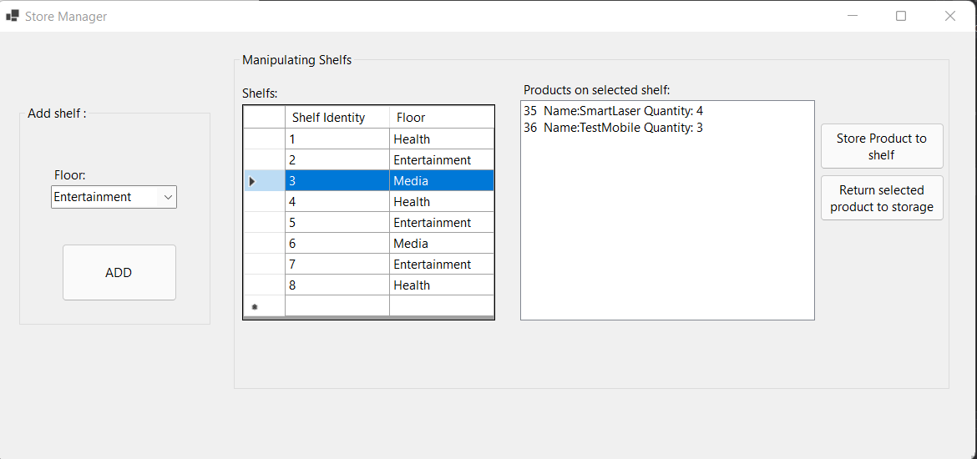

The Store Manager is the User that can manage the shelfs for the products in the system.

And where the user can move products to shelfs and request restocks.

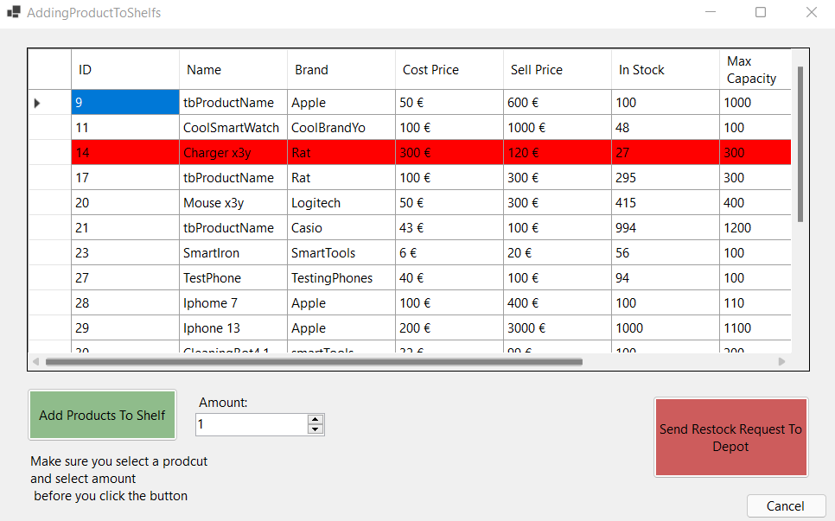

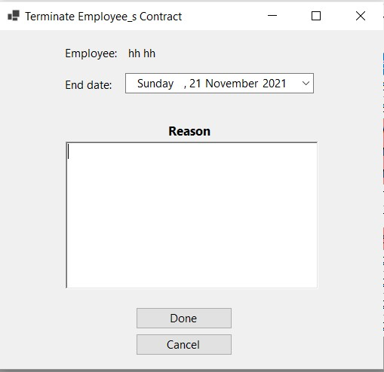User logged in as HR Manager can terminate employee’s contract. After performing that operation, the employee is shown in the list in red.

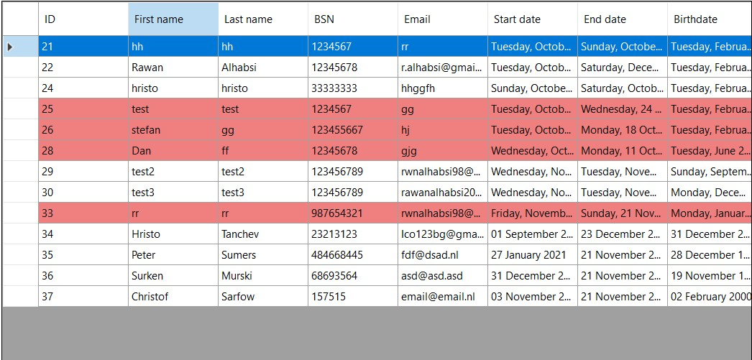

Here we can view some of the product statistics.

Here we can view some employee statistics from the Employee Manager Form.

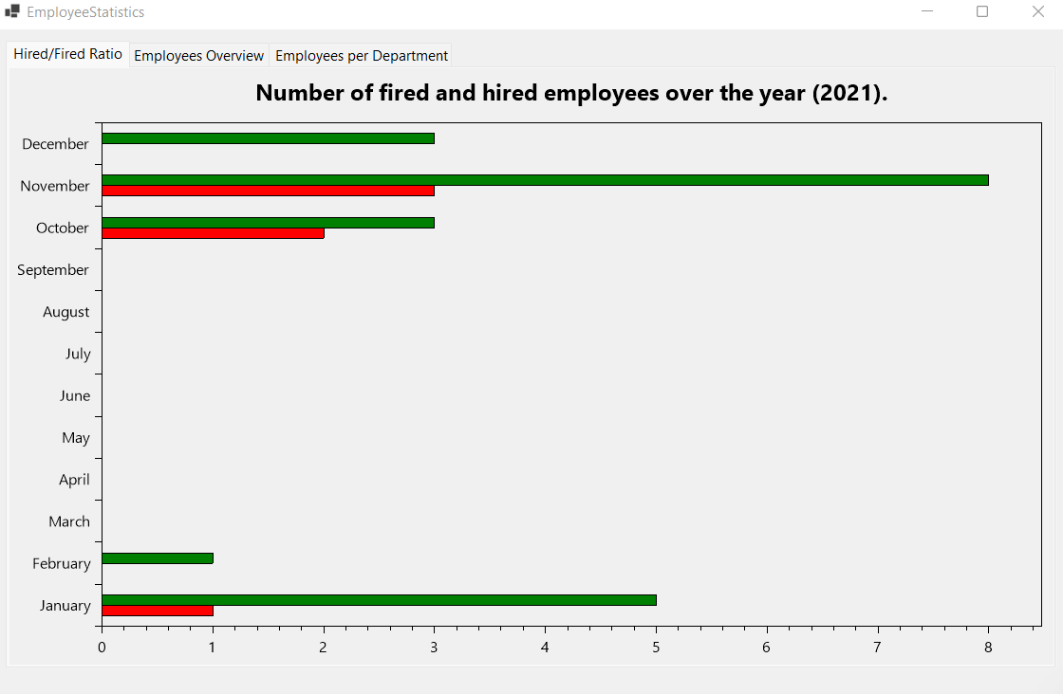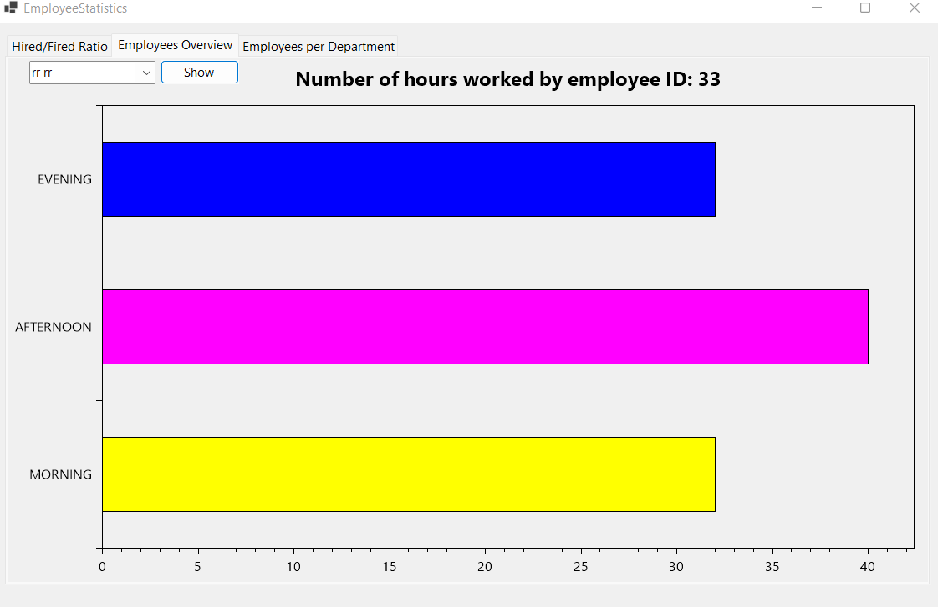

Here we can see the Employee Scheduler. Here the user can manually or automatically assign(one or all) employees. to a shift

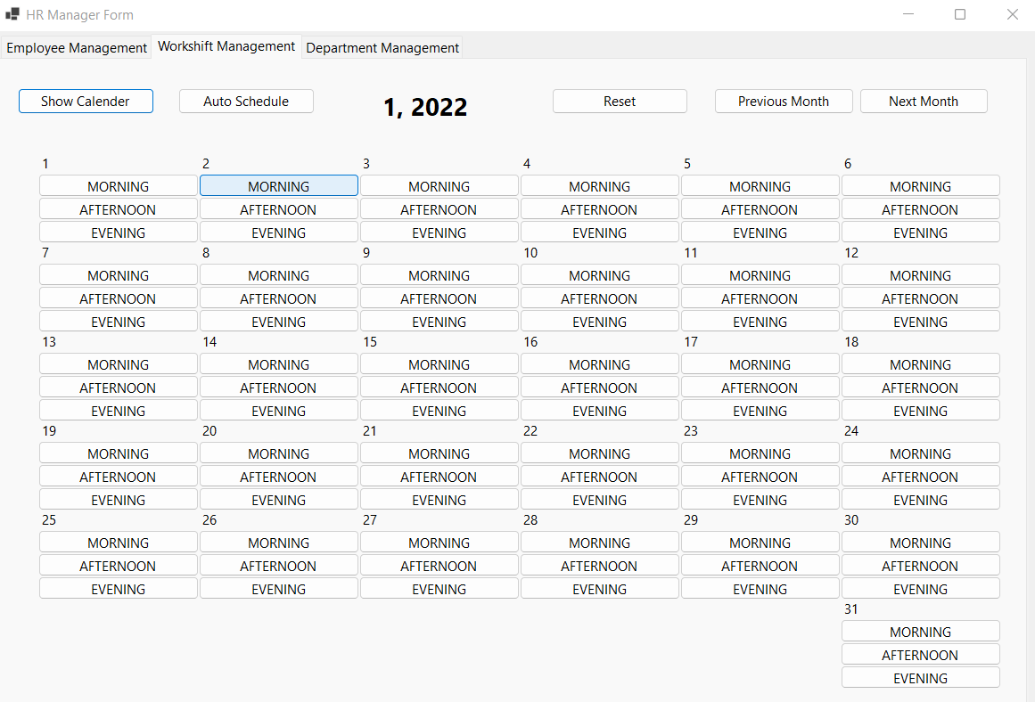

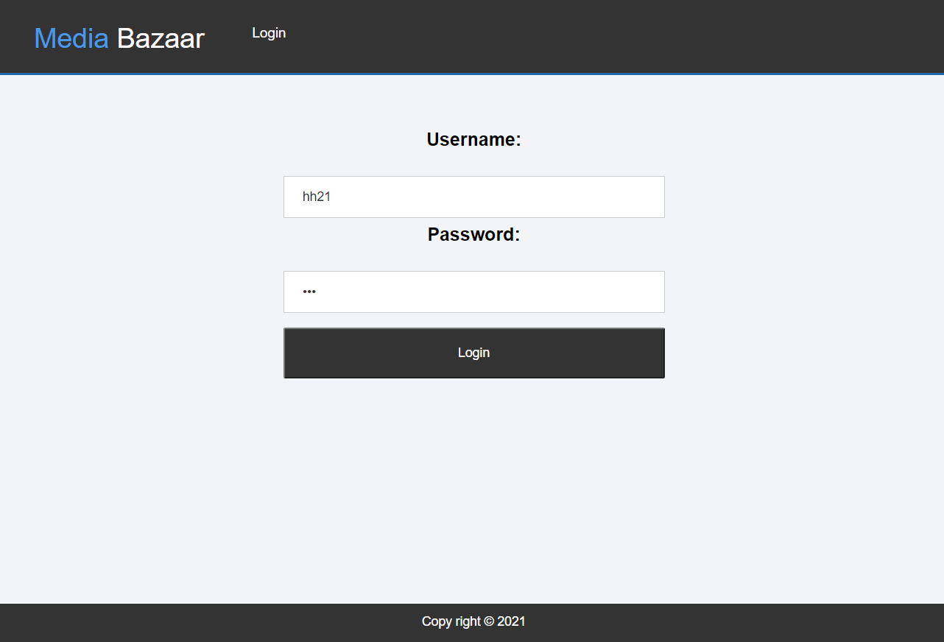

And this is the Web Application.

Here we can see the Log in Page.

Where the user can log in.

Here we can see the Account page where the user can view his personal data.

Here is the Change Password page where the user can chamge his password by appling his old one and adding his new one.

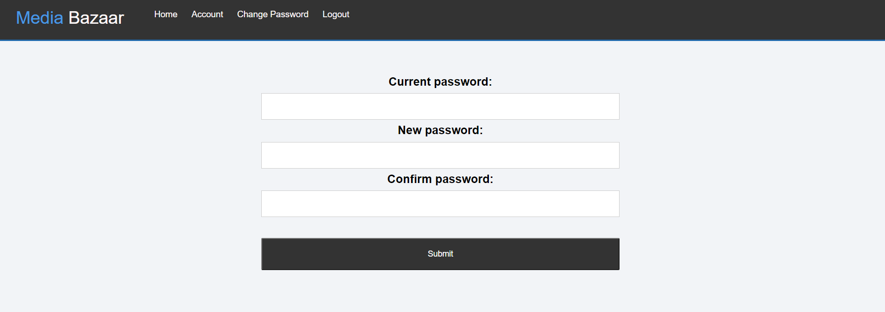

On the Home page the user can view his scheduled shifts and also can manage his availability.

