Versions:

Date | Version | Author | Comments

Analysis&Design for Physics Experiment Simulator

Continut:
- General Presentation
- Theoretical Fundamentals
- IT technology
- List of functionalities
- General Presentation of Actors and Access Rights
- Use-Case Diagrams
- System Architecture
- Design (detailed presentation of UML diagrams)
- Getting Running
- Operating Mode / Interactivity features
- Portability
- Resources
- Competing Software
- Glossary & Bibliography

1. General Presentation

The project provides an easy-to use interface that allows users to edit and run experiments. The creation of a physical experiment has never been easier than now, and there is a set of experiments that come with the application.
The use will be able to create his/her own experiments and share them with the world, test experiments created by other users, or even famous physics experiments.

- Theoretical Fundamentals

Main theoretical fundamentals will be physics. The project should be able to compute any experiment, from any branch of physics. So a basic knowledge of physics and what you want to achive through this program is required. The user can write a description for an experiment, which will provide some therethical background on that experiment and which results should be expected from it. The application also comes with some tutorials on how to write and run experiments.

- IT Technology

This program will be developed using xtend/java programming language, and using the eclipse RCP framework to export the application as exe, for the sake of portablity. Ecplipse RCP framework is also used to design the UI (together with SWT), and for dependency and OSGi management. Google Injection was intended to be used in some cases, but it proved not to bring any benefits for the current desing, so it was dropped.

- List of functionalities

Provides a list of local experiments, Search action for the list, Easy to add experiments and a lot of info about them.
Experiments will be stored locally and a preference page will be available to allow the user to set the location of the experiment folder.

The application use cases are the following:

- Check the welcome page and the help section to get started
- Local CRUD operations for experiments
- Download experiments from a public repostory
- View a list of local experiments
- Select and view details of experiments from the list
- Run a selected experiment
- Debug the experiment using the console
- View what problems the experiment ecountered in the problems view
- Create your own experiments in just a few simple steps!
- Enrich experiment computation by using methods from the java.lang.Math class;

- General Presentation of Actors and Access Rights

Simple application that can be used by anyone. You do not need special access rights to add/edit/remove experiments on your local machine. Although, in order to share experiments you need to push them on the repository. Here, you will need developer rights, or to pass the checks of a developer.

- Use-Case Diagrams

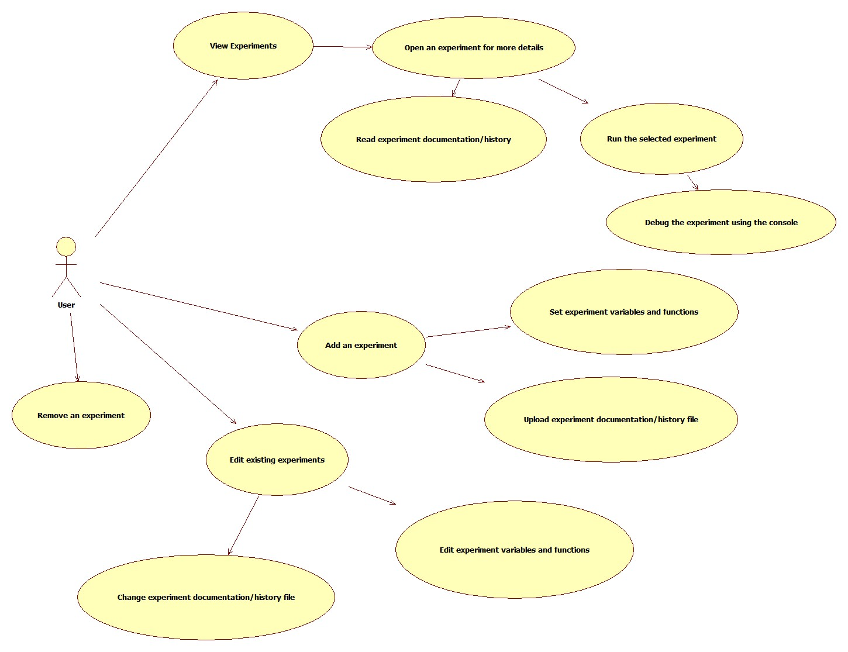

- System Architecture

The system is divided in the following main components:
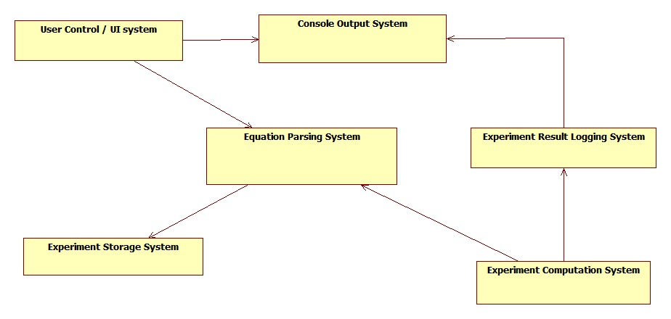
- UI System → allows user controll over an experiments and displays the results of computations as well as problems
- Console Output System → creates a console in the console view that will display the results from computations
- Experiment Result Logging System → uses a costum logger to log each result that is obtained in the computers in the Console Output System.
Enhances experiment debugging as it uses collored texts to differ an experiment from another and to ligh-up errors.
- Experiment Computation System → uses the computers to obtain the results of experiments
- Equation Parsing System → parses each equation of the experiment, separating variables, mathematical functions and simple numbers into operations of 2 operands.
- Experiment Storage System → deals with storing experiments.

- Design (detailed presentation of UML diagrams)

Here is an UML class diagram that shows the relations between the experiment computers :

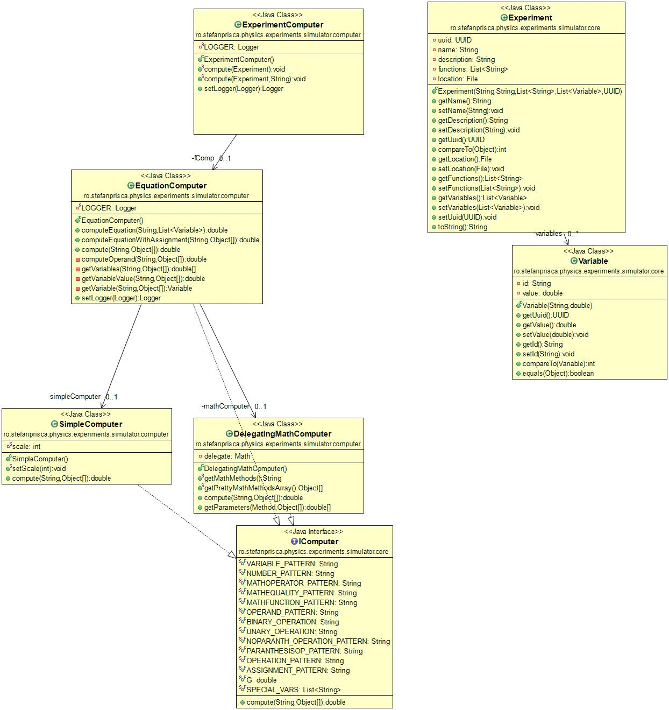

The following sequence diagram is showing how experiments get computed:

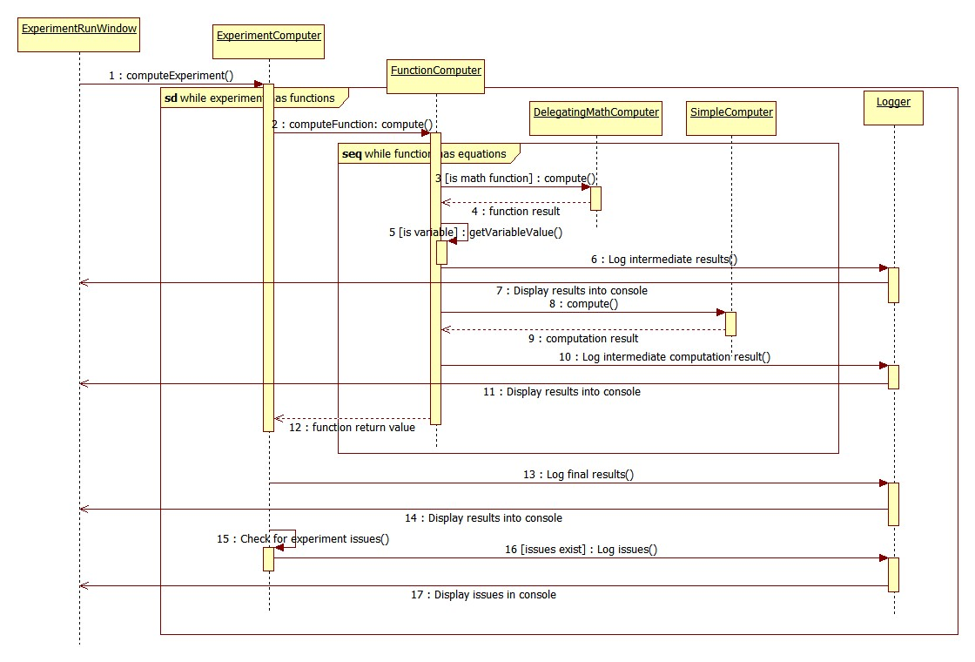
This next diagram will present the core UI structure, and what classes it uses to show the experiments in the experiments list (Note that this do not include the editors):

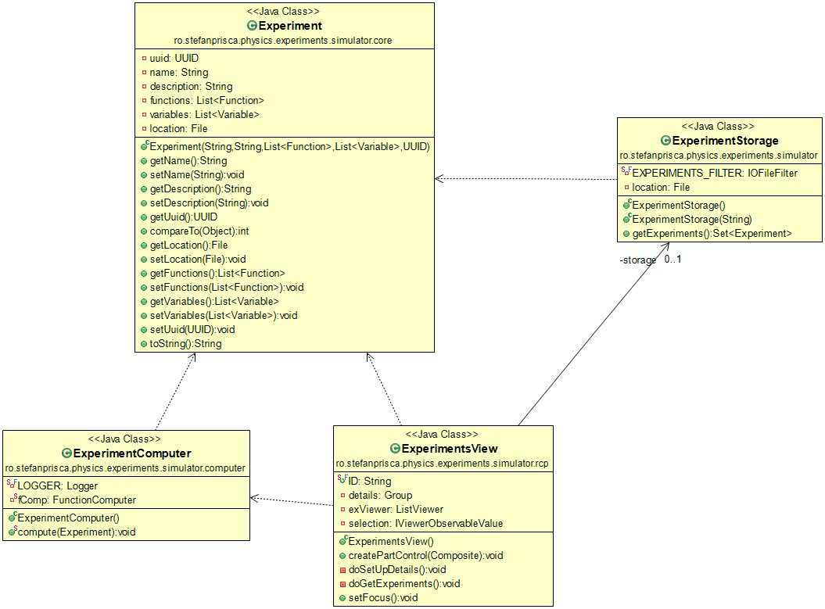

The experiment editors class diagram :

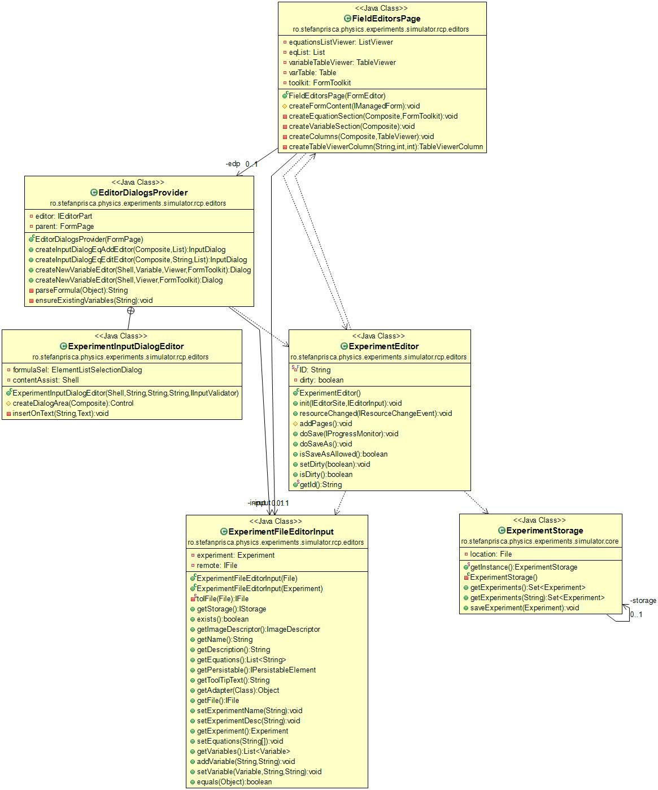

A class diagram showing the logging system:
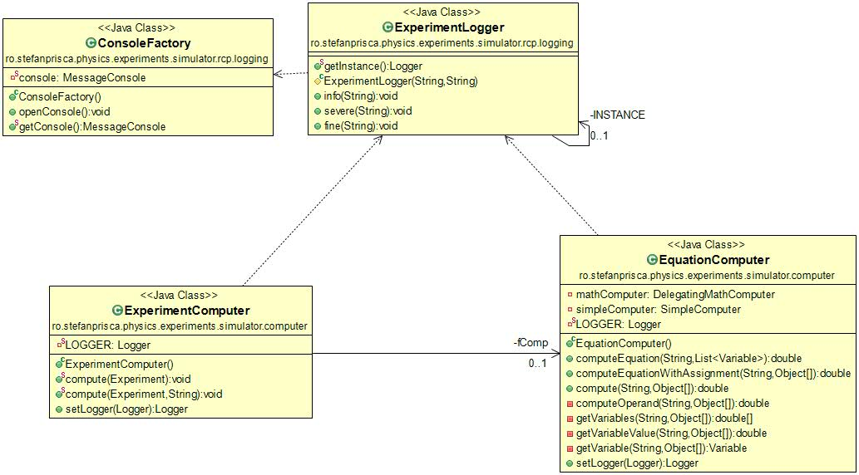

- Gettin Running :
Copy the Physics Simulator folder from the provided disk on the local machine and run the PysicsSimulator.exe file. This will get the application running.

- Operating Mode/ Interactivity Features

First, the user will select an experiment from the list. This brings up the following:
- After starting the application, the user needs to set the path to the experiment folder.
This is done via File->Preferences->Simulator Preferences
- Next, in order to show the local experiments, you need to press the Re-Index button next to the experiment list in the upper left corner. This will bring all experiments in the list.
- the user will be able to run this experiments. This means that:
  - The experiment will do the computations required and post the results in a console. This will be done as interactively as possible using a logger to display step-by-step what happens in the experiment.
  - If a computation went wrong (e.g. division by zero) an message will be displayed in the console suggesting to look for issues in the log.
  - The user will be able to analyze intermediate results and debug the experiment if something went wrong.
- Editing experiments is done with the experiment editor. This allows the user to edit each field of the experiment. You can find more about this in the help section of the application and on the welcome page.

Besides running experiments, a wizard that will help you create your own will be available. So not only you can test existing experiments, but you can add your own contribution to science! Cool, eh?

- Portability
Given the fact that it is written in java and the project is exported as an exe file using the eclipse RCP development framework, the application is portable on any machine that runs java.

- Resources
The project is available on my personal GitHub repository:
https://github.com/stefanprisca/PhysicsExperimentSimulator
You can follow it updates here. Also the experiments are stored in this repository.

- Competing Software

Phet: http://phet.colorado.edu/en/simulations/category/physics .

- Glossary &Bibliography

- Eclipse RCP development: http://wiki.eclipse.org/index.php/Rich_Client_Platform
- Xtend developing language: http://www.eclipse.org/xtend/

