Dokumen Perancangan Perangkat Lunak

OLEH:
Stefanus Andri Hendrawan 103072400115
Fatih Khairu Alfifajri 103072400105
Irham Maulana .A. 103072400063
Alif Lutfan .A. 1030724001634
Jevico Royvaldo F 103072400151

FAKULTAS INFORMATIKA
PROGRAM STUDI INFORMATIKA
TELKOM UNIVERSITY SURABAYA
2026

DOKUMEN 2: DPPL (Dokumen Perancangan Perangkat Lunak)
SmartKasir (Point of Sale System)

1. DESAIN ARSITEKTUR SISTEM
Sistem dirancang menggunakan arsitektur berlapis (Layered Pattern / MVC Pattern):
- Presentation Layer (View): Menangani interaksi langsung dengan kasir/admin (Form Login, Layar Transaksi Kasir, Form Manajemen Barang).
- Business Logic Layer (Controller / Service): Memvalidasi masukan kasir, aturan bisnis perhitungan diskon/pajak (jika ada), kalkulasi kembalian, orkestrasi pemotongan stok, dan service rendering struk belanja PDF.
- Data Access Layer (Model / DAO): Bertanggung jawab atas kueri SQL transaksi (Data Definition & Manipulation) ke database engine (MySQL / PostgreSQL / SQLite).

2. DESAIN BASIS DATA (PHYSICAL DATA MODEL)
Skema Relasi Database
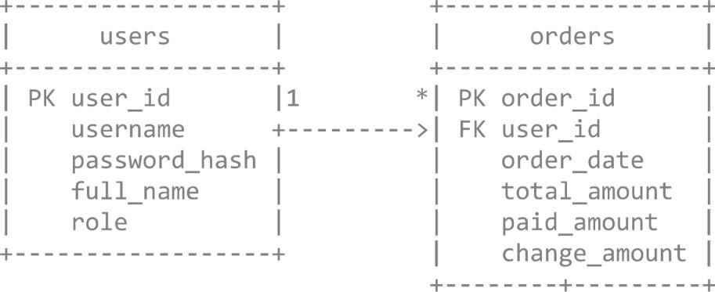

I l
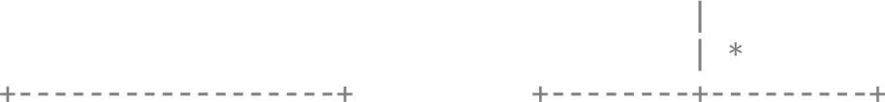
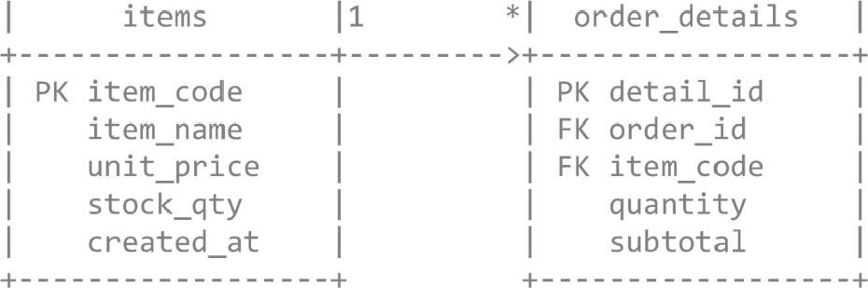
Kamus Data Tabel
Tabel: users
- user id (INT, Primary Key, Auto Increment)
- username (VARCHAR(50), Unique, Not Null)
- password_hash (VARCHAR(255), Not Null)
- full name (VARCHAR(IOO), Not Null)
- role (ENUM('ADMIN', 'CASHIER'), Not Null) Tabel: items
- item code (VARCHAR(30), Primary Key) item name
(VARCHAR(150), Not Null)

• unit_ price 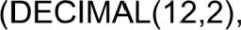 Not Null)
- stock_qty (INT, Not Null, Default: 0) created at
(TIMESTAMP, Default: CURRENT_TIMESTAMP)
Tabel: orders
- order id (VARCHAR(35), Primary Key)— Format: TRXYYYYMMDD-XXXX order date (DATETIME, Not Null) user id (INT, Foreign Key users. user_id)
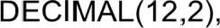
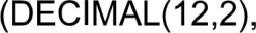
- total amount Not Null) paid_amount 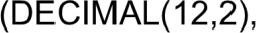Not Null) change_amount Not Null)
- detail id (INT, Primary Key, Auto Increment) order id
(VARCHAR(35), Foreign Key + orders. order_id ON DELETE
CASCADE) o item code (VARCHAR(30), Foreign Key + items . item_code) quantity (INT, Not Null)
- subtotal 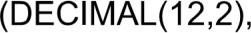 Not Null)

3. DESAIN KELAS DAN MODUL PROGRAM (CLASS DIAGRAM SPECIFICATION)
3.1 Entitas Model
- User: Atribut (userld, username, passwordHash, role)
- Item: Atribut (itemCode, itemName, unitPrice, stockQty
- Order: Atribut (orderld, orderDate, userld, itemsList, totalAmount, paidAmount, changeAmount)
- OrderDetai1: Atribut (detailld, orderld, itemCode, quantity, subtotal)
3.2 Service & Controller
- AuthService:
- login(username, rawPassword) : UserSession o logout(): void o hashPassword(password) : String
- ProductService:
- get Item(itemCode) : Item o updateStock(itemCode, deltaQty) : boolean o saveProduct(Item) : boolean
- TransactionService:
- calculateSubtota1(unitPrice, qty): double o calculateGrandTota1(cartItems): double o validatePayment(grandTota1, paidAmount) : boolean

- calculateChange(grandTota1, paidAmount) : double
- commit Transaction (Order) : boolean (Menjalankan insert ke orders, order details, dan update items . stock_qty dalam satu transaksi database).
- PdfReceiptService:
- generateReceiptPdf(orderId) : File (Mengisi template struk: daftar item, total, nominal bayar, kembalian, nama kasir, dan waktu transak

4. PERANCANGAN ANTARMUKA PENGGUNA (UI WIREFRAME LAYOUT)
Layout 1: Layar Kasir / POS (Fokus Sprint 2)

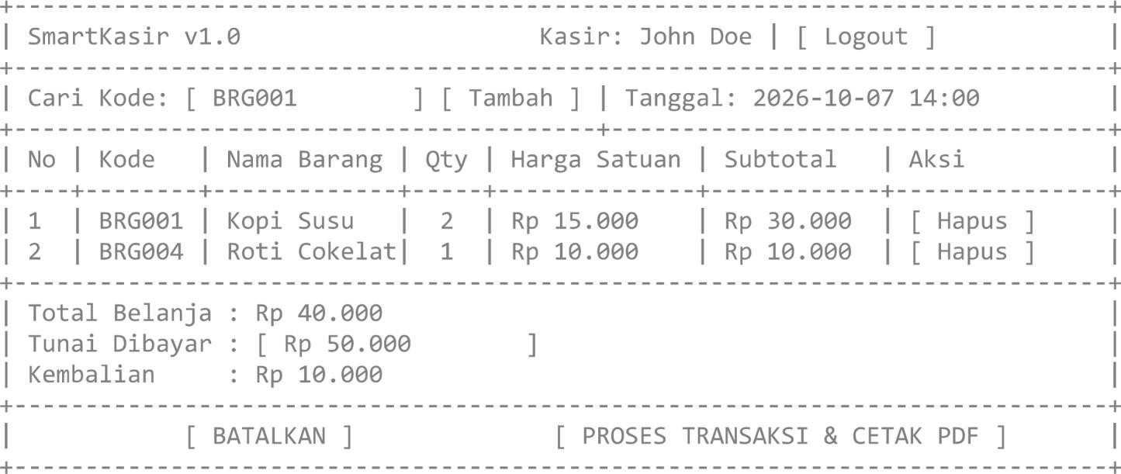

5. STRUKTUR FOLDER REPOSITORI GIT
