2017-03-15 11:38:02,945 - INFO --- END: Embed the graph into the plane (is_planar(set_embedding = True)

2017-03-15 11:38:02,966 - INFO --- Face: [(6, 7), (7, 9), (9, 6)]

2017-03-15 11:38:02,966 - INFO --- Face: [(1, 2), (2, 3), (3, 0), (0, 1)]

2017-03-15 11:38:02,966 - INFO --- Face: [(5, 4), (4, 1), (1, 0), (0, 5)]

2017-03-15 11:38:02,966 - INFO --- Face: [(3, 8), (8, 5), (5, 0), (0, 3)]

2017-03-15 11:38:02,966 - INFO --- Face: [(4, 7), (7, 6), (6, 2), (2, 1), (1, 4)]

2017-03-15 11:38:02,967 - INFO --- Face: [(3, 2), (2, 6), (6, 9), (9, 8), (8, 3)]

2017-03-15 11:38:02,967 - INFO --- Face: [(7, 4), (4, 5), (5, 8), (8, 9), (9, 7)]

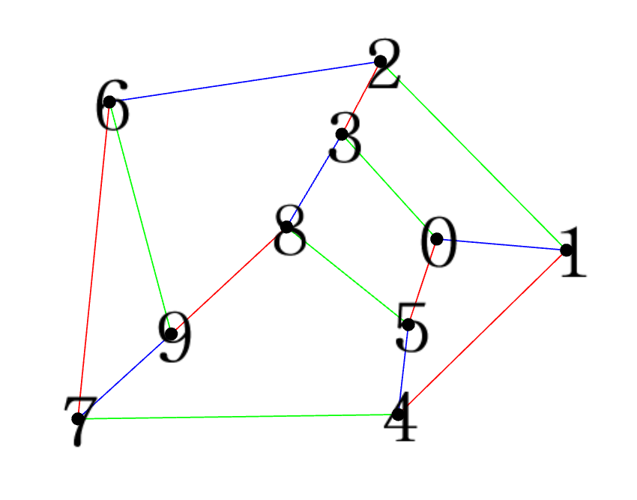

2017-03-15 11:57:15,898 - INFO --- DEBUG: OOOOOOOOOOOOOOOOOOOOOOOOOOOOOOO: temp_face_up: [(4, 7), (7, 6), (6, 2), (2, 1), (1, 4)]

2017-03-15 11:57:15,899 - INFO --- DEBUG: OOOOOOOOOOOOOOOOOOOOOOOOOOOOOOO: temp_face_down: [(1, 2), (2, 3), (3, 0), (0, 1)]

edge[0]: 1 --- edge[1]: 2

2017-03-15 11:54:38,238 - INFO --- DEBUG XXX: temp_face_left: [(5, 4), (4, 1), (1, 0), (0, 5)]

2017-03-15 11:54:38,238 - INFO --- DEBUG XXX: temp_face_right: [(3, 2), (2, 6), (6, 9), (9, 8), (8, 3)]

temp_three_faces_left:

[[(1, 2), (2, 3), (3, 0), (0, 1)],

[(5, 4), (4, 1), (1, 0), (0, 5)],

[(4, 7), (7, 6), (6, 2), (2, 1), (1, 4)]]

temp_three_faces_right:

[[(1, 2), (2, 3), (3, 0), (0, 1)],

[(4, 7), (7, 6), (6, 2), (2, 1), (1, 4)],

[(3, 2), (2, 6), (6, 9), (9, 8), (8, 3)]]