Does me being in my room change the humidity of the room?

Research Design  
13-10-2019

Stefan van Poppel  
500711170

# Abstract

In this experiment, the answer to “Does me being in my room change the humidity of the room?” will be answered. The hypotheses will be that is does and it will raise as people lose moisture through breathing and transpiration.

The experiment uses a si7021 Humidity and Temperature sensor and a Raspberry Pi Zero W. The sensor is connected to the Pi over I2C.

The code retrieves the humidity and temperature data from the sensor and adds a comma separated line with the data to a csv file. At the end of the day, the collecting is ended, and the file is renamed to the date of that day.

The experiment was done for two days. After these two days, the csv files were downloaded from the pi.

The first day resulted in 1461 records, the second day resulted in 1417 records, each record containing both humidity and temperature, bringing the total data points to 5756 points of data.

This experiment would have been better if it would have been done over more days.

Me being in the room does influence the humidity in the room, but so do other circumstances and actions.

The results are a lot of guess work. It is known when I entered and left the room, but it is not known what the other influences are.

# Introduction

In this experiment, the answer to “Does me being in my room change the humidity of the room?” will be answered. The hypotheses will be that is does and it will raise as people lose moisture through breathing and transpiration.

Experimental setup

The experiment uses a si7021 Humidity and Temperature sensor and a Raspberry Pi Zero W. The sensor is connected to the Pi over I2C. The pi was used for another experiment and the code on it was reused for this experiment. The previous experiment used Node.js and this experiment thus as well. To gather the data from the sensor, the “si7021-sensor” npm-package was installed. The used code can be found in the appendix and on github.com/stefanvp/research_design. The datasets can be found there too.

The code retrieves the humidity and temperature data from the sensor and adds a comma separated line with the data to a csv file. At the end of the day, the collecting is ended, and the file is renamed to the date of that day.

The experiment was done for two days but could easily be expended to more days.

After these two days, the csv files were downloaded from the pi.

The first day resulted in 1461 records, the second day resulted in 1417 records, each record containing both humidity and temperature, bringing the total data points to 5756 points of data.

# Results

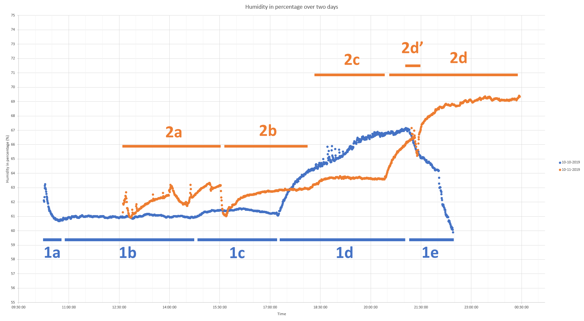

This is the graph created from the data collected on 10 and 11 October 2019. It displays the humidity over time. Indicators for periods are added to identify the periods discussed. The min and max of the vertical axes are 55% and 75%. Displaying from 0% to 100% would result in a line.

The full image can be found in the appendix and on github.com/stefanvp/research_design. The datasets can be found there too.

It looks like there is an average rise of humidity towards the end of the day, after which it falls to repeat again.

## 1a

The recording started soon after I got up and closed the window. It was raining at the time. This could mean that closing the window blocked the humidity generated by the rain.

After starting the recording, I did not enter the room again until 17:15, the start of 1c.

## 1b

I was away during this time. The humidity seems to be hovering around 61.0%.

## 1c

At around 15:00, it started raining again. I was still away, but the humidity in the room did raise with 0.5%. The weather can be checked on buienradar.nl, I live in Amsterdam.

*https://www.buienradar.nl/nederland/neerslag/buienradar-terugkijken/archief/201910101500*

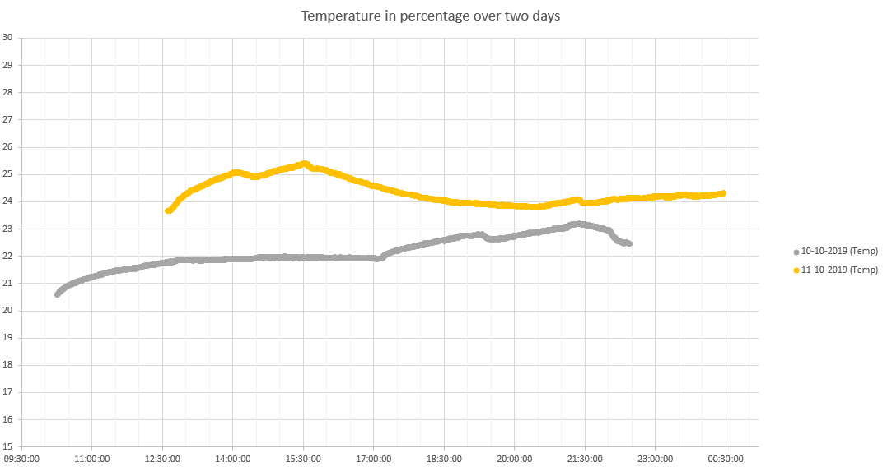

## 1d

I returned to my room. It had stopped raining when I returned. The raise is bigger than expected, especially in comparison with 2a, when I was in my room as well. The dip could be when I was away to have dinner. I do not know why the measurements are spread around.

## 1e

I can not explain why the humidity dropped. In hindsight it might had something to do with the heating turning off. I went to bed at the end of 1e.

## 2a

I was in my room during this period, using the computer.

## 2b

I was away. I was working in the kitchen and would not return until the start of 2d. It looks like me not being in the room gave the humidity some time to settle.

## 2c

I can not explain this raise. It was already raining and it actually cleared up during 2c.

## 2d

I took a shower at the start of 2d, of which the humidity creeped to my room, I assume. Even then I find it strange that the humidity would be rising for several hours and not go down before the recording was terminated.

## 2d’

I can’t explain the dip in the raise. I think it needs to be called out, because it is an anomaly in a straight line and it somewhat follows the line of the previous day.

# Discussion

It looks like me being in the room does influence the humidity in the room.

This experiment would have been better if it would have been done over more days.

The results are a lot of guess work. It is known when I entered and left the room, but it is not known what the other influences are.

To test the hypotheses of 1e, another experiment would be necessary with the heating turned on and off, which would also had been a great idea to log when doing the experiment and to cross the humidity data with the temperature data

# Conclusion

Me being in the room does influence the humidity in the room, but so do other circumstances and actions and maybe even more.

# Appendix

## Code

*Can also be found on https://github.com/stefanvp/research_design*

const Si7021 = require('si7021-sensor');

const fs = require('fs');

const si7021 = new Si7021({ i2cBusNo : 1 });

const readSensorData = () => {

si7021.readSensorData()

.then((data) => {

data.now = Date.now();

fs.appendFile('data.csv', `${data.now},${data.humidity},${data.temperature_C}\n`, err => { if (err) throw err });

setTimeout(readSensorData, 30000);

})

.catch((err) => {

console.log(`Si7021 read error: ${err}`);

setTimeout(readSensorData, 2000);

});

};

si7021.reset()

.then((result) => readSensorData())

.catch((err) => console.error(`Si7021 reset failed: ${err} `));

## Data in graph Humidity

## Data in graph Temperature

