**Search Function**

The purpose of this search function is to be able to search through directories and files to find values in an efficient way and locate their location. Users will be able to run this program through the command line and search through directories of their choosing.

Example call to search through the directory C:\Users\rizva\Desktop\simple-text-search\input:



After specifying a directory, the program will index out the directories and pop up a new line where it asks the user to enter a query. In this box, users will be able to enter AND or OR to start a query where AND will return results where the queries words must appear in the same file while OR just returns all the files in which the queries words appear.

Example call to find all occurrences of study technical communication:

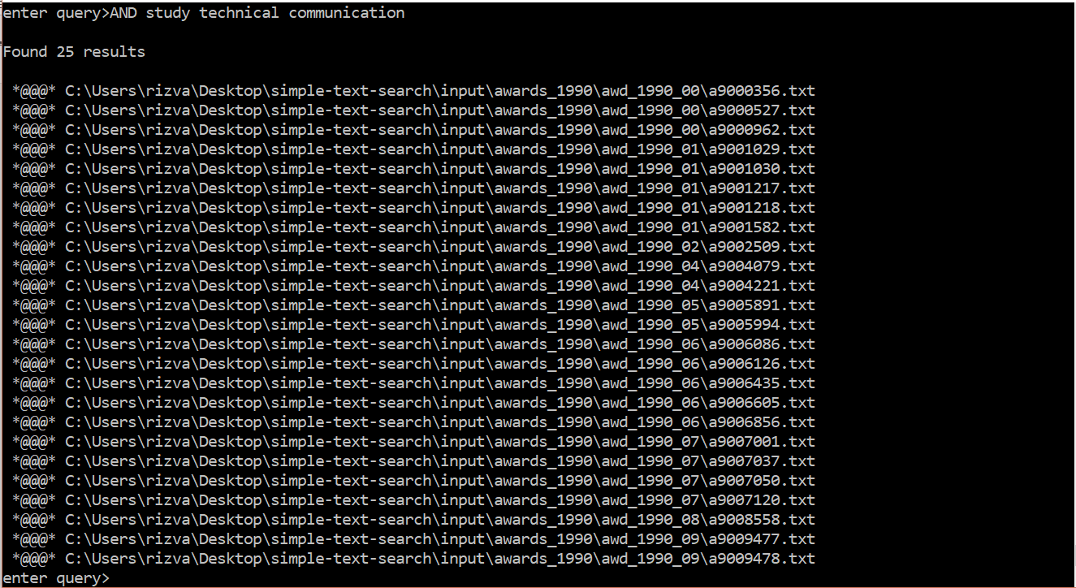

Example call to find any occurrence of bryn:

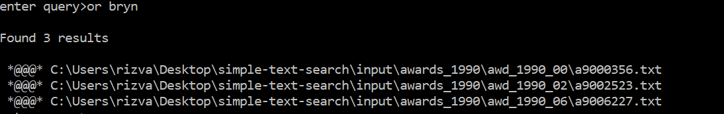

Users also have the option to exit program by hitting CTRL + C.