BRAND STRATEGY & CREATIVE VISION
SkillGap
.ai

The single source of truth for our brand — and the creative north star for all art direction that follows.
Everything an art director needs to understand what we are, who we serve, why it matters, and what great looks like.

Prepared for
Christopher A. Ritter — Art Direction, Branding & Design
Prepared by
Steffan Howey
Status
v1.0 · Pre-art-direction · Open-canvas identity mandate

READ THIS FIRST

How to use this document

This is not a spec sheet. It is a way of seeing the problem — so that what you design feels inevitable rather than decorated.
SkillGap.ai is a real, working product with an unusually clear strategy and an unusually unformed identity. The thinking is finished. The brand is not. That gap is the opportunity, and it is yours to fill.
The document is in five parts. Part I is the brief — what the product is and who it serves, in plain language. Part II is positioning and voice — how we stand against the alternatives and how we sound. Part III is a study of your own method, Chris, distilled from your portfolio — because the way you work is the way we want this brand built. Part IV is the strategy and creative vision: the brand idea, the principles, the territories to explore. Part V is the springboard — the surfaces, the success criteria, and what we are asking you to bring back.
One thing to hold onto throughout: the current green-and-serif look you may have seen in the codebase is placeholder. It was adapted wholesale from an unrelated brand. Treat the visual identity as a blank canvas. The strategy is the constraint; the look is wide open.

CONTENTS

What’s inside

I
The Brief

What SkillGap is, who it serves, and why it matters — in plain language, before a single design decision is made.

The one-sentence version
SkillGap.ai is where working professionals close the gap between the skills they have and the skills the AI-driven economy now demands — by doing real work, alongside other people, in the time they actually have.
It is part learning platform, part live community, part personal career mirror. Think Duolingo’s daily habit loop, Focusmate’s social accountability, and an always-current AI curriculum — fused into one product. You don’t watch a course. You sit down for forty minutes, build something real with a real AI tool, get feedback, and walk away measurably more capable. And you can prove it.

Why now: the world is splitting in two
AI is not a feature update. It is a literacy shift — the kind that happens once or twice in a career, like the internet in the late ’90s or mobile in 2008. Except faster. Six months ago, coding with an AI copilot was a novelty; now developers who don’t use one are measurably slower. Marketers who prompt well produce in an afternoon what used to take a team a week.
The gap between “AI-fluent” and “AI-curious” is already wide and widening weekly. Underneath it sits a deeper shift: the economy is moving from role-defined careers to skill-defined ones. Your job title used to be your career. Now it’s a container for a collection of skills — and those skills are becoming portable, tradeable assets. Skills are the atoms. Job titles were the molecules. The molecules are breaking apart.
This gap is not about intelligence or talent. It’s about exposure, practice, self-knowledge, and having someone show you what actually matters right now versus what’s hype.
The market backs this up. The WEF Future of Jobs Report 2025 found 63% of employers name skill gaps as the single biggest barrier to transformation, and that 39% of core job skills will change by 2030. Yet only 26% of organizations run formal AI upskilling. When employers do provide training, AI adoption jumps to 76% versus 25% without. SkillGap is that missing structural support.

Who we serve
Our users are working professionals — employed, competent, busy — who see AI transforming their field and feel real urgency. They are not students or hobbyists. They are mid-career engineers, marketers, designers, PMs, analysts, salespeople, operators, and founders with genuine track records. Their anxiety isn’t about being bad at their jobs. It’s about their jobs changing into something they don’t quite recognize yet.
They share six truths. Design should speak to all of them at once — to the competence and the unease in the same breath.
- They’re already good at what they do. Don’t talk down to them. This is the difference between a brand that respects its user and one that condescends.
- They know they need to move but not where to start. They’ve opened YouTube, seen 47 videos of wildly varying quality, and closed the tab. They want a trusted guide who says: this matters, this is noise, start here.
- They learn by doing, not by watching. They’ve sat through the tutorial and changed nothing. They want to be pushed into the tool with a real task.
- They have 40 minutes, not 40 hours. They learn in the cracks — lunch breaks, evenings, the hour before the kids wake up.
- They’re navigating an unexpected convergence. AI is collapsing the walls between disciplines. They feel the pull to grow beyond their lane even while still mastering AI within it.
- They don’t know what their skills are worth anymore. Some skills they spent years building are becoming commodities; others they’ve never considered are suddenly high-leverage. They need a mirror.

The two waves
Wave 1 (now): employed professionals navigating role transformation. Their jobs still exist but are changing. They have paychecks and professional-development budgets. This is the market today. Wave 2 (later): displaced professionals navigating career translation — “my job is gone; what transferable skills do I have, and where do they plug in?” Building for Wave 1 in a way that naturally serves Wave 2 is the strategic bet. The brand has to carry both an optimistic, momentum-forward energy and a deep, grounded reassurance.

The problems we solve
Every problem below is a feeling first and a feature second. The design job is to make the feeling of relief and momentum tangible.
The user’s words | What we do about it
“I don’t know what I don’t know.” | An always-on intelligence engine watches the AI landscape and surfaces what actually matters — before you search for it.
“I watched the tutorial but I can’t do the thing.” | Task-first learning. Watch → Do → Check → Reflect. Watching is 30%, doing is 70%. Real tools, real tasks, AI feedback.
“Everything is already outdated.” | When a tool ships Tuesday, there’s a structured path by Wednesday. We teach from what the best creators published this week.
“I don’t have time for a course.” | 30–60 minute paths. From “I’ve heard of this” to “I can do this” in one focused sitting.
“I’m learning alone and can’t tell if I’m on track.” | AI feedback on every submission — plus live rooms where professionals sprint together. The isolation breaks.
“I don’t know what my skills are worth.” | Your skill graph: a personal, portable, verified record of what you can actually do, with proof.

The product, plainly: five engines as one
Behind the experience are five systems that feed each other in a continuous loop. You don’t need to design all of them — but the brand has to feel like it could only come from a company that thinks this way.
1 · The Intelligence Engine
Watches YouTube, Reddit, Hacker News and RSS 24/7, detects what’s trending, curates the best content, and maps everything to skills. The reason a learning path exists before you search for it.

2 · The Learning Engine
Turns that content into task-first, 30–60 minute experiences where you build real things with real tools. Every mission generates a skill receipt.

3 · The Social Engine
Live rooms where professionals sprint together — always-on domain rooms, scheduled sessions, and live events. The reason people come back tomorrow.

4 · The Growth Engine
Every completion, artifact, and credential becomes a natural moment of sharing. The skill graph is the new portfolio — personal, portable, worth showing.

5 · The Authority Engine
The byproduct that may matter most: the world’s most accurate, real-time, practitioner-verified dataset on AI skills — the AI Skills Index, the Pulse Dashboard, the State of AI Skills Report. The product is the learning engine. The moat is the authority.

The experience, beat by beat
The room and the sprint. You join a room with a theme and an AI host. You declare what you’re working on — a micro-commitment to strangers that changes everything. A timer runs. You do focused work. At the break you watch one curated, lean-back video. You reflect. You repeat. The four-beat rhythm — check-in, sprint, break, reflection — is the product. Everything else supports it.
The learning path. Three to five short modules that move from orientation to a solo challenge. You don’t passively absorb; you’re scaffolded from guided (we give you the prompt) to independent (you write your own) to solo (no help at all). You can feel yourself needing less help over time. That feeling is the whole point.
The skill graph. After a few paths, it unlocks: a visual map of your verified capabilities, your fluency levels, your adjacencies (“you’re 70% of the way to Product Strategy”), and your gaps against where the market is moving. Unlike a LinkedIn endorsement, every skill here has evidence — work you submitted, evaluated against a rubric. This artifact is the most important thing the brand will ever render. It is the hero. It must be beautiful enough that a professional wants to post it.

Three fixed concepts the design must honor
These are the load-bearing ideas. Everything visual should make them legible at a glance.
Concept | What it means
Skills | Discrete, transferable capabilities — the primary axis. Writing, Prompt Engineering, Technical Building, Data & Analysis, Visual & Design, Strategy, Automation, Persuasion, Operations. You carry them across roles.
Functions | Professional domains where skills are applied — Engineering, Marketing, Design, Product, Data, Sales, Operations. A lens, not an identity. The walls between them are dissolving.
Fluency | Depth in a skill: Exploring → Practicing → Proficient → Advanced. Granular — you can be Proficient in one thing and Exploring in another at the same time.
Note the fluency ladder. Exploring → Practicing → Proficient → Advanced is a four-step progression that recurs everywhere — badges, the skill graph, credentials, room recommendations. It is a natural system to design around: four states, a clear direction of travel, a built-in sense of earned momentum.

The tagline
Close the gap.
It works on four levels at once, and the best visual idea will work on all four too:
- Personal — “I feel behind. I want to catch up.” The emotional truth of every user.
- Professional — “There’s a gap between where I am and where my field demands I be.”
- Structural — “The market is moving from role-defined to skill-defined. I need to navigate it.”
- Visible — “Here’s my skill portfolio, my fluency, and exactly where I’m behind.” The tangible artifact.

Where the brand stands today — the honest part
The product is real and live. The brand is borrowed. The current identity — forest greens, a Fraunces + DM Sans pairing, the existing wordmark — was lifted almost wholesale from an unrelated company’s Figma mockups (a marketing-staffing brand called GrowthAssistant). The placeholder wordmark in the repo literally still reads “GrowthAssistant.” The codebase itself is still named “focusparty,” a previous incarnation of the product.
Nothing about the current look is sacred. It is scaffolding, not architecture.
This is freeing. It means the strategy in this document is the only real constraint. The green-growth direction is a reasonable instinct — and you may well keep some of it — but you are not inheriting a brand. You are creating one. The mandate is open canvas.
II
Positioning & Voice

Where we stand against what people do instead — and how we sound when we say it.

What we’re really competing against
The right question isn’t “who are our competitors” but “what would our user do if we didn’t exist.” The honest answers are unglamorous — and they tell us what to design against.
The alternative | What it looks like | What it lacks
DIY YouTube rabbit holes | Search “learn Cursor,” get 47 results, watch three, close the tab. | Structure
Follow the timeline | Scroll X/LinkedIn, read the trending AI thread, feel informed, forget by Friday. | Practice
Ask a friend who’s ahead | DM the colleague who figured it out. Works once. Doesn’t scale. | Repeatability
Buy a course, never finish | Enroll, watch 20%, hit the wall where you’d have to do something, quit. | Accountability
Do nothing and hope | “I’ll get to it next week. My skills are probably fine.” The default. | Everything
The pattern: every alternative lacks structure, or practice, or accountability — usually all three. “Do nothing and hope” is the one we beat most often, and it’s the most dangerous, because the gap grows quietly. Our design has to make starting feel lighter than not starting.

What makes us different
Six differentiators. Each is a design brief in disguise.
- Opinionated, not comprehensive. We reject more content than we accept. The restraint is the product. The brand should feel curated and confident, never like a content firehose.
- We make you do the work. Real tools, real tasks, real output. The brand should feel active — verbs, momentum, making — not passive consumption.
- We stay current automatically. Always live, always fresh. The brand needs a sense of pulse and now-ness without feeling frantic.
- We respect your time. 40 focused minutes, not 40 hours. The brand should feel efficient, sharp, uncluttered — nothing wasted.
- You’re never learning alone. Presence, company, a heartbeat of others. The brand needs human warmth and a feeling of inhabited space.
- We make progress worth sharing. Verified, beautiful, postable proof. The brand has to look premium on a LinkedIn feed next to a person’s headshot.

Voice
Confident but not arrogant. Warm but not soft. Direct but not cold.
We speak to experts navigating unfamiliar territory — not beginners who need hand-holding. The voice is a peer who is a step ahead and genuinely wants you to catch up, not a guru performing expertise. It is plain-spoken, specific, and a little understated. It earns trust by being useful, not by being loud.
Said another way: we are the calm, well-read friend who actually did the reading — who can tell you in one sentence what’s worth your Tuesday night and what isn’t. The visual voice should match: assured, literate, uncrowded, with the confidence to leave space.
III
Learning From Chris

We don’t just want your hands on this brand. We want it built the way you build — so this section is your own method, reflected back.
Chris — this part is unusual, and deliberate. Before briefing you, we studied your portfolio closely: the Cubs’ “[THIS] is Everything,” Cincinnati Ballet’s “Élever l’Émotion,” Veritas Automata, NMU Graduate Studies, the Pelicans’ “Fly or Die,” Ignite’s “For the Million,” adidas Running, lululemon, Bureau Division, For Good Sauce. The point isn’t flattery. It’s that your method is exactly the method this brand needs, and we want to name it so we’re working from a shared playbook.

Your method, in five moves
Across wildly different categories — sports, ballet, B2B automation, chocolate, higher ed — the same sequence recurs. It is, essentially, the operating system of this project.
- Find the human truth. You never start from the logo. You start from an insight. Cubs fans return “not just for the game, but for the shared moments around it.” New Orleans “loves to celebrate.” NMU’s setting offers “the head space and physical space you need to grow.” The truth comes first; everything else is its consequence.
- Compress it into a flexible platform. Then a short, ownable declaration that can stretch: “[THIS] is Everything.” “Fly or Die.” “For the Million.” “Move Like a Woman.” “Solving for Alpha.” Not a tagline you read — a sentence the audience can finish themselves.
- Build a living system, not a mark. You design languages, not logos: a parametric pipe-letterform alphabet for the Pelicans; a layout system on dynamic symmetry with Fibonacci-scaled type for the Ballet; a modular pattern built from the wordmark for NMU; “Hexagonal Architecture” geometry for Veritas. The system is what lets a brand show up a thousand times and still feel like one thing.
- Ground it in something tactile and cultural. You resist the slick and the generic. Handcrafted paint gestures for the Cubs. Motion-distorted stills for the Ballet. Photocopier grit and MICR code for Bureau Division. Streetwear and local icons for the Ballet × Aimé Leon Dore concept. There’s always a human hand and a cultural anchor in the work.
- Express it everywhere, with conviction. Then it runs — OOH, transit, apparel, web, packaging, environmental, social — each execution unmistakably from the same world. The platform earns its keep by scaling.

Your aesthetic signatures
Beyond method, there’s a recognizable hand. These aren’t prescriptions for SkillGap — they’re the qualities that make your work feel like yours, noted so we can talk about them.
- Editorial restraint. Your portfolio itself is the tell: cream canvas, enormous confident type, whisper-small monospaced metadata in the corners, oceans of whitespace. You trust the work to carry the page.
- Type as the hero. Display serif against clean grotesk (Albra Display / Albra Grotesk). Custom letterforms. Type that carries the entire identity when it needs to.
- Motion and distortion as emotion. Blur, smear, motion-stills — you use imperfection to make a static page feel alive and felt.
- Bold, reductive geometry. The Veritas “VA” monogram; flexible modular systems. Confident, structural, never fussy.
- Saturated, decisive color. When you commit to a color (NMU’s electric green), you flood with it. Color as a statement, not a garnish — which, notably, is already how SkillGap thinks about color.

Four of your projects we keep coming back to
These map onto SkillGap with uncanny precision. Each lends a specific lesson.
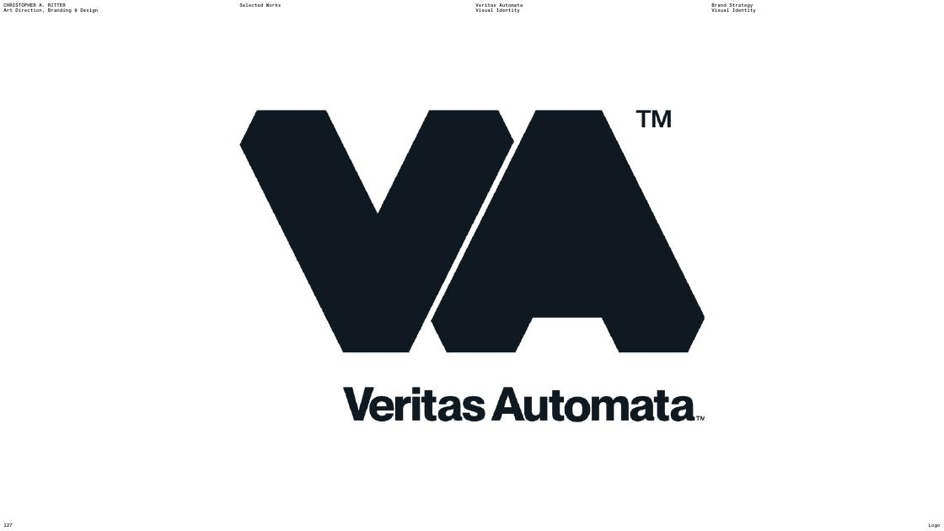
Veritas Automata — “Solving for Alpha.” Geometry as argument.
Veritas Automata → the tech-with-a-soul problem
A decade-incubated automation company, made to feel like a confident market leader through reductive geometry and a “Hexagonal Architecture” system. The lesson for SkillGap: a deeply technical product (an intelligence engine, a skill graph, a real-time index) can be expressed through human, structural design — not cold dashboards. We are technical. We must not look it.

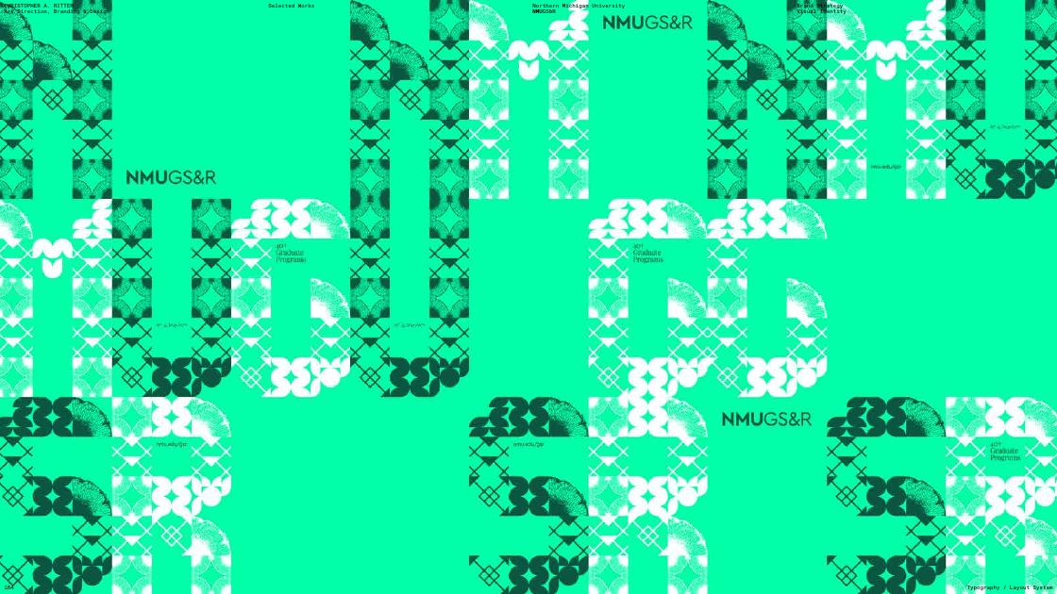
NMU Graduate Studies — growth, nature, a modular system built from the letters.
NMU GS&R → the growth-and-nature problem
The brief was “design for a nurturing environment” — a place that gives you “the head space and physical space you need to grow.” The answer was a saturated green flood and a flexible pattern system grown from the wordmark itself. That is almost exactly SkillGap’s instinct (growth, green, momentum) — proof the territory can be done with real craft instead of cliché.


adidas Running — designing the future of running, including in-app AI.
adidas Running → the future-of-a-discipline problem
Design-sprint prototypes for how running gets recommended and experienced — including an in-app AI experience and immersive retail. The lesson: SkillGap is, similarly, “designing the future of” professional development. The brand should feel like a forward edge, not a classroom.

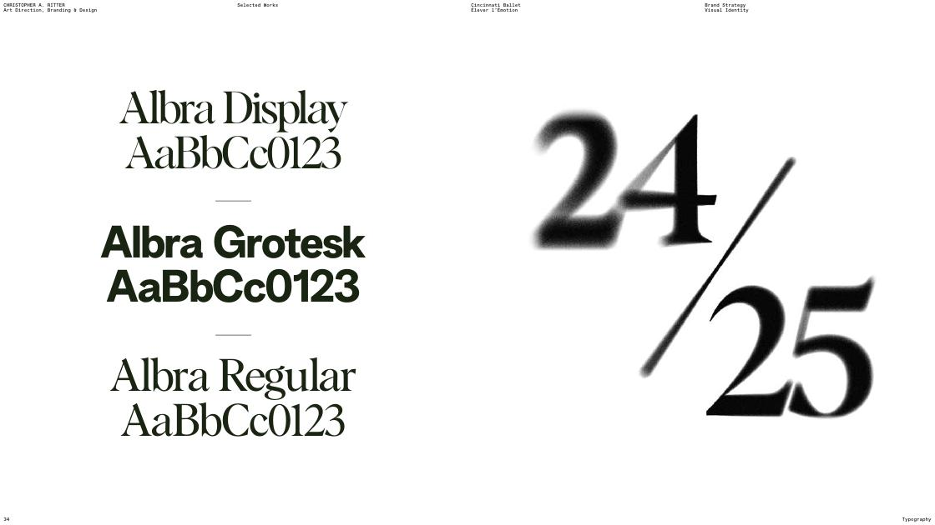
Cincinnati Ballet — type scaled on Fibonacci, motion-distorted, “bold, cinematic, human.”
Cincinnati Ballet → the make-it-feel-not-just-work problem
You reframed something seen as “elite or traditional” into “an immersive, resonant experience” — “bold, cinematic, and human.” SkillGap risks reading as dry professional-development software. Your Ballet move — emotion and cinema applied to something people assumed was stiff — is precisely the elevation we need. Learning under pressure can feel human and even beautiful.

The synthesis
SkillGap needs Veritas’s structural confidence, NMU’s growth energy, adidas’s future-facing edge, and the Ballet’s human warmth — built as a flexible system off one true insight, grounded in something tactile, and run everywhere with conviction.
That sentence is the whole reason you’re the right person for this. The rest of the document gives you the raw material to do it.
IV
Brand Strategy & Creative Vision

The north star. The brand idea, the principles, and the territories worth exploring — framed to provoke, not to prescribe.

The brand idea
SkillGap is the place you go to stop feeling behind — and start having proof you’re ahead.
Everything we make should move a person along one emotional arc: from quiet anxiety (the gap is growing and I can’t see it) to visible momentum (I can see the gap, I’m closing it, and I can show it). The brand is the rendering of that arc. If a design doesn’t move someone along it, it’s decoration.
The central metaphor is the gap itself — and crucially, the closing of it. A gap is a space between two things. It can be drawn, measured, narrowed, bridged, filled. It is one of the rare brand metaphors that is genuinely visual, genuinely ownable, and genuinely tied to the product (the skill graph literally visualizes gaps). The best identity will likely live here — but how you render “the gap” is wide open. It could be typographic, spatial, chromatic, or motion-based. We have deliberately not solved it for you.

Brand attributes
Five words to design toward. If a surface isn’t doing at least three of these, it’s off.
Attribute | What it means here | What it is NOT
Confident | Opinionated, curated, assured enough to leave whitespace and say “start here.” | Arrogant, loud, hype-y
Alive | A pulse, a now-ness, presence of other people, real-time freshness. | Frantic, gimmicky, busy
Earned | Progress is proven, not claimed. Color and reward signal real achievement. | Participation-trophy, gamified-for-its-own-sake
Human | Warm, literate, a peer who did the reading. A hand in the work. | Corporate, robotic, sterile SaaS
Sharp | Efficient, precise, nothing wasted — respects 40 minutes. | Cluttered, decorative, slow

The tone spectrum
SkillGap lives on a tightrope between two emotional registers, and the design must hold both. Lean too far either way and it breaks.
On one end — Reassurance
Grounded, warm, calm. “You’re not behind forever. Here’s the next step. You’ve got this.” This is what serves the anxiety, and especially Wave 2.

On the other — Momentum
Forward-leaning, electric, a little competitive. “The market is moving. Move with it. Look how far you’ve come.” This is what serves the urgency, and the share.

The magic is in holding both at once — the calm of a trusted guide and the charge of forward motion. Think of a great coach: completely reassuring and completely demanding, in the same sentence. That duality is the brand’s signature feeling.

Design principles
Six principles to judge any execution against. They’re written to be usable in a crit — “does this pass principle 3?”
- Color is earned. This is already the product’s philosophy and it’s a strong one: color signals state, progress, or achievement — everything else is restrained. Whatever palette you build, keep the discipline that a burst of color means something happened.
- Make the gap visible. The single best test of an idea: does it make “the gap” — and the closing of it — something you can see? Distance, progression, before/after, the four-step fluency climb. If progress isn’t legible, push further.
- Design the proof. The credential and the skill graph are the brand’s billboards — they go on LinkedIn beside a real person’s face. They must be the most beautiful, most premium things we make. Design them as hero artifacts, not as features.
- Show the people. “You’re never alone” is a core promise. Presence, company, a living heartbeat — the design should feel inhabited, never like an empty room. But these are professionals, semi-anonymous and focused — not a chirpy social network.
- Respect 40 minutes. Sharp, efficient, uncluttered. Nothing decorative for its own sake. The brand should feel like it values the user’s time as much as the product does.
- Stay opinionated. We curate; we don’t aggregate. The brand should feel like it has taste and a point of view — the confidence to show you less, better.

What to explore — raw material, not answers
Below are the dimensions of the identity, each framed as a provocation rather than a spec. Treat every “could” as a door, not an instruction.

Naming the system: the fluency ladder
Exploring → Practicing → Proficient → Advanced is the spine of the product. It’s a gift to a designer: four states, one direction, earned progression. A signature visual treatment for this climb — owned, instantly recognizable, usable from a tiny badge to a full skill-graph hero — could become the brand’s most reusable asset. This is arguably the highest-leverage thing to crack.

Typography
The current Fraunces + DM Sans pairing is placeholder, but the instinct — an expressive display face against a clean, hard-working sans — matches both this brand and your own hand (Albra Display / Grotesk). Type may well carry the whole identity. The product is full of words: skill names, fluency levels, path titles, credentials. A confident typographic system that makes a list of skills feel like a manifesto would go a long way. Custom or modified letterforms are very much on the table.

Color
Green-as-growth is a reasonable instinct and your NMU work proves it can be done with craft rather than cliché — but it is not locked. The real constraint is the philosophy (color = achievement/state) and the need for a system that can express the four fluency levels and the difference between “where you are” and “where the market is.” Consider whether the palette should encode progression (a journey from cool/quiet to warm/earned), and whether “the gap” wants a color of its own.

Imagery & texture
Pure stock photography of smiling professionals would kill this brand — it’s the GrowthAssistant trap. If we show people, they should look like real working professionals, mid-focus, in real contexts. But your portfolio suggests a richer path: tactile texture, motion and distortion, handcrafted gesture, the human hand. “The gap” could be a photographic, typographic, or abstract motif rather than a person at a laptop. There’s room for an idea here that isn’t “people using software.”

Motion
This is a live, real-time product with a literal heartbeat (“89 practicing now”). Motion isn’t a nice-to-have — it’s where “alive” and “momentum” become real. The closing of a gap, the climb up the fluency ladder, the pulse of presence: all want a motion language. Even in static form, the identity should imply movement.

The hero artifacts
Two surfaces deserve disproportionate love because they are the brand’s growth engine: the credential card (shared on completion) and the skill graph (the personal portfolio). They are what a stranger sees first, on someone else’s LinkedIn, with no other context. If they look premium and unmistakably ours, the brand spreads itself.

Anti-patterns: what would make this fail
Naming the failure modes up front so we can avoid them in crit.
- The GrowthAssistant trap. Generic, friendly, rounded SaaS with stock smiles and a green gradient. It says nothing and could belong to anyone.
- AI-slop. Glowing neural orbs, circuit-board motifs, purple-blue gradients, “futuristic” cliché. We are about human capability, not robot aesthetics.
- Edu-condescension. Primary colors, cartoon mascots, “learning is fun!” energy. Our users are accomplished adults with anxiety, not children.
- Gamification for its own sake. Confetti, streaks-as-pressure, trophy clutter. Reward must read as real, earned, professional proof — not a mobile-game dopamine loop.
- Cold enterprise dashboard. All charts and grids and no soul. We have serious data, but we are not Workday. The Veritas lesson: render the technical as human.
V
The Springboard

What we’re asking you to make, what we’ll judge it against, and where to start.

The surfaces this brand has to live on
The identity has to survive contact with all of these. You don’t need to design them all in exploration — but the system should clearly be able to.
Surface | Why it matters
The wordmark & core identity | “SkillGap.ai” — the foundational mark and the system around it.
The skill graph | The hero. The personal, portable, visual portfolio. The thing people share.
The credential card | The completion artifact built to look premium on LinkedIn.
The fluency system | Exploring → Practicing → Proficient → Advanced, from tiny badge to full hero.
The live room | Presence, the sprint timer, the heartbeat of other people.
The marketing site | Where “Close the gap” lands first, and where SEO path-previews live.
The Authority surfaces | The AI Skills Index & Pulse Dashboard — the data that gets cited and screenshotted.

Creative territories to explore
To get the exploration moving, three starting directions — deliberately distinct, deliberately incomplete. They’re prompts, not options to pick from; the best answer may sit between them or beyond them.
Territory A · “The Measured Gap”
Lean into distance, measurement, and progression as the visual core. Type and space do the work; the closing of a gap is rendered literally and elegantly. Editorial, confident, type-led — closest to your own restraint. Risk: too austere if the warmth isn’t engineered in.

Territory B · “Growth, Earned”
Evolve the green-growth instinct with real craft — a living, modular system in the NMU spirit, where color and pattern signal earned progress. Warm, optimistic, energetic. Risk: must escape generic green-SaaS gravity by sheer quality of system and texture.

Territory C · “The Live Edge”
Lead with alive and now — motion, pulse, presence, the heartbeat of people practicing together in real time. Future-facing in the adidas sense, not the sci-fi sense. Risk: needs an anchor of calm so it reassures as well as energizes.

How we’ll know it’s working
The bar for the exploration. A direction is succeeding when it can answer yes to these.
- Does it carry the tagline? Can you see “Close the gap” in the visual idea — ideally on more than one of its four levels?
- Does it hold both registers? Reassurance and momentum at once. The coach test.
- Would a 47-year-old VP and a 28-year-old engineer both feel it’s for them? Broad professional appeal without skewing young or junior.
- Does the credential look premium on a LinkedIn feed? Beside a real headshot, with no context, does it read as proof worth having?
- Could it only be SkillGap? Cover the logo. Is it still unmistakably ours — or could it belong to any learning startup?
- Does it avoid every anti-pattern? No slop, no stock smiles, no edu-cartoon, no cold dashboard.

What we’re asking you to bring back
For the first exploration round, breadth over polish. We want to see the thinking and the range — not a finished system.
- The insight you’re building from. In your method, the platform comes from a truth. Tell us the truth you chose.
- Two to three distinct territories taken far enough to feel — wordmark, type direction, color, and one rendering of “the gap.”
- One hero artifact per territory — ideally the credential or the skill graph — so we can judge the brand where it matters most.
- A first pass at the fluency system, even rough. It’s the most reusable asset in the whole identity.
- Texture and motion notes. How it moves, how it feels in the hand — even as words and references.

A closing note
The strategy is finished. The feeling is yours to make.
We have an unusually clear product, an unusually motivated audience, and an unusually open canvas. The thinking in this document is the constraint and the fuel — not a fence. Find the truth, compress it into something that can stretch, build the system, ground it in something with a hand and a pulse, and run it everywhere with conviction. That’s your method. It’s also, exactly, the brief.
—
Appendix

Source materials and a shared vocabulary, so nothing in here floats free of where it came from.

Where this came from
Every claim in this document traces to internal source material, so it can be checked and updated.
- STRATEGY_Foundation.md — the full strategic narrative: the two waves, six problems, the three-axis model, the skill graph, growth loops, and the authority play.
- SKILLGAP_PROJECT_CONTEXT.md — product reality: rooms, sprints, the content intelligence pipeline, the five engines, the FocusParty→SkillGap rebrand status.
- brand/BRAND_GUIDELINES.md & skillgap-brand-voice.html — the current (placeholder) visual system and the Dunford positioning/voice canvas.
- ChristopherARitter_Portfolio_260217.pdf — 292 pages of selected works; the basis for Part III.
- Market data — WEF Future of Jobs 2025, and figures cited in the strategy foundation.

Vocabulary
Term | Meaning
Skill graph | A user’s personal, portable, verified map of capabilities, fluency levels, adjacencies, and gaps. The hero artifact.
Skill receipt | The record generated after a path: which skills were developed, at what fluency, with what evidence.
Fluency level | Exploring → Practicing → Proficient → Advanced. Depth in a single skill.
Path | A 30–60 minute, 3–5 module learning experience. Watch → Do → Check → Reflect.
Room | A live space where professionals sprint together with an AI host. Internally called a “party.”
The four-beat rhythm | Check-in → sprint → break → reflection. The core ritual of the live experience.
AI Skills Index | The public, cited, real-time ranking of AI skills by function — the brand’s authority surface.
Close the gap | The tagline. Works on four levels: personal, professional, structural, visible.

