**ESP Hospital Bed Controller: Instructions**

This system allows a hospital bed to be controlled via voice commands. This system is tested with the New Span America Hospital Bed, Pendant QP3392.

**Usage:**

Each command must be preceded by the wake word. The wake word is **“Hi. E.S.P.”** Then, any of the following commands may be issued:

Normal commands:

|  |  |
| --- | --- |
| “Headrest up” or “Headrest down” | *Presses the headrest up/down button for 2 seconds.* |
| “Legrest up” or “Legrest down” | *Presses the legrest up/down button for 2 seconds.* |
| “Bed up” or “Bed down” | *Presses the bed up/down button for 2 seconds.* |

Modified commands

|  |  |
| --- | --- |
| “Headrest a little up” or “Headrest a little down” | *Presses the headrest up/down button for 1 seconds.* |
| “Legrest a little up” or “Legrest a little down” | *Presses the legrest up/down button for 1 seconds.* |
| “Bed a little up” or “Bed a little down” | *Presses the bed up/down button for 1 seconds.* |
| “Headrest way up” or “Headrest way down” | *Presses the headrest up/down button for 4 seconds.* |
| “Legrest way up” or “Legrest way down” | *Presses the legrest up/down button for 4 seconds.* |
| “Bed way up” or “Bed way down” | *Presses the bed up/down button for 4 seconds.* |
| “Headrest fully up” or “Headrest fully down” | *Presses the headrest up/down button for 15 seconds.* |
| “Legrest fully up” or “Legrest fully down” | *Presses the legrest up/down button for 15 seconds.* |
| “Bed fully up” or “Bed fully down” | *Presses the bed up/down button for 15 seconds.* |

**Setup**

Setup the device as per the diagram below. The remote should be plugged in to one of the RJ50 ports at the base of the device. Then, the second RJ50 port should be connected with an RJ50 cable to the socket where the pendant normally connects to the bed. Finally, a USB-C cable should be plugged into the USB socket on the side of the device, and the other side connected to a USB charger.

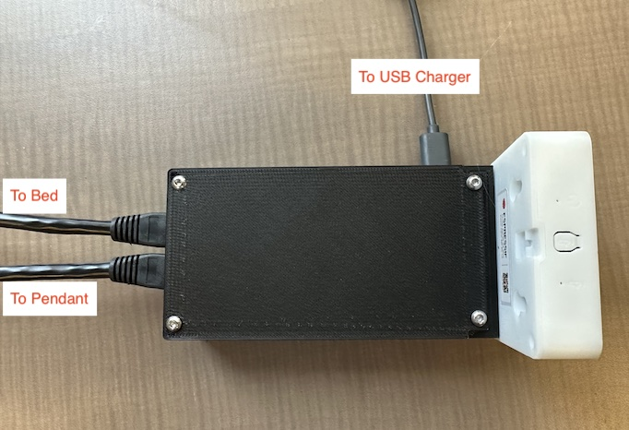

Note: If the usb socket on the black body doesn’t work, you may use the USB-C port on the other side of the white box instead.

**Troubleshooting**

In case of issues, please try the following steps:

1. Restart the device. This can be done by cycling power to the ESB box. Simply unplug the USB cable on the side of the device, then plug it back in again.
2. If this does not correct the issue, email Steffan Lloyd ([steffan.lloyd@icloud.com](mailto:steffan.lloyd@icloud.com)) and Nick Berezny ([Nicholas.Berezny@carleton.ca](mailto:Nicholas.Berezny@carleton.ca)) to describe the issue.
3. If the functioning of the bed is affected (e.g. if the pendant no longer works), the bed should resume normal functioning by disconnecting the ESB box entirely. Unplug the pendant from the ESP box, then plug it directly into the bed.