**Computing for Animation 1: CA1 Assignment Part 1**

Stefani Chrysostomou – i7245105

CVA

What I’ll be doing:

From the list of options that were given to us, I decided that the most interesting one was the flocking system by Craig Reynolds as I have always been interested in particles and I think that this will be a great way to challenge myself and expand my knowledge while putting my knowledge of object oriented programming to use. The most important part of this assignment is achieving to create the flocking system in the given time scale and if there is still time, I will attempt to make it pretty by giving it colour or different shapes.

These are some of the results I would be hoping to achieve:

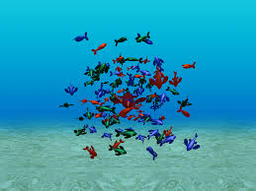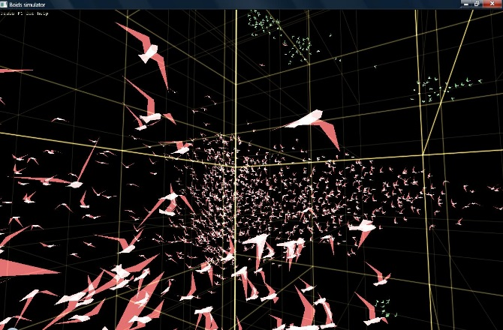

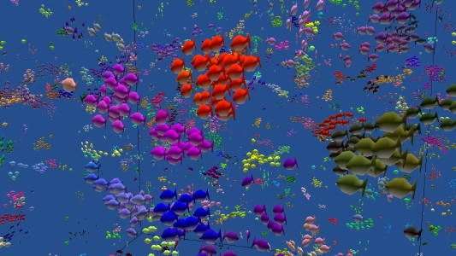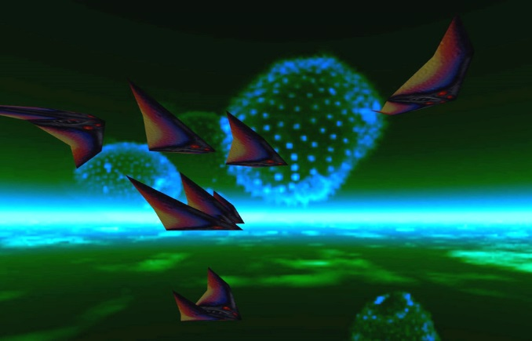

(Images were taken from the Internet)

Background Research:

The main things that I’ve learned from Graig Reynold’s page is that in order to create a flocking system, we need 3 rules which are: separation, alignment and cohesion. Separation means that a boid needs to keep some distance from other boids. Alignment means that all boids should be heading pretty much in the same direction and Cohesion means that a boid should be heading in the centre of a mass of boids.

Furthermore, each boid needs to have its own neighborhood that it needs to stay in it even though it has access to the whole scene. Craig has also introduced obstacle avoidance in his flocking system which is where boids have to avoid the objects in the scene by flying around them.

Apart from obstacles, predators can also be introduced which are also boids that chase normal boids, the boids then have to scatter to avoid them. That could be done by increasing the speed of boids and decreasing the speed of predators.

The main website that helped me understand Craig Reynold’s thinking is the blog of Conrad Parker who explains the whole process of making a flocking system with the use of pseudo code.

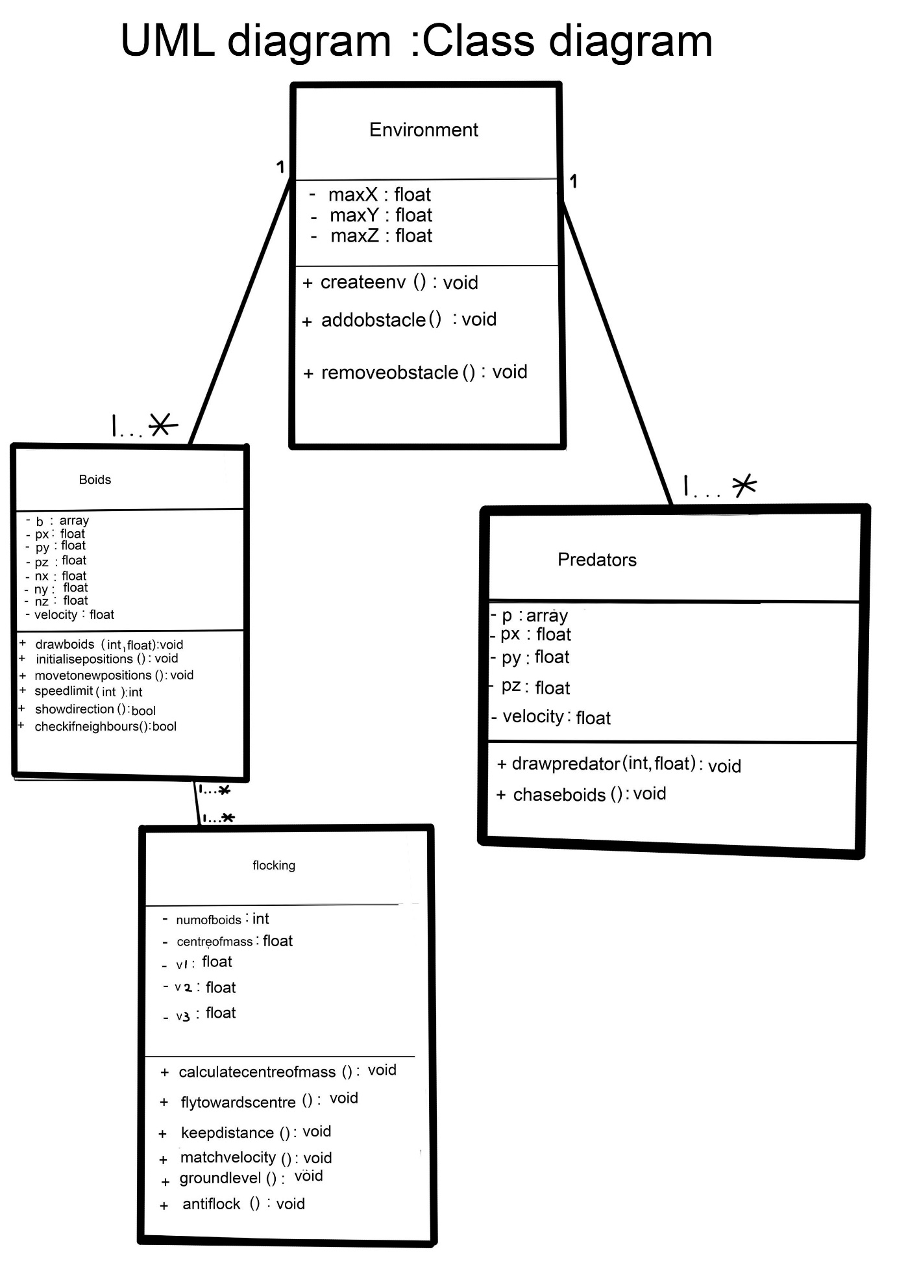

Diagram below shows the order in which action will be executed.

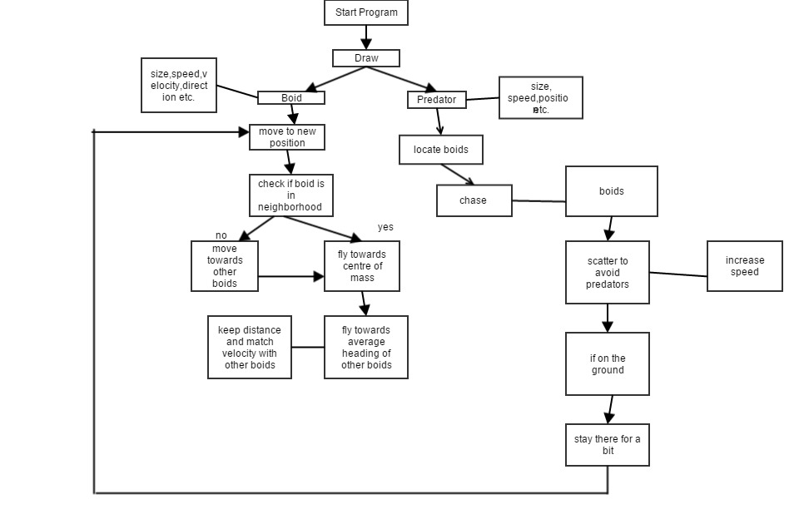

References

Parker, C. (2007). Boids Pseudocode. [Blog] *kfish*. Available at: http://www.kfish.org/boids/pseudocode.html [Accessed 18 Jan. 2015].

Rabin, S. (n.d.). *Al Game Programming wisdom*. Canada.

Reynolds, C. (1995). Boids. [Blog] Available at: http://www.red3d.com/cwr/boids/ [Accessed 18 Jan. 2015].

Reynolds, C. (2000). Flocks, Herds, and Schools: A Distributed Behavioral Model. [Blog] Available at: http://www.red3d.com/cwr/papers/1987/boids.html [Accessed 18 Jan. 2015].