Read:

<https://expressjs.com/en/guide/routing.html>

<http://dustwell.com/how-to-handle-passwords-bcrypt.html>

Nodejs: 8.12.0

Express: 4.16.3

HTTP

GET: get data

POST: Save new data

PUT: Edit existing data

DELETE: Delete data

Express

app.all(): responding whether using GET, POST, PUT, DELETE, or any other HTTP request

app.route(): chained route handlers.

app.use(): load middleware functions.

Middleware functions are functions that have access to the request object (req), the response object (res), and the next middleware function in the application’s request-response cycle

If the current middleware function does not end the request-response cycle, it must call next() to pass control to the next middleware function

<https://expressjs.com/en/advanced/best-practice-security.html>

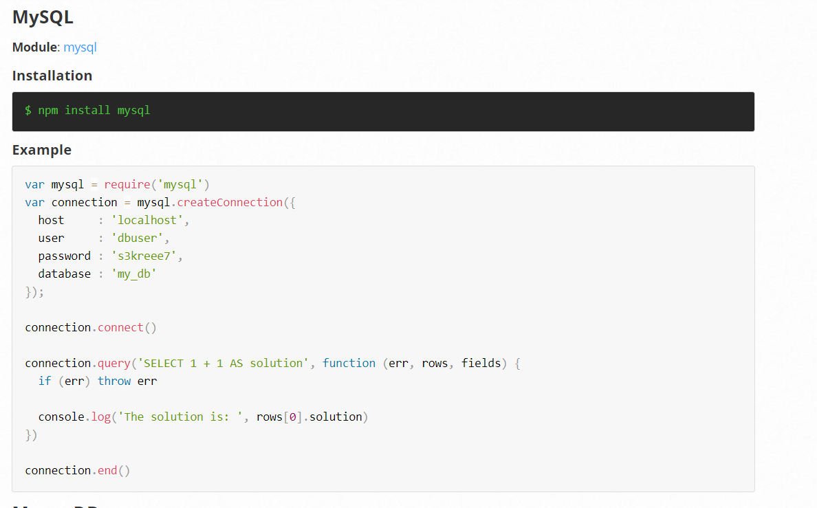

Bcrypt:

rounds=10: ~10 hashes/sec

8 x 1080 – 5 rounds

